**Virtual Fencing Technology for Rotational Grazing**

**Project Team: Spark**

**Team Members:** Canxuan Gang (z5158295), Jinhong CAI (z5542386),

Shiyan Zhao (z5536495), Wenzhi Hu (z5511644), Yihong Yao (z5593964)

I. INTRODUCTION

Livestock farming remains essential to agriculture, but managing animal movement can be difficult, especially in large or remote areas. Traditional fences are costly and inflexible, while manual monitoring takes time and effort.

To address these issues, we propose a virtual fencing system that uses Bluetooth Low Energy (BLE) signal strength and fingerprinting to estimate cattle positions, without GPS or physical barriers. The system works with low-power BLE devices and processes data in real time to detect when animals move beyond set boundaries.

This report outlines our BLE RSSI-based virtual fencing solution, which combines fingerprinting, MQTT messaging, and lightweight hardware to offer a practical, scalable alternative to traditional livestock tracking.

II. BACKGROUND RESEARCH

We reviewed several studies and found that BLE RSSI-based localization is widely used in smart cities, agriculture, and livestock management. Compared to GPS, it offers advantages including low power consumption (suitable for long-term use), small device size, low cost, no need for complex infrastructure, and real-time distance estimation using RSSI signals. These features make it ideal for applications like outdoor cattle monitoring and virtual fencing.

The basic principle of BLE RSSI-based localization is to first collect signal strength data (RSSI) at known reference points to build a "fingerprint database". During operation, real-time RSSI measurements from the target device are compared with this database to estimate its location. As illustrated in the Figure below, this is a system architecture for tracking children in and out of school buses.

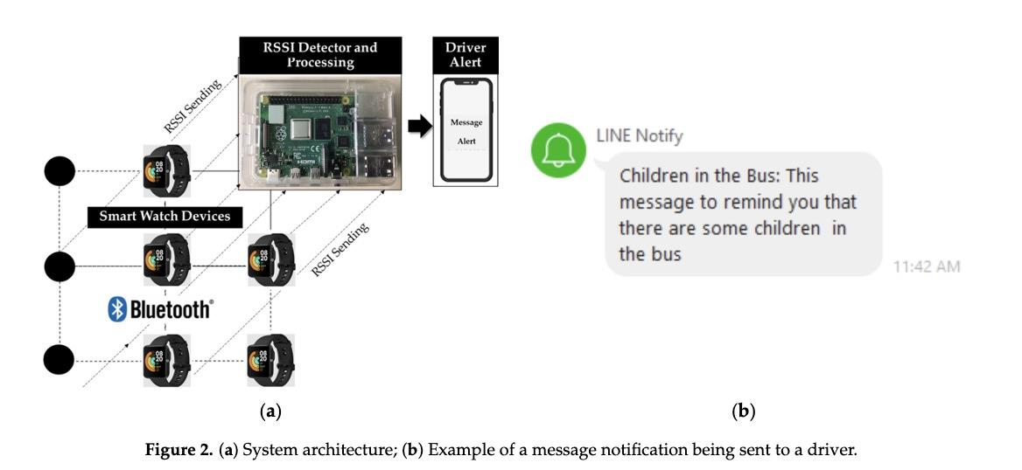

*Source: Sakphrom, S, Suwannarat, K, Haiges, R & Funsian, K 2021, ‘A Simplified and High Accuracy Algorithm of RSSI-Based Localization Zoning for Children Tracking In-Out the School Buses Using Bluetooth Low Energy Beacon’, Informatics (Basel), vol. 8, no. 4, pp. 65-.*

Furthermore, recent research also integrates machine learning methods (e.g., KNN, SVM, bagged trees, neural networks) to reduce signal fluctuation and multi-path effects and to improve localization accuracy. Performance comparisons among these classifiers show that these approaches improve localization accuracy and stability in complex outdoor environments.

III. METHODS

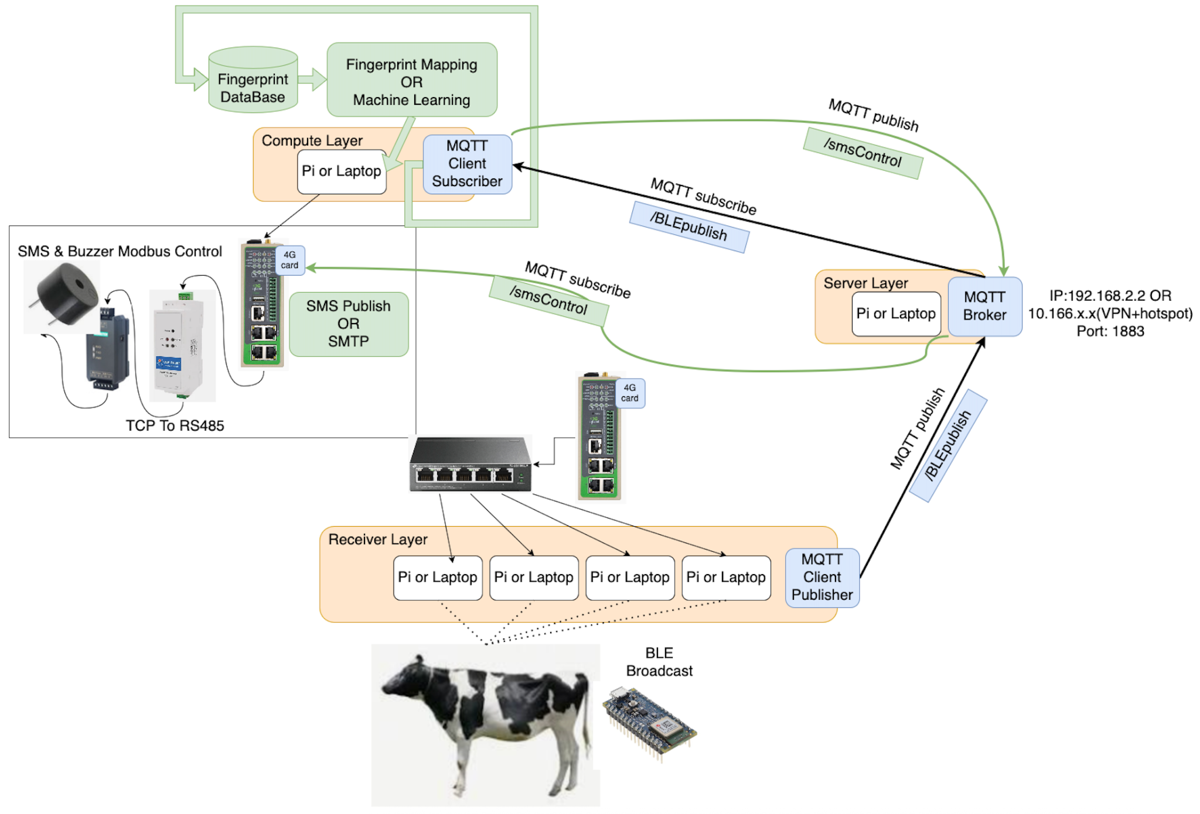

Our current goal is to locate the cow within the virtual fence. When the cow walks out of the virtual fence, it will send information to the manager and sound a buzzer.

1. We first select a relatively open scene to avoid signal interference, and place a data receiver at a fixed location on the site, such as a pi or a computer.
2. Then we wear the BLE Nano 33 on our body to simulate the movement of the cow. The receiver layer collects the RSSI and different Nanos at each location in detail.
3. Then the receiver layer accesses the Internet through the gateway and sends the data to the MQTT Broker (server layer), publishing the Topic name /BLEpublish, port 1883 without password (this setting needs to be enabled in the broker).
4. The Compute layer obtains the raw data of the RSSI by subscribing to the same topic (/BLEpublish), thereby normalizing the data and building a fingerprint library.

4.1. After having the fingerprint library, the model is trained and tested. To evaluate the accuracy.

4.2. The buzzer is deployed and the SMS function is implemented at the same time. When there is a positioning outside the fence, it is judged as outside the circle (this can be directly made into a whitelist and deployed in a 4G gateway with a SIM card).

4.3. Then publish the topic named /smsControl to the MQTT Broker, and let the gateway subscribe to this topic again, so that the script inside the gateway can send SMS messages. At the same time, the compute layer writes the register of the buzzer to the TCP network port converter through the script to control whether the buzzer buzzes or not.

1. Finally, the function of scanning RSSI every 5 seconds, entering the fingerprint library, generating coordinates, determining the location and alarming is realized.

IV. MILESTONES AND PROJECT PLAN

The project is divided into four weekly phases, each marking a key milestone. In Week 6, we will select a test site, deploy hardware, configure the MQTT broker, and verify BLE signal range and frequency. Week 7 focuses on collecting RSSI data across a 3×3 grid, simulating cow movement, and building a fingerprint database through filtering and averaging. In Week 8, we will implement a location inference system using Euclidean distance and perform boundary detection via point-in-polygon tests with 5-second refresh intervals. By the end of this phase, we aim to establish BLE data flow, complete the fingerprint database, and validate system functionality through end-to-end testing. Weeks 9–10 will focus on finalising the alert mechanism, integrating buzzer control via MQTT-to-RS485, and enabling SMS alerts through a SIM and API in preparation for the final demo.

V. Risk&Solution

In the development of the RSSI-based localization system, several practical risks were identified and mitigated. To reduce signal fluctuation caused by occlusion or reflection, data was collected in an outdoor area with average filtering. For hardware limitations, such as insufficient computers or battery life, devices were borrowed from the library, data was collected in batches, and power banks were prepared.

To address RSSI instability and missing values, a grid sampling strategy was used, with multiple readings per point and the median taken to ensure spatial coverage. For inconsistent timestamps, a standardized format was adopted across equipment.

Lastly, to prevent model overfitting and handle sample imbalance, the region was split for testing, and regularization/ensemble methods (e.g., KNN, EfficientNet) were applied to improve generalization.

VI. Predict Result

The system is expected to complete the full BLE data transmission loop, including broadcasting, receiving, and uploading to the MQTT Broker. A usable fingerprint database will be built to support localization. The location inference model is predicted to achieve over 60% accuracy, and the cross-border detection logic will function as intended. Additionally, SMS notification and buzzer alarm features are expected to be successfully implemented.

REFERENCES

[1] Abbas, S, Abu Talib, M, Nasir, Q, Idhis, S, Alaboudi, M & Mohamed, A 2024, ‘Radio frequency fingerprinting techniques for device identification: a survey’, International journal of information security, vol. 23, no. 2, pp. 1389–1427.

[2] Biswas, D, Barai, S & Sau, B 2023, ‘New RSSI-fingerprinting-based smartphone localization system for indoor environments’, Wireless networks, vol. 29, no. 3, pp. 1281–1297.

[3] Dogan, D, Dalveren, Y, Kara, A & Derawi, M 2024, ‘A Simplified Method Based on RSSI Fingerprinting for IoT Device Localization in Smart Cities’, IEEE access, vol. 12, pp. 163752–163763.

[4] Magsino, E, Barrameda, JMC, Puno, A, Ong, S, Siapco, C & Vibal, J 2023, ‘Determining Commercial Parking Vacancies Employing Multiple WiFiRSSI Fingerprinting Method’, Journal of sensor and actuator networks, vol. 12, no. 2, pp. 22-.

[5] P. Bahl and V. N. Padmanabhan, "RADAR: an in-building RF-based user location and tracking system," Proceedings IEEE INFOCOM 2000. Conference on Computer Communications. Nineteenth Annual Joint Conference of the IEEE Computer and Communications Societies (Cat. No.00CH37064), Tel Aviv, Israel, 2000, pp. 775-784 vol.2,

[6] Sakphrom, S, Suwannarat, K, Haiges, R & Funsian, K 2021, ‘A Simplified and High Accuracy Algorithm of RSSI-Based Localization Zoning for Children Tracking In-Out the School Buses Using Bluetooth Low Energy Beacon’, Informatics (Basel), vol. 8, no. 4, pp. 65-.

[7] Shin, K, McConville, R, Metatla, O, Chang, M, Han, C, Lee, J & Roudaut, A 2022, ‘Outdoor Localization Using BLE RSSI and Accessible Pedestrian Signals for the Visually Impaired at Intersections’, Sensors (Basel, Switzerland), vol. 22, no. 1, pp. 371-.