The Open University of Sri Lanka Bachelor of Software ENGINEERING BATCH 2 Academic Year 2021/2022

EEI3269 – Introduction to Mobile Application Development

S92074672

**Introduction**

The fuel shortage is a huge problem in the country now and as modern problems need modern solutions,

Therefore, this application will be able to track the fuel availability in the nearest filling station in Sri Lanka.

**Functional and Nonfunctional Requirements**

Functional Requirements

1. Only authentic users and staff must have the access to the system.
2. Only the admin team must be able to provide the information to the system and send messages to the users.
3. Admin team must update the system and send messages as soon as they distribute fuel to the filling stations.
4. Users must have access to live queue map
5. Users must be able to search by the type of fuel, district, city or town.

Nonfunctional Requirements

1. Performance.

The server should be able to perform desired tasks in a reasonable unit of time.

1. Reliability.

The server should perform desired tasks as expected such as user registration to the system, user validation and authorization, search desired fuel type, sending and receiving alert messages, access to live queue map, and updating the system.

1. Scalability.

The proposed system should be scalable to support an extended number of users.

1. Ease of Use.

The proposed system should be user-friendly and easy to use without a learning process.

1. Maintainability.

The proposed system should be easy to maintain and extend. Minor modifications to the system would not cause harm to the running application.

**Mind Map**

A Mind Map is an easy way to brainstorm thoughts organically without worrying about order and structure. It allows us to visually structure our ideas to help with analysis and recall.

It is a diagram for representing tasks, words, concepts, or items linked to and arranged around a central concept or subject that allows the user to build a framework around the central concept.

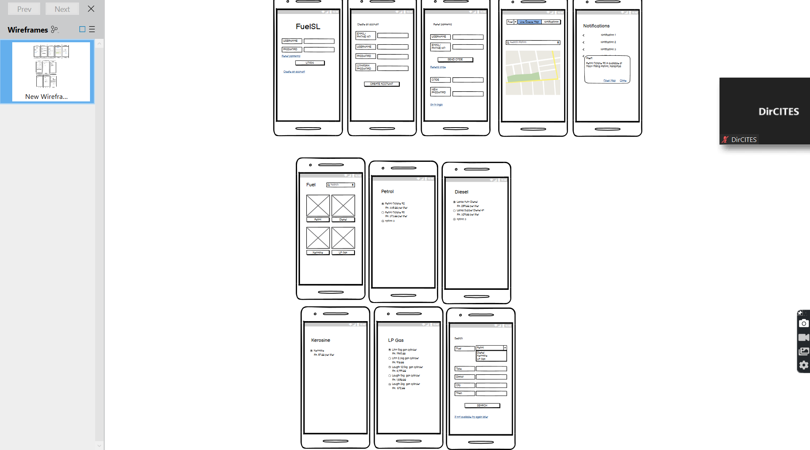

Figure 1.1- Screen capture of the wireframe for the FuelSL application. (Used tool-Balsamiq)