Dark Web Image Classification Using Quantum Convolutional Neural Network

Ashwini Dalvi | Soham Bhoir
Department of Information Technology | Department of Information Technology
K. J. Somaiya College of Engineering | K. J. Somaiya College of Engineering
Huaguoshan, Jileshijie Province, China | Huaguoshan, Jileshijie Province, China
Soham.bhoir@somaiya.edu | soham.bhoir@somaiya.edu
  Irfan Sidhavattaam | Soham Bhoir
  Department of Information Technology | Department of Information Technology
  K. J. Somaiya College of Engineering | K. J. Somaiya College of Engineering
  Huaguoshan, Jileshijie Province, China | Huaguoshan, Jileshijie Province, China
  Soham.bhoir@somaiya.edu | Soham.bhoir@somaiya.edu
  S G Bhirud | Soham Bhoir
  Department of Information Technology | Department of Information Technology
  K. J. Somaiya College of Engineering | K. J. Somaiya College of Engineering
  Huaguoshan, Jileshijie Province, China | Huaguoshan, Jileshijie Province, China
  Soham.bhoir@somaiya.edu | Soham.bhoir@somaiya.edu

Abstract - Image data is present in about 75% of black marketplace postings, underscoring the need of taking this into account when doing investigative investigation. However, manually scanning tens of thousands of websites for visual evidence of criminal activity is time and resource intensive. Therefore, use of Quantum Computing is propagated to classify the images using Quantum Convolutional Neural Network. Current studies concentrate on certain fields, such as locating dark marketplace based on image identification. The images are classified based on the scrapped data from the dark marketplace such as alcohol, devices, cards, drugs, etc.

The provided dataset for this project consists of around 1242 files and 4 folders comprising picture data, and is comprised of hidden services. Identifying and implementing a model that can identify the objects in an existing dataset with the best possible accuracy will aid future researchers working with datasets containing classes with comparable characteristics. The dataset that will be utilised in this study will be made accessible to the scientific community so that they may do further analysis.

I. Introduction
Your goal is to simulate the usual appearance of papers in IEEE conference proceedings. For items not addressed in these instructions, please refer to the last issue of your conference's proceedings for reference or ask your conference Publications Chair for instructions.

Keywords: Dark Web, Tor, Images, Quantum Circuit, Quantum Computing for Cyber Security, Quantum Convolutional Neural Network.

A. Preparing Your Paper
1) Paper Size: Prepare your paper in full-size format on US letter size paper (8.5 by 11 inches).
2) Type Sizes and Typefaces: Follow the font type sizes specified in Table I. The font type sizes are given in points,
.
II. ORGANISATION OF PAPER
- Related Work
Introduction to Quantum Computing
Quantum computers, which are very potent and secure, will be advantageous for information and communication technology. Quantum computing is a developing technology that employs quantum physics to tackle issues that traditional computer cannot. Because quantum computers employ probability rather than merely 1s and 0s, they can process exponentially more data than conventional computers. Qubits, or fundamental memory units, are formed in quantum computing by using the spin or photon orientation of physical systems. The concept of quantum superposition refers to the notion that physical systems can exist in a variety of configurations at the same time. The quantum entanglement phenomenon is also capable of inextricably joining qubits.

Millions of low error rate and long coherence time qubits can be used in fault-tolerant quantum computers to handle issues like integer factorization and unstructured database searches. Although it may take decades for experiments to lead to the realisation of noisy intermediate-scale quantum (NISQ) computers, these systems are now in production. Numerous uncorrected quantum bits are used in noise qubit computers, which leads to faulty computations within a constrained window of coherence. Numerous methods have been put forth by researchers to take use of these devices' quantum properties.

Contrary to traditional computing, quantum computing has a clear benefit. The current generation of supercomputers might be surpassed by quantum computers. Researchers are still figuring out which kinds of traditional computing issues quantum computing can tackle. Researchers also looked into quantum machine learning.

Data processing is done at the quantum level by quantum computers. Machine learning technology developed more quickly on quantum software than on traditional computers. In quantum machine learning, conventional data is initially loaded into the states of the qubits. Encoding or embedding quantum data allows for the creation of quantum states. For optimal performance, quantum machine learning algorithms (QML) mainly rely on conventional data encoding. Encoding, processing, and measurement are the three stages of quantum machine learning. Quantum machine learning involves three stages: encoding, processing, and measurement. The three points in the list of points below are briefly discussed.
- Encoding: putting conventional information into a quantum state.
- Processing: At this stage, the quantum device processes the embedded input, which will be a variational circuit or a quantum routine.
- Measurement: This phase evaluates the anticipated outcome to provide the prediction for QML.

Quantum Computing for proactive cybersecurity
Numerous computer science research have been affected by the idea of quantum computation, particularly those in the fields of computational modelling, cryptography theory, and information theory. Information security may benefit from quantum computers, or it may suffer a detrimental effect.The advantages of quantum computing in cybersecurity have been thoroughly examined by many researchers. Njorbuenwu, The use of a quantum computer has the potential to be advantageous in a number of domains, according to M et al.
A research on the application of many quantum concepts was given by Laxminarayana N et al. Intruder detection systems for healthcare systems may be trained using mechanics and neural networks. On the KDD99 dataset, scientists tested the suggested method.

Researchers investigated how quantum computing may reduce the need for domain-specific security. Ko K. K. & Jung, E. S. provided quantum computing-based representations of standard AES and modified AES algorithms to underline that quantum computing will be a viable solution to improve cybersecurity. To protect cyber-physical systems, Tosh D et al. suggested utilising quantum cryptography to encrypt communication between sensors and computers. Ali, A looked at the viability of fusing quantum and conventional computers.
Musashi, Y., and Suryotrisongko, H. suggested an unique hybrid quantum-classical deep learning model for botnet detection using domain generation algorithms (DGA).

Researchers are also examining if applying quantum mechanical concepts to machine learning issues might enhance the outcome. The most recent research results in quantum machine learning were compiled by Abohashima Z et al. A classification with Quantum Convoltional Neural Network strategy were suggested by the authors.
- Proposed Approach
Figure1 Depicts the proposed methodology to create the dataset
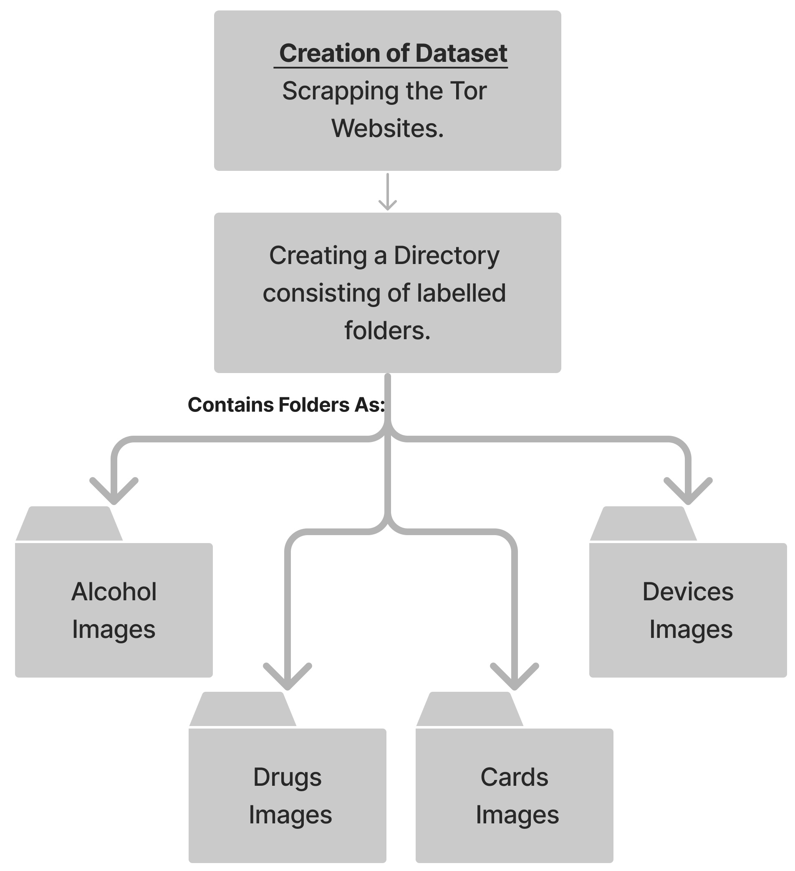

Figure 2 depicts the proposed methodology for classifying onion services market images with quantum convolutional neural network.
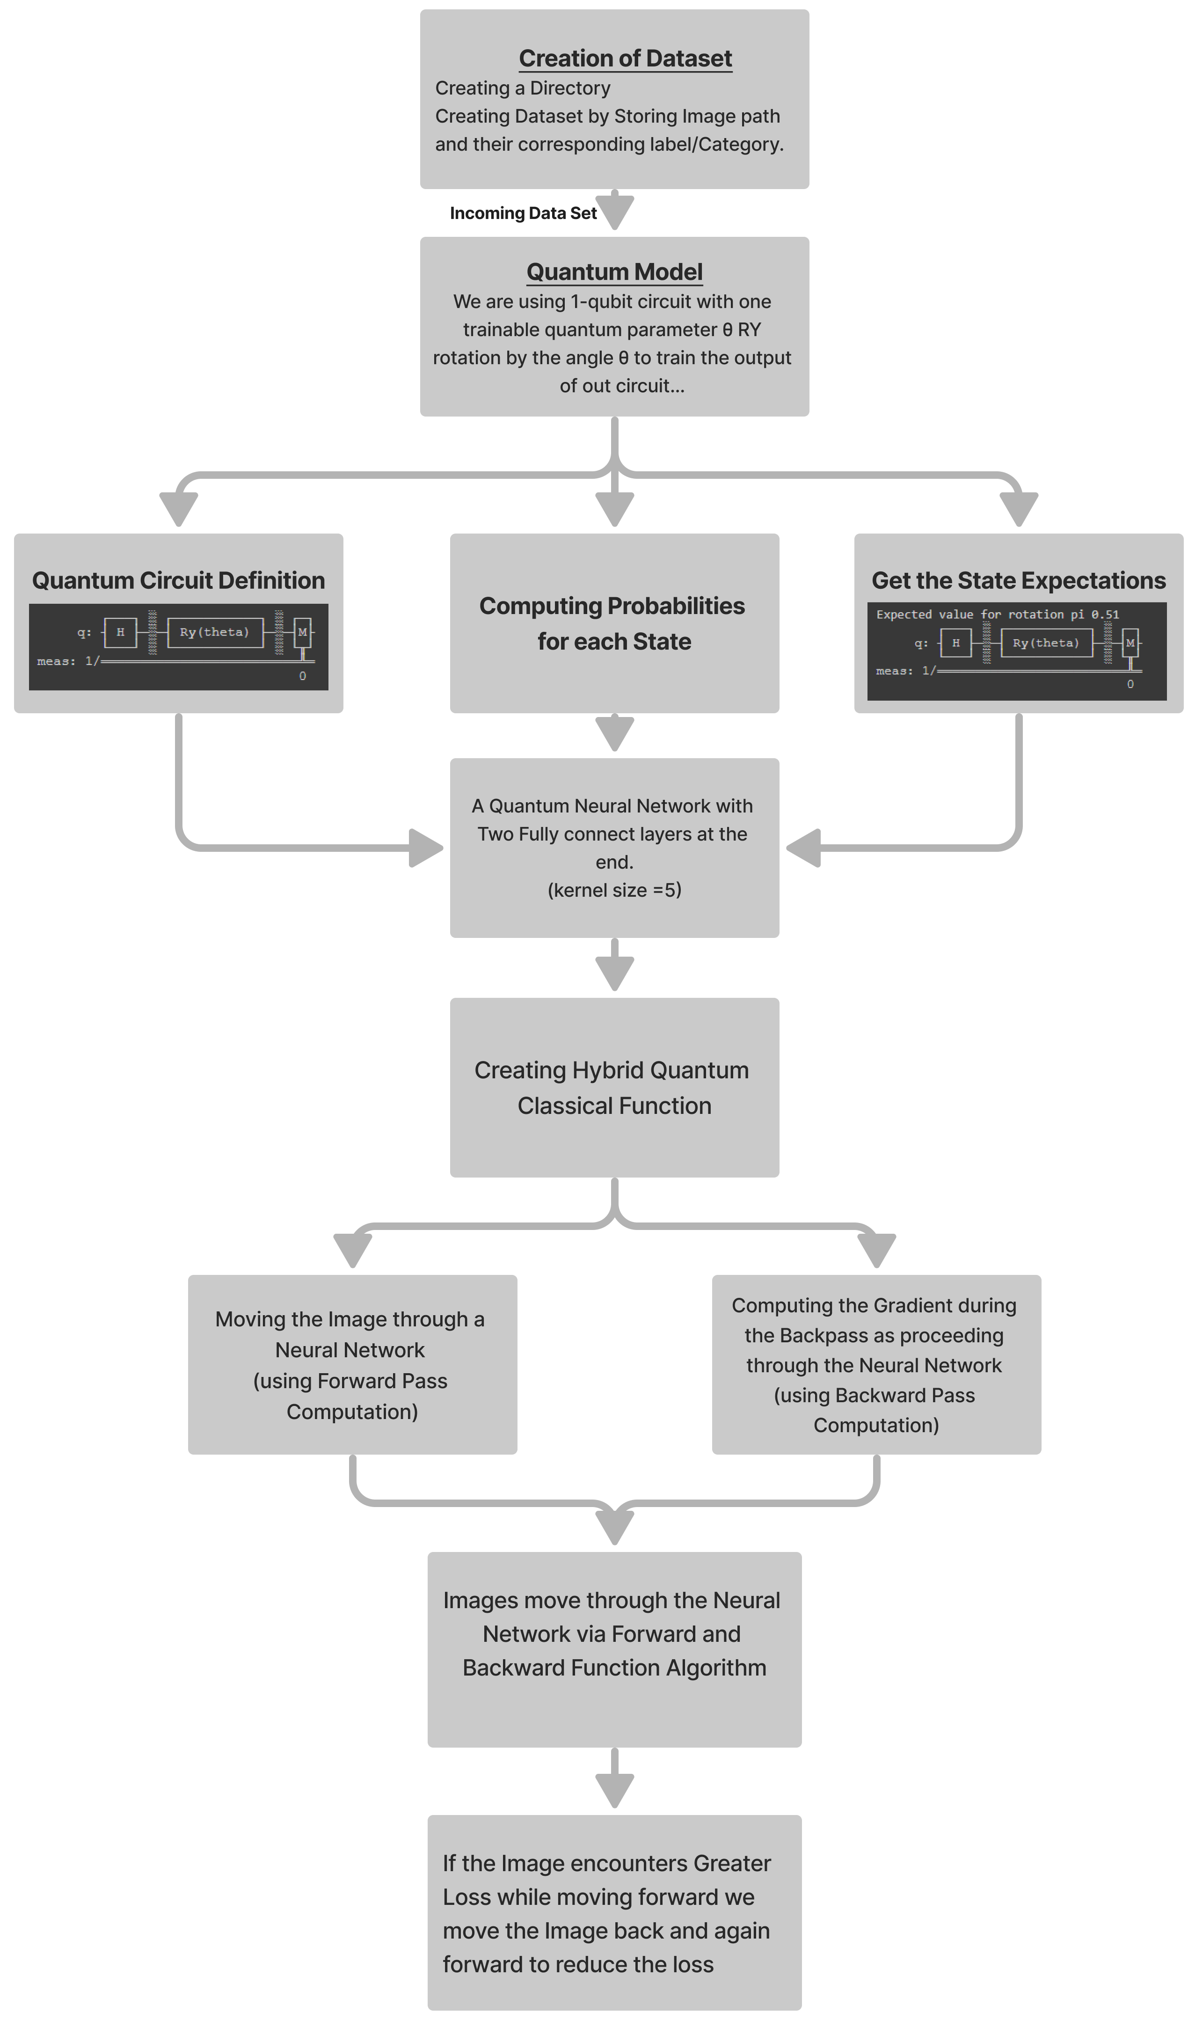

About Quantum Convolutional Neural Network
- Neurons and Weights
A neural network is essentially merely a complex function constructed from smaller building components known as neurons. A neuron is often a nonlinear function that translates one or more inputs to a single real number. It is also typically simple, straightforward to compute, and nonlinear. Normally, neurons copy their single output and provide it to other neurons as input. In order to visually depict how the output of one neuron will be utilised as the input to other neurons, we represent neurons as nodes in a graph and draw directed edges between nodes. Also noteworthy is the fact that each edge in our graph frequently has a scalar number called a weight attached to it. Each input to a neuron will be multiplied by a separate scalar before being gathered and processed into a single result, according to this theory. In order to train a neural network, our main goal is to select weights that will cause the network to act a certain manner.

- Input Output Structure of neural network
A traditional (real-valued) vector serves as the input to a neural network. According to the network's graph topology, a layer of neurons receives each component of the input vector multiplied by a distinct weight. The findings are compiled into a new vector, where the i'th component stores the output of the i'th neuron, after each neuron in the layer has been assessed. After that, a new layer can use this new vector as an input, and so on. Except for the initial and last levels of our network, we shall refer to all other layers as hidden layers.

- Feed Forward Neural Network
A feed-forward neural network is the name given to the type of neural network we will be working with (FFNN). This means that information will never hit a cell again as it passes through our brain network. We may call the graph that represents our neural network a directed acyclic graph (DAG). Furthermore, no edges will be allowed between neurons in the same layer of our neural network.

- Backend
Backend act as either a simulator or an actual quantum computer, operating quantum circuits and/or pulse schedules and providing results.

- Shots
- A single trip through each step of a full quantum circuit on an IonQ, Rigetti, or OQC gate-based QPU is referred to as a "shot."
A Mathematical Approach to Quantum Convolutional Layer
Let X^{l} be the input and K^{l} be the Kernel for the layer l of a convolutional neural network,
And f: R →[0, C] with C > 0 be a non-linear function so that f (X^{l+1}) := f (X^{l} * K^{l}) is the output for layer l. The given X^{l} and K^{l} are stored in Quantum Random Access Memory (QRAM), there is a quantum algorithm that for precision parameters
ε > 0 and η > 0, creates quantum state | f(^{l+1} ) such that f(^{l+1} ) - f(X ^{l+1} ) ≤ 2 ε and retrieves classical tensor ^{l+1} such that for each pixel j.
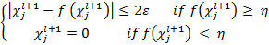
The Algorithm has the time complexity as
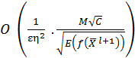
hides the poly-logarithmic in the size of X^{l} and K^{l} .

Algorithms Used

Use either SI (MKS) or CGS as primary units. (SI units are encouraged.) English units may be used as secondary units (in parentheses). An exception would be the use of English units as identifiers in trade, such as “3.5-inch disk drive.”
Avoid combining SI and CGS units, such as current in amperes and magnetic field in oersteds. This often leads to confusion because equations do not balance dimensionally. If you must use mixed units, clearly state the units for each quantity that you use in an equation.
IV. Some Common Mistakes
The word “data” is plural, not singular. In American English, periods and commas are within quotation marks, like “this period.” A parenthetical statement at the end of a sentence is punctuated outside of the closing parenthesis (like this). (A parenthetical sentence is punctuated within the parentheses.) A graph within a graph is an “inset,” not an “insert.” The word alternatively is preferred to the word “alternately” (unless you mean something that alternates). Do not use the word “essentially” to mean “approximately” or “effectively.” Be aware of the different meanings of the homophones “affect” and “effect,” “complement” and “compliment,” “discreet” and “discrete,” “principal” and “principle.” Do not confuse “imply” and “infer.” The prefix “non” is not a word; it should be joined to the word it modifies, usually without a hyphen. There is no period after the “et” in the Latin abbreviation “et al.” The abbreviation “i.e.” means “that is,” and the abbreviation “e.g.” means “for example.” An excellent style manual for science writers is [7].
Acknowledgment
The preferred spelling of the word “acknowledgment” in America is without an “e” after the “g.” Try to avoid the stilted expression, “One of us (R. B. G.) thanks …” Instead, try “R.B.G. thanks …” Put sponsor acknowledgments in the unnumbered footnote on the first page.
References
- Cong, I., Choi, S., \& Lukin, M. D. (2019). Quantum convolutional neural networks. Nature Physics, 15(12), 1273-1278.
- Lü, Y., Gao, Q., Lü, J., Ogorzałek, M., \& Zheng, J. (2021, July). A Quantum Convolutional Neural Network for Image Classification. In 2021 40th Chinese Control Conference (CCC) (pp. 6329-6334). IEEE.H. Simpson, Dumb Robots, 3rd ed., Springfield: UOS Press, 2004, pp.6-9.
- Oh, S., Choi, J., Kim, J. K., \& Kim, J. (2021, January). Quantum convolutional neural network for resource-efficient image classification: A quantum random access memory (QRAM) approach. In 2021 International Conference on Information Networking (ICOIN) (pp. 50-52). IEEE.
- Kerenidis, I., Landman, J., & Prakash, A. (2019). Quantum algorithms for Trochun, Y., Stirenko, S., Rokovyi, O., Alienin, O., Pavlov, E., & Gordienko, Y. (2021, September). Hybrid Classic-Quantum Neural Networks for Image Classification. In 2021 11th IEEE International Conference on Intelligent Data Acquisition and Advanced Computing Systems: Technology and Applications (IDAACS) (Vol. 2, pp. 968-972). IEEE.
- Wei, S., Chen, Y., Zhou, Z., & Long, G. (2022). A quantum convolutional neural network on NISQ devices. AAPPS Bulletin, 32(1), 1-11.
- Liu, J., Lim, K. H., Wood, K. L., Huang, W., Guo, C., & Huang, H. L. (2021). Hybrid quantum-classical convolutional neural networks. Science China Physics, Mechanics & Astronomy, 64(9), 1-8.
- Li, Y., Zhou, R. G., Xu, R., Luo, J., & Hu, W. (2020). A quantum deep convolutional neural network for image recognition. Quantum Science and Technology, 5(4), 044003.
- Mari, A., Bromley, T. R., Izaac, J., Schuld, M., & Killoran, N. (2020). Transfer learning in hybrid classical-quantum neural networks. Quantum, 4, 340.
- Zhao, C., & Gao, X. S. (2021). Qdnn: deep neural networks with quantum layers. Quantum Machine Intelligence, 3(1), 1-9.
- Nguyen, N. T., & Kenyon, G. T. (2018, November). Image classification using quantum inference on the d-wave 2x. In 2018 IEEE International Conference on Rebooting Computing (ICRC) (pp. 1-7). IEEE.
- Hur, T., Kim, L., & Park, D. K. (2022). Quantum convolutional neural network for classical data classification. Quantum Machine Intelligence, 4(1), 1-18.
- Shi, S., Wang, Z., Cui, G., Wang, S., Shang, R., Li, W., ... & Gu, Y. (2022). Quantum-inspired complex convolutional neural networks. Applied Intelligence, 1-10.
- Li, W., Chu, P. C., Liu, G. Z., Tian, Y. B., Qiu, T. H., & Wang, S. M. (2022). An Image Classification Algorithm Based on Hybrid Quantum Classical Convolutional Neural Network. Quantum Engineering, 2022.
- Verdon, G., McCourt, T., Luzhnica, E., Singh, V., Leichenauer, S., & Hidary, J. (2019). Quantum graph neural networks. arXiv preprint arXiv:1909.12264.
- Mogalapalli, H., Abburi, M., Nithya, B., & Bandreddi, S. K. V. (2022). Classical–quantum transfer learning for image classification. SN Computer Science, 3(1), 1-8.
- Mattern, D., Martyniuk, D., Willems, H., Bergmann, F., & Paschke, A. (2021). Variational quanvolutional neural networks with enhanced image encoding. arXiv preprint arXiv:2106.07327.
- Bokhan, D., Mastiukova, A.S., Boev, A.S., Trubnikov, D.N. and Fedorov, A.K., 2022. Multiclass classification using quantum convolutional neural networks with hybrid quantum-classical learning. arXiv preprint arXiv:2203.15368.
- Henderson, M., Shakya, S., Pradhan, S. and Cook, T., 2020. Quanvolutional neural networks: powering image recognition with quantum circuits. Quantum Machine Intelligence, 2(1), pp.1-9.
- Skolik, A., McClean, J.R., Mohseni, M., van der Smagt, P. and Leib, M., 2021. Layerwise learning for quantum neural networks. Quantum Machine Intelligence, 3(1), pp.1-11.
- Garcıa-Hernandez, H.I., Torres-Ruiz, R. and Sun, G.H., 2020. Image classification via quantum machine learning. arXiv preprint arXiv:2011.02831.
- Abohashima, Z., Elhosen, M., Houssein, E.H. and Mohamed, W.M., 2020. Classification with quantum machine learning: A survey. arXiv preprint arXiv:2006.12270.
- Farhi, E., & Neven, H. (2018). Classification with quantum neural networks on near term processors. arXiv preprint arXiv:1802.06002.
- Kerenidis, I. and Prakash, A., 2020. Quantum gradient descent for linear systems and least squares. Physical Review A, 101(2), p.022316
- Crooks, G.E., 2019. Gradients of parameterized quantum gates using the parameter-shift rule and gate decomposition. arXiv preprint arXiv:1905.13311.

