**Group**: 20

**Name**: Soham Bhoir

**Roll No.**: 16010420117

**Class**: B/B2

Flutter Project: NFT Marketplace

**Topic Name**: NFT-Marketplace

**GitHub Repository Link**: <https://github.com/ThunderBolt-OS/Flutter-NFT-Marketplace>

**Description:** This NFT Marketplace is Ethereum based Matic decentralised marketplace where users can create digital art and can trade and bid the arts. The frontend of the application is backed by web3 environment truffle and ganache. It is based on Polygon Mumbai Matic token as 1 Matic is 0.87 US Dollars so everyone can afford the trading and bidding the digital arts.

**The Splash Screen:**

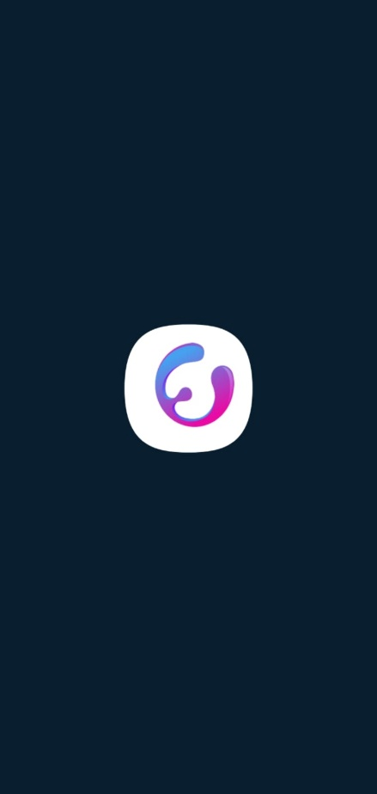

**The Main Login Screen:**

From here user can either create a new digital wallet or can use his existing digital wallet as Meta Mask.

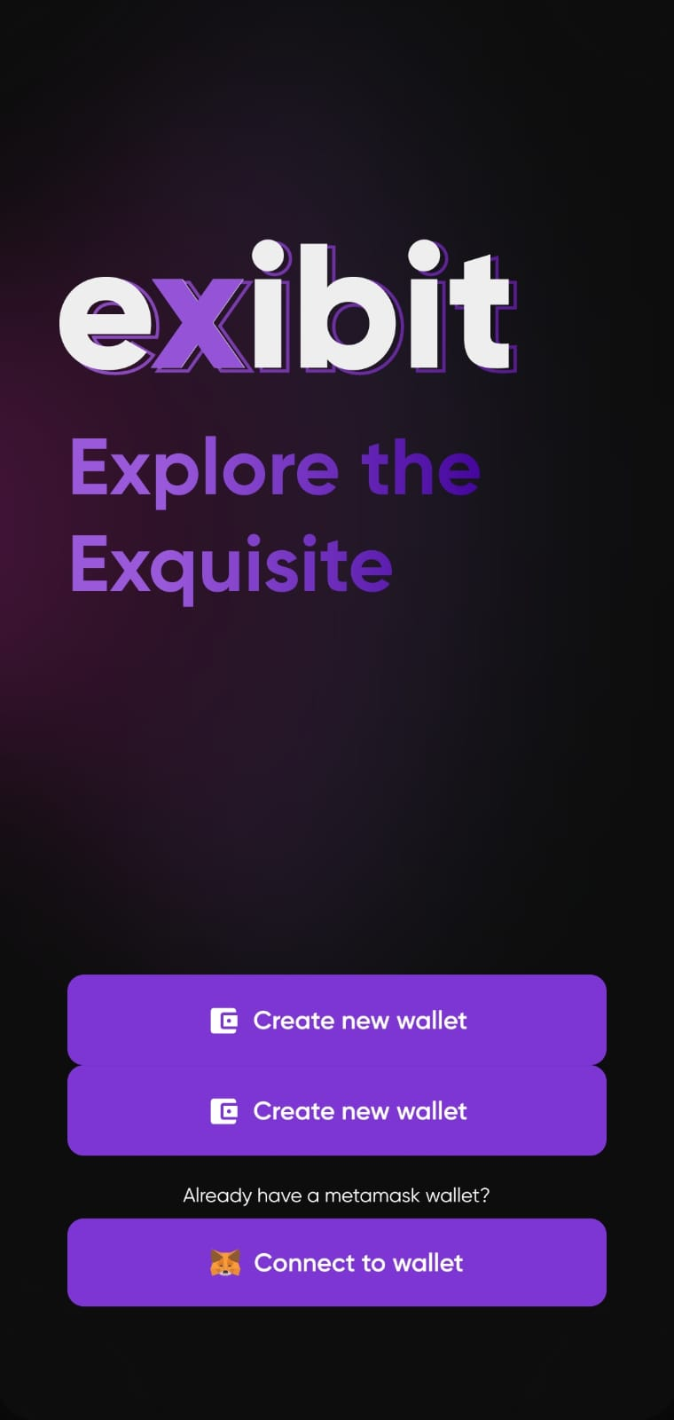

When user doesn’t have any digital accounts he/she can create a new wallet, and the wallet uses Polygon Mumbai Ethereum Matic. The new wallet ID gets automatically copied to the clipboard and user can get some test matic for testing purposes.

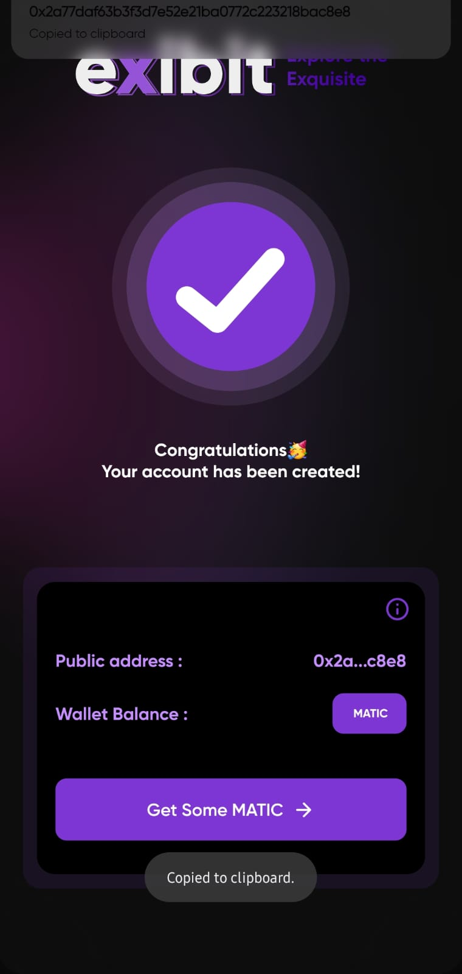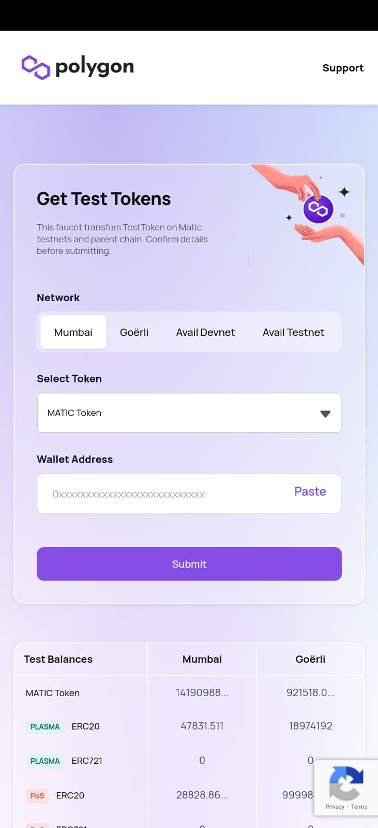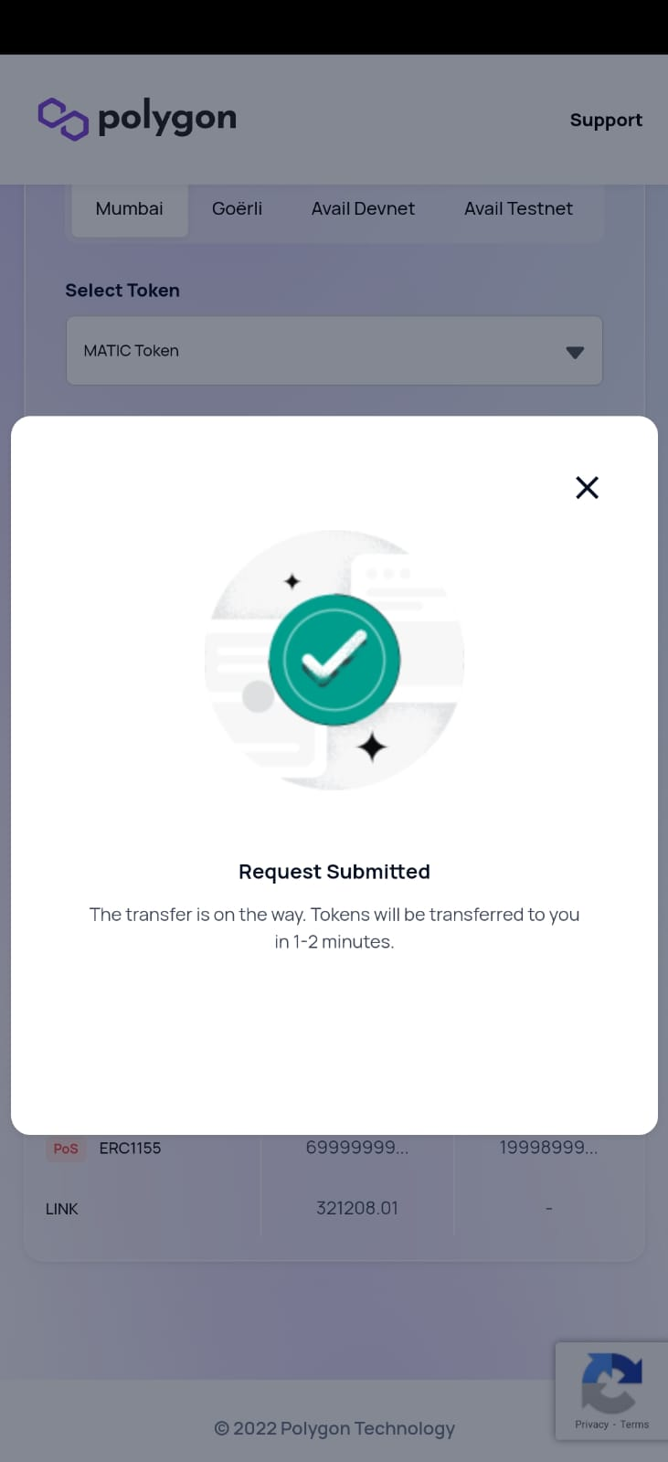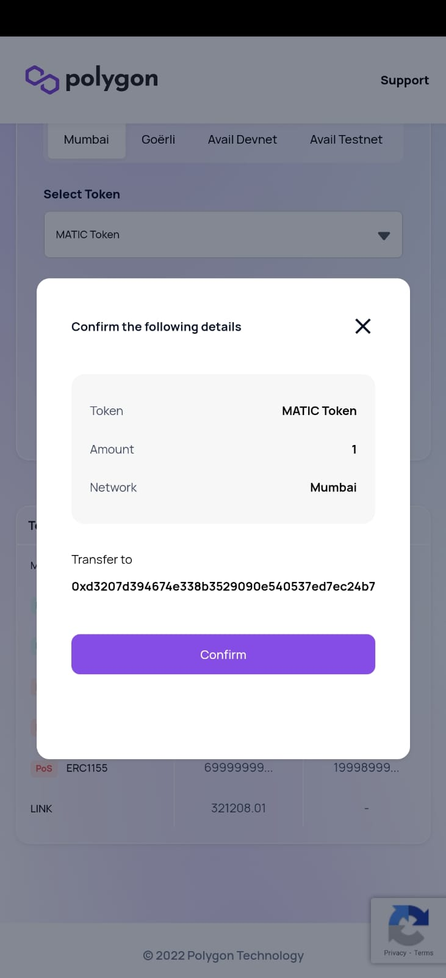

With these 4 steps user can get on board if he/she doesn’t have any digital wallet

**Firebase Authentication**

If user doesn’t want to buy any NFT and just want to look around the application to see what exactly is NFT marketplace then user can signup and the details are saved in firebase database.

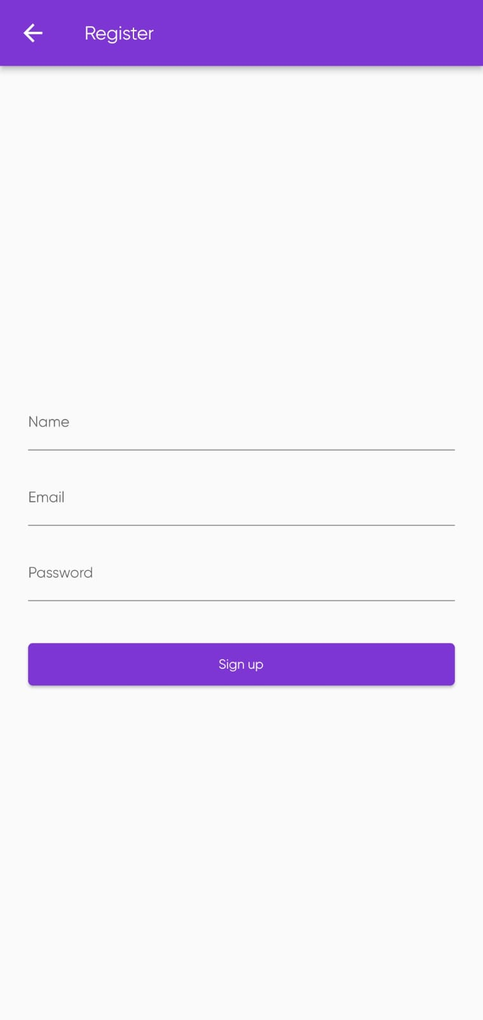

**When User is inside the application:**

User can like as well as save the NFT.

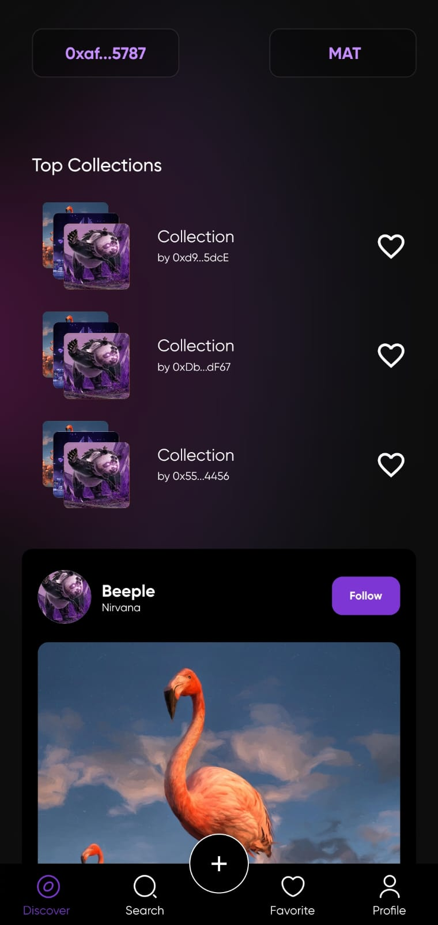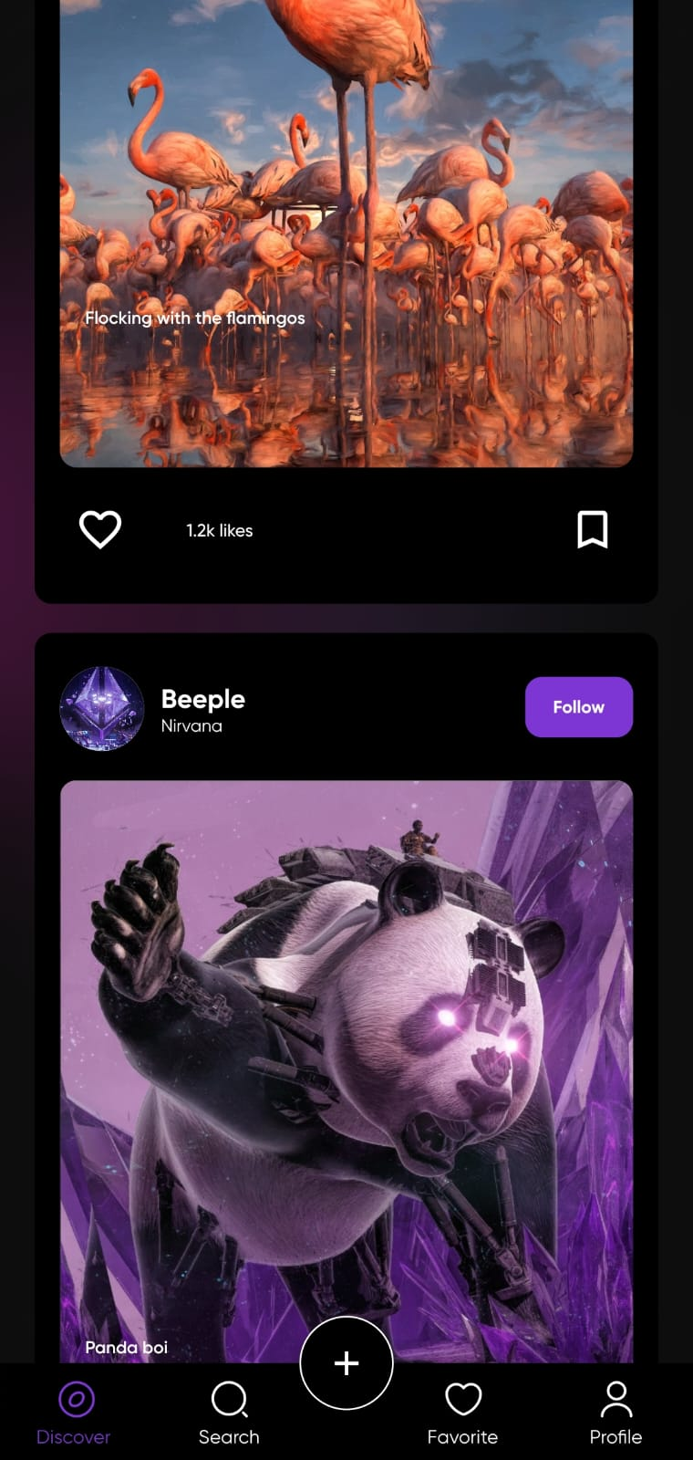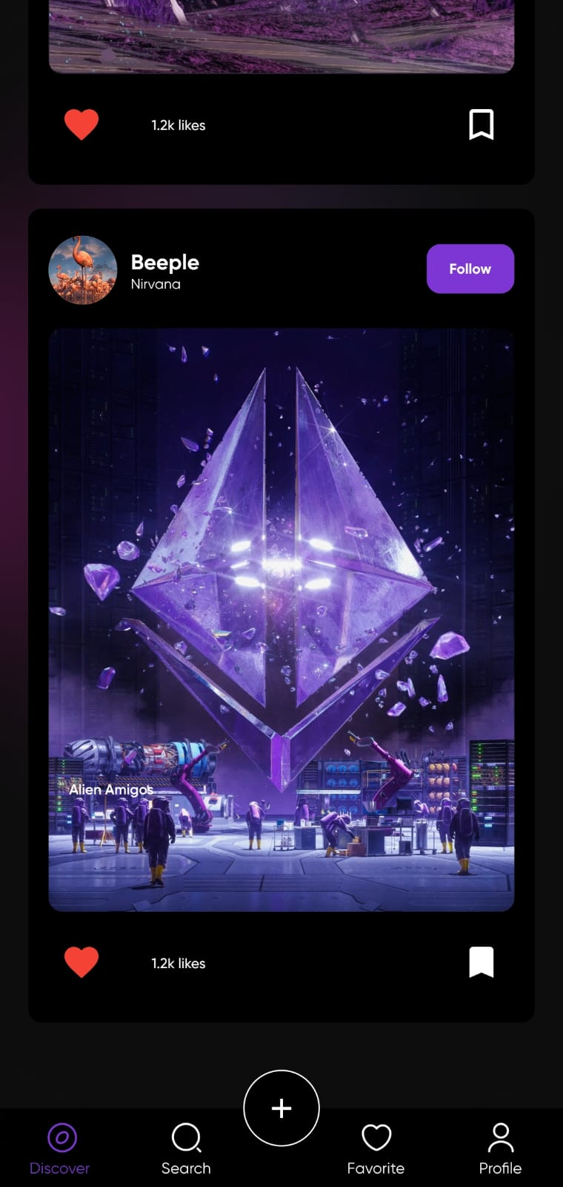

**NFT Creation**

User can create NFT either by uploading an image or by clicking the image with the help of camera.

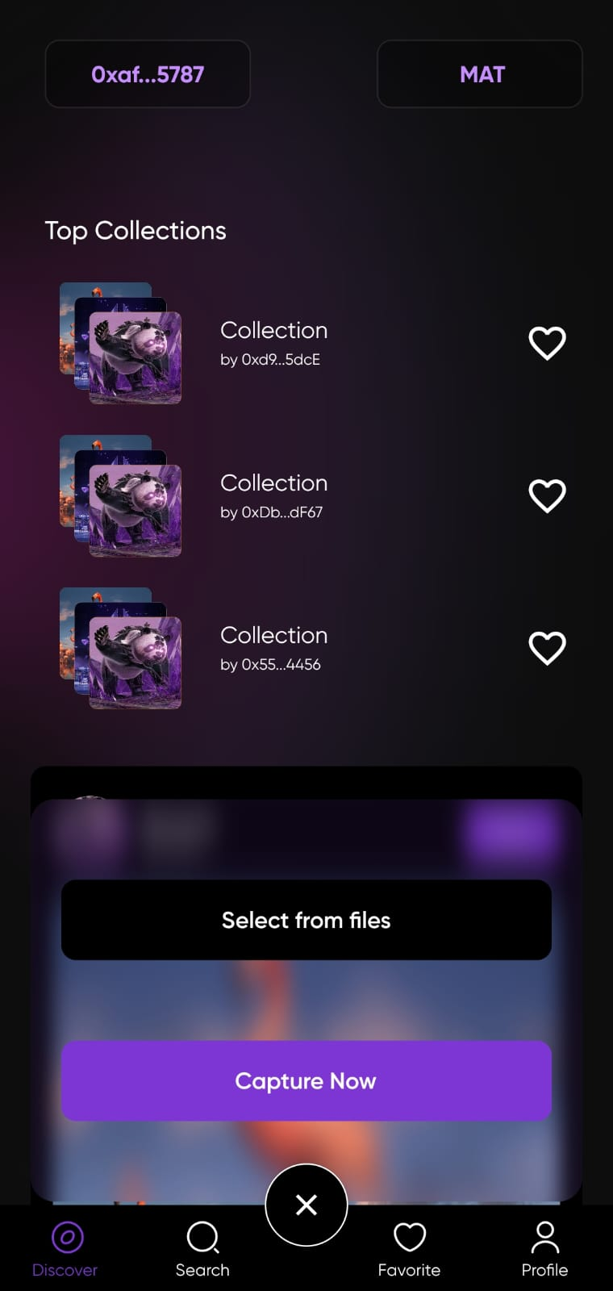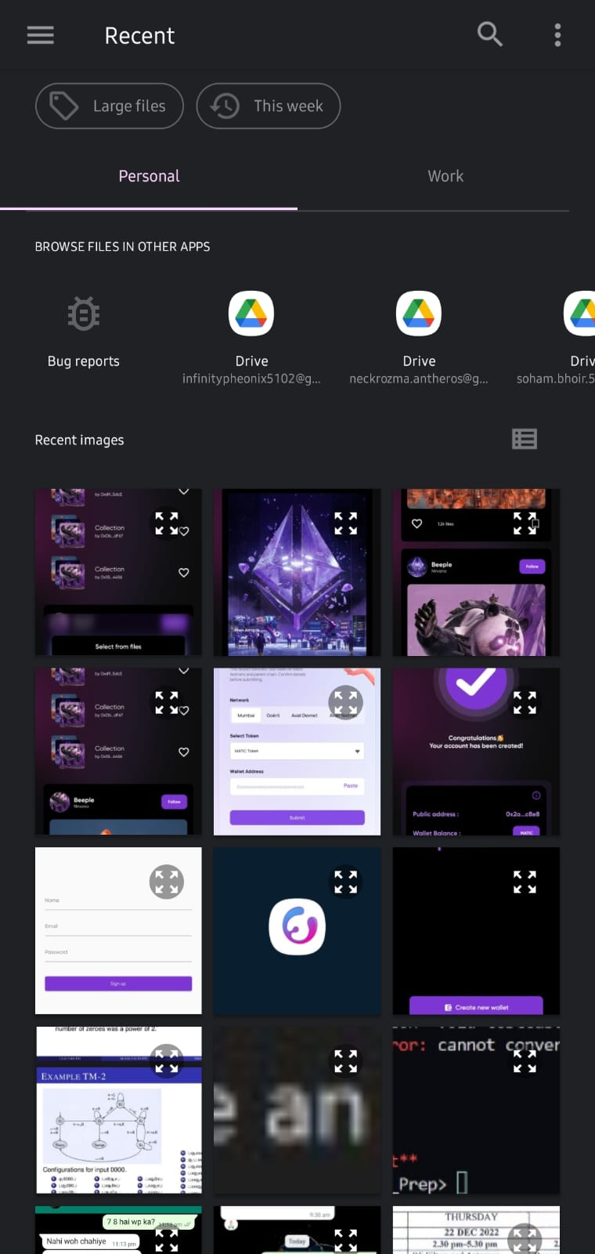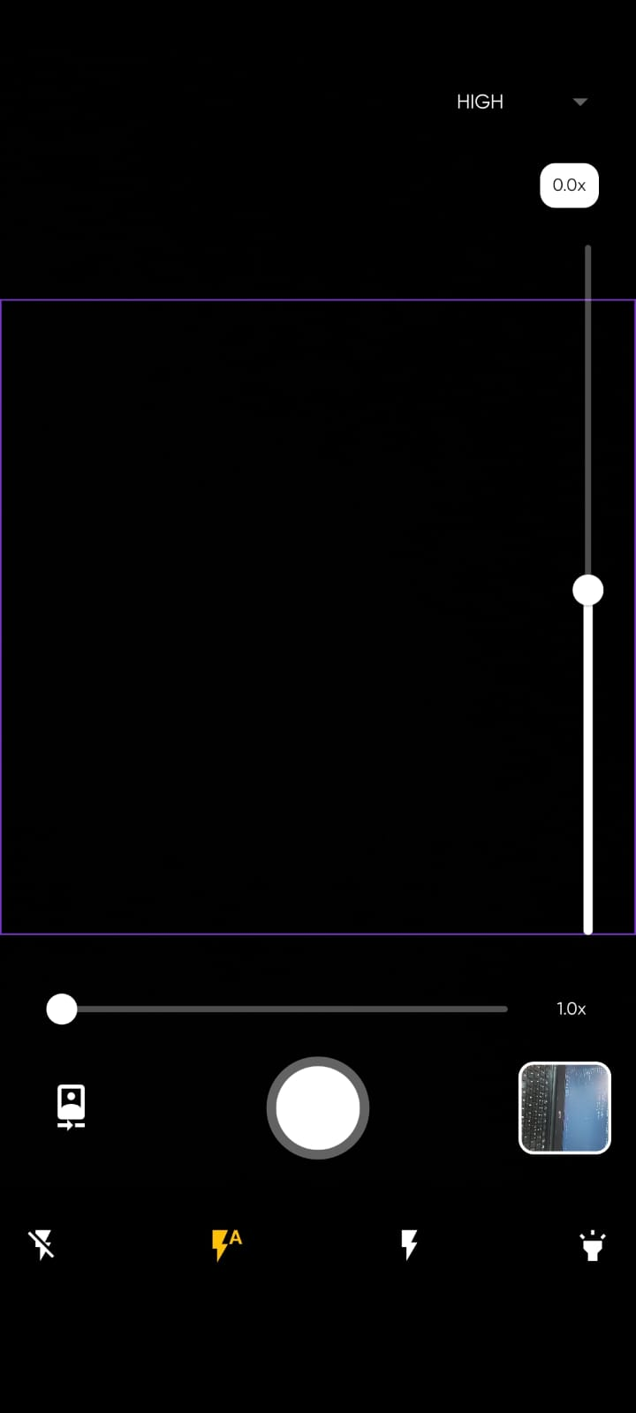

**Anonymous Screens:**

When user doesn’t have any internet connection and we want the user to stop interacting with the application then we invoke a No Internet Screen.

