**Experiment No. 9**

**Title: Report on developed user interface (UI)**

**Batch: B2 Roll No.: 16010420117 Experiment No.:9**

### Aim: To prepare consolidated report on developed user interface (UI)

### --------------------------------------------------------------------------------------------

**Resources needed:** Wireframing tool, Word Document

### Theory:

### UI screens are important part in development of project/concept. The presentation of same is even more important for all the stakeholders.

### The presentation of selected topic for UI screen preparation will be complied in form of report in this experiment.

### Include following point in report:

### 1. Begin with Topic of choice in form of problem definition

### 2. Add User case, persona, scenarios

### 3. Discuss choice of Wireframing tool

### 4. Discuss web UI with principle employed

### 5. Discuss mobile UI with principle employed

### 6. Wherever possible highlights the principle apply of UI design

### ___________________________________________________________________________

**Procedure:**

### Prepare consolidated report on developed user interface (UI) for chosen topic

### Instructions to be followed while writing the report:

### Follow the following instructions for report writing.

### Title of the document- 14 bold Times New Roman, center alignment

### Heading - 12 bold Times New Roman

### Subheading- 12 Italics Times New Roman

### Text- 12 regular Times New Roman

### Line spacing- single

### Alignment- justified

_____________________________________________________________________________________

### Result:

**NFT Marketplace**

**Problem Statement:**

### A non-fungible token is a record on a blockchain which is associated with a particular digital or physical asset. The ownership of an NFT is recorded in the blockchain, and can be transferred by the owner, allowing NFTs to be sold and traded. A non-fungible token (NFT) marketplace to counterfeit and leverage the digital arts of an digital artist. A Mobile App to manage the selling, adding, creating, bidding, borrowing, lending a NFT can be developed.

### A non-fungible token is a record on a blockchain which is associated with a particular digital or physical asset. The ownership of an NFT is recorded in the blockchain, and can be transferred by the owner, allowing NFTs to be sold and traded.

**Tool Used:** Figma

**UI Screens:**

**Splash Screen:**

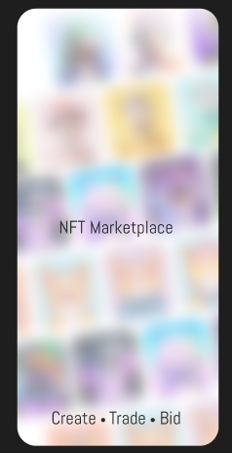

**Individual collections screen**

**Display of Information:** Vertical List - Infinite List

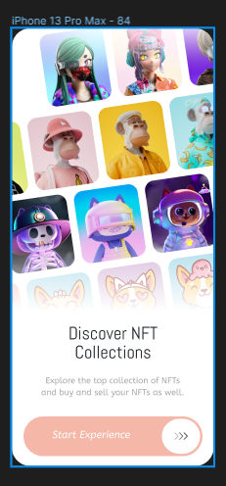

**Login Screen**

When enters into the app he/she needs to connect to a digital web3 wallet to make transactions and also to authenticate them.

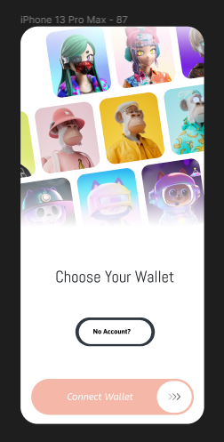User need to either connect his wallet if he already has or he can fill the form on the left side. Via this user can perform all operations via his digital wallets.

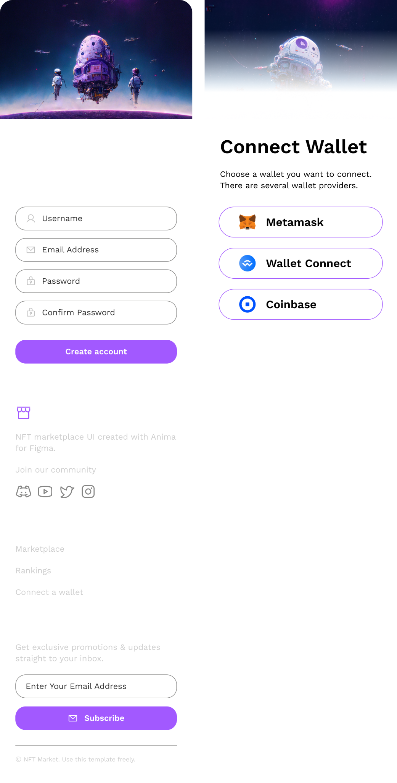

**List of various NFTs created by many users:**

Here user can find many NFTs and can chose any one either to buy it or trade between other NFT creators.

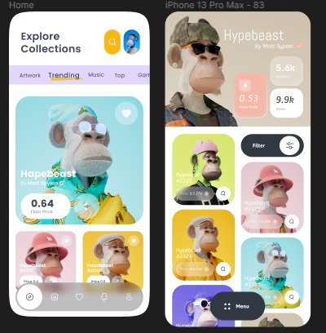

Titles

Fixed Menu

**NFT:**

**Stay of page principle: In-Page Overlay**

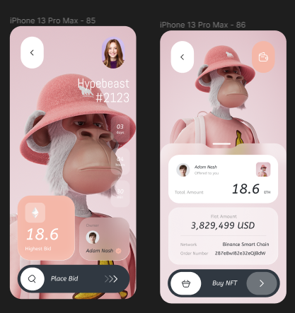

**Creating an NFT:**

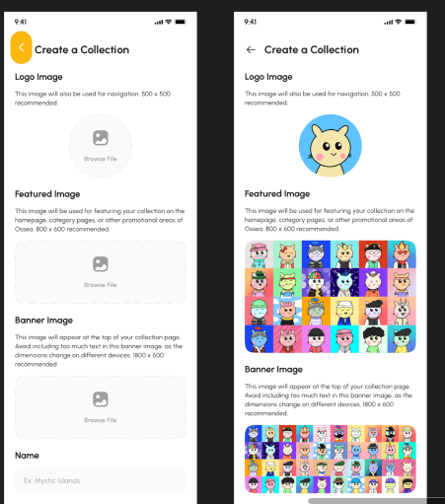

Preview of Drag & Drop

Drag and Drop

**In-Page Editing**

Here the user can change the details of his profile by clicking on the settings button located at the top right corner of the profile page, where we can see the “Change my details”. Here user can update the details and can also update his/her password

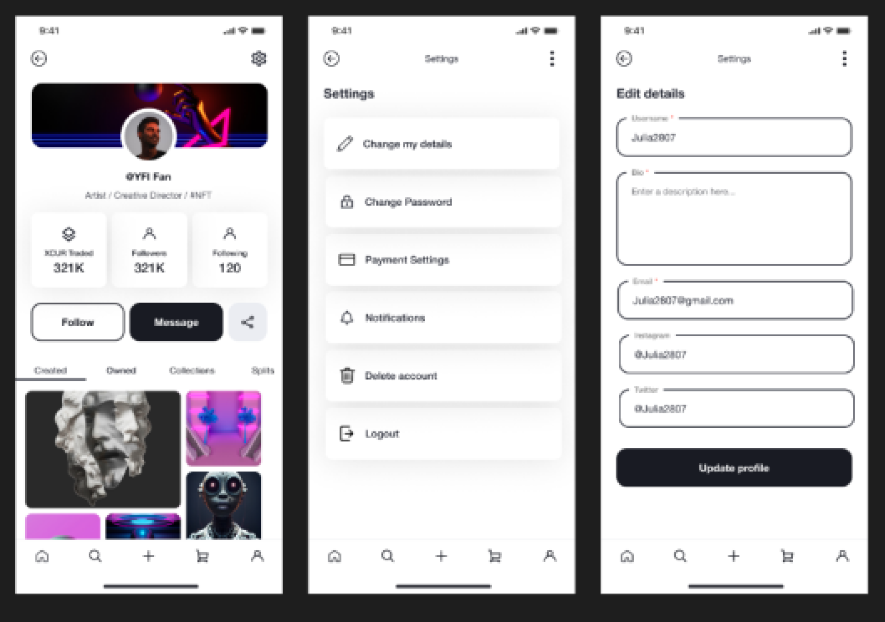

### Outcomes: CO1 CO2 CO3 CO4

**Conclusion: (Conclusion to be based on the objectives and outcomes achieved)  
Understood and successfully implemented all the UI design in NFT Marketplace Project**

**Grade: AA / AB / BB / BC / CC / CD /DD**

**Signature of faculty in-charge with date**

**References:**

1. Wilbert O. Galitz, “The Essential Guide to User Interface Design - An Introduction to GUI Design Principles and Techniques”, Wiley Computer Publishing, Second Edition, 2002
2. Steven Hoober, Eric Berkman, “Designing Mobile Interfaces: Patterns for Interaction Design”, O’rielly Media, First Edition, 2012
3. Tidwell, J. (2010). Designing interfaces: Patterns for effective interaction design. " O'Reilly Media, Inc.".