**Name:** Soham Bhoir

**Roll No.:** 16010420117

**Batch:** A4

TryHackMe: Google Dorking

Link: <https://tryhackme.com/room/googledorking>

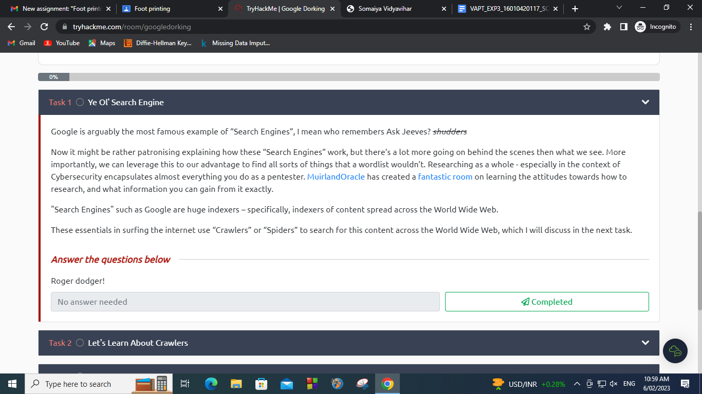

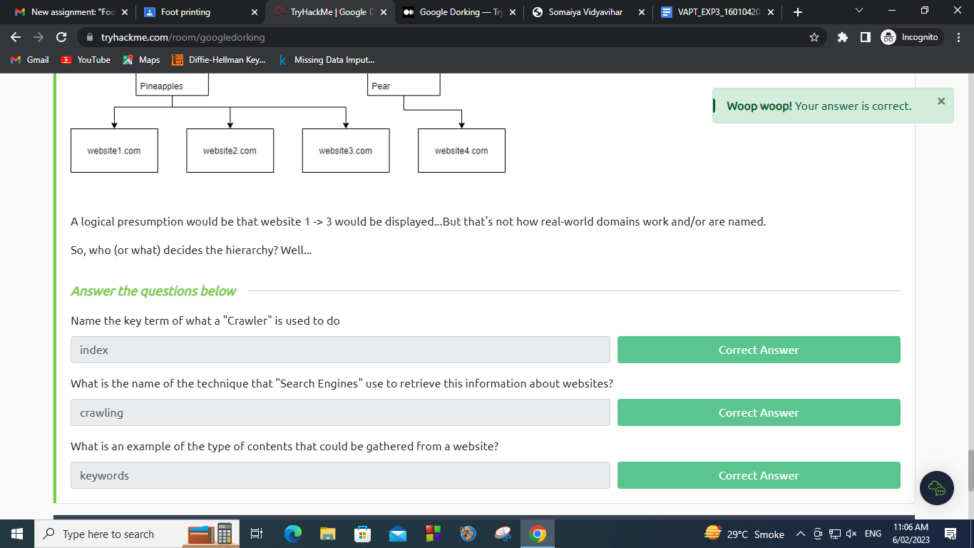

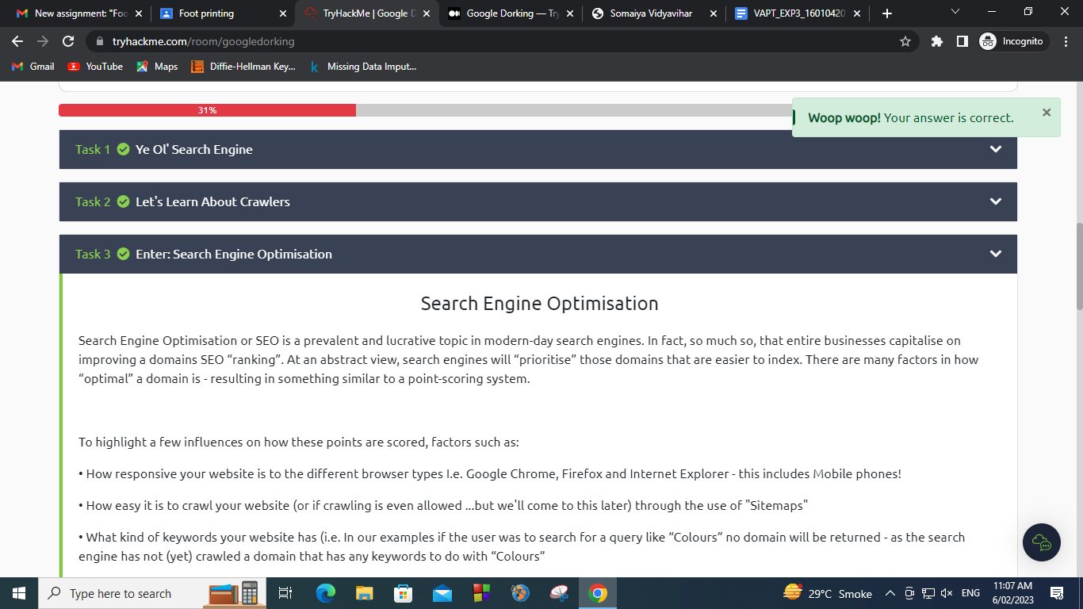

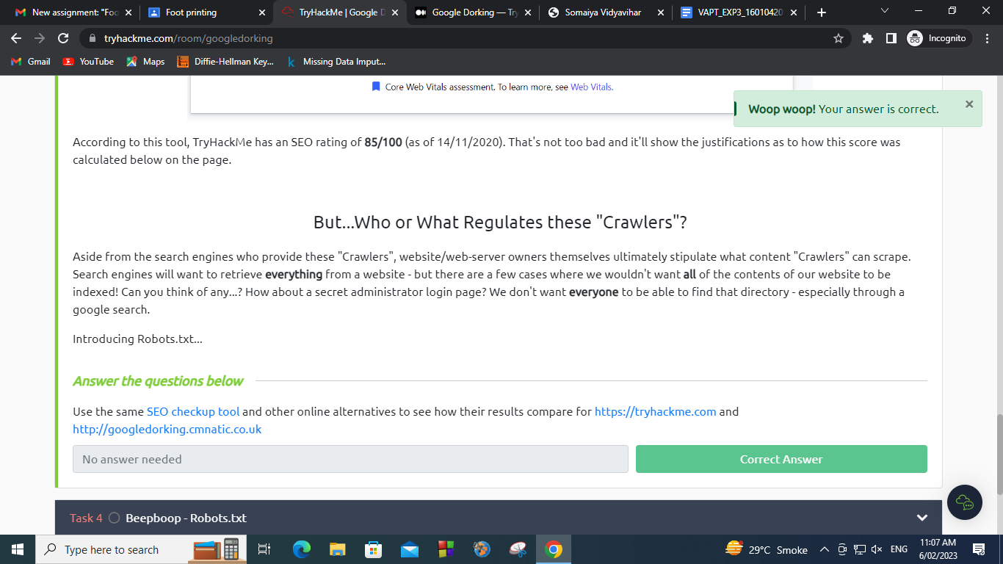

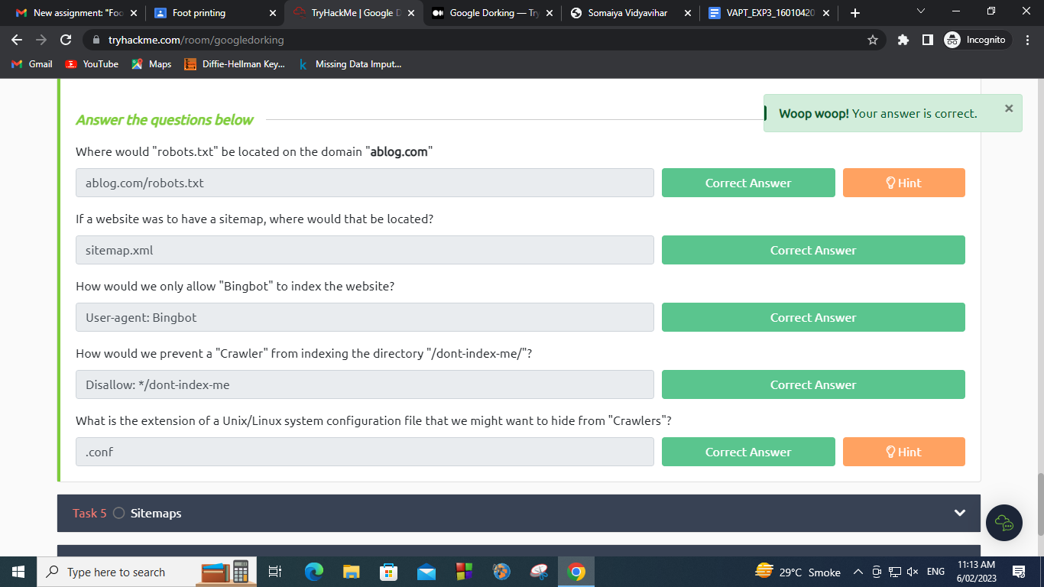

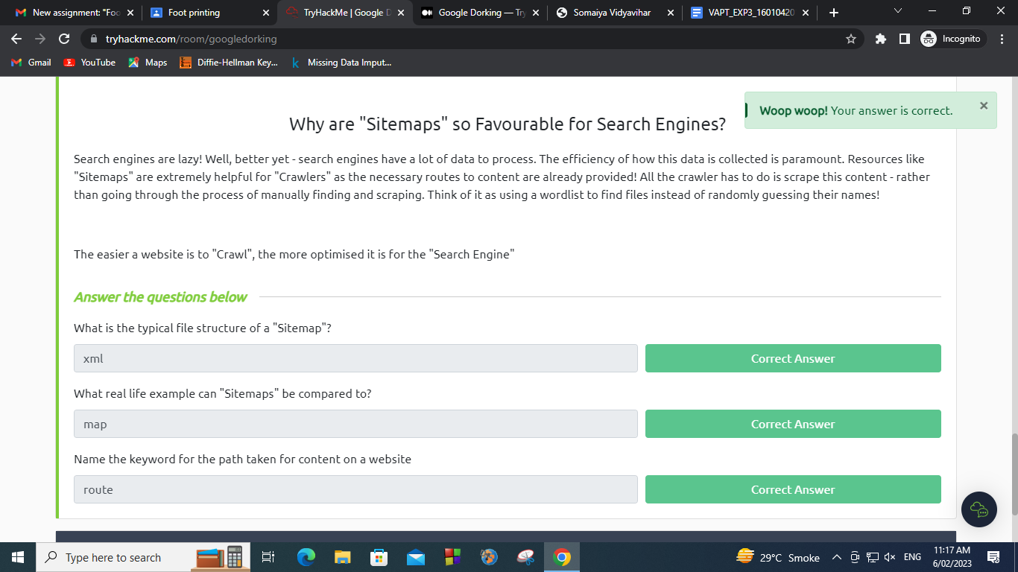

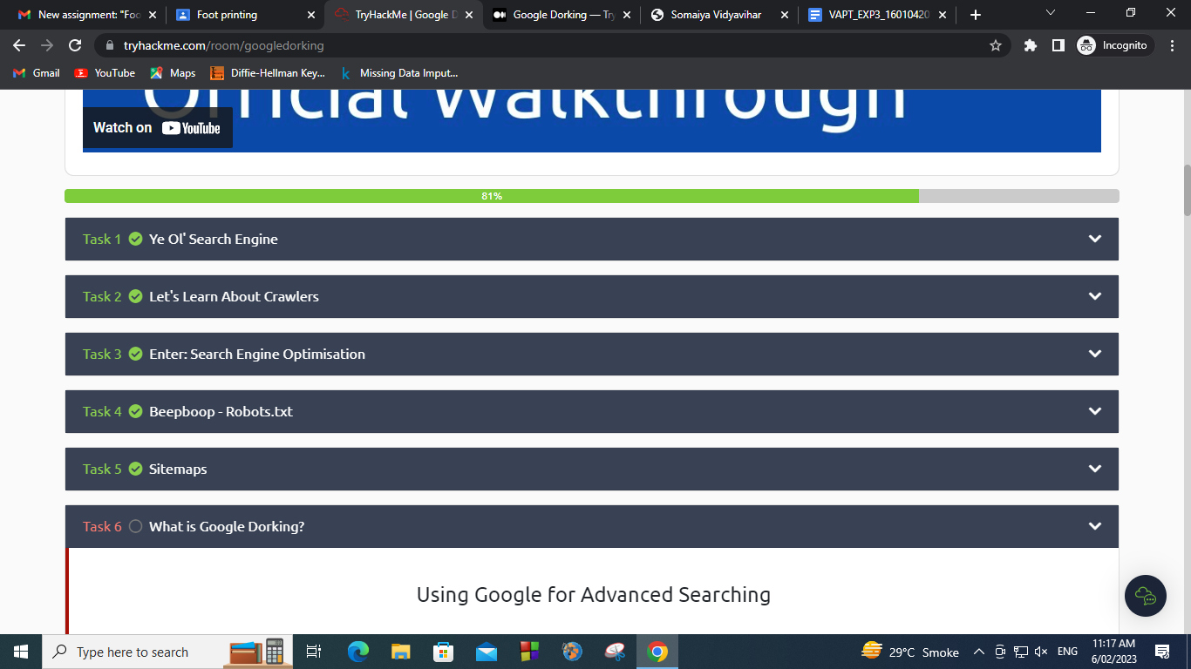

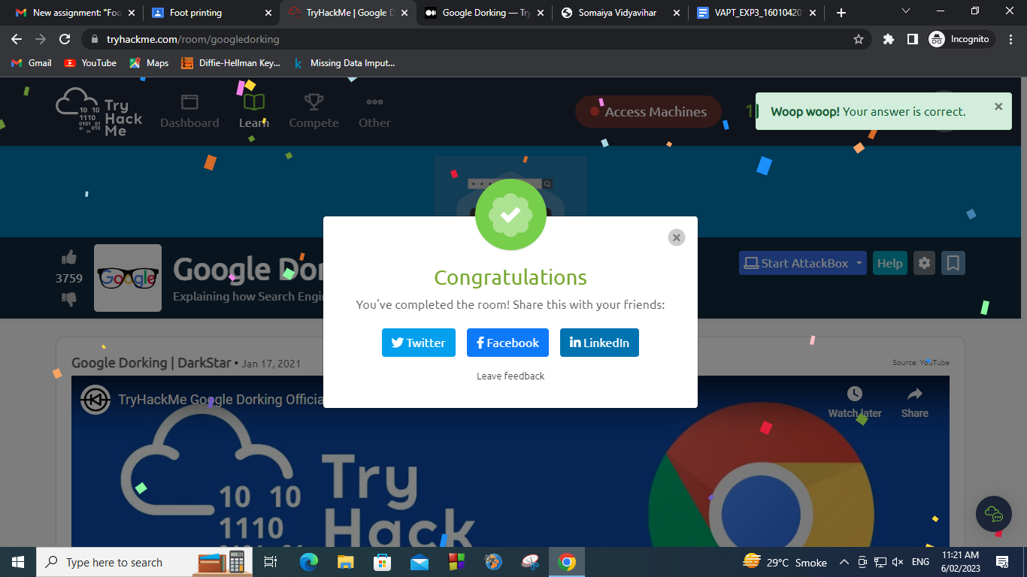

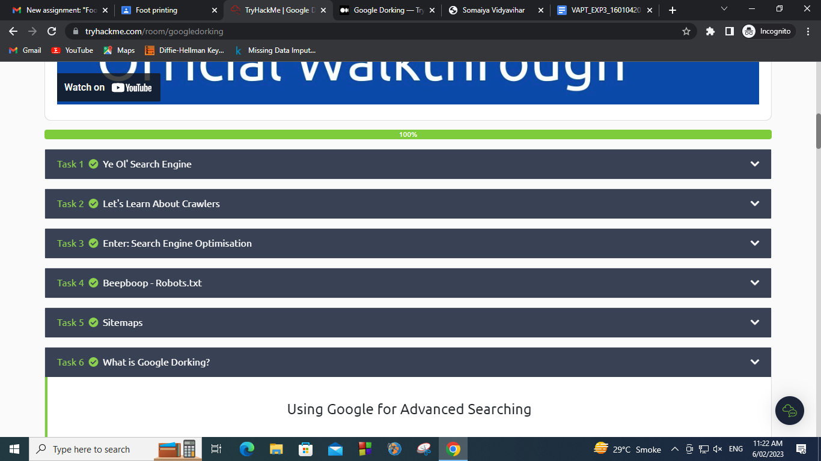

Google Hacking 101

Link: <https://drive.google.com/drive/folders/1lyuSTqt4tQGBT3NqwecGRY5orYcVPd9i>

1. Google Search Basics
2. snowblower Honda "Green Bay"

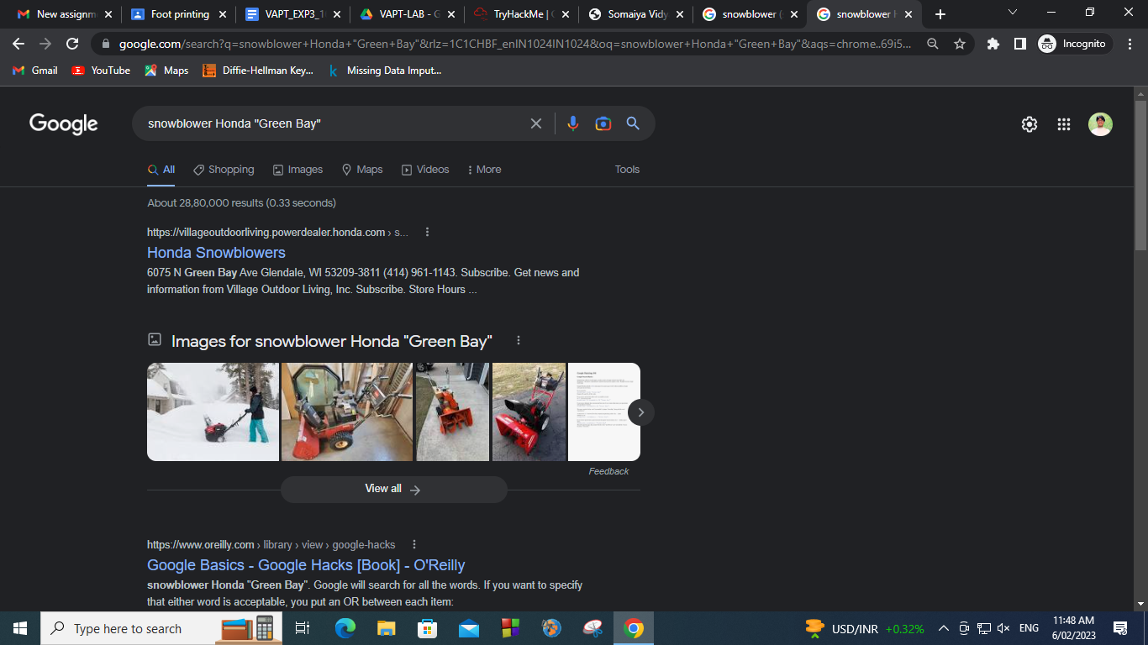

1. snowblower (snowmobile OR "Green Bay")

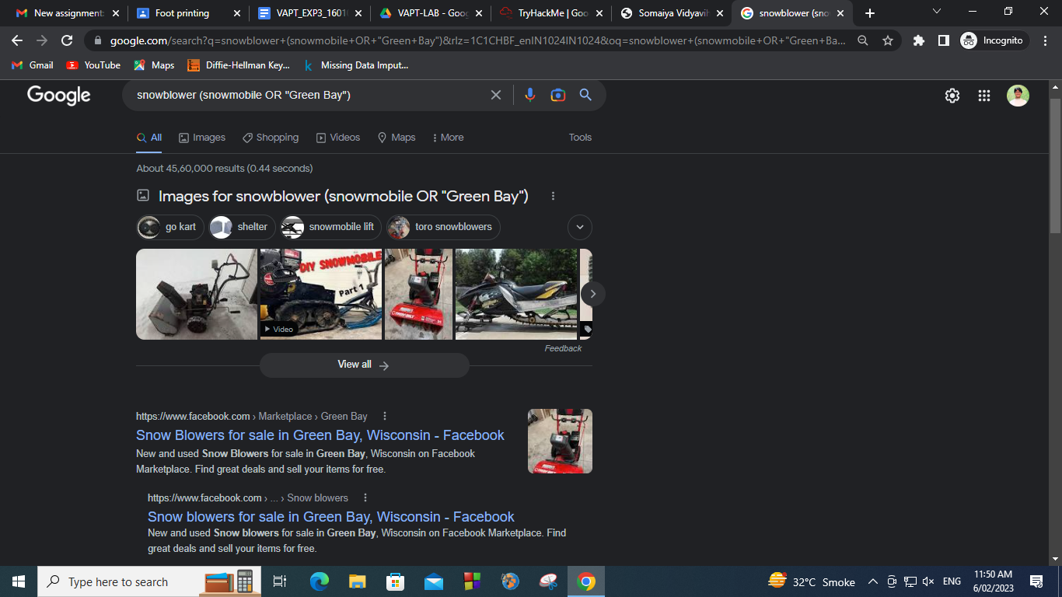

1. snowblower snowmobile -"Green Bay"

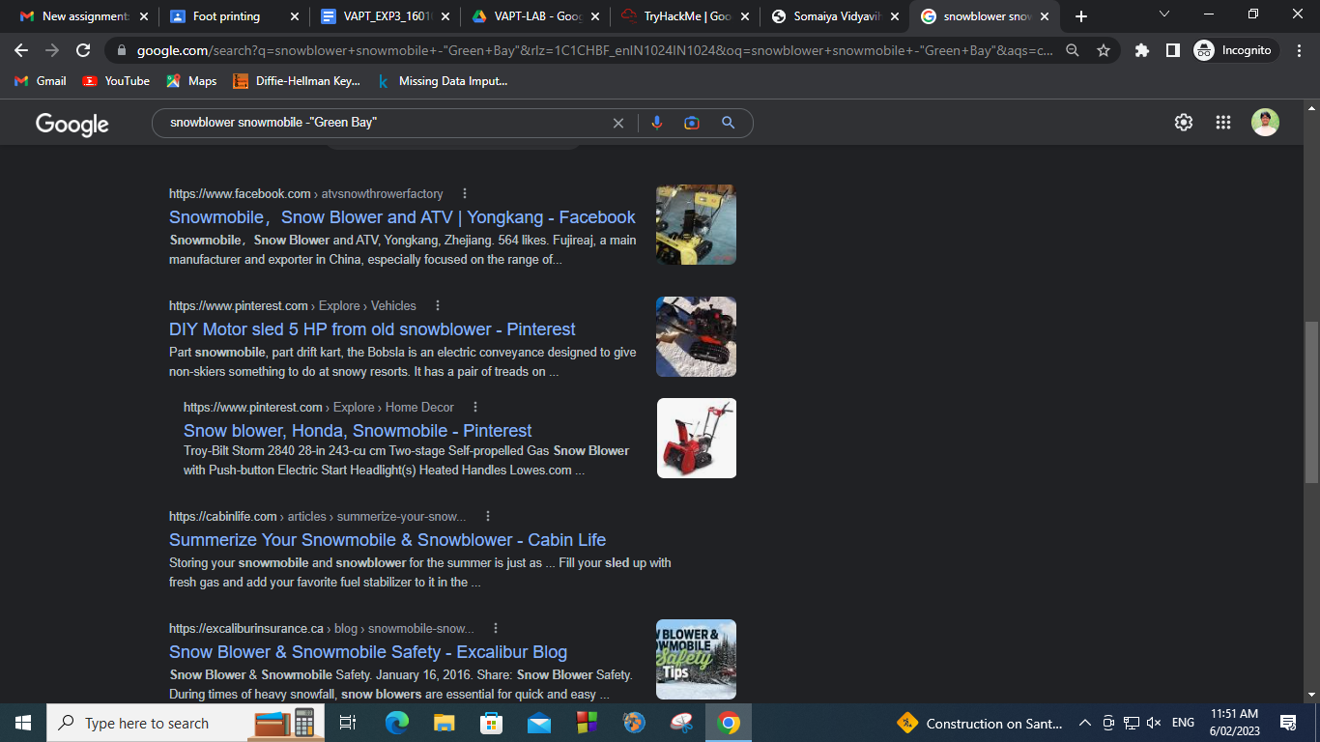

2. Google Syntax words

1. Intitle (eg)

intitle:"soham bhoir"

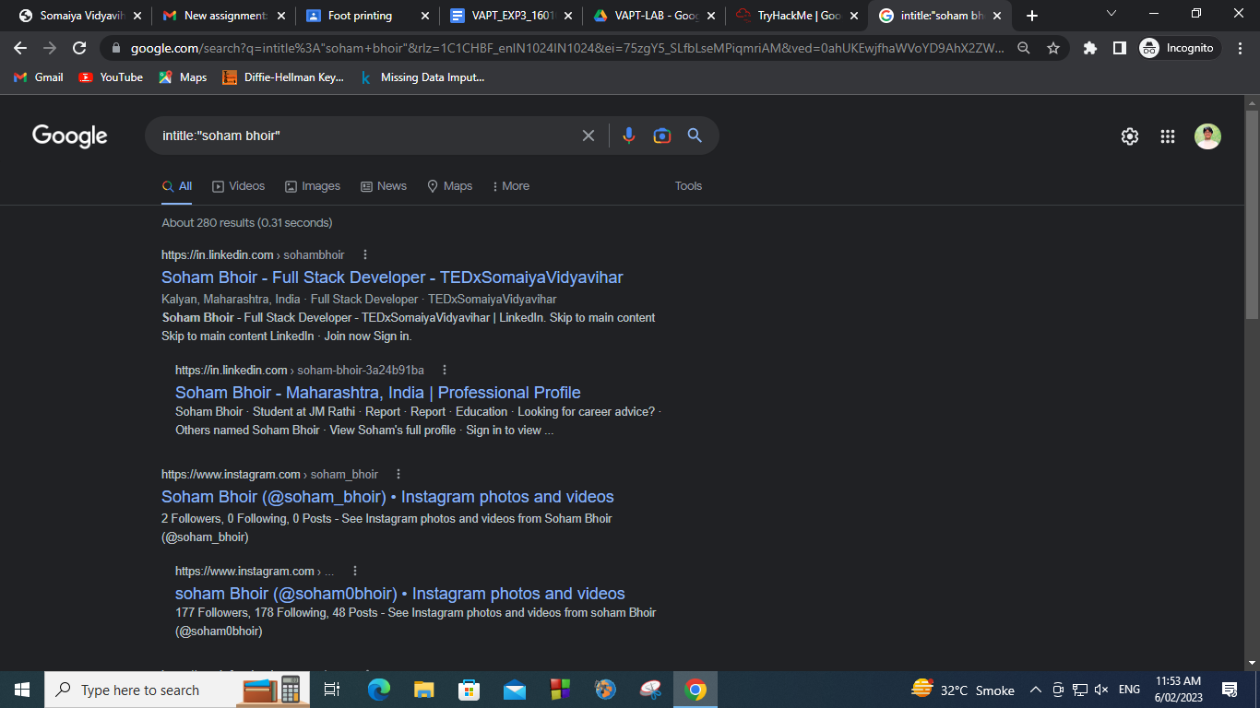

1. Inanchor (eg)

inanchor:"quantum teleportation space"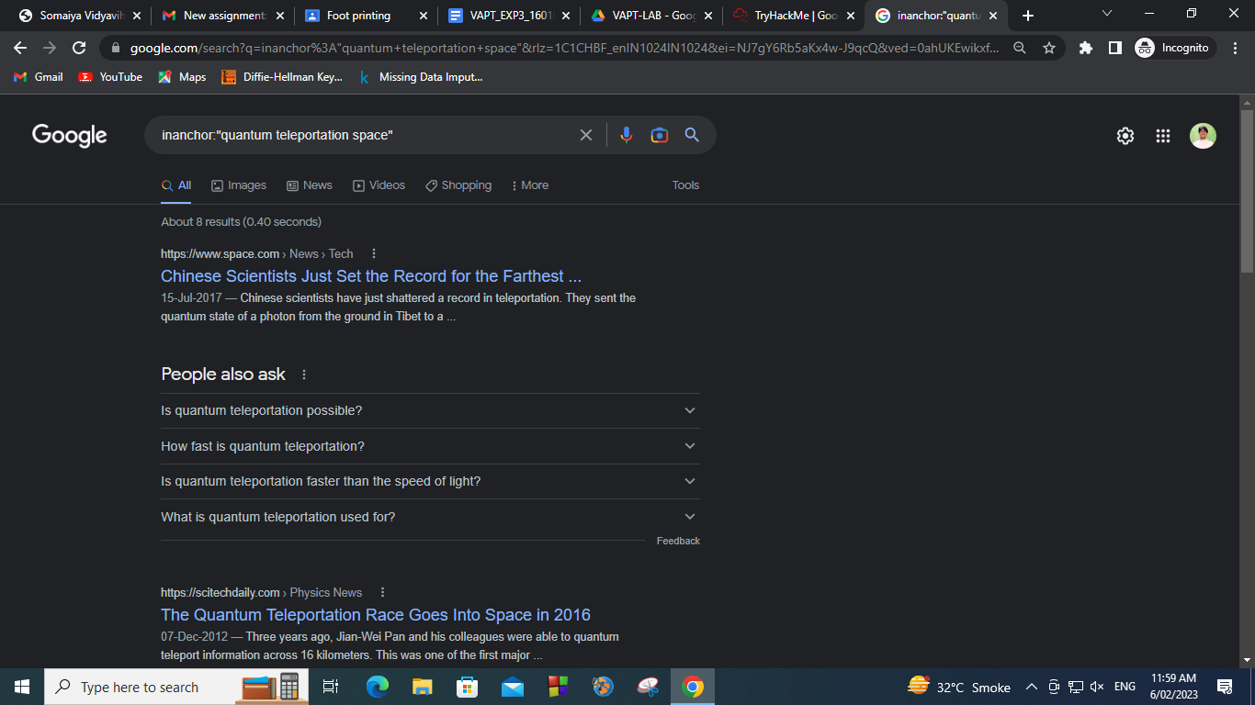

1. Link (eg)

link: soham-bhoir.vercel.app

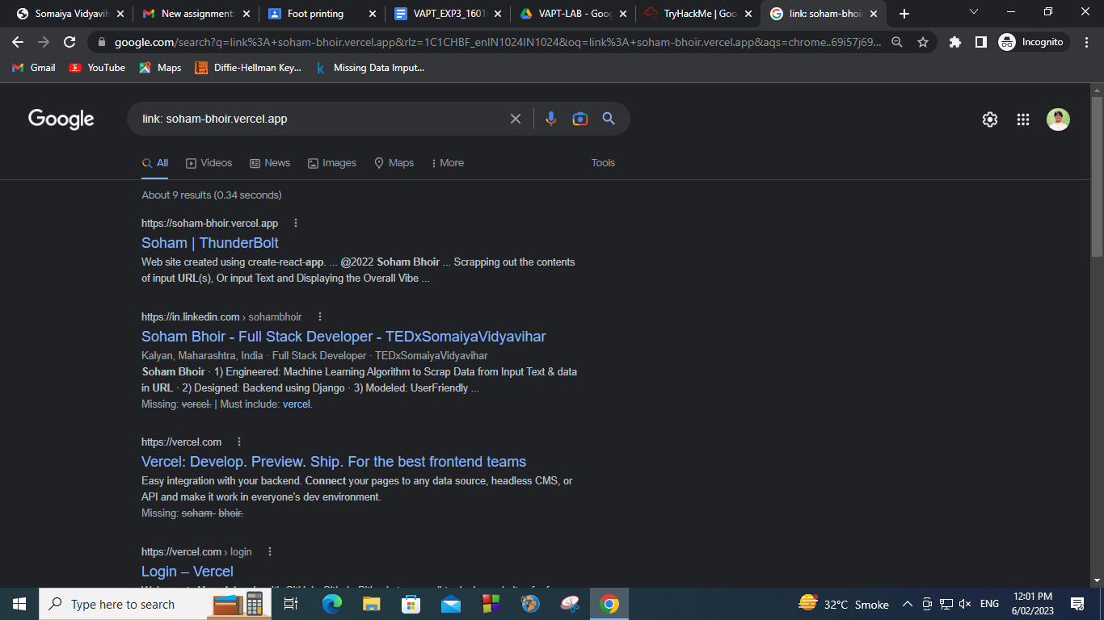

1. Daterange (eg)

"George Bush" daterange:2452389-2452389

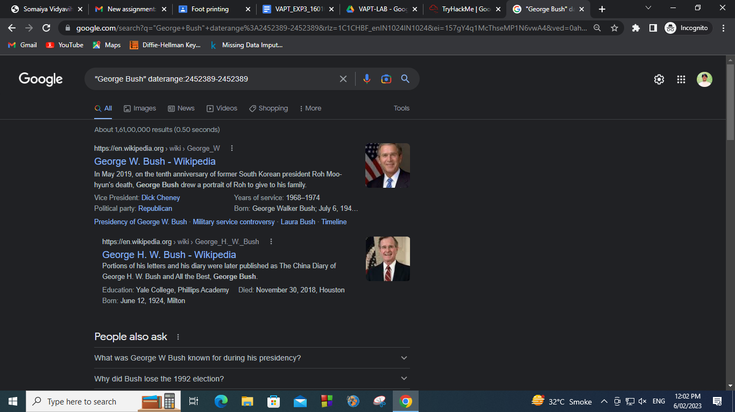

1. Filetype (eg)

quantum filetype:pdf

