**Name:** Siddhant mishra **Roll Number:** 16010420104 **Batch:** B1

**Date:** 30/11/2022

# Experiment 6: E-mail handling using PHP

**Command:**

*composer require phpmailer / phpmailer*

# Code:

**Index.php**

<!DOCTYPE html>

<html lang="en">

<head>

<meta charset="UTF-8">

<meta http-equiv="X-UA-Compatible" content="IE=edge">

<meta name="viewport" content="width=device-width, initial-scale=1.0">

<title>PHPMailer</title>

</head>

<body>

<form action="mail.php" method="POST">

<label for="password">Hi ! Enter your password : </label>

<input type="password" name="passwd"></input>

<hr>

<h2>Enter the deatils To send the mail:</h2>

<label for="mailto">Reciever's mail address : </label>

<input type="email" name="mailto"></input>

<br><br>

<label for="sub">Enter the Subject : </label>

<input type="text" name="sub"></input>

<br><br>

<label for="body">Enter the body text : </label><br>

<textarea name="body" id="body" cols="50" rows="10"></textarea>

<br><br>

<button type="submit">Submit</button>

</form>

</body>

</html>

<form action="mail.php" method="POST">

<label for="password">Hi ! Enter your password : </label>

<input type="password" name="passwd"></input>

<hr>

<h2>Enter the deatils To send the mail:</h2>

<label for="mailto">Reciever's mail address : </label>

<input type="email" name="mailto"></input>

<br><br>

<label for="sub">Enter the Subject : </label>

<input type="text" name="sub"></input>

<br><br>

<label for="body">Enter the body text : </label><br>

<textarea name="body" id="body" cols="50" rows="10"></textarea>

<br><br>

<button type="submit">Submit</button>

</form>

**Mail.php**

<?php

use PHPMailer\PHPMailer\PHPMailer; use PHPMailer\PHPMailer\Exception;

require 'vendor/autoload.php';

$mail = new PHPMailer(true);

$password = $_POST["passwd"];

$mailto = $_POST["mailto"];

$subject = $_POST["sub"];

$body = $_POST["body"];

try {

$mail->isSMTP();

$mail->Host = 'ssl://smtp.gmail.com';

$mail->SMTPAuth = true;

$mail->Username = 'siddhant.mishra@somaiya.edu';

$mail->Password = $password;

$mail->SMTPSecure = 'tls';

$mail->Port = 465;

$mail->setFrom('siddhant.mishra@somaiya.edu', $subject);

$mail->addAddress($mailto);

$mail->isHTML(true);

$mail->Subject = $subject;

$mail->Body = $body;

$mail->send();

echo "Mail has been sent successfully!";

} catch (Exception $e) {

echo "Message could not be sent. Mailer Error: {$mail->ErrorInfo}";

}

?>

# Screenshot:

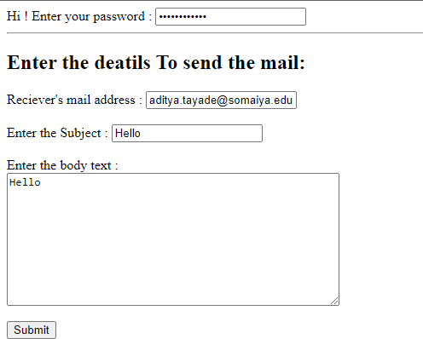

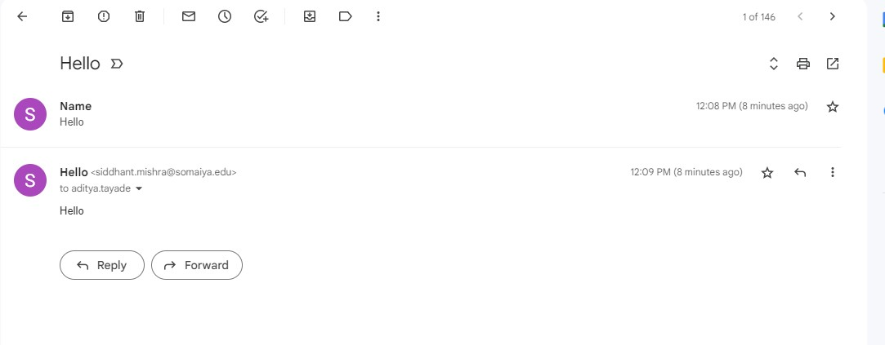

Questions:

Q1. What are the advantages of using PHPMailer over mail() function to send mail in PHP?

Ans:

First of all, PHPMailer provides an object-oriented interface, whereas mail() is not object oriented. PHP developers generally hate to create $headers strings while sending emails using the mail() function because they require a lot of escaping. PHPMailer makes this a breeze. Developers also need to

write dirty code (escaping characters, encoding and formatting) to send attachments and HTML based emails when using the mail() function,

whereas PHPMailer makes this painless.Also, the mail() function requires a local mail server to send out emails, which is not always trivial to set up.

PHPMailer can use a non-local mail server (SMTP) if you have authentication.Further advantages include:

* It can print various kinds of error messages in more than 40 languages when it fails to send an email.
* It has integrated SMTP protocol support and authentication over SSL and TLS.
* It can send an alternative plain-text version of email for non-HTML email clients.
* It has a very active developer community that keeps it secure and up to date.

Q2.How to use PHPMailer with Gmail? Ans:

The first step in using PHPMailer to send an HTML or plain text email is to mandate that PHPMailer utilize Composer.

Open the command prompt in the root directory of your project, then enter:

compose phpmailer / phpmailer

If the package is added successfully, the composer.json file should include the PHPMailer.

Go to Gmail, enable the less secure apps, disable two-factor authentication, and enter the aforementioned code. Your email will be sent successfully.