Experiment No. 2

Title: Problem definition, Persona and Usecases

Batch: B2 Roll No.: 16010420117 Experiment No.:2

Aim: To write problem definition, persona and usecase

--------------------------------------------------------------------------------------------

Resources needed: Web Resources

Theory:

Identifying personas and uses case is important step in design of user interface design.

Personas

Personas are complimentary to a scenario-based approach to requirements engineering. Specific names of the personas are used in the description of the scenario. Personas are defined by their needs and goals. These include their personal goals as well as their goals for the system. A goal-directed design project may, and probably will, have multiple personas because different kinds of users with different goals will use the system. The system may not be designed for all personas. However, each system will have at least one primary persona.

A primary persona is someone who must be satisfied with the system for it to be considered a success and who cannot be satisfied with an interaction designed for another persona. The user interaction designed for each primary persona should be based on the needs and goals of that persona.

Example of persona:

Following is example of persona for online song streaming application:

“Being a student, Chirag travels 2 hours daily, and his long commutes are usually very boring. Therefore, he looks for some form of entertainment like movies, songs and TV series. There’s a plethora of new content to consume and it’s not possible to download all the material out there, therefore using an online portal is the best way for Chirag. He is also interested in dance and music and therefore is always in search for new and different music. He owns a laptop and a cell phone. While travelling he uses his cellphone and can use the mobile app to listen songs. He uses his laptop for gaming and for his college studies. Thus, he can use the website too.”

Use case:

Use cases are a mechanism to help keep it simple and understandable for all stakeholders. Informally, they are stories of using a system to meet goals. Use cases often need to be more elaborate than this, but the essence is discovering and recording functional requirements by writing stories of using a system to help fulfill various stakeholder goals. A scenario is a specific sequence of actions and interactions between actors and the system under discussion; it is also called a use case instance. It is one particular story of using a system, or one path through the use case; for example, the scenario of successfully purchasing items with cash, or the scenario of failing to purchase items because of a credit card transaction denial.

Informally then, a use case is a collection of related success and failure scenarios that describe actors using a system to support a goal.

Use cases are requirements; primarily they are functional requirements that indicate what the system will do. Use cases are text documents, not diagrams, and use case modeling is primarily an act of writing, not drawing. However, the UML defines a use case diagram to illustrate the names of use cases and actors, and their relationships.

___________________________________________________________________________

Procedure:

Write problem definition, personas (minimum two), use cases (minimum five)
_____________________________________________________________________________________

Result:

Problem Statement:

A non-fungible token is a record on a blockchain which is associated with a particular digital or physical asset. The ownership of an NFT is recorded in the blockchain, and can be transferred by the owner, allowing NFTs to be sold and traded. A non-fungible token (NFT) marketplace to counterfeit and leverage the digital arts of an digital artist. A Mobile App to manage the selling, adding, creating, bidding, borrowing, lending a NFT can be developed.

A non-fungible token is a record on a blockchain which is associated with a particular digital or physical asset. The ownership of an NFT is recorded in the blockchain, and can be transferred by the owner, allowing NFTs to be sold and traded.

User Personas:

User: A millennial

Name: Talan George

Gender: Male

Age: 32

Talan George is a user of NFT. Talan is a 32-year-old male. He is an artist by profession.Talana George is a thriving designer with multiple years of experience working for prominent international companies. He has an online exhibition of art objects. He is currently learning modern technologies in art and NFT technologies. He wants to utilize the NFT marketplace to sell his art.

User: College Student

Name: Kaiya Kenter

Gender: Female

Age: 20
- Kaiya Kenter is a user of NFT. Kaiya is a 20-year-old female. She is a content creator by profession. Kaiya is currently a student at the University of the Arts London. She illustrates books and comics for a living. Kaiya uses the NFT marketplace for inspiration and ideas. She has a passion for pixel art and intends to use the NFT platform to increase her earnings.

User: A business milenneal

Name: Terry Workman

Gender: Male

Age: 44
- Terry Workman is a user of NFT. Terry is a 44-year-old male. He is a businessman by profession. Terry was formerly a financial analyst. Through the help of research and analysis, he has successfully built a cryptocurrency exchange business. Although the area of creativity is a new concept to Terry, he is currently in the process of learning. He intends to use the NFT platform as a channel to grow his business.

User: The Fanatics

Name: Kruzma Antheroz

Gender: Male

Age: 21
- The main objective of Fanatics is to collect the rariables. Since NFTs are authentic and rare, they are considered as luxurious and exclusive goods. Fanatics are often driven by the psychological desire to attain these digital assets which further generates a feeling of privilege and social flex. From buying virtual ticket stubs for movies and sport games, owning digital collectibles to winning a rare moment from live events, the majority of Fanatics are excited about the unique experiences offered by NFTs marketplaces.
- They can exchange, buy or bid for an NFT.

User: The Buyers

Name: Rintron Glade

Gender: Male

Age: 20
- The main objective of Buyer is to collect the any type of NFTs. They can exchange, buy or bid for an NFT. There main focus is to keep the flow of NFTs on in the market going on.
Use Case Diagram (UML):
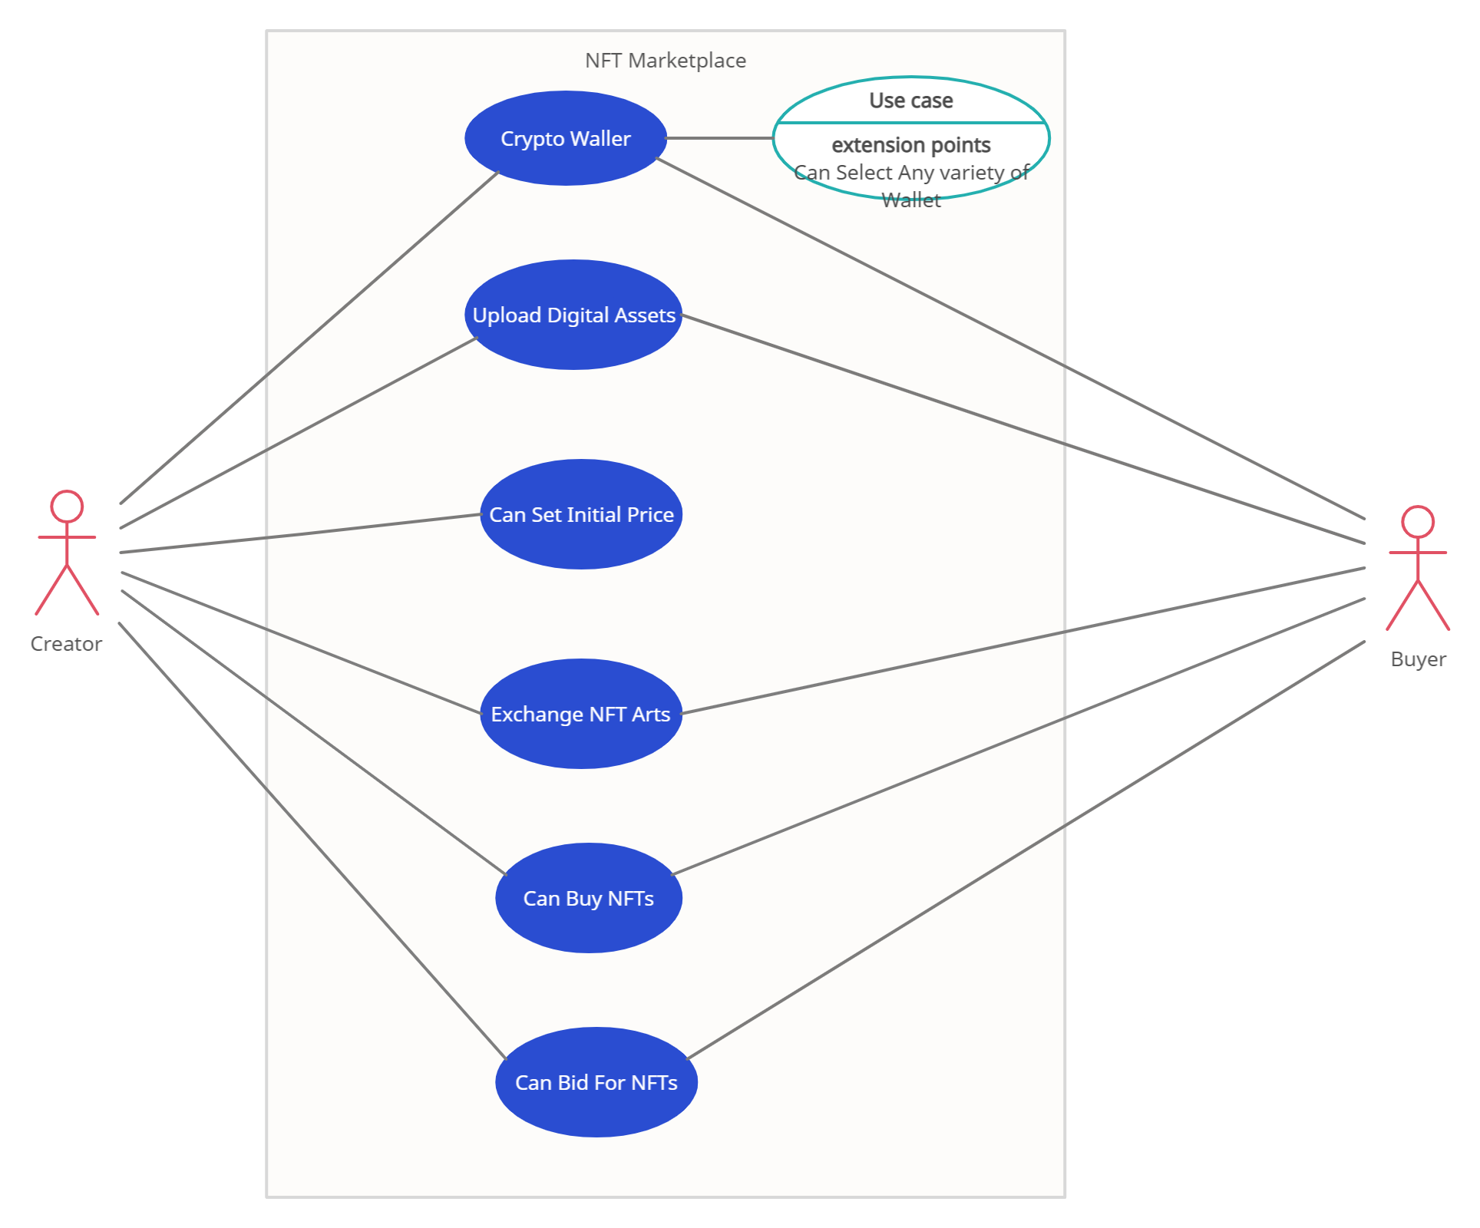

Outcomes: CO1: Comprehend role of user and designer in User Interface Design

Conclusion: (Conclusion to be based on the objectives and outcomes achieved)
Formally defined an application concept using appropriate problem statement, user personas and use case diagrams.

Grade: AA / AB / BB / BC / CC / CD /DD

Signature of faculty in-charge with date

References:

- Wilbert O. Galitz, “The Essential Guide to User Interface Design - An Introduction to GUI Design Principles and Techniques”, Wiley Computer Publishing, Second Edition, 2002
- Bill Scott, Theresa Neil, “Designing Web Interfaces Principles & Patterns for Rich Interaction”, O’rielly Media, First Edition, 2009
- Randolph, Gary. "Use-cases and personas: a case study in light-weight user interaction design for small development projects." Informing Science: International Journal of an Emerging Transdiscipline 7 (2004): 105-116.
- Stein, Ben. "6 Use-Case Model: Writing Requirements In Context."

