

**Batch: B2 RollNo.: 16010420117 ExperimentNo.:1**

**Aim:** To study case study on User Interface (UI) Design

**Resources needed:**Web Resources

**--------------------------------------------------------------------------------------------**

### Theory:

User interface (UI) defines interactions of user with information system. The user interface is the part of a computer and its software that people can see, hear,touch, talk to, or otherwise understand or direct.

The user interface has essentially twocomponents: input and output.

Input is how a person communicates his or her needsor desires to the computer. Some common input components are the keyboard, mouse,trackball, one’s finger (for touch-sensitive screens), and one’s voice (for spoken instructions).

Output is how the computer conveys the results of its computations and requirements to the user. Today, the most common computer output mechanism is thedisplay screen, followed by mechanisms that take advantage of a person’s auditory capabilities: voice and sound. The use of the human senses of smell and touch output ininterface design still remain largely unexplored.



Proper interface design will provide a mix of well-designed input and output mechanisms that satisfy the user’s needs, capabilities, and limitations in the most effective way possible. The best interface is one that it not noticed, one that permits the user to focus on the information and task at hand, not the mechanisms used to present the information and perform the task.

**--------------------------------------------------------------------------------------------**

### Results: (Screenshots of hosting steps and web pages)

1. Discuss one UI selected for best, average and poor experience and elaborate on strengths and weakness of same.

# Best UI

## Website: AirBnB

**Link:** [**https://www.airbnb.co.in/**](https://www.airbnb.co.in/)

## Website type: Accommodation letting website

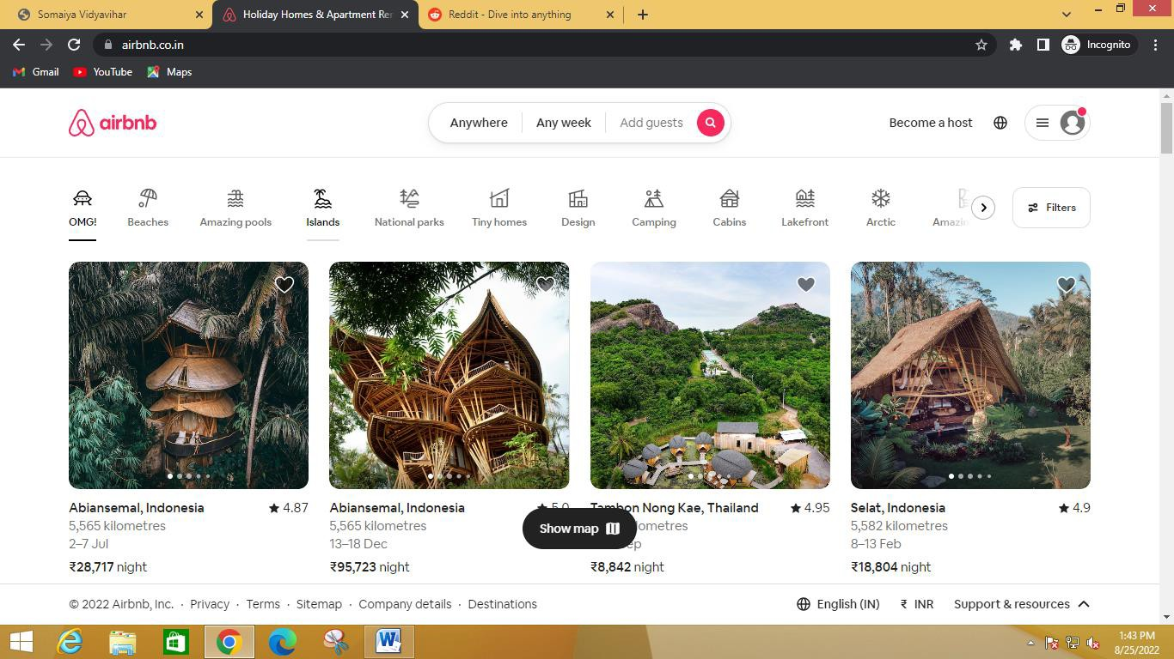

**Landing Page**



* + Airbnb (ABNB) is an online marketplace that connects people who want to rent out their homes with people who are looking for accommodations in specific locales. The website (Airbnb) serves its purpose and has a soothing UI, the presentation is clear.

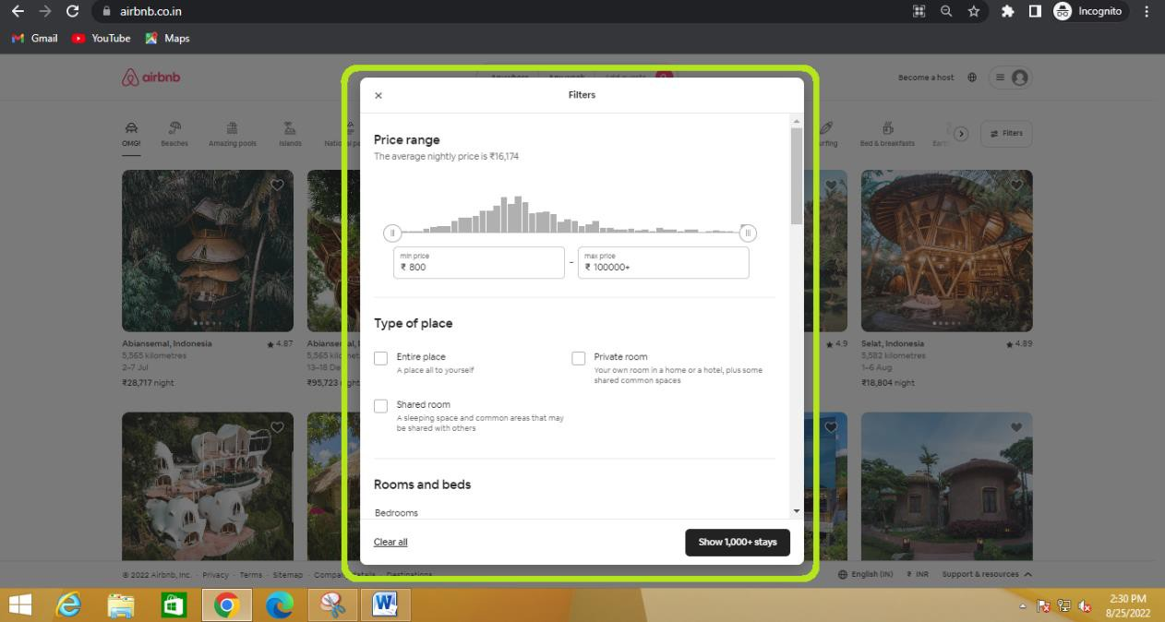

**Easy to filter our choices**

* + There are plenty of ways to sort and filter the types of houses we are looking for. The website gives easy switching between the types of home.

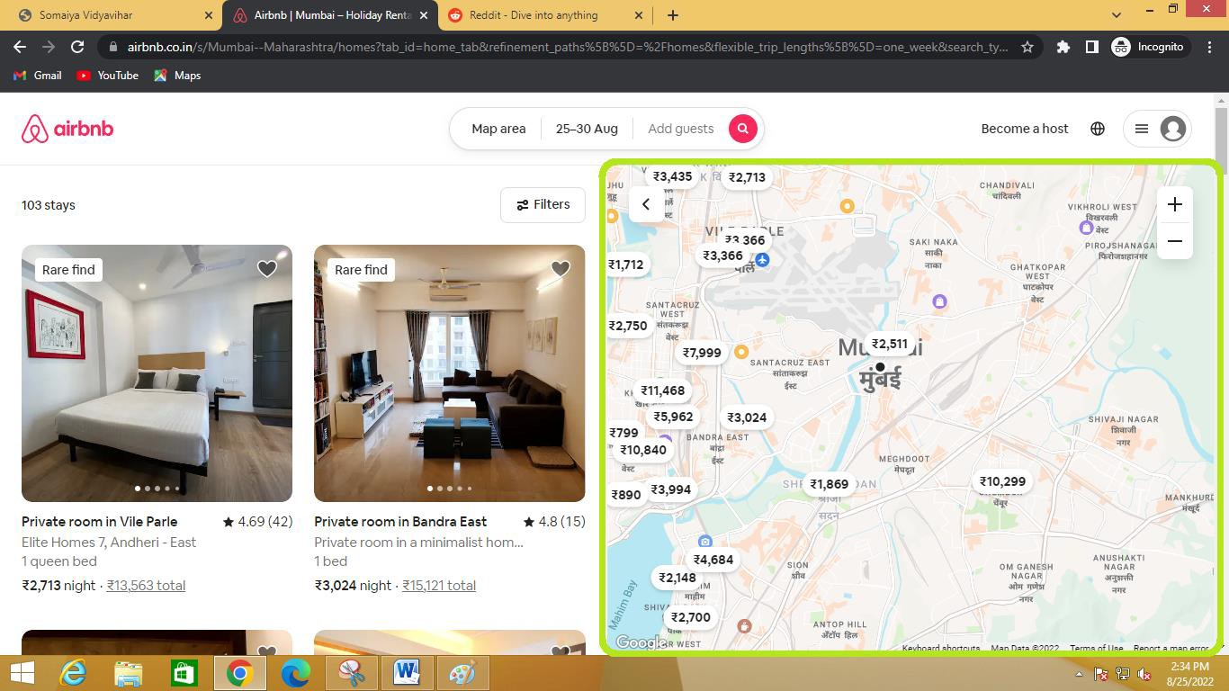

**Explore Nearby**



* + Also, there’s a show map feature (as shown above) via which we can browse through the map, and it includes price of the map in the locality but apart from that, famous tourist places, shopping malls, cinemas, worship places are highlighted to choose the best place to accommodate according to preference.

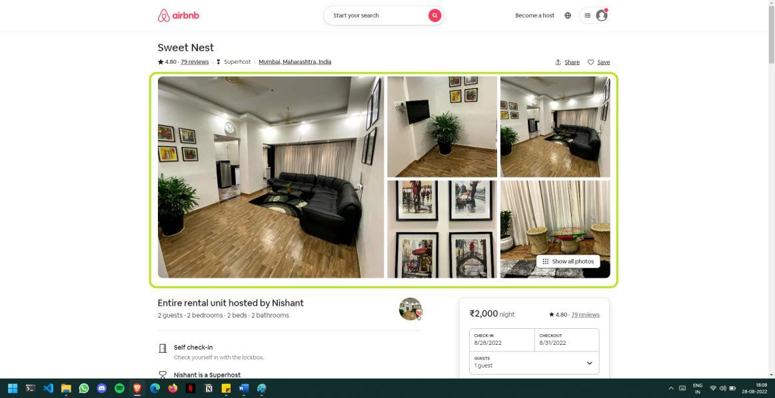

**Multiple Images**

* + AirBnb uses plenty of images to give an accurate idea of the place.

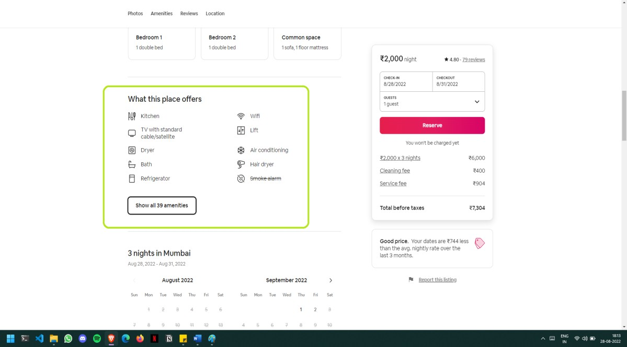

**Expressive logos**



* + Website uses features like symbols and bold highlighting to help users notice the useful information. Also, apart from just mentioning what is included, it also highlights what is not included.

*Overall, the UI of the website is interesting and responsive.*

# Average UI

## Website: Reddit

**Link: https**[**://ww**](http://www.reddit.com/)**w**[**.reddit.co**](http://www.reddit.com/)**m/**

## Website type: Accommodation letting website

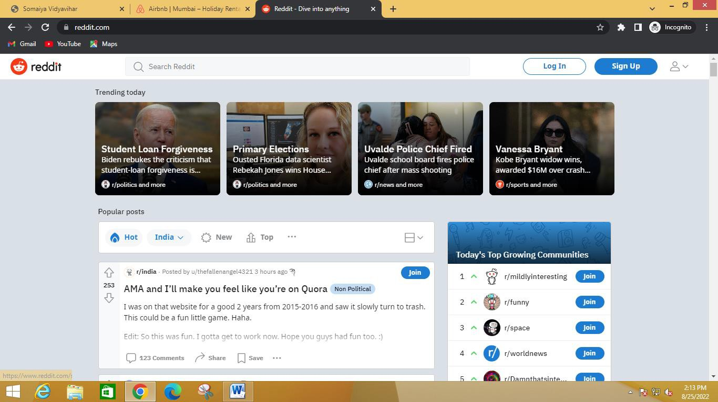

**Landing Page**



* + Reddit is an American [social news](https://en.wikipedia.org/wiki/Social_news) [aggregation](https://en.wikipedia.org/wiki/News_aggregator), [content](https://en.wikipedia.org/wiki/Review_site" \l "Rating_site) rating, and [discussion website](https://en.wikipedia.org/wiki/Internet_forum). Reddit’s

UI is not so beginner friendly, and a beginner might find himself lost.

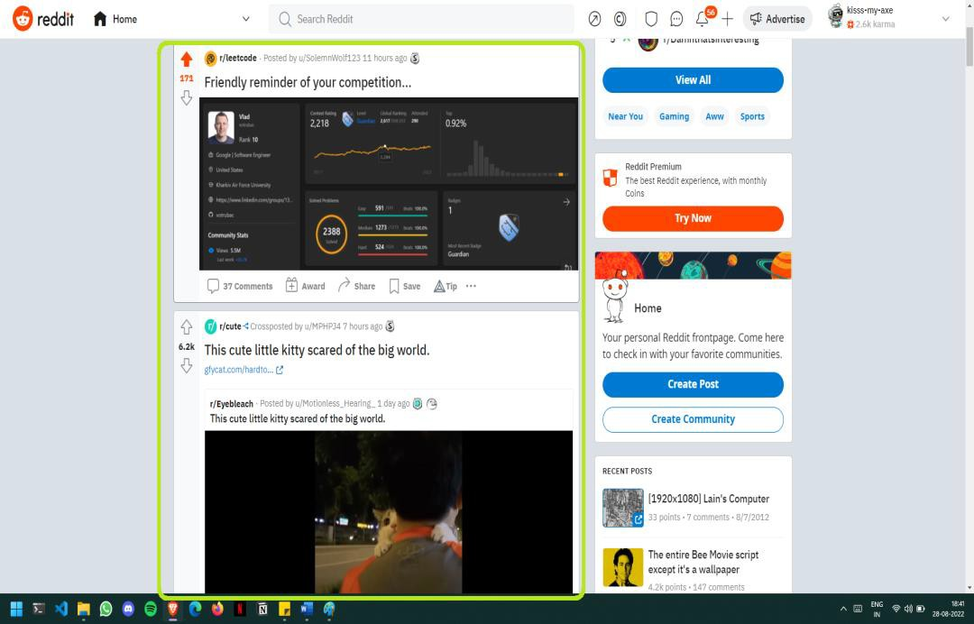

**Nice spacing**

* + - Reddit dedicates a lot of space for the content. This is important on a site like Reddit that's driven entirely by user-created content.



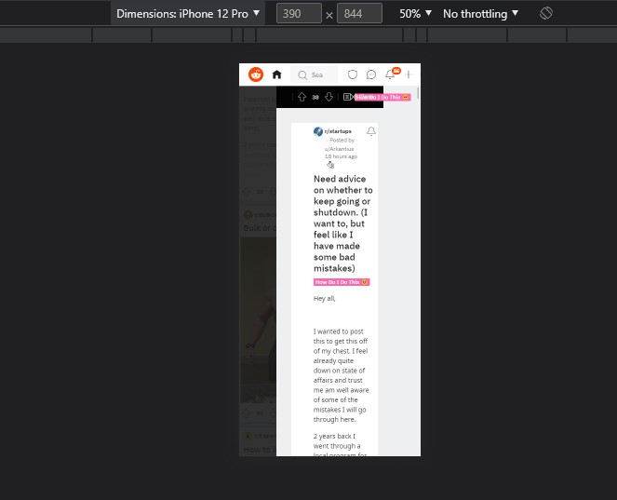

**Not Responsive**

**Easy Readability of comments**

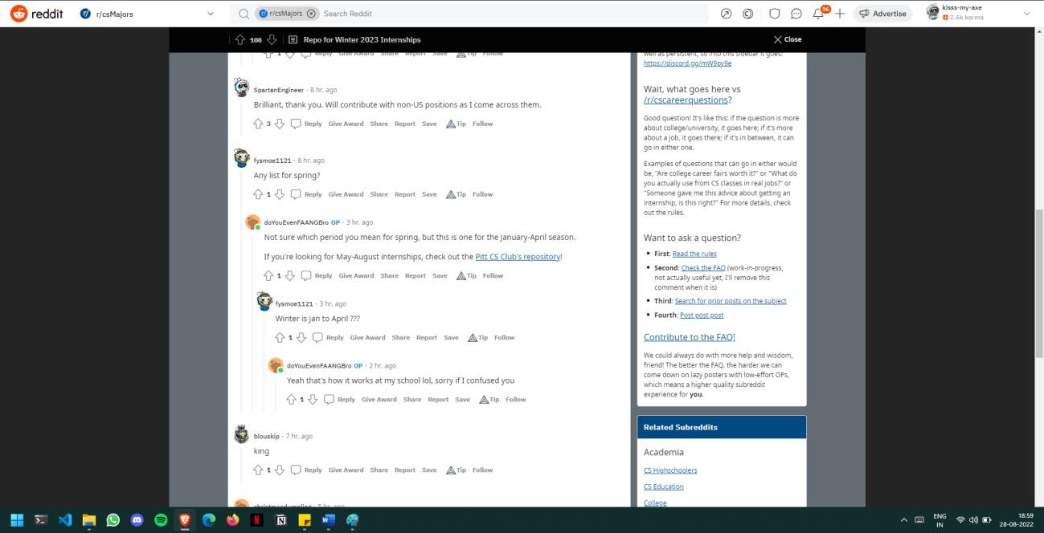

* + - The comment section is "conversation threading" which allows for any person to read the replies on the thread easily

*Even though design wise the UI isn't much good. But this is the best UI considering that Reddit is content driven as this UI helps people read easily.*

# Poor UI

## Website: Hacker News

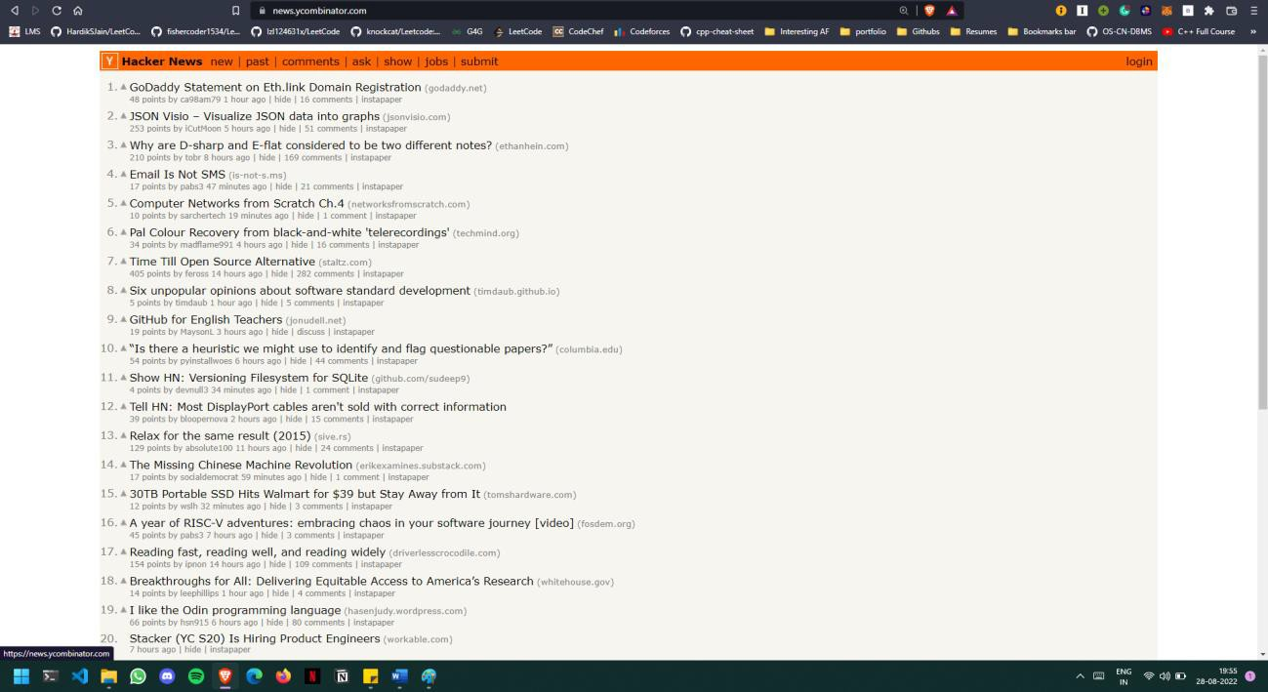**Link: https: https://news.ycombinator.com/ Website type: Social News Website**

**Landing Page**

* + Hacker News is the go-to source for tech coverage and breaking news related to cybersecurity. Although it's a widely read publication, it has some readability issues.
  + The UI of the website is very basic and not at all engaging.

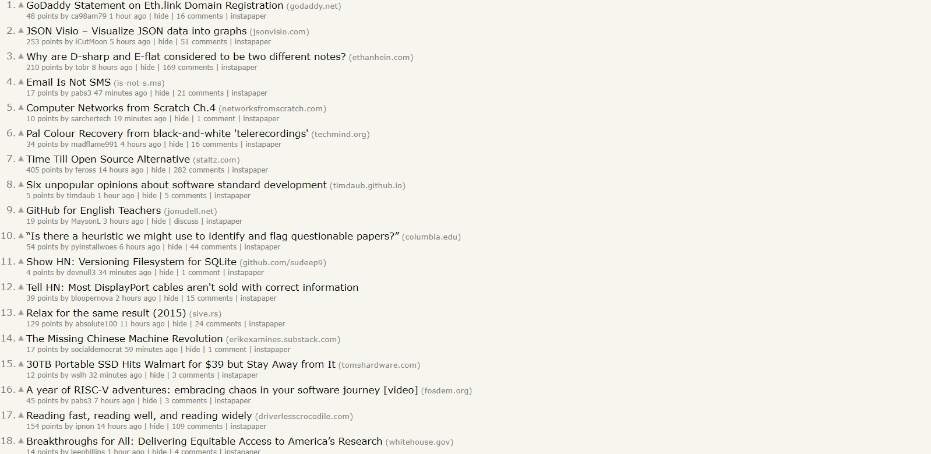

* + The website could have utilized the empty space smartly. The website provides many features such as upvote, sort by website, view submitter’s profile, sort by time of the post which is posted or go to the source. But poor UI and lack of white space makes it really difficult to explore all these features.



* + Also hovering effects would make a great impact on the UI. Right now, it is hard to distinguish which is plain text and which is hyperlink.

*Some changes in typography, color, placement, and whitespace would vastly improve the readability and scannability of this site.*

### Questions:

1. List down the characteristics of good screen design.

### Ans:

1. **Simplicity :**
   * User Interface design should be simple.
   * Less number of mouse clicks and keystrokes are required to accomplish this task.
   * It is important that new features only add if there is compelling need for them and they add significant values to the application.

### Consistency :

* + The user interface should have a more consistency.
  + Consistency also prevents online designers information chaos, ambiguity and instability.
  + We should apply typeface, style and size convention in a consistent manner to all screen components that will add screen learning and improve screen readability. In this we can provide permanent objects as unchanging reference points around which the user can navigate.

### Intuitiveness :

* + The most important quality of good user interface design is intuitive.
  + Intuitive user interface design is one that is easy to learn so that user can pick it up quickly and easily.
  + Icons and labels should be concise and cogent. A clear unambiguous icon can help to make user interface intuitive and a good practice is make labels conform to the terminology that the application supports.



### Outcomes:

CO : Comprehend role of user and designer in User Interface design

### Conclusion: (Conclusion to be based on the objectives and outcomesachieved)

Hence we gained the ability to distinguish and notice all the features of UI.

### Grade: AA / AB / BB / BC / CC / CD/DD

**Signature of faculty in-charge withdate Reference:**

1. Wilbert O. Galitz, The Essential Guide toUser Interface Design - An Introduction to GUI DesignPrinciples and Techniques, Wiley Computer Publishing, Second Edition, 2002