How to create levels
To edit levels use the Tiled map editor (http://www.mapeditor.org/). This manual doesn't cover basic use and functions of Tiled, so it is assumed, that you are already familiar with this map editor.

Start with the empty level
The empty level empty_level.tmx can be used as a starting point. It contains already all needed sprite sheets with correct tile properties for game objects.
- Foremost erase elements and resize the map.
- Add decoration layers. Theoretically you can use any amount of them, but as more layers and elements you place the slower game will run. Decoration layer can be named as you like and placed on top or bottom of walls layer, depending where you want it to appear: behind or on top of characters.
- When adding portals edit the position where player character is teleported. Position is given in tiles.
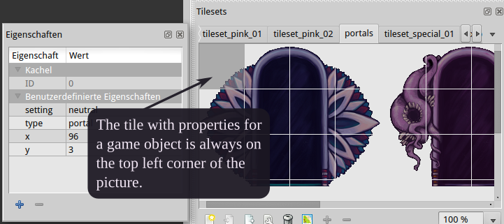

Notes:
- Place platforms inside walls layer on level borders so the player can not fall out of level.
- Place tiles with which player will never collide on a decoration layer underneath the walls layer. This way this tiles will not be included for collision checks.
- Player can not see further than 6 tiles on given resolution 800x600 pixels. Consider this and omit placing tiles which will never be seen in game.
- Consider that a tile with properties for a game object is always on the top left corner of the picture. It is recommended to place game objects as whole picture from the sprite sheet and erase them as the whole picture to ensure that it appears correctly in game.
- Game objects are rendered on top of walls layer but the layer characters is always placed on the very top of the layer stack and is set invisible.
- Don't forget to place the players character exactly once inside a level.
- Known bug: Whole level size in pixes should be larger than 800x600 otherwise parallax layer will not be drawn

Additional and advanced information

must have layers
Layer named characters on top of level stack and set invisible that contains characters portals collectibles.
Layer named walls contains tiles which characters can not surpass.

properties player
Name of the property | Value | Description
type | player | Mark the game object as player character.
max_hp | Number | Hitpoints.
max_x_vel | Number | Maximum run speed in pixels per frame.
max_y_vel | Number | Jump speed. How high the character can jump in pixels per frame.
att_1_damage | Number | Damage.
att_1_stun | Number | Duration of stun in frames.
att_1_cooldown | Number | Time till new projectiles can be spawned again.
att_1_projectile_amount | Number | Amount of spawned projectiles.
att_1_projectile_lifetime | Number | Lifetime in frames. Speed and lifetime result range of attack.
att_1_spread_angle | Number | Degrees between projectiles.
att_1_projectile_speed | Number | Speed in pixels per frame. Speed and lifetime result range of attack.
att_1_pierce | Number | Attack is piercing when value is set to 1.

properties enemies
Name of the property | Value | Description
type | enemy | Mark the game object as an enemy.
max_hp | Number | Hitpoints.
max_x_vel | Number | Maximum run speed in pixels per frame.
max_y_vel | Number | Jump speed, how high the character can jump in pixels per frame.
no_gravity | Number | If this is set to 1, than character is not affected by gravity.
att_1_damage | Number | Damage.
att_1_stun | Number | Duration of stun in frames.
att_1_cooldown | Number | Time till new projectiles can be spawned again.
att_1_projectile_amount | Number | Amount of projectiles.
att_1_projectile_lifetime | Number | Lifetime in frames. Speed and lifetime result range of attack.
att_1_spread_angle | Number | Degrees between projectiles.
att_1_projectile_speed | Number | Speed in pixels per frame. Speed and lifetime result range of attack.
att_1_pierce | Number | Attack is piercing when value is set to 1.
Every enemy has one attack. Only the boss needs exactly 3 attacks. So he needs analogous properties for attack 2 and 3.
ai | Possible values: | This property determines the appearance of the enemy and his behavior and attacks.
 | green_1 | Enemy is patrolling the level. He switches the walk direction when colliding with a corner or a deadly tile. The enemy can at small possibility go into idle state while patrolling. When player appears in sight the enemy attacks.
 | green_2 | Same AI as enemy pink_2. Not moving enemy. Starts attacking when player appears in range.
 | pink_1 | Enemy is patrolling the level. He switches the walk direction when colliding with a corner or a deadly tile. The enemy can at small possibility go into idle state while patrolling. When player is in sight and in range the enemy attacks the player otherwise the enemy walks towards the player. Enemy can jump over projectiles from ranged attacks.
 | pink_2 | Same AI as enemy green_2. Not moving enemy. Starts attacking when player appears in range.
 | pink_3 | Enemy is patrolling the level. He switches the walk direction when colliding with a corner or a deadly tile. The enemy can at small possibility go into idle state while patrolling. When player is in sight and not too near enemy attacks.
 | pink_boss | The boss is patrolling the level. He switches the walk direction when colliding with a corner or a deadly tile. The boss can at small possibility go into idle state while patrolling. Ranged attacks are blocked. The boss has two other attacks. One for close combat and other for ranged. If player is too far but in sight, boss is walking towards the player. But if player is too near, then the boss is executing his ranged attack, so the player is safe.  Attack 1 is the shield to block projectiles.  Attack 2 close combat attack.  Attack 3 ranged attack.

properties tiles
Name of the property | Value | Description
type | Possible values:
 | corner | Is needed by AI to flip the walk direction.
 | deadly | Player dies instantly on collision with this tile. AI flips its walking direction on collision.
curse | Possible values: | Curses can be of different type.
 | green | Spawns a projectile from random position towards the player.
 | pink | Spawns an attack underneath the player.

Heal Potion
Name of the property | Value | Description
type | heal_potion | Restores hit points.
recovery | Number | Number of hit points restored.
size | Possible values: | Determines appearance of the heal potion.
 | s
 | l
 | m

Power-ups
Name of the property | Value | Description
type | skill_up | Power up modify players attack.
tag | Possible values:
 | add_projectile | Add one more projectile.
 | pierce | Projectiles pierce now.

Portals
Name of the property | Value | Description
type | portal | Portal
x | Number | X-coordinate for teleport destination in tiles inside the level.
y | Number | Y-coordinate for teleport destination in tiles inside the level.
setting | Possible values: | Determines appearance of portal.
 | neutral
 | pink
 | green

