陕西师范大学

**可视化程序设计**

**课程设计报告**

**设计题目： 酒店管理系统**

**学 院： 计算机科学学院**

**专 业： 软件工程**

**学 号： 41612202**

**姓 名： 肖鹏波**

**指导教师： 卢俊岭**

**2018 年 12 月 18 日**

# 

# 目录

1. 目录 1

2. 设计目的和内容 2

2.1. 设计目的 2

2.2. 设计内容 2

3. 设计思路 2

4. 基本功能描述 2

4.1. 基本功能 2

4.2. 功能模块图 3

5. 软件设计 4

5.1. 设计步骤 4

5.2. 系统开发工具 4

5.3. 数据库逻辑设计 4

5.4. 界面设计 5

6. 结论与心得体会 9

7. 参考文献 9

. 附录 9

7.1. 调试报告 9

7.2. 测试结果 10

7.3. 关键源代码11

# 设计目的和内容

* 1. **设计目的**

酒店管理是酒店发展不可或缺的一部分，随着计算机技术的飞速发展，计算机在日常管理应用中越来越普及，利用计算机对旅客和员工等信息进行管理可以避免人工管理的复杂和繁琐。本软件基于.NET平台，建立了一个高效的数字化管理平台，安全可靠并且节约了酒店管理的各种开支 ，为管理人员带来了很大便捷。

* 1. **设计内容**

一款面向酒店管理的Winform程序，用以提供旅客信息登记服务，员工信息以及旅客信息查询，主要具有以下几大功能：

1. 主页:显示用户个人头像、今日天气情况、当前系统时间以及房间住宿情况。
2. 记事本：用户可以自己编辑一些文本信息，作为提示信息。
3. 一键锁屏：用户在短时间内离开时，可以设置临时锁屏密码，禁止他人使用该系统。
4. 用户管理:对系统内当前用户和旅客的信息进行增加、修改、删除。
5. 员工管理：可以对员工信息进行增删改查（**仅限管理员使用**）。
6. 登陆管理：可以对员工的登陆信息进行查看和修改，可以修改授权密码，可以修改当前登陆管理员的密码（**仅限管理员使用**）

# 设计思路

该系统是由数据库，逻辑层和前端层三部分构成，用户在前端层进行操作，数据通过逻辑层传至数据库，根据不同的逻辑代码，可以实现对数据库的增删改查。 前端层方便用户进行各种操作；逻辑层连通前端层和数据层，进行数据的分析和传输；数据库为系统提供数据的存储。

# 基本功能描述

* 1. **基本功能**

1.注册：

在注册界面进行注册时，用户可以选择系统提供的的头像，如若不喜欢可以自己上传喜欢的图片，格式需为133*133.

2.显示时间：

显示当前的系统时间和星期，时间能精确到秒

3.天气概况：

在项目引用使用现有的查询天气信息的web 服务，网址:http://www.webxml.

com.cn/WebServices/WeatherWebService.asmx

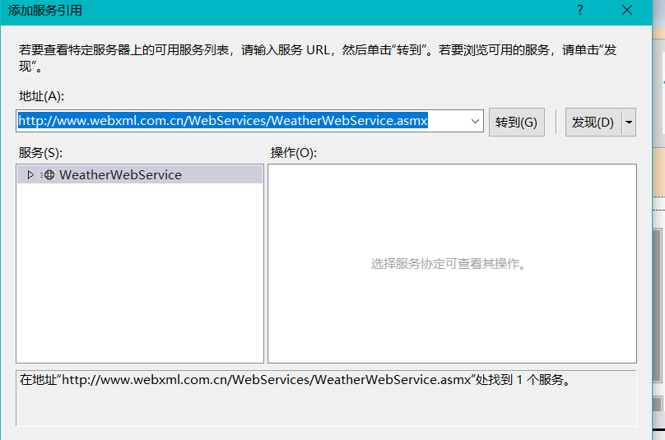

用户可以查询全国所有省会城市的天气情况，也可以输入自己想要查询的城市，若无法查询会提示“不支持查询该城市”。查询到的信息包括现在的天气实况，天气、风向、湿度、紫外线强度和空气质量等以及第二天、第三天的气温，天气趋势。

4.头像显示：

左上角会显示每个用户自己选择的头像。

5.跑马灯：

最下面有一个跑马灯，可以显示该用户是第几次登陆该系统。

6.记事本：

用户点击编辑按钮可以在文本框中输入一些重要事件，点击保存可以在下次登陆系统时再次看到。

7.旅客登记：

点击相应的房间号按钮会弹出登记窗口，输入相应的旅客信息点击登记即可，登记成功后相应的房间按钮颜色会发生改变并变得不可使用，同时左下角的房间状态会根据住宿情况发生改变。

8.旅客信息：

可以对以住宿的旅客信息进行查询和修改。

9.员工管理：

可以对员工信息进行增删改查（只有管理员才可以使用）。

10.退房：

对以住宿的旅客信息进行退房操作。

11.一键锁屏：

点击按钮可以设置锁屏密码，设置完成后再输入临时解锁密码前不可对该系统进行操作。

12.登陆管理：

对员工的登陆信息进行查询和修改，可以修改授权密码，并对自己的登陆密码进行修改（只有管理员才可以使用）。

13.托盘图标：

系统运行后，会在托盘区生成小图标，托盘图标菜单有显示系统和退出功能。

* 1. **功能模块图**

酒店管理系统

管理员

员工

修改授权密码

添加新的员工

员工信息修改

员工信息查询

旅客信息修改

旅客信息查询

旅客登记

# 软件设计

* 1. **设计步骤**

1. 根据不同用户进行需求分析，划分功能模块。
2. 根据功能设计数据库和数据库中的表。
3. 设计主界面，根据用户身份的不同，左上角的提示也不同。
4. 在各个界面中与数据库建立连接。
5. 连接所有模块形成完整系统。
6. 不断测试、调试，完成系统设计。
   1. **系统开发工具**

根据用户需求和现有资源，针对酒店管理系统选择以下开发工具进行开发：

开发工具：Microsoft Visual Studio 2017

开发语言：C#.NET

数据库：ACCESS2016

* 1. **数据库逻辑设计**

根据系统功能需求以及功能模块的划分，对于系统数据库可以列出以下的数据项和数据结构：

数据库User:

employee表：

列名 数据类型 是否可以为空 说明

Password 短文本 否 密码

UserName 短文本 否 用户名

Number 数字 否 登录次数

Touxiang OLE对象 否 头像

main表：

列名 数据类型 是否可以为空 说明

empower 短文本 否 授权密码

manager表：

列名 数据类型 是否可以为空 说明

Password 短文本 否 密码

UserName 短文本 否 用户名

Number 数字 否 登录次数

Touxiang OLE对象 否 头像

数据库 Passenger：

accommodation表：

列名 数据类型 是否可以为空 说明

Num 短文本 否 房间号

Type 短文本 否 房间类型

Name 短文本 否 旅客姓名

Peoplenum 数字 否 身份证号

Sex 短文本 否 性别

Money 数字 否 缴纳金额

Deposit 数字 否 押金

Time 短文本 否 时间

数据库 informationdb：

PERSON表：

列名 数据类型 是否可以为空 说明

id 短文本 否 编号

Name 短文本 否 姓名

Sex 短文本 否 性别

Age 短文本 否 年龄

department 短文本 否 部门

tel 短文本 否 电话

address 短文本 否 住址

position 短文本 否 职位

notepad表：

列名 数据类型 是否可以为空 说明

Note 长文本 是 记事本

* 1. **界面设计**

登录界面：

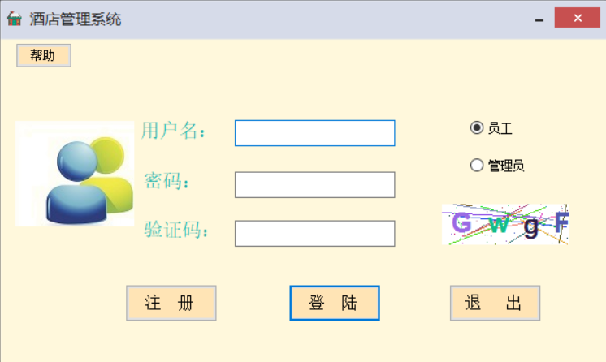

帮助：

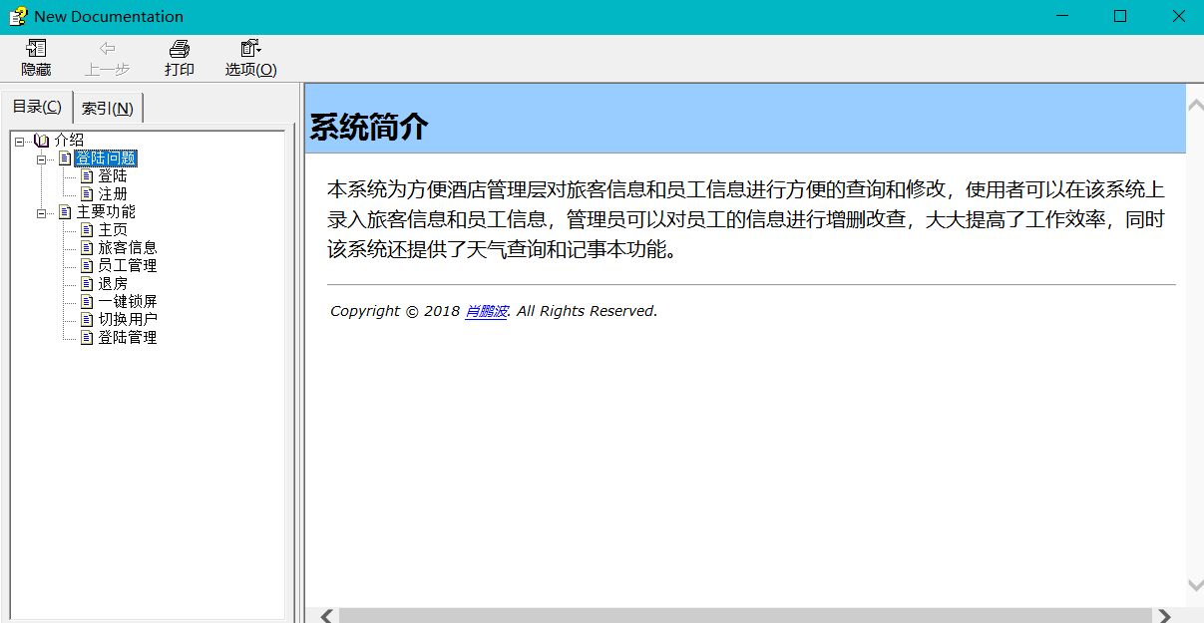

注册界面：

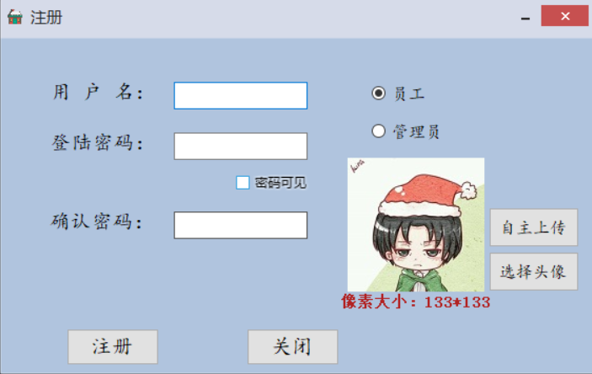

用户界面：

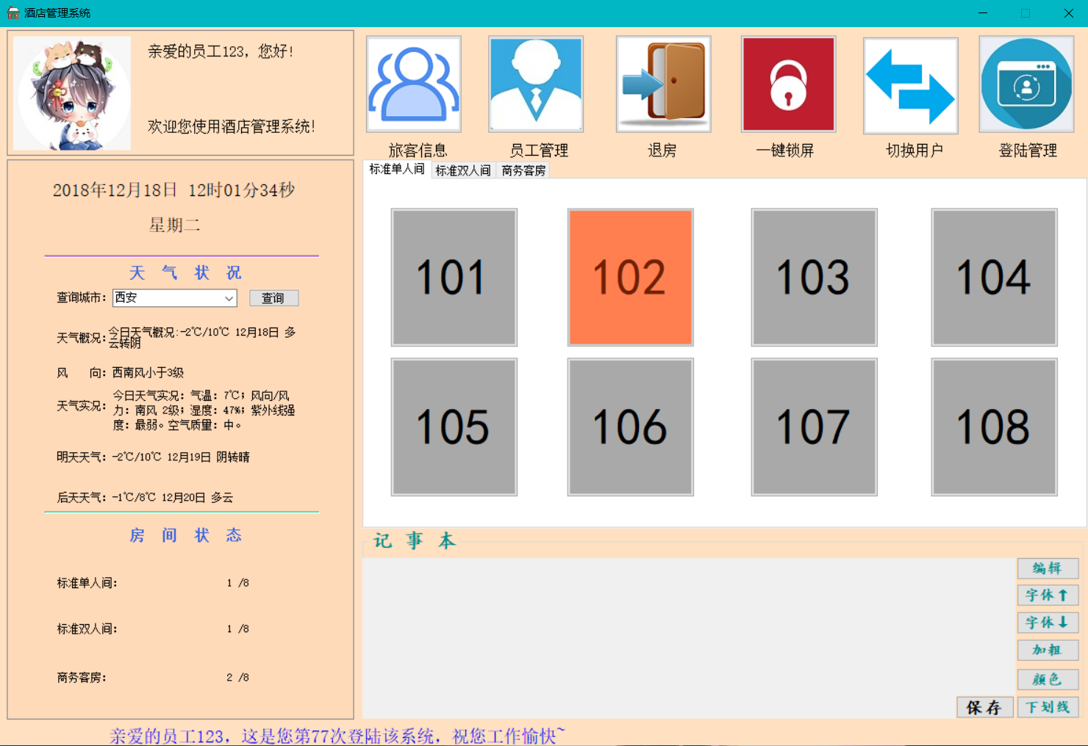

# 结论与心得体会

耗费了差不多一个月的时间，花费了很大的精力，我终于吧课程大作业写出来了，整个过程很累也很辛苦，但同时我也收获了很多知识经验。在开始做大作业的时候，数据库的各种sql语句一直让我很头疼，因为我在这方面的知识有所欠缺，增删改查的基本语句不够熟练，通过做实验五和查阅资料，我慢慢的解决了一个个问题，但是我掌握的还是一些基础操作，没有做一些数据库的关联操作，虽然作业完成了，但是以后还是要多多学习数据库方面的知识

在做作业的过程中我遇到了很多问题，我印象比较深刻的一个就是代码优化的问题，邹业中需要我查询到已住宿的房间号，并根据房间号找到相应的button，并对其属性进行操作，我一开始用的很复杂的switch…case语句，因为我只能通过相应的button的name对该button控件进行操作，这样的写法不仅让代码变得冗长而且还效率低下，并且代码不灵活，后来通过不断的查阅资料，我学到了一个很方便的方法，通过字符串找到相应的控件，仅需几行代码通过循环就解决了之前的问题。我很享受发现问题并解决问题的过程，我觉得这不仅仅是一种锻炼，更是一种能力的提高。

在整个的学习过程中，我不仅学到了c#语言的各种知识，同时也让我发现了自身的一些问题，比如写代码时不够严谨，有时候一个问题可以用多种方法解决，我们应该想一些更好的办法提高效率，而不仅仅是完成任务。大作业虽然写完了，但是我觉得学习并不应该停下来，知识是永无止境的，我还需要不断地学习。

这次课程设计我认为很多地方我已经尽我的最大努力去做了，有些地方我还是很满意的，但是仍然有许多不足和值得改进的地方，我自己发现的有如下几点：

1. 还是不够人性化，因为并不是所有酒店的房间都是按照我所写的那样，还应该添加用户自主添加和删除房间的功能，这需要考虑到很多问题，
2. 记事本的功能实际上并没有很完善，因为它存储在数据库中知识文本而已，对字体的改变并没有存储，再次进入系统会发现之前字体的改变都恢复到最初的样子了。
3. 没有设计密码找回功能，员工的密码更改只能通过管理员进行，用户体验感会因此降低。

4.有些地方都做得不够严谨，细节考虑的不够到位，导致很多错误操作导致程序崩溃。

# 参考资料

王小科 《C#全能速查宝典》 人民邮电出版社 北京 2009年

C#操作access数据库进行存取图片 [https://blog.csdn.net/chainway765/article/details/9012105](%20https:/blog.csdn.net/chainway765/article/details/9012105)

Visual studio installer打包安装  [https://www.cnblogs.com/dongh/p/6868638.html](%20https:/www.cnblogs.com/dongh/p/6868638.html)

C#调用webservice实现天气预报 <https://www.cnblogs.com/zkwarrior/p/5941741.html>

# 附录

* 1. **调试报告**

1. 从数据库的User表中检查用户是否存在时，出现如下异常:from子句语法错误  
   原因：语句中某一单词为Access中的关键字。如：select * from user。其中user就是系统保留关键字。

解决方法:在User两边加上中括号，如: select * from [user]

2. chm文件打开之后提示无法访问此页的问题

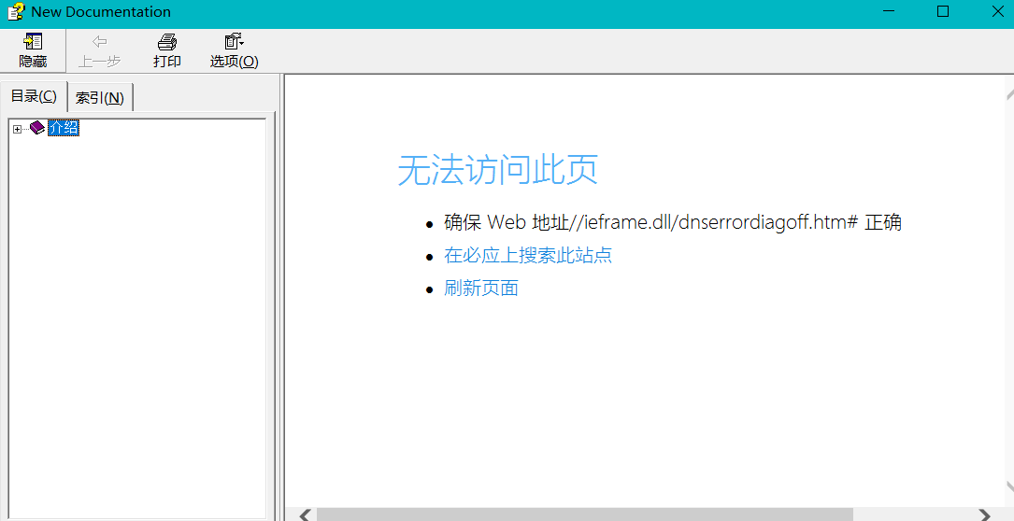

原因是chm文件不能放在带有#的文件夹下面，将文件夹的名字中的#去除即可正常打开

3.软件打包之后，在桌面端使用时无法登陆和注册的的问题，原因是打包的时候没有把数据库放进去，解决办法是把相应的数据库文件一同打包便可解决。

4安装成功后可在某些电脑上可能会出现 未注册Microsoft.ACE.OLEDB.12.0提供程序的问题，原因是我使用的是Microsoft.ACE.OLEDB.12.0，这会存在版本高低的问题，

解决办法是：<http://download.microsoft.com/download/7/0/3/703ffbcb-dc0c-4e19-b0da-1463960fdcdb/AccessDatabaseEngine.exe> 打开该链接下载安装后便可以解决

* 1. **测试结果**

帮助：

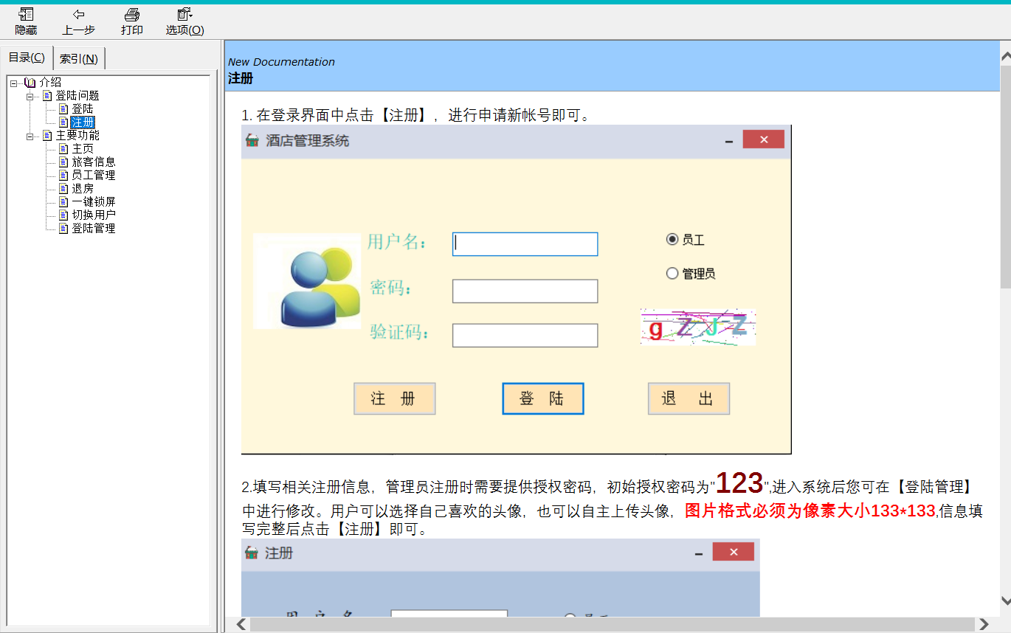

密码错误：

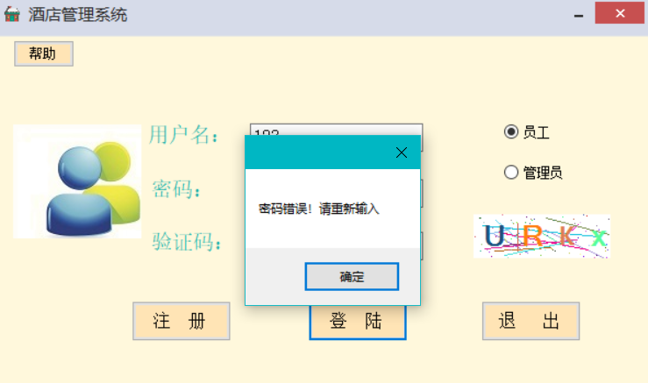

用户名已存在：

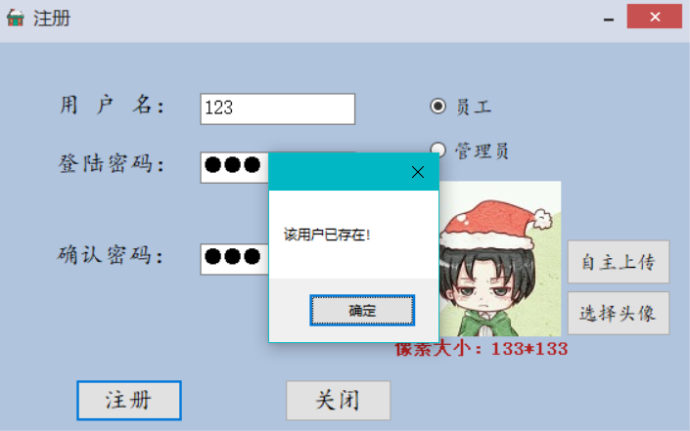

用户不存在，请注册

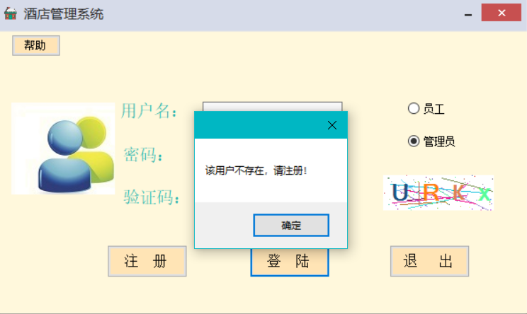

网络状态不可用：

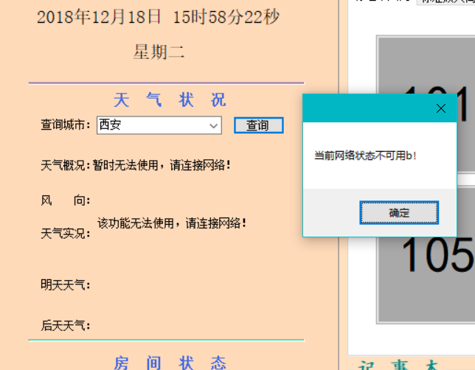

天气查询

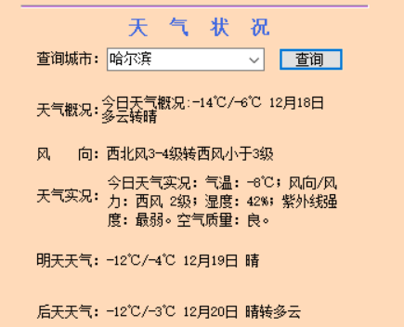

旅客信息：

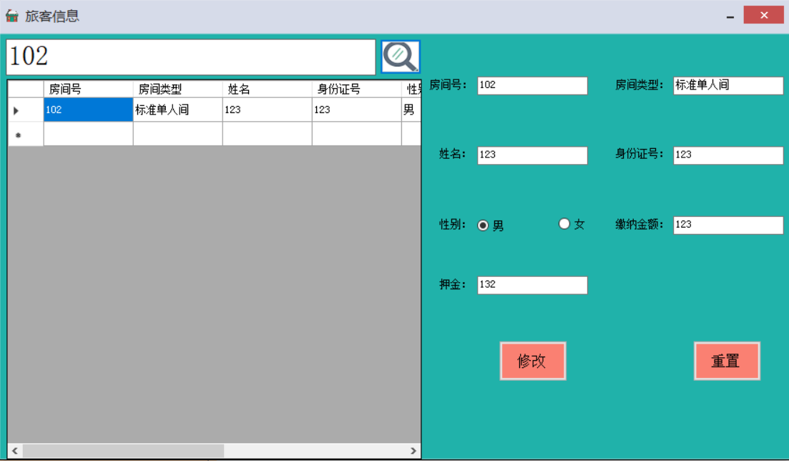

旅客登记：

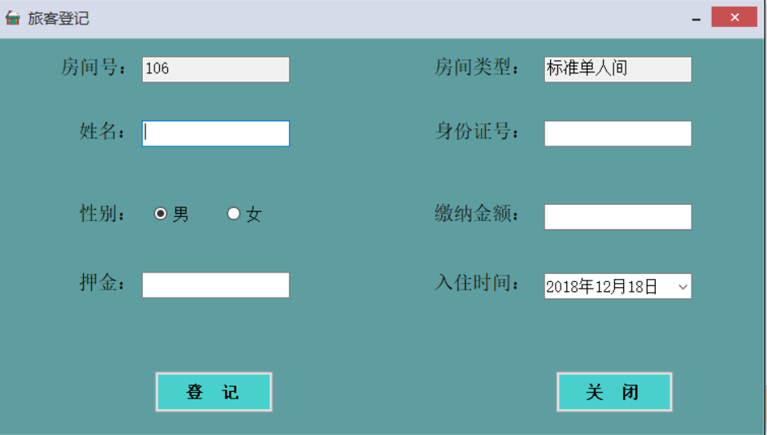

员工管理：

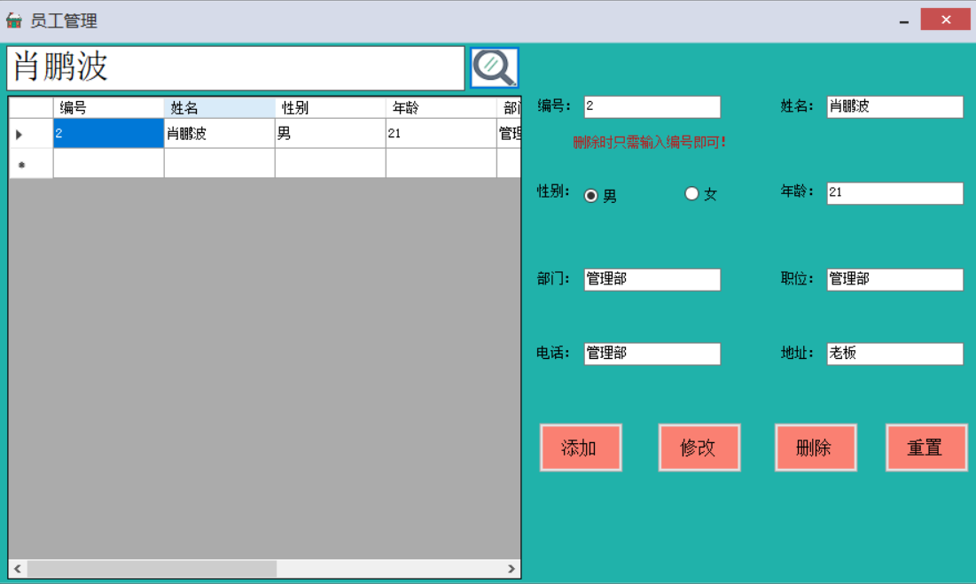

退房：

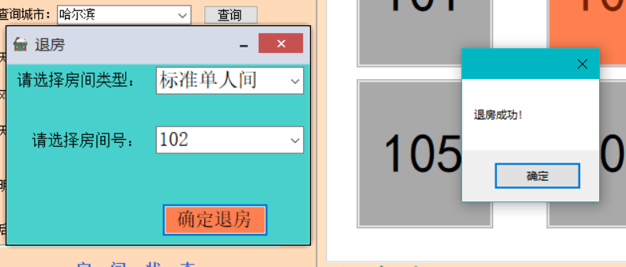

一键锁屏;

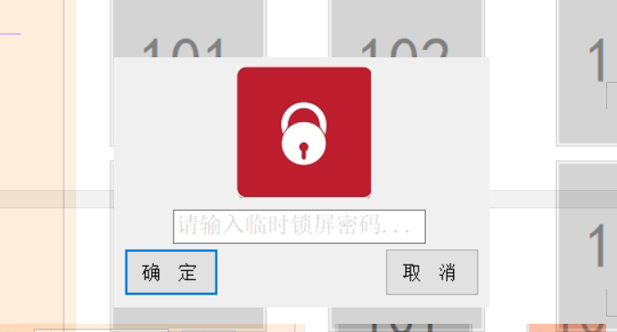

登陆管理：

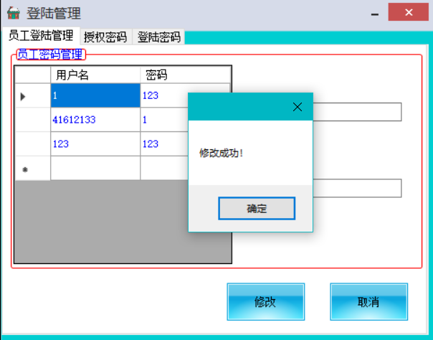

记事本：

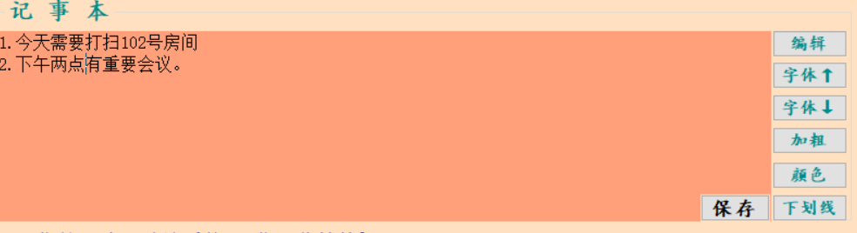

* 1. **关键源代码**

**登录界面源代码：**

using System;

using System.Collections.Generic;

using System.ComponentModel;

using System.Data;

using System.Drawing;

using System.Linq;

using System.Text;

using System.Threading.Tasks;

using System.Windows.Forms;

using System.Data.OleDb;

using System.Runtime.InteropServices;

using CCWin;

namespace Hotel

{

public partial class entry : Skin_VS

{

string connstr = "Provider=Microsoft.ACE.OLEDB.12.0;Data Source=User.accdb";

SecurityCode securitycode;

public entry()

{

InitializeComponent();

securitycode = new SecurityCode(4);

}

public class Win32

{

public const Int32 AW_HOR_POSITIVE = 0x00000001; // 从左到右打开窗口

public const Int32 AW_HOR_NEGATIVE = 0x00000002; // 从右到左打开窗口

public const Int32 AW_VER_POSITIVE = 0x00000004; // 从上到下打开窗口

public const Int32 AW_VER_NEGATIVE = 0x00000008; // 从下到上打开窗口

public const Int32 AW_CENTER = 0x00000010; //若使用了AW_HIDE标志，则使窗口向内重叠；若未使用AW_HIDE标志，则使窗口向外扩展。

public const Int32 AW_HIDE = 0x00010000; //隐藏窗口，缺省则显示窗口。

public const Int32 AW_ACTIVATE = 0x00020000; //激活窗口。在使用了AW_HIDE标志后不要使用这个标志。

public const Int32 AW_SLIDE = 0x00040000; //使用滑动类型。缺省则为滚动动画类型。当使用AW_CENTER标志时，这个标志就被忽略。

public const Int32 AW_BLEND = 0x00080000; //使用淡出效果。只有当hWnd为顶层窗口的时候才可以使用此标志。

[DllImport("user32.dll", CharSet = CharSet.Auto)]

public static extern bool AnimateWindow(

IntPtr hwnd, // handle to window

int dwTime, // duration of animation

int dwFlags // animation type

);

}

private void Form1_Load(object sender, EventArgs e)

{

Win32.AnimateWindow(this.Handle, 2000, Win32.AW_BLEND);

securitycode.UpdateVerifyCode();

SecCodePic.Image = securitycode.getImage();

}

private void exit_Click(object sender, EventArgs e)

{

Application.Exit();

}

private void login_Click(object sender, EventArgs e)

{

if (username.Text == "" || passw.Text == "")

MessageBox.Show("用户名或密码不能为空！");

else if (textBox1.Text == "")

{

MessageBox.Show("验证码不能为空！");

}

else

{

OleDbConnection conn = new OleDbConnection(connstr);

conn.Open();

string selectcmd = "";

if (employee.Checked)

{

selectcmd = "Select * from [employee] where [UserName]='" + username.Text + "'";

}

if (manager.Checked)

{

selectcmd = "Select * from [manager] where [UserName]='" + username.Text + "'";

}

OleDbCommand command = new OleDbCommand(selectcmd, conn);

OleDbDataReader myreader = command.ExecuteReader();

if (myreader.Read())

{

if (this.passw.Text.Equals(myreader["Password"].ToString()) && securitycode.Check(textBox1.Text) == true)

{

this.Visible = false;

if (employee.Checked)

{

string selectcmd1 = "Select * from [employee] where [UserName]='" + username.Text + "'";

OleDbCommand command1 = new OleDbCommand(selectcmd1, conn);

OleDbDataReader myreader1 = command1.ExecuteReader();

myreader1.Read();

string bianhao = myreader1["UserName"].ToString();

string selectcmd2 = "Select * from [employee] where [UserName]='" + username.Text + "'";

OleDbCommand command2 = new OleDbCommand(selectcmd2, conn);

OleDbDataReader myreader2 = command2.ExecuteReader();

myreader2.Read();

int num = Convert.ToInt32(myreader2["number"].ToString());

MessageBox.Show("登陆成功，欢迎您使用！");

main t = new main(0, bianhao, num);

t.Show();

notifyIcon1.Visible = false;

}

if (manager.Checked)

{

string selectcmd1 = "Select * from [manager] where [UserName]='" + username.Text + "'";

OleDbCommand command1 = new OleDbCommand(selectcmd1, conn);

OleDbDataReader myreader1 = command1.ExecuteReader();

myreader1.Read();

string bianhao = myreader1["UserName"].ToString();

string selectcmd2 = "Select * from [manager] where [UserName]='" + username.Text + "'";

OleDbCommand command2 = new OleDbCommand(selectcmd2, conn);

OleDbDataReader myreader2 = command2.ExecuteReader();

myreader2.Read();

int num = Convert.ToInt32(myreader2["number"].ToString());

MessageBox.Show("登陆成功，欢迎您使用！");

main s = new main(1, bianhao, num);

s.Show();

notifyIcon1.Visible = false;

}

}

else if (securitycode.Check(textBox1.Text) == false)

{

MessageBox.Show("验证码错误！请重新输入");

textBox1.Text = "";

}

else

{

MessageBox.Show("密码错误！请重新输入");

this.passw.Text = "";

}

}

else

{

this.username.Text = "";

this.passw.Text = "";

MessageBox.Show("该用户不存在，请注册！");

}

myreader.Close();

conn.Close();

}

}

private void register_Click(object sender, EventArgs e)

{

register r = new register();

r.ShowDialog();

//在C#中窗口的显示有两种方式：模态显示（showdialog）和非模态显示（show）。

//模态与非模态窗体的主要区别是窗体显示的时候是否可以操作其他窗体。模态窗体不允许操作其他窗体，非模态窗体可以操作其他窗体。

}

private void notifyIcon1_MouseDoubleClick(object sender, MouseEventArgs e)

{

if (WindowState == FormWindowState.Minimized)

{

//还原窗体显示

WindowState = FormWindowState.Normal;

//激活窗体并给予它焦点

this.Activate();

//任务栏区显示图标

this.ShowInTaskbar = true;

//托盘区图标隐藏

notifyIcon1.Visible = false;

}

}

private void FormSizeChanged(object sender, EventArgs e)

{

//判断是否选择的是最小化按钮

if (WindowState == FormWindowState.Minimized)

{

//隐藏任务栏区图标

this.ShowInTaskbar = false;

//图标显示在托盘区

notifyIcon1.Visible = true;

}

}

private void toolStripMenuItem1_Click(object sender, EventArgs e)

{

WindowState = FormWindowState.Normal;

}

private void 退出ToolStripMenuItem_Click(object sender, EventArgs e)

{

if (MessageBox.Show("是否确认退出程序？", "退出", MessageBoxButtons.OKCancel, MessageBoxIcon.Question) == DialogResult.OK)

{

// 关闭所有的线程

Application.Exit();

}

}

private void entry_FormClosing(object sender, FormClosingEventArgs e)

{

Win32.AnimateWindow(this.Handle, 2000, Win32.AW_SLIDE | Win32.AW_HIDE | Win32.AW_BLEND);

}

private void SecCodePic_Click(object sender, EventArgs e)

{

securitycode.UpdateVerifyCode();

SecCodePic.Image = securitycode.getImage();

}

private void entry_Load(object sender, EventArgs e)

{

}

private void entry_Load_1(object sender, EventArgs e)

{

System.Diagnostics.Process[] myProcesses = System.Diagnostics.Process.GetProcessesByName("HOTEL");//获取指定的进程名

if (myProcesses.Length > 1) //如果可以获取到知道的进程名则说明已经启动

{

MessageBox.Show("程序已启动！");

Application.Exit(); //关闭系统

}

Win32.AnimateWindow(this.Handle, 2000, Win32.AW_BLEND);

securitycode.UpdateVerifyCode();

SecCodePic.Image = securitycode.getImage();

}

private void button4_Click(object sender, EventArgs e)

{

System.Diagnostics.Process process = new System.Diagnostics.Process();

process.StartInfo.FileName = "Hotel.chm";

process.Start();

}

}

}

**注册界面源代码：**

using System;

using System.Collections.Generic;

using System.ComponentModel;

using System.Data;

using System.Drawing;

using System.Linq;

using System.Text;

using System.Threading.Tasks;

using System.Windows.Forms;

using System.Data.OleDb;

using CCWin;

using System.IO;

namespace Hotel

{

public partial class register :Skin_VS

{

public int ensure;

string connstr = "Provider=Microsoft.ACE.OLEDB.12.0;Data Source=User.accdb";

public register()

{

InitializeComponent();

}

private void enroll_Click(object sender, EventArgs e)

{

string selectcmd = "";

string selectcmd0 = "Select * from [main] where name='管理员'";

if (employee.Checked)

selectcmd = "Select * from [employee] where Username='" + username.Text + "'";

if (manager.Checked)

selectcmd = "Select * from [manager] where Username='" + username.Text + "'";

OleDbConnection conn = new OleDbConnection(connstr);

conn.Open();

OleDbCommand command = new OleDbCommand(selectcmd, conn);

OleDbCommand command0 = new OleDbCommand(selectcmd0, conn);

OleDbDataReader myreader0 = command0.ExecuteReader();

myreader0.Read();

ensure = Convert.ToInt32 (myreader0["empower"]);

if (this.username.Text.Trim() == null || this.passw.Text.Trim() == null)

MessageBox.Show("用户名或密码不能为空！");

else

{

if (command.ExecuteScalar() != null)

{

MessageBox.Show("该用户已存在！");

this.username.Text = "";

this.passw.Text = "";

this.ensurepw.Text = "";

}

else

{

string insertcmd = "";

if (employee.Checked)

{

insertcmd = "insert into employee([UserName],[Password]) values('" + username.Text + "','" + passw.Text + "')";

}

if (manager.Checked)

{

insertcmd = "insert into manager([UserName],[Password]) values('" + username.Text + "','" + passw.Text + "')";

}

OleDbCommand command2 = new OleDbCommand(insertcmd, conn);

if (manager.Checked)

{

if (this.passw.Text.Trim() != this.ensurepw.Text.Trim())

{

MessageBox.Show("两次密码不一致，请重新输入！");

passw.Text = "";

ensurepw.Text = "";

}

else if(username.Text==""||passw.Text==""||ensurepw.Text==""||textempower.Text=="")

{

MessageBox.Show("请将信息补充完整！");

}

else if (ensure != Convert.ToInt32(textempower.Text))

{

MessageBox.Show("授权验证码错误！");

//this.passw.Text = "";

//this.ensurepw.Text = "";

this.textempower.Text = "";

}

else if (command2.ExecuteNonQuery() != -1 && ensure == Convert.ToInt32(textempower.Text))

{

MemoryStream stream = new MemoryStream();

byte[] photo = null;

Image img = this.pictureBox1.Image;

img.Save(stream, System.Drawing.Imaging.ImageFormat.Bmp);

photo = stream.ToArray();

stream.Close();

string sql = "UPDATE manager set[touxiang] =@img where [username]='" + username.Text + "'";

OleDbCommand comm = new OleDbCommand(sql, conn);

comm.Parameters.Add("@img", OleDbType.VarBinary, photo.Length).Value = photo;

comm.ExecuteNonQuery();

MessageBox.Show("注册成功！");

this.Close();

}

else

{

MessageBox.Show("注册失败！");

this.passw.Text = "";

this.ensurepw.Text = "";

}

}

if (employee.Checked)

{

if (this.passw.Text.Trim() != this.ensurepw.Text.Trim())

{

MessageBox.Show("两次密码不一致，请重新输入！");

passw.Text = "";

ensurepw.Text = "";

}

else if (username.Text == "" || passw.Text == "" || ensurepw.Text == "" )

{

MessageBox.Show("请将信息补充完整！");

}

else if (command2.ExecuteNonQuery() != -1 )

{

MemoryStream stream = new MemoryStream();

byte[] photo = null;

Image img = this.pictureBox1.Image;

img.Save(stream, System.Drawing.Imaging.ImageFormat.Bmp);

photo = stream.ToArray();

stream.Close();

string sql = "UPDATE employee set[touxiang] =@img where [username]='" + username.Text + "'";

OleDbCommand comm = new OleDbCommand(sql, conn);

comm.Parameters.Add("@img", OleDbType.VarBinary, photo.Length).Value = photo;

comm.ExecuteNonQuery();

MessageBox.Show("注册成功！");

this.Close();

}

else

{

MessageBox.Show("注册失败！");

this.passw.Text = "";

this.ensurepw.Text = "";

}

}

}

}

conn.Close();

}

private void button2_Click(object sender, EventArgs e)

{

this.Close();

}

private void manager_CheckedChanged(object sender, EventArgs e)

{

if(employee.Checked)

{

empowerp.Visible = false;

textempower.Visible = false;

}

else

{

MessageBox.Show("注册管理员，需要您提供授权密码！");

empowerp.Visible = true;

textempower.Visible = true;

}

}

private void button1_Click(object sender, EventArgs e)

{

head_sculpture hea = new head_sculpture();

hea.GetForm(this);

hea.ShowDialog();

}

private void pictureBox1_Click(object sender, EventArgs e)

{

pictureBox1.Image = global::Hotel.Properties.Resources.管理员;

}

private void skinCheckBox1_CheckedChanged(object sender, EventArgs e)

{

if (skinCheckBox1.Checked == true)

passw.UseSystemPasswordChar = false;

else

passw.UseSystemPasswordChar = true;

}

private void button3_Click(object sender, EventArgs e)

{

OpenFileDialog open = new OpenFileDialog();

DialogResult dr = open.ShowDialog();

if (dr == DialogResult.OK)

{

string imgpath = open.FileName;

string s = imgpath.Substring(imgpath.IndexOf('.'));//截取图片后缀，例如.jpg

if (s != ".jpg" && s != ".png" && s != ".gif"&& s != ".jpeg")

{

MessageBox.Show("只能上传jpg,png,gif,jpeg格式的图片");

return;

}

Bitmap bmp = new Bitmap(open.FileName);

int w = bmp.Width;//宽

int h = bmp.Height;//高

if(w==133&&h==133)

{

MessageBox.Show("上传成功！");

string picName = Guid.NewGuid().ToString() + s;

this.pictureBox1.Image = Image.FromFile(imgpath);//显示图片

File.Copy(open.FileName, Application.StartupPath + "\\image\\" + picName);

}

else

{

MessageBox.Show("请将图片像素大小设置为133*133！");

}

}

}

}

}

**主窗体源代码：**

using CCWin;

using System;

using System.Collections;

using System.Collections.Generic;

using System.ComponentModel;

using System.Data;

using System.Data.OleDb;

using System.Data.SqlClient;

using System.Drawing;

using System.IO;

using System.Linq;

using System.Net.NetworkInformation;

using System.Text;

using System.Threading.Tasks;

using System.Windows.Forms;

namespace Hotel

{

public partial class main : Form

{

ArrayList flag = new ArrayList();

public static string week;

int position,new_number;

string bianhao;

Boolean flag1 = true;

Button but = new Button();

public main(int posit,string id,int num)

{

InitializeComponent();

weather();

func();

transfer();

status();

read_note();

position = posit;

bianhao = id;

new_number = num+1;

update();

timer2.Enabled = true;

timer2.Interval = 10;

}

public void weather()

{

string server = "www.baidu.com";

Ping p = new Ping();

PingReply pr;

try

{

pr = p.Send(server);

if (pr.Status == IPStatus.Success)

{

cn.com.webxml.www.WeatherWebService w = new cn.com.webxml.www.WeatherWebService();

//把webservice当做一个类来操作

string[] s = new string[23];//声明string数组存放返回结果

string city = comboBox2.Text.Trim();//获得文本框录入的查询城市

s = w.getWeatherbyCityName(city);

//以文本框内容为变量实现方法getWeatherbyCityName

if (s[8] == "")

{

MessageBox.Show("暂时不支持您查询的城市");

}

else

{

label9.Text = "今日天气概况:" + s[5] + " " + s[6];

wind.Text = "风 向：" + s[7];

second.Text = "明天天气：" + s[12] + " " + s[13];

richTextBox1.Text = s[10];

third.Text = "后天天气：" + s[17] + " " + s[18];

}

}

}

catch

{

MessageBox.Show("当前网络状态不可用！");

}

}

public void func()

{

string connStr;

connStr = "Provider=Microsoft.ACE.OLEDB.12.0;Data Source=Passenger.accdb";

string selectcmd = "Select num from [accommodation] ";

OleDbConnection conn = new OleDbConnection(connStr);

conn.Open();

OleDbCommand command = new OleDbCommand(selectcmd, conn);

OleDbDataReader dr = command.ExecuteReader(); //查询获得所需的记录

while (dr.Read()) //通过遍历读取

{

flag.Add( Convert.ToString( dr["num"]));

//i++;

}

}

public void transfer()

{

string connstr = "Provider=Microsoft.ACE.OLEDB.12.0;Data Source=Passenger.accdb";

for (int i = 0; i < flag.Count; i++)

{

string selectcmd = "Select * from [accommodation] where num='" + flag[i] + "'";

OleDbConnection conn = new OleDbConnection(connstr);

conn.Open();

OleDbCommand command = new OleDbCommand(selectcmd, conn);

if (command.ExecuteScalar() != null)

{

string a = "r" + flag[i];

but = (Button)this.Controls.Find(a, true)[0];

but.BackColor = Color.Coral;

but.Enabled = false;

}

else

{

string a = "r" + flag[i];

but = (Button)this.Controls.Find(a, true)[0];

but.BackColor = Color.DarkGray;

but.Enabled = true;

}

conn.Close();

}

}

private void timer1_Tick(object sender, EventArgs e)

{

timer1.Interval = 1000;

label2.Text = DateTime.Now.ToString("yyyy年MM月dd日 HH时mm分ss秒");

string dt= DateTime.Now.DayOfWeek.ToString();

switch (dt)

{

case "Monday":

week = "星期一";

break;

case "Tuesday":

week = "星期二";

break;

case "Wednesday":

week = "星期三";

break;

case "Thursday":

week = "星期四";

break;

case "Friday":

week = "星期五";

break;

case "Saturday":

week = "星期六";

break;

case "Sunday":

week = "星期日";

break;

}

label5.Text = week;

}

private void button2_Click(object sender, EventArgs e)

{

//customer cus = new customer();

//cus.Show();

}

private void notifyIcon1_MouseDoubleClick(object sender, MouseEventArgs e)

{

if (WindowState == FormWindowState.Minimized)

{

//还原窗体显示

WindowState = FormWindowState.Normal;

//激活窗体并给予它焦点

this.Activate();

//任务栏区显示图标

this.ShowInTaskbar = true;

//托盘区图标隐藏

notifyIcon1.Visible = false;

}

}

private void FormSizeChanged(object sender, EventArgs e)

{

//判断是否选择的是最小化按钮

if (WindowState == FormWindowState.Minimized)

{

//隐藏任务栏区图标

this.ShowInTaskbar = false;

//图标显示在托盘区

notifyIcon1.Visible = true;

}

}

private void toolStripMenuItem1_Click_1(object sender, EventArgs e)

{

WindowState = FormWindowState.Maximized;

}

private void 退出ToolStripMenuItem_Click_1(object sender, EventArgs e)

{

if (MessageBox.Show("是否确认退出程序？", "退出", MessageBoxButtons.OKCancel, MessageBoxIcon.Question) == DialogResult.OK)

{

// 关闭所有的线程

Application.Exit();

}

}

private void room_Click(object sender, EventArgs e)

{

Button btn = (Button)sender;

string Attributes;

if (tabControl1.SelectedTab.Name == "tabPage1")

{

Attributes = "标准单人间";

customer cus = new customer(btn.Text, btn.Name, Attributes,btn);

cus.ShowDialog();

func();

status();

}

else if(tabControl1.SelectedTab.Name == "tabPage2")

{

Attributes = "标准双人间";

customer cus = new customer(btn.Text, btn.Name, Attributes,btn);

cus.ShowDialog();

func();

status();

}

else

{

Attributes = "商务客房";

customer cus = new customer(btn.Text, btn.Name, Attributes,btn);

cus.ShowDialog();

func();

status();

}

}

private void main_Load(object sender, EventArgs e)

{

}

private void button2_Click_1(object sender, EventArgs e)

{

if (position == 0)

MessageBox.Show("员工无法使用该功能！");

else

{

information inf = new information();

inf.ShowDialog();

}

}

private void button3_Click(object sender, EventArgs e)

{

Passengerinfo passenger = new Passengerinfo();

passenger.ShowDialog();

}

private void button4_Click(object sender, EventArgs e)

{

string server = "www.baidu.com";

Ping p = new Ping();

PingReply pr;

try

{

pr = p.Send(server);

if (pr.Status == IPStatus.Success)

{

cn.com.webxml.www.WeatherWebService w = new cn.com.webxml.www.WeatherWebService();

//把webservice当做一个类来操作

string[] s = new string[23];//声明string数组存放返回结果

string city = comboBox2.Text.Trim();//获得文本框录入的查询城市

s = w.getWeatherbyCityName(city);

//以文本框内容为变量实现方法getWeatherbyCityName

if (s[8] == "")

{

MessageBox.Show("暂时不支持您查询的城市");

}

else

{

label9.Text = "今日天气概况:" + s[5] + " " + s[6];

wind.Text = "风 向：" + s[7];

second.Text = "明天天气：" + s[12] + " " + s[13];

richTextBox1.Text = s[10];

third.Text = "后天天气：" + s[17] + " " + s[18];

}

}

}

catch

{

MessageBox.Show("当前网络状态不可用b！");

}

}

public void status()

{

string[] arr = { "标准单人间", "标准双人间", "商务客房" };

int num;

string connstr = "Provider=Microsoft.ACE.OLEDB.12.0;Data Source=Passenger.accdb";

for (int i = 0; i <= 2; i++)

{

string selectcmd = "Select count(*) from [accommodation] where type='" + arr[i] + "'";

OleDbConnection conn = new OleDbConnection(connstr);

conn.Open();

OleDbCommand command = new OleDbCommand(selectcmd, conn);

num =Convert.ToInt32(command.ExecuteScalar());

if (i == 0)

{

label13.Text = num + " /" + 8;

conn.Close();

}

else if (i == 1)

{

label15.Text = num + " /" + 8;

conn.Close();

}

else

{

label17.Text = num + " /" + 8;

conn.Close();

}

}

}

private void button5_Click(object sender, EventArgs e)

{

exit ex = new exit();

if (ex.ShowDialog() == DialogResult.OK)

{

transfer();

status();

}

}

private void button6_Click(object sender, EventArgs e)

{

entry en = new entry();

en.Show();

this.Dispose();

}

private void button7_Click(object sender, EventArgs e)

{

if (position == 0)

MessageBox.Show("员工无法使用该功能！");

else

{

login_manage lo = new login_manage(bianhao);

lo.ShowDialog();

}

}

private void timer2_Tick(object sender, EventArgs e)

{

if (flag1 == true)

{

label24.Left -= 1;

if (label24.Left <= 0)

flag1 = false;

}

else

{

label24.Left += 1;

if (label24.Right == 1180)

flag1 = true;

}

}

private void button1_Click(object sender, EventArgs e)

{

Form1 fr = new Form1();

this.Opacity = 0.5;

fr.ShowDialog();

this.Opacity = 1;

}

private void button8_Click_1(object sender, EventArgs e)

{

richTextBox2.Enabled = true;

}

private void button10_Click(object sender, EventArgs e)

{

FontStyle fontStyle = richTextBox2.SelectionFont.Style;

richTextBox2.SelectionFont = new Font("新宋体", richTextBox2.SelectionFont.Size + 1, fontStyle);

}

private void button11_Click(object sender, EventArgs e)

{

FontStyle fontStyle = richTextBox2.SelectionFont.Style;

richTextBox2.SelectionFont = new Font("新宋体", richTextBox2.SelectionFont.Size - 1, fontStyle);

}

private void button12_Click(object sender, EventArgs e)

{

FontStyle fontStyle = richTextBox2.SelectionFont.Style;

richTextBox2.SelectionFont = new Font(richTextBox2.SelectionFont, fontStyle ^ FontStyle.Bold);

}

private void button15_Click(object sender, EventArgs e)

{

ColorDialog ColorForm = new ColorDialog();

if (ColorForm.ShowDialog() == DialogResult.OK)

{

Color GetColor = ColorForm.Color;

//GetColor就是用户选择的颜色，接下来就可以使用该颜色了

richTextBox2.SelectionColor = GetColor;

}

}

private void button16_Click(object sender, EventArgs e)

{

FontStyle fontStyle = richTextBox2.SelectionFont.Style;

richTextBox2.SelectionFont = new Font(richTextBox2.SelectionFont, fontStyle ^ FontStyle.Underline);

}

private void button9_Click(object sender, EventArgs e)

{

string connstr = "Provider=Microsoft.ACE.OLEDB.12.0;Data Source=Informationdb.accdb";

string updateCmd = "UPDATE notepad Set [note]=@便签 Where [ID]=1";

OleDbConnection conn = new OleDbConnection(connstr);

conn.Open();

OleDbCommand cmd = new OleDbCommand(updateCmd, conn);

cmd.Parameters.Add(new OleDbParameter("@便签", OleDbType.Char));

cmd.Parameters["@便签"].Value = richTextBox2.Text;

cmd.ExecuteNonQuery();

conn.Close();

richTextBox2.Enabled = false;

}

private void read_note()

{

string connStr;

connStr = "Provider=Microsoft.ACE.OLEDB.12.0;Data Source=Informationdb.accdb";

string selectcmd = "Select [note] AS 便签 From notepad where [ID]=1" ;

OleDbConnection conn = new OleDbConnection(connStr);

conn.Open();

OleDbDataAdapter myadapter = new OleDbDataAdapter(selectcmd, conn);

DataSet mydataset = new DataSet();

myadapter.Fill(mydataset, "notepad");

OleDbCommand command = new OleDbCommand(selectcmd, conn);

richTextBox2.DataBindings.Clear();

richTextBox2.DataBindings.Add("Text", mydataset, "notepad.便签");

conn.Close();

}

private void tabPage1_Click(object sender, EventArgs e)

{

}

private void main_FormClosing(object sender, FormClosingEventArgs e)

{

DialogResult result = MessageBox.Show("确认退出吗?", "操作提示", MessageBoxButtons.OKCancel, MessageBoxIcon.Information);

if (result == DialogResult.OK)

{

Dispose();

Application.Exit();

}

else

{

e.Cancel = true;

}

}

public void update()

{

if(position==0)

{

///this.pictureBox1.Image = global::Hotel.Properties.Resources.员工;

string sql = "Select touxiang From employee Where[UserName]='" + bianhao + "'";

label23.Text = "亲爱的员工" + bianhao + "，您好!";

label24.Text = "亲爱的员工" + bianhao + "，这是您第" + new_number + "次登陆该系统，祝您工作愉快~";

string connStr, updateCmd;

connStr = "Provider=Microsoft.ACE.OLEDB.12.0;Data Source=User.accdb";

updateCmd = "UPDATE employee Set [number]=@次数 where [UserName]='" + bianhao+"'";

OleDbConnection conn = new OleDbConnection(connStr);

conn.Open();

OleDbCommand comm = new OleDbCommand(sql, conn);

OleDbDataReader sdr = comm.ExecuteReader();

sdr.Read();

MemoryStream ms = new MemoryStream((byte[])sdr[0]);

Image image = Image.FromStream(ms);

sdr.Close();

pictureBox1.Image = image;

OleDbCommand cmd = new OleDbCommand(updateCmd, conn);

cmd.Parameters.Add(new OleDbParameter("@次数", OleDbType.Integer));

cmd.Parameters["@次数"].Value = new_number;

cmd.ExecuteNonQuery();

conn.Close();

}

else

{

string sql = "Select touxiang From manager Where[UserName]='" + bianhao + "'";

///this.pictureBox1.Image = global::Hotel.Properties.Resources.管理员;

label23.Text = "尊敬的管理员" + bianhao + "，您好!";

label24.Text = "尊敬的管理员" + bianhao + "，这是您第" + new_number + "次登陆该系统,祝您工作愉快~";

string connStr, updateCmd;

connStr = "Provider=Microsoft.ACE.OLEDB.12.0;Data Source=User.accdb";

updateCmd = "UPDATE manager Set [number]=@次数 where [UserName]='" + bianhao + "'";

OleDbConnection conn = new OleDbConnection(connStr);

conn.Open();

OleDbCommand comm = new OleDbCommand(sql, conn);

OleDbDataReader sdr = comm.ExecuteReader();

sdr.Read();

MemoryStream ms = new MemoryStream((byte[])sdr[0]);

Image image = Image.FromStream(ms);

sdr.Close();

pictureBox1.Image = image;

OleDbCommand cmd = new OleDbCommand(updateCmd, conn);

cmd.Parameters.Add(new OleDbParameter("@次数", OleDbType.Integer));

cmd.Parameters["@次数"].Value = new_number;

cmd.ExecuteNonQuery();

conn.Close();

}

}

}

}

**旅客信息界面源代码：**

using System;

using System.Collections.Generic;

using System.ComponentModel;

using System.Data;

using System.Data.OleDb;

using System.Drawing;

using System.Linq;

using System.Text;

using System.Threading.Tasks;

using System.Windows.Forms;

using CCWin;

namespace Hotel

{

public partial class Passengerinfo : Skin_VS

{

Boolean textboxHasText = false;

public Passengerinfo()

{

InitializeComponent();

showperson();

if (textBox1.Text == "")

{

textBox1.Text = "请输入要查询的房间号...";

textBox1.ForeColor = Color.LightGray;

textboxHasText = false;

}

else

textboxHasText = true;

}

private void button1_Click(object sender, EventArgs e)

{

string connStr;

connStr = "Provider=Microsoft.ACE.OLEDB.12.0;Data Source=Passenger.accdb";

string selectcmd = "Select [num] AS 房间号 ,[type] AS 房间类型,[name] AS 姓名,[peoplenum] AS 身份证号,[sex] AS 性别,[money] AS 缴纳金额,[deposit] AS 押金,[time] AS 入住时间 From accommodation where [num]='" + textBox1.Text + "'";

OleDbConnection conn = new OleDbConnection(connStr);

conn.Open();

OleDbCommand command = new OleDbCommand(selectcmd, conn);

string selectcmd1 = "Select * From accommodation where [num]='" + textBox1.Text + "'";

OleDbCommand command1 = new OleDbCommand(selectcmd1, conn);

OleDbDataReader myreader2 = command1.ExecuteReader();

myreader2.Read();

if (command.ExecuteScalar() == null)

{

MessageBox.Show("请输入准确的查询信息！");

}

else

{

OleDbDataAdapter myadapter = new OleDbDataAdapter(selectcmd, conn);

DataSet mydataset = new DataSet();

myadapter.Fill(mydataset, "accommodation");

dataGridView1.DataSource = mydataset.Tables["accommodation"].DefaultView;

DataView mydataview = new DataView();

textBox2.DataBindings.Clear();

textBox2.DataBindings.Add("Text", mydataset, "accommodation.房间号");

textBox6.DataBindings.Clear();

textBox6.DataBindings.Add("Text", mydataset, "accommodation.房间类型");

textBox3.DataBindings.Clear();

textBox3.DataBindings.Add("Text", mydataset, "accommodation.姓名");

textBox7.DataBindings.Clear();

textBox7.DataBindings.Add("Text", mydataset, "accommodation.身份证号");

if (myreader2["sex"].ToString()=="女")

radioButton2.Checked = true;

else

radioButton1.Checked = true;

textBox5.DataBindings.Clear();

textBox5.DataBindings.Add("Text", mydataset, "accommodation.缴纳金额");

textBox4.DataBindings.Clear();

textBox4.DataBindings.Add("Text", mydataset, "accommodation.押金");

//textBox9.DataBindings.Clear();

//textBox9.DataBindings.Add("Value", mydataset, "accommodation.时间");

}

conn.Close();

}

private void showperson()

{

string connStr, selectCmd;

connStr = "Provider=Microsoft.ACE.OLEDB.12.0;Data Source=Passenger.accdb";

selectCmd = "Select [num] AS 房间号 ,[type] AS 房间类型,[name] AS 姓名,[peoplenum] AS 身份证号,[sex] AS 性别,[money] AS 缴纳金额,[deposit] AS 押金,[time] AS 入住时间 From accommodation Order By num ASC";

OleDbConnection conn;

OleDbDataAdapter myAdapter;

DataSet myDataSet = new DataSet();

conn = new OleDbConnection(connStr);

conn.Open();

myAdapter = new OleDbDataAdapter(selectCmd, conn);

myAdapter.Fill(myDataSet, "accommodation");

dataGridView1.DataSource = myDataSet.Tables["accommodation"];

}

private void textBox1_Enter(object sender, EventArgs e)

{

if (textboxHasText == false)

textBox1.Text = "";

textBox1.ForeColor = Color.Black;

}

private void textBox1_Leave(object sender, EventArgs e)

{

if (textBox1.Text == "")

{

textBox1.Text = "请输入要查询的房间号...";

textBox1.ForeColor = Color.LightGray;

textboxHasText = false;

showperson();

}

else

textboxHasText = true;

}

private void button3_Click(object sender, EventArgs e)

{

string connStr, updateCmd;

connStr = "Provider=Microsoft.ACE.OLEDB.12.0;Data Source=Passenger.accdb";

updateCmd = "UPDATE accommodation Set [num]=@房间号 ,[type]=@房间类型,[name]=@姓名,[peoplenum]=@身份证号,[sex]=@性别,[money]=@缴纳金额,[deposit]=@押金 Where [num]=@房间号";

OleDbConnection conn = new OleDbConnection(connStr);

conn.Open();

OleDbCommand cmd = new OleDbCommand(updateCmd, conn);

cmd.Parameters.Add(new OleDbParameter("@房间号", OleDbType.Char));

cmd.Parameters.Add(new OleDbParameter("@房间类型", OleDbType.Char));

cmd.Parameters.Add(new OleDbParameter("@姓名", OleDbType.Char));

cmd.Parameters.Add(new OleDbParameter("@身份证号", OleDbType.Char));

cmd.Parameters.Add(new OleDbParameter("@性别", OleDbType.Char));

cmd.Parameters.Add(new OleDbParameter("@缴纳金额", OleDbType.Char));

cmd.Parameters.Add(new OleDbParameter("@押金", OleDbType.Char));

//cmd.Parameters.Add(new OleDbParameter("@入住时间", OleDbType.Char));

cmd.Parameters["@房间号"].Value = textBox2.Text;

cmd.Parameters["@房间类型"].Value = textBox6.Text;

if (radioButton1.Checked)

cmd.Parameters["@性别"].Value = radioButton1.Text;

else

cmd.Parameters["@性别"].Value = radioButton2.Text;

cmd.Parameters["@姓名"].Value = textBox3.Text;

cmd.Parameters["@身份证号"].Value = textBox7.Text;

cmd.Parameters["@缴纳金额"].Value = textBox5.Text;

cmd.Parameters["@押金"].Value = textBox4.Text;

string selectCmd = "Select [num] From accommodation WHERE num= '" + textBox2.Text + "'";

OleDbCommand command = new OleDbCommand(selectCmd, conn);

if (textBox2.Text == "")

MessageBox.Show("请务必输入房间号！");

else if (command.ExecuteScalar() == null)

{

MessageBox.Show("该房间号不存在，请重新输入！");

textBox2.Text = "";

}

else

{

cmd.ExecuteNonQuery();

conn.Close();

showperson();

MessageBox.Show("修改成功！");

}

}

}

}

**员工信息界面源代码：**

using CCWin;

using System;

using System.Collections.Generic;

using System.ComponentModel;

using System.Data;

using System.Data.OleDb;

using System.Drawing;

using System.Linq;

using System.Text;

using System.Threading.Tasks;

using System.Windows.Forms;

namespace Hotel

{

public partial class information : Skin_VS

{

public information()

{

InitializeComponent();

showperson();

if (textBox1.Text == "")

{

textBox1.Text = "请输入要查询的员工姓名...";

textBox1.ForeColor = Color.LightGray;

textboxHasText = false;

}

else

textboxHasText = true;

}

private void information_FormClosed(object sender, FormClosedEventArgs e)

{

this.Close();

}

Boolean textboxHasText = false;

private void textBox1_Enter(object sender, EventArgs e)

{

if (textboxHasText == false)

textBox1.Text = "";

textBox1.ForeColor = Color.Black;

}

private void textBox1_Leave(object sender, EventArgs e)

{

if (textBox1.Text == "")

{

textBox1.Text = "请输入要查询的员工姓名...";

textBox1.ForeColor = Color.LightGray;

textboxHasText = false;

showperson();

}

else

textboxHasText = true;

}

private void button1_Click(object sender, EventArgs e)

{

string connStr;

connStr = "Provider=Microsoft.ACE.OLEDB.12.0;Data Source=Informationdb.accdb";

string selectcmd = "Select [id] AS 编号,[name] AS 姓名,[sex] AS 性别,[age] AS 年龄,[department] AS 部门,[position] AS 职位,[tel] AS 电话,[address] AS 地址 From PERSON where [name]='" + textBox1.Text + "'";

OleDbConnection conn = new OleDbConnection(connStr);

conn.Open();

OleDbCommand command = new OleDbCommand(selectcmd, conn);

string selectcmd1 = "Select * From PERSON where [name]='" + textBox1.Text + "'";

OleDbCommand command1 = new OleDbCommand(selectcmd1, conn);

OleDbDataReader myreader2 = command1.ExecuteReader();

myreader2.Read();

if (command.ExecuteScalar() == null)

{

MessageBox.Show("请输入准确的查询信息！");

}

else

{

OleDbDataAdapter myadapter = new OleDbDataAdapter(selectcmd, conn);

DataSet mydataset = new DataSet();

myadapter.Fill(mydataset, "PERSON");

dataGridView1.DataSource = mydataset.Tables["PERSON"].DefaultView;

DataView mydataview = new DataView();

textBox2.DataBindings.Clear();

textBox2.DataBindings.Add("Text", mydataset, "PERSON.编号");

textBox6.DataBindings.Clear();

textBox6.DataBindings.Add("Text", mydataset, "PERSON.姓名");

if (myreader2["sex"].ToString() == "女")

radioButton2.Checked = true;

else

radioButton1.Checked = true;

textBox7.DataBindings.Clear();

textBox7.DataBindings.Add("Text", mydataset, "PERSON.年龄");

textBox9.DataBindings.Clear();

textBox9.DataBindings.Add("Text", mydataset, "PERSON.部门");

textBox5.DataBindings.Clear();

textBox5.DataBindings.Add("Text", mydataset, "PERSON.职位");

textBox4.DataBindings.Clear();

textBox4.DataBindings.Add("Text", mydataset, "PERSON.电话");

textBox8.DataBindings.Clear();

textBox8.DataBindings.Add("Text", mydataset, "PERSON.地址");

}

}

private void showperson()

{

string connStr, selectCmd;

connStr = "Provider=Microsoft.ACE.OLEDB.12.0;Data Source=Informationdb.accdb";

selectCmd = "Select [id] AS 编号,[name] AS 姓名,[sex] AS 性别,[age] AS 年龄,[department] AS 部门,[position] AS 职位,[tel] AS 电话,[address] AS 地址 From PERSON Order By id ASC";

OleDbConnection conn;

OleDbDataAdapter myAdapter;

DataSet myDataSet = new DataSet();

conn = new OleDbConnection(connStr);

conn.Open();

myAdapter = new OleDbDataAdapter(selectCmd, conn);

myAdapter.Fill(myDataSet,"PERSON");

dataGridView1.DataSource = myDataSet.Tables["PERSON"];

}

private void button2_Click(object sender, EventArgs e)

{

string connStr, selectCmd,insertCmd;

connStr = "Provider=Microsoft.ACE.OLEDB.12.0;Data Source=Informationdb.accdb";

insertCmd = "Insert Into PERSON([id],[name], [sex], [age], [department], [position], [tel], [address]) Values(@编号, @姓名, @性别, @年龄, @部门, @职位, @电话, @地址)";

OleDbConnection conn = new OleDbConnection(connStr);

conn.Open();

OleDbCommand cmd = new OleDbCommand(insertCmd, conn);

cmd.Parameters.Add(new OleDbParameter("@编号", OleDbType.Char));

cmd.Parameters.Add(new OleDbParameter("@姓名", OleDbType.Char));

cmd.Parameters.Add(new OleDbParameter("@性别", OleDbType.Char));

cmd.Parameters.Add(new OleDbParameter("@年龄", OleDbType.Char));

cmd.Parameters.Add(new OleDbParameter("@部门", OleDbType.Char));

cmd.Parameters.Add(new OleDbParameter("@职位", OleDbType.Char));

cmd.Parameters.Add(new OleDbParameter("@电话", OleDbType.Char));

cmd.Parameters.Add(new OleDbParameter("@地址", OleDbType.Char));

cmd.Parameters["@编号"].Value = textBox2.Text;

cmd.Parameters["@姓名"].Value = textBox6.Text;

if(radioButton1.Checked)

cmd.Parameters["@性别"].Value = radioButton1.Text;

else

cmd.Parameters["@性别"].Value = radioButton2.Text;

cmd.Parameters["@年龄"].Value = textBox7.Text;

cmd.Parameters["@部门"].Value = textBox9.Text;

cmd.Parameters["@职位"].Value = textBox5.Text;

cmd.Parameters["@电话"].Value = textBox4.Text;

cmd.Parameters["@地址"].Value = textBox8.Text;

selectCmd = "Select [id] From PERSON WHERE id= '" + textBox2.Text + "'";

OleDbCommand command = new OleDbCommand(selectCmd, conn);

if (textBox2.Text == "" || textBox4.Text == "" || textBox5.Text == "" || textBox6.Text == "" || textBox7.Text == "" || textBox8.Text == "" || textBox9.Text == "")

MessageBox.Show("请将信息补充完整！");

else if (command.ExecuteScalar() != null)

{

MessageBox.Show("不能添加编号相同的员工，请重新输入！");

textBox2.Text = "";

}

else

{

cmd.ExecuteNonQuery();

conn.Close();

showperson();

MessageBox.Show("添加成功！");

}

}

private void button3_Click(object sender, EventArgs e)

{

string connStr, updateCmd;

connStr = "Provider=Microsoft.ACE.OLEDB.12.0;Data Source=Informationdb.accdb";

updateCmd = "UPDATE PERSON Set [id]=@编号, [name]=@姓名,[sex]=@性别,[age]=@年龄,[position]=@职位,[tel]=@电话, [address]=@地址 Where [id]=@编号";

OleDbConnection conn = new OleDbConnection(connStr);

conn.Open();

OleDbCommand cmd = new OleDbCommand(updateCmd, conn);

cmd.Parameters.Add(new OleDbParameter("@编号", OleDbType.Char));

cmd.Parameters.Add(new OleDbParameter("@姓名", OleDbType.Char));

cmd.Parameters.Add(new OleDbParameter("@性别", OleDbType.Char));

cmd.Parameters.Add(new OleDbParameter("@年龄", OleDbType.Char));

cmd.Parameters.Add(new OleDbParameter("@部门", OleDbType.Char));

cmd.Parameters.Add(new OleDbParameter("@职位", OleDbType.Char));

cmd.Parameters.Add(new OleDbParameter("@电话", OleDbType.Char));

cmd.Parameters.Add(new OleDbParameter("@地址", OleDbType.Char));

cmd.Parameters["@编号"].Value = textBox2.Text;

cmd.Parameters["@姓名"].Value = textBox6.Text;

if (radioButton1.Checked)

cmd.Parameters["@性别"].Value = radioButton1.Text;

else

cmd.Parameters["@性别"].Value = radioButton2.Text;

cmd.Parameters["@年龄"].Value = textBox7.Text;

cmd.Parameters["@部门"].Value = textBox9.Text;

cmd.Parameters["@职位"].Value = textBox5.Text;

cmd.Parameters["@电话"].Value = textBox4.Text;

cmd.Parameters["@地址"].Value = textBox8.Text;

string selectCmd = "Select [id] From PERSON WHERE id= '" + textBox2.Text + "'";

OleDbCommand command = new OleDbCommand(selectCmd, conn);

if (textBox2.Text == "" )

MessageBox.Show("请务必输入编号！");

else if (command.ExecuteScalar() == null)

{

MessageBox.Show("该编号不存在，请重新输入！");

textBox2.Text = "";

}

else

{

cmd.ExecuteNonQuery();

conn.Close();

showperson();

MessageBox.Show("修改成功！");

}

}

string GetSqlStr(string str)

{

return str.Replace("'", "''");

}

private void button4_Click(object sender, EventArgs e)

{

string connStr, delCmd;

connStr = "Provider=Microsoft.ACE.OLEDB.12.0;Data Source=Informationdb.accdb";

delCmd = "Delete From PERSON Where id = '" + GetSqlStr(textBox2.Text) + "'";

string selectCmd = "Select [id] From PERSON WHERE id= '" + textBox2.Text + "'";

OleDbConnection conn = new OleDbConnection(connStr);

conn.Open();

OleDbCommand command = new OleDbCommand(selectCmd, conn);

OleDbCommand cmd = new OleDbCommand(delCmd, conn);

if (textBox2.Text == "")

MessageBox.Show("请务必输入编号！");

else if (command.ExecuteScalar() == null)

{

MessageBox.Show("该编号不存在，请重新输入！");

textBox2.Text = "";

}

else

{

cmd.ExecuteNonQuery();

conn.Close();

showperson();

MessageBox.Show("删除成功！");

}

}

private void button5_Click(object sender, EventArgs e)

{

textBox2.Text = "";

textBox4.Text = "";

textBox5.Text = "";

textBox6.Text = "";

textBox7.Text = "";

textBox8.Text = "";

textBox9.Text = "";

}

}

}

**登陆管理界面源代码：**

using System;

using System.Collections.Generic;

using System.ComponentModel;

using System.Data;

using System.Data.OleDb;

using System.Drawing;

using System.Linq;

using System.Text;

using System.Threading.Tasks;

using System.Windows.Forms;

using CCWin;

namespace Hotel

{

public partial class login_manage : Skin_VS

{

string username;

public login_manage(string x)

{

InitializeComponent();

show();

username = x;

}

public void show()

{

string connstr = "Provider=Microsoft.ACE.OLEDB.12.0;Data Source=User.accdb";

string selectCmd = "Select [UserName] AS 用户名,[Password] AS 密码 From employee Order By [id] DESC";

OleDbConnection conn;

OleDbDataAdapter myAdapter;

DataSet myDataSet = new DataSet();

conn = new OleDbConnection(connstr);

conn.Open();

myAdapter = new OleDbDataAdapter(selectCmd, conn);

myAdapter.Fill(myDataSet, "employee");

dataGridView1.DataSource = myDataSet.Tables["employee"];

conn.Close();

}

private void skinButton1_Click(object sender, EventArgs e)

{

string connStr, updateCmd;

connStr = "Provider=Microsoft.ACE.OLEDB.12.0;Data Source=User.accdb";

updateCmd = "UPDATE employee set [UserName]=@用户名, [Password]=@密码 Where [UserName]=@用户名";

OleDbConnection conn = new OleDbConnection(connStr);

conn.Open();

OleDbCommand cmd = new OleDbCommand(updateCmd, conn);

cmd = new OleDbCommand(updateCmd, conn);

cmd.Parameters.Add(new OleDbParameter("@用户名", OleDbType.Char));

cmd.Parameters.Add(new OleDbParameter("@密码", OleDbType.Char));

cmd.Parameters["@用户名"].Value = textBox1.Text;

cmd.Parameters["@密码"].Value = textBox2.Text;

string selectcmd = "Select * from [employee] where Username='" + textBox1.Text + "'";

OleDbCommand command = new OleDbCommand(selectcmd, conn);

if (textBox1.Text == "" || textBox2.Text == "")

MessageBox.Show("请将信息填写完整！");

else if (command.ExecuteScalar() == null)

MessageBox.Show("该用户不存在！");

else

{

cmd.ExecuteNonQuery();

conn.Close();

show();

textBox1.Text ="" ;

textBox2.Text = "";

MessageBox.Show("修改成功！");

}

}

private void skinButton2_Click(object sender, EventArgs e)

{

this.Close();

}

private void label1_Click(object sender, EventArgs e)

{

if (MessageBox.Show("是否确认退出程序？", "退出", MessageBoxButtons.OKCancel, MessageBoxIcon.Question) == DialogResult.OK)

{

// 关闭所有的线程

Application.Exit();

}

}

private void skinButton3_Click(object sender, EventArgs e)

{

string connstr;

connstr = "Provider=Microsoft.ACE.OLEDB.12.0;Data Source=User.accdb";

string selectCmd = "Select * From main where empower='" + textBox3.Text + "'";

OleDbConnection conn = new OleDbConnection(connstr);

conn.Open();

OleDbCommand command = new OleDbCommand(selectCmd, conn);

if (textBox3.Text == "")

MessageBox.Show("请输入密码！");

else if (command.ExecuteScalar() != null)

{

skinButton3.Visible = false;

textBox3.Text = "";

label3.Text = "新的授权密码：";

label3.ForeColor = Color.Red;

conn.Close();

skinCheckBox1.Visible = true;

}

else

{

MessageBox.Show("密码错误，请重新输入！");

textBox3.Text = "";

}

}

private void skinButton4_Click(object sender, EventArgs e)

{

if (skinButton3.Visible == true)

MessageBox.Show("请先验证授权密码");

else

{

string connstr;

connstr = "Provider=Microsoft.ACE.OLEDB.12.0;Data Source=User.accdb";

string updateCmd = "UPDATE main set [empower]=@授权密码 Where [name]=@管理员";

OleDbConnection conn = new OleDbConnection(connstr);

conn.Open();

OleDbCommand cmd = new OleDbCommand(updateCmd, conn);

cmd = new OleDbCommand(updateCmd, conn);

cmd.Parameters.Add(new OleDbParameter("@授权密码", OleDbType.Char));

if (textBox3.Text == "")

MessageBox.Show("授权密码不能为空！");

else if (MessageBox.Show("是否确认修改？", "确定", MessageBoxButtons.OKCancel, MessageBoxIcon.Question) == DialogResult.OK)

{

cmd.Parameters["@授权密码"].Value = textBox3.Text;

MessageBox.Show("修改成功！");

}

}

}

private void skinCheckBox1_CheckedChanged(object sender, EventArgs e)

{

if (skinCheckBox1.Checked == true)

textBox3.UseSystemPasswordChar = false;

else

textBox3.UseSystemPasswordChar = true;

}

private void skinButton5_Click(object sender, EventArgs e)

{

this.Close();

}

private void tabControl1_SelectedIndexChanged(object sender, EventArgs e)

{

textBox3.Text = "";

}

private void skinCheckBox2_CheckedChanged(object sender, EventArgs e)

{

if (skinCheckBox2.Checked == true)

textBox4.UseSystemPasswordChar = false;

else

textBox4.UseSystemPasswordChar = true;

}

private void skinButton6_Click(object sender, EventArgs e)

{

string connstr = "Provider=Microsoft.ACE.OLEDB.12.0;Data Source=User.accdb";

string updateCmd = "UPDATE manager set [Password]=@密码 Where [UserName]='" + username + "'";

OleDbConnection conn = new OleDbConnection(connstr);

conn.Open();

OleDbCommand cmd = new OleDbCommand(updateCmd, conn);

cmd = new OleDbCommand(updateCmd, conn);

cmd.Parameters.Add(new OleDbParameter("@密码", OleDbType.Char));

if (textBox4.Text == "")

MessageBox.Show("密码不能为空！");

else

{

cmd.Parameters["@密码"].Value = textBox4.Text;

cmd.ExecuteNonQuery();

conn.Close();

MessageBox.Show("修改成功！");

}

}

}

}