MPI实现矩阵乘法
计试61 张翀 2140506063

1.按行并行算法的实现
在按行计算矩阵乘法时，主进程首先把A按行划分为大致相等的部分，然后将部分的A和全部的B传递给子进程。子进程计算部分乘法并返回结果，主进程收集并报告结果。在实现中，我使用了Send-Recv和Scatter-Gather两种方式进行通信，代码如附录1,2所示。

2.分块算法的实现
分块算法的核心在于每个进程计算一块矩阵的结果。因此，每个进程需要的数据是一个范围内的数行和数列。针对此，给出这样的实现思路：将可用于计算的进程数n分解为a*b，然后将全体行划分为a个部分，全体列划分为b个部分，从而将整个矩阵划分为size相同的n个块。每个子进程负责计算最终结果的一块，只需要接收A对应范围的行和B对应范围的列，而不需要把整个矩阵传过去。主进程负责分发和汇总结果。实现代码如附录3所示。
在上述实现的基础上，按照实验要求实现了Cannon算法：Cannon算法实际上和之前的分块乘法相同，每个进程负责矩阵其中一块的计算；但partA, partB每次只传入一块（而非整行整列），虽然增加了Send和Recv的次数，但是节省了内存，用于存储partA, partB的内存减少到原来的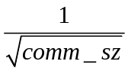.实现代码如附录4所示。

3.实验结果

不同算法之间运行时间的比较
在四核四进程机器上尝试三种算法：1）按行并行；2）为子进程分配行列的分块并行；3）为子进程分配块的分块并行。实验获得如下的结果：
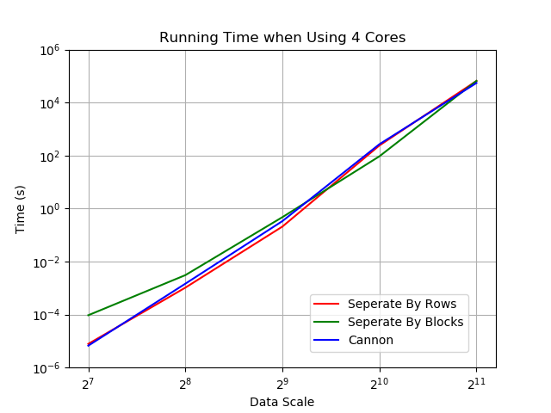
用时（秒） |  | 矩阵维度
 |  | 128 | 256 | 512 | 1024 | 2048
计算模式 | 按行并行 | 0.00605488 | 0.0505784 | 0.506645 | 10.8184 | 123.499
计算模式 | 分块并行 | 0.0178633 | 0.081084 | 0.72291 | 10.19026 | 123.906
计算模式 | Cannon | 0.00566483 | 0.0586975 | 0.622711 | 11.3504 | 114.323

图表显示，各种不同方法之间用时差距不大，这主要是因为记录下的用时主要花在计算上，在数据量较大时，计算结果所需的时间远大于其他成本，导致其他成本造成的差异不显著。

不同算法之间运行内存的比较
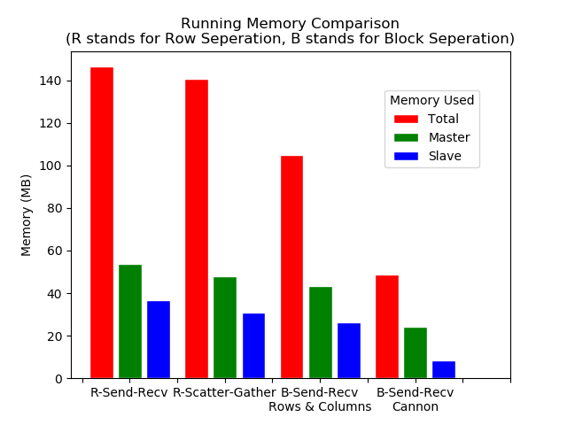
用时（秒） |  | 使用内存（MB）
 |  | 使用总量（峰值） | 主进程使用的内存（峰值） | 普通计算进程使用的内存（峰值）
计算模式 | 按行并行  Send-Recv | 146.4 | 53.6 | 36.6
计算模式 | 按行并行  Scatter-Gather | 140.6 | 47.9 | 30.9
计算模式 | 分块并行  传递行列 | 104.8 | 43.2 | 26.2
计算模式 | 分块并行  Cannon | 48.8 | 24.2 | 8.2

通过比较容易见得，基于分块的并行矩阵乘法对内存的消耗更少，尤其是Cannon算法，理论上对内存的消耗可以达到一般算法的3/comm_sz倍。

并行程序的速度提升
在四核机器上调整执行程序的进程数，对1024*1024维矩阵进行运算，实验获得如下的结果：
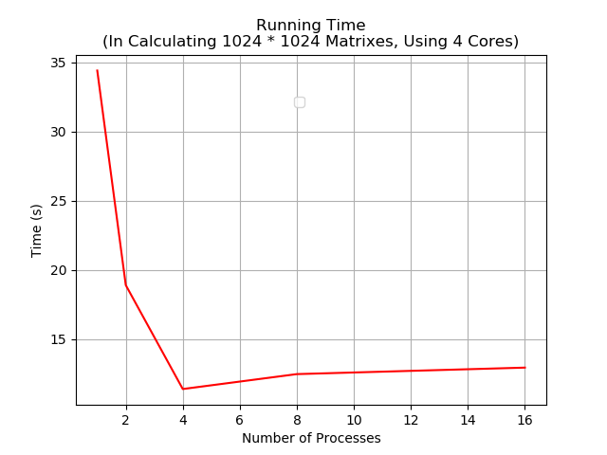
 | 进程数
 | 1 | 2 | 4 | 8 | 16
用时（秒） | 34.4074 | 18.9103 | 11.4054 | 12.4829 | 12.9519

进程数从1增加到4时，性能成倍改善；进程数增加时，执行时间反而增加。上述结果说明，进程数和核数正好相同时，能最大利用处理器性能。

4.反思与改进

主从模式与协同计算的比较
在主从模式中，作为管理者的主进程不进行计算，只负责发放和接收数据，所有的计算任务由子进程完成；在协同模式中，所有的进程都参与计算，主进程不但需要进行管理工作，还有和子进程工作量完全一样的计算任务。
在多核系统上，当进程数和核数一致时，两种模式的执行效率孰优孰劣视情况而定：在主从模式中，运行子进程的核工作量加大，但主进程可以更有效地收集汇总数据，不在这个步骤进行拖沓；在协同计算中，每个核的计算工作量减小，但主进程收信的时刻可能延后，从而影响整体执行时间。
针对上述优劣，在四核机器上尝试两种模式的计算：1）使用4个进程，其中1个作为进程，其他3个进程参与计算；2）使用4个进程，均参与计算。实验获得如下的结果：
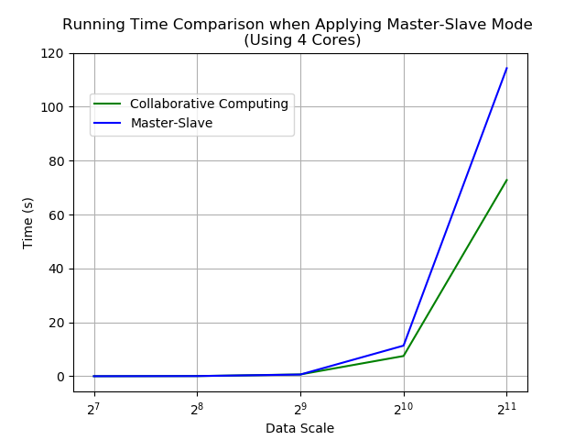
用时（秒） |  | 矩阵维度
 |  | 128 | 256 | 512 | 1024 | 2048
计算模式 | 主从模式 | 0.0178633 | 0.081084 | 0.72291 | 10.19026 | 123.906
计算模式 | 协同计算 | 0.00772738 | 0.062777 | 0.660287 | 7.50298 | 72.8096

协同计算的效率大约是主从模式的4/3倍。上述结果说明，在大规模数据计算时，通信成本相对计算成本影响较小，可以忽略。

5.实验心得
1.改用Scatter分配数据后，每个进程分配的部分矩阵具有完全相等的规模。因此。记comm_sz为进程数，矩阵的维度需要是comm_sz的倍数。我们将矩阵的维度扩展到comm_sz的倍数，多余的部分用0填充，保证正确性。
2.改用Scatter分配数据后，计算任务平均地分配给每一个进程，所以主进程不仅要分发收集结果，也要参与计算。起初我没有注意到这个情况，而将矩阵按(comm_sz-1)的倍数填充维度，导致分发的不平均。如果分发的行数不够，就不能保证结果正确；如果分发的行数超出，就会出现很多不同类型的内存错误（大多都源于free时内存泄漏等原因）。调这个bug很有意思，在调整指令执行顺序（比如delete的先后），调整进程数和矩阵维度时都会报不同类型的错误信息，使人误入歧途。
3.通信接口使用Send/Recv时，进程编号要管理好。另外，因为主进程不能和自己通信，如果主进程还要参与局部计算，需要通过拷贝的方式获得部分矩阵，要对应进行特定设计。

6.附录
- 按行并行，并使用Send-Recv
#include <mpi.h>
#include <iostream>
#include <cstdlib>
#include <ctime>
using namespace std;
const int N = 317; // 随便写的，随机数位于[0, N]之间

void matGene(int *A, int row, int column){
srand(time(NULL));
for (int i = 0; i < row; i++)
for (int j = 0; j < column; j++)
A[i * row + j] = rand() % N; //A[i][j]
}

void matMulti(int *A, int *B, int*C, int row, int n){
for (int i = 0; i < row; i++){
for (int j = 0; j < n; j++){
C[i*n + j] = 0;
for (int k = 0; k < n; k++)
C[i*n + j] = A[i*n + k] * B[k*n + j];
}
}
}

int main(int argc, char *argv[]){
// Sorry but Only Deal With Square Matrixs

// To Run:
// mpicxx matrix_multi.cpp
// mpiexec -n comm_sz ./a.out mat_dim

// Calculate Parameters Definition
int n = atoi(argv[1]); // matrix dimension
int beginRow, endRow; // the range of rows calculating in certain process
double beginTime, endTime; // time record

// MPI Common Head
int my_rank = 0, comm_sz = 0;
MPI_Init(&argc, &argv);
MPI_Comm_rank(MPI_COMM_WORLD, &my_rank);
MPI_Comm_size(MPI_COMM_WORLD, &comm_sz);
MPI_Status status;

if (comm_sz == 1){ // no parallel
// Prepare data
int* A = new int[n * n];
int* B = new int[n * n];
int* C = new int[n * n];
matGene(A, n, n);
matGene(B, n, n);

// Calculate C[i][j] & Time
beginTime = MPI_Wtime();
matMulti(A, B, C, n, n);
endTime = MPI_Wtime();
cout << "Time: " << endTime - beginTime << endl;

// End
delete[] A;
delete[] B;
delete[] C;
}

else{ // parallel: main process collect the result, others calculate for result of "each_row" rows

int each_row = n / (comm_sz - 1);

if (my_rank == 0){ // process 0: main process, data distribution & collect calculate results
// Prepare data
int* A = new int[n * n];
int* B = new int[n * n];
int* C = new int[n * n];
matGene(A, n, n);
matGene(B, n, n);

beginTime = MPI_Wtime();

// Send: A[beginRow:endRow, :], whole B
// beginRow = each_row * (my_rank-1), endRow = each_row * my_rank;
for (int i = 0; i < comm_sz-1; i++){
beginRow = each_row * i, endRow = each_row * (i + 1);
MPI_Send(&A[beginRow * n + 0], each_row * n, MPI_INT, i + 1, 1, MPI_COMM_WORLD);
MPI_Send(&B[0 * n + 0], n * n, MPI_INT, i + 1, 2, MPI_COMM_WORLD);
// cout << "I am alive in sending data to process " << i << endl;
}

// Recv: C[beginRow:endRow, :]
for (int i = 0; i < comm_sz-1; i++){
MPI_Recv(&C[beginRow * n + 0], each_row*n, MPI_INT, i + 1, 3, MPI_COMM_WORLD, &status);
// cout << "I am alive in receiving data from process " << i << endl;
}

endTime = MPI_Wtime();
cout << "Time: " << endTime - beginTime << endl;

delete[] A;
delete[] B;
delete[] C;
}

if (my_rank != 0){ // other processes: calculate A * B

// beginRow = each_row * (my_rank-1), endRow = each_row * my_rank;

int* A = new int[each_row * n]; // A[beginRow:endRow, :]
int* B = new int[n * n];
int* C = new int[each_row * n]; // C[beginRow:endRow, :]

MPI_Recv(&A[0 * n + 0], each_row * n, MPI_INT, 0, 1, MPI_COMM_WORLD, &status);//从A[0][0]和B[0][0]开始接受
MPI_Recv(&B[0 * n + 0], n * n, MPI_INT, 0, 2, MPI_COMM_WORLD, &status);

matMulti(A, B, C, each_row, n);

// cout << "Hello and I am process " << my_rank << endl;

MPI_Send(&C[0 * n + 0], each_row*n, MPI_INT, 0, 3, MPI_COMM_WORLD);//起始地址是C[my_rank-1][0],大小是each_row*n

delete[] A;
delete[] B;
delete[] C;
}
}

MPI_Finalize();
return 0;
}

- 按行并行，并使用Scatter-Gather
#include <mpi.h>
#include <iostream>
#include <cstdlib>
#include <ctime>
using namespace std;

// To Run:
// mpicxx matrix_multi_improvement1.cpp
// mpiexec -n 4 ./a.out 64

// Improvement 1:
// Matrix A: different processes deal with different components, so Scatter instead of Send/Recv
// Matrix B: Shared by all processes, so Bcast instead of Send/Recv
// Matrix C: receive different components from different processes, so Gather instead of Send/Recv
// Main process should also involve in calculation

void matGene(int *A, int size, int actual_size){
// actual size: the matrix we use may have a larger dimension than n * n
for (int i = 0; i < actual_size; i++){
for (int j = 0; j < actual_size; j++){
if(i < size && j < size) A[i * actual_size + j] = rand() % 5; //A[i][j]
else A[i * actual_size + j] = 0;
}
}
}

void matMulti(int *A, int *B, int*C, int row, int n){
for (int i = 0; i < row; i++){
for (int j = 0; j < n; j++){
C[i*n + j] = 0;
for (int k = 0; k < n; k++)
C[i*n + j] += A[i*n + k] * B[k*n + j];
}
}
}

int main(int argc, char *argv[]){
// Only Deal With Square Matrixs

// Calculate Parameters Definition
int n = atoi(argv[1]); // matrix dimension
// int beginRow, endRow; // the range of rows calculating in certain process
double beginTime, endTime; // time record
srand(time(NULL));

// MPI Common Head
int my_rank = 0, comm_sz = 0;
MPI_Init(&argc, &argv);
MPI_Comm_rank(MPI_COMM_WORLD, &my_rank);
MPI_Comm_size(MPI_COMM_WORLD, &comm_sz);
MPI_Status status;

if (comm_sz == 1){ // no parallel
// Prepare data
int* A = new int[n * n + 2];
int* B = new int[n * n + 2];
int* C = new int[n * n + 2];
int saveN = n;
matGene(A, saveN, n);
matGene(B, saveN, n);

// Calculate C[i][j] & Time
beginTime = MPI_Wtime();
matMulti(A, B, C, n, n);
endTime = MPI_Wtime();
cout << "Time: " << endTime - beginTime << endl;

// Output
/*
cout << "A" << endl;
for(int i = 0; i < saveN; i++){
for(int j = 0; j < saveN; j++)
cout << A[i * n + j] << " ";
cout << endl;
}

cout << "B" << endl;
for(int i = 0; i < saveN; i++){
for(int j = 0; j < saveN; j++)
cout << B[i * n + j] << " ";
cout << endl;
}

cout << "C" << endl;
for(int i = 0; i < saveN; i++){
for(int j = 0; j < saveN; j++)
cout << C[i * n + j] << " ";
cout << endl;
}
*/

delete[] A;
delete[] B;
delete[] C;
}

else{ // parallel: main process collect the result and also involve in calculation

int saveN = n;

// must equal scatter: actual n is bigger than input
if(n % comm_sz != 0){
n -= n % comm_sz;
n += comm_sz;
}

int each_row = n / comm_sz;

// Matrixs
int* A = new int[n * n + 2];
int* B = new int[n * n + 2];
int* C = new int[n * n + 2];
// beginRow = each_row * (my_rank-1), endRow = each_row * my_rank;
int* partA = new int[each_row * n + 2]; // A[beginRow:endRow, :]
int* partC = new int[each_row * n + 2]; // C[beginRow:endRow, :]

if (my_rank == 0){

// Prepare data
cout << "n = " << n << endl;
matGene(A, saveN, n);
matGene(B, saveN, n);

beginTime = MPI_Wtime();

}

// data distribution & calculate results & collect

// Send: Scatter A, Bcast whole B
MPI_Scatter(&A[0 * n + 0], each_row * n, MPI_INT, &partA[0 * n + 0], each_row * n, MPI_INT, 0, MPI_COMM_WORLD);
MPI_Bcast(&B[0 * n + 0], n * n, MPI_INT, 0, MPI_COMM_WORLD);

// All processes involve calculation
matMulti(partA, B, partC, each_row, n);

// Recv: Gather C
MPI_Gather(&partC[0 * n + 0], each_row * n, MPI_INT, &C[0 * n + 0], each_row * n, MPI_INT, 0, MPI_COMM_WORLD);

if (my_rank == 0){

endTime = MPI_Wtime();
cout << "Time: " << endTime - beginTime << endl;

// Output

/*

cout << "A" << endl;
for(int i = 0; i < saveN; i++){
for(int j = 0; j < saveN; j++)
cout << A[i * n + j] << " ";
cout << endl;
}

cout << "B" << endl;
for(int i = 0; i < saveN; i++){
for(int j = 0; j < saveN; j++)
cout << B[i * n + j] << " ";
cout << endl;
}

cout << "C" << endl;
for(int i = 0; i < saveN; i++){
for(int j = 0; j < saveN; j++)
cout << C[i * n + j] << " ";
cout << endl;
}

*/

}

// if(my_rank != 0)
if(true){
delete[] A;
delete[] B;
delete[] C;
delete[] partA;
delete[] partC;
}
else{
delete[] A;
cout << "Delete A in " << my_rank << endl;
delete[] B;
cout << "Delete B in " << my_rank << endl;
delete[] C;
cout << "Delete C in " << my_rank << endl;
delete[] partA;
cout << "Delete partA in " << my_rank << endl;
delete[] partC;
cout << "Delete partC in " << my_rank << endl;
}

}

MPI_Finalize();
return 0;
}

- 分块并行的普通实现
#include <mpi.h>
#include <iostream>
#include <cstdlib>
#include <ctime>
#include <cmath>
using namespace std;

// To Run:
// mpicxx matrix_multi_improvement2.cpp
// mpiexec -n 4 ./a.out 64

// Improvement 2: Block Multiplication, based on Original
// Main process: process 0, data distribution & collect calculate results, no calculation
// Others: calculate for a block of A * B

void matGene(int *A, int size, int actual_size){
// actual size: the matrix we use may have a larger dimension than n * n
for (int i = 0; i < actual_size; i++){
for (int j = 0; j < actual_size; j++){
if(i < size && j < size) A[i * actual_size + j] = 1; //A[i][j]
else A[i * actual_size + j] = 0;
}
}
}

void matMulti(int *A, int *B, int*C, int m, int n, int p){
for (int i = 0; i < m; i++){
for (int j = 0; j < p; j++){
C[i*p + j] = 0;
for (int k = 0; k < n; k++)
C[i*p + j] += A[i*n + k] * B[k*p + j];
}
}
}

int factor(int n){
// return the largest factor that is not larger than sqrt(n)
double sqr_root = sqrt(n);
for(int i = sqr_root; i >= 1; i--){
if(n % i == 0) return i;
}
}

int main(int argc, char *argv[]){
// Only Deal With Square Matrixs

// Calculate Parameters Definition
int n = atoi(argv[1]); // matrix dimension
// int beginRow, endRow; // the range of rows calculating in certain process
double beginTime, endTime; // time record
srand(time(NULL));

// MPI Common Head
int my_rank = 0, comm_sz = 0;
MPI_Init(&argc, &argv);
MPI_Comm_rank(MPI_COMM_WORLD, &my_rank);
MPI_Comm_size(MPI_COMM_WORLD, &comm_sz);
MPI_Status status;

if (comm_sz == 1){ // no parallel
// Prepare data
int* A = new int[n * n + 2];
int* B = new int[n * n + 2];
int* C = new int[n * n + 2];
int saveN = n;
matGene(A, saveN, n);
matGene(B, saveN, n);

// Calculate C[i][j] & Time
beginTime = MPI_Wtime();
matMulti(A, B, C, n, n, n);
endTime = MPI_Wtime();
cout << "Time: " << endTime - beginTime << endl;

// Output

cout << "A" << endl;
for(int i = 0; i < saveN; i++){
for(int j = 0; j < saveN; j++)
cout << A[i * n + j] << " ";
cout << endl;
}

cout << "B" << endl;
for(int i = 0; i < saveN; i++){
for(int j = 0; j < saveN; j++)
cout << B[i * n + j] << " ";
cout << endl;
}

cout << "C" << endl;
for(int i = 0; i < saveN; i++){
for(int j = 0; j < saveN; j++)
cout << C[i * n + j] << " ";
cout << endl;
}

delete[] A;
delete[] B;
delete[] C;
}

else{ // parallel: main process collect the result and also involve in calculation

int saveN = n;

// must equal scatter: actual n is bigger than input
if(n % (comm_sz - 1) != 0){
n -= n % (comm_sz - 1);
n += (comm_sz - 1);
}

int a = (comm_sz - 1) / factor(comm_sz - 1);
int b = factor(comm_sz - 1);
int each_row = n / a;
int each_column = n / b;
if(my_rank == 0) cout << each_row << "\t" << each_column << endl;

if (my_rank == 0){

int* A = new int[n * n + 2];
int* B = new int[n * n + 2];
int* C = new int[n * n + 2];

// Prepare data
cout << "n = " << n << endl;
matGene(A, saveN, n);
matGene(B, saveN, n);

beginTime = MPI_Wtime();

// include begin not end
// beginRow = ((my_rank - 1) / b) * each_row, endRow = beginRow + each_row;
// beginColumn = ((my_rank - 1) % b) * each_column, endColumn = beginColumn + each_column;

// Send: A[beginRow:endRow, :], B[:, beginColumn:endColumn]
for(int i = 1; i < comm_sz; i++){
int beginRow = ((i - 1) / b) * each_row;
int beginColumn = ((i - 1) % b) * each_column;
// A: beginRow ~ endRow
MPI_Send(&A[beginRow * n + 0], each_row * n, MPI_INT, i, i, MPI_COMM_WORLD);
// B: n times, once a row
for(int j = 0; j < n; j++){
MPI_Send(&B[j * n + beginColumn], each_column, MPI_INT, i, i * n + j + comm_sz + 2, MPI_COMM_WORLD);;
}
}

// Recv: C[beginRow:endRow, beginColumn:endColumn]
for (int i = 1; i < comm_sz; i++){
int beginRow = ((i - 1) / b) * each_row;
int endRow = beginRow + each_row;
int beginColumn = ((i - 1) % b) * each_column;
for(int j = beginRow; j < endRow; j++){
MPI_Recv(&C[j * n + beginColumn], each_column, MPI_INT, i, each_row * i + (j - beginRow), MPI_COMM_WORLD, &status);
}
}

endTime = MPI_Wtime();
cout << "Time: " << endTime - beginTime << endl;

// Output

/*

cout << "A" << endl;
for(int i = 0; i < saveN; i++){
for(int j = 0; j < saveN; j++)
cout << A[i * n + j] << " ";
cout << endl;
}

cout << "B" << endl;
for(int i = 0; i < saveN; i++){
for(int j = 0; j < saveN; j++)
cout << B[i * n + j] << " ";
cout << endl;
}

cout << "C" << endl;
for(int i = 0; i < saveN; i++){
for(int j = 0; j < saveN; j++)
cout << C[i * n + j] << " ";
cout << endl;
}

*/

delete[] A;
delete[] B;
delete[] C;

}

else{

int* partA = new int[each_row * n + 2]; // A[beginRow:endRow, :]
int* partB = new int[n * each_column + 2]; // B[:, beginColumn:endColumn]
int* partC = new int[each_row * each_column + 2]; // C[beginRow:endRow, beginColumn:endColumn]

// include begin not end
// beginRow = ((my_rank - 1) / b) * each_row, endRow = beginRow + each_row;
// beginColumn = ((my_rank - 1) % b) * each_column, endColumn = beginColumn + each_column;

// Recv: partA, partB
MPI_Recv(&partA[0 * n + 0], each_row * n, MPI_INT, 0, my_rank, MPI_COMM_WORLD, &status);
for(int j = 0; j < n; j++){
MPI_Recv(&partB[j * each_column + 0], each_column, MPI_INT, 0, my_rank * n + j + comm_sz + 2, MPI_COMM_WORLD, &status);
}

matMulti(partA, partB, partC, each_row, n, each_column);

// Send: partC
for(int j = 0; j < each_row; j++){
MPI_Send(&partC[j * each_column + 0], each_column, MPI_INT, 0, each_row * my_rank + j, MPI_COMM_WORLD);
}

delete[] partA;
delete[] partB;
delete[] partC;
}

}

MPI_Finalize();
return 0;
}

- 分块并行的Cannon算法实现
#include <mpi.h>
#include <iostream>
#include <cstdlib>
#include <ctime>
#include <cmath>
using namespace std;

// To Run:
// mpicxx matrix_multi_improvement2.cpp
// mpiexec -n 4 ./a.out 64

// Improvement 3: Cannon Algorithm + Block Multiplication, based on Improvement 2
// Main process: process 0, data distribution & collect calculate results, no calculation
// Others: calculate for a block of A * B

void matGene(int *A, int size, int actual_size){
// actual size: the matrix we use may have a larger dimension than n * n
for (int i = 0; i < actual_size; i++){
for (int j = 0; j < actual_size; j++){
if(i < size && j < size) A[i * actual_size + j] = 1; //A[i][j]
else A[i * actual_size + j] = 0;
}
}
}

void matMulti(int *A, int *B, int*C, int m, int n, int p){
for (int i = 0; i < m; i++){
for (int j = 0; j < p; j++){
C[i*p + j] = 0;
for (int k = 0; k < n; k++)
C[i*p + j] += A[i*n + k] * B[k*p + j];
}
}
}

int factor(int n){
// return the largest factor that is not larger than sqrt(n)
double sqr_root = sqrt(n);
for(int i = sqr_root; i >= 1; i--){
if(n % i == 0) return i;
}
}

int main(int argc, char *argv[]){
// Only Deal With Square Matrixs

// Calculate Parameters Definition
int n = atoi(argv[1]); // matrix dimension
// int beginRow, endRow; // the range of rows calculating in certain process
double beginTime, endTime; // time record
srand(time(NULL));

// MPI Common Head
int my_rank = 0, comm_sz = 0;
MPI_Init(&argc, &argv);
MPI_Comm_rank(MPI_COMM_WORLD, &my_rank);
MPI_Comm_size(MPI_COMM_WORLD, &comm_sz);
MPI_Status status;

if (comm_sz == 1){ // no parallel
// Prepare data
int* A = new int[n * n + 2];
int* B = new int[n * n + 2];
int* C = new int[n * n + 2];
int saveN = n;
matGene(A, saveN, n);
matGene(B, saveN, n);

// Calculate C[i][j] & Time
beginTime = MPI_Wtime();
matMulti(A, B, C, n, n, n);
endTime = MPI_Wtime();
cout << "Time: " << endTime - beginTime << endl;

// Output
/*
cout << "A" << endl;
for(int i = 0; i < saveN; i++){
for(int j = 0; j < saveN; j++)
cout << A[i * n + j] << " ";
cout << endl;
}

cout << "B" << endl;
for(int i = 0; i < saveN; i++){
for(int j = 0; j < saveN; j++)
cout << B[i * n + j] << " ";
cout << endl;
}

cout << "C" << endl;
for(int i = 0; i < saveN; i++){
for(int j = 0; j < saveN; j++)
cout << C[i * n + j] << " ";
cout << endl;
}
*/
delete[] A;
delete[] B;
delete[] C;
}

else{ // parallel: main process collect the result and also involve in calculation

int a = sqrt(comm_sz);
if(my_rank == 0 && comm_sz != a * a){
cout << "Not Full Square" << endl;
MPI_Finalize();
return 0;
}

int saveN = n;
// must equal scatter: actual n is bigger than input
if(n % a != 0){
n -= n % a;
n += a;
}

int each_row = n / a;
int* partA = new int[each_row * each_row + 2]; // A[beginRow:endRow, :]
int* partB = new int[each_row * each_row + 2]; // B[:, beginColumn:endColumn]
int* partC = new int[each_row * each_row + 2]; // C[beginRow:endRow, beginColumn:endColumn]
int beginRow, beginColumn;

// Data generation
if (my_rank == 0){
// Prepare data
cout << "n = " << n << endl;
int* A = new int[n * n + 2];
int* B = new int[n * n + 2];
int* C = new int[n * n + 2];
matGene(A, saveN, n);
matGene(B, saveN, n);
for(int ii = 0; ii < n; ii++){
for(int jj = 0; jj < n; jj++){
C[ii * n + jj] = 0;
}
}
beginTime = MPI_Wtime();
}

for(int k = 0; k < a; k++){
int begin_part = k * each_row;
// k th
// Data Distributing
if (my_rank == 0){
for(int i = 0; i < comm_sz; i++){
// A[beginRow:beginRow+each_row, begin_part:begin_part+each_row]
// B[begin_part:begin_part+each_row, beginColumn:beginColumn+each_row]
beginRow = (i / a) * each_row;
beginColumn = (i % a) * each_row;
if(i == 0){
// Copy Straightly
for(int ii = 0; ii < each_row; ii++){
for(int jj = 0; jj < each_row; jj++){
partA[ii * each_row + jj] = A[(beginRow + ii) * n + (begin_part + jj)];
partB[ii * each_row + jj] = A[(begin_part + ii) * n + (beginColumn + jj)];
}
}
}
else{
for(int ii = 0; ii < each_row; ii++){
MPI_Send(&A[(beginRow + ii) * n + begin_part], each_row, MPI_INT, i, i * each_row + ii, MPI_COMM_WORLD);
MPI_Send(&B[(begin_part + ii) * n + beginColumn], each_row, MPI_INT, i, (i + comm_sz) * each_row + ii, MPI_COMM_WORLD);
}
}
}
}
// Data Receive
if (my_rank != 0){
for(int ii = 0; ii < each_row; ii++){
MPI_Recv(&partA[ii * each_row + 0], each_row, MPI_INT, 0, my_rank * each_row + ii, MPI_COMM_WORLD, &status);
MPI_Recv(&partB[ii * each_row + 0], each_row, MPI_INT, 0, (my_rank + comm_sz) * each_row + ii, MPI_COMM_WORLD, &status);
}
}
// Calculation
matMulti(partA, partB, partC, each_row, each_row, each_row);
// Return Result
if (my_rank != 0){
for(int ii = 0; ii < each_row; ii++){
MPI_Send(&partC[ii * each_row + 0], each_row, MPI_INT, 0, (my_rank + 2 * comm_sz) * each_row + ii, MPI_COMM_WORLD);
}
}
// Data Collection & add
if (my_rank == 0){
// C[beginRow:beginRow+each_row, beginColumn:beginColumn+each_row]
for(int i = 0; i < comm_sz; i++){
beginRow = (i / a) * each_row;
beginColumn = (i % a) * each_row;
if(i == 0){
// Copy Straightly
for(int ii = 0; ii < each_row; ii++){
for(int jj = 0; jj < each_row; jj++){
C[(beginRow + ii) * n + (beginColumn + jj)] += partC[ii * each_row + jj];
}
}
}
else{
for(int ii = 0; ii < each_row; ii++){
int* tmp_partC = new int[each_row + 2];
MPI_Recv(&tmp_partC[0], each_row, MPI_INT, i, (i + 2 * comm_sz) * each_row + ii, MPI_COMM_WORLD, &status);
for(int jj = 0; jj < each_row; jj++){
C[(beginRow + ii) * n + (beginColumn + jj)] += tmp_partC[jj];
}
delete[] tmp_partC;
}
}
}
}
}

if (my_rank == 0){
endTime = MPI_Wtime();
cout << "Time: " << endTime - beginTime << endl;
// Output
/*
cout << "A" << endl;
for(int i = 0; i < saveN; i++){
for(int j = 0; j < saveN; j++)
cout << A[i * n + j] << " ";
cout << endl;
}
cout << "B" << endl;
for(int i = 0; i < saveN; i++){
for(int j = 0; j < saveN; j++)
cout << B[i * n + j] << " ";
cout << endl;
}
cout << "C" << endl;
for(int i = 0; i < saveN; i++){
for(int j = 0; j < saveN; j++)
cout << C[i * n + j] << " ";
cout << endl;
}
*/
delete[] A;
delete[] B;
delete[] C;
}
delete[] partA;
delete[] partB;
delete[] partC;
}
MPI_Finalize();
return 0;
}

