Game documentation and HowTo guide.
Matching Game Template

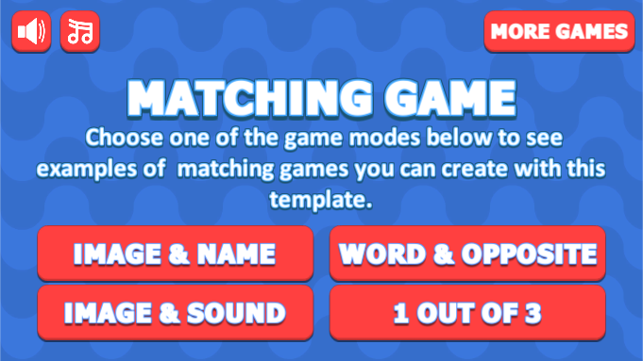

This document contains:

Package Description and features 2
Try the Webplayer Error! Bookmark not defined.
Try the WebGL Error! Bookmark not defined.
Credits 3
Overview of the game's library contents 3
Customization Guide 4
Getting started 4
The Game Controller 4
Adding pairs to the game 6
How pairs are organized 7
Editing the default object in the pair 9
UnityAds Integration 10
Frequently Asked Questions 12
Does this package work on mobile? 12
My sprites are not showing on iOS 12
How to change font in the game? 12
More games by Puppeteer 14

Package Description and features
Matching Game Template is an action packed game full of challenge and fun. The game is ready to release straight out of the box, and it can also be easily customized to make it even more engaging to your players. The game supports PC/Mac, iOS, Android, etc. It can be played with the mouse or touch controls.

How to Play?

Click on one of the objects and then match it to another object. Clear the all pairs to advance to the next level. Match all pairs to win the game!

Features:
- Game ready for release straight out of the box, just build and play!
- Works on all platforms, PC, Mac, iOS, Android, etc
- Supports multiple resolutions and aspect ratios, automatically.
- Supports Mouse, Keyboard, Gamepad, and Touch controls.
- Easily customizable with lots of options to control game difficulty.
- Great learning resource with commented scripts and documentation.
- All assets included: graphics, sounds, and code.

Current version 1.3

Update history

1.3 (23.08.2021)
- New game mode, one vs multiple answer, and you must choose one!
- Fresh new look for game UI, and portrait/landscape layout
1.22 (04.06.2019)
- Fixed the Image-Image mode so that you can match any pair of images, even if they are not the same.
1.15 (11.01.2018)
- Added new game mode that has pairs of Images and Images. This allows you to match two images to each other based on their names.

1.10 (19.10.2017)
- Added new game mode that has pairs of Images and Sounds. You can select a sound to listen to, and then try to match it to the correct image in the other group.
- Tuned gamepad/keyboard button selection to work with the new game mode too.
- Updated package to Unity versions 5.5.0, 5.6.0, and 2017.
- Fixed sound/music tags.

1.05 (20.10.2016)
- Gave the game graphics an overhaul with a more colorful presentation, and a frame to hold the images and text in a more presentable way within the grid.
- Fixed gamepad/keyboard support, so now you can correctly select the objects on screen and the menu.
- Fixed a case in which the Text/Text game mode gets stuck on mobile devices.
- Made it so that when using gamepad/keyboard you don’t need to go through the empty slots, and will only move between visible objects. This makes the game easier to play with gamepad/keyboard.

Credits
The main font used is Fava Black by Themnific

The sounds are courtesy of the free sound project.
Music is River Meditation by Jason Shaw (Public Domain)
Credits go to these authors for their great sound samples: xyzr-kx, isaac200000, harris85, speedygonzo, wagna, jimhancock, sforsman
Please rate my file, I’d appreciate it

Overview of the game's library contents
Let's take a look inside the game files. Open the main MGTAssets folder using Unity3D 5.3.0 or newer. Take a look at the project library, usually placed on the right or bottom side of the screen. Here are the various folders inside:

- Animations: Holds the animation clips made with Unity’s built-in animation system.
- FLA: Holds the object graphics made with Flash CS3. These are vector graphics than can be easily scaled without loss of quality and then exported as PNG to be used in Unity.
- Fonts: Holds the font used in the game.
- Prefabs: Holds all the prefabs used in the game. These are distributed to various folders for easier access, Buttons, Enemies, Objects, etc. It also holds all the canvases in the game which are used to hold buttons and other UI elements.
- Scenes: The first scene that runs in the game is MainMenu. From this scene you can get to the Game scene.
- Scripts: Holds all the scripts used in the game. Each prefab contains one or more of these scripts.
- Sounds: Holds all the sounds used in the game. Correct, Wrong, etc
- Textures: Holds all the textures used in the game which are used as sprites in Unity.

Customization Guide

Getting started
Matching Game Template (MGT) is considered a complete project, and as such is supposed to work as the starting point of your planned game, rather than an addition to an existing project. That said, you may of course pick and choose some of the scripts/models to import into your existing project, but MGT works best as a starter kit which you can customize any part of to your liking.

The Game Controller
The Game Controller is the main prefab that controls all the progress of the game from start to finish. It controls the UI of the game, creates pairs and checks the level up condition.
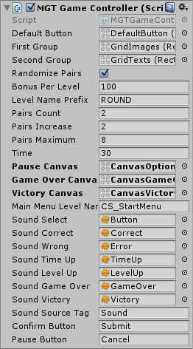
Default Button – The default button that displays an image or a text for a pair. Read more about it here.
First Group – This holds the first half of each pair. Read more about groups here.
Randomize Pairs – Randomize the list of pairs so that we don't get the same pairs each time we start the game.
Bonus Per Level – How many points we get for each matched pair. This value is multiplied by the number of the level we are on. Ex: Level 1 give 100 points, Level 2 gives 200 points.
Level Name Prefix – The name of a level, followed by the number of a level.
Pairs Count – The number of pairs in the first level.
Pairs Increase – The number of pairs added to the game in each level.
Pairs Maximum – The maximum allowed number of pairs in the game.
Time – How many seconds are left before game is over.
Canvases – These UI screens are assigned from the scene for each level.
Main Menu Level Name – The level of the main menu that can be loaded after the game ends.
Confirm Button – The keyboard/gamepad button that will restart the game after game over.
Pause Button – The keyboard/gamepad button that pauses the game.
User Interface – Various canvases for the UI, assign them from the scene.
Sounds – Various sounds that play during the game.
Sound Source Tag – The audio source from which the Game Over sound plays.

Adding pairs to the game
There are two types of pairs you can have in the game, Image – Text or Text – Text. In order to use a certain pair type you must attach the correct component to the gamecontroller object. The two game examples already have the pairs set so you can use them as a basis for your own game, and just fill out the pairs you want.

Image – Text pairs ( Images must be imported as Sprites ):
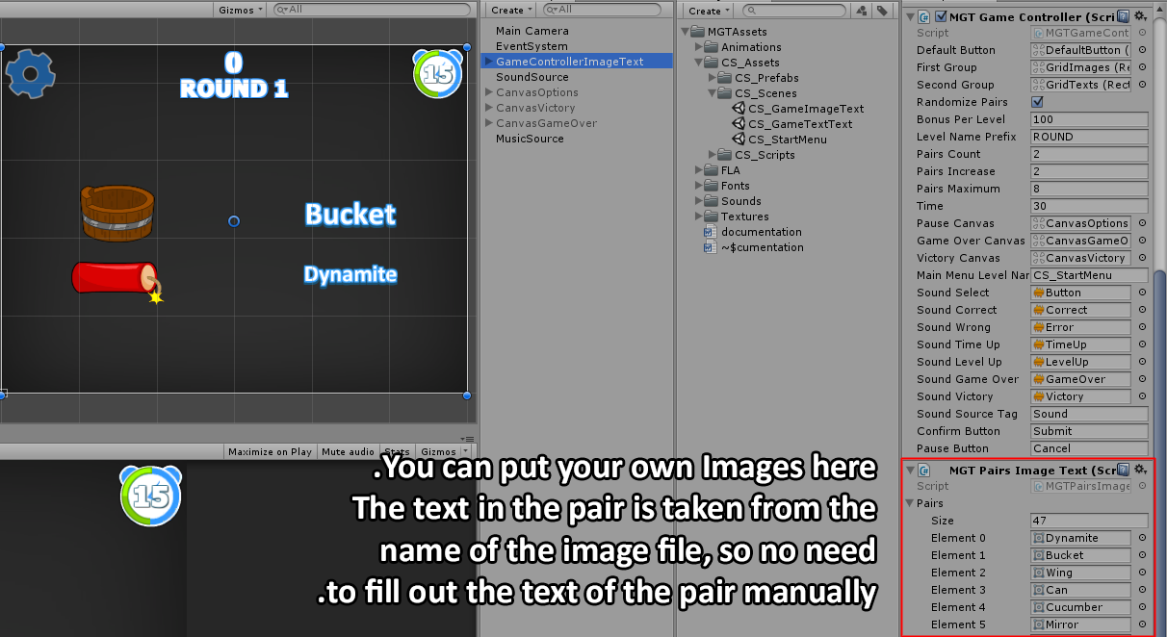

Text – Text pairs:
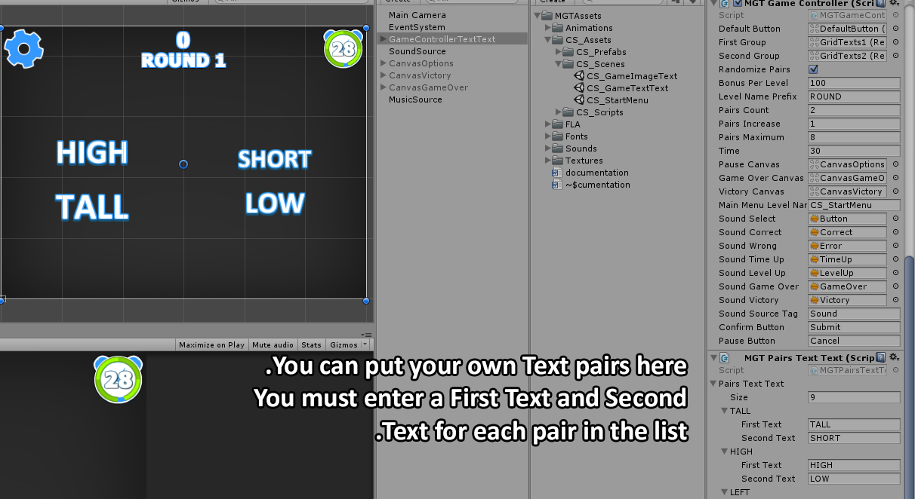

Image – Sound pairs:

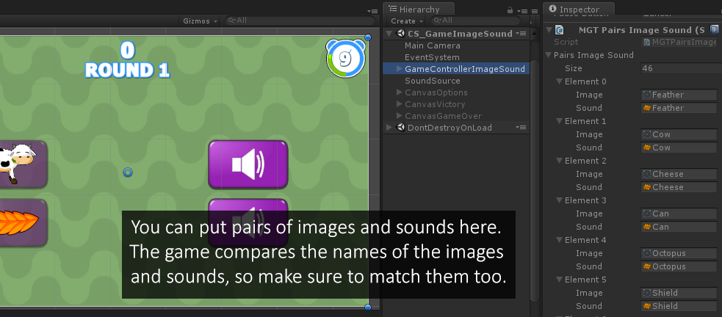

How pairs are organized
Pairs are organized into two groups, each group must be assigned in the gamecontroller. If you take a look at the groups you can see they have a component which organizes the objects into a nice looking grid.
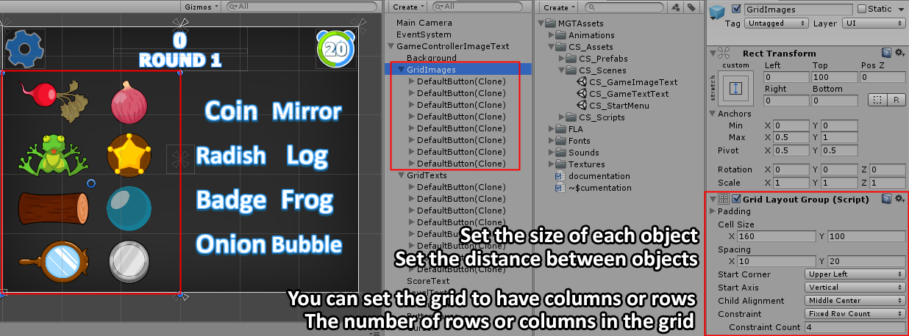

Editing the default object in the pair
Each object in the pairs is made up of the same base object, which contains an image, a text, and button to listen for clicks on it. To take a look at the button and change its appearance, drag it from the project screen into one of the gamecontrollers.
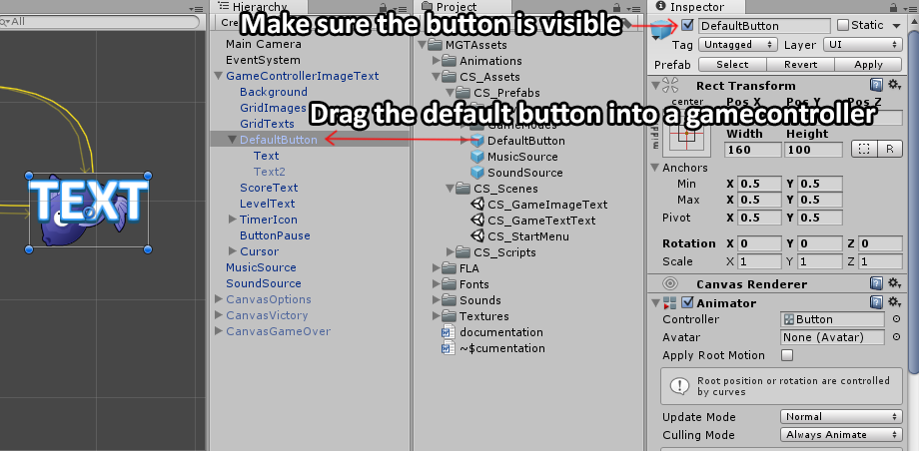

Now you can edit the text of the object. After you are done editing, drag the default button out of the gamecontroller and press the Apply button.
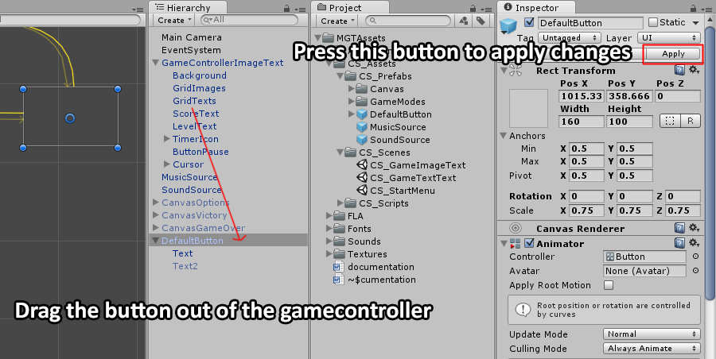

UnityAds Integration
Since Unity 5.2 UnityAds integration has been simplified, here’s how you can have full screen video ads in your game.
This video shows a quick process of integrating UnityAds into your project. In the example we used one of my templates, but it works on all my other templates too.
https://www.youtube.com/watch?v=EQNTgfV35DU
Here is what we did in the process:
- Sign in to your Unity account in order to allow Unity Services such as UnityAds to be activated.
- Open Build Settings and switch the platform to one of the supported ones (iOS, Android).
- Download Puppeteer's UnityAds package from: http://puppeteerinteractive.com/freebies/PUPUnityAds.unitypackage
- Drag the downloaded package into your Unity project, and import it. This UnityAds prefab can be used to display ads every several minutes.
- Drag the prefab into any scene where you want ads to be shown. Make sure to save changes.
- The time check is shared between all prefabs in all scenes, so you will never show too many ads.
- The final step is to activate UnityAds services and get your unique project ID.
- Open the services window and choose your organization, then click create.
- Choose UnityAds from the list and turn it On.
- Choose age group for your project ( Will affect the nature of ads shown ), and save changes.
- While working on your project keep Test Mode activated. But when you are ready to release the final project, switch Test Mode off.
- That's it! Now when you start the game, an ad will be shown after 3 minutes. The ad will never appear during gameplay or post-game screen. Instead, it will wait until the next level load ( restart, main menu, etc ) and then show the ad.

Before releasing a game, make sure you uncheck Enable Test Mode.
For more info about integrating UnityAds read this:
http://unityads.unity3d.com/help/monetization/integration-guide-unity

Frequently Asked Questions

Does this package work on mobile?
Yes, this package has been successfully tested on both Android and iOS devices. The scripts for each lock type include controls for mobile that are detected automatically based on the platform it’s built on.

My sprites are not showing on iOS
Sprite-based textures made with the new Unity 4.3 can sometimes disappear when working on the iOS platform.
You can notice this by opening a scene playing it. When you switch from your current platform to the iOS platform the sprite textures become invisible.
To solve this we must change the texture compression format for iOS. Follow these steps:
- Click on a texture in the project view.
- Click on the override for iPhone button on the right side.
- Change the format to 16bit.
- Click Apply.

How to change font in the game?
To change a font in the game do the following:
Find a font you like and drag the .ttf file over to the Fonts folder in your game.
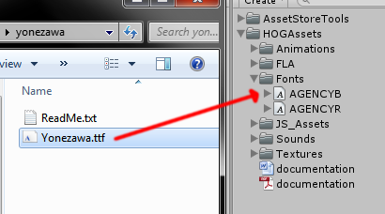
Click on the font you added and edit its attributes. I personally set all my fonts to a high number (and then scale the text object down) so that they look crisper in-game.
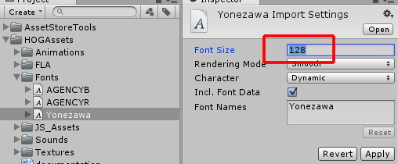
Select any text object in the game and change its font to the new font you have. Sometimes the text might disappear, but it's normal. Just write something in the text box above and it will refresh. Also, make sure you change the text for the shadow; you can select both the main text and its shadow and edit them together.
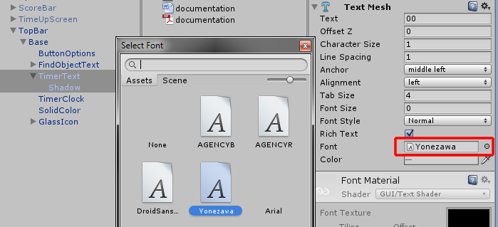

More games by Puppeteer
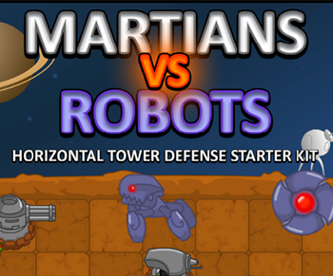
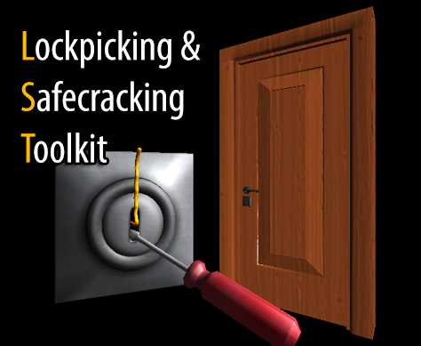
Click here to see the full catalogue of Asset Store files!
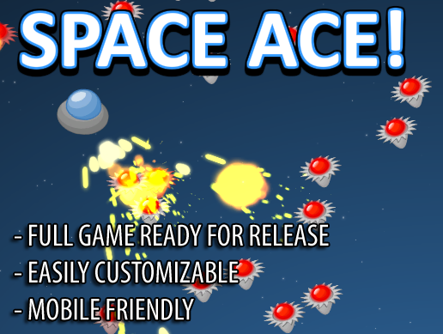
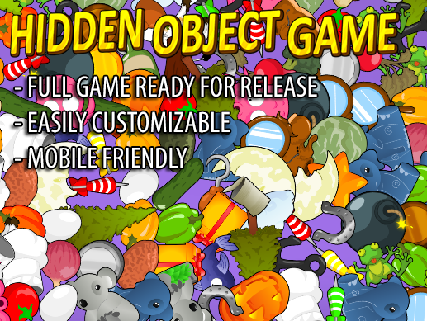

It is highly advised, whether you are a designer or a developer to look further into the code and customize it to your pleasing. See what can be improved upon or changed to make this file work better and faster. Don't hesitate to send me suggestions and feedback to puppeteerint@gmail.com
Follow me on twitter for updates and freebies!
Good luck with your modifications!

