April 22, 2026
- Winterisme6/CS-4440-Website (William Lopez)
- If you guys wanna use the same CSS file, go ahead (William Lopez)
- I also created two different folders for the codes and stuff, just in case you guys wanted to have them separated. If not, you guys can change the folders and files. Fix the directories as you need and wish. (William Lopez)
- I also created this document so we can share progress and comments (William Lopez)
- 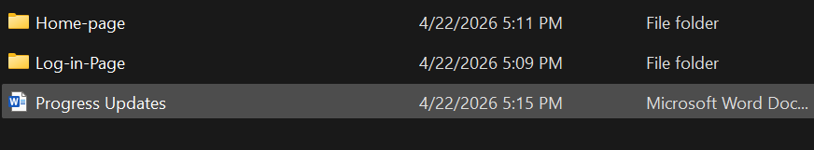
- 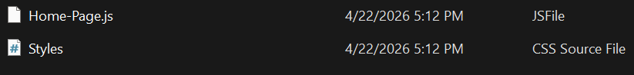
- 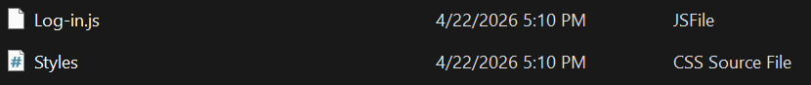
- (William Lopez)
- 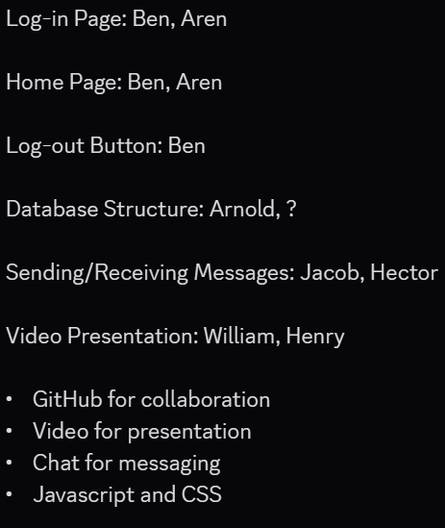
- 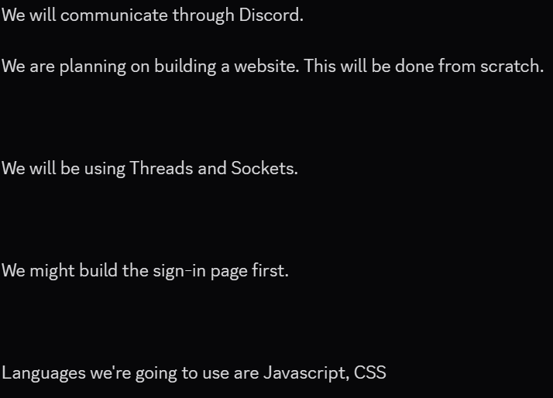
- (William Lopez) 5:23pm
- It seems like I’m the only one showing progress on here, but that’s fine, sorry Ricky. (William Lopez)
- 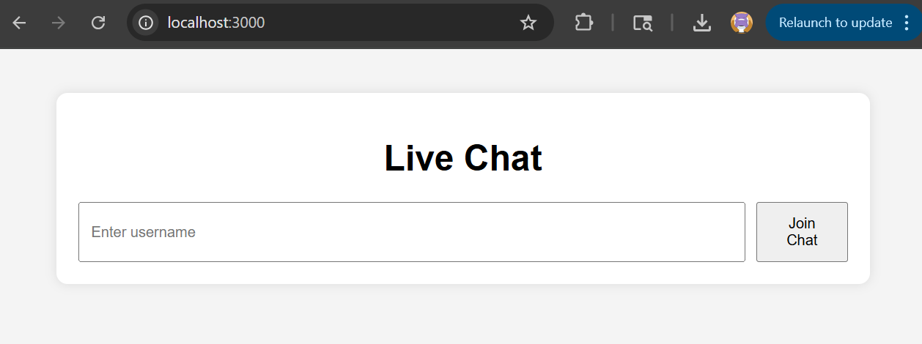
- 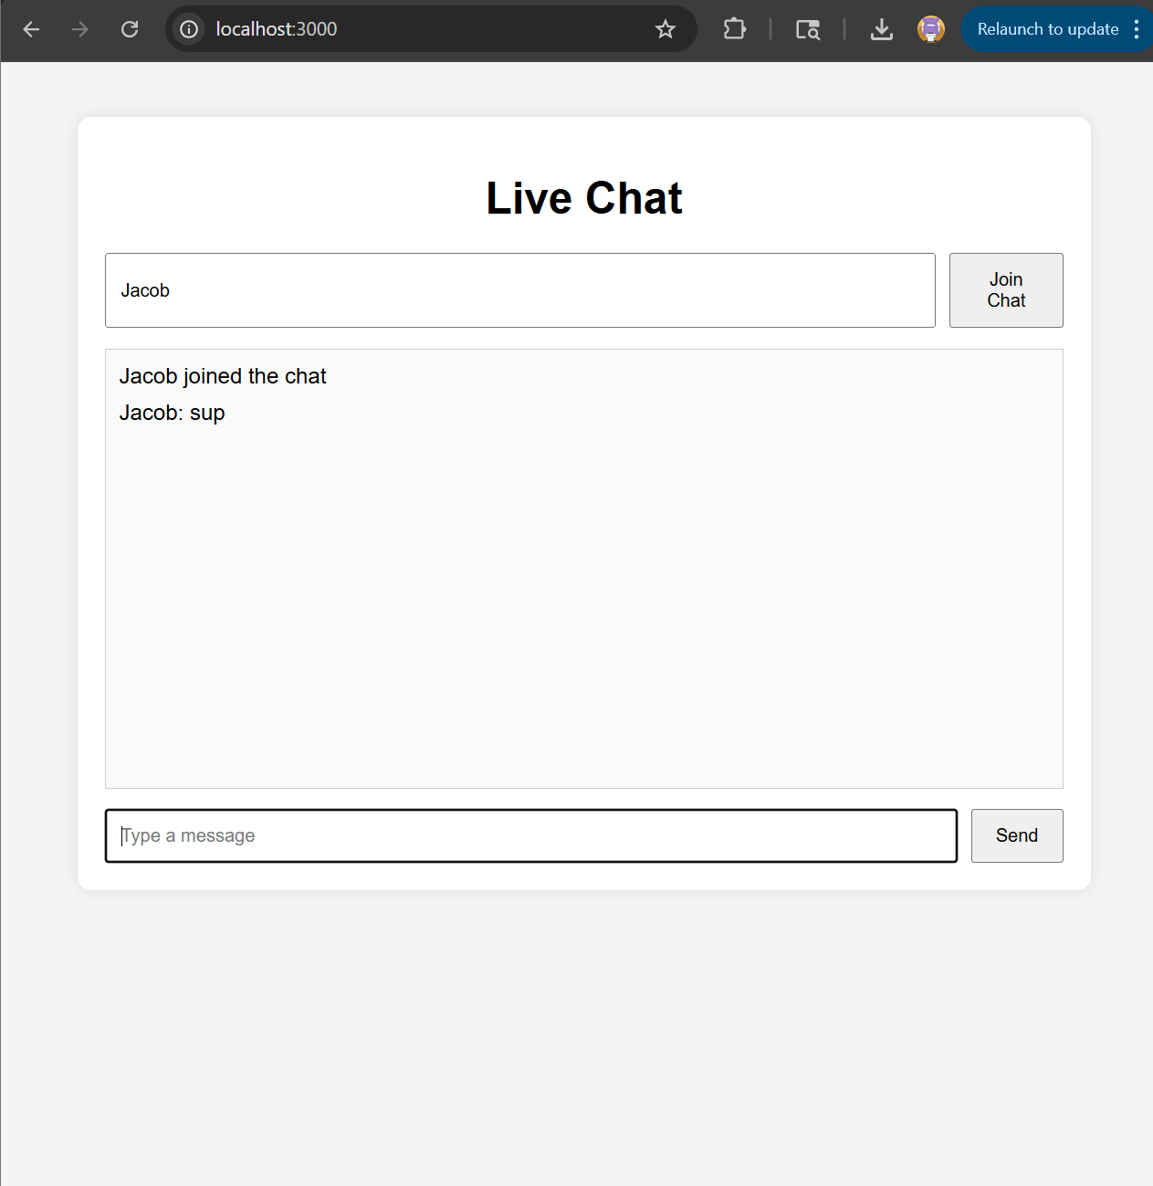
- 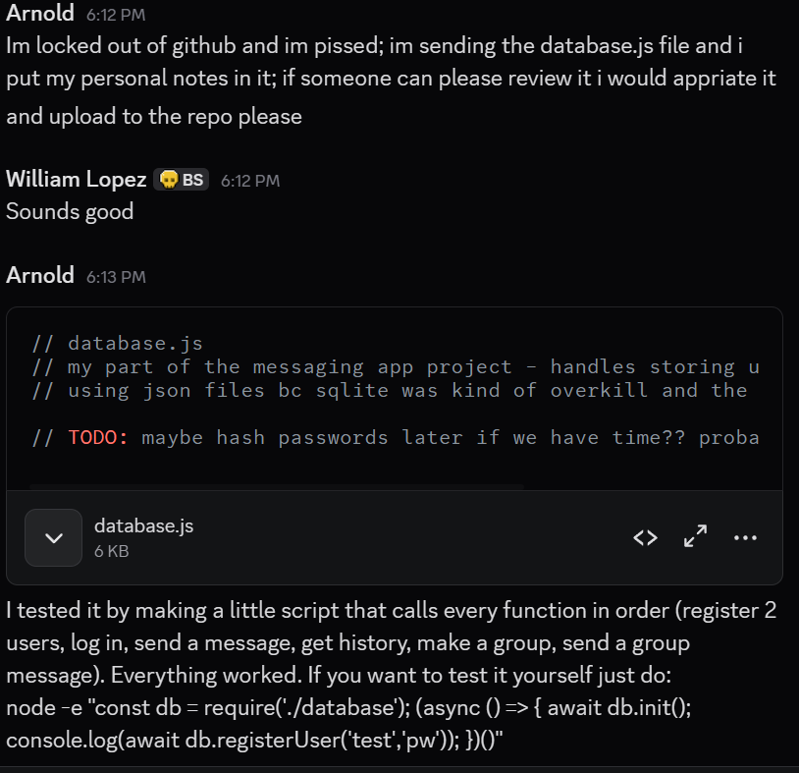
- (William Lopez)
- I don’t know where the database file is supposed to go, so I just randomly placed it. (William Lopez)

