System Statement of Scope

1. Scope Statement

The product of the project will be an android application that will interpret and display data

gathered from the logic cane device developed by Joshua’s Vanderbilt research group.

Users for the product will be

1. Administrators
2. Physical therapists
3. Patients
4. Functionality

What will the product do?

The app will display and visualize data gathered from the logic can in order to provide the patient and therapist useful information.

What are the features?

The app will have a page with dynamic content used to visualize patient data. Users can select which signal they want to view. Descriptive statistics and other features of the window content will be presented. The app must be able to interact with python code in order to analyze the data. The application will also need user authentication including a login page before accessing the data.

Who owns this system?

Joshua’s Vanderbilt research team owns the system.

What will the system look like?

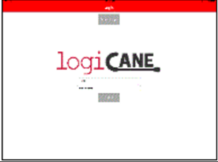

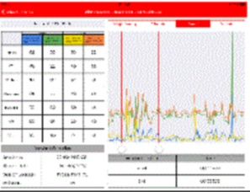

How will information be updated, used modified, and distributed?

The application needs to interpret dynamic data and present it dynamically as well. It will need to update consistently. The app will be distributed through the android development/google play store.

What will be the physical environment of the system?

It will be an android application for used primarily for tablets and phones if possible.