How productivity is measured in current excel file to create the hart in the image below

=SUMIF('Sales Perfromance'!$B$2:$B$201,'Monaco Team stats'!$A$2:$A$10,'Sales Perfromance'!$L$2:$L$201)/SUMIF('Sales Perfromance'!$B$2:$B$201,'Monaco Team stats'!$A$2:$A$10,'Sales Perfromance'!$K$2:$K$201)

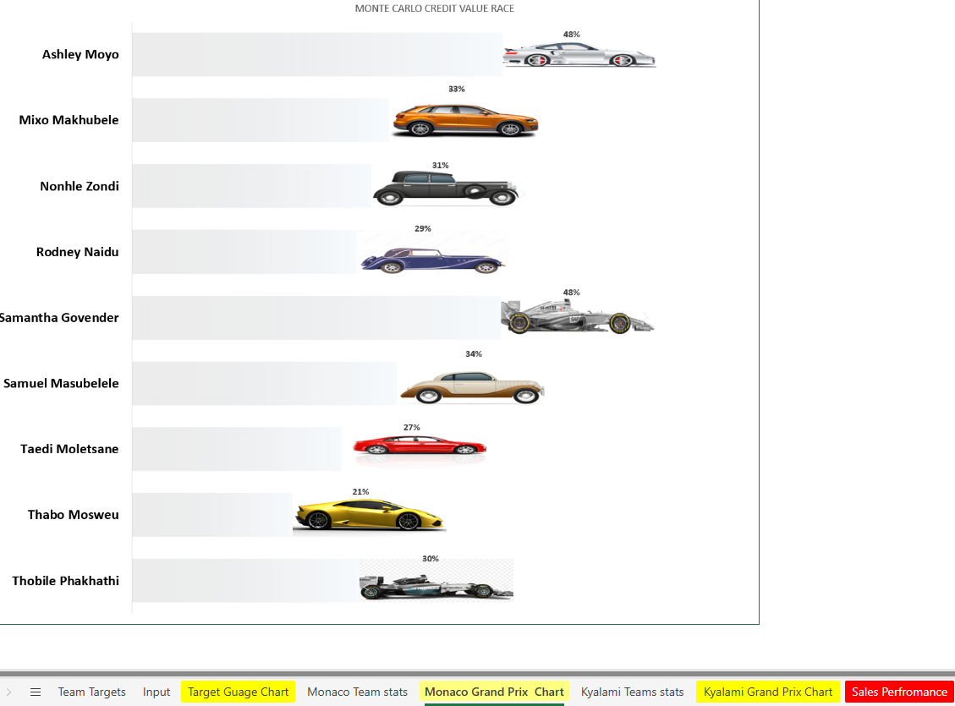

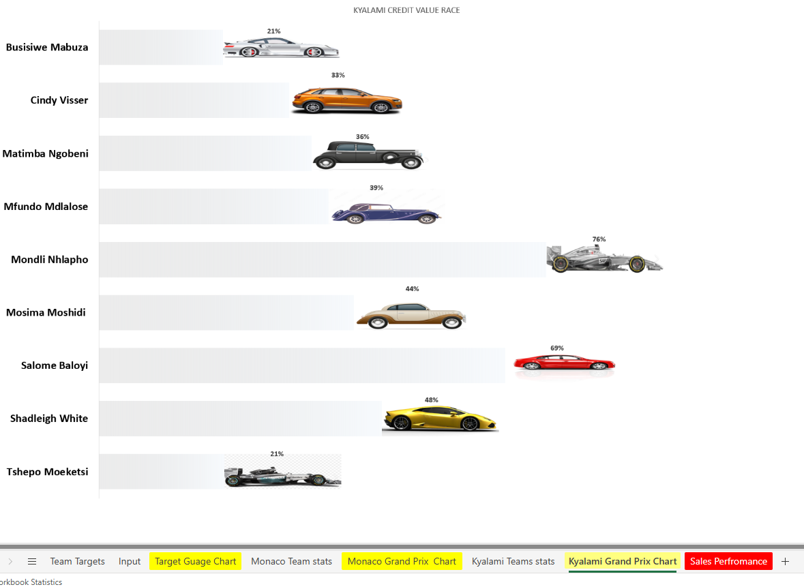

Supervisor names:

|  |
| --- |
| Ashley Moyo |
| Busisiwe Mabuza |
| Cindy Visser |
| Matimba Ngobeni |
| Mfundo Mdlalose |
| Mixo Makhubele |
| Mondli Nhlapho |
| Mosima Moshidi |
| Nonhle Zondi |
| Rodney Naidu |
| Salome Baloyi |
| Samantha Govender |
| Samuel Masubelele |
| Shadleigh White |
| Taedi Moletsane |
| Thabo Mosweu |
| Thobile Phakhathi |
| Tshepo Moeketsi |

Consultants

|  |
| --- |
| Ayanda Delubom |
| Boipelo Zitha |
| Grace Baloyi |
| Koketjo Kekae |
| Lunga Mabona |
| Ngibongiseni Chavango |
| Ntando Sibisi |
| Sibongile Dlali |
| Siphokazi Ndamase |
| Sthandokuhle Mwelase |
| Teboho Tau |
| Zintle Mshengu |
|  |
| Antonaite Mkhatshwa |
| Bhonda Thompson |
| Daphney Legodi |
| Dumisani Mtsweni |
| Karabo Motau |
| Mlungisi Nkidi |
| Mulweli Mushweu |
| Puseletso Mokoena |
| Rorisang Masalesa |
| Thato Moletsane |
| Zamokuhle Mazibuko |
|  |
| Basetsana Rakitla |
| Ivan Mashimbye |
| Mary Tshabalala |
| Mary-Ann Moloto |
| Mbavhalelo Ndou |
| Mokgadi Mathiane |
| Morongwa Rasekgololo |
| Rendani Nephambani |
| Tshwarelo Motlhala |
| Vhugala Davhula |
| Zinhle Mtshweni |
| Zwivhuya Magwara |
|  |
| Kefilwe Mokgotle |
| Kgabo Mokonyama |
| Nozuko Ndamase |
| Shannon Prince |
| Simphiwe Madlabane |
| Siyavuya Mnukwa |
| Tshepisang Molefe |
| Tumi Moloi |
|  |
| Gloria Seutloadi |
| Jody Shingange |
| Lebone Maile |
| Lufuno Makhado |
| Menziwoxolo Sibeko |
| Mmateboho Mosekedi |
| Naledi Mashiane |
| Nokuthula Mabongo |
| Odirile Mathe |
| Rolindela Nephembani |
| Tebogo Sentsho |
| Wendy Van Wyk |
|  |
| Bontle Nyama |
| Lethabo Manamela |
| Linah Raletshena |
| Lindiwe Dladla |
| Matlhogonolo Mosidi |
| Moatlhodi Montshojang |
| Saafiyah Borman |
| Thabo Maphutsi |
| Thandazo Mavuso |
| Tshegofatso Mahlangu |
| Vishaiya Pillay |
| Xolile Zikhali |
|  |
| Amogelang Khunou |
| Busisiwe Nyembe |
| Khutso Mothiba |
| Lucas Gamede |
| Mana Zungu |
| Matlading Sebei |
| Nokuthula Mabena |
| Nothando Dlamini |
|  |
| Aboo-Baker Cara |
| Akhona Mbangendlu |
| Dimakatso Tsotetsi |
| Dumisane Maqoga |
| Oratilwe Modibane |
| Palesa Masekwa |
| Potego Selatole |
| Precious Mmola |
| Thabiso Mokgupi |
| Tumelo Mabena |
| Xolani Mafunda |
|  |
| Bridget Madonsela |
| Gcina Mazibuko |
| Lerato Banda |
| Letlhogonolo Mokwena |
| Londolani Lishivha |
| Nothando Makwakwa |
| Ntando Mwelase |
| Phelelwa Nkabinde |
| Phumeza Khyolo |
| Tebogo Maluleke |
| Tebogo Moremi |
| Thato Mokoena |
| Tiyani Khoza |
|  |
| Carmen Shiburi |
| Chanda Bowa |
| Kabelo Molamudi |
| Keitumetse Tsotetsi |
| Lekelela Mkhize |
| Livhuwani Tharaga |
| Masana Mabunda |
| Mbuelo Mukwevho |
| Mmaphuti Lamola |
| Monde Mbele |
| Murunwa Rakgogo |
| Musa Mathebula |
| Nomathemba Gwatyu |
|  |
| Daniel Ramabu |
| Florence Matjila |
| Lesego Raseroka |
| Malatankwe Nkwatse |
| Naledi Moletsane |
| Neo Molifi |
| Nomfundo Mazibuko |
| Nonkulumo Xalisa |
| Precious Mashabane |
| Siphilile Biyela |
|  |
| Aldrin JR Monaisa |
| Babalo Tshabalala |
| Cindy Milani |
| Cowan Stewart |
| Hannah Tabane |
| Kyle van Vught |
| Lerato Sekati |
| Nkateko Rikhotso |
| Precious Madonsela |
| Ronald Madisha |
| Sanelisiwe Madela |
| Tholwana Mosweu |
| Winton de Villiers |
| Xolisa Mkhosana |
|  |
| Anelisa Ngobo |
| Cyprian April |
| Fortunate Skhakhane |
| Gift Nkosi |
| Katlego Langa |
| Keneilwe Rooi |
| Lusapho Ntaka |
| Moreen Nkosi |
| Ntsako Maswanganye |
| Onica Mathebula |
| Phindile Mabunda |
| Sibusiso Khanyile |
| Thembekile Sithebe |
|  |
| Cebisile Nhlabathi |
| Chwayita Mnukwa |
| David Rapia |
| Dudu Madumise |
| Matimu Chauke |
| Mokiritla Selepe |
| Moratehi Tseisi |
| Tshepang Ramokgopa |
|  |
| Angelinah Khoza |
| Dumoluhle Ndlovu |
| Hlezipi Maqoga |
| Jabulani Khosa |
| Lethabo Komane |
| Mmathapelo Maine |
| Mosa Seleka |
| Odwa Duba |
| Phindile Nkosi |
| Thabiso Manamela |
| Tshepo Lekgowane |
|  |
| Bridgette Kholeng |
| Deborah Dinala |
| Dineo Mdlalose |
| Lerato Nthite |
| Lerato Rakhokole |
| Mamfana Mogale |
| Masego Moremi |
| Mmadira Malatjie |
| Mpho Moeketsi |
| Nomthandazo Nkutha |
| Ziningi Mabizela |
| Zwivhuya Siaga |
|  |
| Betty Mawela |
| Boipelo Rabeng |
| Bongeka Ntethe |
| David Phala |
| Karabo Mlambo |
| Lebogang Motau |
| Nozipho Radebe |
| Palesa Jama |
| Thabang Mokoena |
| Thabo Setlhako |
| Thato Majoro |
| Tshepo Tshekiso |
|  |
| Bongumusa Nkosi |
| Lebohang Tlali |
| Mandy Sibisi |
| Nonhlanhla Mhlungu |
| Nsovo Kubayi |
| Phenyo Maepa |
| Ronewa Sibara |
| Senamile Ngema |

For total gauge use these columns   
 K L M

|  |  |  |
| --- | --- | --- |
| **SalesValTarget** | **TotalSalesVal** | **Sales Val % to Target** |

The Supervisors Target will be the sum of individuals team members target

Below are images of the previous implementation

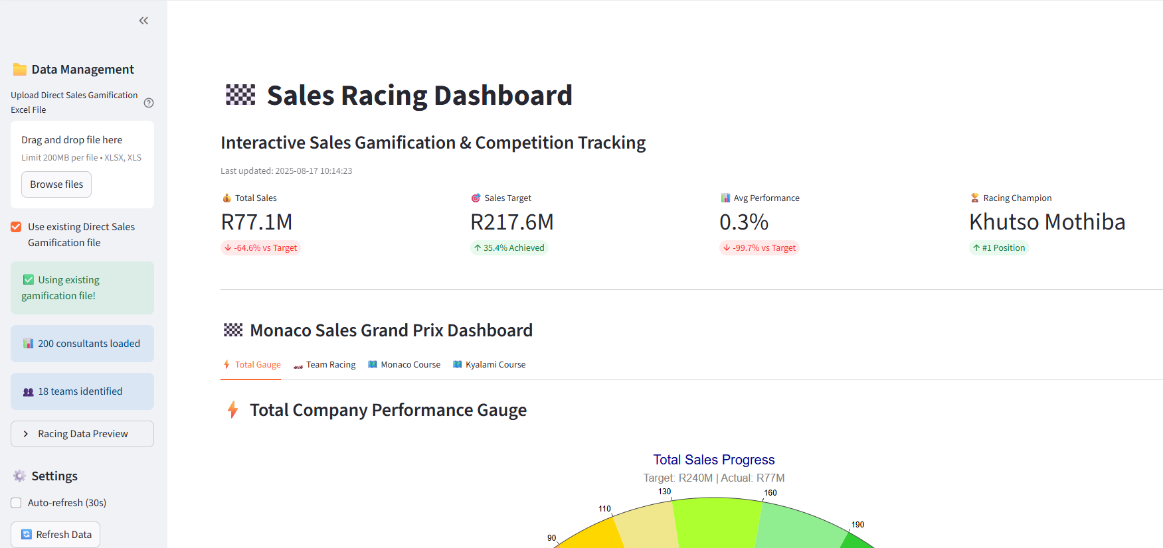

­

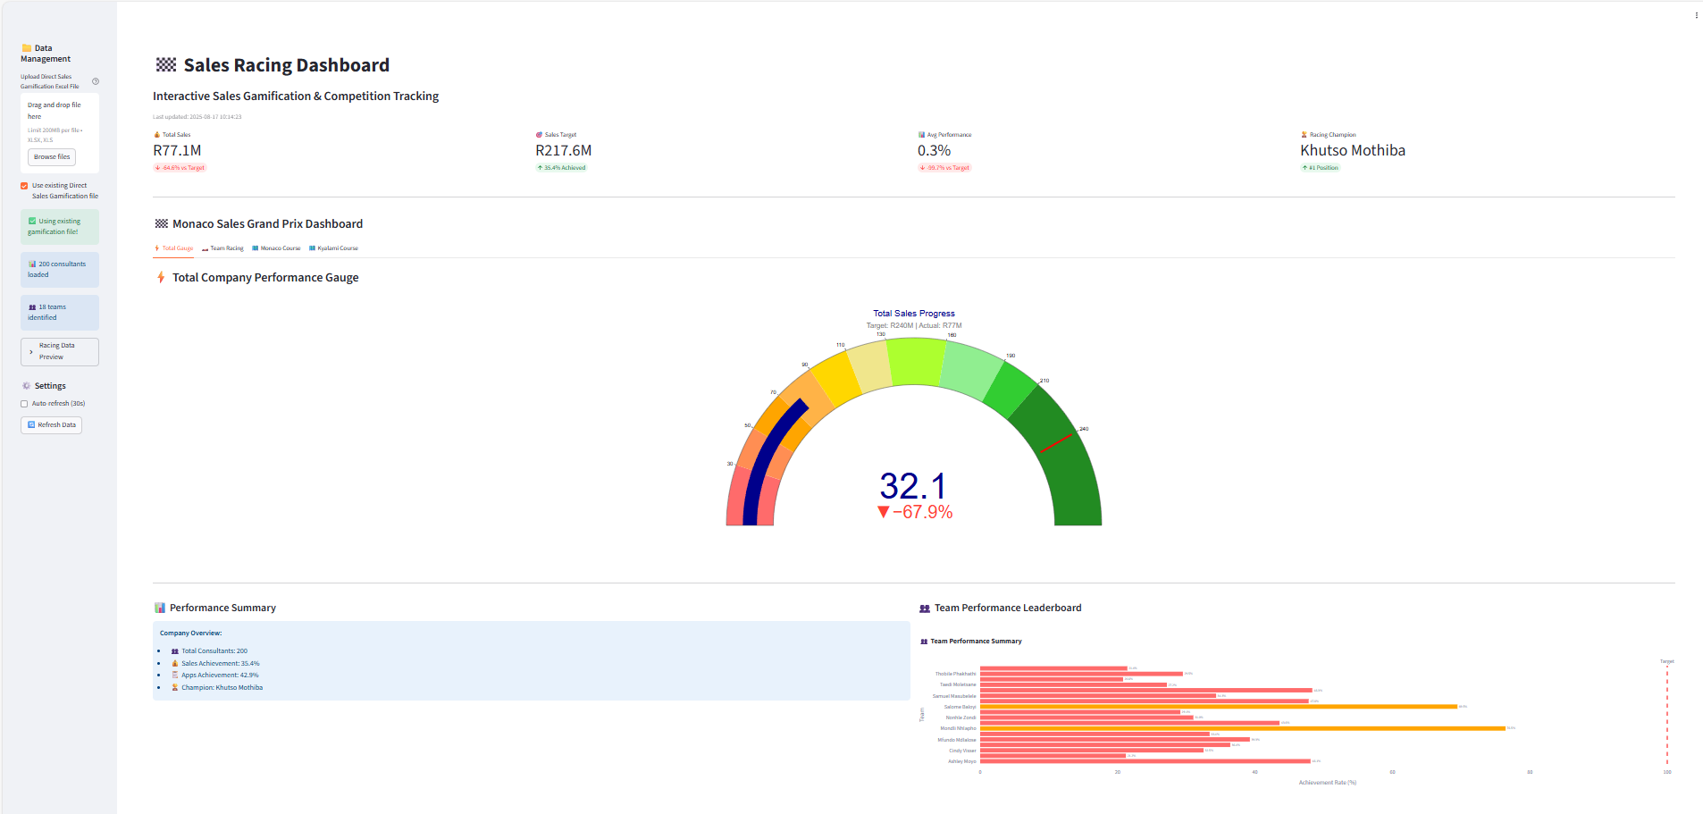

skslkslsslsssk

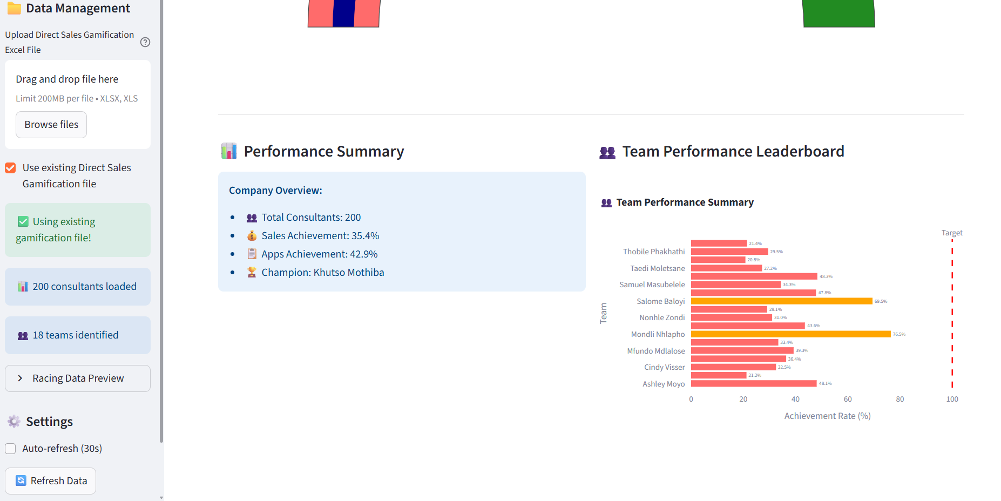

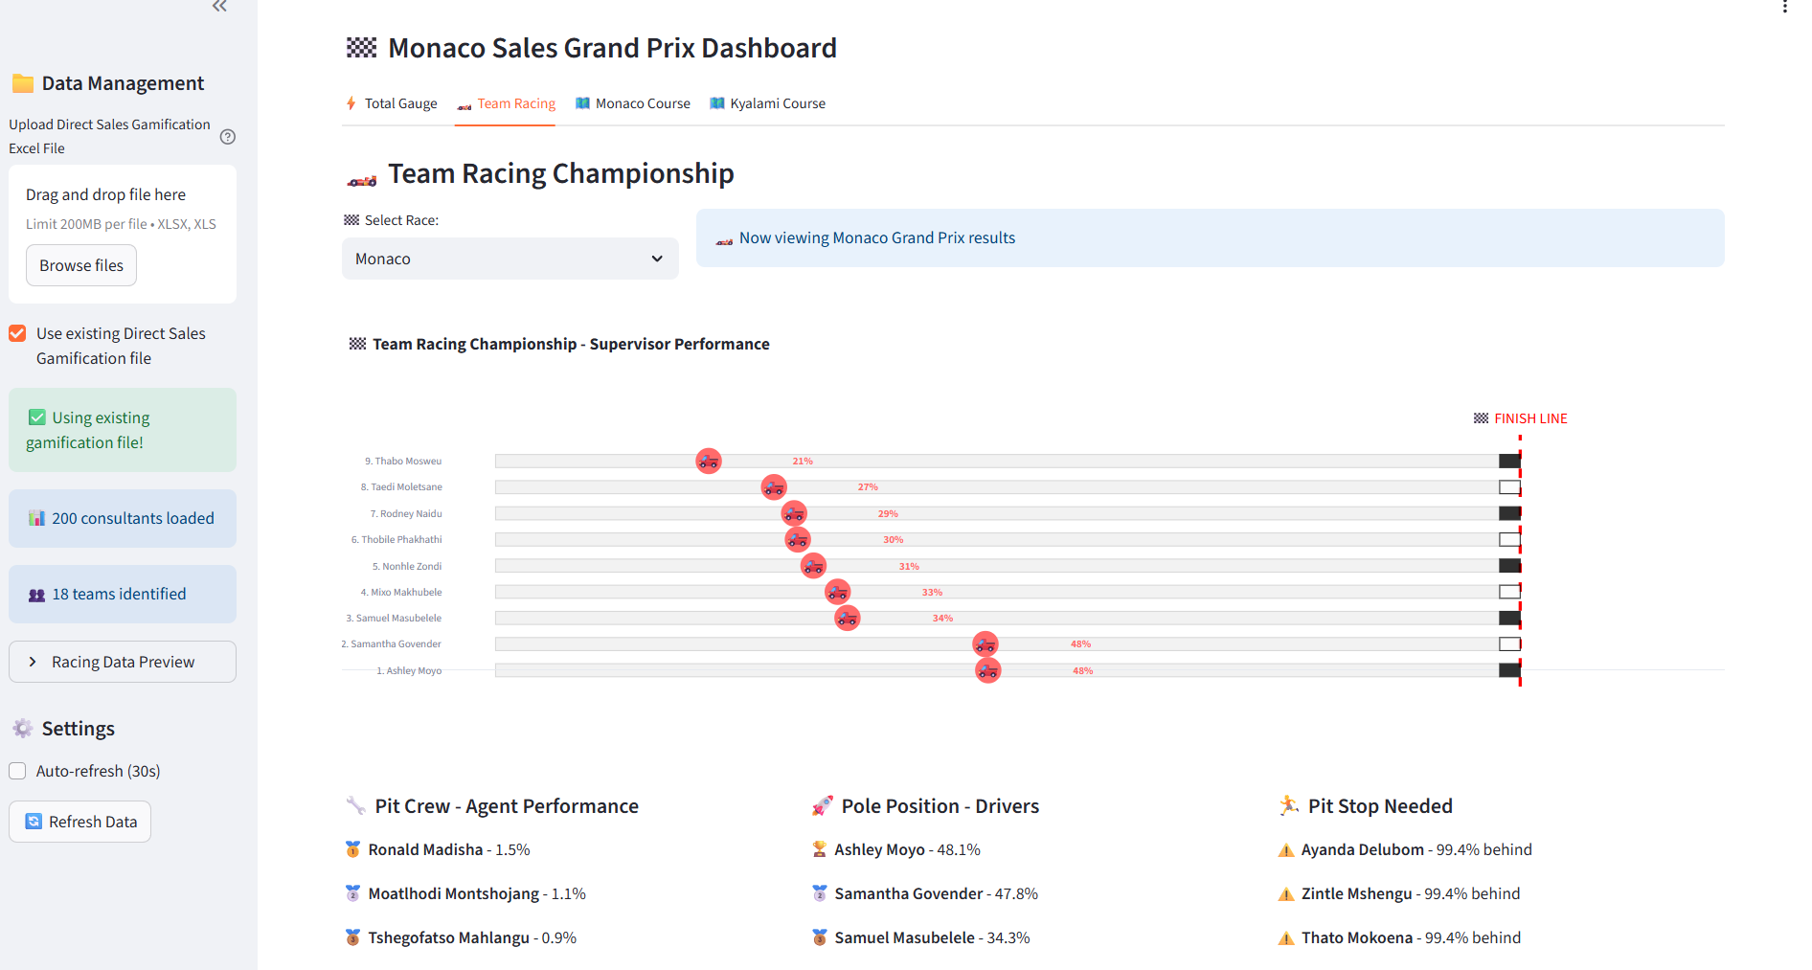

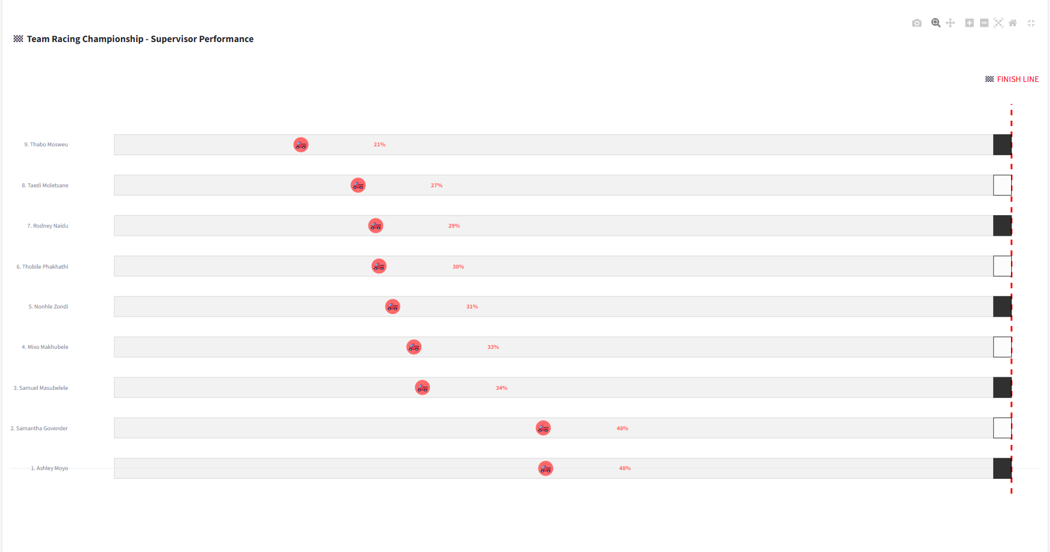

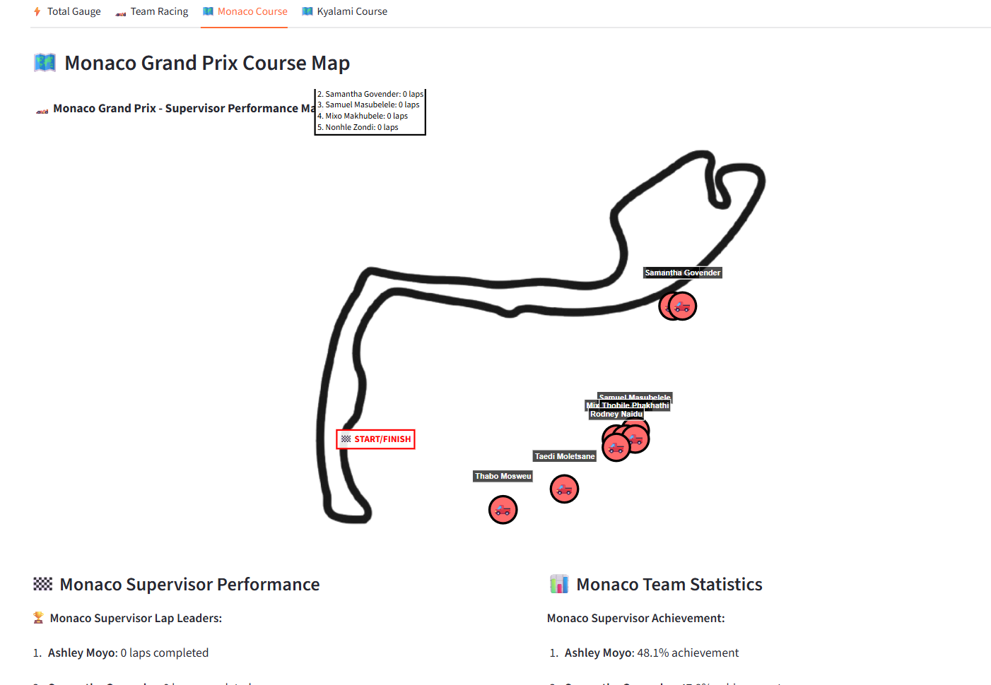

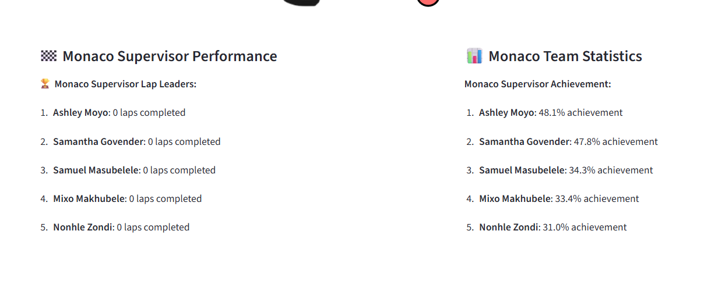

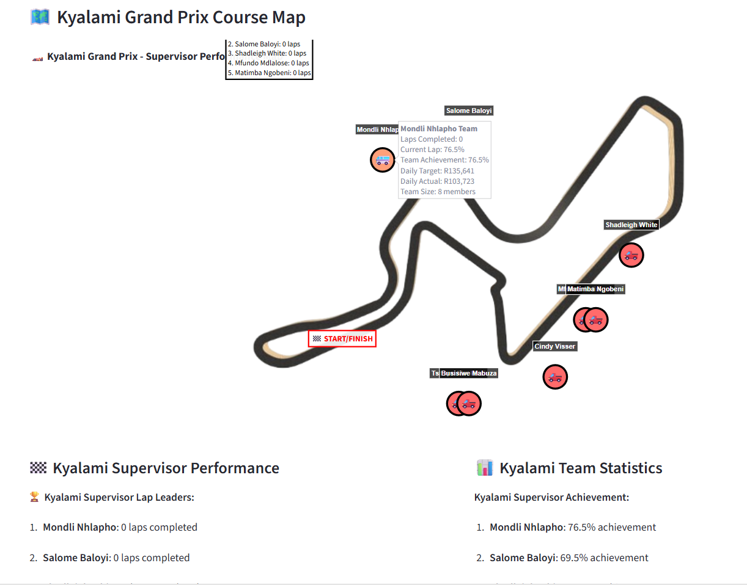

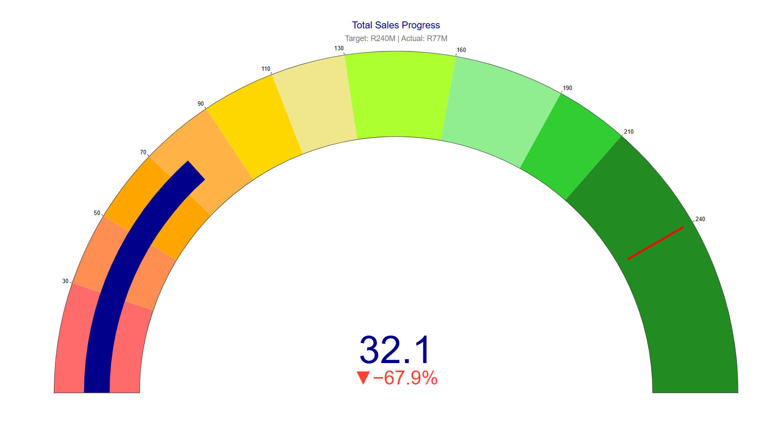

we can use the following columns to represent Pit-Crew Member “health”/”status”  
RealAppsTarget ,TotalRealAppsVol ,Real Apps % to Target,LoanAppsVol ,CardAppsVol, TotalDealsVol,SalesValTarget ,TotalSalesVal ,Sales Val % to Target,LoanDealsVol ,LoanSaleVal ,CardDealsVol ,CardSaleVal ,CardLimIncSaleVal ,CreditCardDealTarget ,Creditcard % to target ,OverDraftSaleVal

Below you will see a pivot table showing the main parts of the data and target values

where Sum od SalesValTarget is the assigned/given target and Sum of TotalSalesVal is the Actual/current amount  
  
also you will see the supervisor and team member break down

|  |  |  |  |
| --- | --- | --- | --- |
| **Supervisor Name** | **Consultant Name** | **Sum of SalesValTarget** | **Sum of TotalSalesVal** |
| **Ashley Moyo** | Ayanda Delubom | R1,560,550.00 | R1,202,000.01 |
|  | Boipelo Zitha | R1,455,060.00 | R809,600.01 |
|  | Grace Baloyi | R1,455,060.00 | R823,250.01 |
|  | Koketjo Kekae | R1,455,060.00 | R813,100.00 |
|  | Lunga Mabona | R727,530.00 |  |
|  | Ngibongiseni Chavango | R1,455,060.00 | R87,700.01 |
|  | Ntando Sibisi | R1,455,060.00 | R581,700.00 |
|  | Sibongile Dlali | R1,455,060.00 | R937,200.02 |
|  | Siphokazi Ndamase | R0.00 | R312,300.00 |
|  | Sthandokuhle Mwelase | R1,560,550.00 | R844,250.02 |
|  | Teboho Tau | R1,455,060.00 | R355,300.00 |
|  | Zintle Mshengu | R727,530.00 | R331,450.00 |
| **Ashley Moyo Total** |  | **R14,761,580.00** | **R7,097,850.08** |
| **Busisiwe Mabuza** | Antonaite Mkhatshwa | R1,455,060.00 | R142,750.00 |
|  | Bhonda Thompson | R1,455,060.00 | R144,250.00 |
|  | Daphney Legodi | R727,530.00 | R17,000.00 |
|  | Dumisani Mtsweni | R1,455,060.00 | R662,200.00 |
|  | Karabo Motau | R727,530.00 | R488,250.00 |
|  | Mlungisi Nkidi | R350,500.00 | R15,000.00 |
|  | Mulweli Mushweu | R0.00 |  |
|  | Puseletso Mokoena | R1,455,060.00 | R322,650.00 |
|  | Rorisang Masalesa | R1,455,060.00 | R260,700.00 |
|  | Thato Moletsane | R1,455,060.00 | R275,400.00 |
|  | Zamokuhle Mazibuko | R1,455,060.00 | R215,250.01 |
| **Busisiwe Mabuza Total** |  | **R11,990,980.00** | **R2,543,450.01** |
| **Cindy Visser** | Basetsana Rakitla | R1,455,060.00 | R194,950.00 |
|  | Ivan Mashimbye | R1,455,060.00 | R751,400.00 |
|  | Mary Tshabalala | R0.00 |  |
|  | Mary-Ann Moloto | R1,560,550.00 | R273,550.01 |
|  | Mbavhalelo Ndou | R0.00 |  |
|  | Mokgadi Mathiane | R1,560,550.00 | R542,200.00 |
|  | Morongwa Rasekgololo | R1,560,550.00 | R465,500.00 |
|  | Rendani Nephambani | R1,455,060.00 | R267,200.00 |
|  | Tshwarelo Motlhala | R1,455,060.00 | R332,250.00 |
|  | Vhugala Davhula | R1,560,550.00 | R561,150.00 |
|  | Zinhle Mtshweni | R1,560,550.00 | R401,000.00 |
|  | Zwivhuya Magwara | R1,560,550.00 | R1,147,700.00 |
| **Cindy Visser Total** |  | **R15,183,540.00** | **R4,936,900.01** |
| **Matimba Ngobeni** | Kefilwe Mokgotle | R1,455,060.00 | R1,063,950.02 |
|  | Kgabo Mokonyama | R1,455,060.00 | R210,850.00 |
|  | Nozuko Ndamase | R1,455,060.00 | R659,750.00 |
|  | Shannon Prince | R1,455,060.00 | R238,250.00 |
|  | Simphiwe Madlabane | R1,455,060.00 | R539,050.00 |
|  | Siyavuya Mnukwa | R1,455,060.00 | R533,550.00 |
|  | Tshepisang Molefe | R1,455,060.00 | R575,400.00 |
|  | Tumi Moloi | R1,455,060.00 | R416,350.00 |
| **Matimba Ngobeni Total** |  | **R11,640,480.00** | **R4,237,150.02** |
| **Mfundo Mdlalose** | Gloria Seutloadi | R1,455,060.00 | R404,500.00 |
|  | Jody Shingange | R1,455,060.00 | R998,050.00 |
|  | Lebone Maile | R1,455,060.00 | R239,000.01 |
|  | Lufuno Makhado | R1,455,060.00 | R960,200.00 |
|  | Menziwoxolo Sibeko | R565,850.00 | R403,550.00 |
|  | Mmateboho Mosekedi | R1,455,060.00 | R675,450.00 |
|  | Naledi Mashiane | R1,455,060.00 | R408,000.00 |
|  | Nokuthula Mabongo | R1,455,060.00 | R429,600.00 |
|  | Odirile Mathe | R350,500.00 | R48,250.00 |
|  | Rolindela Nephembani | R1,455,060.00 | R309,600.00 |
|  | Tebogo Sentsho | R0.00 | R174,000.00 |
|  | Wendy Van Wyk | R1,455,060.00 | R450,050.00 |
| **Mfundo Mdlalose Total** |  | **R14,011,890.00** | **R5,500,250.01** |
| **Mixo Makhubele** | Bontle Nyama | R1,455,060.00 | R620,250.00 |
|  | Lethabo Manamela | R1,455,060.00 | R123,750.00 |
|  | Linah Raletshena | R1,455,060.00 | R14,500.00 |
|  | Lindiwe Dladla | R0.00 | R80,000.00 |
|  | Matlhogonolo Mosidi | R0.00 | R120,150.00 |
|  | Moatlhodi Montshojang | R565,850.00 | R664,200.01 |
|  | Saafiyah Borman | R1,455,060.00 | R473,650.00 |
|  | Thabo Maphutsi | R1,455,060.00 | R435,250.00 |
|  | Thandazo Mavuso | R1,455,060.00 | R316,050.00 |
|  | Tshegofatso Mahlangu | R1,455,060.00 | R1,521,650.01 |
|  | Vishaiya Pillay | R1,455,060.00 | R45,000.00 |
|  | Xolile Zikhali | R1,455,060.00 | R147,750.00 |
| **Mixo Makhubele Total** |  | **R13,661,390.00** | **R4,562,200.02** |
| **Mondli Nhlapho** | Amogelang Khunou | R560,650.00 | R439,200.00 |
|  | Busisiwe Nyembe | R560,650.00 | R69,950.00 |
|  | Khutso Mothiba | R560,650.00 | R1,022,650.01 |
|  | Lucas Gamede | R280,325.00 | R144,050.00 |
|  | Mana Zungu | R560,650.00 | R87,100.00 |
|  | Matlading Sebei | R560,650.00 | R682,150.00 |
|  | Nokuthula Mabena | R560,650.00 | R86,250.00 |
|  | Nothando Dlamini | R560,650.00 | R684,050.00 |
| **Mondli Nhlapho Total** |  | **R4,204,875.00** | **R3,215,400.01** |
| **Mosima Moshidi** | Aboo-Baker Cara | R1,455,060.00 | R630,600.00 |
|  | Akhona Mbangendlu | R1,455,060.00 | R108,000.00 |
|  | Dimakatso Tsotetsi | R1,455,060.00 | R322,150.01 |
|  | Dumisane Maqoga | R0.00 | R46,050.00 |
|  | Oratilwe Modibane | R1,455,060.00 | R277,750.01 |
|  | Palesa Masekwa | R1,455,060.00 | R459,700.00 |
|  | Potego Selatole | R1,455,060.00 | R1,254,350.01 |
|  | Precious Mmola | R1,455,060.00 | R485,000.00 |
|  | Thabiso Mokgupi | R1,455,060.00 | R741,750.00 |
|  | Tumelo Mabena | R0.00 | R124,150.00 |
|  | Xolani Mafunda | R1,455,060.00 | R1,256,400.01 |
| **Mosima Moshidi  Total** |  | **R13,095,540.00** | **R5,705,900.04** |
| **Nonhle Zondi** | Bridget Madonsela | R1,455,060.00 | R705,400.00 |
|  | Gcina Mazibuko | R1,455,060.00 | R176,400.00 |
|  | Lerato Banda | R1,455,060.00 | R705,850.01 |
|  | Letlhogonolo Mokwena | R1,455,060.00 | R25,000.00 |
|  | Londolani Lishivha | R1,455,060.00 | R152,400.00 |
|  | Nothando Makwakwa | R1,455,060.00 | R425,900.01 |
|  | Ntando Mwelase | R0.00 | R133,050.00 |
|  | Phelelwa Nkabinde | R1,455,060.00 | R77,750.00 |
|  | Phumeza Khyolo | R1,455,060.00 | R80,300.00 |
|  | Tebogo Maluleke | R0.00 |  |
|  | Tebogo Moremi | R1,455,060.00 | R1,232,650.00 |
|  | Thato Mokoena | R350,500.00 | R186,600.00 |
|  | Tiyani Khoza | R727,530.00 | R496,950.00 |
| **Nonhle Zondi Total** |  | **R14,173,570.00** | **R4,398,250.02** |
| **Rodney Naidu** | Carmen Shiburi | R0.00 | R57,300.00 |
|  | Chanda Bowa | R565,850.00 | R319,850.00 |
|  | Kabelo Molamudi | R1,455,060.00 | R245,000.00 |
|  | Keitumetse Tsotetsi | R1,455,060.00 | R446,400.00 |
|  | Lekelela Mkhize | R1,455,060.00 | R241,250.01 |
|  | Livhuwani Tharaga | R1,455,060.00 | R120,000.00 |
|  | Masana Mabunda | R1,560,550.00 | R454,100.00 |
|  | Mbuelo Mukwevho | R1,455,060.00 | R664,800.01 |
|  | Mmaphuti Lamola | R1,455,060.00 | R585,850.00 |
|  | Monde Mbele | R0.00 |  |
|  | Murunwa Rakgogo | R0.00 | R173,200.00 |
|  | Musa Mathebula | R1,455,060.00 | R303,400.01 |
|  | Nomathemba Gwatyu | R1,455,060.00 | R400,400.00 |
| **Rodney Naidu Total** |  | **R13,766,880.00** | **R4,011,550.03** |
| **Salome Baloyi** | Daniel Ramabu | R560,650.00 | R98,000.00 |
|  | Florence Matjila | R0.00 | R116,100.00 |
|  | Lesego Raseroka | R560,650.00 | R276,750.00 |
|  | Malatankwe Nkwatse | R0.00 | R36,000.00 |
|  | Naledi Moletsane | R0.00 | R17,950.00 |
|  | Neo Molifi | R560,650.00 | R951,200.01 |
|  | Nomfundo Mazibuko | R560,650.00 | R195,500.00 |
|  | Nonkulumo Xalisa | R0.00 | R210,450.00 |
|  | Precious Mashabane | R560,650.00 | R194,350.00 |
|  | Siphilile Biyela | R560,650.00 | R240,500.00 |
| **Salome Baloyi Total** |  | **R3,363,900.00** | **R2,336,800.01** |
| **Samantha Govender** | Aldrin JR Monaisa | R1,365,500.00 | R40,900.00 |
|  | Babalo Tshabalala |  |  |
|  | Cindy Milani | R1,365,500.00 | R779,250.00 |
|  | Cowan Stewart | R1,365,500.00 | R100,000.00 |
|  | Hannah Tabane | R1,365,500.00 | R1,413,700.00 |
|  | Kyle van Vught |  |  |
|  | Lerato Sekati | R1,365,500.00 | R734,700.00 |
|  | Nkateko Rikhotso | R1,365,500.00 | R652,850.00 |
|  | Precious Madonsela | R682,750.00 | R200,300.00 |
|  | Ronald Madisha | R682,750.00 | R1,258,450.00 |
|  | Sanelisiwe Madela | R1,365,500.00 | R804,350.00 |
|  | Tholwana Mosweu | R1,365,500.00 | R519,000.00 |
|  | Winton de Villiers | R0.00 |  |
|  | Xolisa Mkhosana | R1,365,500.00 | R25,000.00 |
| **Samantha Govender Total** |  | **R13,655,000.00** | **R6,528,500.00** |
| **Samuel Masubelele** | Anelisa Ngobo | R1,455,060.00 | R688,150.00 |
|  | Cyprian April | R1,455,060.00 | R418,050.01 |
|  | Fortunate Skhakhane | R1,455,060.00 | R1,003,850.00 |
|  | Gift Nkosi | R1,455,060.00 | R399,650.00 |
|  | Katlego Langa | R0.00 | R37,500.00 |
|  | Keneilwe Rooi | R0.00 |  |
|  | Lusapho Ntaka | R1,455,060.00 | R913,000.03 |
|  | Moreen Nkosi | R0.00 |  |
|  | Ntsako Maswanganye | R1,455,060.00 | R251,400.00 |
|  | Onica Mathebula | R509,271.00 | R26,000.00 |
|  | Phindile Mabunda | R1,455,060.00 | R247,300.00 |
|  | Sibusiso Khanyile | R1,455,060.00 | R407,250.00 |
|  | Thembekile Sithebe | R1,455,060.00 | R280,300.00 |
| **Samuel Masubelele Total** |  | **R13,604,811.00** | **R4,672,450.04** |
| **Shadleigh White** | Cebisile Nhlabathi | R1,455,060.00 | R94,700.00 |
|  | Chwayita Mnukwa | R1,455,060.00 | R776,200.01 |
|  | David Rapia | R1,455,060.00 | R849,750.00 |
|  | Dudu Madumise | R1,455,060.00 | R862,950.01 |
|  | Matimu Chauke | R1,455,060.00 | R675,350.00 |
|  | Mokiritla Selepe | R1,455,060.00 | R1,055,400.00 |
|  | Moratehi Tseisi | R350,500.00 | R18,000.00 |
|  | Tshepang Ramokgopa | R565,850.00 | R330,850.00 |
| **Shadleigh White Total** |  | **R9,646,710.00** | **R4,663,200.02** |
| **Taedi Moletsane** | Angelinah Khoza | R1,560,550.00 | R697,150.02 |
|  | Dumoluhle Ndlovu | R1,560,550.00 | R581,550.00 |
|  | Hlezipi Maqoga | R1,455,060.00 | R375,500.02 |
|  | Jabulani Khosa | R1,560,550.00 | R699,000.00 |
|  | Lethabo Komane | R0.00 |  |
|  | Mmathapelo Maine | R1,560,550.00 | R494,300.00 |
|  | Mosa Seleka | R1,560,550.00 | R254,750.01 |
|  | Odwa Duba | R1,560,550.00 | R342,000.00 |
|  | Phindile Nkosi | R0.00 | R2,000.00 |
|  | Thabiso Manamela | R1,560,550.00 | R181,750.00 |
|  | Tshepo Lekgowane | R1,560,550.00 | R160,250.00 |
| **Taedi Moletsane Total** |  | **R13,939,460.00** | **R3,788,250.05** |
| **Thabo Mosweu** | Bridgette Kholeng | R1,455,060.00 | R537,750.00 |
|  | Deborah Dinala | R1,455,060.00 | R90,750.00 |
|  | Dineo Mdlalose | R1,455,060.00 | R307,150.00 |
|  | Lerato Nthite | R0.00 | R29,300.00 |
|  | Lerato Rakhokole | R1,455,060.00 | R273,450.01 |
|  | Mamfana Mogale | R0.00 | R257,300.00 |
|  | Masego Moremi | R1,455,060.00 | R44,250.00 |
|  | Mmadira Malatjie | R1,455,060.00 | R66,250.00 |
|  | Mpho Moeketsi | R1,455,060.00 | R280,000.00 |
|  | Nomthandazo Nkutha | R1,455,060.00 | R503,800.00 |
|  | Ziningi Mabizela | R1,455,060.00 | R110,400.00 |
|  | Zwivhuya Siaga | R1,455,060.00 | R526,750.00 |
| **Thabo Mosweu Total** |  | **R14,550,600.00** | **R3,027,150.01** |
| **Thobile Phakhathi** | Betty Mawela | R0.00 |  |
|  | Boipelo Rabeng | R1,455,060.00 | R771,050.00 |
|  | Bongeka Ntethe | R1,455,060.00 | R197,000.00 |
|  | David Phala | R1,455,060.00 | R246,150.00 |
|  | Karabo Mlambo | R0.00 | R112,750.00 |
|  | Lebogang Motau | R1,455,060.00 | R330,300.00 |
|  | Nozipho Radebe | R1,455,060.00 | R512,600.00 |
|  | Palesa Jama | R0.00 | R95,750.00 |
|  | Thabang Mokoena | R1,455,060.00 | R395,100.00 |
|  | Thabo Setlhako | R1,455,060.00 | R356,850.00 |
|  | Thato Majoro | R1,455,060.00 | R247,650.00 |
|  | Tshepo Tshekiso | R1,455,060.00 | R598,500.01 |
| **Thobile Phakhathi Total** |  | **R13,095,540.00** | **R3,863,700.01** |
| **Tshepo Moeketsi** | Bongumusa Nkosi | R1,455,060.00 | R523,850.01 |
|  | Lebohang Tlali | R0.00 |  |
|  | Mandy Sibisi | R1,455,060.00 | R188,300.00 |
|  | Nonhlanhla Mhlungu | R1,455,060.00 | R117,450.00 |
|  | Nsovo Kubayi | R1,455,060.00 | R32,000.01 |
|  | Phenyo Maepa | R565,850.00 | R489,500.00 |
|  | Ronewa Sibara | R1,455,060.00 | R37,150.00 |
|  | Senamile Ngema | R1,455,060.00 | R602,950.01 |
| **Tshepo Moeketsi Total** |  | **R9,296,210.00** | **R1,991,200.03** |
| **(blank)** | (blank) | R217,642,956.00 | R77,080,150.42 |