How productivity is measured in current excel file to create the hart in the image below
=SUMIF('Sales Perfromance'!$B$2:$B$201,'Monaco Team stats'!$A$2:$A$10,'Sales Perfromance'!$L$2:$L$201)/SUMIF('Sales Perfromance'!$B$2:$B$201,'Monaco Team stats'!$A$2:$A$10,'Sales Perfromance'!$K$2:$K$201)

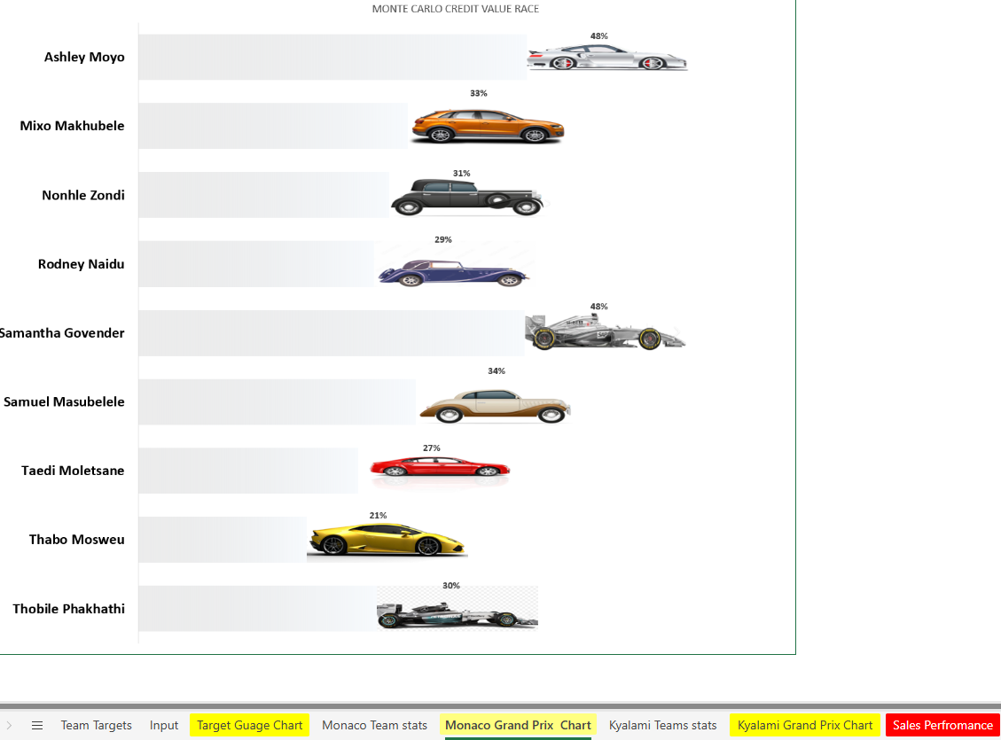

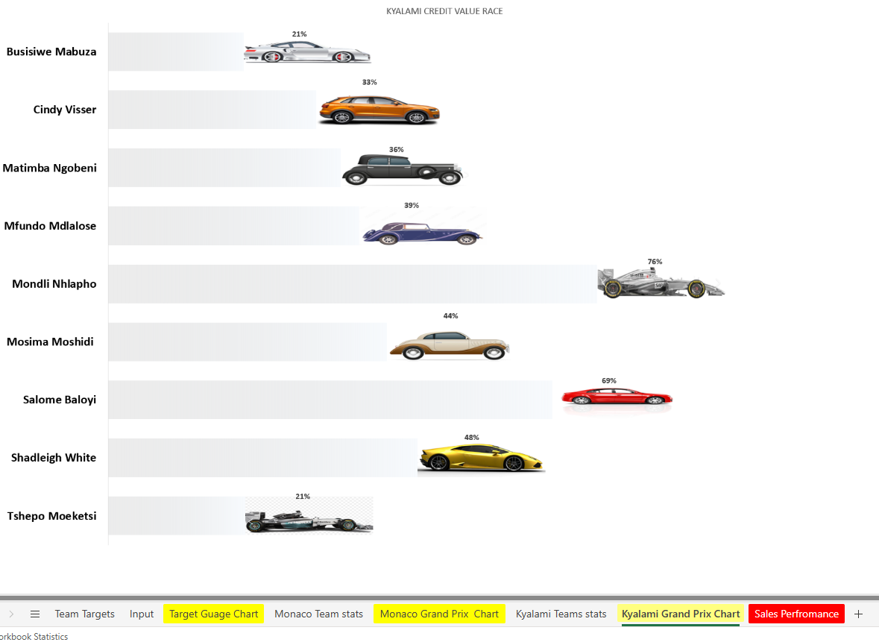

Supervisor names:

Ashley Moyo
Busisiwe Mabuza
Cindy Visser
Matimba Ngobeni
Mfundo Mdlalose
Mixo Makhubele
Mondli Nhlapho
Mosima Moshidi
Nonhle Zondi
Rodney Naidu
Salome Baloyi
Samantha Govender
Samuel Masubelele
Shadleigh White
Taedi Moletsane
Thabo Mosweu
Thobile Phakhathi
Tshepo Moeketsi

Consultants
Ayanda Delubom
Boipelo Zitha
Grace Baloyi
Koketjo Kekae
Lunga Mabona
Ngibongiseni Chavango
Ntando Sibisi
Sibongile Dlali
Siphokazi Ndamase
Sthandokuhle Mwelase
Teboho Tau
Zintle Mshengu
Antonaite Mkhatshwa
Bhonda Thompson
Daphney Legodi
Dumisani Mtsweni
Karabo Motau
Mlungisi Nkidi
Mulweli Mushweu
Puseletso Mokoena
Rorisang Masalesa
Thato Moletsane
Zamokuhle Mazibuko
Basetsana Rakitla
Ivan Mashimbye
Mary Tshabalala
Mary-Ann Moloto
Mbavhalelo Ndou
Mokgadi Mathiane
Morongwa Rasekgololo
Rendani Nephambani
Tshwarelo Motlhala
Vhugala Davhula
Zinhle Mtshweni
Zwivhuya Magwara
Kefilwe Mokgotle
Kgabo Mokonyama
Nozuko Ndamase
Shannon Prince
Simphiwe Madlabane
Siyavuya Mnukwa
Tshepisang Molefe
Tumi Moloi
Gloria Seutloadi
Jody Shingange
Lebone Maile
Lufuno Makhado
Menziwoxolo Sibeko
Mmateboho Mosekedi
Naledi Mashiane
Nokuthula Mabongo
Odirile Mathe
Rolindela Nephembani
Tebogo Sentsho
Wendy Van Wyk
Bontle Nyama
Lethabo Manamela
Linah Raletshena
Lindiwe Dladla
Matlhogonolo Mosidi
Moatlhodi Montshojang
Saafiyah Borman
Thabo Maphutsi
Thandazo Mavuso
Tshegofatso Mahlangu
Vishaiya Pillay
Xolile Zikhali
Amogelang Khunou
Busisiwe Nyembe
Khutso Mothiba
Lucas Gamede
Mana Zungu
Matlading Sebei
Nokuthula Mabena
Nothando Dlamini
Aboo-Baker Cara
Akhona Mbangendlu
Dimakatso Tsotetsi
Dumisane Maqoga
Oratilwe Modibane
Palesa Masekwa
Potego Selatole
Precious Mmola
Thabiso Mokgupi
Tumelo Mabena
Xolani Mafunda
Bridget Madonsela
Gcina Mazibuko
Lerato Banda
Letlhogonolo Mokwena
Londolani Lishivha
Nothando Makwakwa
Ntando Mwelase
Phelelwa Nkabinde
Phumeza Khyolo
Tebogo Maluleke
Tebogo Moremi
Thato Mokoena
Tiyani Khoza
Carmen Shiburi
Chanda Bowa
Kabelo Molamudi
Keitumetse Tsotetsi
Lekelela Mkhize
Livhuwani Tharaga
Masana Mabunda
Mbuelo Mukwevho
Mmaphuti Lamola
Monde Mbele
Murunwa Rakgogo
Musa Mathebula
Nomathemba Gwatyu
Daniel Ramabu
Florence Matjila
Lesego Raseroka
Malatankwe Nkwatse
Naledi Moletsane
Neo Molifi
Nomfundo Mazibuko
Nonkulumo Xalisa
Precious Mashabane
Siphilile Biyela
Aldrin JR Monaisa
Babalo Tshabalala
Cindy Milani
Cowan Stewart
Hannah Tabane
Kyle van Vught
Lerato Sekati
Nkateko Rikhotso
Precious Madonsela
Ronald Madisha
Sanelisiwe Madela
Tholwana Mosweu
Winton de Villiers
Xolisa Mkhosana
Anelisa Ngobo
Cyprian April
Fortunate Skhakhane
Gift Nkosi
Katlego Langa
Keneilwe Rooi
Lusapho Ntaka
Moreen Nkosi
Ntsako Maswanganye
Onica Mathebula
Phindile Mabunda
Sibusiso Khanyile
Thembekile Sithebe
Cebisile Nhlabathi
Chwayita Mnukwa
David Rapia
Dudu Madumise
Matimu Chauke
Mokiritla Selepe
Moratehi Tseisi
Tshepang Ramokgopa
Angelinah Khoza
Dumoluhle Ndlovu
Hlezipi Maqoga
Jabulani Khosa
Lethabo Komane
Mmathapelo Maine
Mosa Seleka
Odwa Duba
Phindile Nkosi
Thabiso Manamela
Tshepo Lekgowane
Bridgette Kholeng
Deborah Dinala
Dineo Mdlalose
Lerato Nthite
Lerato Rakhokole
Mamfana Mogale
Masego Moremi
Mmadira Malatjie
Mpho Moeketsi
Nomthandazo Nkutha
Ziningi Mabizela
Zwivhuya Siaga
Betty Mawela
Boipelo Rabeng
Bongeka Ntethe
David Phala
Karabo Mlambo
Lebogang Motau
Nozipho Radebe
Palesa Jama
Thabang Mokoena
Thabo Setlhako
Thato Majoro
Tshepo Tshekiso
Bongumusa Nkosi
Lebohang Tlali
Mandy Sibisi
Nonhlanhla Mhlungu
Nsovo Kubayi
Phenyo Maepa
Ronewa Sibara
Senamile Ngema

For total gauge use these columns
K L M
SalesValTarget | TotalSalesVal | Sales Val % to Target

The Supervisors Target will be the sum of individuals team members target

Below are images of the previous implementation

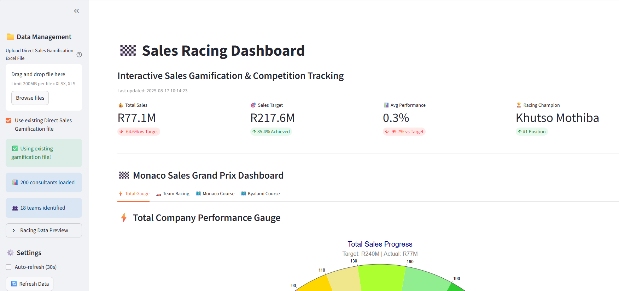

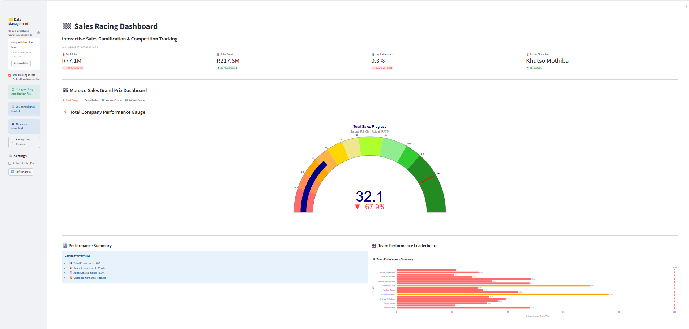

skslkslsslsssk

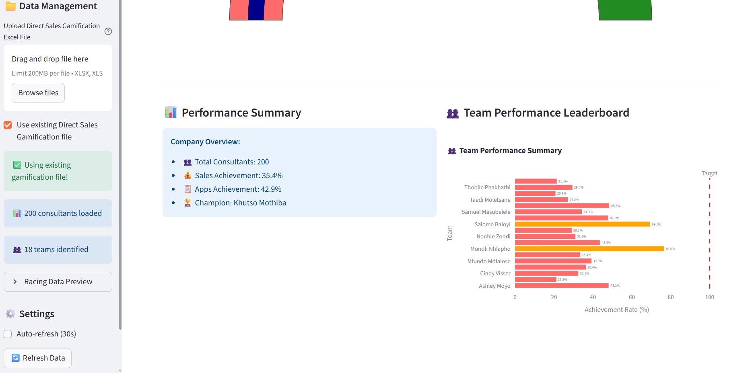

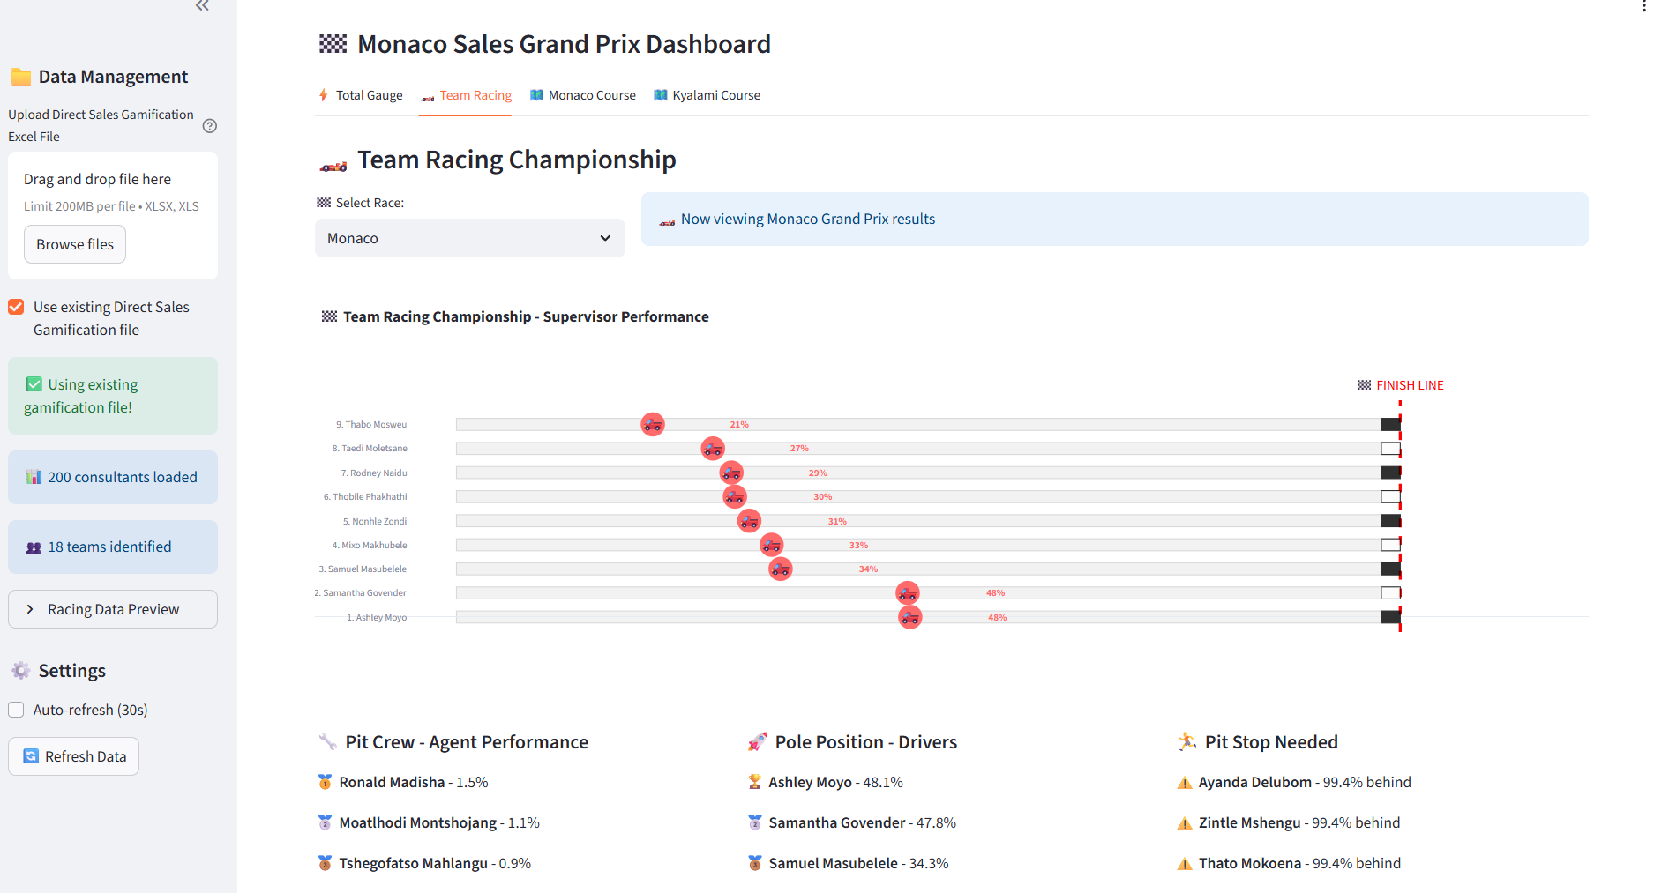

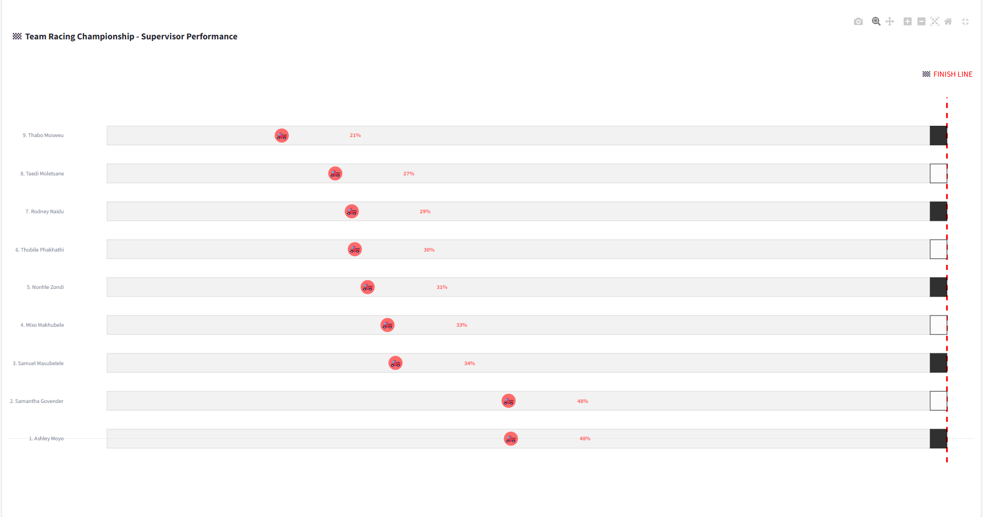

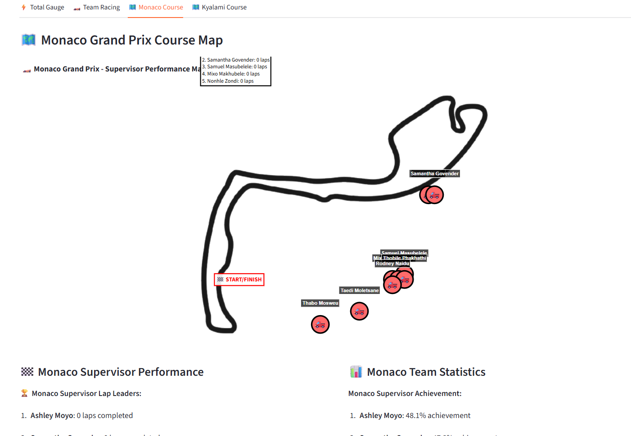

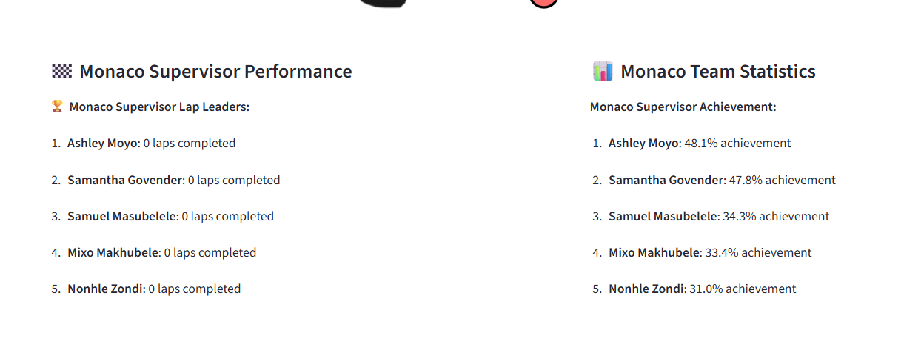

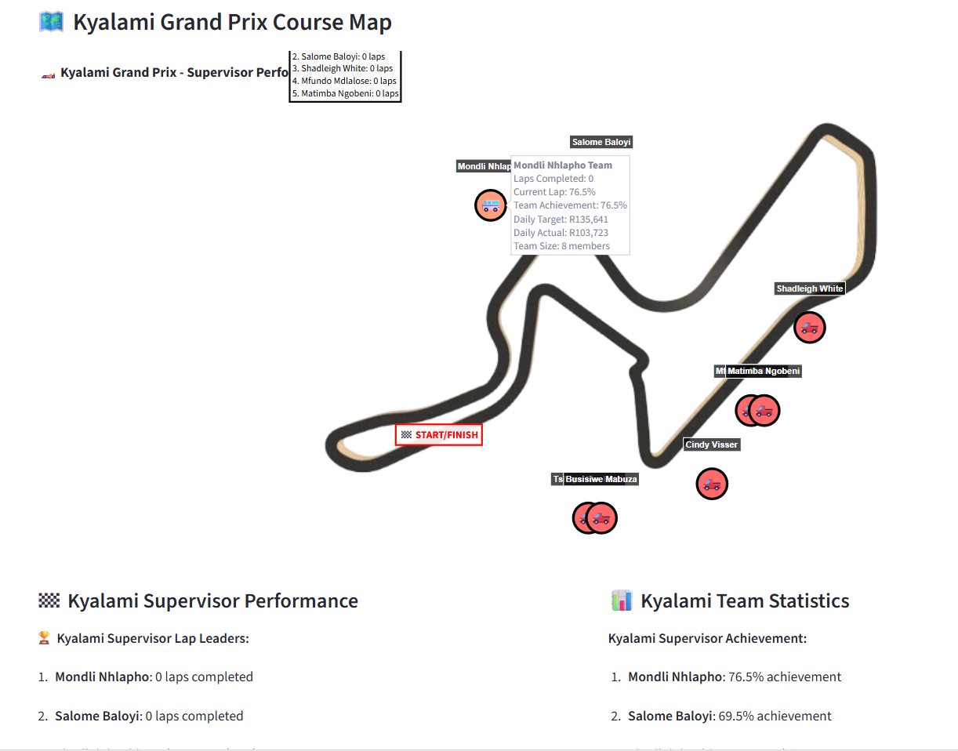

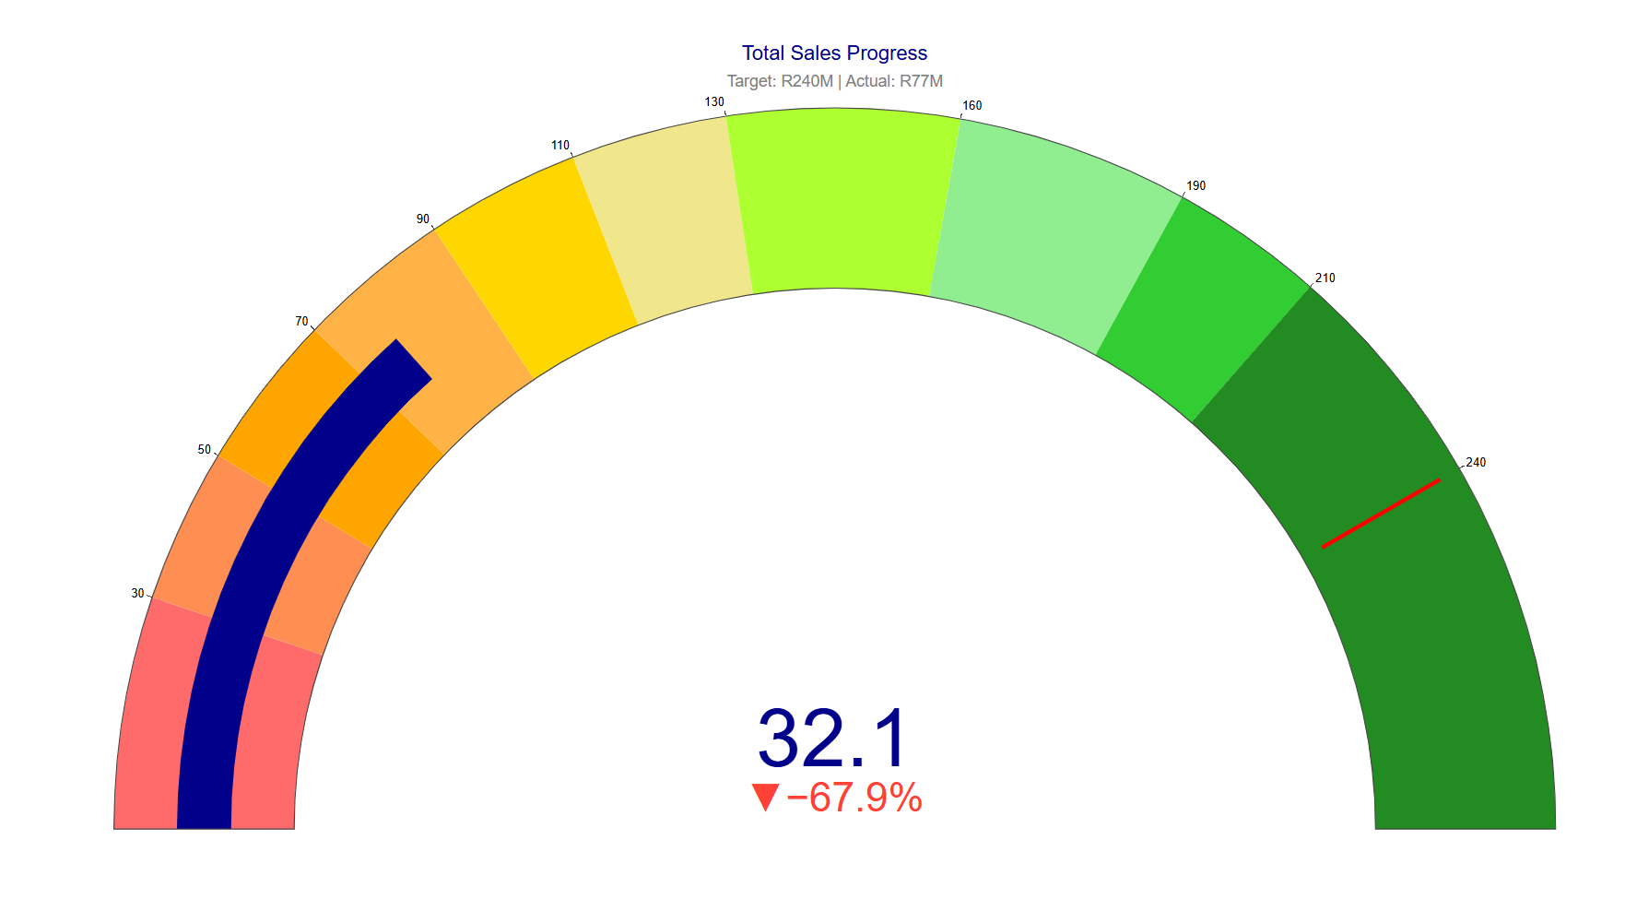

we can use the following columns to represent Pit-Crew Member “health”/”status”
RealAppsTarget ,TotalRealAppsVol ,Real Apps % to Target,LoanAppsVol ,CardAppsVol, TotalDealsVol,SalesValTarget ,TotalSalesVal ,Sales Val % to Target,LoanDealsVol ,LoanSaleVal ,CardDealsVol ,CardSaleVal ,CardLimIncSaleVal ,CreditCardDealTarget ,Creditcard % to target ,OverDraftSaleVal

skslkslsslsssk

