成绩



课程设计报告


题 目 员工管理系统

课 程 名 称 面向对象程序设计课程设计
院 部 名 称 计算机工程学院
专 业 数字媒体技术
班 级 25数字媒体技术（专转本）
学 生 姓 名 吴昊阳
学 号 2513313045
课程设计地点 607-1
课程设计学时 20学时
指 导 教 师 马青霞

金陵科技学院教务处制
目录

一、引言
二、需求分析
三、总体设计
四、数据库设计
五、系统实现
六、系统测试
七、总结
题目
一、引言
员工管理系统，使用JAVA，Mysql数据库
二、需求分析
实现员工管理系统
1、管理员类
String adminID - 账号
String adminName - 姓名
String adminPWD - 密码
- 员工类
String empID - 工号
String empName - 姓名
String department - 部门
String position - 职位
double salary - 薪资
2、登录菜单：
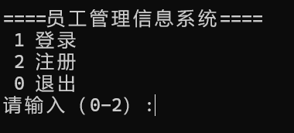
登录：根据账号和密码登录，如果不存在，则给出提示；
注册：注册管理员信息，管理员账号唯一，两次密码一致；
退出：退出系统。
3、登录成功后进入主菜单：
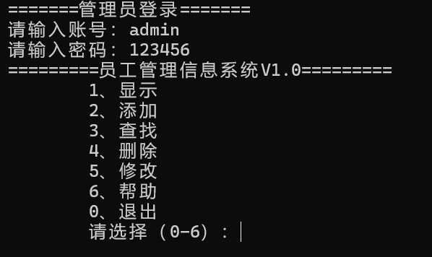
显示：显示所有的员工信息，如果没有员工，提示当前系统无员工，请添加后再操作；
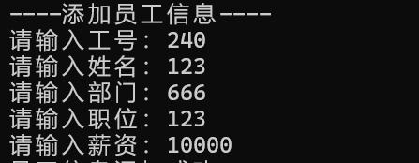
添加：添加员工信息，工号唯一，需输入工号、姓名、部门、职位、薪资，如果工号已存在，提示你输入的工号已经存在；
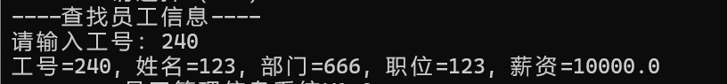
查找：根据工号查找员工信息，如果找到，显示员工信息（工号、姓名、部门、职位、薪资），如果没有找到，则给出提示没有找到工号为XXX的信息；

删除：根据工号删除员工信息，如果工号存在则删除并提示工号为XXX的员工信息已删除，如果工号不存在，给出提示没有找到工号为XXX的信息；


修改： 根据工号修改员工信息（姓名、部门、职位、薪资），如果没有找到工号，则给出提示你输入的工号不存在；
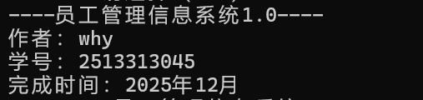
帮助：显示系统相关信息

退出：返回到登录菜单
三、总体设计
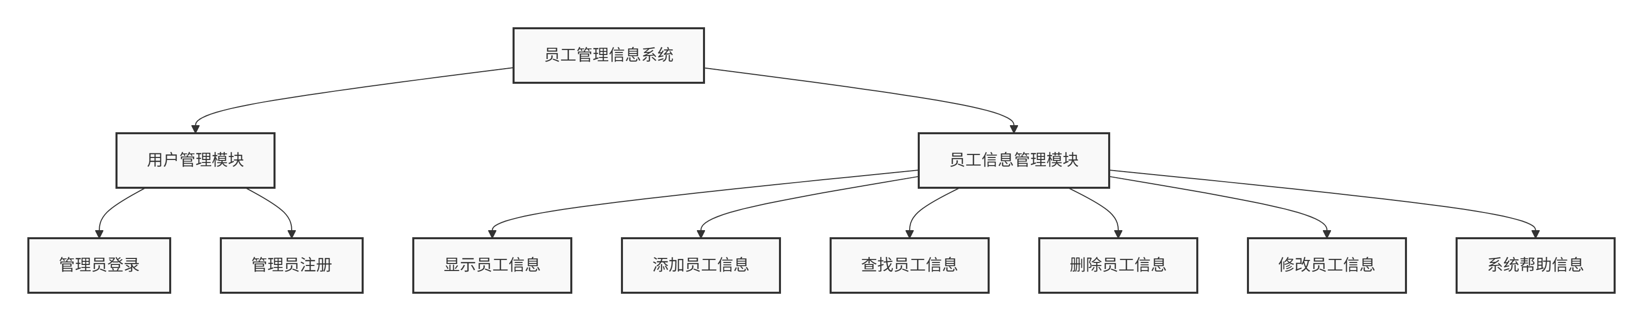
- 数据库设计
字段名 | 数据类型 | 长度 | 约束 | 说明
adminID | VARCHAR | 20 | PRIMARY KEY | 管理员账号
adminName | VARCHAR | 50 | NOT NULL | 管理员姓名
adminPWD | VARCHAR | 100 | NOT NULL | 管理员密码

字段名 | 数据类型 | 长度 | 约束 | 说明
empID | VARCHAR | 20 | PRIMARY KEY | 员工工号
empName | VARCHAR | 50 | NOT NULL | 员工姓名
department | VARCHAR | 50 | NOT NULL | 所属部门
position | VARCHAR | 50 | NOT NULL | 职位
salary | DECIMAL | 10,2 | NOT NULL | 薪资

相关SQL语句
-- 创建数据库
CREATE DATABASE IF NOT EXISTS student CHARACTER SET utf8mb4 COLLATE utf8mb4_unicode_ci;

-- 使用数据库
USE student;

-- 管理员信息表
CREATE TABLE IF NOT EXISTS adminInfo (
adminID VARCHAR(20) PRIMARY KEY COMMENT '管理员账号',
adminName VARCHAR(50) NOT NULL COMMENT '管理员姓名',
adminPWD VARCHAR(100) NOT NULL COMMENT '管理员密码'
) ENGINE=InnoDB DEFAULT CHARSET=utf8mb4 COMMENT='管理员信息表';

-- 员工信息表
CREATE TABLE IF NOT EXISTS employeeinfo (
empID VARCHAR(20) PRIMARY KEY COMMENT '员工工号',
empName VARCHAR(50) NOT NULL COMMENT '员工姓名',
department VARCHAR(50) NOT NULL COMMENT '所属部门',
position VARCHAR(50) NOT NULL COMMENT '职位',
position VARCHAR(50) NOT NULL COMMENT '职位',
salary DECIMAL(10,2) NOT NULL COMMENT '薪资'
) ENGINE=InnoDB DEFAULT CHARSET=utf8mb4 COMMENT='员工信息表';

-- 默认管理员账号
INSERT INTO adminInfo (adminID, adminName, adminPWD) VALUES
('admin', '系统管理员', '123456');

-- 测试员工数据
INSERT INTO employeeinfo (empID, empName, department, position, salary) VALUES
('E001', '张三', '技术部', '软件工程师', 8000.00),
('E002', '李四', '人事部', '人事专员', 6000.00),
('E003', '王五', '财务部', '会计', 7000.00);
五、系统实现
View层UI

EmployeeAPP.java - 系统主程序
package mqx.view;
public class EmployeeAPP {
public static void main(String[] args) {
new EmpMenuLogin();
}
}

EmpMenuLogin.java - 登录注册界面
package mqx.view;
import java.util.ArrayList;
import java.util.List;
import java.util.Scanner;

import mqx.dao.AdminDAO;
import mqx.pojo.Admin;

public class EmpMenuLogin {
AdminDAO adminDAO = new AdminDAO();
Admin admin = null;
private char key = ' ';
Scanner input = new Scanner(System.in);
String adminID = null;
String adminName = null;
String adminPWD = null;

public EmpMenuLogin() {
while(true) {
System.out.println("====员工管理信息系统====");
System.out.println(" 1 登录");
System.out.println(" 2 注册");
System.out.println(" 0 退出");
System.out.print("请输入（0-2）:");
Scanner input = new Scanner(System.in);
key = input.next().charAt(0);
switch (key) {
case '1':
System.out.println("=======管理员登录=======");
while (true) {
System.out.print("请输入账号：");
adminID = input.next();
admin = adminDAO.getAdminByID(adminID);
if (admin != null) {
break;
}
System.out.println("你输入的账号不存在！");
}

while (true) {
System.out.print("请输入密码：");
adminPWD = input.next();
if (admin.getAdminPWD().trim().equals(adminPWD)) {
break;
}
System.out.println("你输入的密码不正确！");
}
new EmployeeSysView();
break;
case '2':
System.out.println("=====管理员注册======");
while(true) {
System.out.print("请输入账号：");
adminID = input.next();
if(adminDAO.getAdminByID(adminID) == null) {
break;
} else {
System.out.println("账号已经存在，请重新输入");
}
}
System.out.print("请输入姓名：");
adminName = input.next();

while(true) {
System.out.print("请输入密码：");
adminPWD = input.next();
System.out.print("请输入确认密码：");
String confirmAdminPWD = input.next();
if(adminPWD.equals(confirmAdminPWD)) {
break;
}
System.out.println("两次密码不一致，请重新输入");
}
admin = new Admin(adminID, adminName, adminPWD);
if(adminDAO.insertAdmin(admin) > 0) {
System.out.println("管理员信息注册成功");
} else {
System.out.println("管理员信息注册失败");
}
break;
case '0':
System.out.println("你已经退出");
System.exit(0);
break;
default:
System.out.println("输入错误");
break;
}
}
}
}

EmployeeSysView.java - 员工管理主界面
package mqx.view;
import java.util.ArrayList;
import java.util.Scanner;

import mqx.dao.EmployeeDAO;
import mqx.pojo.Employee;

public class EmployeeSysView {
public EmployeeSysView() {
char key, confirm;
EmployeeDAO employeeDAO = new EmployeeDAO();
ArrayList<Employee> employees = new ArrayList<Employee>();
Employee employee = null;
String empID = null;
String empName = null;
String department = null;
String position = null;
double salary = 0.0;
Scanner input = new Scanner(System.in);

while (true) {
menu();
key = input.next().charAt(0);
switch (key) {
case '1':
System.out.println("----显示员工信息----");
employees = employeeDAO.getAllEmployee();
if (employees.size() == 0) {
System.out.println("当前系统无员工，请添加后再操作");
break;
}
for (Employee emp : employees) {
System.out.println(emp);
}
break;

case '2':
System.out.println("----添加员工信息----");
System.out.print("请输入工号：");
empID = input.next();
employee = employeeDAO.getEmployeeByID(empID);
if (employee != null) {
System.out.println("你输入的工号已经存在！");
break;
}
System.out.print("请输入姓名：");
empName = input.next();
System.out.print("请输入部门：");
department = input.next();
System.out.print("请输入职位：");
position = input.next();
System.out.print("请输入薪资：");
salary = input.nextDouble();

employee = new Employee(empID, empName, department, position, salary);
if (employeeDAO.insertEmployee(employee) > 0) {
System.out.println("员工信息添加成功");
} else {
System.out.println("员工信息添加失败");
}
break;

case '3':
System.out.println("----查找员工信息----");
System.out.print("请输入工号：");
empID = input.next();
employee = employeeDAO.getEmployeeByID(empID);
if (employee != null) {
System.out.println(employee);
} else {
System.out.println("没有找到工号为" + empID + "的信息");
}
break;

case '4':
System.out.println("----删除员工信息----");
System.out.print("请输入要删除的工号：");
empID = input.next();
employee = employeeDAO.getEmployeeByID(empID);
if (employee != null) {
employeeDAO.deleteEmployee(empID);
System.out.println("工号为" + empID + "的员工信息已删除");
} else {
System.out.println("没有找到工号为" + empID + "的信息");
}
break;

case '5':
System.out.println("----修改员工信息----");
System.out.print("请输入要修改的工号：");
empID = input.next();
employee = employeeDAO.getEmployeeByID(empID);
if (employee == null) {
System.out.println("你输入的工号不存在！");
break;
}
System.out.print("请输入姓名：");
empName = input.next();
System.out.print("请输入部门：");
department = input.next();
System.out.print("请输入职位：");
position = input.next();
System.out.print("请输入薪资：");
salary = input.nextDouble();

employee = new Employee(empID, empName, department, position, salary);
if (employeeDAO.updateEmployee(employee) > 0) {
System.out.println("员工信息修改成功");
} else {
System.out.println("员工信息修改失败");
}
break;

case '6':
System.out.println("----员工管理信息系统1.0----");
System.out.println("作者：why");
System.out.println("学号：2513313045");
System.out.println("完成时间：2025年12月");
break;

case '0':
System.out.print("\t确定要退出吗？（y/n）");
confirm = input.next().charAt(0);
if ('Y' == confirm || 'y' == confirm) {
System.out.println("\t程序已经退出~~~~~~");
System.exit(0);
}
break;

default:
System.out.println("输入错误");
break;
}
}
}

public static void menu() {
System.out.println("=========员工管理信息系统V1.0=========");
System.out.println("\t1、显示");
System.out.println("\t2、添加");
System.out.println("\t3、查找");
System.out.println("\t4、删除");
System.out.println("\t5、修改");
System.out.println("\t6、帮助");
System.out.println("\t0、退出");
System.out.print("\t请选择（0-6）：");
}
}

实体类包pojo
Admin.java - 管理员实体类
package mqx.pojo;

public class Admin {
private String adminID, adminName, adminPWD;

public String getAdminID() {
return adminID;
}

public void setAdminID(String adminID) {
this.adminID = adminID;
}

public String getAdminName() {
return adminName;
}

public void setAdminName(String adminName) {
this.adminName = adminName;
}

public String getAdminPWD() {
return adminPWD;
}

public void setAdminPWD(String adminPWD) {
this.adminPWD = adminPWD;
}

public Admin() {
super();

}

public Admin(String adminID, String adminName, String adminPWD) {
super();
this.adminID = adminID;
this.adminName = adminName;
this.adminPWD = adminPWD;
}

@Override
public String toString() {
return "Admin [adminID=" + adminID + ", adminName=" + adminName + ", adminPWD=" + adminPWD + "]";
}

}

Employee.java - 员工实体类
package mqx.pojo;

public class Employee {
private String empID, empName, department, position;
private double salary;

public String getEmpID() {
return empID;
}

public void setEmpID(String empID) {
this.empID = empID;
}

public String getEmpName() {
return empName;
}

public void setEmpName(String empName) {
this.empName = empName;
}

public String getDepartment() {
return department;
}

public void setDepartment(String department) {
this.department = department;
}

public String getPosition() {
return position;
}

public void setPosition(String position) {
this.position = position;
}

public double getSalary() {
return salary;
}

public void setSalary(double salary) {
this.salary = salary;
}

public Employee() {
super();
}

public Employee(String empID, String empName, String department, String position, double salary) {
super();
this.empID = empID;
this.empName = empName;
this.department = department;
this.position = position;
this.salary = salary;
}

@Override
public String toString() {
return "工号=" + empID + ", 姓名=" + empName + ", 部门=" + department +
", 职位=" + position + ", 薪资=" + salary;
}
}

DAO数据访问，连接数据库包
DbHelperByMySQL.java - 数据库连接工具类
package mqx.dao;

import java.io.FileInputStream;
import java.io.IOException;
import java.sql.*;

import java.util.Properties;

public class DbHelperByMySQL {
// 定义相关属性，只要一份，所以可以定义为静态的
private static String username, password, url, driverClassName;
// 在静态代码块中初始化
static {
Properties properties = new Properties();
try {
// 使用类路径加载配置文件
properties.load(DbHelperByMySQL.class.getClassLoader().getResourceAsStream("jdbc.config"));
username = properties.getProperty("username");
password = properties.getProperty("password");
url = properties.getProperty("url");
driverClassName = properties.getProperty("driverClassName");
Class.forName(driverClassName);

} catch (Exception e) {
e.printStackTrace();
throw new RuntimeException("Failed to load database configuration", e);
}

}

// 获取连接，返回Connection
public static Connection getConnection() {
Connection conn = null;
try {
conn = DriverManager.getConnection(url, username, password);
} catch (SQLException e) {
throw new RuntimeException(e);
}
return conn;
}

// 关闭资源
public static void close(ResultSet rs, Statement st, Connection conn) {
try {
if (rs != null)
rs.close();
if (st != null)
st.close();
if (conn != null)
conn.close();
} catch (SQLException e) {
throw new RuntimeException(e);
}
}

}

AdminDAO.java - 管理员数据访问类
package mqx.dao;

import java.sql.Connection;
import java.sql.PreparedStatement;
import java.sql.ResultSet;
import java.sql.SQLException;
import java.util.ArrayList;

import mqx.pojo.Admin;

public class AdminDAO {
Connection conn =null;
PreparedStatement pst = null;
ResultSet rs = null;

// 注册管理员
public int insertAdmin(Admin admin) {
conn=DbHelperByMySQL.getConnection();
String sql = "insert into adminInfo(adminid,adminName,adminPWD)values(?,?,?)";

int i = 0;
try {
pst = conn.prepareStatement(sql);
pst.setString(1, admin.getAdminID());
pst.setString(2, admin.getAdminName());
pst.setString(3, admin.getAdminPWD());
i = pst.executeUpdate();
} catch (SQLException e) {
e.printStackTrace();
} finally {
DbHelperByMySQL.close(null, pst, conn);
}

return i;

}

// 根据账号查找
public Admin getAdminByID(String parAdminID) {
conn=DbHelperByMySQL.getConnection();
String sql = "select * from adminInfo where adminID=?";
Admin admin = null;
try {
pst = conn.prepareStatement(sql);
pst.setString(1, parAdminID);
rs = pst.executeQuery();
while (rs.next()) {
String adminID = rs.getString("adminID");
String adminName = rs.getString("adminName");
String adminPWD=rs.getString("adminPWD");
admin = new Admin(adminID, adminName,adminPWD);
}
} catch (SQLException e) {

e.printStackTrace();
}finally {
DbHelperByMySQL.close(null, pst, conn);
}
return admin;

}
}

EmployeeDAO.java - 员工数据访问类
package mqx.dao;

import java.sql.Connection;
import java.sql.PreparedStatement;
import java.sql.ResultSet;
import java.sql.SQLException;
import java.util.ArrayList;

import mqx.pojo.Employee;

public class EmployeeDAO {

Connection conn = null;
PreparedStatement pst = null;
ResultSet rs = null;

// 添加员工
public int insertEmployee(Employee emp) {
conn = DbHelperByMySQL.getConnection();
String sql = "insert into employeeinfo(empID,empName,department,position,salary)values(?,?,?,?,?)";

int i = 0;
try {
pst = conn.prepareStatement(sql);
pst.setString(1, emp.getEmpID());
pst.setString(2, emp.getEmpName());
pst.setString(3, emp.getDepartment());
pst.setString(4, emp.getPosition());
pst.setDouble(5, emp.getSalary());
i = pst.executeUpdate();
} catch (SQLException e) {
e.printStackTrace();
} finally {
DbHelperByMySQL.close(null, pst, conn);
}

return i;
}

// 删除员工
public int deleteEmployee(String empID) {
conn = DbHelperByMySQL.getConnection();
String sql = "delete from employeeinfo where empID=?";
int i = 0;
try {
pst = conn.prepareStatement(sql);
pst.setString(1, empID);
i = pst.executeUpdate();
} catch (SQLException e) {
e.printStackTrace();
} finally {
DbHelperByMySQL.close(null, pst, conn);
}

return i;
}

// 修改员工信息
public int updateEmployee(Employee emp) {
conn = DbHelperByMySQL.getConnection();
String sql = "update employeeinfo set empName=?,department=?,position=?,salary=? where empID=?";
int i = 0;
try {
pst = conn.prepareStatement(sql);
pst.setString(1, emp.getEmpName());
pst.setString(2, emp.getDepartment());
pst.setString(3, emp.getPosition());
pst.setDouble(4, emp.getSalary());
pst.setString(5, emp.getEmpID());
i = pst.executeUpdate();
} catch (SQLException e) {
e.printStackTrace();
} finally {
DbHelperByMySQL.close(null, pst, conn);
}

return i;
}

// 查找所有员工
public ArrayList<Employee> getAllEmployee() {
conn = DbHelperByMySQL.getConnection();
String sql = "select * from employeeinfo";
ArrayList<Employee> employees = new ArrayList<Employee>();
try {
pst = conn.prepareStatement(sql);
rs = pst.executeQuery();
while (rs.next()) {
String empID = rs.getString("empID");
String empName = rs.getString("empName");
String department = rs.getString("department");
String position = rs.getString("position");
double salary = rs.getDouble("salary");
Employee emp = new Employee(empID, empName, department, position, salary);
employees.add(emp);
}
} catch (SQLException e) {
e.printStackTrace();
} finally {
DbHelperByMySQL.close(rs, pst, conn);
}
return employees;
}

// 根据工号查找员工
public Employee getEmployeeByID(String parEmpID) {
conn = DbHelperByMySQL.getConnection();
String sql = "select * from employeeinfo where empID=?";
Employee employee = null;
try {
pst = conn.prepareStatement(sql);
pst.setString(1, parEmpID);
rs = pst.executeQuery();
while (rs.next()) {
String empID = rs.getString("empID");
String empName = rs.getString("empName");
String department = rs.getString("department");
String position = rs.getString("position");
double salary = rs.getDouble("salary");
employee = new Employee(empID, empName, department, position, salary);
}
} catch (SQLException e) {
e.printStackTrace();
} finally {
DbHelperByMySQL.close(rs, pst, conn);
}
return employee;
}
}

六、系统测试
1.测试注册管理员账户8080 密码8080，并确认初始表中没有这个账户
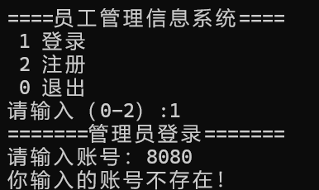
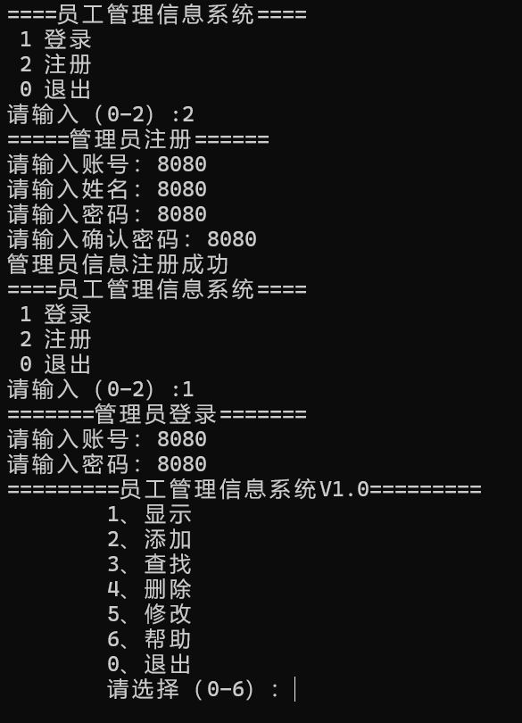
验证管理员注册成功并成功登录

- 测试添加数据8080
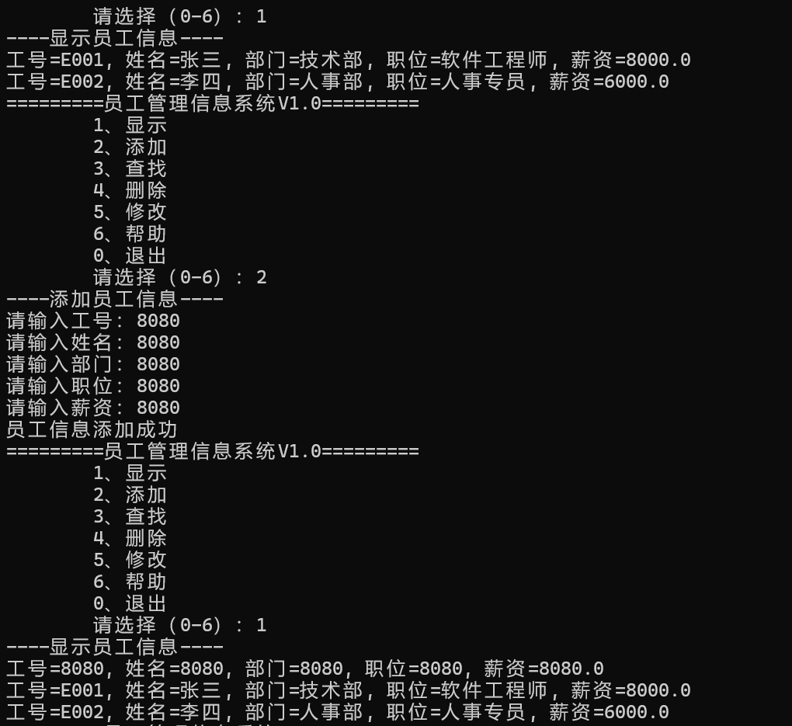

- 测试查找数据8080
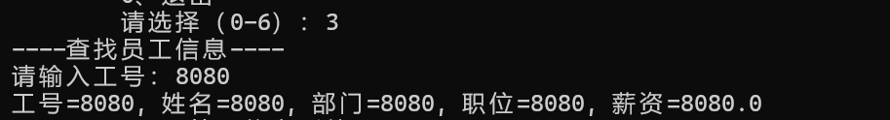

- 测试修改数据8080为9090
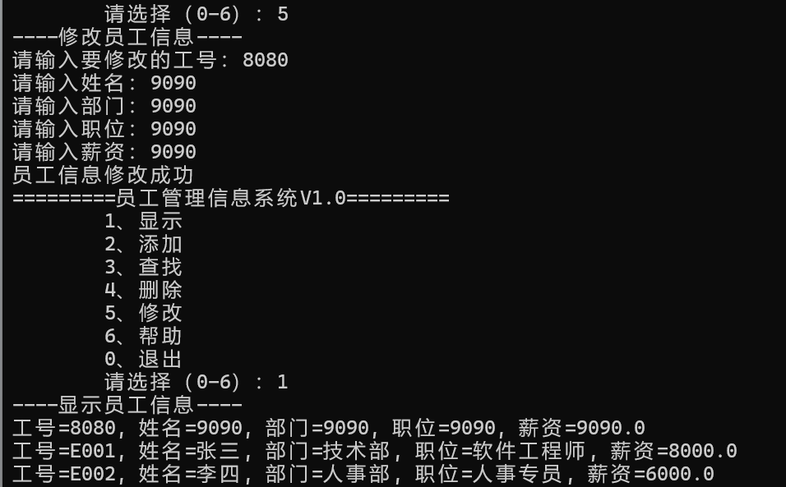

- 测试删除8080
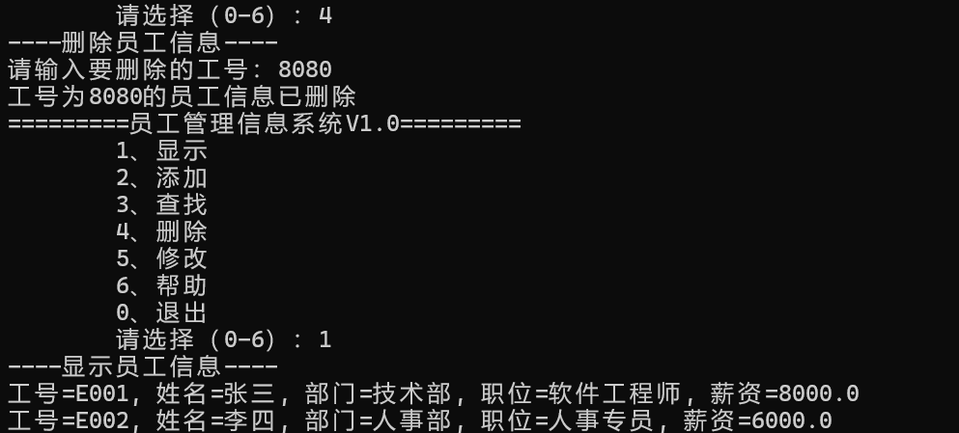

- 帮助
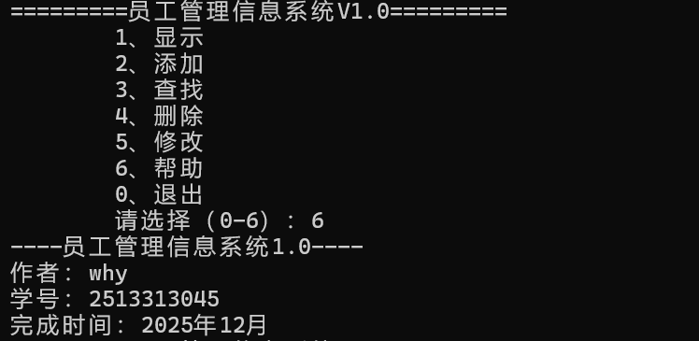

- 退出
