TẬP ĐOÀN CÔNG NGHIÊP
VIỄN THÔNG-QUÂN ĐỘI
VIETTEL



DESIGN SPECIFICATION

REGISTER INTERFACE

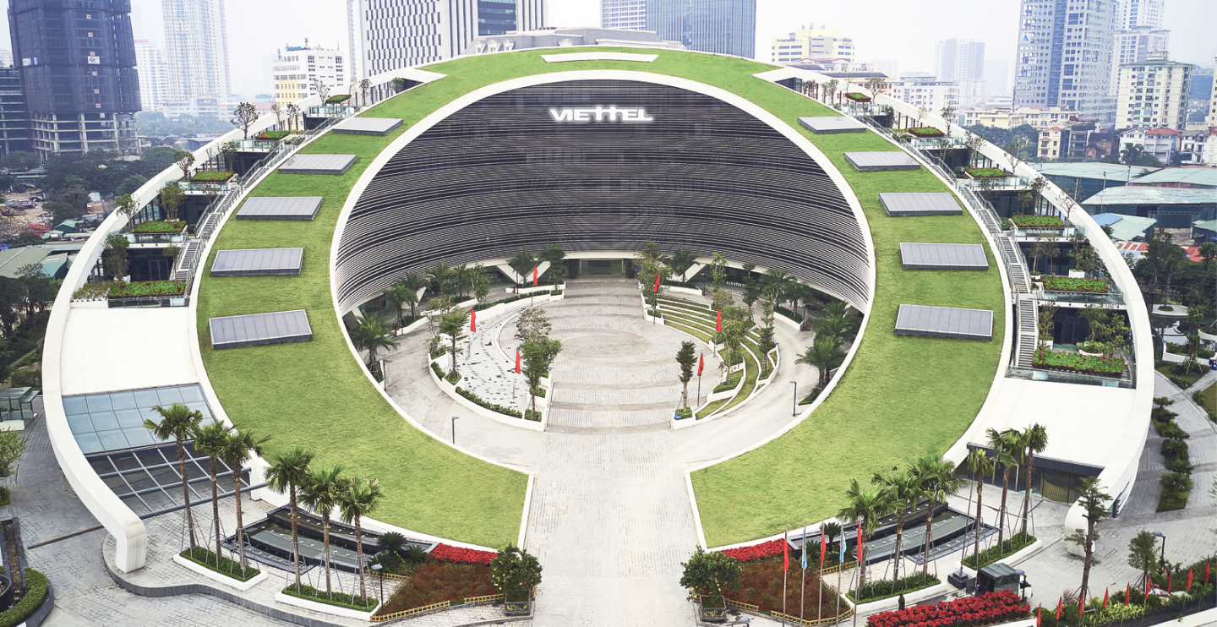

Author: Huan Nguyen-Duy
Date: 8/19/2024

CATALOG
1. OVERVIEW 4
2. DUMMY MASTER ARCHITECTURE 5
3. SEQUENCE DIAGRAM 6
4. CLASS STRUCTURE 7
4.1. Variable definition 8
5. FLOW DIAGRAM 9
5.1. Nb_transport_fw flow diagram 10
5.2. Nb_transport_bw flow diagram 11
5.3. TS_handle_begin_req flow diagram 12
5.4. Forward_transaction_process flow diagram 13

FIGURE
Figure 1 : BUS architecture 5
Figure 2 : The sequence diagram using TLM non-blocking 6
Figure 3 : Nb_transport_fw flow diagram 15
Figure 4 : Nb_transport_bw flow diagram 16
Figure 5 : Ts_handle_begin_req flow diagram 17
Figure 6 : forward_transaction_process flow diagram 18

TABLE
Table 1 : Variable definition of class bus 8
Table 2 The list of functions 10

OVERVIEW

DUMMY MASTER ARCHITECTURE

SEQUENCE DIAGRAM

CLASS STRUCTURE

Variable definition

FLOW DIAGRAM

Nb_transport_fw flow diagram

Nb_transport_bw flow diagram

TS_handle_begin_req flow diagram

Forward_transaction_process flow diagram

