TẬP ĐOÀN CÔNG NGHIÊP
VIỄN THÔNG-QUÂN ĐỘI
VIETTEL



DESIGN SPECIFICATION

MODEL

DMAC (Direct memory access controller)

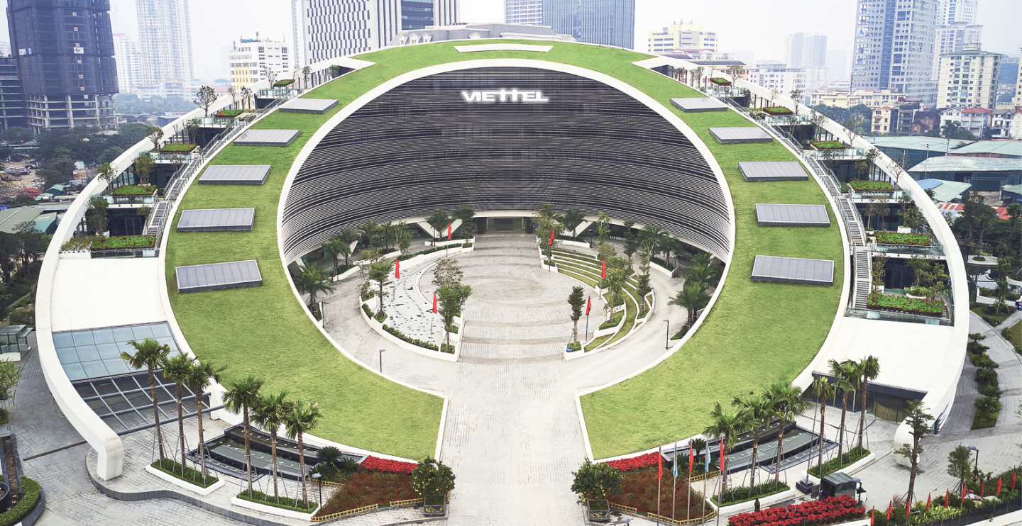

Author: Huan Nguyen-Duy
Date: 7/31/2024

CATALOG
1. OVERVIEW 4
2. DMAC ARCHITECTURE 5
3. Register 6
3.1. DMADESADDRi ( 0 - 255) 7
3.2. DMASRCADDRi ( 0 - 255) 7
3.3. DMADATALENGTHi ( 0 - 255) 8
3.4. DMACHENi ( 0 - 31) 8
3.5. DMAREQi ( 0 - 31) 9
3.6. DMAACKi ( 0 - 31) 9
3.7. DMAINTi ( 0 - 31) 10
4. SEQUENCE DIAGRAM 11
4.1. Memory to peripheral 12
4.2. Peripheral to memory 13
4.3. Peripheral to peripheral 14
4.4. Memory to memory 15
5. FLOW DIAGRAM 16

FIGURE
Figure 1 : BUS architecture 5
Figure 2 : The sequence diagram using TLM non-blocking 6
Figure 3 : Nb_transport_fw flow diagram 15
Figure 4 : Nb_transport_bw flow diagram 16
Figure 5 : Ts_handle_begin_req flow diagram 17
Figure 6 : forward_transaction_process flow diagram 18

TABLE
Table 1 : Variable definition of class bus 8
Table 2 The list of functions 10

OVERVIEW
The document illustrates the design specification for DMAC (direct memory access controller). The DMAC contain 256 channels for peripherals, the lower channel will have higher priority compared to others. On the other hand, the user can test operation of DMAC model by using register instead of signal request. In particular, DMAC mainly support 4 features: memory to peripheral, peripheral to peripheral, peripheral to memory, memory to memory.

DMAC ARCHITECTURE

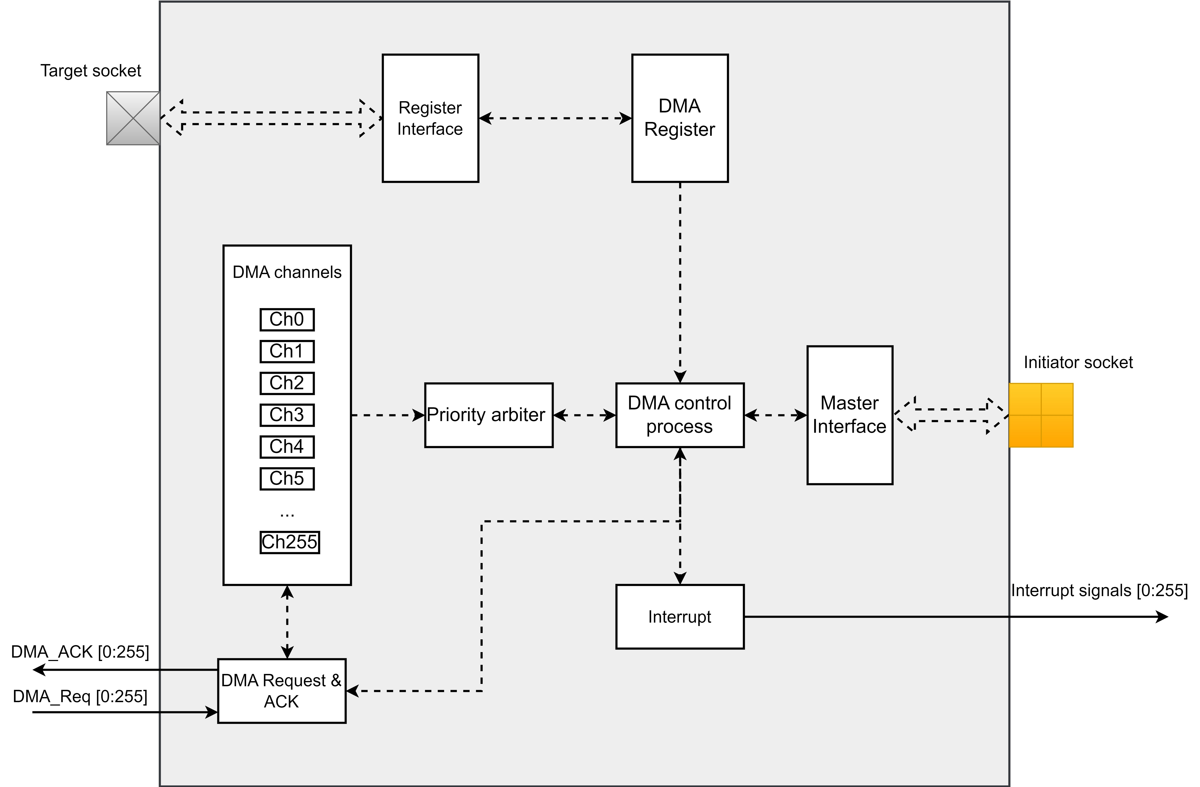
Figure 1: DMAC architecture

Figure 1 show DMAC architecture, including 256 DMA channels and register interface, lower channels have higher priority than others. Specially, DMAC registers can be accessed by register interface.

In particular, the priority arbiter will decide the channel that is used by DMA request signals (the channel 0 is the highest priority). After that, the DMA controller process gets the source and destination address from registers, starting DMA operation and returning ACK to peripherals and interrupts to CPU. During DMA operation, other requests will be ignored.

Register
Overall, DMAC model supports 256 channels DMA register to store source address, destination address, and data length that corresponds with 256 DMA channels. Moreover, it offers 32 channel registers to enable or disable DMA channels.

In test mode operation, DMAC model offers 32 channels registers for DMA request operation, interrupt, and and acknowledge operation.

Register name | Base address
DMADESADD(i) (i = [0,255]) | 0x00 + 0x04*(i)
DMASRCADD(i) (i = [0,255]) | 0x400 + 0x04*(i)
DMADATALENGTH(i) (i = [0,255]) | 0x800 + 0x04*(i)
DMAREQ(i) (i = [0,31]) | 0xC00 + 0x04*(i)
DMAACK(i) (i = [0,31]) | 0xC20 + 0x04*(i)
DMAINT(i) (i = [0,31]) | 0xC40 + 0x04*(i)
DMACHEN(i) (i = [0,31]) | 0xC60 + 0x04*(i)

DMADESADDRi ( 0 - 255)
31 24 16
DESADDR
DESADDR
14 8 0

The DMADESADDR register contain 256 channels corresponding with 256 DMA channels

Bit name | Range | Permission | Description
DESADDR | [0,31] | R/W | Containing destination address information

DMASRCADDRi ( 0 - 255)
31 24 16
SRCADDR
SRCADDR
14 8 0

The DMASRCADDR register contain 256 channels corresponding with 256 DMA channels

Bit name | Range | Permission | Description
SRCADDR | [0,31] | R/W | Containing source address information

DMADATALENGTHi ( 0 - 255)
31 24 16
DATALENGTH
DATALENGTH
14 8 0

The DMASRCADDR register contain 256 channels corresponding with 256 DMA channels

Bit name | Range | Permission | Description
DATALENGTH | [0,31] | R/W | Containing data length information

DMACHENi ( 0 - 31)
31 24 16
En  31*i | En  30*i | En  29*i | En  28*i | En  27*i | En  26*i | En  25*i | En  24*i | En  23*i | En  22*i | En  21*i | En  20*i | En  19*i | En  18*i | En  17*i | En  16*i
En  15*i | En  14*i | En  13*i | En  12*i | En  11*i | En  10*i | En  9*i | En  8*i | En  7*i | En  6*i | En  5*i | En  4*i | En  3*i | En  2*i | En  1*i | En  0*i
14 8 0

The DMACHEN register contain 32 channels corresponding with 256 DMA channels. The channel will be enable if the corresponding En bit is high.

Bit name | Range | Permission | Description
En n*I  (n = [0,31],  I = [0,31] ) | [n,n] | R/W | Enable or disable the corresponding DMA channels.  0x01: Enable DMA operation  0x00: Disable DMA operation

DMAREQi ( 0 - 31)
31 24 16
Req  31*i | Req  30*i | Req  29*i | Req  28*i | Req  27*i | Req  26*i | Req  25*i | Req  24*i | Req  23*i | Req  22*i | Req  21*i | Req  20*i | Req  19*i | Req  18*i | Req  17*i | Req  16*i
Req  15*i | Req  14*i | Req  13*i | Req  12*i | Req  11*i | Req  10*i | Req  9*i | Req  8*i | Req  7*i | Req  6*i | Req  5*i | Req  4*i | Req  3*i | Req  2*i | Req  1*i | Req  0*i
14 8 0

The DMACREQ register contain 32 channels corresponding with 256 DMA channels. The channel will be triggered DMA operation if the corresponding Req bit is high.

Bit name | Range | Permission | Description
Ack n*I  (n = [0,31],  I = [0,31] ) | [n,n] | R/W | Trigger or disable DMA operation of the corresponding DMA channels.  0x01: Trigger DMA operation  0x00: Not trigger DMA operation

DMAACKi ( 0 - 31)
31 24 16
Ack  31*i | Ack  30*i | Ack  29*i | Ack  28*i | Ack  27*i | Ack  26*i | Ack  25*i | Ack  24*i | Ack  23*i | Ack  22*i | Ack  21*i | Ack  20*i | Ack  19*i | Ack  18*i | Ack  17*i | Ack  16*i
Ack  15*i | Ack  14*i | Ack  13*i | Ack  12*i | Ack  11*i | Ack  10*i | Ack  9*i | Ack  8*i | Ack  7*i | Ack  6*i | Ack  5*i | Ack  4*i | Ack  3*i | Ack  2*i | Ack  1*i | Ack  0*i
14 8 0

The DMACACK register contain 32 channels corresponding with 256 DMA channels. It is used to store the state of DMA operation.

Bit name | Range | Permission | Description
Ack n*I  (n = [0,31],  I = [0,31] ) | [n,n] | R/W | Using to store the state of DMA operation  0x01: DMA operation is done.  0x00: DMA operation is not done.

DMAINTi ( 0 - 31)
31 24 16
Int  31*i | Int  30*i | Int  29*i | Int  28*i | Int  27*i | Int  26*i | Int  25*i | Int  24*i | Int  23*i | Int  22*i | Int  21*i | Int  20*i | Int  19*i | Int  18*i | Int  17*i | Int  16*i
Int  15*i | Int  14*i | Int  13*i | Int  12*i | Int  11*i | Int  10*i | Int  9*i | Int  8*i | Int  7*i | Int  6*i | Int  5*i | Int  4*i | Int  3*i | Int  2*i | Int  1*i | Int  0*i
14 8 0

The DMACINT register contain 32 channels corresponding with 256 DMA channels. It is used to store the state of interrupt that corresponds with each channel.

Bit name | Range | Permission | Description
Int n*I  (n = [0,31],  I = [0,31] ) | [n,n] | R/W | Using to store the state of interrupt that corresponds with each channel  0x01: Interrupt is high  0x00: Interrupt is low

SEQUENCE DIAGRAM
The DMAC mainly supports 4 features, including transferring data from memory to peripheral, memory to memory, peripheral to peripheral, and peripheral to memory. All operations is processed by a initiator socket that have role as master in bus MMIO.

Memory to peripheral

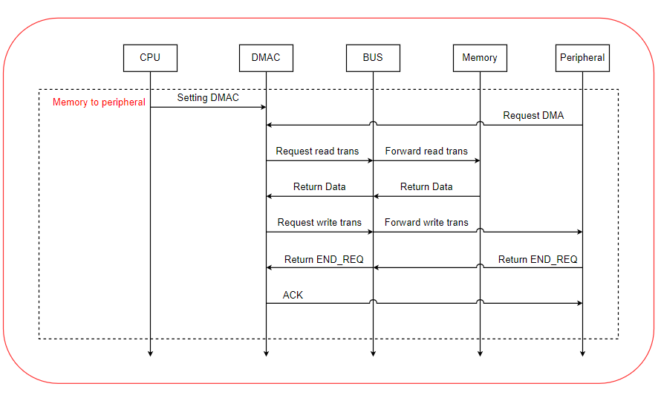
Figure 2: memory to peripheral sequence diagram

to peripheral

Peripheral to memory
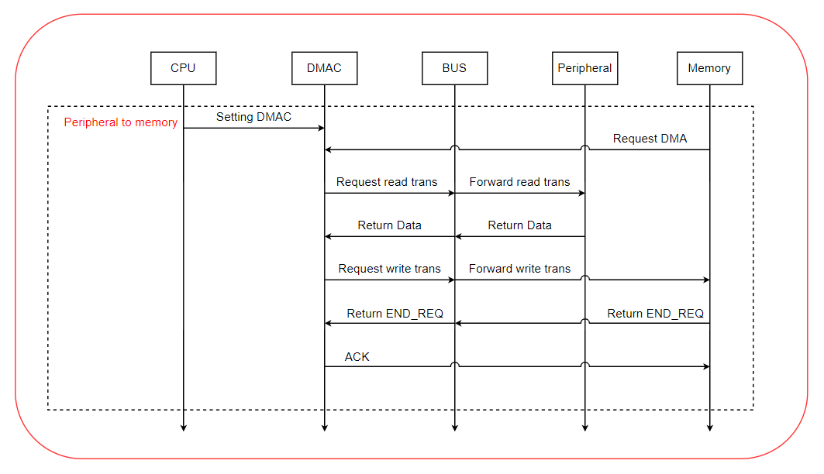
Figure 3: Peripheral to peripheral sequence diagram

Before DMAC operation, registers are configured by CPU. The source address is the address of peripheral, and the destination address is the address of memory. When request signal is triggered by memory, the DMA operation is process and return ACK signal to memory when it done.

Peripheral to peripheral
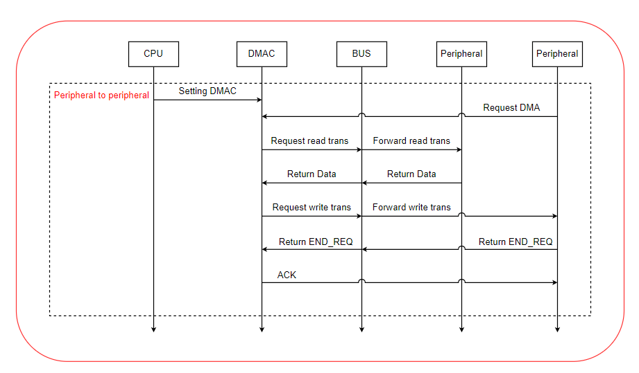
Figure 4: Peripheral to peripheral sequence diagram

Before DMAC operation, registers are configured by CPU. The source address is the address of peripheral, and the destination address is the address of peripheral. When request signal is triggered by peripheral, the DMA operation is process and return ACK signal to peripheral when it done.

Memory to memory
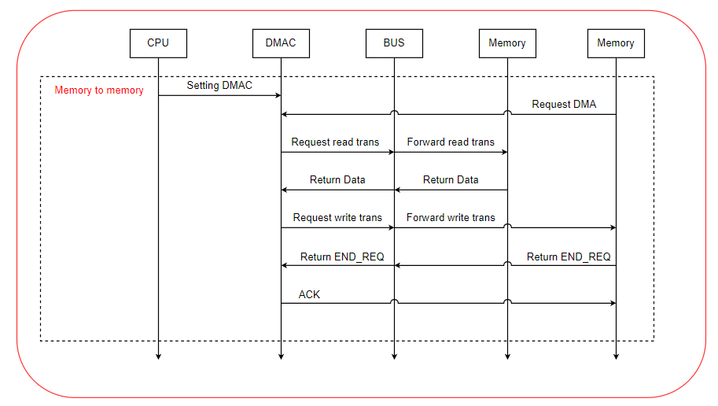
Figure 5: Memory to memory sequence diagram

Before DMAC operation, registers are configured by CPU. The source address is the address of memory , and the destination address is the address of memory . When request signal is triggered by memory , the DMA operation is process and return ACK signal to memory when it done.

FLOW DIAGRAM
In this section, the document mainly explains detail about flow diagrams of each function that demonstrates for DMAC operation. The flow diagrams illustrate for operations of each function, thread, and method. Note that the document just provide flow diagram for main functions that have important roles in DMA operation.

