TẬP ĐOÀN CÔNG NGHIÊP
VIỄN THÔNG-QUÂN ĐỘI
VIETTEL



DESIGN SPECIFICATION

MODEL

DUMMY MASTER



Author: Huan Nguyen-Duy
Date: 8/02/2024

CATALOG
1. OVERVIEW 4
2. DUMMY MASTER ARCHITECTURE 5
3. SEQUENCE DIAGRAM 6
4. FLOW DIAGRAM 7
4.1. Nb_transport_bw flow diagram 8
4.2. Send transaction flow diagram 9
4.3. Send custom transaction flow diagram 10

FIGURE
Figure 1 : The overview of systemC environment with dummy master 4
Figure 2 :Dummy master architecture 5
Figure 3 : Sequence diagram 6
Figure 4 : nb_transport_bw flow diagram 8
Figure 5 : send transaction flow diagram 9
Figure 6 : Send custom transaction flow diagram 10

TABLE
Error! No table of figures entries found.

OVERVIEW
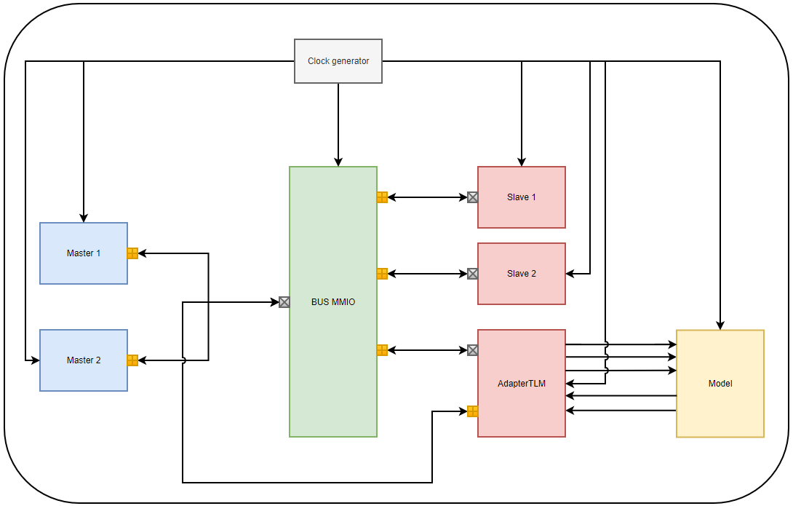
Figure 1: The overview of systemC environment with dummy master

The document shows detail the design specification of dummy master model that is implemented by systemC language. The dummy master model is used to control the read or write transaction through bus MMIO model. Using tlm 2.0 library, it provides API (application programming interface) to sent the request transaction. The fig 1 shows the systemC environment with dummy master model as masters to control read or write request transaction to slaves through bus MMIO.

DUMMY MASTER ARCHITECTURE

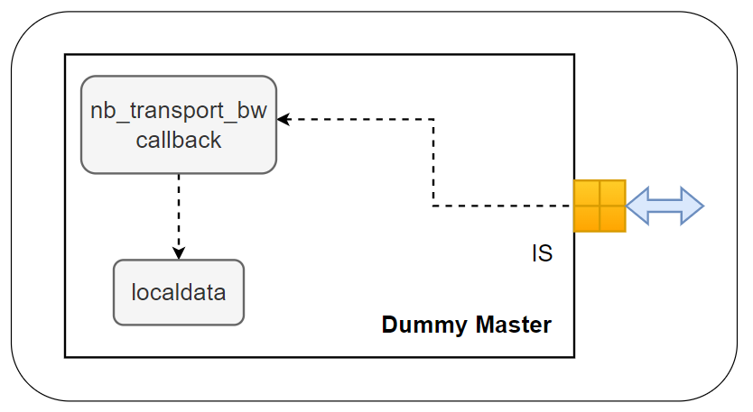
Figure 2:Dummy master architecture

The fig 2 illustrates the dummy master architecture that included a initiator socket supported by tlm 2.0 library. The nb_transport_bw function is used to get received data and respond status from the target socket as call back function. Moreover, the local data is used to save the received data.

SEQUENCE DIAGRAM
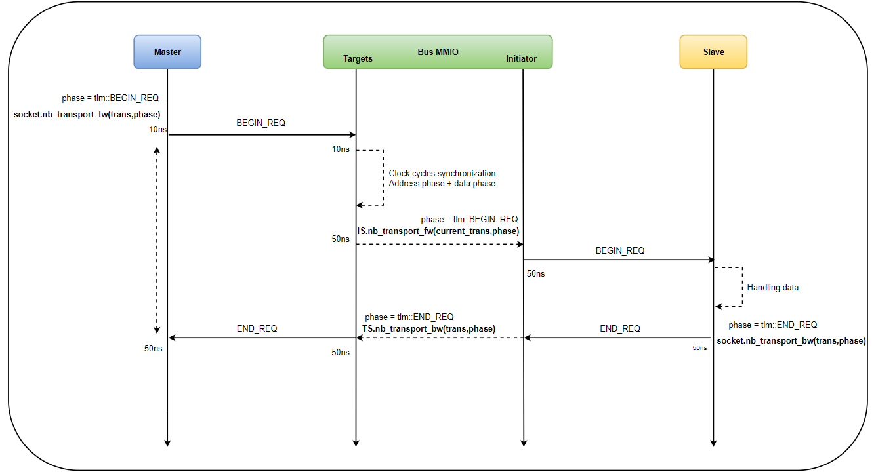
Figure 3: Sequence diagram

The fig 3 illustrates for requested transaction from master to slave using dummy master. Firstly, the dummy master sent a requested transaction with BEGIN_REQ phase to bus MMIO, it synchronizes with clock cycles, forwarding the request transaction to salve. When the salve return the transaction with END_REQ, bus MMIO will forward it to dummy master and finish the transaction.

FLOW DIAGRAM

In this section, the document provides flow diagrams of functions that illustrates clearly the operation of the dummy master model.

Nb_transport_bw flow diagram
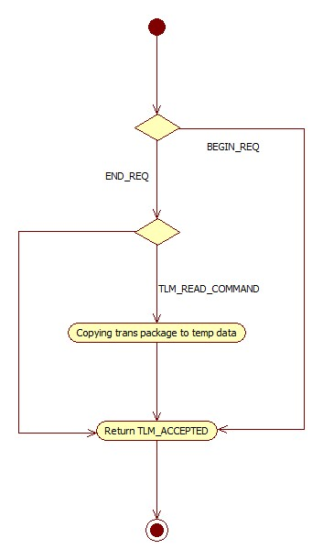
Figure 4: nb_transport_bw flow diagram

The fig 4 illustrates for the flow diagram of nb_transport_bw call back function. The read received data will be copied to temp data before ending transaction.

Send transaction flow diagram
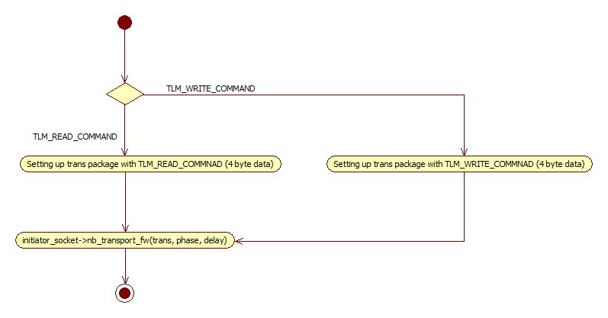
Figure 5: send transaction flow diagram

The fig 5 show sending requested transaction operation. It is send by the initiator socket. In this function, the data length is fixed within 4 byte data.

Send custom transaction flow diagram
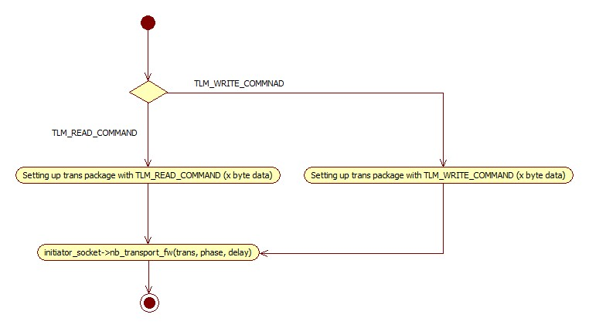
Figure 6: Send custom transaction flow diagram
The fig 6 show sending requested transaction operation. It is send by the initiator socket. In this function, the data length depends on the setting of user.

