TẬP ĐOÀN CÔNG NGHIÊP
VIỄN THÔNG-QUÂN ĐỘI
VIETTEL



DESIGN SPECIFICATION

SOC PLATFORM



Author: Huan Nguyen-Duy
Date: 8/16/2024

CATALOG
1. OVERVIEW 4
2. SOC PLATFORM ARCHITECTURE 5
3. FEATURES 6
3.1. Transferring data among internal components 7
3.2. Setting registers using dummy master 8
3.3. Monitoring internal ports using dummy slave 9
3.4. Register interface implementation 10
3.5. External memory 11
3.6. Wrapper for connection with RTL model 12
4. DEMO 13

FIGURE
Error! No table of figures entries found.
TABLE
Table 1 : Variable definition of class bus 8
Table 2 The list of functions 10

OVERVIEW
This document illustrates the design of custom SoC platform using systemC. This platform contains all essential models that are connected by bus with memory mapping I/O. In particular, the basic SoC platform includes a dummy master and dummy slave for controlling register read/write operation and monitoring all the status of interconnected ports. Furthermore, external memory is support for DMA operation and other purposes. Specially, the SoC platform supports a register interface that is implemented independently to use as common interface, it helps developer easily create registers of models that are mapped into memory mapping I/O that can access by dummy master model (having a crucial role as the cpu core of system).

On the other hand, to connect with models that are implemented at RTL level, we propose a way to implement wrapper model that will map all registers to TLM socket and using bus memory mapping I/O to control it.

SOC PLATFORM ARCHITECTURE
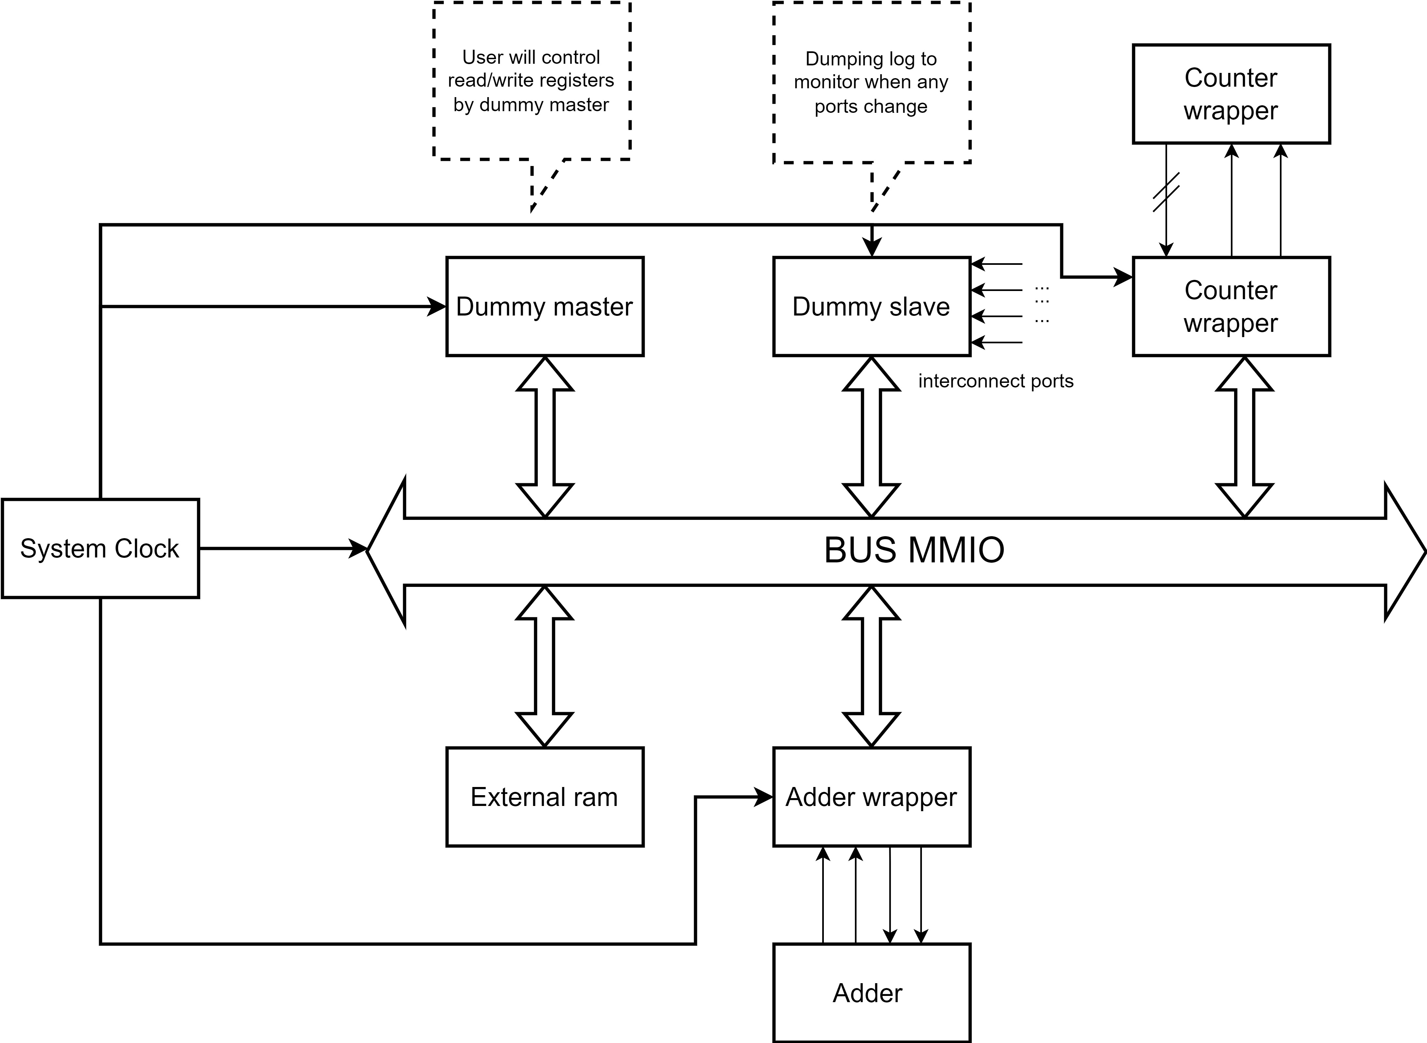
Figure 1: The basic SoC platform architecture

The fig 1 shows the basic of SoC platform architecture, user will control read/write register operation through dummy master that provided several public application programming interface. Wrapper models are implemented dependently on each RLT level model (RTL modules are write by verilog that is converted to systemC model using v2sc tool), it will implement register interface for each reg ports and binding them on bus memory mapping I/O.

FEATURES
In this section, the document illustrates all features that are supported by SoC platform. It contains all basic operation of SoC system. In particular, peripherals are mapped into bus MMIO with specific address, dummy master can access to all peripherals by sending specific TLM payload with the corresponding address.

Transferring data among internal components
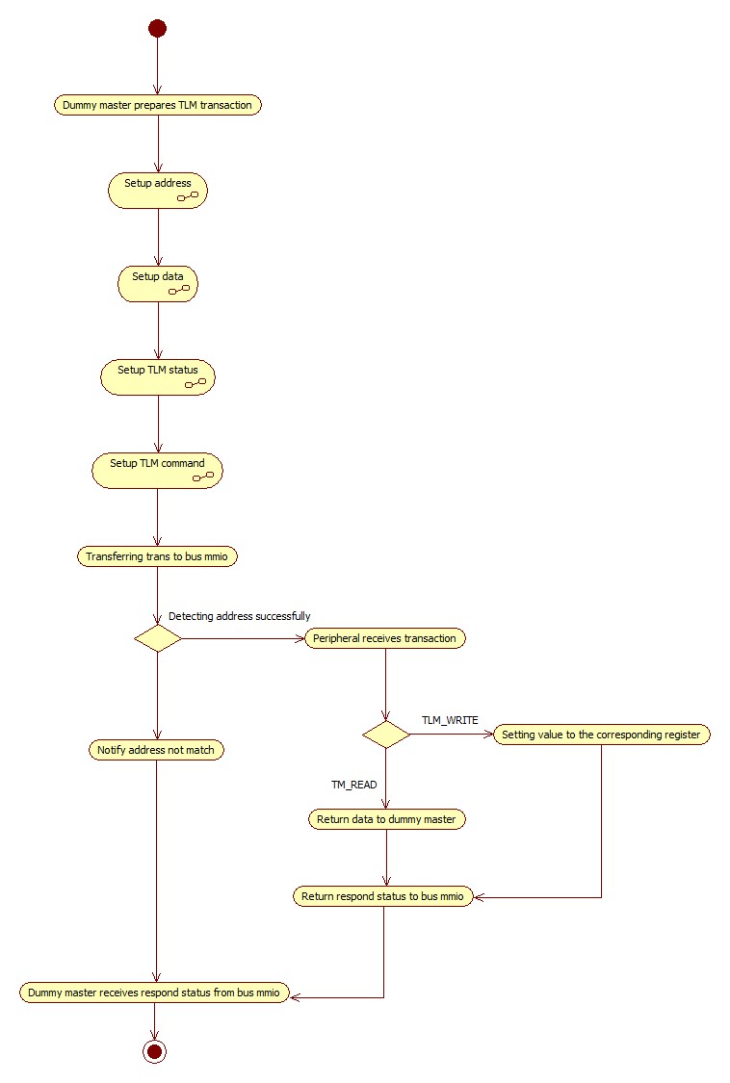
Figure 2: Transferring data using dummy master

The fig 2 shows operation using dummy master access to peripheral model in SoC platform. The dummy master provides application programming interface to setup TLM transaction, user will define the address of register and the value for write operation and 0x0 value for read operation. When TLM transaction is forwarded to peripheral successfully, peripheral will check the TLM command and handling another operation.

Setting registers using dummy master
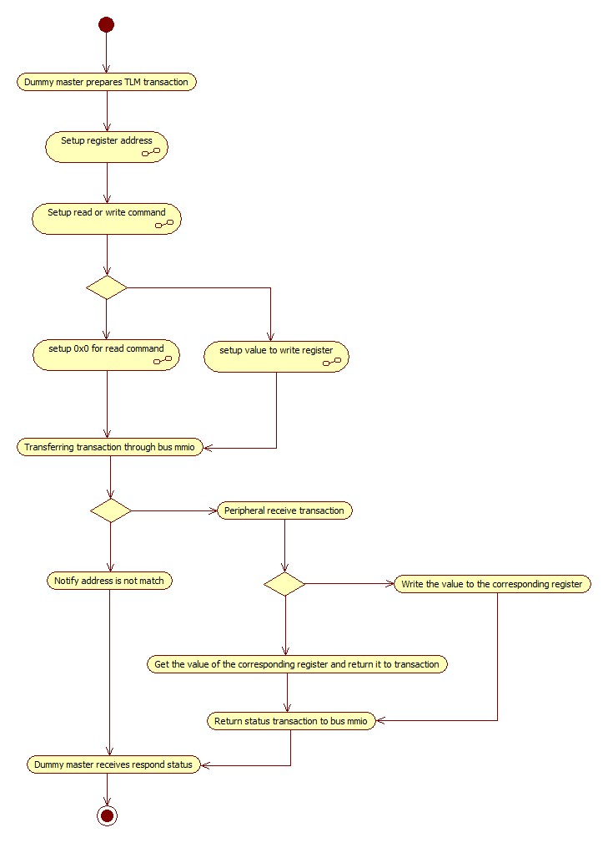
Figure 3: Read or Write register operation

The fig 3 shows the read / write register operation of SoC platform. User define the address space of each peripherals in the top module that is used to mapping with all registers, to read or write register of each peripheral, user writes or reads to the corresponding register address.

Monitoring internal ports using dummy slave

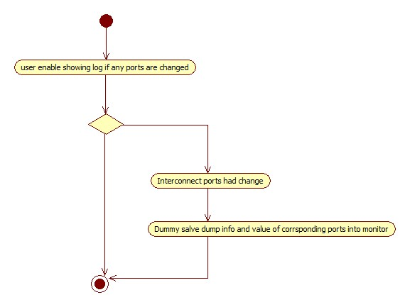
Figure 4: Monitoring ports using dummy salve

For debug demand, the SoC platform provides a method to monitor all interconnected signals in its. If any ports change its status, the dummy salve will show log in the monitor and user can use it for debug demand.

Register interface implementation
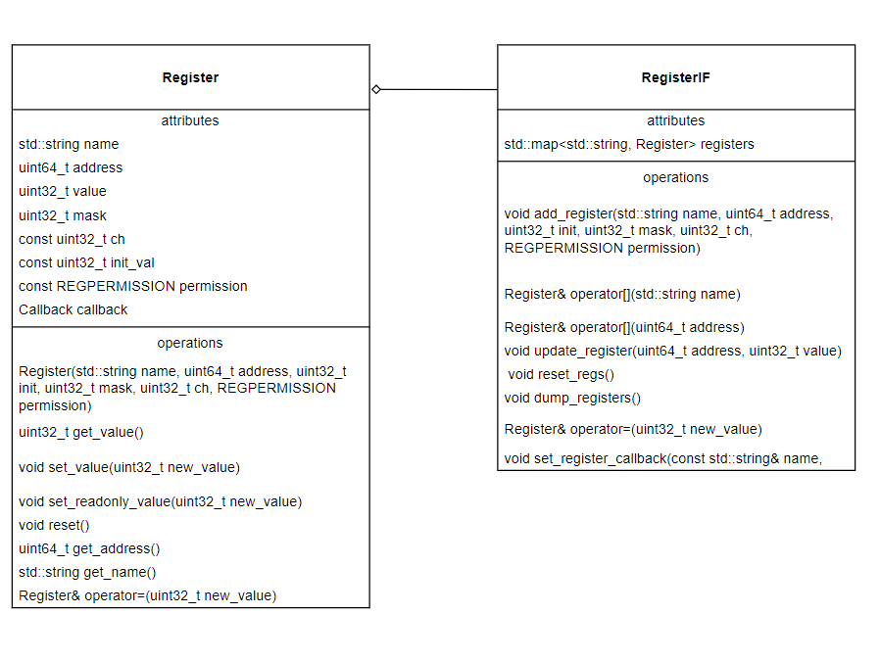
Figure 5: Register interface support

The SoC platform offers a register interface that support to instance all registers for each model. The address of registers will be mapped into bus MMIO and register the specific addresses. User can access to registers through the address of TLM transaction. Specially, this interface support for callback registration, if user register callback function for specific register, when it change the value, the callback function is called. It is helpful for implement HW simulation.

External memory
The SoC platform support ram model that is connected directly to bus MMIO, it is used for further DMA operation.

Wrapper for connection with RTL model

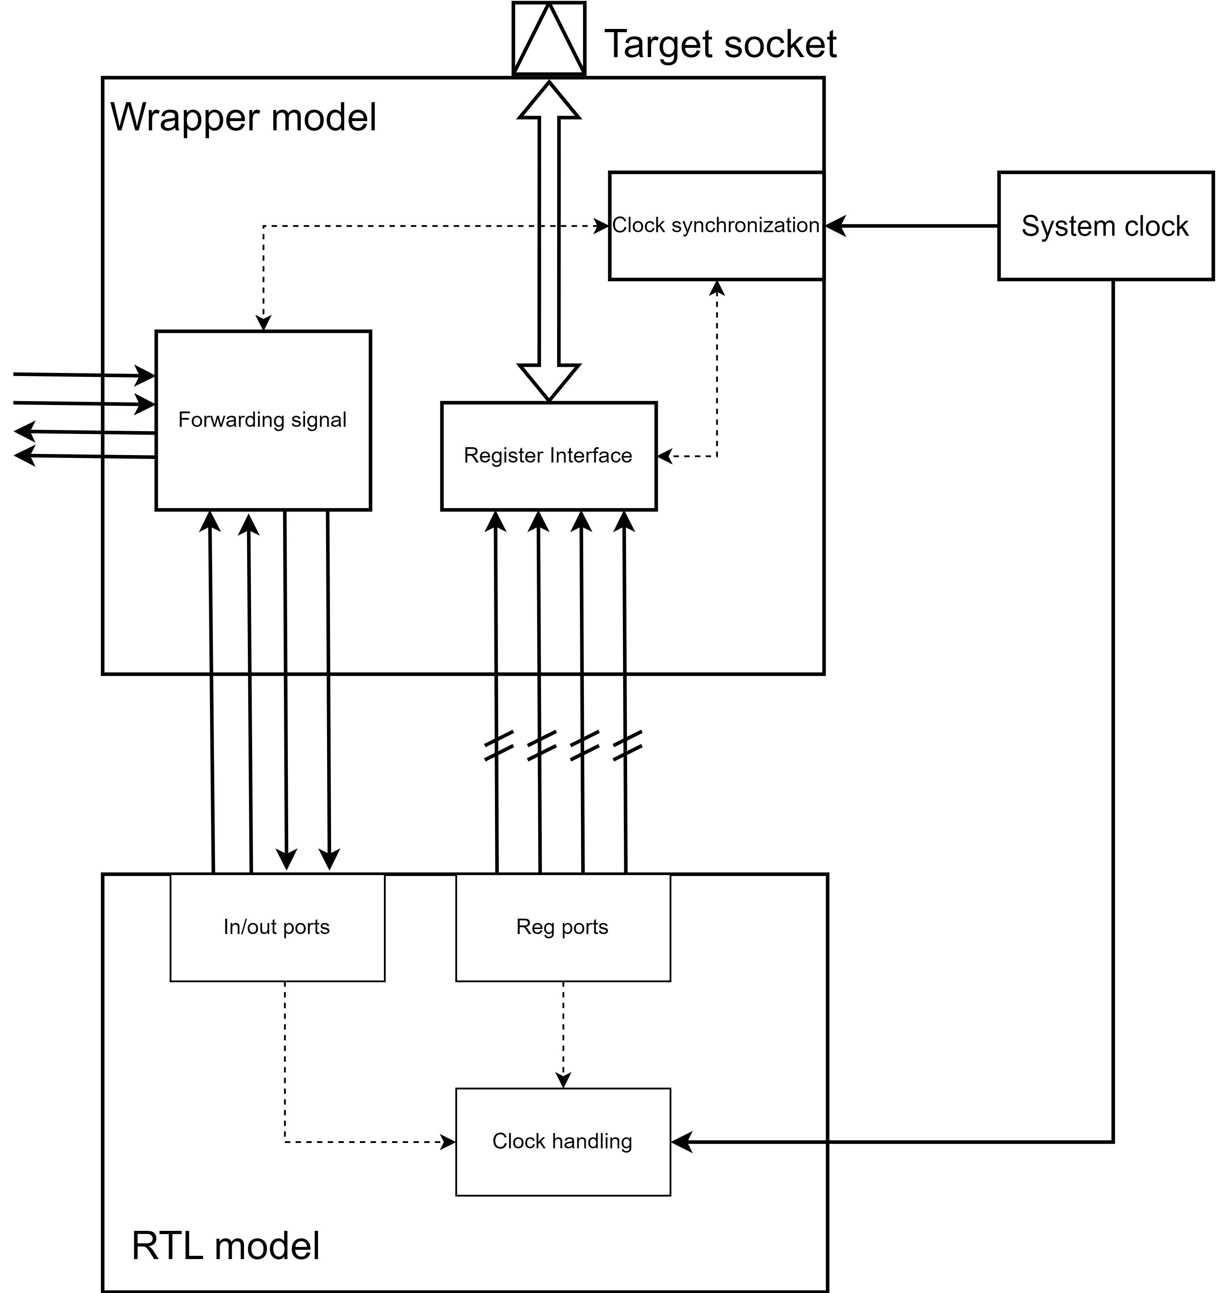

Figure 6: Wrapper common architecture for connecting RTL model

The fig 6 illustrates the idea for implementation wrapper that converts bus MMIO interface to reg ports and forwards in/out signals.

TOP MODULE
In this section, the document will show the illustration of top module for SoC platform.

Instance internal SoC model
DummyMaster<32> m_dummymaster;
DummySlave<32> m_dummyslave;
BUS<APB> m_bus;
Target<32> m_target1;
Target<32> m_target2;
Target<32> m_target3;
Target<32> m_target4;
RAM<32> m_ram1;
wrapper_four_bit_adder<32> m_wrapper_four_bit_adder;
wrapper_counter<32> m_wrapper_counter;
wrapper_uart<32> m_wrapper_uart;

Mapping address of peripheral into bus MMIO
void do_bus_binding()
{
// Connecting Initiator socket to bus MMIO
m_dummymaster.initiator_socket.bind(m_bus.target_sockets);
m_dmac.initiator_socket.bind(m_bus.target_sockets);

// Binding target sockets into bus MMIO
m_bus.mapping_target_sockets(BASE_RAM1,SIZE_RAM1).bind(m_ram1.socket);

m_bus.mapping_target_sockets(BASE_DUMMYSLAVE,SIZE_DUMMYSLAVE).bind(m_dummyslave.target_socket);

m_bus.mapping_target_sockets(BASE_TARGET1,SIZE_TARGET1).bind(m_target1.target_socket);

m_bus.mapping_target_sockets(BASE_TARGET2,SIZE_TARGET2).bind(m_target2.target_socket);

m_bus.mapping_target_sockets(BASE_TARGET3,SIZE_TARGET3).bind(m_target3.target_socket);

m_bus.mapping_target_sockets(BASE_TARGET4,SIZE_TARGET4).bind(m_target4.target_socket);

m_bus.mapping_target_sockets(BASE_FOUR_BIT_ADDER,SIZE_FOUR_BIT_ADDER).bind(m_wrapper_four_bit_adder.target_socket);
m_bus.mapping_target_sockets(BASE_COUNTER,SIZE_COUNTER).bind(m_wrapper_counter.target_socket);
m_bus.mapping_target_sockets(BASE_UART,SIZE_UART).bind(m_wrapper_uart.target_socket);

}

Binding signal
void do_signals_binding()
{
m_dummyslave.add_input_port("system_reset")->bind(m_sysrst);
// binding system clock
m_bus.m_clk(m_sysclk);
m_dmac.clk.bind(m_sysclk);
m_dummymaster.clk.bind(m_sysclk);
m_dummyslave.clk.bind(m_sysclk);
m_dummyslave.rst(m_sysrst);
m_wrapper_counter.m_clk(m_sysclk);
m_wrapper_uart.m_clk(m_sysclk);

// binding reset
m_dummymaster.rst.bind(m_sysrst);
m_bus.m_rst.bind(m_sysrst);
m_dmac.rst.bind(m_sysrst);
m_wrapper_uart.m_rst(m_sysrst);

/* Counter */
m_wrapper_counter.m_clear(counter_clear);
m_wrapper_counter.m_load(counter_load);
m_wrapper_counter.m_start(counter_start);
m_dummyslave.add_output_port("counter_clear")->bind(counter_clear);
m_dummyslave.add_output_port("counter_load")->bind(counter_load);
m_dummyslave.add_output_port("counter_start")->bind(counter_start);

/* UART */
m_wrapper_uart.m_nrw(uart_nrw);
m_wrapper_uart.m_cs(uart_cs);
m_wrapper_uart.m_sin(uart_sin);
m_wrapper_uart.m_int2(uart_int2);
m_wrapper_uart.m_sout(uart_sout);
m_dummyslave.add_output_port("uart_nrw")->bind(uart_nrw);
m_dummyslave.add_output_port("uart_cs")->bind(uart_cs);
m_dummyslave.add_output_port("uart_sin")->bind(uart_sin);
m_dummyslave.add_input_port("uart_int2")->bind(uart_int2);
m_dummyslave.add_input_port("uart_sout")->bind(uart_sout);

}

