**ELCASH Payments**

Contents

ELCASH Mining Plan purchase path 1

Pay It Forward functionality in ELCASH Wallet 4

CP1 and CP2 Payments in ELCASH 5

Citizen List and After Reg Update 5

# **ELCASH Mining Plan purchase path**

ELCASH is a new cryptocurrency in Mining City which can be used to purchase ELCASH Mining Plans.

**Process description**

A user can use this new form of payment by clicking the [Buy now with ELCASH] button, which is available in **Buy Plans – ELCASH section -> ELCASH Dashboard -> ELCASH Sub-dashboard**. The button is displayed below the [Buy now with BTC] and [Buy now with BTCV] buttons.

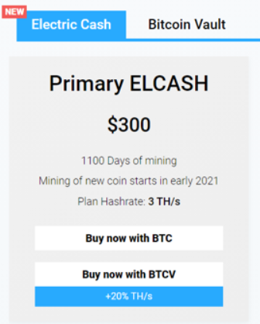

**The purchase path** looks as follows:

**1**. Terms of service display and acceptance

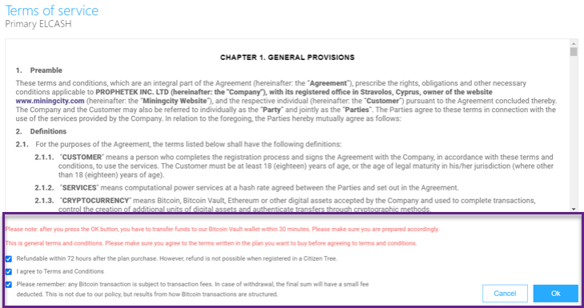

**2**. Purchase summary, which displays the buying plan and the username.

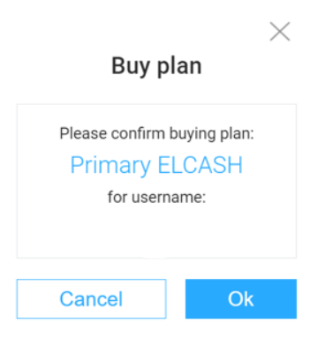

**3**. One time wallet address creation

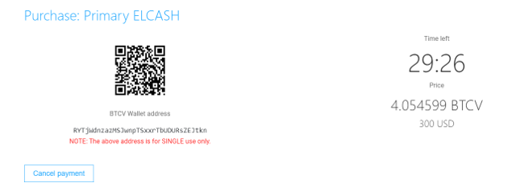

# **Pay It Forward functionality in ELCASH Wallet**

Mining City users have the possibility to do PIF (Pay It Forward) in ELCASH wallet so they can purchase a Mining Plan in ELCASH for another user.

Pay It Forward tab is available in ELCASH Wallet Section.



**Process description**

**1**. The user enters the receivers’ username  
 **2**. The user chooses the Plan from the list to purchase  
 **3**. The user clicks on [Purchase] button  
 **4**. The email with confirmation link is sent to the user  
 **5**. After clicking on the link the PIF transaction is finished

The filed with choosing cryptocurrency to mine should not be implemented.



# **CP1 and CP2 Payments in ELCASH**

MC Users have the possibility to receive Compensation Plan 1 (Cp1) and Compensation Plan 2 (Cp2) commissions in ELCASH so that they can see Cp1 and Cp2 payments in ELCASH General Balance.

Compensation Plan 1 and 2 should be paid in ELCASH when the user’s downliner purchased Mining Plan in ELCASH currency. The logic of payment is the same as or BTC and BTCV. In ELCASH, General Balance should reflect the payment in ELCASH for CP1 and CP2 with the details.

# **Citizen List and After Reg Update**

MC users have the possibility to see the ELCASH plans in Citizen List.  
The **Citizen List** tab (also available in After Reg section) is updated according to the ELCASH Plans.

The **Mining Plans** section includes as follows:

* ELCASH Plan #1
* ELCASH Plan #2
* ELCASH Plan #3

In the section level ELCASH should also be added.

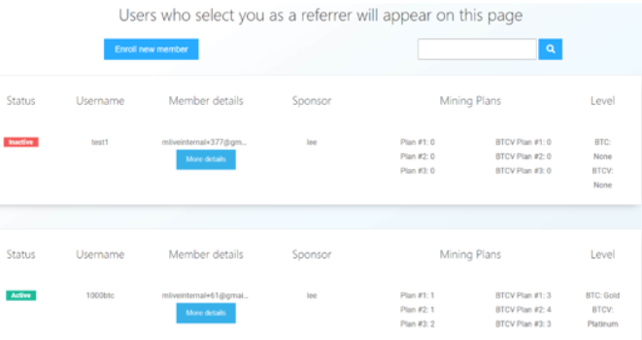

The section details are updated according to the ELCASH payments.

