**Mining City Product Backlog Requests (PBR)**

User Manual

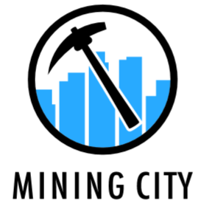

The aim of PBR is to collect ideas and needs regarding Mining City Product among both MC Users and company employees. Submitted requests are going to be scrutinized by the Product Team and if they are in line with the product strategy, they will be implemented.

How to create a ticket?

1. In **JIRA**, click on **Create**.



1. Select the project: **Mining City Product Backlog Request (PBR).**

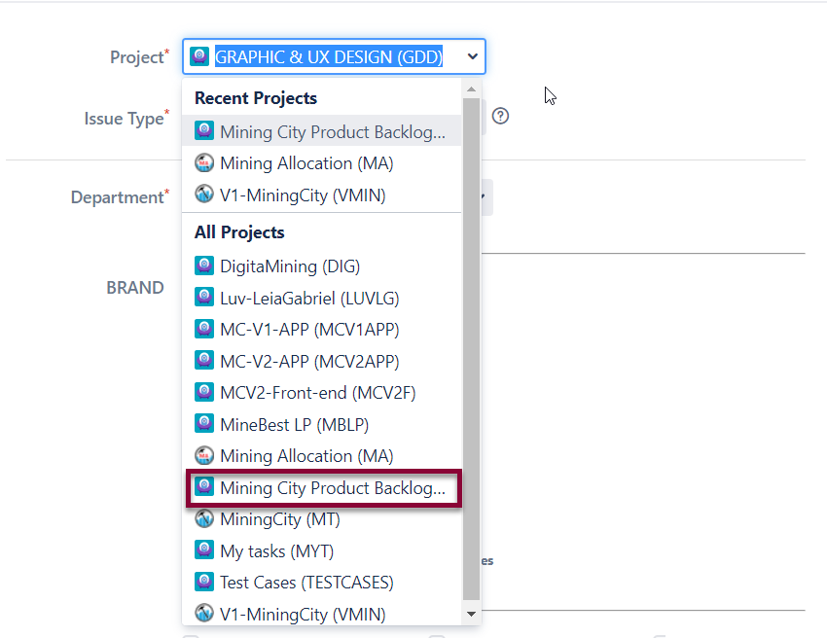

1. Select **New Feature** or **Improvement** as an **Issue Type.**

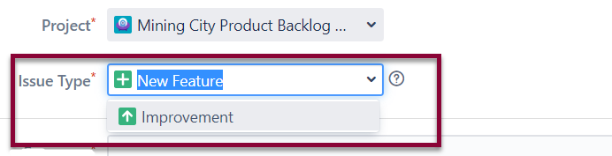

1. Fill in the **Summary** as briefly as possible.

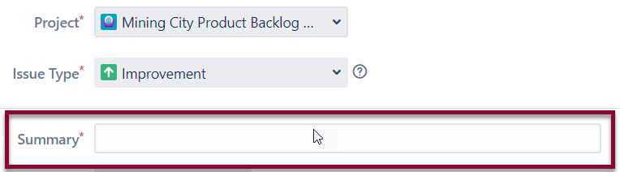

1. Select **Product** type you want to improve/ comment on. You can choose **MC Landing Page**, **MC User Dashboard** or **MC ACP Dashboard**.

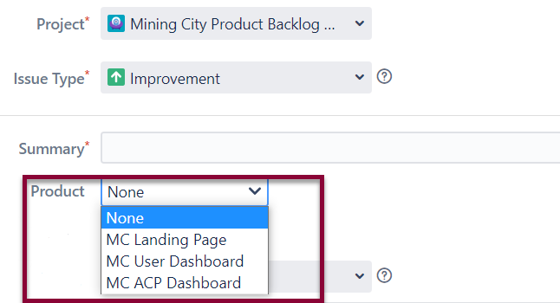

1. Select **MC Version**: **V1** or **V2**.

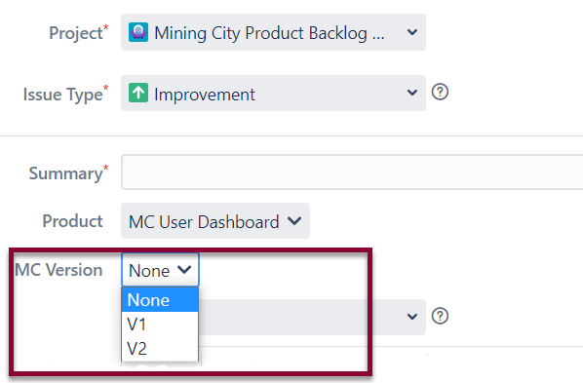

1. Choose **Priority**.

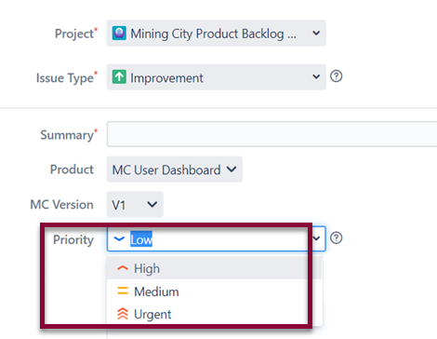

1. Fill in the **Description** as precisely as possible. Depending on the type of your request, provide the appropriate **Attachments** i.e., screenshots.

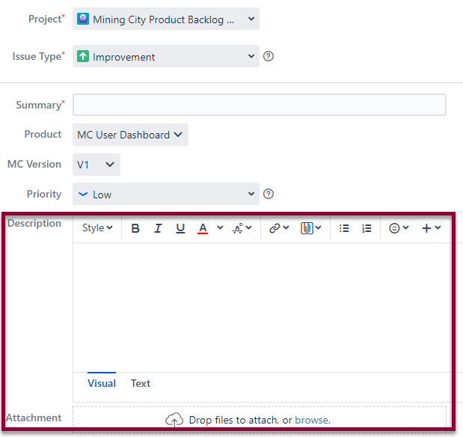

1. **Assignee** is automatically chosen by the Product Team.

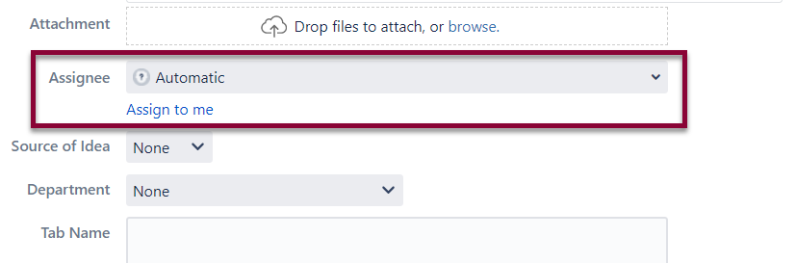

1. Choose your **Source of Idea**:

**External** – Mining City Users

**Internal** – Company employees.

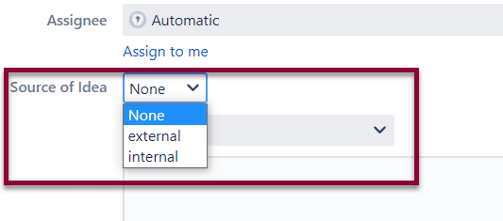

1. Choose **Department** name.

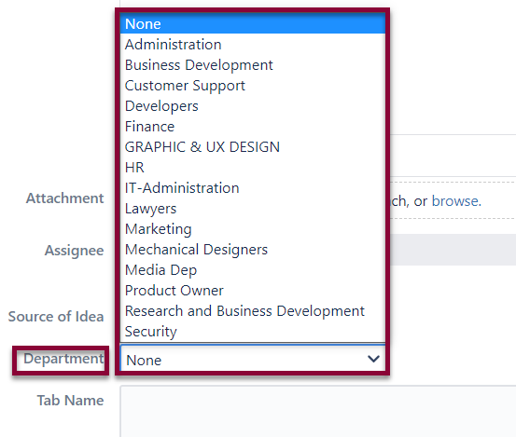

1. Put down **Tab Name** i.e., My Plans, My Wallet or Manage Users.

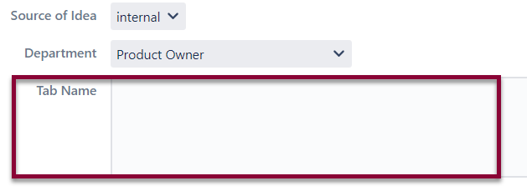

1. Click on the **Create** button.

