Contents
Reports 1st Iteration 1
Reports - CP Commissions .csv file generation 2
Reports - Shares Report .csv file generation 3
Reports - New reports permission 5
Reports - Sales Report .csv file generation 5
[ACP] Reports - Generic report blueprint 6
[ACP] Reports - Generic report blueprint - customizable filters 7
[ACP] Reports - Generic report blueprint - generate filename and title 7
[ACP] Reports - Reports grouping 7
[ACP] Reports - Add report name to the filters section 8
[ACP] Reports - Mining Report .csv file generation 8
[ACP] Reports - Users Report .csv file generation - PoC of cron functionality 11
[ACP Reports] Possibility to generate reports from maximum 180 days back 13
[ACP] Reports - CP Commissions .csv file generation 13
[ACP] Reports search box 15
[ACP] Reports search box – Backend 15
[ACP] Reports search box – Frontend 16
[ACP] Reports search box - searchable columns 16
[ACP] Reports - GeoIP Report .csv file generation and view 16
[ACP] Reports - GeoIP Report - connect to IP API and save zone data 17
[ACP] Reports 3rd Iteration - Sales by country 17
[ACP Reports] Total sales by TH/s report 18
[ACP Reports] Possibility to choose one cryptocurrency when applicable 19
[ACP] Reports - disable visibility of mining report 19
[ACP] Reports 3rd Iteration - Elcash reports 19
[ACP Reports] Withdrawal report - change tables from where we fetch data 20
[ACP] Reports - Monthly Rank Promotion .csv file generation 20
[ACP] Reports - Withdrawals Report .csv file generation 21
[ACP Reports] Displaying BTC / BTCV and USD values up to X decimal places 22
[ACP Reports] Report error because of new Elcash plans 22
[ACP Reports] TH/s Reports need to add Elcash 23
[ACP] Reports - Refunds Report .csv file generation and view 23

Reports 1st Iteration

An ACP User has the possibility to generate .csv file for the specific reports containing different data. What is more, (s)he can check previous reports in order.
A user has access to the following reports. (S)he can also generate .csv and filter the reports:
- Mining Report
- CP Commissions
- Users Report
- Shares Report
- Sales Report
The reports that already exist are split into two groups:
- To Hide - these reports are hidden. Yet, it is possible to access them:
- Plans 4-5 Reports
- Repurchases Report
- Withdraws Reports BTC
- Withdraws Reports BTCV
- Balance Reports
- Bonus Reports
- Payouts Reports BTC
- Payouts Reports BTCV
- BTCV Purchases
2. Other tab needs to be implemented. The reports need to be improved; yet the main logic still applies:
- Plans 1-3 Reports BTC
- Rank Reports
- Income by Country Reports BTC
- Income by Country Reports BTCV
- Stats Reports BTC
- Stats Reports BTCV
- TH/s reports
The reports contain sensitive data so the permissions should be defined. Different permissions will apply to different report groups.
Reports - CP Commissions .csv file generation
An ACP User has the possibility to see and generate .csv file for CP Commissions.
In the Reports Tab (ACP Panel), there is the CP Commissions subtab.
The CP Commissions Report is displayed in the Web View. It is possible to generate .csv file.
Filters:
- Coin (check boxes, multiple select)
- BTC
- BTCV
- Checkbox (multiple select) CP to generate: CP1, CP2 or CP3.
- Filters to search by date range - from DD.MM.YYYY to DD.MM.YYYY
- DD.MM.YYYY selectable from the calendar, there is the possibility to set one day
- 'View' and 'Generate CSV' buttons are available after setting the filters

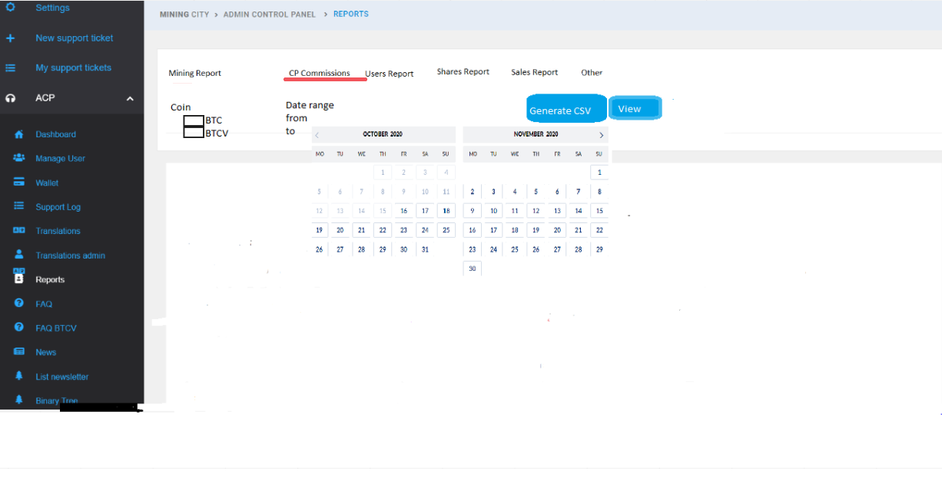

- Report contains the following columns:
Date | Username | CP Number | Amount paid | Coin | USD equivalent
dd-mm-yyyy-HH-MM | abc | 1 | 0.0987 | BTC | 100

- Time reflected in date column is the UTC time.
- Generated file name: MC_CP_ Commissions_DD_MM_YYYY_HH_mm.csv
- DD_MM_YYYY_HH_mm reflects the exact date of clicking the 'Generate CSV' button.
- After clicking 'Generate .CSV', the download is started.
- After clicking 'View', the popup is displayed with the information that the request is under processing:
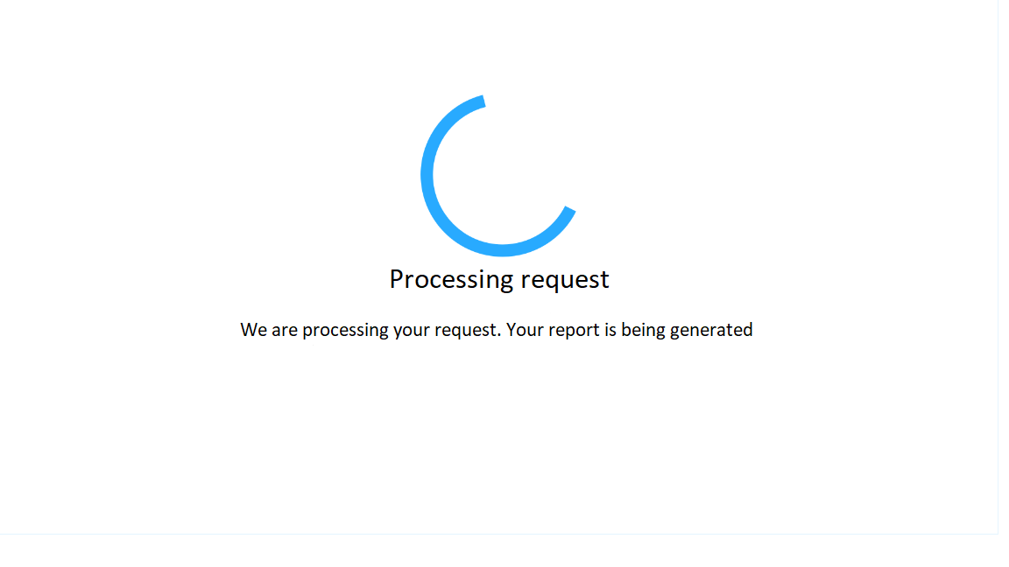

Reports - Shares Report .csv file generation

An ACP User has the possibility to see and generate .csv file for Shares Report.
In the Reports Tab (ACP Panel), there is a new subtab - Shares Report.
- Filters to search by date range - from DD.MM.YYYY to DD.MM.YYYY
- DD.MM.YYYY selectable from the calendar, there is the possibility to set one day
- 'View' and 'Generate CSV' buttons are available after setting the filters

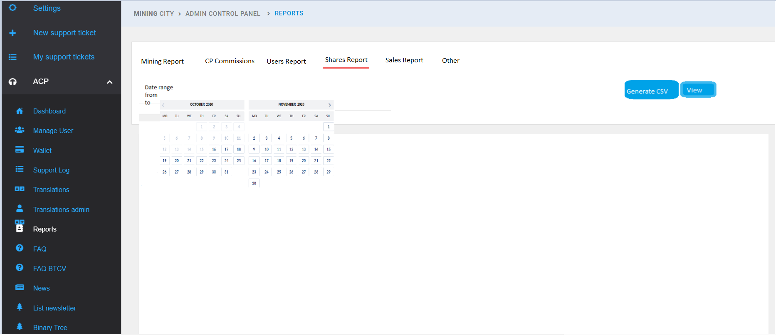

- After clicking 'View', the data is displayed on the page. What is more, the popup with information that the request is under processing appears:
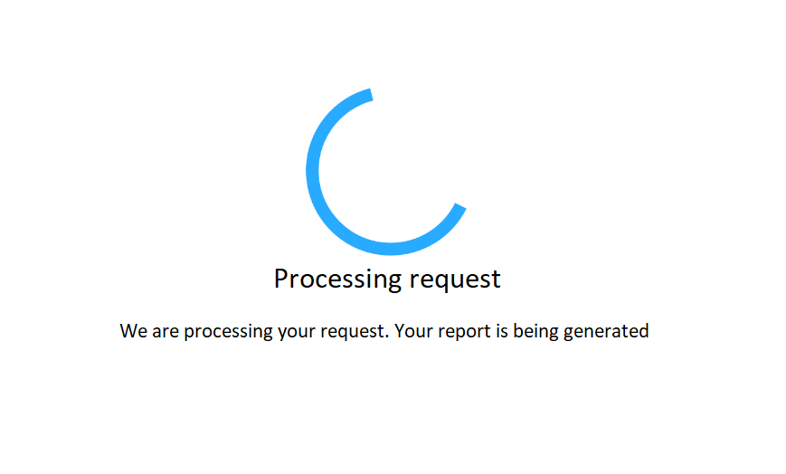

- After clicking 'Generate CSV' the data is downloaded as a CSV file.
- Generated file name: MC_Shares_Report_DD_MM_YYYY_HH_mm.csv
- DD_MM_YYYY_HH_mm reflects the exact date of clicking the 'Generate CSV' button.
The report contains the following information:
- Username
- Mining Plan ID
- Mining Plan purchase date
- Share TH/s
- Share value
- Share start date
- Share end date
- Flag: Miner changed - marked [0, 1]

Username | Plan ID | Plan purchase date | Share TH/s | Share value | Share start date | Share end date | Miner changed
ColA1 | 28168 | 01.06.2019 | 0.1 | 10 | 08.01.2020 | 12.01.2023 | 1

Reports - New reports permission

The reports are split into two permissions groups:
- old reports permission (stays as it is), it will be the "OTHER" group of reports
- new reports permission - name to be decided, it will be the "NEW" group of reports
- hidden reports permission (these which are hidden and not used)
Permission names: reports_other, reports_new, reports_hidden

Reports - Sales Report .csv file generation

An ACP User has the possibility to see and generate .csv file for Sales Report.
In the Reports Tab (ACP Panel), there is the new subtab - Sales Report.
The Sales Report is displayed in the Web View and it is possible to generate a .csv file.
Filters:
- Filters to search by date range - from DD.MM.YYYY to DD.MM.YYYY
- DD.MM.YYYY selectable from the calendar, there is a possibility to set one day
- 'View' and 'Generate CSV' buttons are available after setting the filters

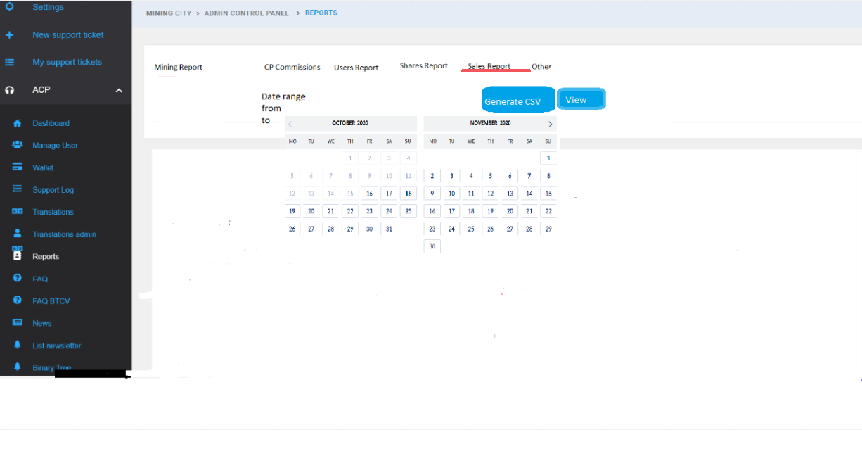
- Report contains the following columns:
- Date
- BTC Plans Purchased with BTC
- BTCV Plans Purchased with BTCV
- BTCV Plans Purchased with BTC
- USD equivalent

Date | BTC Plans purchased with BTC | BTCV Plans Purchased with BTCV | BTCV Plans Purchased with BTC | USD equivalent
DD-MM-YYYY-HH-MM

- Time reflected in date column is the UTC time.
- Generated file name: MC_Sales_ Report_DD_MM_YYYY_HH_mm.csv
- DD_MM_YYYY_HH_mm reflects the exact date of clicking the 'Generate CSV' button.
- After clicking 'Generate .CSV' the download is started.
- After clicking 'View', the popup is displayed with information that the request is under processing:

[ACP] Reports - Generic report blueprint

To create the new reports functionality, we need to provide generic classes and methods to the new report module.
What is needed:
- customizable filters
- generic csv exporter
- representation of SQL on the frontend
- generate report title and filename

[ACP] Reports - Generic report blueprint - customizable filters

Filters that are needed: Date range (calendar), coin checkbox selection (multi select + future new coins), Compensation plans selection (checkbox, multiselect)
Defaults:
- date - today
- coin checkbox - BTC and BTCV selected
- Compensation plan - plan 1 as a default
- Date filter should be at max 3 months range

[ACP] Reports - Generic report blueprint - generate filename and title

- {color:#FF0000}{color}
- Generated file name: MC_XXXXX_DD_MM_YYYY_HH_mm.csv
- DD_MM_YYYY_HH_mm will reflect the exact date of clicking the 'Generate CSV' button
- Where XXXX is a report name

[ACP] Reports - Reports grouping
An ACP User has access to the reports section divided into specific groups.
The reports are split into two permissions groups:
  - Other tab needs to be implemented. The reports need to be improved; however, the main logic still applies.
When you click 'Other' reports group, all reports links in the other group are visible. If clicked back, they remain hidden (toggle view). Permission to the 'Other' tab are granted automatically with access to ACP Reports section and they cover the below reports:
- Plans 1-3 Reports BTC
- Rank Reports
- Income By Country Reports BTC
- Income By Country Reports BTCV
- Stats Reports BTC
- Stats Reports BTCV
- TH/s reports
2. The following reports need to be implemented as separate tabs. Separate permissions to access the following reports need to be created:
- Mining Report
- CP Commissions
- Users Report
- Shares Report
- Sales Report

[ACP] Reports - Add report name to the filters section

An ACP User can view the report name above the filters so that (s)he is sure which report (s)he chooses filters for.
Details:
After clicking the report tab, the report name and filters should appear. The name of the report is the same as the names of the tabs.

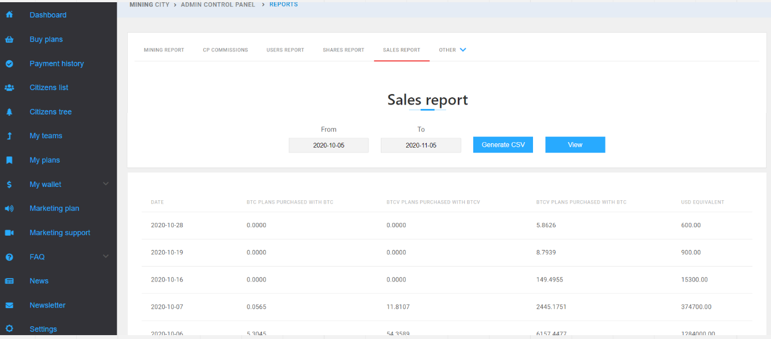

[ACP] Reports - Mining Report .csv file generation

An ACP User has the possibility to see and generate .csv file for Mining Report. In the Reports Tab (ACP Panel) there is a new subtab - Mining Report.
The Mining Report is displayed in the Web View. It is possible to generate a csv file.
Filters:
- Coin Mined (check boxes, multiple select)
- BTC
- BTCV
- Filters to search by date range - from DD.MM.YYYY to DD.MM.YYYY
- DD.MM.YYYY selectable from the calendar; it is possible to set one day
- 'View' and 'Generate CSV' buttons are available after setting the filters

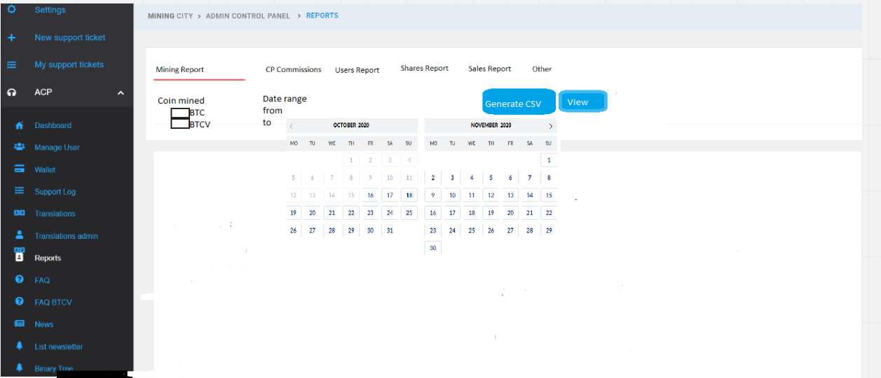

- Report should contain the following columns:
- Date
- Username
- Total mining
- Coin
- USD Equivalent(of total mining)
- Total bonus
- USD Equivalent (of total bonus)

Date | Username | Total mining | Coin | USD equivalent | Total bonus | USD equivalent
dd-mm-yyyy-hh-mm | abc | 0.01234567 | BTC | 100 | 0.00006 | 6

- Time reflected in date column is the UTC time
- Generated file name: MC_Mining_Report_DD_MM_YYYY_HH_mm.csv
- DD_MM_YYYY_HH_mm reflects the exact date of clicking the 'Generate CSV' button
- After clicking 'Generate .CSV' the download is initiated
- After clicking 'View', the popup with information that the request is under processing is displayed:

Exemplary SQL (it might be missing some fields):

SELECT from_unixtime(bh.created::int)::date as date_day, u.user_name, SUM(COALESCE(bh.value, 0 ))
FROM balance_history_btcr bh
JOIN users u on bh.user_id = u.id
WHERE bh.event_type ='CLOUDMINING.MINING'
AND from_unixtime(bh.created::int)::date >= '2020-09-01'
AND from_unixtime(bh.created::int)::date < '2020-11-01'
GROUP BY date_day, u.user_name order by 1 asc;

[ACP] Reports - Users Report .csv file generation - PoC of cron functionality

An ACP User has the possibility to see and generate .csv file for Users Report.
In the Reports Tab (ACP Panel), there is a new subtab - Users Report.
There are no filters to search by – there are only ‘View’ and ‘Generate CSV’ buttons.

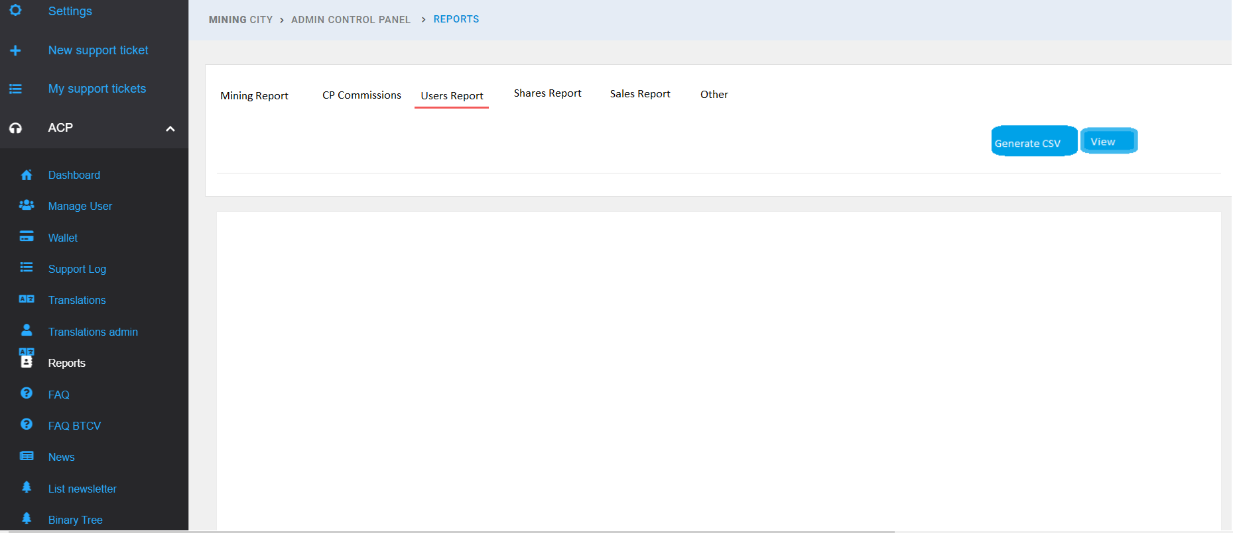

After clicking ‘View’, the data is displayed on the page. What is more, the popup with information that the request is under processing appears:
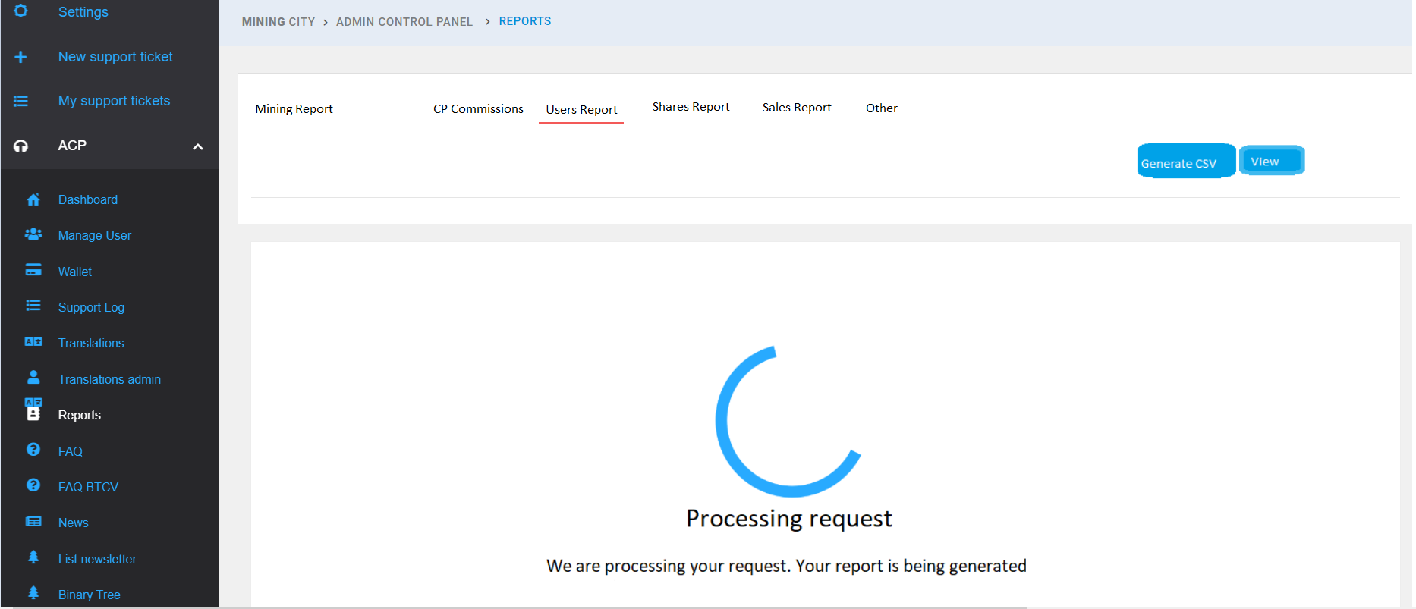

- After clicking ‘Generate CSV’ the data is downloaded as a CSV file.
- Generated file name: MC_Users_Report_DD_MM_YYYY_HH_mm.csv
- DD_MM_YYYY_HH_mm reflects the exact date of clicking the ‘Generate CSV’ button.

The report should contain the following information:
- Username
- Left BTC / BTCV Binary Points
- Right BTC / BTCV Binary Points
- Current aside balance divided into [Primary, Standard, Bronze, Silver, Gold, Platinium]
- Current total aside balance - new
- Current BTC / BTCV Mining Balance - new
- Current BTC / BTCV General Balance - new
- Level in the Binary Tree
- Level in the Team Tree - new
- Current rank
- Browser lang
- Registration date
- Flags - do not count, activated - marked [0,1]; iftestuser - marked [true, false]
- Current BTC / BTCV wallet address
- Referrer name
- Date of data extraction [UTC]
- First Mining Plan purchase date - new
- How many users are directly referrer by - new
- How many users are enrolled in his/her Binary Tree - new
- How many users are enrolled in his/her Team Tree - new
- How many points (s)he contributed to Binary Tree - new

new - data that is NOT COVERED by the current SQL.

Username | Left BTC credits |  | Left BTCV credits |  | Right BTC credits |  | Right BTCV credits |  | Aside Balance Primary |  | Aside Balance Standard |  | Aside Balance Bronze |  | Aside Balance Silver |  | Aside Balance Gold |  | Aside Balance Primary
Col A1 | 10 |  | 20 |  | 5 |  | 15 |  | 0 |  | 0 |  | 0 |  | 0 |  | 0 |  | 0
Aside Balance Total | BTC  Mining Balance |  | BTCV Mining Balance |  | BTC General Balance |  | BTCV General Balance |  | Binary Tree Level |  | Team Tree Level |  | Rank |  | Browser language |  | Registration Date
0 | 2 |  | 0 |  | 1 |  | 0 |  | 55 |  | Col A1 |  | Citizen |  | zh |  | 27.06.2020
dontcount | is_test_user |  | activated |  | Current BTC Wallet |  | Current BTCV wallet |  | Referrer |  | Extract date
0 | false |  | 1 |  |  |  |  |  | qwer2 |  | 16.10.2020
First Plan purchased |  | Sponsor |  | Users in Binary Tree |  | Users in Team Tree |  | Credits contributed to Binary Tree
10.01.2019 |  | 15 |  | 14 |  | 14

[ACP Reports] Possibility to generate reports from maximum 180 days back

An ACP User has the possibility to generate report for maximum period of 31 days with an option to choose 180 days back.
The option relates to the following reports:
- Mining
- Sales
- CP Commissions
- Shares
- Refunds
- Monthly Rank Promotion
- Withdrawals

[ACP] Reports - CP Commissions .csv file generation

An ACP User has the possibility to see and generate .csv file for CP Commissions.
In the Reports Tab (ACP Panel) there is a new subtab - CP Commissions.
The CP Commissions Report is displayed in the Web View. It is possible to generate a .csv file.
Filters:
- Coin (check boxes, multiple select)
- BTC
- BTCV
- Checkbox (multiple select) CP to generate: CP1, CP2 or CP3.
- Filters to search by date range - from DD.MM.YYYY to DD.MM.YYYY
- DD.MM.YYYY selectable from the calendar; it is possible to set one day
- 'View' and 'Generate CSV' buttons are available after setting the filters.
Report contains the following columns:

Date | Username | CP Number | Amount paid | Coin | USD equivalent
dd-mm-yyyy-HH-MM | abc | 1 | 0.0987 | BTC | 100

- Time reflected in date column is the UTC time.
- Generated file name: MC_CP_ Commissions_DD_MM_YYYY_HH_mm.csv
- DD_MM_YYYY_HH_mm reflects the exact date of clicking the 'Generate CSV' button.
- After clicking 'Generate .CSV', download is initiated.
- After clicking 'View', the popup is displayed with information that the request is under processing:

[ACP] Reports search box

Filter/search box needs to search and return results among all records related to the specified report.
Now, this filter/search box works only for one page as mentioned in this story.
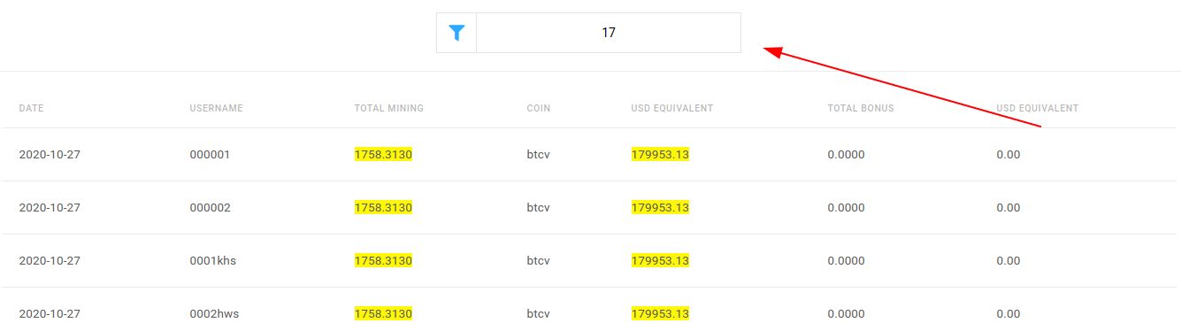

[ACP] Reports search box – Backend

The following ajax request needs to be created for the new reports:
- MINING REPORT
- CP COMMISSIONS
- USERS REPORT
- SHARES REPORT
- SALES REPORT
- and for the new ones
The request will be like GetReport.php but it will contain an additional parameter - for example 'content'. The response will return all matched records by that `content` parameter.

[ACP] Reports search box – Frontend

Connect the new ajax method and create a ‘Load more’ button for that filter/search box instead of pagination for better user-experience.

[ACP] Reports search box - searchable columns

A Mining City Admin has access to additional filters so that (s)he can view only the specific information.
Details:
Besides the required filters, additional filters should be available for selection. In the following reports, users will be able also to use additional (not required) filters such as:
- Mining report - Username
- CP Commissions - Username
- Users report - Username, Rank, Referrer, browser lang, current BTC wallet, current BTCV wallet, activated (0,1), registration date (date range)
- Shares report - Username, Share Th/s
- Sales report - no additional filters needed
- Refunds - Username, Plan Name, Wallet address
- Withdrawals - username, wallet address, TXID

[ACP] Reports - GeoIP Report .csv file generation and view

An ACP User views and generates a .csv file to GeoIP so that (s)he can check which country the users come from.
Details
In the Reports Tab (ACP Panel), there is a new subtab - Geo IP.

- Filters to search by date range - from DD.MM.YYYY to DD.MM.YYYY
- DD.MM.YYYY selectable from the calendar, it is possible to set one day - select from user_join column
- 'View' and 'Generate CSV' buttons are available after setting the filters
- After clicking 'View' the data is displayed on the page. What’s more, the popup with information that the request is under processing appears
- After clicking 'Generate CSV', the data is downloaded as a CSV file.
- Generated file name: MC_GeoIP_Report_DD_MM_YYYY_HH_mm.csv
- DD_MM_YYYY_HH_mm reflects the exact date of clicking the 'Generate CSV' button.
- The report should contain the following information:
- Date
- Country [name]
- Users [number of users]
Date | Country | Users
DD.MM.YYYY | Japan | 94886

[ACP] Reports - GeoIP Report - connect to IP API and save zone data
- Get user IP from Akamai and filter it (remove Akamai's IP)
- Send IP to ip-api.com (license details will be provided by Marek) and await the response
- Save the response in a database

[ACP] Reports 3rd Iteration - Sales by country
An ACP Admin has the possibility to see and generate .csv file for the 'Sales by Country' Report so that (s)he can easily access the information that is needed.
Details
In the Reports Tab (ACP Panel), there is a new subtab - Sales by Country.
Sales by Country generates information about sales volume (income from purchased Mining Plans, without PIF purchases) for each country (country defined by localization). Data can be generated for the last 90 days.
The Sales by country Report can be displayed in the Web View. It is possible to generate a .csv file.
Filters to search by:
- Date range - from DD.MM.YYYY to DD.MM.YYYY
- DD.MM.YYYY selectable from the calendar, it is possible to set one day
- Coin type used for purchase [BTC/BTCV/ELCASH]
'View' and 'Generate CSV' buttons are available after setting the filters.
The report contains the following columns:
- Date [DD-MM-YYYY HH:MM] - time reflected in the date column is the UTC time
- Country [localization]- each localization with a selected plan type is presented in the separate row
- COIN [BTC/BTCV/ELCASH] - a cryptocurrency used for the purchase. Each selected cryptocurrency is presented in different rows
- Sales - total sales volume in selected cryptocurrency from the moment of payment for the selected period. Sales should concern only full sales day (00:00 - 23:59 UTC). If sales day is not finished, then it should not be calculated to sales volume
- USD equivalent - USD value of sales

DATE | COUNTRY | COIN | SALES | USD EQUIVALENT
08-03-2021 | KO | BTC | 7,231.293 | $ 59,908.08
08-03-2021 | KO | BTCV | 1,008.155 | $ 1,217,611.45
08-03-2021 | KO | ELCASH | 1,008.155 | $ 4,99.08
 | JA

- Generated file name: MC_Sales_by_Country_ Report_DD_MM_YYYY_HH_mm.csv
- DD_MM_YYYY_HH_mm reflects the exact date of clicking the 'Generate CSV' button
- After clicking 'Generate .CSV', the download starts
- After clicking 'View', the popup with information that the request is under processing appears

[ACP Reports] Total sales by TH/s report

An ACP Admin has the possibility to see and generate .csv file for Total TH/s sold along with the start date of mining and total TH/s sold.
Details:
In the Reports Tab (ACP Panel) there is a new subtab - Total TH/s.
Filters:
- Coin (check boxes, multiple select)
- BTC
- BTCV
- ELCASH
- Filters to search by date range - from MM.YYYY to MM.YYYY - sales date
- MM.YYYY selectable from the calendar, it is possible to set one month
- 'View' and 'Generate CSV' buttons are available after setting the filters
- Report should contain the following columns:

Sales date | TH/s sold | Mining Start of TH/s sold | Coin | total sold TH/s
04.03.2021 | 120 | 14.03.2021 | BTCV | 123456

- Sales date - a date when the TH/s were sold - it concerns only full sales days so the possibility to choose f.ex. 04.03 should be from 0:00 05.03 after the full sales day is over
- TH/s sold - the total TH/s sold this specific day
- Mining Start of TH/s sold - the date when the sold TH/s will start to mine
- Coin - BTC/BTCV/ELCASH
- Total TH/s sold - the total number of TH/s sold for the specific coin updated with the TH/s with the specific day

- Generated file name: MC_ Total_TH/s_DD_MM_YYYY_HH_mm.csv
- DD_MM_YYYY_HH_mm reflects the exact date of clicking the 'Generate CSV' button
- After clicking 'Generate .CSV' the download is started
- After clicking 'View', the popup with information that the request is under processing appears

[ACP Reports] Possibility to choose one cryptocurrency when applicable

A Mining City Admin has the possibility to choose only one cryptocurrency in New reports so that the file shows only BTC, BTCV or ELCASH data.
Details:
In the New Reports (filter to choose cryptocurrency), there should be only one option. What’s more, user should have a possibility to generate file/view only for one currency.
New reports that contain ELCASH currency:
- refunds
- withdrawals
- monthly rank promo
- cp commissions
- mining

[ACP] Reports - disable visibility of mining report
As we are not finished yet with the mining report, we need to disable the visibility of the mining reports tab so that ACP users won't see it.

[ACP] Reports 3rd Iteration - ELCASH reports
- Add ELCASH coin to frontend filters
- Add ELCASH to backend reports generator
New reports that need new currency:
- refunds
- withdrawals
- monthly rank promo
- cp commissions
- mining

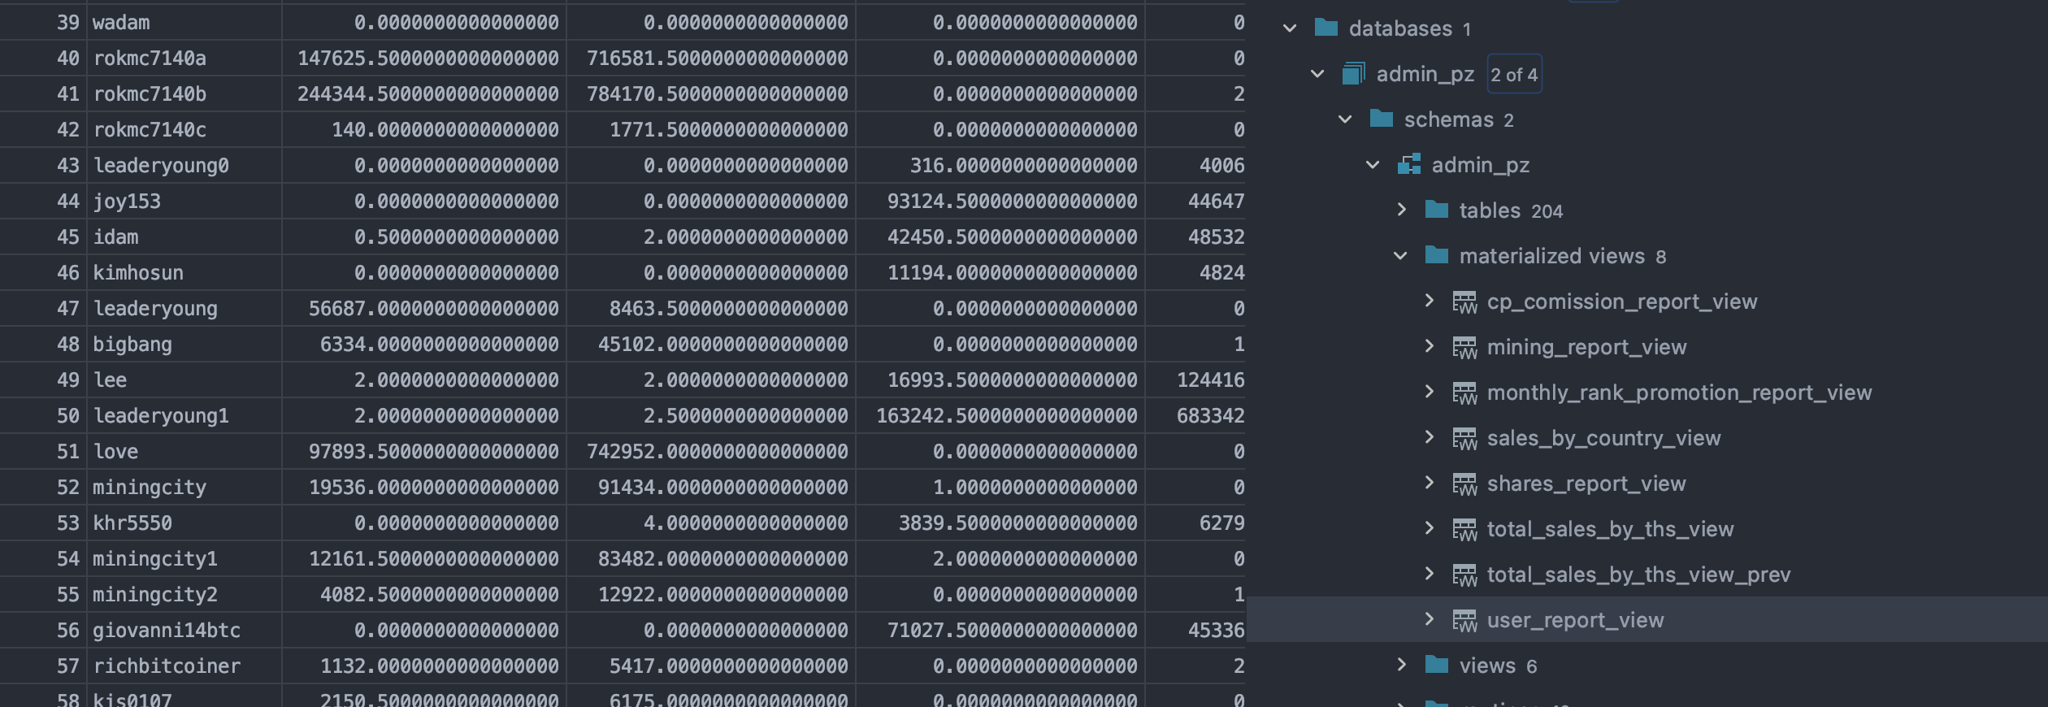

[ACP Reports] Withdrawal report - change tables from where we fetch data

Withdrawals Report table where we fetch data needs to be changed:
from {type}_wallet_transactions to balance_{type}_approvals

[ACP] Reports - Monthly Rank Promotion .csv file generation

An ACP User has the possibility to see and generate .csv file for Monthly Rank Promotion Payouts.
In the Reports Tab (ACP Panel), there is a new subtab - Monthly Rank Promotion.
Filters:
- Coin (check boxes, multiple select)
- BTC
- BTCV
- Filters to search by date range - from MM.YYYY to MM.YYYY
- MM.YYYY selectable from the calendar, it is possible to set one month.
- 'View' and 'Generate CSV' buttons should be available after setting the filters.
- Report should contain the below columns:

Date | Username | Transaction event |  | Amount | Coin | Exchange rate
dd-mm-yyyy-HH-MM | Col A2
- Username
- Transaction event
- Amount - Payout amount
- Coin - BTC or BTCV
- Exchange rate
- Generated file name: MC_Monthly_Rank_Promotion_DD_MM_YYYY_HH_mm.csv
- DD_MM_YYYY_HH_mm reflects the exact date of clicking the 'Generate CSV' button
- After clicking 'Generate .CSV' the download is started
- After clicking 'View', the popup with information that the request is under processing appears

[ACP] Reports - Withdrawals Report .csv file generation

An ACP User has the possibility to see and generate .csv file for Withdrawals Report.
In the Reports Tab (ACP Panel), there is a new subtab - Withdrawals Report.
Filters:
- Coin (check boxes, multiple select)
- BTC
- BTCV
Balance (check boxes, multiple select)
- General Balance
- Mining Balance
- Filters to search by date range - from DD.MM.YYYY to DD.MM.YYYY
- DD.MM.YYYY selectable from the calendar, it is possible to set one day
- 'View' and 'Generate CSV' buttons should be available after setting the filters
- Report should contain the below columns:

Date | Username | Transaction ID (TXID) | Wallet address | Amount | Transaction fee | General Balance | Mining Balance

- Date
- Username
- Transaction ID (TXID) - TX ID from blockchain
- Wallet address - external wallet address on which the withdraw is done
- Amount - of withdraw
- Transaction fee - the amount of transaction fee
- General Balance - the amount of general balance after withdrawing is done
- Mining Balance - the amount of mining balance after withdrawing is done
- Generated file name: MC_Withdrawals_ Report_DD_MM_YYYY_HH_mm.csv
- DD_MM_YYYY_HH_mm reflects the exact date of clicking the 'Generate CSV' button
- After clicking 'Generate .CSV' the download is started
- After clicking 'View' the popup with information that the request is under processing appears

[ACP Reports] Displaying BTC / BTCV and USD values up to X decimal places

Add rounding of BTC / BTCV to 8 decimal places and USD to 2 decimal places in CSV and View report.

[ACP Reports] Report error because of new ELCASH plans
Issue with reports error script not seeing new plans which is stopping it to execute:

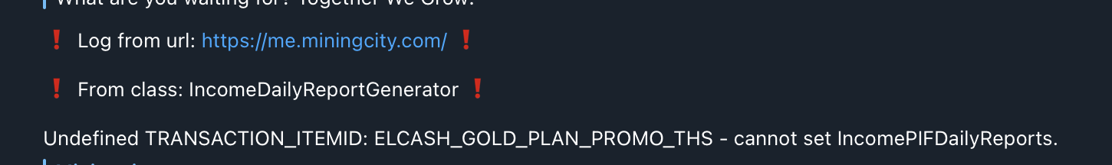

[ACP Reports] TH/s Reports need to add Elcash
We need to add ELCASH plans into THs reports https://me.miningcity.com/acp/reports
We need to add another column for THs daily increase for ELCASH and for general THs reports section where we sum BTC, BTCV and ELCASH plans separately.
Make sure it is currency mined TH/s displayed.

[ACP] Reports - Refunds Report .csv file generation and view

An ACP User has the possibility to see and generate .csv file for Refunds Report.
In the Reports Tab (ACP Panel), there is a new subtab - Refunds Report.
Filters:
- Coin (check boxes, multiple select)
- BTC
- BTCV
- Filters to search by date range - from DD.MM.YYYY to DD.MM.YYYY
- DD.MM.YYYY selectable from the calendar, it is possible to set one day
- 'View' and 'Generate CSV' buttons are available after setting the filters
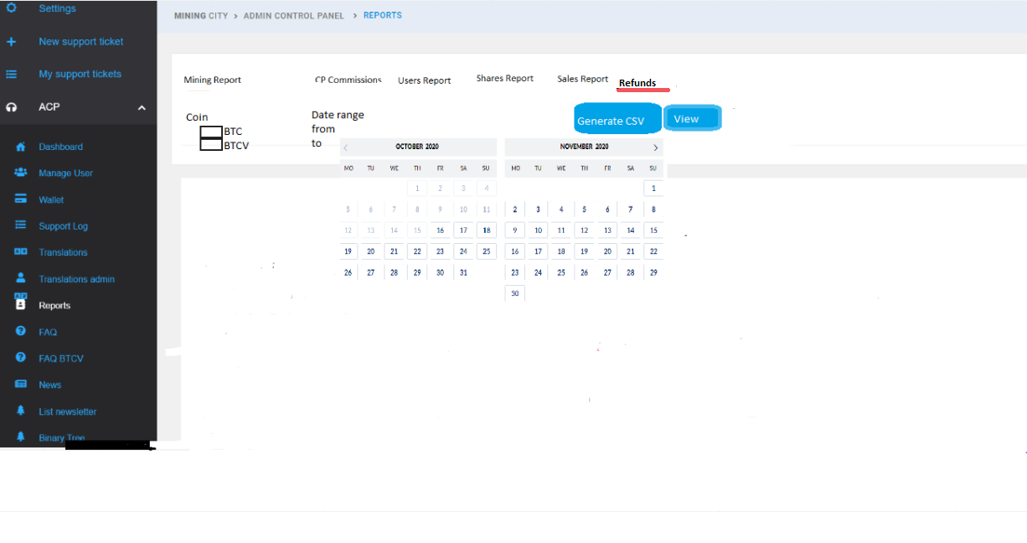

- Report should contain the following columns:

Date | Transaction ID (TXID) | Refund amount | Wallet address | Username | Plan ID | Plan Name | Form of Payment
dd-mm-yyyy-HH-MM

- Transaction ID - TX id from blockchain
- Refund amount - value of refund in the selected coin (BTC or BTCV)
- Wallet address - the wallet address to which the refund is sent
- Username
- Pland ID - ID of Purchased Plan
- Plan Name – for instance, Gold BTCV
- Form of Payment - BTC or BTCV (original form of payment)
- Generated file name:MC_Refunds_ Report_DD_MM_YYYY_HH_mm.csv
- DD_MM_YYYY_HH_mm reflects the exact date of clicking the 'Generate CSV' button
- After clicking 'Generate .CS download is started
- After clicking 'View' the popup with information that the request is under processing appears

