**BD**

**WIOLETTA ŁUPKOWSKA, 244831**

**PONIEDZIAŁEK 15:15**

**LISTA 6**

1.1

-- A)

SELECT @x:=ABS((SELECT longitudeStopnie FROM airports where kodICAO = "BGSF")- (SELECT longitudeStopnie FROM airports where kodICAO = "BGTL")) AS roznicaStopnie,

@x:= @x*4 as roznicaStopnieWMinutach,

@y:=ABS((SELECT longitudeMinuty FROM airports where kodICAO = "BGSF")- (SELECT longitudeMinuty FROM airports where KodICAO = "BGTL")) AS roznicaMinuty ,

@z:= ABS(@x+@y*1/15) AS wynik;

-- B)

SELECT @g:=11, @m:=5, @s:=4, @t1:=MAKETIME(@g, @m, @s) as godzina1,

@godziny:=@z/60 as pelneGodziny, @minuty:=@m-@godziny as roznicaMinut, @g2:=@g+@godziny as godzina2 , @m2:=@m+@minuty as minuty2, @t2:=MAKETIME(@g2,@m2,@s) as godzina2;

-- C)

SELECT nazwa, JSON_OBJECTAGG(kodICAO, kodIATA) FROM airports WHERE kraj="Poland" GROUP BY nazwa;

-- D)

SELECT concat( "LOT OD: ", (select nazwa from airports where kodICAO = "BGSF") ,

" (", (select kodIATA from airports where kodICAO = "BGSF"), ") ",

" DO: " , (select nazwa from airports where kodICAO = "BGTL"),

" (", (select nazwa from airports where kodICAO = "BGTL"), ") ",

"DATA ", CURDATE()) AS bilecik;

-- E)

SELECT concat( "LOT OD: ", (select nazwa from airports where kodICAO = "BGSF") ,

" (", (select kodIATA from airports where kodICAO = "BGSF"), ") ",

" DO: " , (select nazwa from airports where kodICAO = "BGTL"),

" (", (select nazwa from airports where kodICAO = "BGTL"), ") ",

"DATA ", CURDATE()," DZIEN: ", DAYOFWEEK(CURDATE())) AS bilecik;

-- F)

SELECT @x:=(SELECT SUM(longitudeStopnie) FROM airports where kodIATA = "LAX" or kodIATA = "SIN") as sumaStopni,

@y:=(SELECT SUM(longitudeMinuty) FROM airports where kodIATA = "LAX" or kodIATA = "SIN") as sumaMinut,

@z:=@x+@y*(1/60) as roznicaGeograficznaStopnie, @v:=@z*4 as roznicaCzasowaZegarowa;

SELECT DATE_ADD("2017-11-10 22:25:00", INTERVAL -@V+120 MINUTE) AS dataGodzinaWylotuWSingapurze;

SELECT DATE_ADD(DATE_ADD("2017-11-10 22:25:00", INTERVAL -@V+120 MINUTE),INTERVAL 17*60+50 MINUTE) AS dataGodzinaPrzylotuWSingapurze;

-- G)

SELECT @x1:=(SELECT (lattitudeStopnie+lattitudeMinuty*(1/60)) FROM airports where kodIATA = "LAX") as lattitudeLAX,

@x2:=(SELECT (lattitudeStopnie+lattitudeMinuty*(1/60)) FROM airports where kodIATA = "SIN") as lattitudeSIN,

@y1:=(SELECT (longitudeStopnie+longitudeMinuty*(1/60)) FROM airports where kodIATA = "LAX") AS longitudeLAX,

@y2:=(SELECT (longitudeStopnie+longitudeMinuty*(1/60)) FROM airports where kodIATA = "SIN") AS longitudeSIN,

@w:=SQRT(POW((@x2-@x1),2) + POW((COS((@x1*PI())/180) * (@y2-@y1)),2)) * (40075.704/360) as wynik;

-- H)

SELECT concat( kodICAO, ":", kodIATA, ":" , nazwa, ";", kraj, ":", lattitudeStopnie, ":", lattitudeMinuty, ":", lattitudeSekundy, ":", kierunekLattitude, ":", longitudeStopnie, ":", longitudeMinuty, ":", longitudeSekundy, ":", kierunekLongitude) as opis from airports WHERE kodICAO="EDDM";

-- I)

SELECT @x:=(SELECT max(lattitudeStopnie) from airports where kierunekLattitude="N") as x,

@y:=(SELECT max(lattitudeStopnie) from airports where kierunekLattitude="S") as y,

@z:=@x+@y as rozciaglosc;

SELECT * from airports WHERE lattitudeStopnie=(SELECT max(lattitudeStopnie) from airports where kierunekLattitude="N")

OR lattitudeStopnie=(SELECT max(lattitudeStopnie) from airports where kierunekLattitude="S");

-- J)

SELECT @z*111.2 as rozciagloscKM;

1.2

A)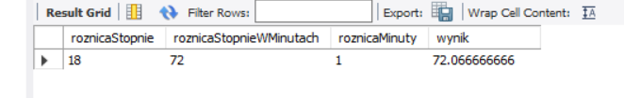

B)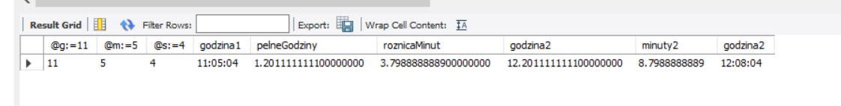

C) 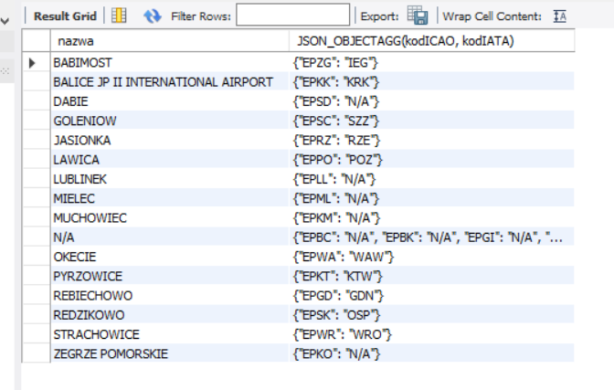

D) 

E)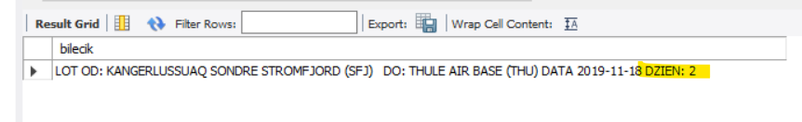

F) 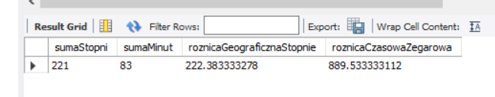

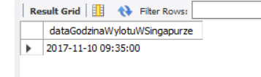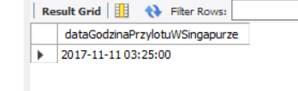

G) 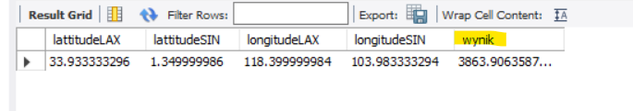

H) 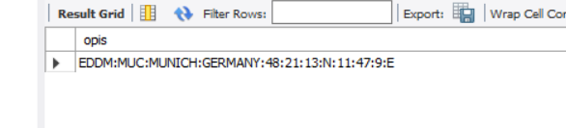

I) 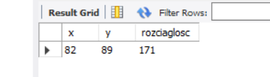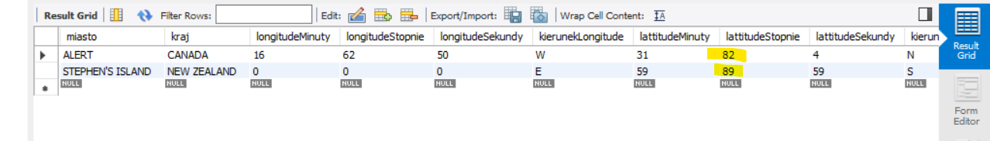

82+89=171

J) 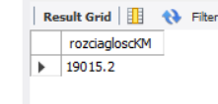

**2.1**

USE airportdb;

DROP TABLE airports_statistics;

SET FOREIGN_KEY_CHECKS = 0;

CREATE TABLE airports_statistics(

kodICAO varchar(4) NOT NULL,

-- FOREIGN KEY (kodICAO) REFERENCES airports(kodICAO), //nie działa import przy kluzczu obcym, struktura tabeli prawidłowa (eer)

pasazerowie INT,

ladowania VARCHAR(10)

);

SELECT * FROM airports_statistics;

-- b

drop view v_icao_nazwa_ladowania_i_starty;

CREATE VIEW v_icao_nazwa_ladowania_i_starty AS SELECT airports.kodICAO, nazwa, ladairportsowania FROM airports

JOIN airports_statistics s ON s.ladowania where airports.kodICAO=s.kodICAO order by s.ladowania desc ;

select*from airports;

select * from v_icao_nazwa_ladowania_i_starty;

drop view v_icao_nazwa_ladowania_i_starty ;

-- a

drop view v_icao_nazwa_pasazerowie;

CREATE VIEW v_icao_nazwa_pasazerowie AS SELECT airports.kodICAO, nazwa, pasazerowie FROM airports

JOIN airports_statistics s ON s.pasazerowie where airports.kodICAO=s.kodICAO order by s.pasazerowie desc ;

select * from v_icao_nazwa_pasazerowie;

-- c

SELECT kodICAO from v_icao_nazwa_pasazerowie where kodICAO like "E%" ;

SELECT kodICAO from v_icao_nazwa_ladowania_i_starty where kodICAO like "E%";

-- w obu sa lotniska z europy

-- d

select @x:= sum(pasazerowie) from v_icao_nazwa_pasazerowie;

select @y:= pasazerowie from v_icao_nazwa_pasazerowie where nazwa="CAPITAL";

select @procent:=@y/@x*100 as procentPasazerowie;

select @x:= sum(ladowania) from v_icao_nazwa_ladowania_i_starty;

select @y:= ladowania from v_icao_nazwa_ladowania_i_starty where kodICAO="KORD";

select @procent:=@y/@x*100 as procentLadowania;

-- e

SELECT @x:=count(kodICAO) as "lotniska USA, widok pasazerowie" from v_icao_nazwa_pasazerowie where kodICAO like "K%";

SELECT @y:=count(kodICAO) as "lotniska USA, widok ladowania" from v_icao_nazwa_ladowania_i_starty where kodICAO like "K%";

-- f

select @x:= sum(pasazerowie) from v_icao_nazwa_pasazerowie;

select @y:= @x/4000000000*100 as procentPasazerow;

-- g

SELECT @x:= pasazerowie from v_icao_nazwa_pasazerowie where kodICAO like "KATL";

SELECT @y:= 107394029/@x*100 AS ZMIANA;

2.2

Mimo dobrej struktury tabel (screen poniżej), import nie działa (importuje 0 elementów) , gdy użyję w tabeli klucza obcego. Zadania zrobione bez użycia FOREIGN KEY.

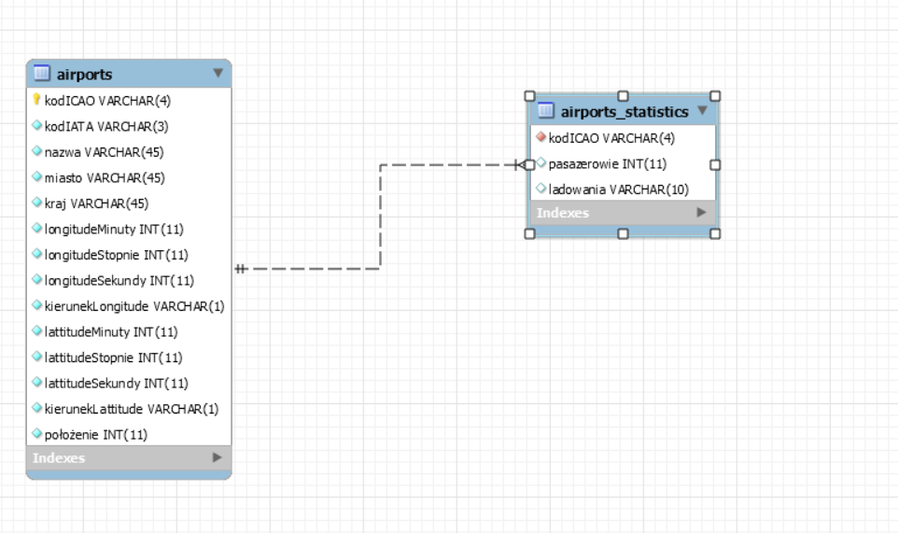

A)

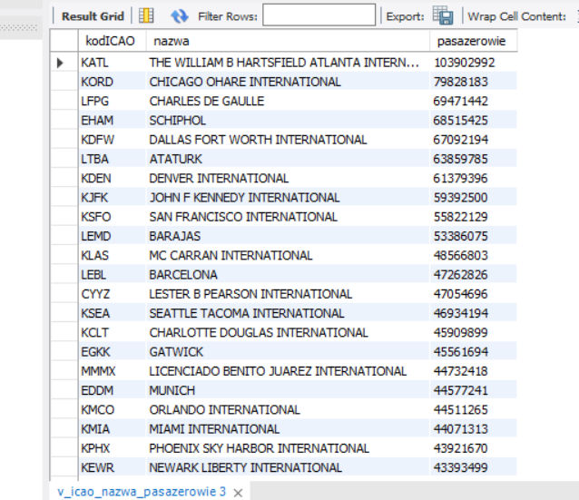

B)

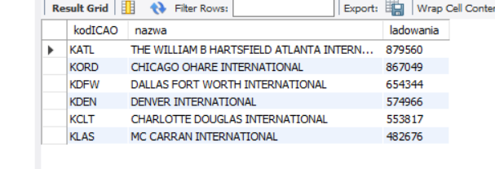

C)

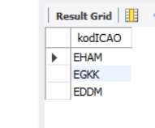Na obu są lotniska z Europy.

D)

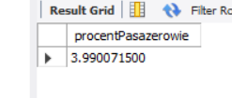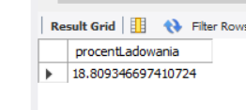

E)

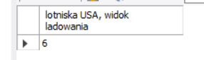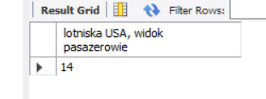

F)

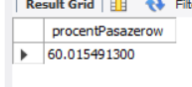

G) 