SEEv2 Cricket Box: parts and connections
To rebuild the box you need two boards, one 4-pin 1.25 mm cable, a USB-C power supply rated at least 15 W and a micro-USB cable. The display (CYD) talks to the Arduino UNO Q over three wires at 115200 baud. Sound goes in and out through the UNO Q's only USB-C port, which needs a USB-C hub with Power Delivery.
Every fact here comes from the manufacturer's documents or from the pinout guides listed under Sources. Where those sources disagree, the document says so.

Two boards do all the work
Part | Model | What it does
Arduino UNO Q | ABX00162 | Linux side (Qualcomm QRB2210) runs the hub and dashboard; microcontroller side (STM32U585) drives the UART link to the display
Cheap Yellow Display (CYD) | ESP32-2432S028R, 2.8 in 320×240 touch screen | Shows the scoreboard; a tap switches screens

The cable and power list is short
Item | Specification | Use
4-pin cable, 1.25 mm pitch, to male Dupont ends | 1.25 mm pitch, 4 pins (sold as “1.25 mm 4P JST”) | CYD P3 to UNO Q D0, D1 and GND. Male ends, because the UNO headers are sockets made to take shields
Micro-USB cable with data lines | Not a charge-only cable | Powers the CYD and flashes its firmware
USB-C Power Delivery supply | 5 V / 3 A, 15 W minimum | Powers the UNO Q, as Arduino requires
5 V USB supply or power bank | For the CYD | Powers the CYD at the stand when it is not fed from the UNO Q

Three wires link the display to the UNO Q
CYD P3 pin | Wire | UNO Q pin | Signal
GND | Black | GND | Common ground
IO35 | Blue | D1 (PB6, USART1_TX) | UNO Q sends, CYD receives
IO22 | Yellow | D0 (PB7, USART1_RX) | CYD sends, UNO Q receives
The link runs at 115200 baud, 8 data bits, no parity, 1 stop bit. IO35 can only be an input, which is why it carries the receive line. Leave the fourth P3 pin, IO21, unconnected: it drives the screen backlight. P3 has no power pin.
The guides number the P3 pins in opposite orders. Wire by the labels printed next to the connector on the board, not by pin number, and check GND with a multimeter before plugging in.
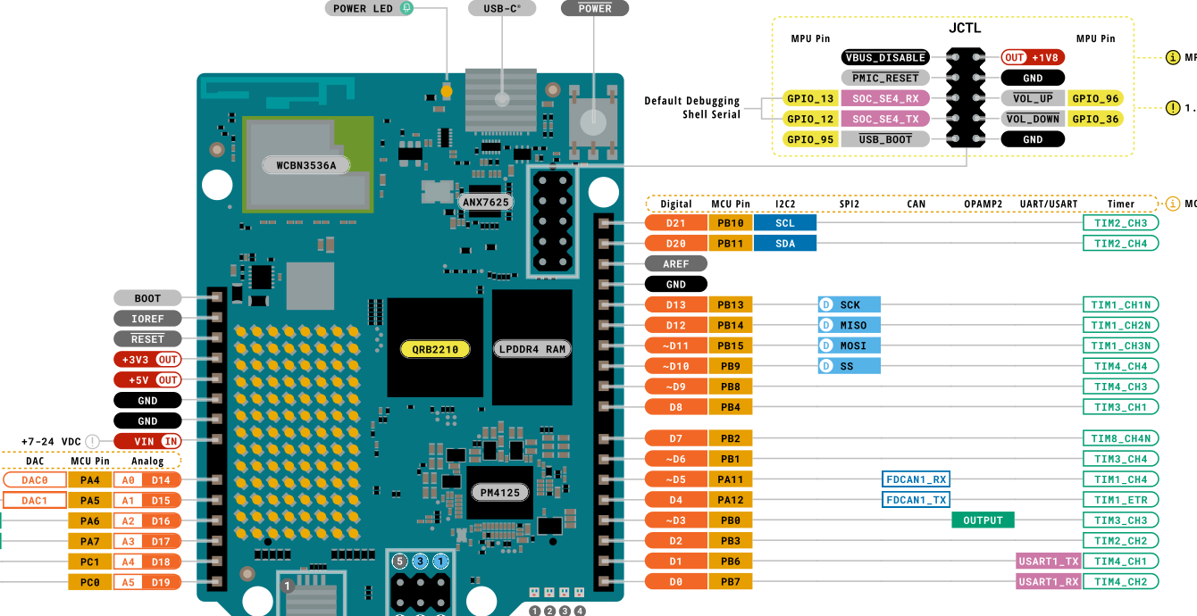
Figure 1. The UNO Q's D0 and D1 are the MCU's USART1 pins, and +5V OUT sits on the left header. Source: Arduino ABX00162 full pinout, page 1.

The CYD can draw its power from the UNO Q
The CYD's P1 connector carries VIN, TX, RX and GND. VIN is the board's 5 V rail, the same one the micro-USB socket feeds. To power the CYD from the UNO Q, run the UNO Q's +5V OUT pin to P1 VIN and GND to P1 GND. Leave P1 TX and RX unconnected: they are wired to the CYD's USB-serial chip. As a precaution, do not feed VIN and plug in micro-USB at the same time.
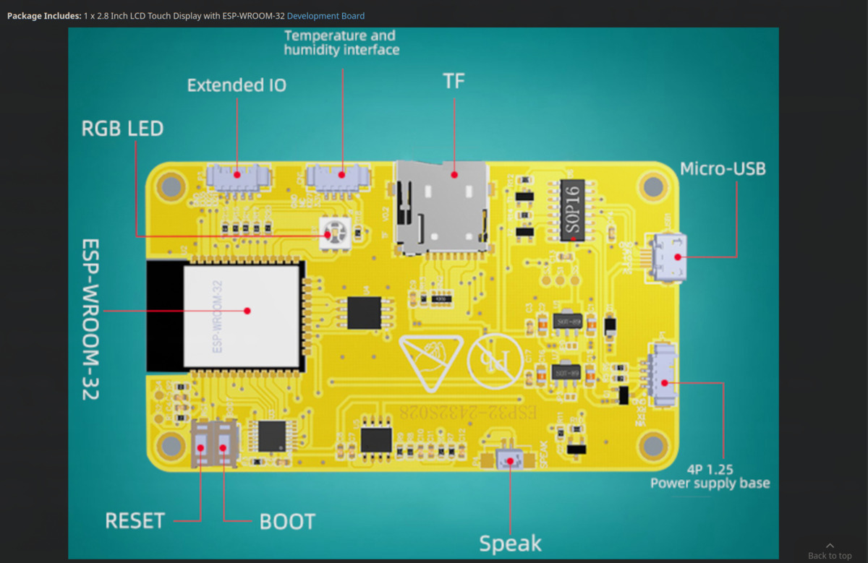
Figure 2. The CYD (ESP32-2432S028R). P3, the extended-IO connector, carries the data link; P1 carries power.

Sound needs a USB-C hub with Power Delivery
Arduino documents one way to add a microphone and headphones: plug a USB-C hub with external Power Delivery into the UNO Q's single USB-C port, then connect a USB microphone and USB headphones to it. The hub must pass power through, because the same port powers the board. Arduino recommends this setup with the 4 GB RAM version of the UNO Q.
Item | Specification | Source
USB-C hub | External Power Delivery passthrough plus USB-A ports. Users on the Arduino forum report the UGREEN Revodok 105, BASEUS 9-in-1 and BENFEI 6-in-1 working | Arduino docs; Arduino forum
USB microphone | Plugs into the hub | Arduino docs
USB headphones | Plug into the hub | Arduino docs
The board also has analog audio pins on JMISC, a high-speed connector on its underside. They include a microphone input (MIC2_INP, MIC2_INM, MIC2_BIAS on pins 29, 31 and 33), an earpiece output (EAR_P_R, EAR_M_R on pins 28 and 30), a line output (LINEOUT_P, LINEOUT_M on pins 32 and 34) and a headphone output (HPH_L, HPH_R on pins 36 and 38). The power-management chip (PMIC) provides this audio. JMISC is meant for carrier boards, not jumper wires, so the USB route is the practical one for this project.
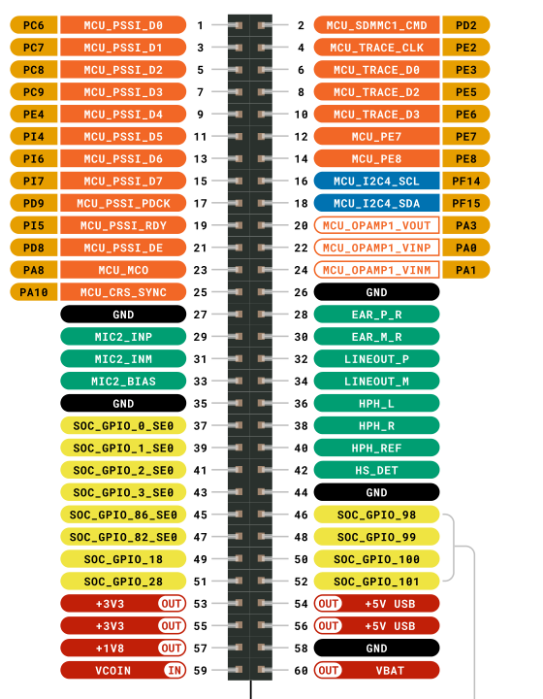
Figure 3. The analog audio pins (green) sit on the JMISC connector under the board. Source: Arduino ABX00162 full pinout, page 4.

Sources
Arduino, UNO Q documentation: docs.arduino.cc/hardware/uno-q
Arduino, ABX00162 full pinout (PDF): docs.arduino.cc/resources/pinouts/ABX00162-full-pinout.pdf
Arduino Forum, “Recommended USB-C hub and Power Supply for Arduino UNO Q”: forum.arduino.cc/t/recommended-usb-c-hub-and-power-supply-for-arduino-uno-q/1421294
Random Nerd Tutorials, “ESP32 Cheap Yellow Display (CYD) Pinout”: randomnerdtutorials.com/esp32-cheap-yellow-display-cyd-pinout-esp32-2432s028r/
ESP3D, “2.8in ESP32-2432S028R”: esp3d.io/ESP3D-TFT/Version_1.X/hardware/esp32/sunton-28-2432/
Project wiring, verified on the bench: docs/CYD_UnoQ_Wiring.docx in the project repository

