# Ansible Ad-Hoc command w/ RAW module Basic lab use case

In this lab activity, the focal point is on leveraging Ansible ad-hoc commands, with an emphasis on the RAW Module, to establish connections to devices that do not support or have Python enabled. Ansible, an open-source automation tool, is adept at managing network device configurations. Unlike executing playbooks, which entail a series of tasks, Ansible ad-hoc commands are standalone commands designed for executing quick, immediate tasks.

**The RAW Module in Ansible is particularly useful in environments where devices do not support Python**. This module allows for the execution of commands in their native form, without relying on the Ansible's module facility. Therefore, even in the absence of Python, the RAW Module facilitates seamless interactions with the devices.

See Ansible official documentation for more information: <https://docs.ansible.com/ansible/latest/command_guide/intro_adhoc.html>

To execute Ansible ad-hoc commands, certain prerequisites are required:

1. **Ansible Installation on a Control Node**: This could be your personal computer or a dedicated server that serves as the communication bridge between Ansible and your network devices. In this lab, we utilize an EVE-NG/GNS3 provided automation appliance. The EVE-NG/GNS3 network container is equipped with widely utilized network automation tools such as Netmiko, NAPALM, Pyntc, and Ansible.
2. **Python**: Given that Ansible is developed in Python, it's imperative to have Python installed on the control node. However, as we are utilizing the Network appliance, this requirement is already satisfied.
3. **Network Modules**: Ansible employs network modules (e.g., ios_command for Cisco IOS devices) to foster interactions with network devices.

Proceeding to create a sample lab with Ansible ad-hoc commands targeting Cisco devices, the primary steps encompass:

1. **Ansible Installation on the Control Node**: This can be achieved via a package manager such as apt or yum, with the assumption that the control node setup is already in place.
2. **Host File Setup**: Ansible necessitates an inventory file to keep track of the hosts constituting your network.
3. **Router/Switch Connectivity Test**: Employing Ansible's ping module, you can ascertain the connectivity to the Cisco router.
4. **Command Execution on Router**: Utilize ad-hoc commands to execute commands on the router, particularly focusing on the raw module for devices without Ansible playbooks.
5. **Output Filtering**: Ansible facilitates output filtering to extract the desired information.
6. **Output Saving**: The ad-hoc commands also enable saving the output to a file for future reference or analysis.

Through this lab, you will garner hands-on experience on the versatility of Ansible ad-hoc commands, especially when employing the RAW Module for devices devoid of Python support or Ansible playbooks.

We will use the following topology:

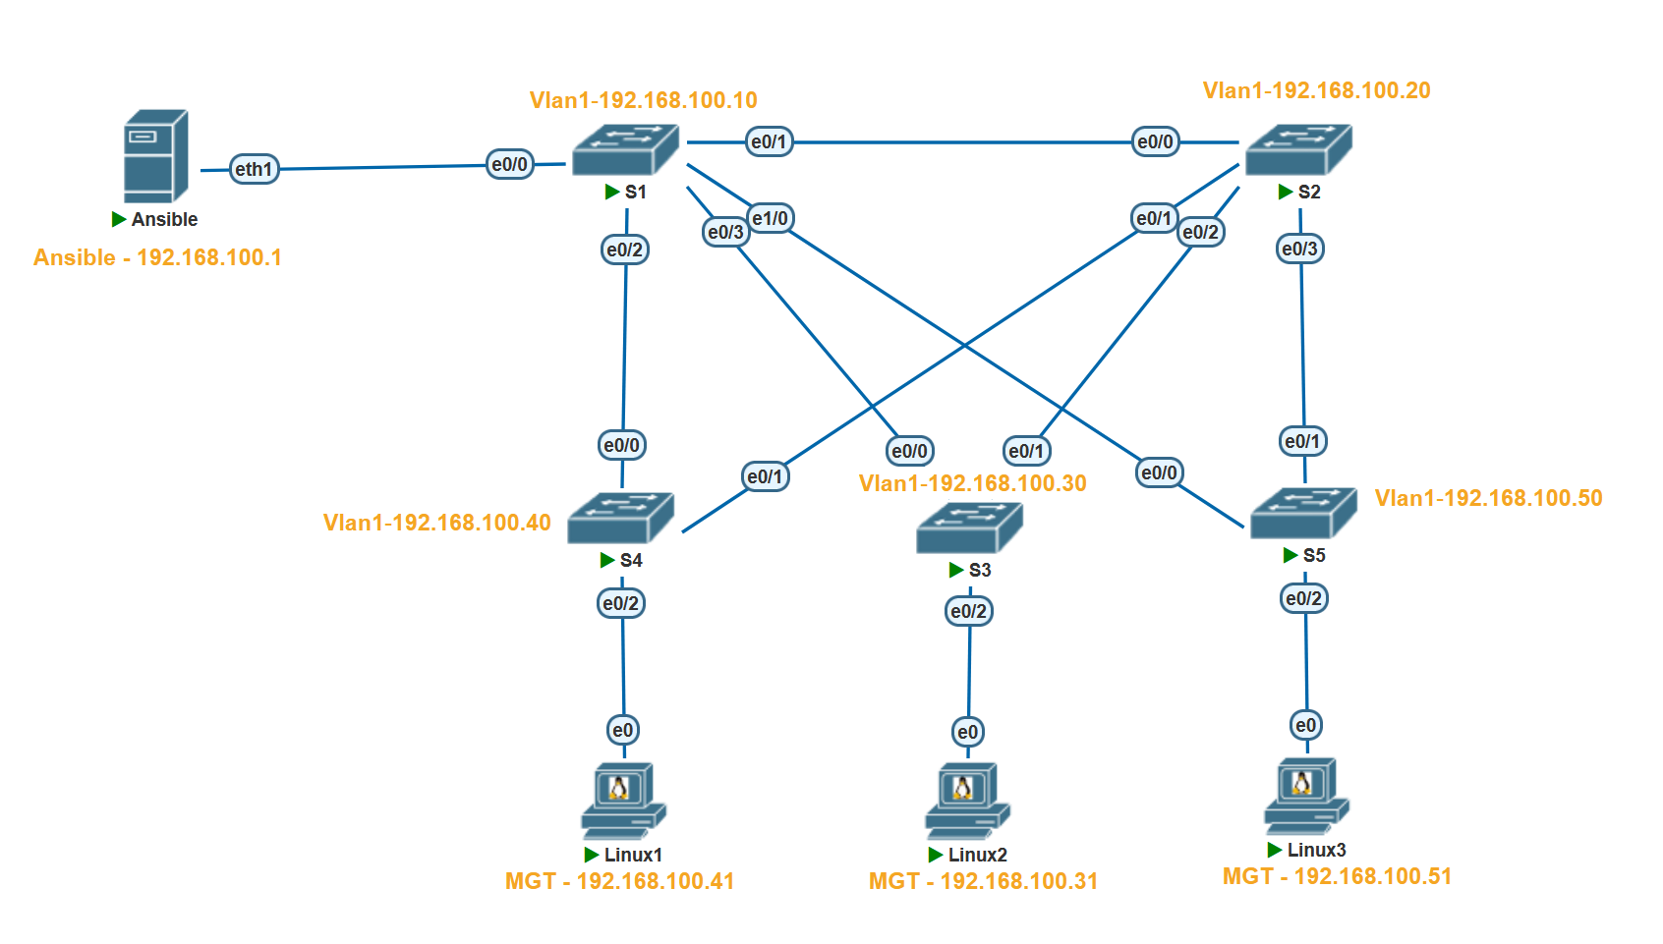Here are some of the information on lab devices

|  |  |
| --- | --- |
| **Hostname** |  |
| **Ansible** | EVE-NG/GNS3 Network appliance @192.168.100.1 |
| **S1** | Cisco Switch running vios_l2 @192.168.100.10 |
| **S2** | Cisco Switch running vios_l2 @192.168.100.20 |
| **S3** | Cisco Switch running vios_l2 @192.168.100.30 |
| **S4** | Cisco Switch running vios_l2 @192.168.100.40 |
| **S5** | Cisco Switch running vios_l2 @192.168.100.50 |

Prerequires:

* EVE-NG/GNS3
* Ansible appliance
* Cisco images for EVE-NG/GNS3

## Step 1: Configure Switch

First, we have to configure the S1 for connectivity and to allow ssh. Use the below configs for S1

no ip domain name lookup

no logging console

cdp run

host S1

int Vlan1

ip address 192.168.100.10 255.255.255.0

no shut

username user privilege 15 secret password

line con 0

login local

line aux 0

line vty 0 4

login local

transport input all

ip domain-name www.Test.home

crypto key generate rsa

1024

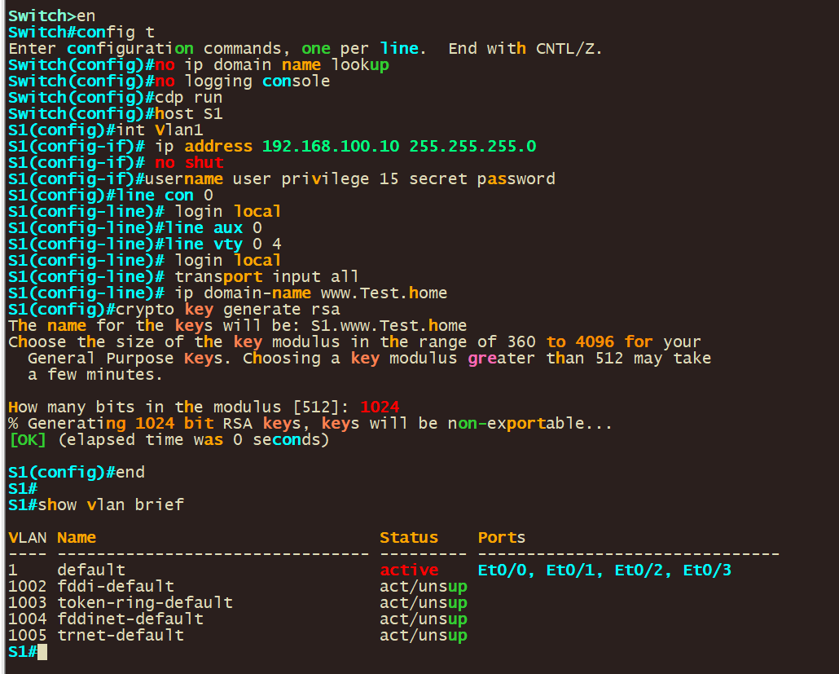

**Let's go through each of the commands listed:**

**no ip domain name lookup**: This command disables DNS lookup. Without this, any mistyped command in the console is interpreted as a hostname by the router, and it will attempt to resolve it via DNS, which can cause a delay.

**no logging console**: This command disables logging to the console. By default, the router sends all log messages to its console port. Therefore, disabling this can be helpful in not interrupting CLI access with log messages.

**cdp run**: This command enables the Cisco Discovery Protocol (CDP). CDP is a Cisco proprietary protocol used to discover Cisco devices in your network.

**host S1**: This command changes the hostname of the device to "S1".

**int vlan 1**: This command enters the configuration mode for VLAN 1.

**ip address 192.168.100.10 255.255.255.0**: This command assigns the IP address 192.168.100.10 with a subnet mask of 255.255.255.0 to VLAN 1.

**no shut**: This command brings up the VLAN interface if it's administratively down. It's equivalent to "enable this interface".

**username user privilege 15 secret password:** This command creates a user with the username "user", assigns it a privilege level of 15 (the highest level, equivalent to root or admin), and sets the password to "password". The keyword "secret" indicates that the password will be stored in a hashed format.

**line con 0**: This command enters line configuration mode for the console port.

**login local**: This command sets the login method to use the local user database for authentication. It's used here for the console and VTY lines, meaning that the username and password set earlier will be used for console and remote logins.

**line vty 0 4**: This command enters line configuration mode for the first 5 VTY lines (0-4). VTY lines are used for Telnet and SSH access to the device.

**transport input all**: This command is also used under vty configuration mode. It allows all types of protocols (telnet, SSH, etc.) for remote access. However, for security purposes, it is recommended to allow only SSH (i.e., `transport input ssh`).

**ip domain-name www.Test.home**: This command sets the domain name of the device to www.Test.home. This is required for generating the RSA keys which are used by SSH for encryption and decryption.

**crypto key generate rsa**: This command initiates the process of generating RSA keys which are required for SSH. After entering this command, you will be prompted to enter the modulus size.

**1024**: This is the modulus size for the RSA keys. It represents the key length of 1024 bits. The larger the key size, the more secure the SSH connection, but at the cost of more processor overhead.

These commands together configure your Cisco IOS device for secure remote access, enabling you to manage your device without needing to be physically connected to it. It also disables some default settings like DNS lookup on mistyped commands and console logging.

Once configured Vlan1 should have a IP in place

* 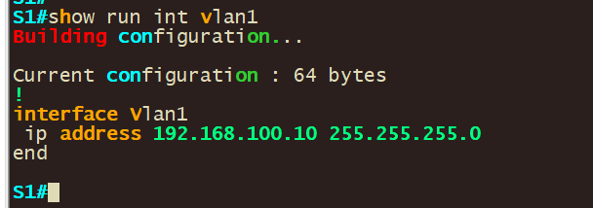
* 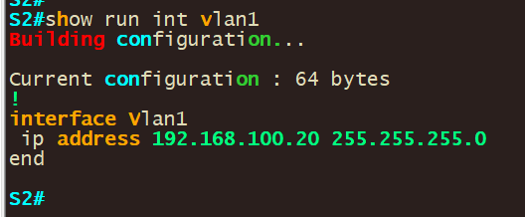
* 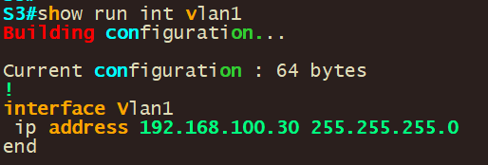
* 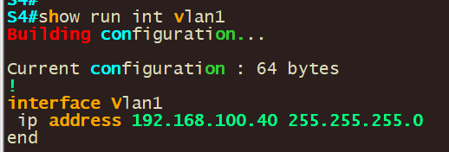
* 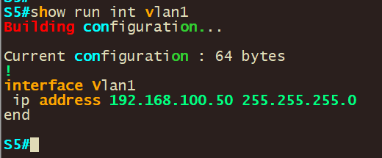
* Repeat this step for all of S2-5 assigning them different IP’s and hostname according to the IP’s listed above

## Step 2: Configure Network connectivity to Ansible and verify connectivity.

Next, we have to configure the Ansible control node and verify that we can reach our router/switch.

1. To statically configure a network right click the docker container and set the static ip: **192.168.100.1/24 in our case**

Note: If you downloaded ansible and installed it on ansible you make changes in /etc/network/interfaces to set the IP on a interface by opening the “/etc/network/interfaces” file using a text editor

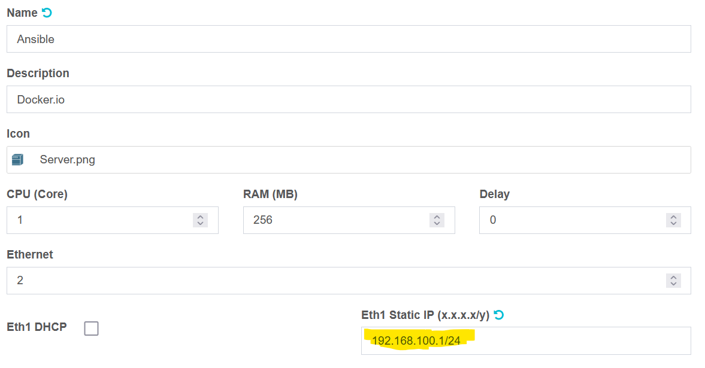

**Save the changes**

2. Restart/Start the network appliance and validate that your configs took by running the **ifconfig** command.

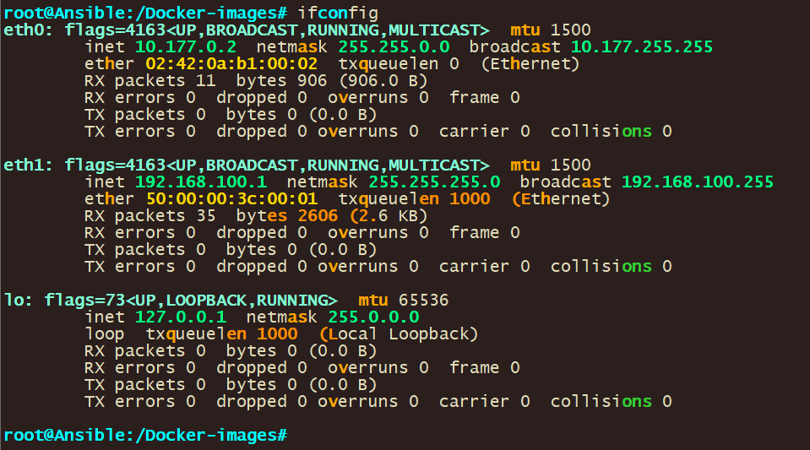

You should the ip address you configured on the network adapter on the output.

3. Validate network connectivity by pinging all the devices you want to reach

The command **ping 192.168.100.10** is used to test the network connectivity from the ansible control node to SW1 with the IP address 192.168.100.10 and so forth for the other switches/destination

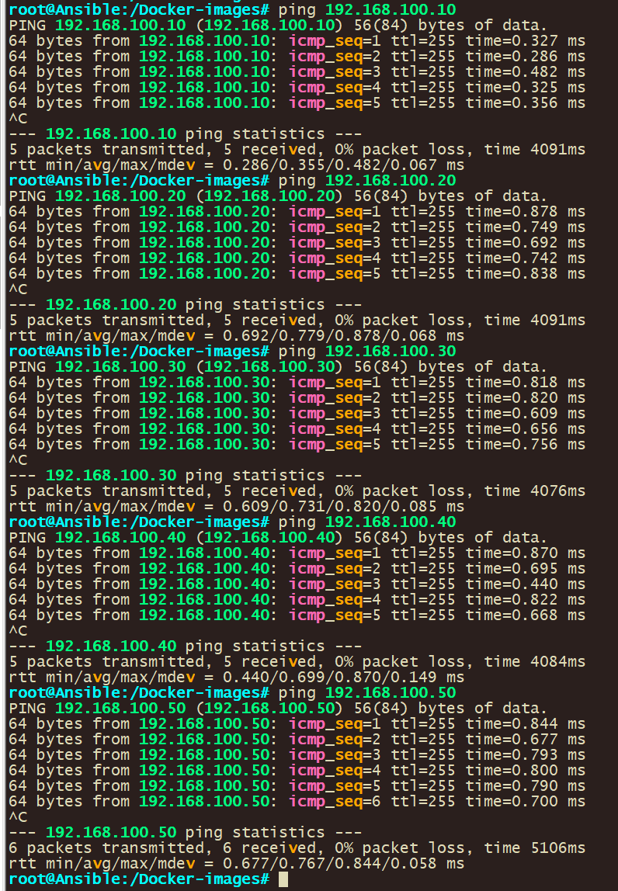

## Step 3: Configure Ansible

1. Validate that you can ssh into S1

* ssh [user@192.168.100.10](mailto:user@192.168.100.10)
* ![](media/bf068cdf260f014a162e63c73bcc07ec.png)
  1. Configure host resolution.
     1. Add entries into the default host file for your devices using the below command: **nano /etc/hosts**
     + ![](media/b88e23d2fc0f805f1e2ccac687d311bc.png)
     1. Add in entries for your devices.
     + ![](media/a02edf71a30aa27eb10d01c1bd86aa0a.png)
  2. Validate that host resolution is working by pinging device host entire name.
  + ![](media/506f66a25a5ee1cfdaf618c22cd0e685.png)
  1. Create Eve-ng/GNS3 host file.
     1. Use below command: **nano Eve-ng/GNS3hosts**
     2. Configure your hostname in the file with group names

[gns-core]

s1

s2

[gns-access]

s3

s4

s5

**![](media/3c0d45f63741e7d0df65bc31f0a66467.png)**

1. Configure ansible configuration file to Eve-ng/GNS3hostfile.
   1. Create ansible configuration file with below command: **nano ansible.cfg**
      1. Use below configs for the ansible configuration file and then save the file.

[defaults]

hostfile = ./Eve-ng/GNS3hosts

host_key_checking = false

timeout = 5

![](media/41adefbd2133214ea6a5cd0e8c5f31fa.png)

Let's go through each of the commands listed:

**- [defaults]:** This is the primary default section which includes a variety of settings you can adjust.

- **hostfile = ./Eve-ng/GNS3hosts:** This specifies the inventory file where Ansible will look to find the hosts that it can connect to. The `./Eve-ng/GNS3hosts` suggests that the inventory file is named `Eve-ng/GNS3hosts` and is located in the same directory as the `ansible.cfg` file.

- **host_key_checking** = false: By default, Ansible checks the SSH key of the remote hosts during the first connection. This configuration disables that check. This is often used in environments where host keys aren't yet known or can change, like in cloud or testing environments.

- **timeout = 5**: This controls the number of seconds Ansible will wait for connections to hosts to complete. This is not the time limit for the entire task, but for the initial connection attempt. The default value is usually 10, but here it's set to 5 seconds.

## Step 4: Use Ansible Ad hoc commands

1. Input the below command to retrieve the output of the Core switchs using ansible.

ansible Eve-ng/GNS3-core -i ./Eve-ng/GNS3hosts -m raw -a "show version" -u user -kble s1 -m raw -a "show version" -u user -k

![](media/8249f19b1a804c10666e6d66c4fe298a.png)

Let's go through the command:  
**ansible**: This is the command to run Ansible.

**Eve-ng/GNS3-core**: This is the target group of hosts as defined in the inventory file, which Ansible will run the command against.

**-i ./Eve-ng/GNS3hosts**: This is specifying the inventory file that Ansible will use to find the hosts. The `./Eve-ng/GNS3hosts` suggests that the inventory file is named `Eve-ng/GNS3hosts` and is located in the same directory as where the command is being run from.

**-m raw**: This is specifying the module that Ansible will use. The `raw` module allows you to run raw commands, unlike most modules which are idempotent and can understand the state of the target system. The `raw` module is usually used for commands that can't be executed with the Ansible `command` or `shell` modules.

**-a "show version”:** This specifies the arguments or the actual command to be run on the target hosts. In this case, it's a command to show the system's version.

**-u user**: This specifies the user as which to run the command. Here, the user is named 'user'.

**-k**: This prompts for a password. This is typically used when password-based SSH authentication is used, as opposed to key-based authentication.

1. You can get the output of all the switches using the below command.

ansible all -i ./Eve-ng/GNS3hosts -m raw -a "show version" -u user -kble s1 -m raw -a "show version" -u user -k

![](media/c874d795baf34ecfab4dc03815fcb84f.png)

Let's go through what has changed in the command:

**all**: This time, instead of specifying a particular group of hosts (like `Eve-ng/GNS3-core` in the previous example), the command targets `all` hosts defined in the inventory file.

## Step 5: Filter on Ansible output

1. You can filter on the output that you get back from ansible using the below command:

ansible all -i ./Eve-ng/GNS3hosts -m raw -a "show version" -u user -k | grep flash0

![](media/ffd43cc754be13f75dabd73322ce5198.png)

This command is similar to the previous ones, but this time it includes a pipe (`|`) to the `grep` command:

**| grep flash0**: The output of the ansible command is piped (`|`) into the `grep` command. `grep` is a command-line utility for searching plain-text data sets for lines that match a regular expression. In this case, it's used to filter and display only the lines of the output that contain the string 'flash0'.

So, in short, this command will ask for a password, then connect as the 'user' to all hosts defined in the `Eve-ng/GNS3hosts` file, run the `show version` command on each of them, and then filter the output to display only the lines that contain 'flash0'.

1. You can do a multiple line filter on the output that you get back from ansible using the below command:

ansible all -i ./Eve-ng/GNS3hosts -m raw -a "show version" -u user -k | grep 'CHANGED\|Version'

![](media/ac3f52f50660d1471bd515136bb63aad.png)

This command is like the previous ones, but this time it includes another pipe (`|`) on the `grep` command:

**| grep 'CHANGED\|Version**: The output of the ansible command is piped (`|`) into the `grep` command. `grep` is a command-line utility for searching plain-text data sets for lines that match a regular expression. In this case, it's used to filter and display only the lines of the output that contain the string 'CHANGED' or 'Version'. CHANGED is used because that is the line that contains the switch username in this example.

In this context, the `**\**` character is used as an escape character. It's telling the shell to interpret the character that follows it literally, as part of the string, rather than as a special character with its own meaning.

In the `**grep 'CHANGED\|Version'**` portion of the command, `**\|**` is used to indicate a logical OR in the `grep` command. It's saying "match lines that contain 'CHANGED' or 'Version'".

Without the **`\`,** the pipe character `**|**` would be interpreted by the shell as a control operator used for piping the stdout (standard output) of one command into the stdin (standard input) of another. By escaping it with `\*\*\**`, you're telling the shell to pass the `**|**` character as part of the argument to `grep`, so `grep` can use it as the OR operator in its regular expression.

So, in short, this command will ask for a password, then connect as the 'user' to all hosts defined in the `Eve-ng/GNS3hosts` file, run the `show version` command on each of them, and then filter the output to display only the lines that contain 'CHANGED' or 'Version'.

## Step 6: Store Ansible file output to a File

1. With ansible you can save your output (filtered or not ) to a file with the below command:

Ansible all -i ./Eve-ng/GNS3hosts -m raw -a "show run" -u user -k | grep 'CHANGED\|username' > usernames.txt

![](media/933839e85d441eb2e6cd8626c1680c97.png)

This command uses Ansible to execute commands on multiple hosts, filters the output, and then writes the filtered output to a file. Here's what it does:

`**ansible**`: This is the command to run Ansible.

`**all**`: This targets all hosts defined in the inventory file.

**`-i ./Eve-ng/GNS3hosts**`: Specifies the inventory file that Ansible uses to find the hosts. The `./Eve-ng/GNS3hosts` implies that the inventory file is named `Eve-ng/GNS3hosts` and is in the same directory from where the command is being run.

`**-m raw**`: Specifies the module that Ansible uses. The `raw` module is used to run low-level commands, usually when regular Ansible modules are not applicable.

`**-a** "show run"`: Specifies the actual command to be run on the target hosts. In this case, the command is `show run`, which typically displays the running configuration of the system.

`**-u user**`: Specifies the user as which to run the command. Here, the user is named 'user'.

`**-k**`: Prompts for a password. Typically used when password-based SSH authentication is used instead of key-based authentication.

**`| grep 'CHANGED\|username'**`: The output of the ansible command is piped (`|`) into the `grep` command. `grep` is a command-line utility for searching plain-text data sets for lines that match a regular expression. In this case, it's used to filter and display only the lines of the output that contain the string 'CHANGED' or 'username'.

-`**> usernames.txt**`: This redirects the output of the command to the file `usernames.txt`. If the file does not exist, it will be created. If it does exist, it will be overwritten.

So, in short, this command will ask for a password, then connect as the 'user' to all hosts defined in the `Eve-ng/GNS3hosts` file, run the `show run` command on each of them, filter the output to display only the lines that contain 'CHANGED' or 'username', and then write these filtered lines to `usernames.txt`.

## Step 7: Use ansible for troubleshooting

1. You can use ansible Ad-hoc commands for troubleshooting. It’s a matter of what you are looking for and filtering for. You can use the below command as an example:

ansible all -i ./Eve-ng/GNS3hosts -m raw -a "show arp" -u user -k | grep 'CHANGED\|3e66'

![](media/7ccf556812c9c40e4defd4358e5a53fb.png)

**`-a "show arp**"`: Specifies the actual command to be run on the target hosts. In this case, the command is `show arp`, which typically displays the Address Resolution Protocol (ARP) table of the system.

**`| grep 'CHANGED\|3e66'**`: The output of the Ansible command is piped (`|`) into the `grep` command. `grep` is a command-line utility for searching plain-text data sets for lines that match a regular expression. In this case, it's used to filter and display only the lines of the output that contain the string 'CHANGED' or '3e66'.

So, in short, this command will ask for a password, then connect as the 'user' to all hosts defined in the `Eve-ng/GNS3hosts` file, run the `show arp` command on each of them, and then filter the output to display only the lines that contain 'CHANGED' or '3e66'.

Finished!