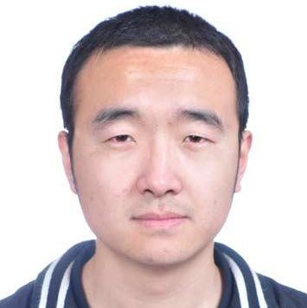
Hongzhi Wang
Operation Engineer · Moji Weather
Male ︳ 30 ︳Bachelor ︳ 7 Years ︳ Beijing

18600113834 ︳h835996498@qq.com

Self Assessment
I have submitted 4 PRs to Kubernetes/website. I am familiar with k8s and Istio. I focus my attention on Could Native technology stack. I am very familiar with cobbler, ansible, Jenkins, Zabbix, elk, etc. I can use Python to develop a CMDB independently, and use Golang to develop a simple web application. Good verbal and written communications skills in English. My blog (at http://cnblogs.com/wiswang) contains all my technology stack. I like roller skating and swimming. I would like to do DEVOPS, and want to move towards the architect in the future.

GITHUB: https://github.com/WisWang

Work Experience
 | Moji Weather
 | Operation Engineer | 2017.02-now

There are two parts in my work:
First part is about Operation. we have more than 1,000 sets of Linux systems, we two are responsible for daily operation and maintenance. During the period I participated in and made the company's application compilation, building, deployment, and running rules. I am also responsible for the cobbler, ELK system. I have summarized a lot of experience during our operation and maintenance, and put it on the quip.
Second part is about Development. I developed a web UI (Just for simplifying our daily operation on Alibaba Cloud), a simple cross-domain SSO (preparing for the unified authentication system), a CMDB, etc. I standardized and automate our online 70 jobs configurations with the Jenkins job DSL plugin.
Recently I have put some of our applications into the k8s for testing. I also did a training on the introduction of service mesh in our company.

Cisco
System Engineer | 2016.04-2017.01
Responsible for on-site maintenance of CA equipment and systems at a department of National Radio and Television Administration.

Isoftstone
System Engineer | 2014.06-2016.02
I was assigned to J&J project and onsite at customer office. I belonged to the Asia-Pacific data center team and I was in charge of the infrastructure management of data center.
With this role, technical work is limited, mostly is about coordination and communication. The primary gain to me is in English and the ability to deal with many kinds of affairs.

Zhongkejincai
System Engineer | 2013.10-2014.02
Responsible for the operation and maintenance of AIX system in a government department.

Isoftstone
System Engineer | 2013.02-2013.10
Responsible for the operation and maintenance of the AIX system of the Bank of China Credit Card Center.

Ce-service
System Engineer | 2011.07-2013.02
First half year my work was about IBM's storage and small computer hardware maintenance. At the end of 2012 Feb, I went to CMBC project in-residence. I was assigned to the system team and in charge of the test environment maintenance.

Education
Hebei Agriculture University
Bachelor · Electronic Information Science and Technology | 2007.09-2011.06

Project Experience
ELK platform build and maintain
Owner | 2017.10-now
Our ELK currently collects Nginx's log. The daily amount is more than 2 billion. My duty is to take charge of the whole project from 0 build to later operation and maintenance. The log data stream is filebeat logstash kafka logstsh elasticsearch Grafana (kibana).
During the period, below are the important things I have done: summarizing data by day according to needs, such as PV for each application, and alarms when the ratio of non-200 is greater than 1%. Upgrade the entire cluster from 5.6.3 to 6.3.0 for the new version of the free monitoring feature. Solved the problem of time zone which the Grafana logstash both have.
Put Jenkins job configuration in version control
Owner | 2018.07-2018.7
At the time, our company's Jenkins had more than 50 jobs, and it would take time to modify a parameter in batches, so I wrote a tool with go, using the Jenkins job DSL plugin to standardize, automate, and configure the job management on Jenkins. This configuration file now manages our 75 jobs.

