|  |  |  |  |
| --- | --- | --- | --- |
| Models | Species | AIC | ME |
| Cousens | *C. benghalensis* | 266.8 | 0.98 |
|  | *R. brasiliensis* | 0.94 |
| Sigmoidal | *C. benghalensis* | 271.3 | 0.89 |
|  | *R. brasiliensis* | 0.83 |
| Polynomial | *C. benghalensis* | 281.8 | 0.96 |
|  | *R. brasiliensis* | 0.95 |

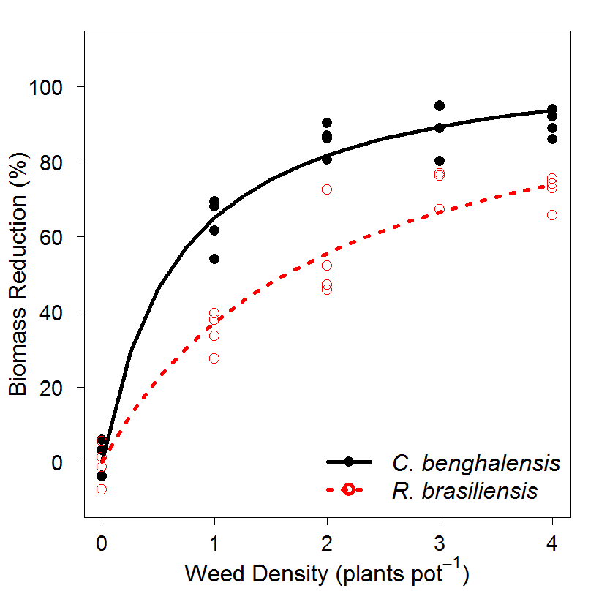

Figure 1. Cousens model

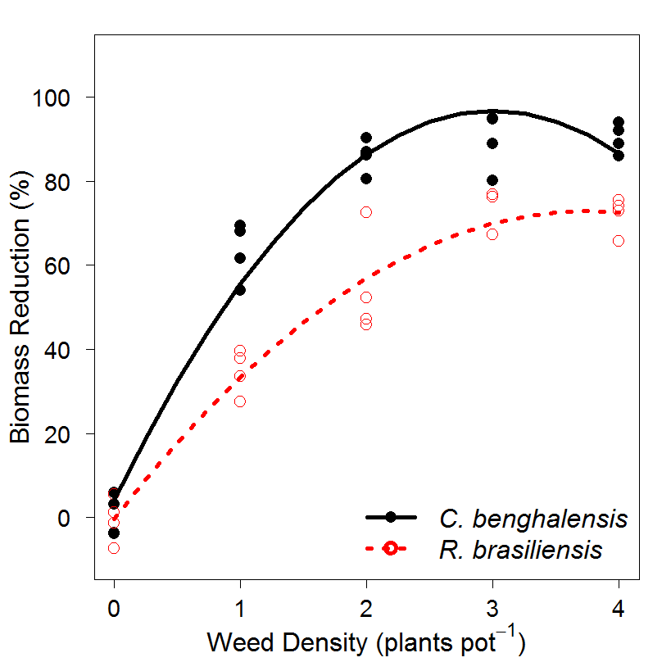

Figure 2. Polynomial quadratic model

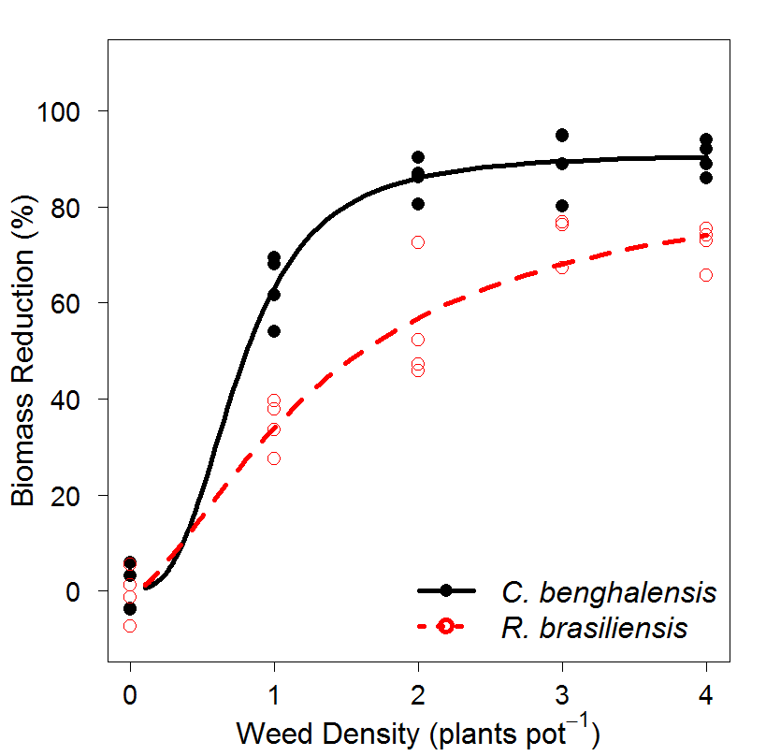

Figure 3. Sigmoid model