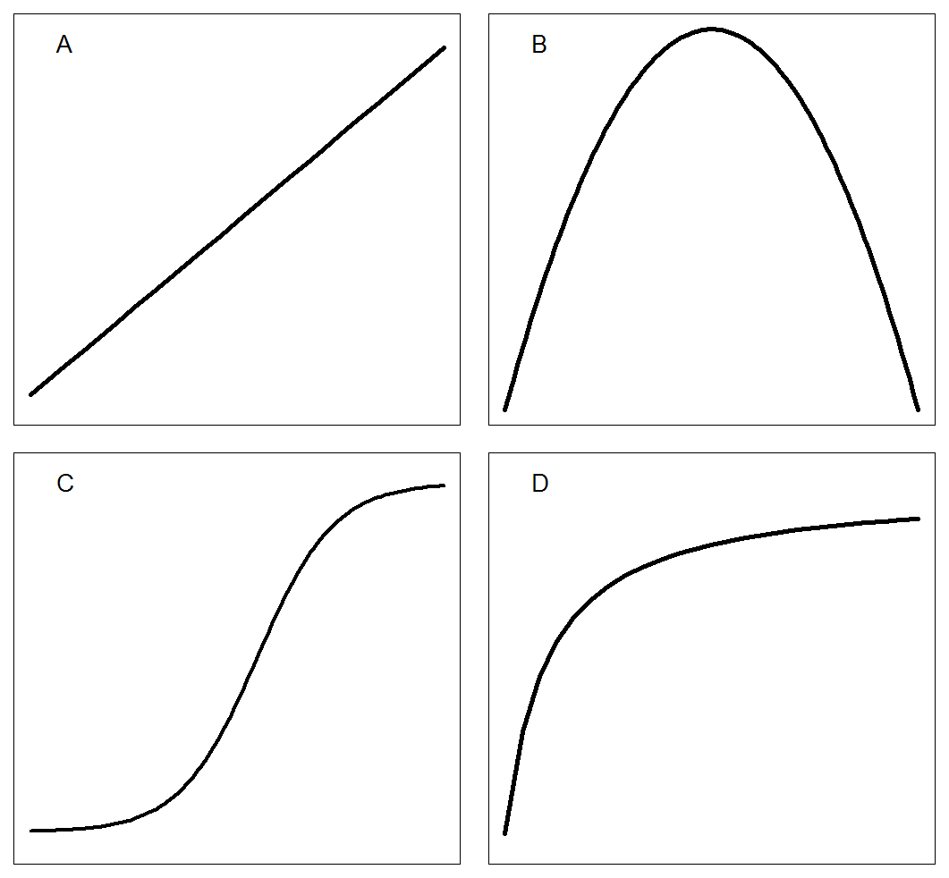Figure 1. Common regression curves used in crop-weed relationships in additive design: A) Linear; B) Polynomial quadratic; C) Sigmoid; D) Rectangular hyperbola.

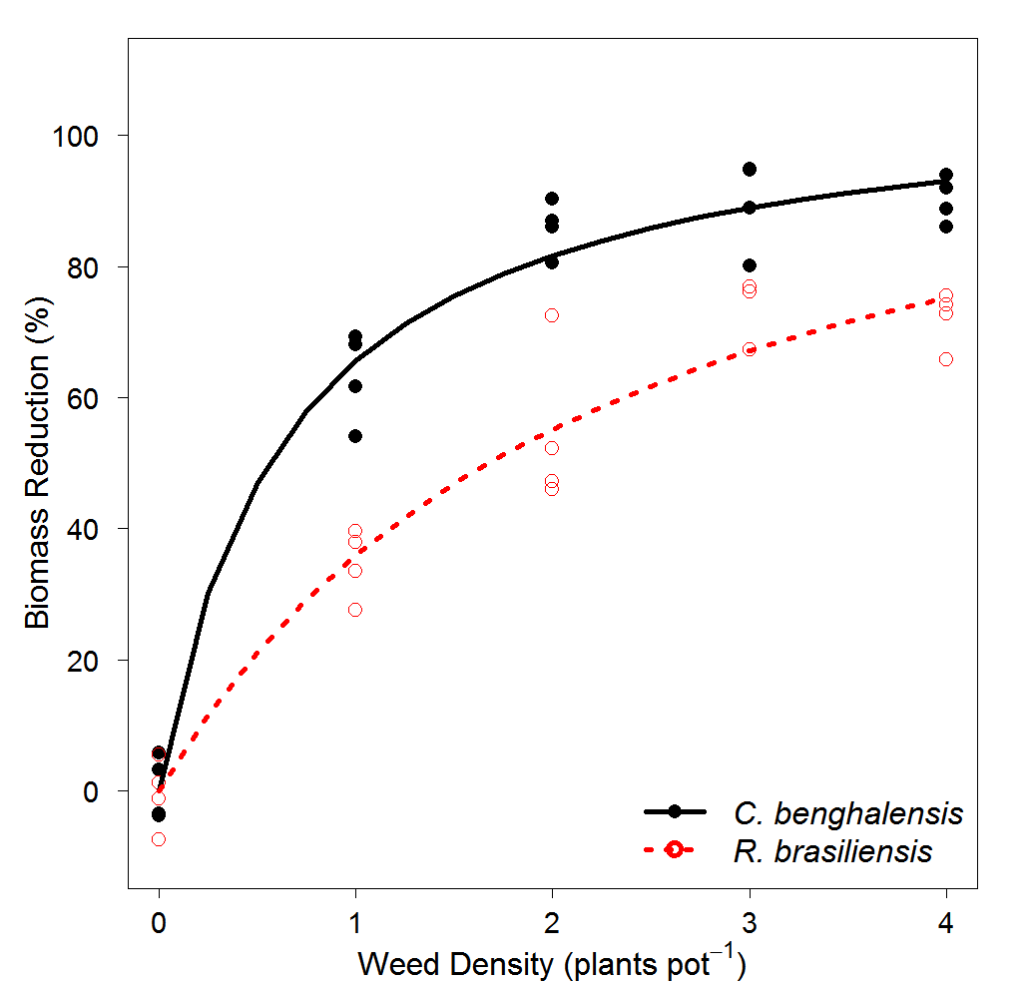

Figure 1. The relationship between maize biomass reduction (%) and weed density (plants pot-1) fitted with rectangular model model. Red dotted lines represent *R. brasiliensis,* and the black solid line represents *C. benghalensis*. Biological model parameter estimates, *R. brasiliensis*: I= 51.7 (7.7) and A= 118.1 (14.6); *C. benghalensis*: I= 167.2 (29.8) and A= 108.1 (5.6).

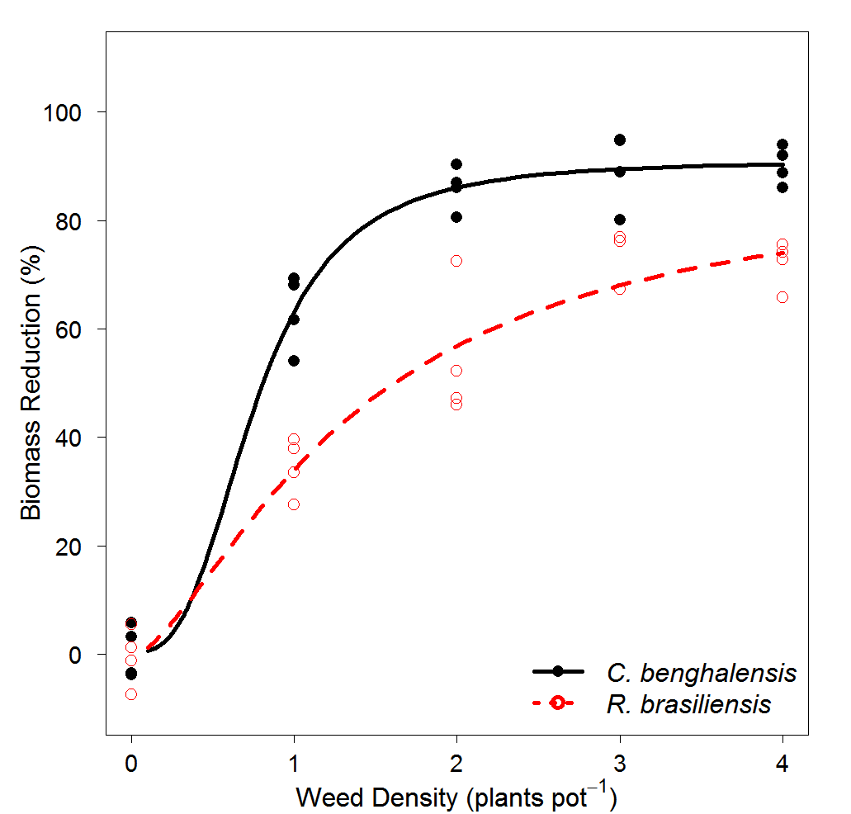

Figure 3. Relationship between maize biomass reduction (%) and weed density (plants pot-1) fitted with a logistic model. Red dotted lines represents *R. brasiliensis* and black solid line represents *C. benghalensis*. Biological model parameter estimates, *R. brasiliensis*: b=-1.5 (0.5), c=-0.4 (3.2), d= 91.0 (3.2), and e= 0.76 (0.09); *C. benghalensis*: b=-2.92 (1.6), c=0.5 (3.2), d= 88.1 (15.9), and e= 1.3 (0.4).

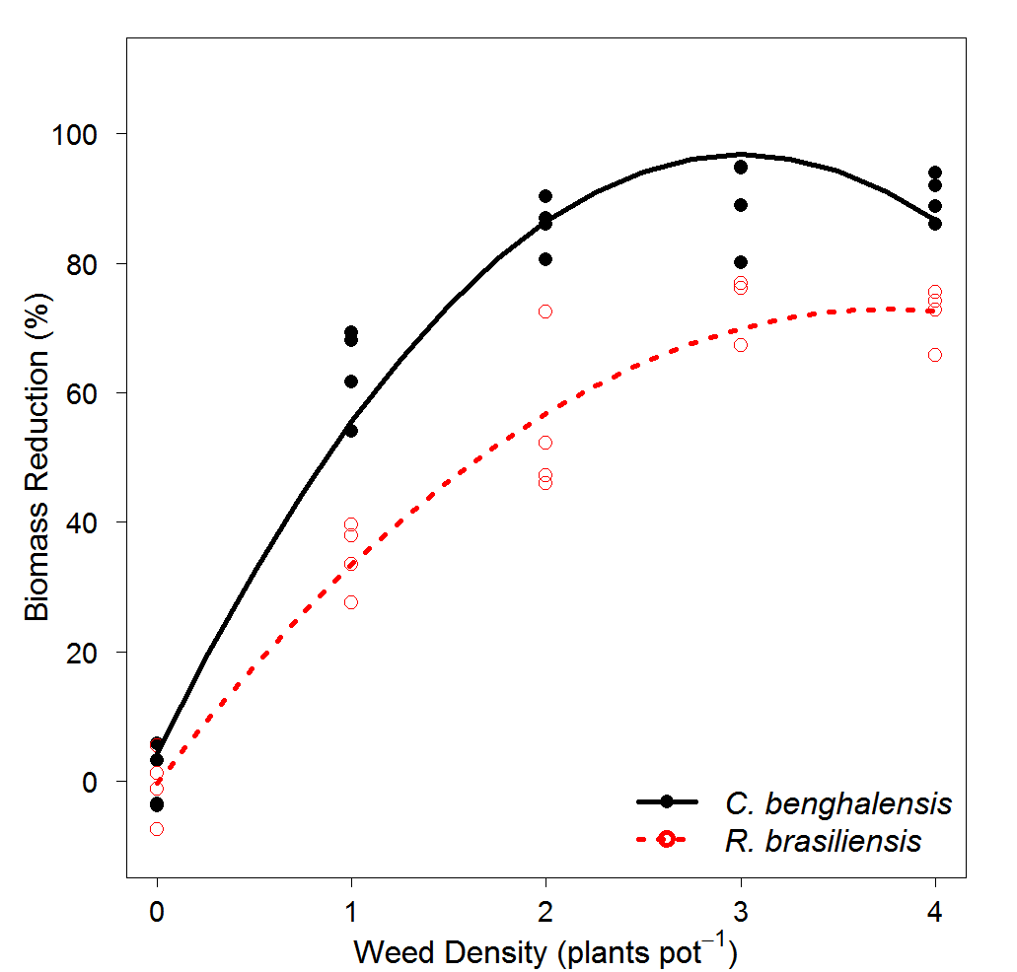

Figure 4. The relationship between maize biomass reduction (%) and weed density (plants pot-1) fitted with a polynomial quadratic model. Red dotted lines represent *R. brasiliensis,* and the black solid line represents *C. benghalensis*. There are no biological model parameters. *R. brasiliensis*: *YL*= 4.2+61.6x-10.3x2; *C. benghalensis*: YL= -0.3+38.9x-5.2x2

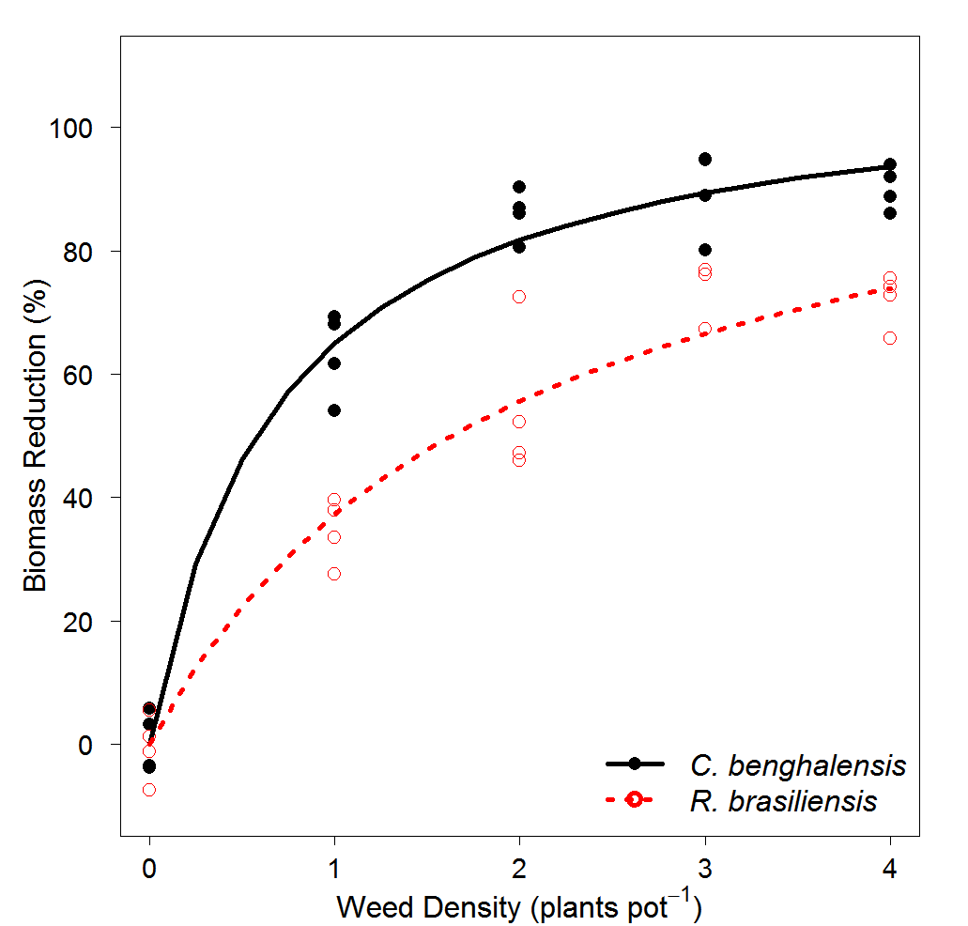

Figure 5. The relationship between maize biomass reduction (%) and weed density (plants pot-1) fitted with rectangular hyperbola model. Red dotted lines represent *R. brasiliensis,* and the black solid line represents *C. benghalensis*. Biological model parameter estimates, *R. brasiliensis*: *I*= 56.4 (4.9) and *A*= 109.7 (5.2); *C. benghalensis*: I= 159.8 (25.4) and A= 109.7 (5.2).

Table 1. Maize biomass reduction model comparison among polynomial quadratic, logistic, and Cousens.

|  |  |  |  |  |  |
| --- | --- | --- | --- | --- | --- |
| Models | Species | Model Selection1 | Goodness of Fit2 | | |
| AIC | RMSE | ME | R2 |
| Polynomial quadratic | *C. benghalensis* | 281.8 | 6.7 | 0.96 | 0.95 |
|  | *R. brasiliensis* | 0.95 | 0.94 |
| Logistic | *C. benghalensis* | 271.3 | 5.7 | 0.89 | - |
|  | *R. brasiliensis* | 0.83 | - |
| Cousens | *C. benghalensis* | 268.3 | 6.1 | 0.97 | - |
|  | *R. brasiliensis* | 0.94 | - |

1Alkeike’s information criterion (AIC).

2Root mean square error (RMSE), model efficiency (ME), and R-squared (R2). R2 is not appropriated for nonlinear models (logistic and Cousens)

Table 2. Cousens model parameters estimates, standard error, t-value and P-value of maize biomass reduction (%) caused by competition of *R. brasiliensis* and *C. benghalensis*.

|  |  |  |  |  |  |
| --- | --- | --- | --- | --- | --- |
| Parameters1 | Species | Estimate | Standard Error | t-value | P-value2 |
|  |  | % | |  |  |
| *I* | *R. brasiliensis* | 51.7 | 7.7 | 6.6 | *** |
| *C. benghalensis* | 167.2 | 29.8 | 5.6 | *** |
| *A* | *R. brasiliensis* | 118.1 | 14.6 | 8.1 | *** |
| *C. benghalensis* | 108.1 | 5.6 | 19.1 | *** |

1*I*: represents maize biomass reduction (%) per unit weed density as density approaches 0; *A*: represents maize biomass reduction (%) as density approaches ∞ (or maximum expected yield loss).

2If P<0.05, there is no lack of fit; If P>0.05, there is a lack of fit. *** Significant at <0.01.

Table 3. Logistic model parameters estimates, standard error, t-value and P-value of maize biomass reduction (%) caused by competition of *R. brasiliensis* and *C. benghalensis*.

|  |  |  |  |  |  |
| --- | --- | --- | --- | --- | --- |
| Parameters1 | Species | Estimate | Standard Error | t-value | P-value |
|  |  | % | |  |  |
| *b* | *R. brasiliensis* | -1.5 | 0.5 | -2.8 | *** |
| *C. benghalensis* | -2.9 | 1.6 | -1.8 | * |
| *c* | *R. brasiliensis* | -0.4 | 3.21 | -0.1 | NS |
| *C. benghalensis* | 0.5 | 3.20 | 0.2 | NS |
| *d* | *R. brasiliensis* | 88.1 | 15.9 | 5.5 | *** |
| *C. benghalensis* | 91.0 | 3.9 | 22.8 | *** |
| *e* | *R. brasiliensis* | 1.34 | 0.4 | 3.7 | *** |
| *C. benghalensis* | 0.76 | 0.1 | 7.0 | *** |

1*b*: slope; *c*: lower limit (weed competition at low densities); d: upper limit (maximum expected maize biomass reduction, %); *e*: inflection point (weed density at maize biomass reduction is 50% relative to *d*.

2If P<0.05, there is no lack of fit; If P>0.05, there is a lack of fit. *** Significant at 0.01; * Significant at 0.1; NS, not significant.

Table 4. Polynomial quadratic parameters estimates, standard error, t-value and P-value of maize biomass reduction (%) caused by competition of *R. brasiliensis* and *C. benghalensis*.

|  |  |  |  |  |  |  |
| --- | --- | --- | --- | --- | --- | --- |
| Parameters1 | Species | Estimate | Standard Error | t-value | P-value | |
|  |  | % | |  |  |  |
| *Intercept* | *R. brasiliensis* | -0.3 | 3.3 | -0.1 | 0.94 | NS |
| *C. benghalensis* | 4.2 | 3.6 | 1.2 | 0.26 | NS |
| *Slope* | *R. brasiliensis* | 38.9 | 3.9 | 10.1 | 1.39e-8 | *** |
| *C. benghalensis* | 61.6 | 4.3 | 14.5 | 5.59e-11 | *** |
| *Quadratic* | *R. brasiliensis* | -5.2 | 0.9 | -5.6 | 3.29e-5 | *** |
| *C. benghalensis* | -10.3 | 1.0 | -10.0 | 1.48e-8 | *** |

1*Intercept*: intercept at Y-value when density equals zero; Slope: the slope of the equation; *quadratic*: the quadratic term of the equation.

2If P<0.05, there is no lack of fit; If P>0.05, there is a lack of fit. *** Significant at 0.01; * Significant at 0.1; NS, not significant.

Table 5. Nested model selection criteria and goodness of fit of Cousens model parameters I and A of maize biomass reduction (%) with *R. brasiliensis* and *C. benghalensi*s.

|  |  |  |  |  |  |  |
| --- | --- | --- | --- | --- | --- | --- |
| Cousens Models | Species | Model Selection1 | | | Goodnes of fit2 | |
| F-test | | AIC | RSME | ME |
| F-value | P-value |
| Different I and A (Full) | *R. brasiliensis* | - | - | 268.2 | 6.1 | 0.97 |
| *C. benghalensis* | 0.94 |
| Similar I and A (Red. I) | *R. brasiliensis* | 57.858 | *** | 321.8 | 12.5 | 0.88 |
| *C. benghalensis* | 0.79 |
| Similar I but different A (Red. II) | *R. brasiliensis* | 26.031 | *** | 288.0 | 8.0 | 0.96 |
| *C. benghalensis* | 0.89 |
| Similar A but different I (Red. III) | *R. brasiliensis* | 0.4947 | 0.4864 | 266.8 | 6.1 | 0.98 |
| *C. benghalensis* | 0.94 |

1F-test model selection; P<0.05: significant different models; P>0.05: non-significant different models. Alkeike’s information criterion (AIC);

2Root mean square error (RMSE) and model efficiency (ME).

Table 6. Cousens model parameters estimates, standard error, t-value and P-value of maize biomass reduction (%) caused by competition of *R. brasiliensis* and *C. benghalensis*.

|  |  |  |  |  |  |  |  |
| --- | --- | --- | --- | --- | --- | --- | --- |
| Parameters1 | Species | Estimate | Standard Error | t-value | | P-value | |
|  |  | % | | |  | |  |
| I | *R. brasiliensis* | 56.4 | 7.7 | | 6.6 | | *** |
| *C. benghalensis* | 159.9 | 29.8 | | 5.6 | | *** |
| A | *R. brasiliensis* | 109.7 | 5.2 | | 20.9 | | *** |
| *C. benghalensis* |

1 *I*: represents maize biomass reduction (%) per unit weed density as density approaches 0; *A*: represents maize biomass reduction (%) as density approaches ∞ (or maximum expected yield loss).

2If P<0.05, there is no lack of fit; If P>0.05, there is a lack of fit. *** Significant at <0.01.