**Tolerance of US Midwest Soybean Cultivars to Preemergent Applications of Metribuzin and Sulfentrazone**

Maxwel C Oliveira, Thomas Butts, Shawn Conley, and Rodrigo Werle

**Material and Methods**

The research was conducted in a greenhouse at the University of Wisconsin-Madison to evaluate 221 soybean varieties tolerance to metribuzin and sulfentrazone. Soybean seeds were collected from …… Soybean seeds were stored at 5 C until the onset of experiment. Experimental units consisted of XXX cm3 plastic pots filled with Plano Silt Loam field soil (pH=6.6 and organic matter=3.1%) containing three soybean seeds manually sown 3 cm deep spaced 5 cm apart. Soybean plants were supplied with adequate water and kept under greenhouse conditions at 28/20 C day/night temperature with 80% relative humidity. Artificial lightning was provided using metal halide lamps (600 μmol photons m-2 s-1) to ensure a 15-h photoperiod.

The experiment was conducted in a completely randomized design with three replications and repeated twice. Treatments were arranged in a factorial design with 221 soybean varieties and three herbicides. The herbicide treatments were metribuzin (TriCor®, United Phosphorus, Inc, King of Prussia, PA, USA) applied at 560 g ai ha-1; sulfentrazone (Spartan 4F®, FMC Corporation, Philadelphia, PA, USA) applied at 280 g ai ha-1; and an untreated control treatment. The day after soybean planting, herbicide treatments were applied using a single-nozzle track research sprayer (DeVries Manufacturing Corp., Hollandale, MN, USA). The sprayer is equipped with 8002 E nozzle ( ) calibrated to delivery 140 L ha-1 spray volume at 83 kPa at a speed of 3.7 km.

Tolerance estimation were assessed when soybeans were transitioning from V1 to V2 growth stages on a scale from 1 to 10 (1 = complete plant death, 10 = healthy, uninjured plant). The tolerance rating was assessed for each soybean plant and averaged within experimental unit. Tolerance estimation were based on herbicide symptoms on soybean leaves and stem such as necrosis and stunting compared to untreated plants.

*Statistical analysis:*

Visible tolerance rating data were converted to proportions (0 = highly susceptible, 1 = highly tolerant), and were standardized to adjust for differences in early-season vigor across cultivars. This was accomplished by dividing the average of the nontreated control for each cultivar by the individual tolerance proportions. As a result of this correction, it was possible to attain a tolerance rating greater than one if the treated plants appeared healthier than the nontreated control plants. All analyses were conducted with R 3.5.1 statistical software and used the adjusted tolerance proportions throughout.

A random forest analysis (RFA) was conducted separately for each herbicide using the *randomForest* package with soybean seed brand, maturity group, seed treatment, herbicide trait, and early-season vigor as explanatory variables. This analysis ranked explanatory variables by importance in predicting soybean cultivar tolerance to the respective herbicide active ingredient after pooling the results from 500 regression trees (Lander 2014).

Pearson correlation tests were used to determine the correlation between tolerance proportions and maturity group, early-season vigor, and herbicide active ingredient. Linear models were then established to quantify the effect of each quantitative variable on predicting soybean cultivar tolerance to metribuzin and sulfentrazone. Analysis of variance (ANOVA) was conducted on the categorical explanatory variables (soybean seed brand, seed treatment, and herbicide trait) to determine their effect on soybean cultivar tolerance to metribuzin and sulfentrazone. Means were separated using Fisher’s least significant difference test at α=0.05.

**Results and Discussion:**

Soybean cultivar tolerances to metribuzin and sulfentrazone ranged from 0.529 to 1.111 and 0.373 to 1.314, respectively, highlighting the variability across cultivars for their tolerance to these herbicides. The high variability observed in tolerance proportions substantiates previous conclusions that identifying tolerant soybean cultivars to PRE herbicides is a foundational component of a successful soybean production system (Belfry et al. 2016, Coble and Schrader 1973). Initially, a Pearson correlation test was conducted to compare the tolerance ratings between the two herbicide active ingredients. This correlation test revealed a positive relationship between the two herbicides and modes-of-action (*r* = 0.256, p=0.0001). However, significant variability in tolerances were noted, hence greater tolerance to metribuzin (PSII-inhibitor) does not necessarily indicate greater tolerance to sulfentrazone (PPO-inhibitor) and vice versa (Figure 1). As a result, all further analyses in this research were conducted separately for each herbicide, and future soybean cultivar herbicide tolerance studies should investigate herbicide modes-of-action separately. Additionally, future research should investigate if a correlation exists between different herbicides within the same mode-of-action as it pertains to soybean cultivar herbicide tolerance [e.g. sulfentrazone, saflufenacil, and flumioxazin (PPO-inhibitors)].

The RFA revealed that the five explanatory variables (early-season vigor, herbicide trait, maturity group, seed treatment, and soybean seed brand) explained 33 and 34% of the model variance when predicting herbicide tolerance for metribuzin and sulfentrazone, respectively. Therefore, approximately two-thirds of the model variability must be explained by other factors not accounted for within this research such as soil characteristics (organic matter, pH, texture, etc.), moisture content, temperature, planting depth, genetic make-up, and their interactions (Griffin and Habetz 1989, Swantek et al. 1998). Early-season vigor was the most important explanatory variable to predict soybean cultivar tolerance to both metribuzin (Figure 2) and sulfentrazone (Figure 3). The remaining four explanatory variables (soybean seed brand, seed treatment, maturity group, and herbicide trait) were deemed substantially less important than early-season vigor by the RFA for both herbicides. Maturity group was the only explanatory variable that differed in importance ranking between metribuzin and sulfentrazone; it was the second most important variable for sulfentrazone while it was the fourth most important variable for metribuzin.

A more in-depth evaluation of the early-season vigor effect on PRE herbicide tolerance revealed relatively similar trends between metribuzin (*r*=0.367; p<0.0001) and sulfentrazone (*r*=0.317; p<0.0001) (Figure 4). A negative relationship predicted that for an increase of one in early-season vigor ratings, metribuzin and sulfentrazone tolerance proportions decreased by 0.05. The negative correlation between early-season vigor (evaluated from the nontreated control plants) and tolerance ratings may be attributed to either an inherent bias of visible injury assessments as healthier plants provide the opportunity of “greater injury” to occur, or low early-season vigor cultivars being more tolerant to injury from PRE herbicides due to uncharacterized physiological constraints.

Soybean maturity group affected tolerance to metribuzin and sulfentrazone differently. Across the 221 Midwest-adapted soybean cultivars evaluated in this research, maturity group ranged from 0.3 to 2.9. No relationship between maturity group and metribuzin tolerance was identified through the Pearson correlation analysis and resulting linear model development (*r* = 0.048; p=0.4760) (Figure 5). Conversely, a negative relationship between maturity group and sulfentrazone tolerance emerged (*r* = 0.273; p<0.0001). Within the range of evaluated Midwest-adapted maturity groups, as maturity group increased by one, the resulting predicted sulfentrazone tolerance proportion decreased by 0.05 (Figure 5). Therefore, growers may need to balance the interaction between maturity group and sulfentrazone tolerance when selecting a cultivar for their operation to successfully optimize their soybean production system.

Soybean seed brand, seed treatment, and herbicide trait minimally impacted soybean tolerance to metribuzin and sulfentrazone, and relatively no discernable trends were identified through the ANOVA. Soybean seed brand #17 had the greatest tolerance proportions for both metribuzin and sulfentrazone (Table 1); however, there were no differences in tolerance proportions between the other 26 soybean seed brands evaluated for either PRE herbicide. Across the 23 seed treatments evaluated, no differences were observed in soybean cultivar tolerance to sulfentrazone (Table 2). Soybean cultivars with seed treatment #4 (1.036), #21 (1.032), and #22 (1.008) had greater metribuzin tolerance than soybean cultivars with seed treatment #5 (0.695) and #10 (0.690). All other seed treatments had similar effects on soybean cultivar tolerance to metribuzin. Across the six herbicide traits evaluated, no differences were observed in soybean cultivar tolerance to sulfentrazone similar to the seed treatments (Table 3). Soybean cultivars with the GT27™ (BASF Corporation, Florham Park, NJ 07932) (0.851) and glyphosate-tolerant (0.854) herbicide traits had greater metribuzin tolerance than soybean cultivars with the Roundup Ready 2 Yield® (Bayer CropScience, Research Triangle Park, NC 27709) (0.770) trait. Soybean cultivars with any other herbicide trait resulted in similar metribuzin tolerance proportions.

Although slight statistical differences were observed in soybean cultivar tolerances due to soybean seed brand, seed treatment, and herbicide trait, these results may be biased due to differing sample sizes for each variable level. Therefore, results indicate soybean seed brand, seed treatment, and herbicide trait are relatively unhelpful in regards to assisting growers with selecting a metribuzin- or sulfentrazone-tolerant soybean cultivar. As a result, these specific soybean characteristics can be selected based on the grower’s preference without concern for PRE herbicide tolerance to metribuzin and sulfentrazone. Previous research drew similar conclusions as soybean yield differences were attributed to a larger interaction between herbicide and soybean variety as opposed to interactions between herbicide and seed treatment or seed treatment and variety (Barlow et al. 2018). Other factors such as soil characteristics (organic matter, pH, texture, moisture, etc.), planting depth, overapplication, and precipitation, among others, and their interactions should be more completely evaluated for their influence on PRE herbicide tolerance of soybean cultivars (Griffin and Habetz 1989, Swantek et al. 1998). Additionally, soybean genetic markers should be evaluated in more detail for their role in determining tolerance to PRE herbicides. A more holistic understanding of the abiotic and biotic factors influencing herbicide activity and soybean growth may assist in accurately predicting cultivar tolerance to PRE herbicides such as metribuzin and sulfentrazone.

Overall, this research highlights the variation in tolerance of 221 Midwest-adapted soybean cultivars to metribuzin and sulfentrazone. Results indicate the negative interaction between early-season vigor and PRE herbicide tolerance is an important consideration when selecting a soybean cultivar for a production system. Generally, there are no consistent trends across soybean seed brands, seed treatment, and herbicide trait in relation to predicting herbicide tolerance. Maturity group was not important when predicting tolerance to metribuzin; however, a negative relationship between tolerance and maturity group was observed for sulfentrazone. Growers may need to balance the interaction between maturity group and sulfentrazone tolerance when selecting a cultivar for their operation, and maturity group should be included as an explanatory variable in future PRE herbicide tolerance screenings. The importance of herbicide screenings such as this is evident as a cultivar selection aid for farmers and advisers searching for high yielding cultivars with reduced likelihood of early-season soybean injury from PRE applications of metribuzin and sulfentrazone herbicides.

**Literature Cited:**

Barlow BR, Shergill LS, Bish MD, Bradley KW (2018) Investigations of the potential interactions between pre-emergence residual herbicides, variety, and seed treatments in soybean. Weed Technol 32:570–578

Belfry KD, Shropshire C, Sikkema PH (2016) Identity-preserved soybean tolerance to protoporphyrinogen oxidase-inhibiting herbicides. Weed Technol 30:137–147

Coble HD, Schrader JW (1973) Soybean tolerance to metribuzin. Weed Sci 21:308–309

Griffin JL, Habetz RJ (1989) Soybean (Glycine max) tolerance to preemergence and postemergence herbicides. Weed Technol 3:459–462

Lander JP (2014) R for Everyone: Advanced Analytics and Graphics. Page (P Dix, ed.). Upper Saddle River, NJ 07458: Addison-Wesley. 432 p

Swantek JM, Sneller CH, Oliver LR (1998) Evaluation of soybean injury from sulfentrazone and inheritance of tolerance. Weed Sci 46:271–277

**Tables**

**Table 1.** Analysis of variance results for the effect of soybean seed brand on the cultivar tolerance to metribuzin and sulfentrazone herbicides.a

|  |  |  |
| --- | --- | --- |
| Soybean seed brand | Metribuzin | Sulfentrazone |
| 1 | 0.756 b | 0.736 b |
| 2 | 0.790 b | 0.759 ab |
| 3 | 0.658 b | 0.772 ab |
| 4 | 0.783 b | 0.676 b |
| 5 | 0.750 b | 0.780 ab |
| 6 | 0.728 b | 0.780 ab |
| 7 | 0.782 b | 0.714 b |
| 8 | 0.722 b | 0.809 ab |
| 9 | 0.804 b | 0.757 ab |
| 10 | 0.887 ab | 0.879 ab |
| 11 | 0.794 b | 0.828 ab |
| 12 | 0.793 b | 0.806 ab |
| 13 | 0.747 b | 0.797 ab |
| 14 | 0.792 b | 0.802 ab |
| 15 | 0.766 b | 0.829 ab |
| 16 | 0.896 ab | 0.839 ab |
| 17 | 1.032 a | 0.923 a |
| 18 | 0.690 b | 0.741 ab |
| 19 | 0.818 b | 0.741 ab |
| 20 | 0.834 ab | 0.790 ab |
| 21 | 0.785 b | 0.789 ab |
| 22 | 0.854 ab | 0.658 b |
| 23 | 0.871 ab | 0.814 ab |
| 24 | 0.832 b | 0.807 ab |
| 25 | 0.914 ab | 0.915 ab |
| 26 | 0.797 b | 0.737 b |
| 27 | 0.835 ab | 0.836 ab |

a Means within a column followed by the same letter are not different at α=0.05.

**Table 2.** Analysis of variance results for the effect of seed treatment on the cultivar tolerance to metribuzin and sulfentrazone herbicides.a

|  |  |  |
| --- | --- | --- |
| Seed treatment | Metribuzin | Sulfentrazone |
| 1 | 0.792 ab | 0.794 a |
| 2 | 0.782 ab | 0.714 a |
| 3 | 0.783 ab | 0.786 a |
| 4 | 1.036 a | 0.995 a |
| 5 | 0.695 b | 0.760 a |
| 6 | 0.867 ab | 0.812 a |
| 7 | 0.854 ab | 0.804 a |
| 8 | 0.750 ab | 0.780 a |
| 9 | 0.772 ab | 0.779 a |
| 10 | 0.690 b | 0.741 a |
| 11 | 0.728 ab | 0.780 a |
| 12 | 0.707 ab | 0.764 a |
| 13 | 0.834 ab | 0.790 a |
| 14 | 0.766 ab | 0.829 a |
| 15 | 0.797 ab | 0.737 a |
| 16 | 0.747 ab | 0.797 a |
| 17 | 0.722 ab | 0.809 a |
| 18 | 0.840 ab | 0.800 a |
| 19 | 0.783 ab | 0.676 a |
| 20 | 0.820 ab | 0.903 a |
| 21 | 1.032 a | 0.923 a |
| 22 | 1.008 a | 0.927 a |
| 23 | 0.771 ab | 0.793 a |

a Means within a column followed by the same letter are not different at α=0.05.

**Table 3.** Analysis of variance results for the effect of herbicide trait on the cultivar tolerance to metribuzin and sulfentrazone herbicides.a

|  |  |  |
| --- | --- | --- |
| Herbicide traitb | Metribuzin | Sulfentrazone |
| GT27™ | 0.851 a | 0.821 a |
| Conventional | 0.834 ab | 0.800 a |
| Glyphosate-Tolerant | 0.854 a | 0.815 a |
| LibertyLink® | 0.809 ab | 0.884 a |
| Roundup Ready 2 Xtend® | 0.798 ab | 0.775 a |
| Roundup Ready 2 Yield® | 0.770 b | 0.801 a |

a Means within a column followed by the same letter are not different at α=0.05.

b GT27™ and LibertyLink®, BASF Corporation, Florham Park, NJ 07932; Roundup Ready 2 Xtend® and Roundup Ready 2 Yield®, Bayer CropScience, Research Triangle Park, NC 27709.

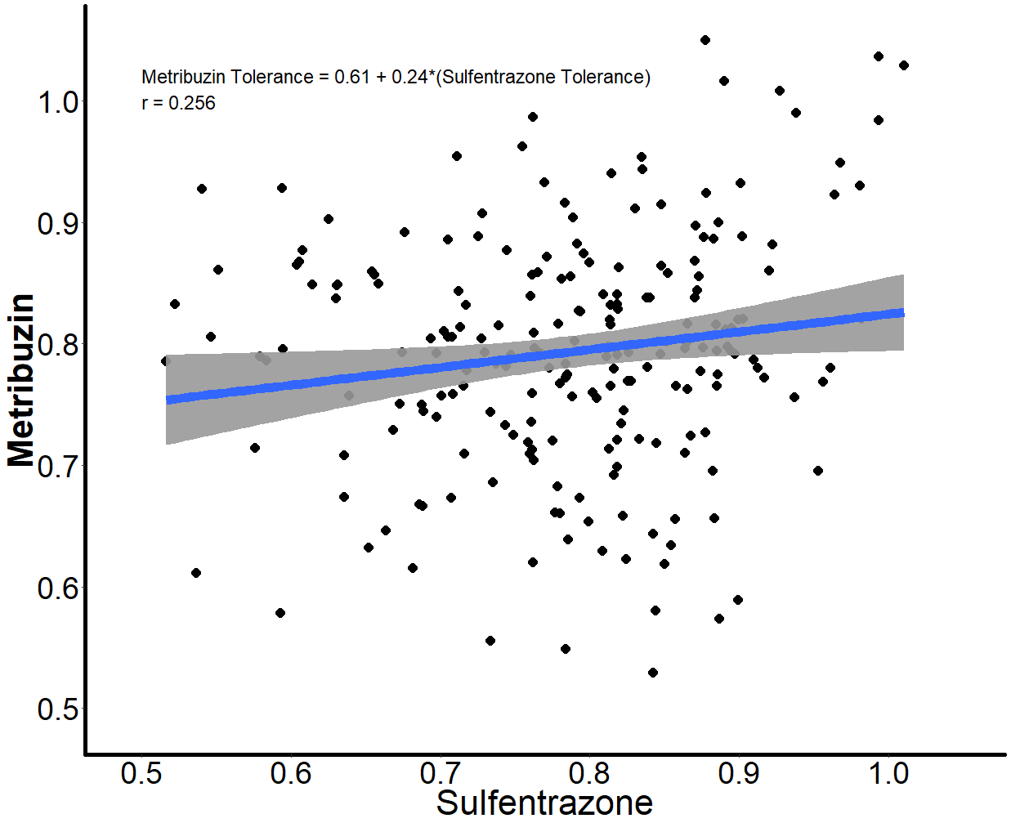**Figures**

**Figure 1.** Linear model and correlation of soybean cultivar tolerance proportions between metribuzin and sulfentrazone herbicide active ingredients (p=0.0001).

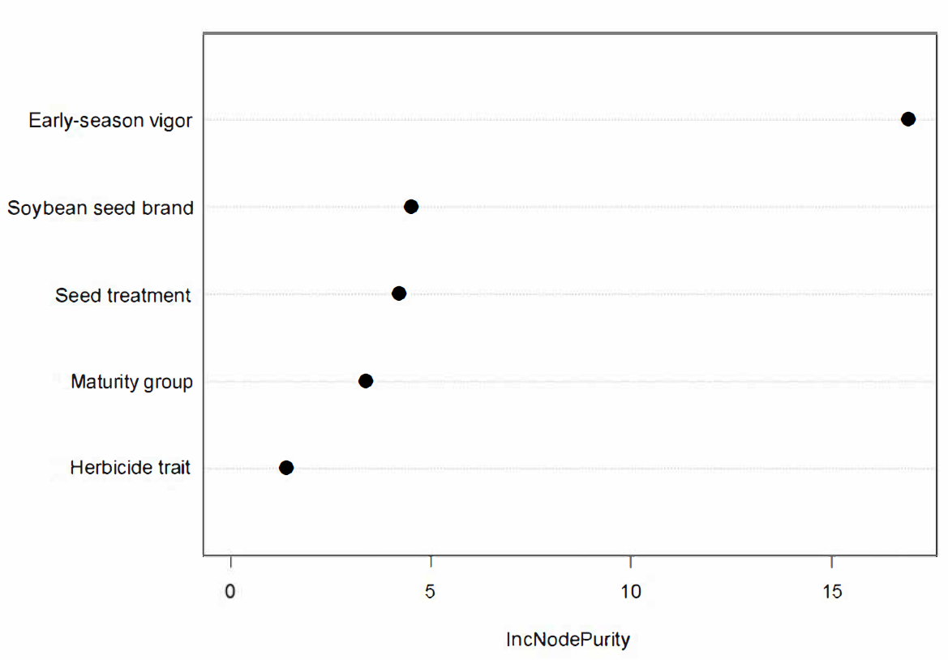**Figure 2.** Importance rankings of explanatory variables for the prediction of soybean cultivar tolerance to metribuzin.

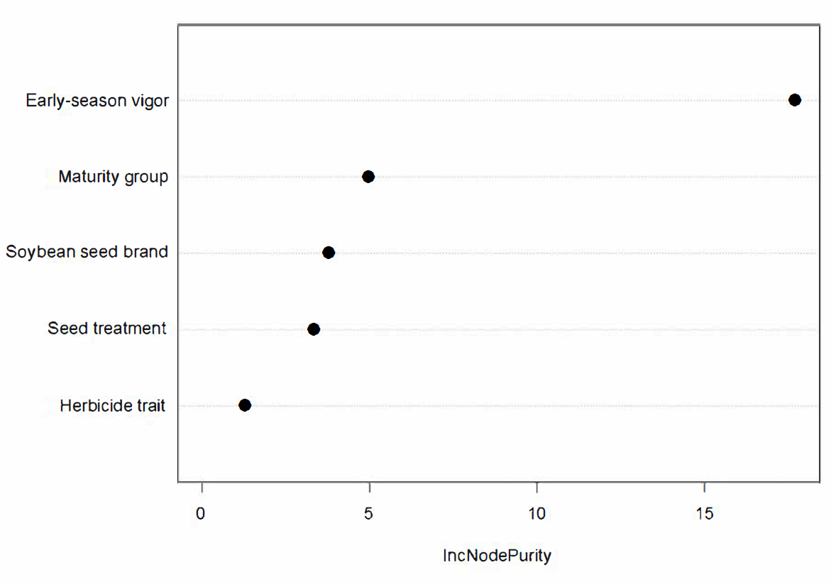**Figure 3.** Importance rankings of explanatory variables for the prediction of soybean cultivar tolerance to sulfentrazone.

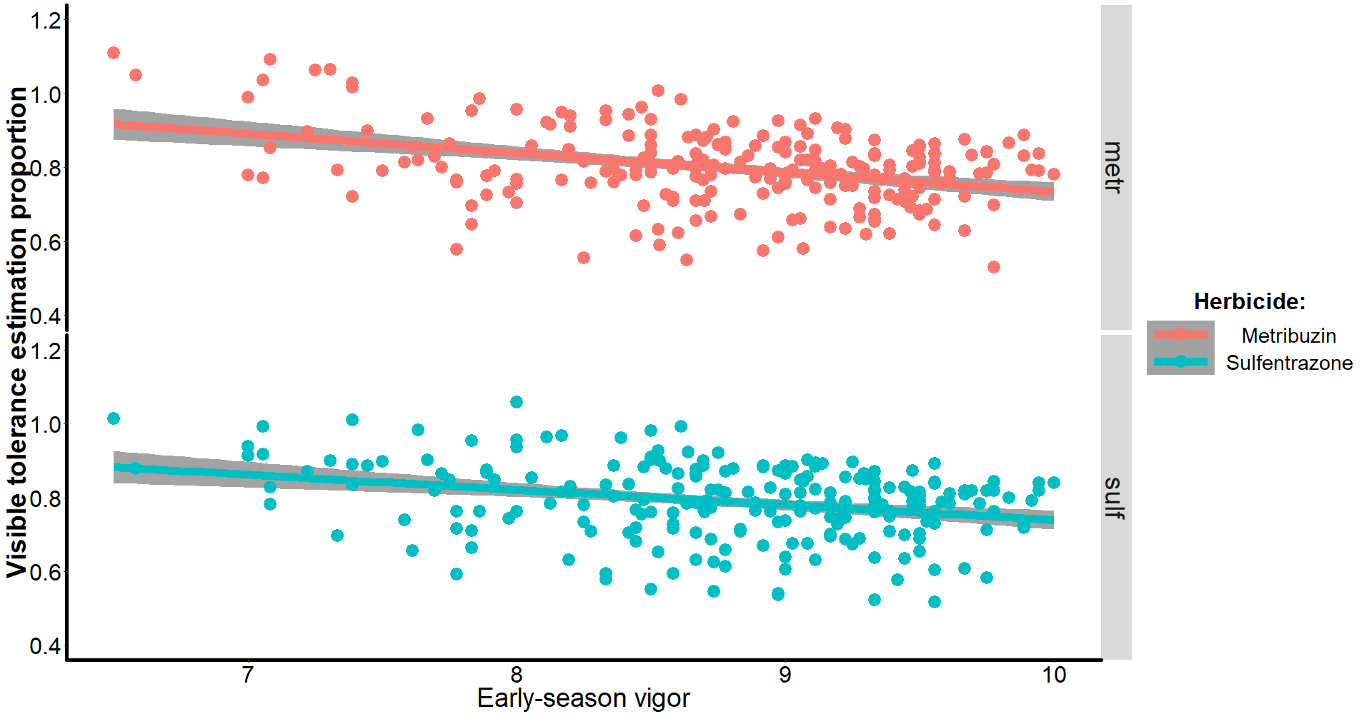**Figure 4.** Linear model and correlation of soybean cultivar tolerance proportions to early-season vigor for both metribuzin [Herbicide tolerance = 1.26 – 0.05*(early-season vigor); *r* = 0.367; p<0.0001] and sulfentrazone [Herbicide tolerance = 1.22 – 0.05*(early-season vigor); *r* = 0.317; p<0.0001] herbicide active ingredients.

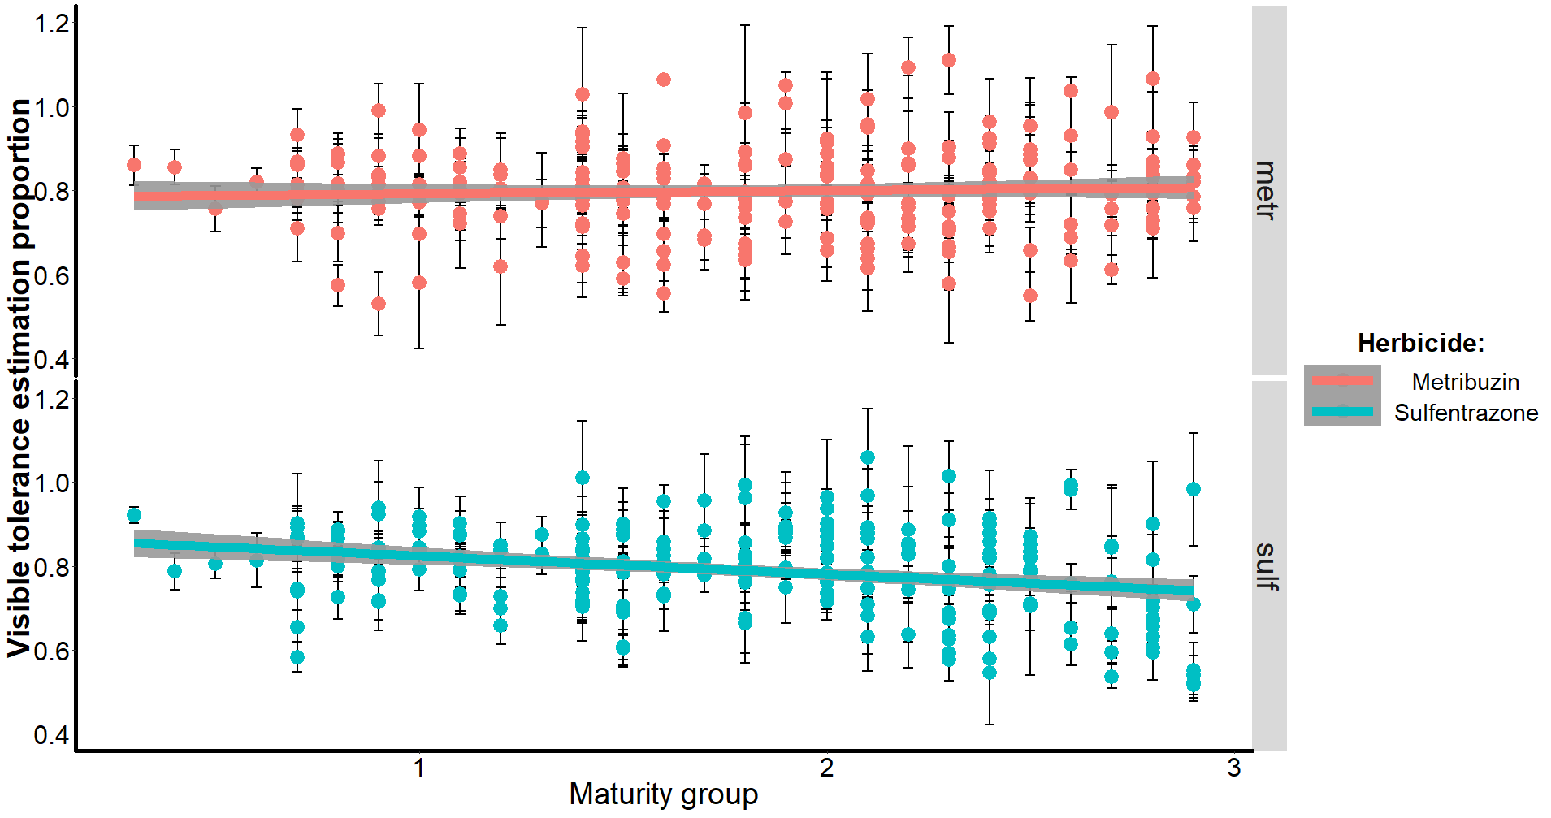**Figure 5.** Linear model and correlation of soybean cultivar tolerance proportions to maturity group for both metribuzin [Herbicide tolerance = 0.78 + 0.01*(maturity group); *r* = 0.048; p=0.4760] and sulfentrazone [Herbicide tolerance = 0.88 – 0.05*(maturity group); *r* = 0.273; p<0.0001] herbicide active ingredients.