Health Data Information System (HealthHive)

Requirements and Specification Document 2023-05-20, v1.0

**Project Abstract**

HealthHive is a health information application designed to empower individual to create personalized and easily accessible health insights. It provides the customer with access to a comprehensive suits of health management resources to assist them to understand and promote their wellness such as health logs, health visualization, wellness forecast, health chat assistants.

HealthHive offers an intuitive and responsive user interface to provide customers a friendly access on different device. It enables the customer to easily login to their account, manage their health data, and understand their health information. With these powerful suites of features, HealthHive is the trusted platform to join to take control your health and build up your healthy lifestyles.

**Document Revision History**

Rev. 1.0 <2023-05-20>: initial version

**Customer**

Our customers can be any individuals who are passionate in tracking their health activities.

**User Stories**

1. I want to be able to easily create my personal account.
2. I want to be able to insert my health data into the record.
3. I want to be able to modify and delete my health data from existed record.
4. I want to be able to review my health data record sorted by date in from my log.
5. I want to be able to visualize my health data trend from different plots.
6. I want to be able to see the statistics/summary from the visualization.
7. I want to be able to compare my health data to the recommended health index value from visualization.
8. I want to be able to check my risks in several disease.
9. I want to be able to understand the statistics/summary from the prediction.
10. I want to be able to check the educational resources of my prediction.
11. I want to be able to have a health assistant to ask health related questions.
12. I want to be able to access the health assistant in a convenient way.

**User Stories Requirements**

1. **Login**
   * 1. User should be able to login with their Google Account
     2. User should be able to create their own username for this application.
     3. User should be able to log back into their session easily (cookie or local storage)
2. **Health Logs**
   * 1. User should be able to insert, modify, delete their data field (not decided yet which fields) in an intuitive form.
     2. User can add multiple data field to their health logs record.
     3. User may require filling certain fields to submit their record, some field can keep optional.
     4. User should be able to review all their logs.
     5. User should be able to sort their logs by the date.
     6. User should be able to filter some necessary field.
3. **Health Visualization**
   * 1. User should be able to generate different type of plot (not decided yet which type) to see their health trend, coming with correct title and label.
     2. Necessary metrics (not decided yet which metrics) is required to evaluate the plot.
     3. User should compare their health data with recommend health index value in plot (not decided yet which type)
4. **Wellness Forecast**
   * 1. User should predict their risks in several popular disease.
     2. The prediction should tell meaningful summary.
     3. Educational resources should be attached for user to reference.
5. **Health Assistant**
   * 1. User should be able to send input to the health assistant.
     2. User should receive the output from the health prompt.
     3. User should access, close the chat window in an easy way.
     4. The conversation should not be stored due to privacy.

**Project Architecture** 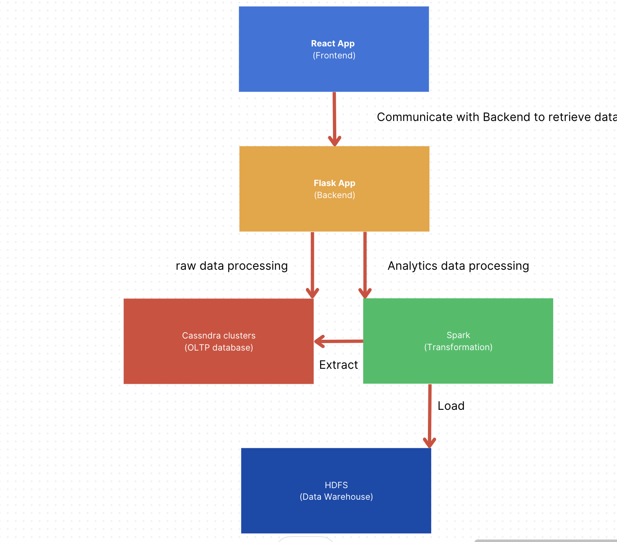

**User Interface Requirements**

**Security Requirements**

**System Requirements**

**Database Structure**

**Keyspace: health-hive**

**Table1: logs**

**Partition key column:** Email

**Static column:** Username

**Cluster column:** Date

**Regular Column (optional):** Heart rate, weight, blood pressure, body temperature

Regular Column (needed): Hours of sleep, stress level, water intake, diet, exercise minutes, mood.

Regular Column (no need to fill): Weather Condition