**Can a cereal rye cover crop effectively suppress giant ragweed?**

As farmers across the Upper Midwest continue to plant their soybean crop earlier in the season and/or adopt cereal rye cover crop, research investigating how these agronomic decisions influence weed communities and best management practices is warranted.

According to our surveys, giant ragweed (*Ambrosia trifida*), an early-emerging and competitive species, is among the most troublesome weeds in soybean cropping systems across the Upper Midwest. In Wisconsin, giant ragweed populations with extended emergence pattern (from April through late June/early July) are common (Figure 1).

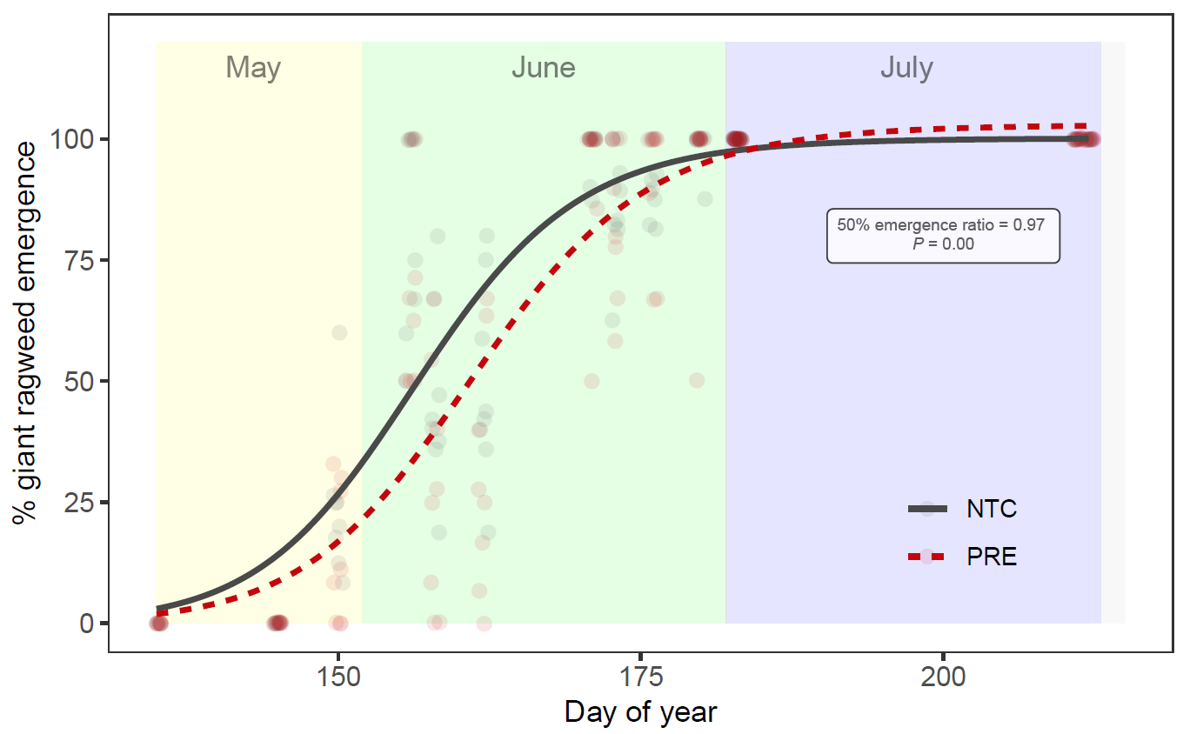

Figure 1: Giant ragweed emergence pattern in a soybean weed management study conducted by former WiscWeeds grad student Sarah Striegel in 2018 and 2019 at Rock County Farm, Janesville, WI (for complete information, see: Striegel et al [2021]).

Thus, a field study was conducted in 2021 and 2022 at Rock County Farm, Janesville, WI to evaluate the impact of soil management practices (including cereal rye cover crop adoption), soybean planting time, and PRE-emergence herbicide application on giant ragweed management in soybean.

Our study treatments consisted of:

* ***four soil management strategies:*** conventional tillage (chisel-plow in the fall and field cultivator in the spring), no-till, and fall-planted cereal rye terminated at two different times: early terminated (10-14 days before planting) and late terminated (planting green; termination within three days after planting) with Roundup PowerMax @ 32 fl oz/ac (glyphosate [Group 9])
* ***two soybean planting times:*** “early” (late-April/early-May) versus “late” (late-May)
* ***two PRE herbicide treatments:*** no PRE versus yes PRE (Sonic @ 6.45 fl. oz /ac; sulfentrazone [Group 14] + cloransulam [Group 2])

To simulate common practices used by soybean growers, Enlist One @ 2 pts/ac + Roundup PowerMax @ 32 fl oz/ac (2,4-D-choline [Group 4] + glyphosate [Group 9]) were applied POST-emergence when ~50% of giant ragweed plants within a treatment reached ~4 inches in height.

**Preliminary Results**

* According to our preliminary results, delaying cereal rye termination in the spring by 3 to 4 weeks allowed the cover crop to accumulate four times more biomass when compared to the earliest time of termination (500 lb/acre compared to 2,100 lb/acre). In this study a later maturing cereal rye variety (“Guardian”) was drilled into heavy corn stubble in the fall thus the relatively low biomass accumulation in the spring compared to other studies were an earlier maturity cereal rye variety (e.g., Aroostook) was adopted (see: **“What benefits (and challenges) can the planting green system bring to soybean production?”** <https://wiscweeds.info/posts/2023soybeanplantinggreensystem/> ).
* Early-planted soybean treatments were the first to require a POST application compared to late-planted soybean treatments.
* In 2021, tillage treatments were amongst the first to require a first POST and had double the giant ragweed density compared to the other treatments (Figures 2 and 3).
* PRE herbicides and cover crops did not impact giant ragweed density at the first POST application. The large seeded nature of giant ragweed makes its control with residual herbicides and cover crops difficult (this is the opposite from small seeded weed species such as waterhemp; please see: **“How we believe cereal rye cover crop suppresses waterhemp”** <https://wiscweeds.info/posts/waterhempsuppressionwithcerealryecovercrop/> ).

**Cereal rye cover crop biomass insight:**

* The amount of cereal rye cover crop biomass accumulated in this study ranged from 500 to 2,100 lbs of dry biomass per acre, with lower values for the early termination ahead of the early-planted soybean and the higher values for late termination (“planting green”) on late-planted soybean.
* An additional study was conducted during the 2022 growing season to quantify the amount of cereal rye dry biomass necessary to effectively suppress giant ragweed emergence. The results of the first year of this study show that 4,000 lbs of dry cereal rye cover crop biomass was needed to suppress emergence of giant ragweed seedling by 50%.
* The results of this additional study help us explain why the cereal rye cover crop treatments in our main study were unable to effectively suppress giant ragweed: our cover crop plots did not accumulate enough cereal rye cover crop biomass at the time giant ragweed was actively emerging (e.g., active giant ragweed emergence starts and occurs for the most part before cereal rye cover crop is actively growing and has enough time to accumulate substantial biomass in the spring in Wisconsin).
* Both of these studies will be replicated in 2023 to validate the results observed during the 2021 and 2022 growing seasons.
* Given the nature and biology of giant ragweed in Wisconsin, tillage and/or effective burndown at planting to eliminate established plants at the time of crop establishment and effective POST-emergence programs (foliar control) are best management practices. Remember that giant ragweed seed has short viability in the soil seedbank (most giant ragweed seeds die after 2 years in the soil). Thus, after a couple years of intensive management (no giant ragweed escapes producing new seed), giant ragweed infestations should become minimal. Check this giant ragweed article by Arneson et al for additional info <https://growiwm.org/weeds/giant-ragweed/>
* Stay tuned for plot tours and additional insights from this study during the 2023 growing season!

INDICATE this is GUILHERME Research

Pictures:

Both pictures taken on 6/14/22 at Janesville, WI. The tillage plot (figure 2) triggered the first POST application on 6/21 (20 days after planting) while the planting green plot (figure 3) triggered the application on 6/29 (28 days after planting).

Figure 2- Tillage treatment in late planted soybeans

Figure 3 - Late terminated cereal rye CC (planting green) in late planted soybeans.

References:

Striegel, S., Oliveira, M. C., DeWerff, R. P., Stoltenberg, D. E., Conley, S. P., & Werle, R. (2021). Influence of postemergence dicamba/glyphosate timing and inclusion of acetochlor as a layered residual on weed control and soybean yield. Frontiers in Agronomy, 3(December), 1–13.