Name: Chukwuemeka Wisdom Arinze

Student Number: 2970177

Description of my Site

My site is about a person I look up to his name is Danzel Washington, the site comprises of 12 pages. The site has a presentation page, the site has a header, I got the inspiration from Dc Comics site. The header has a different font from the rest of the page. I downloaded a font family from Google fonts (font-family: 'Noto Serif', serif. My decision for using this font is that it looks clear and beautiful. The Navigation font color is different (color: #B6B5B5). I used another shade of white and this shade matches my site perfectly. I made this choice because I wanted something different from the content and this color was just perfect.

Apart from the home page there is a space on the rest of the page. The reason for this is because I wanted the site to look different. I did not want it look like an online book if you get my meaning.

For the background body of the page I used a picture of my hero, the picture says a lot about him. It identifies the fact that he is a black American, the black background also makes it easy for content to be shown on it. The home page has a welcome Text which is appealing. I put opacity on the text which made it transparent. The header and footer are 100 percent wide while the content is 80 percent wide.

The Biography page contains the early life of my Danzel Washington. Where he was born, his parents, their profession and his school years. By the look of the pictures you can see how he progressed from a boyhood to a manhood. I floated pictures left and right.

The family page contains information about his family starting from his wife to his children. It includes how they met and his children’s education and respective careers. I included pictures of all his family members and floated them

Career page shows Denzel’s acting career and how he became an actor, his first acting gig in a broad way show and his first film as a professional actor. Pictures are present which I floated left and right of the page

In the awards page I listed all his awards and nominations and I put it in a table and aligned it to the centre. I did it this way because without aligning the entire content centre the table heading and the content will not be aligned correctly.

In the quotes page I put pictures of Danzel Washington and quotes in between them I centred the whole page because it is more readable and look better that way.

Movies page contains all Danzel Washington’s movies and plays he has done all his life, from first to recent. I put it in a table and then I centred it. This way it looks more presentable and better rather than putting it in a narrative format.

Model page contains Danzel Washington’s work as a model in magazines. Since most of the pictures are from Italian tailors I made the font Georgia and italicised. Also, the way I arranged the pictures I got that from the site pinterest.ie.

Media page contains videos of Danzel Washington given speeches and advice to people. Words to live by and encouragement that helped him to grow physically, mentally, socially and spiritually. These links are in the Images and I arranged them the way I did because they look better in rows.

Site Map

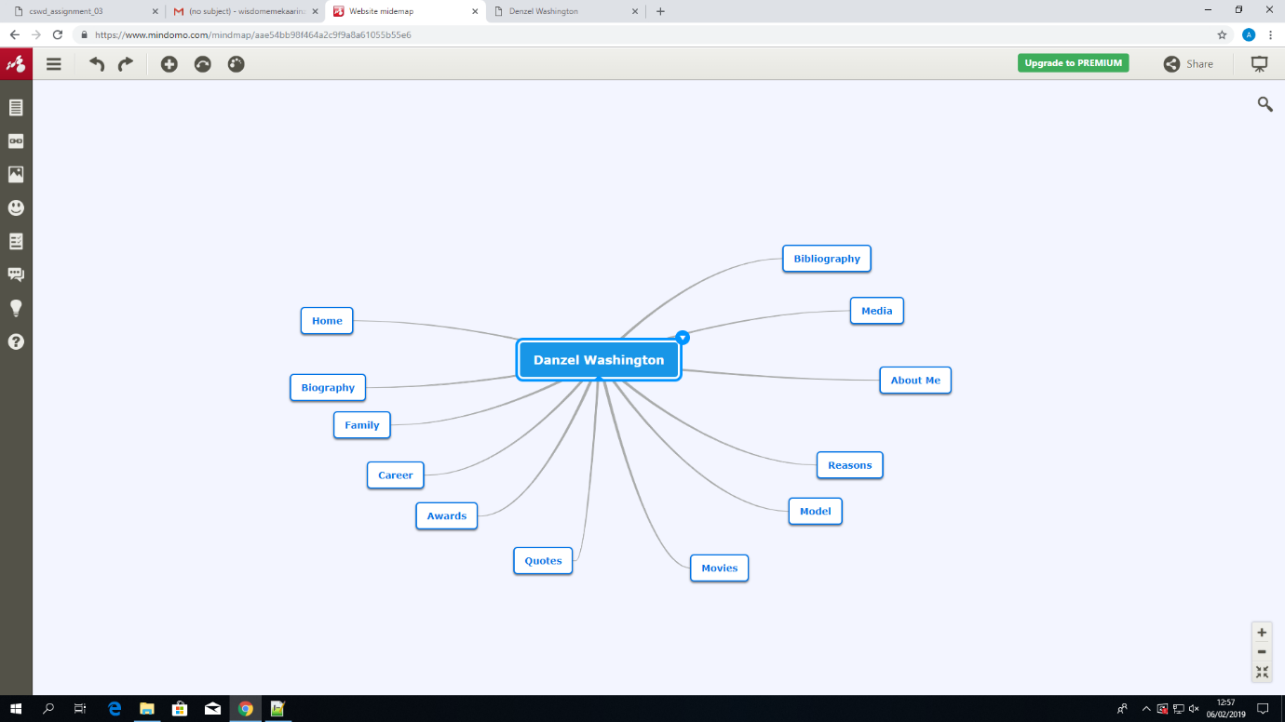

Wire Frame

Home Page

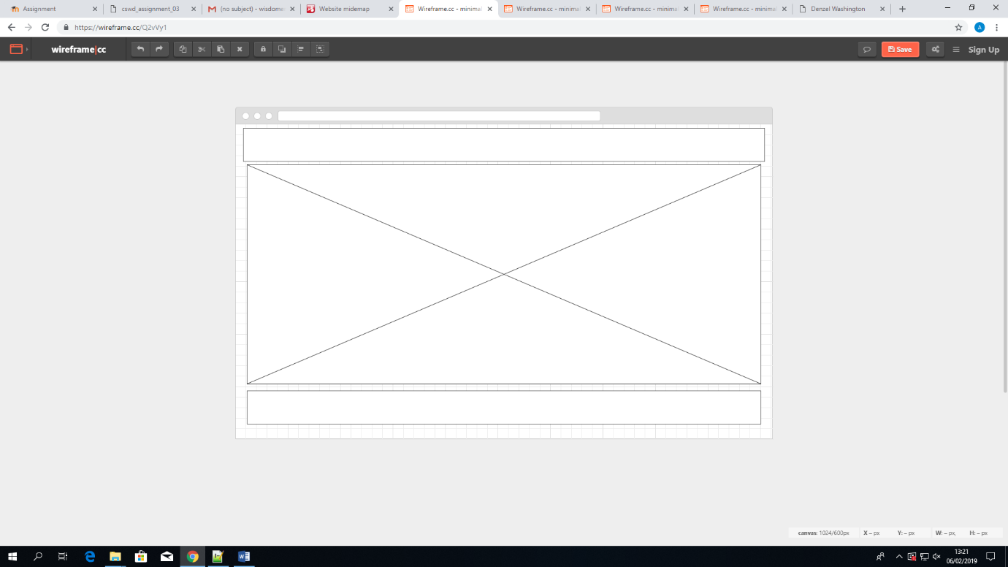

Biography and Career Page

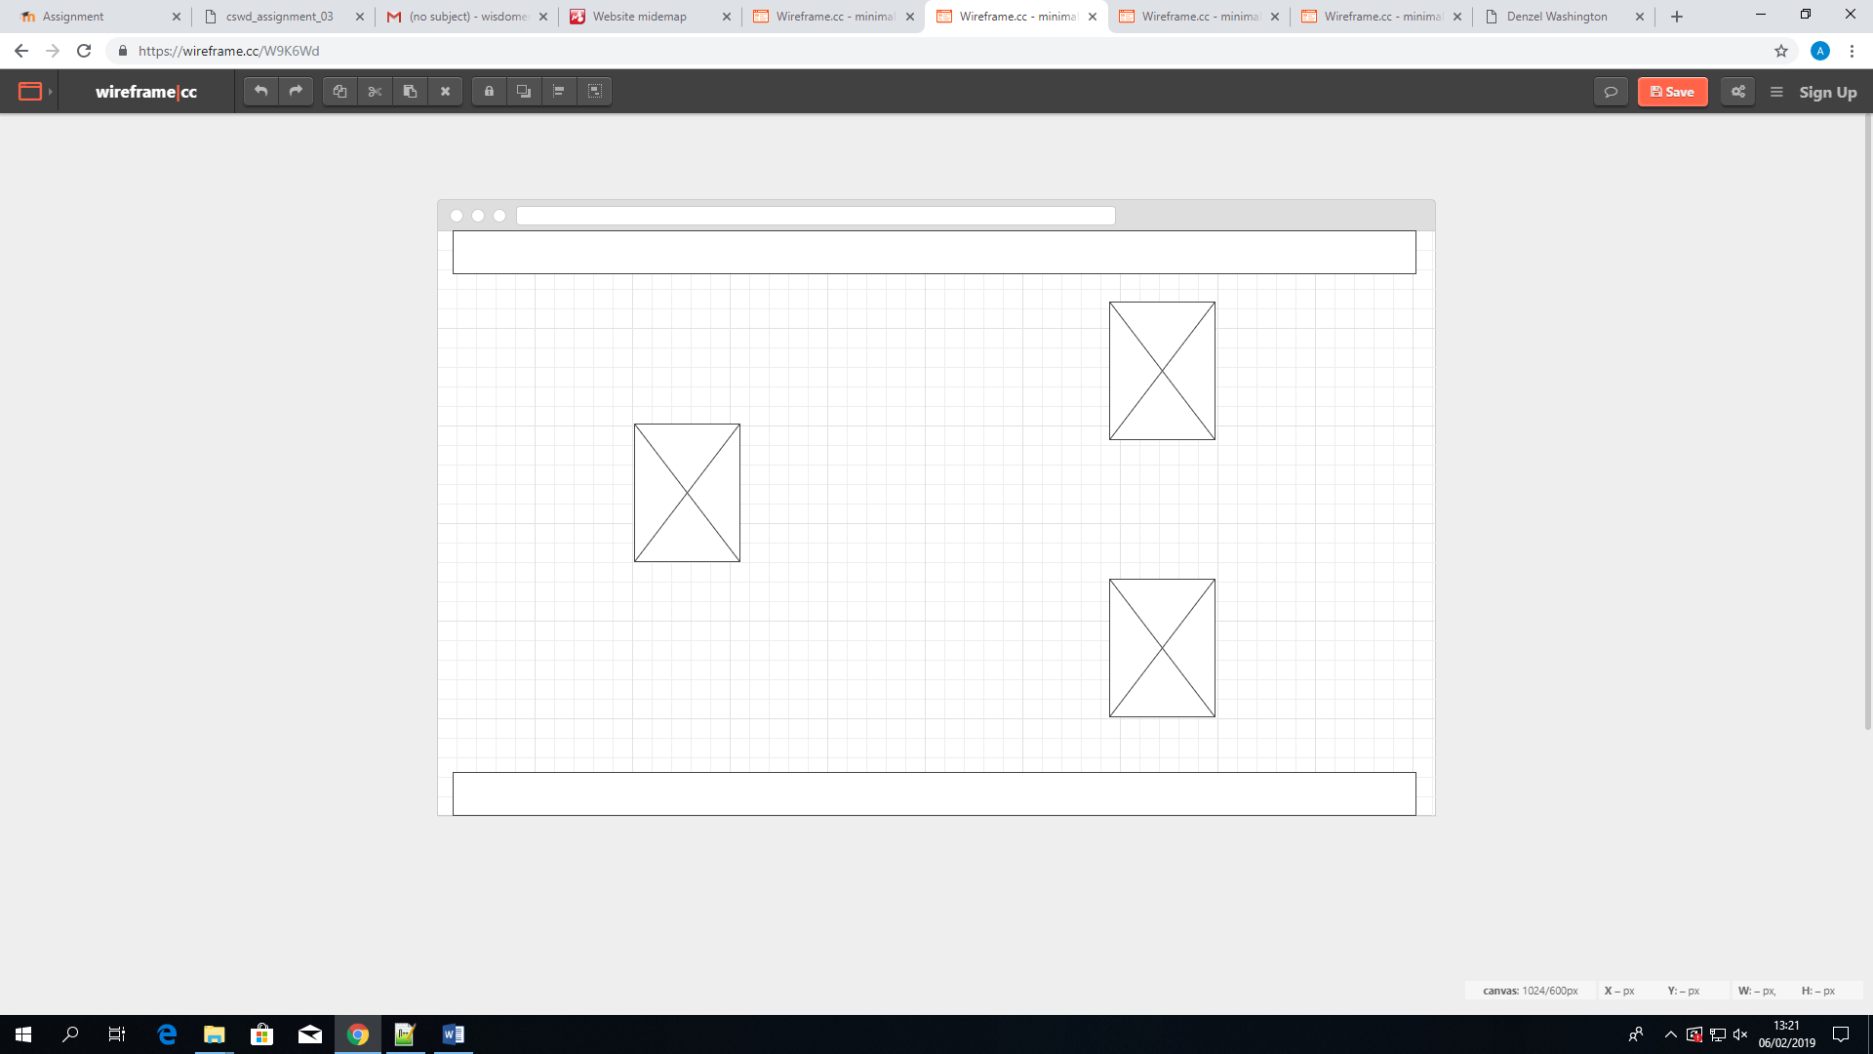

Model Page

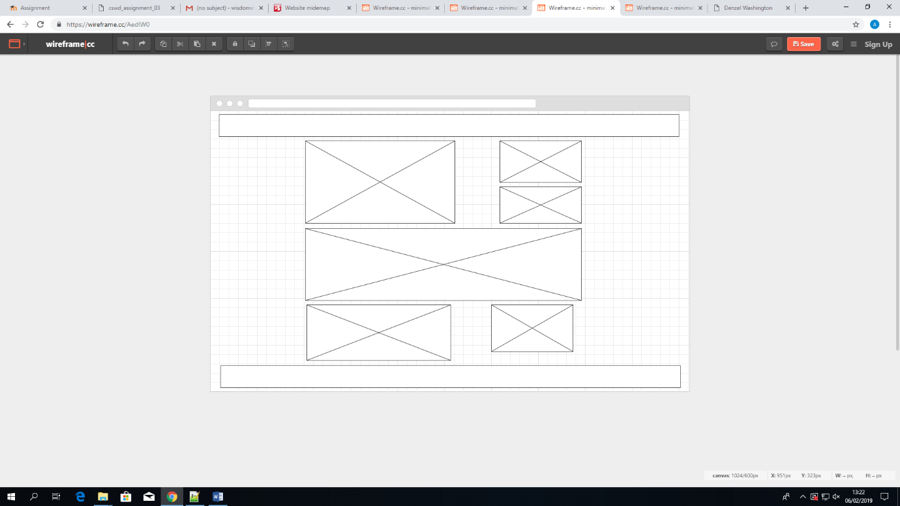

Quotes

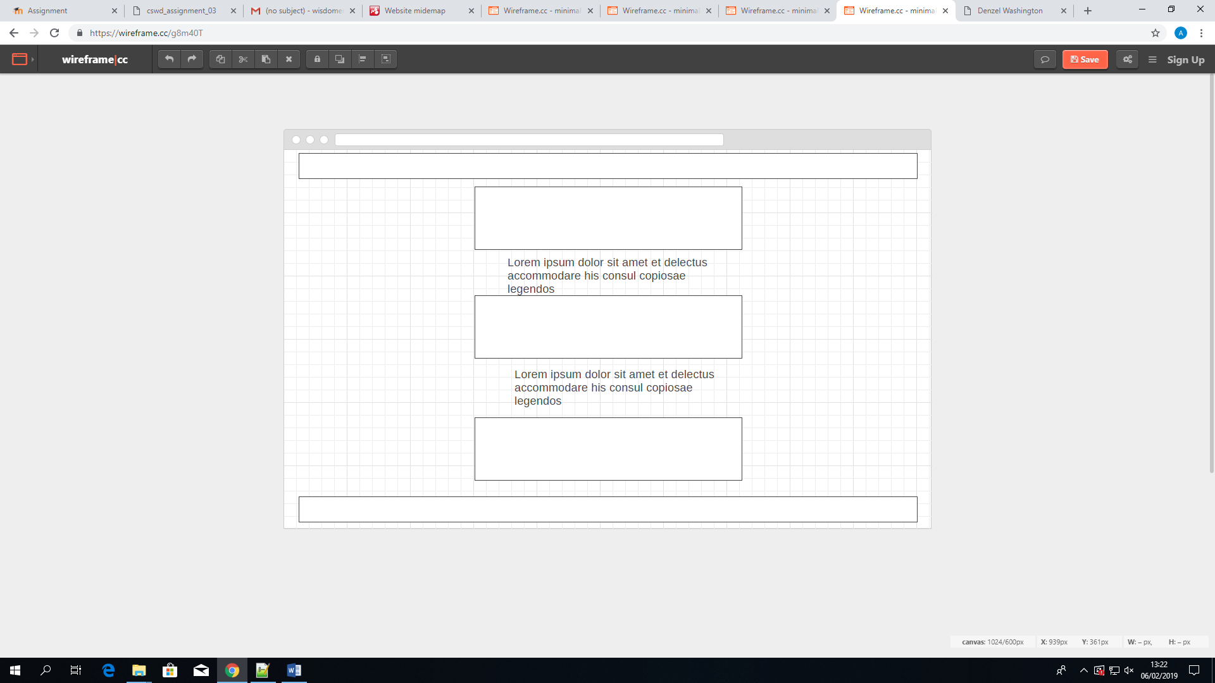

Media

Sites that Helped/Research

DC comics

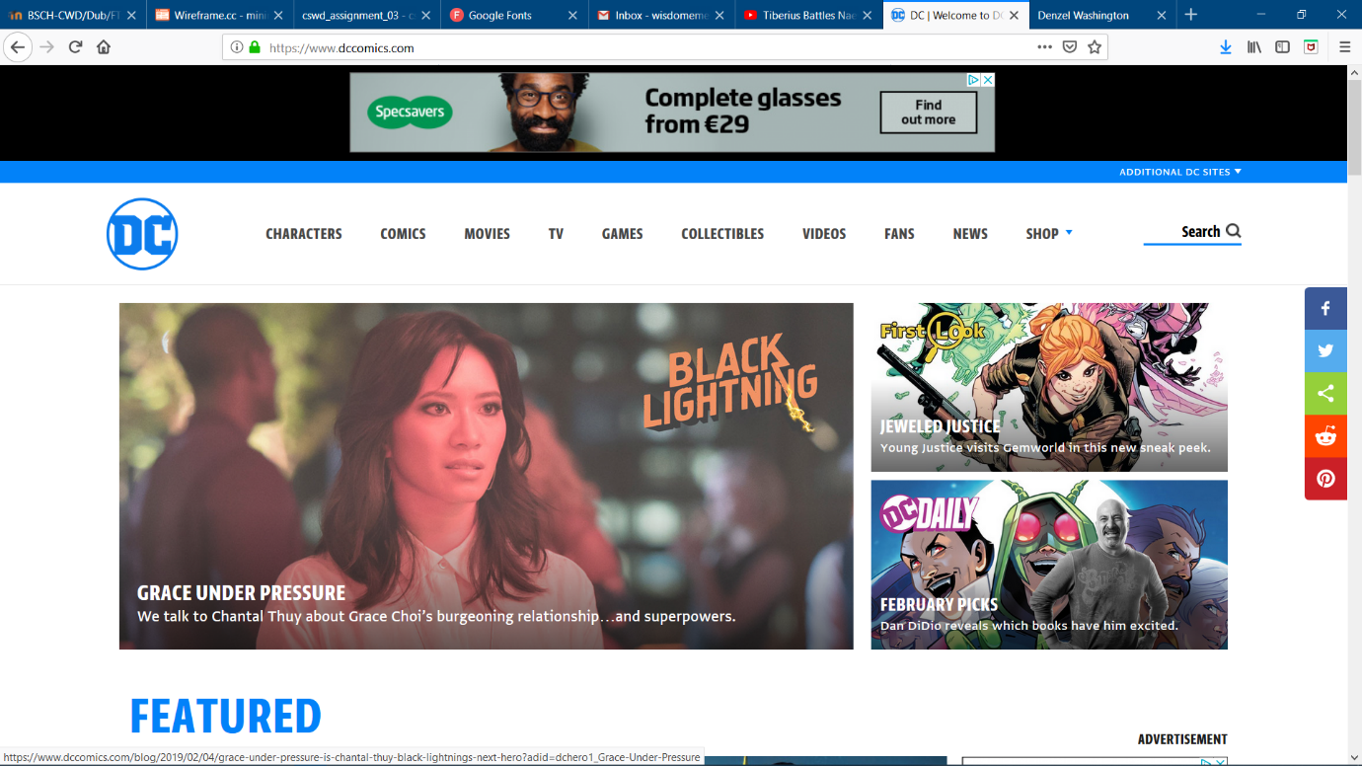

Pinterest

