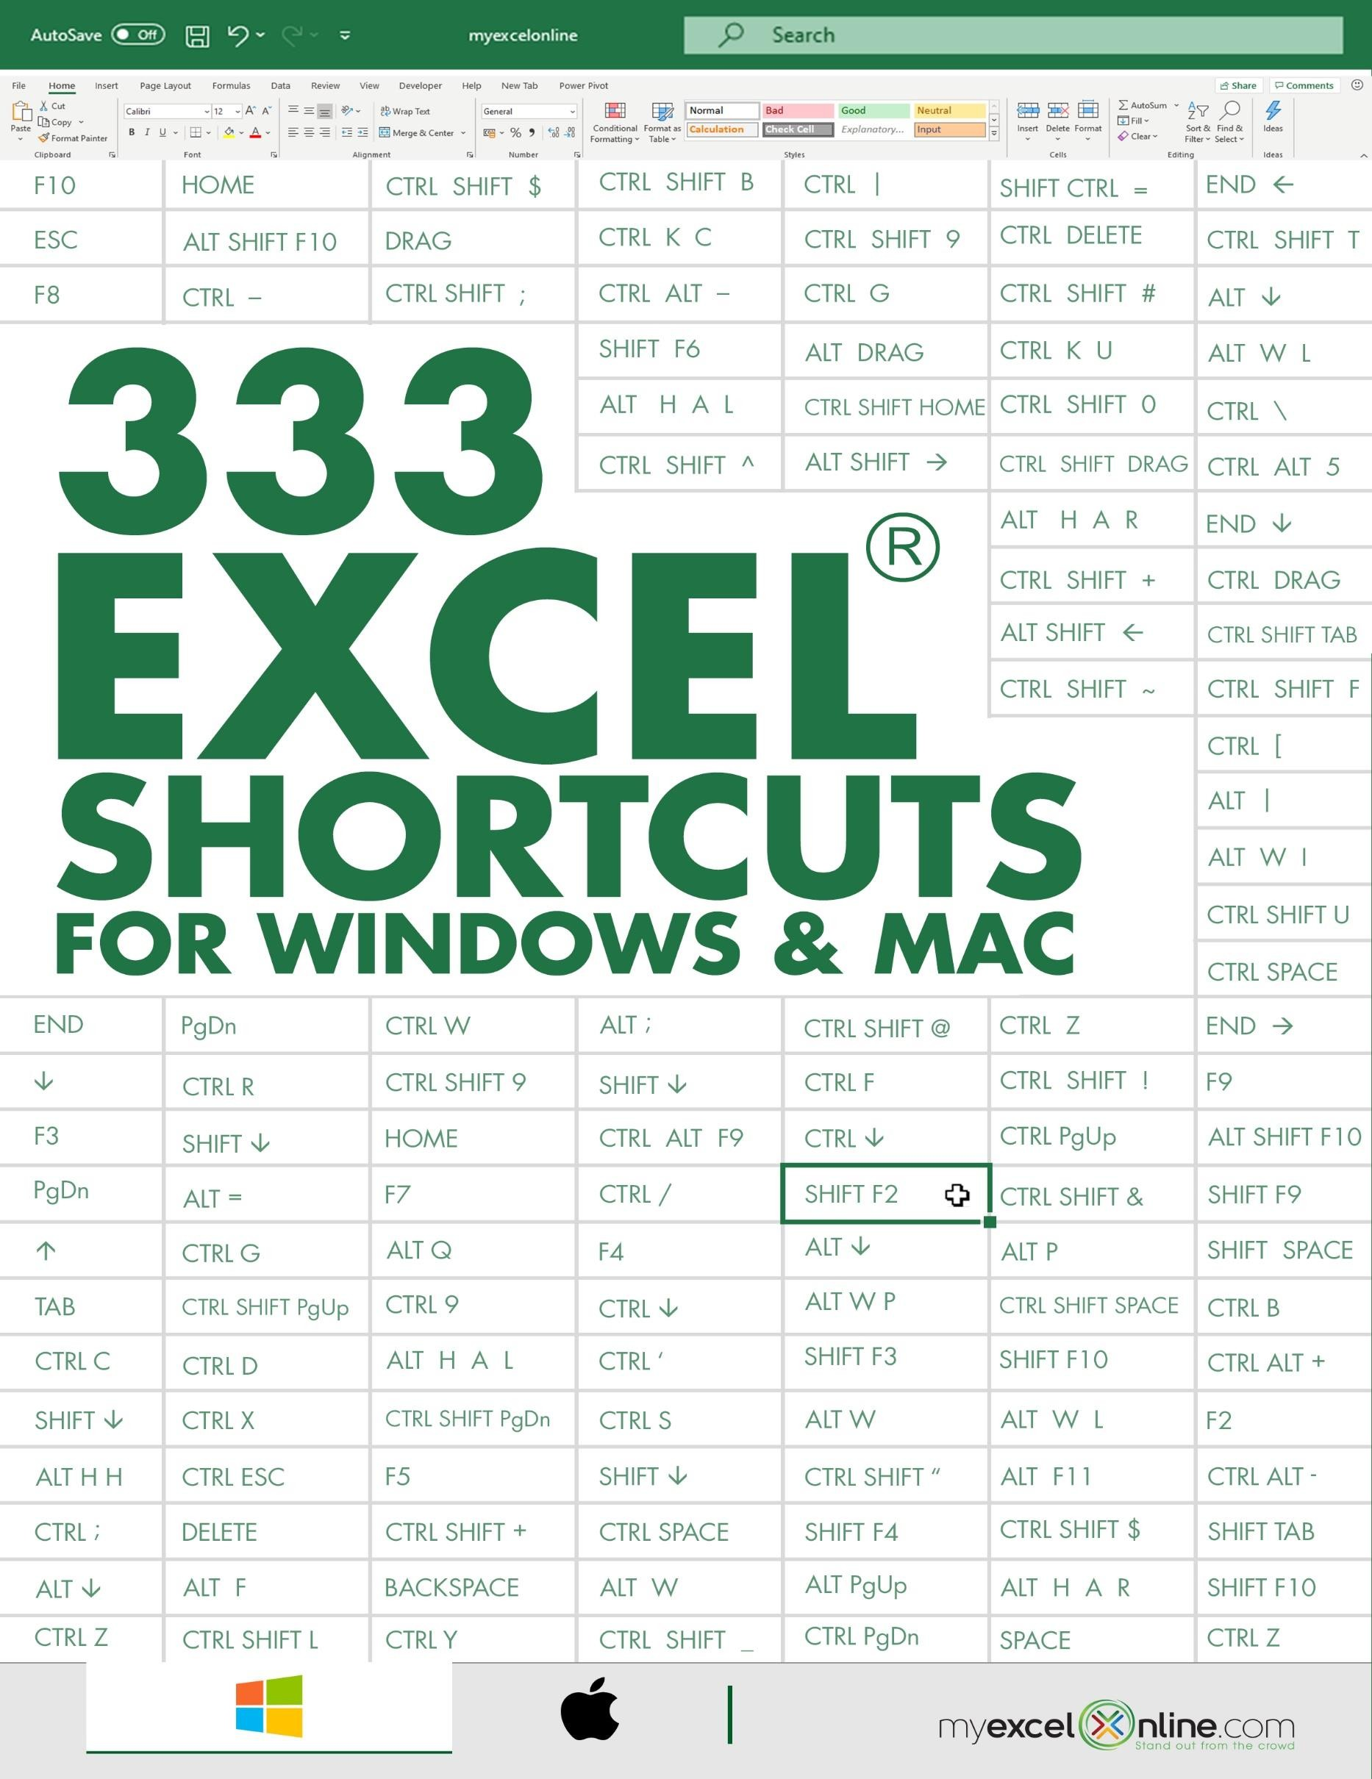



333 EXCEL SHORTCUTS 3

Frequent Keyboard Shortcuts 4

Inside the Ribbon Shortcuts 6

Cell Navigation Shortcuts 7

Formatting Cell Shortcuts 9

Making Selection Shortcuts 11

Working with Formula Shortcuts 13

Ribbon Tab Shortcuts 14

Power Pivot Shortcuts 15

Function Key Shortcuts 17

Drag and Drop Shortcuts 19

Macros and VBA Shortcuts 20

Pivot Table Shortcuts 21

Power BI Shortcuts 22

Other Shortcuts 24

WINDOWS SHORTCUTS CHEAT SHEET 26

MAC SHORTCUTS CHEAT SHEET 28



# Frequent Keyboard Shortcuts

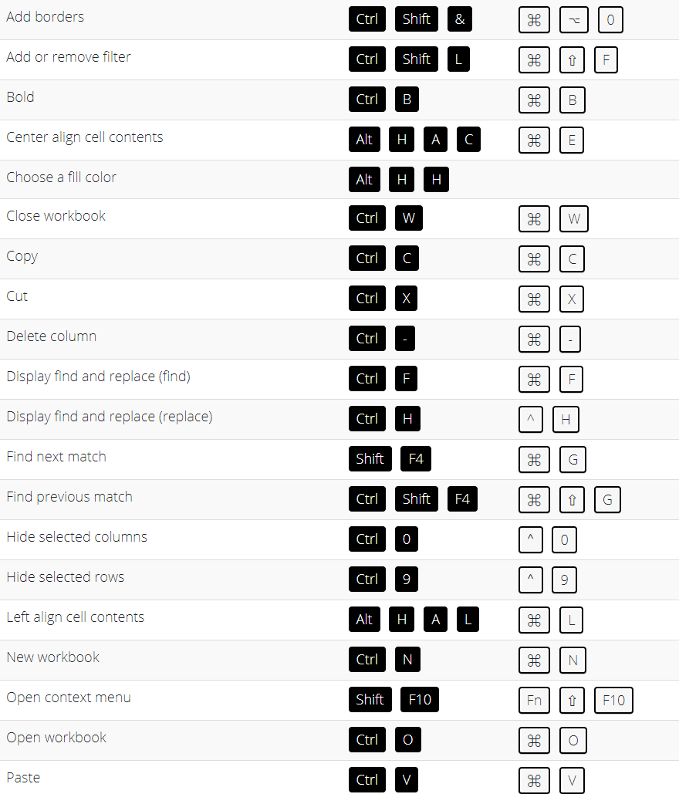

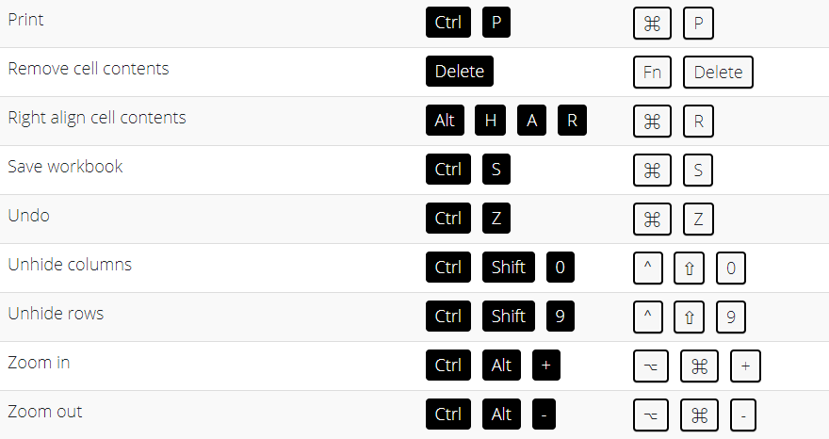

# Inside the Ribbon Shortcuts

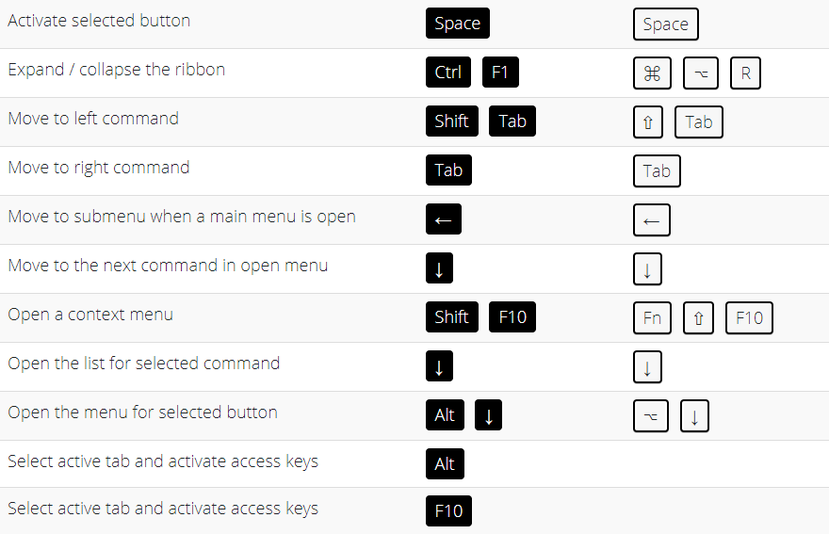

# Cell Navigation Shortcuts

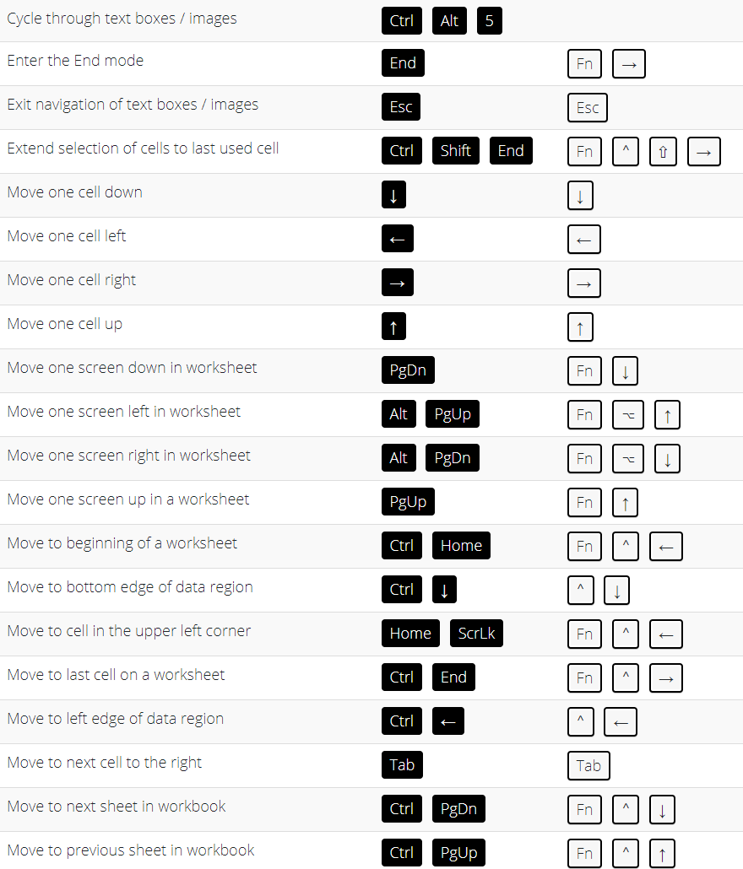

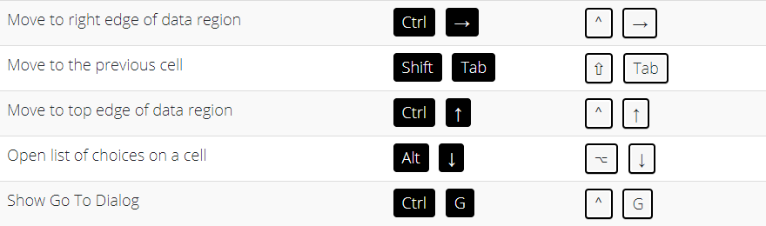

# Formatting Cell Shortcuts

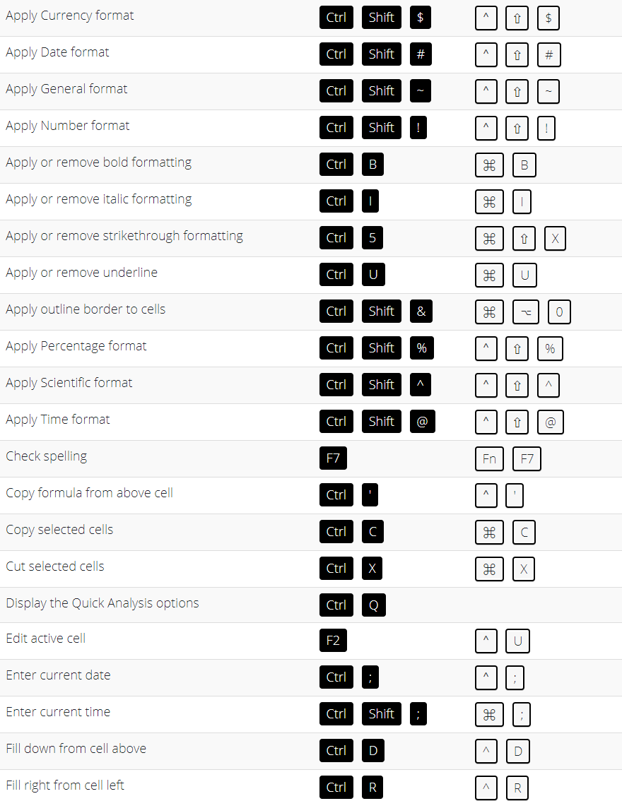

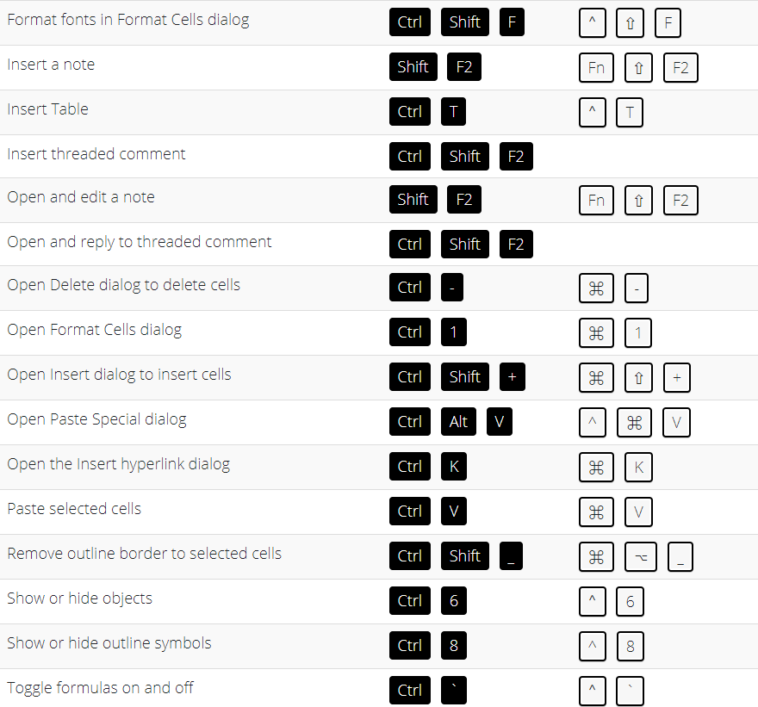

# Making Selection Shortcuts

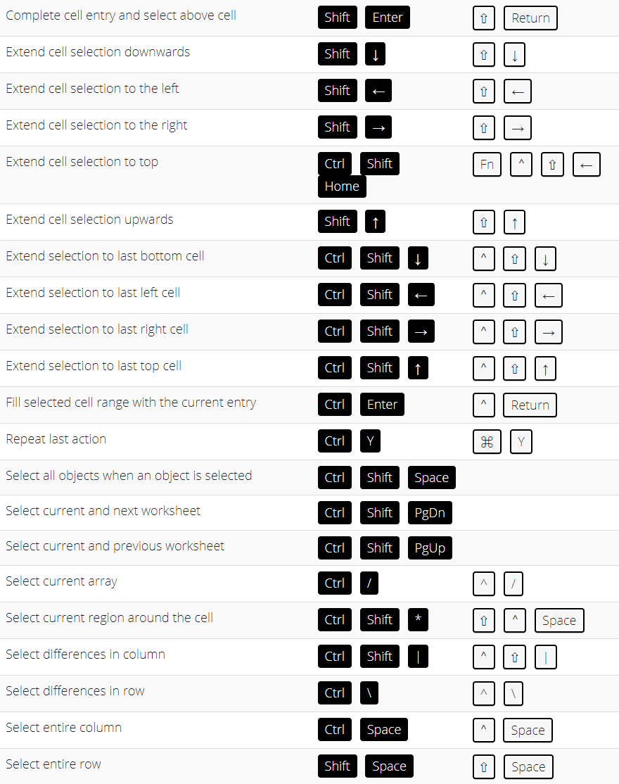

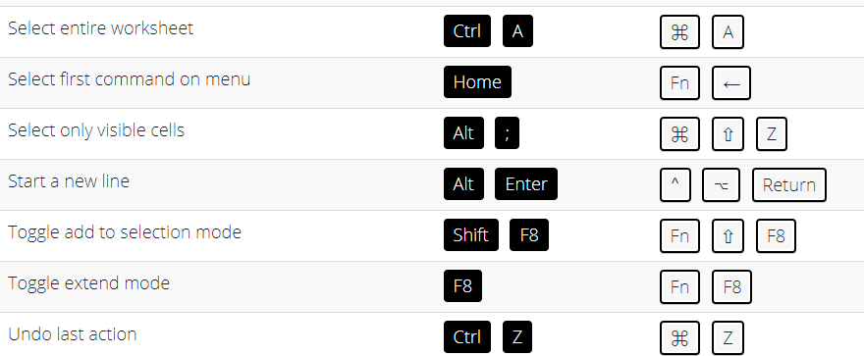

# Working with Formula Shortcuts

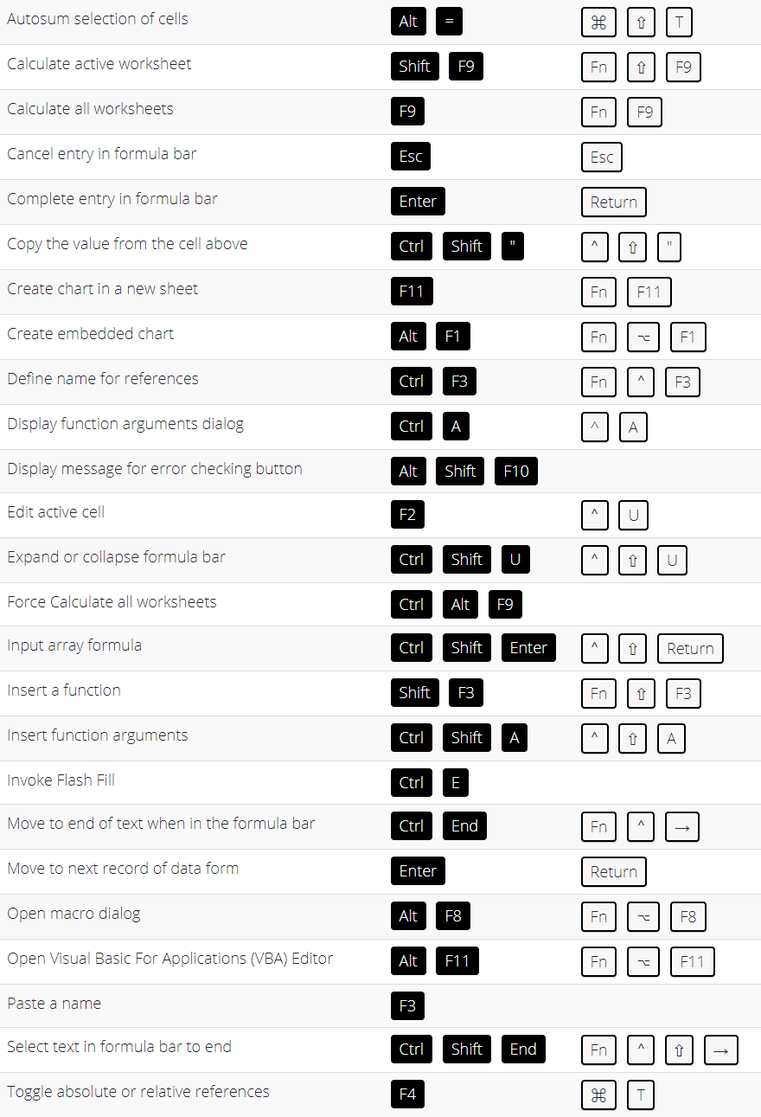

# Ribbon Tab Shortcuts

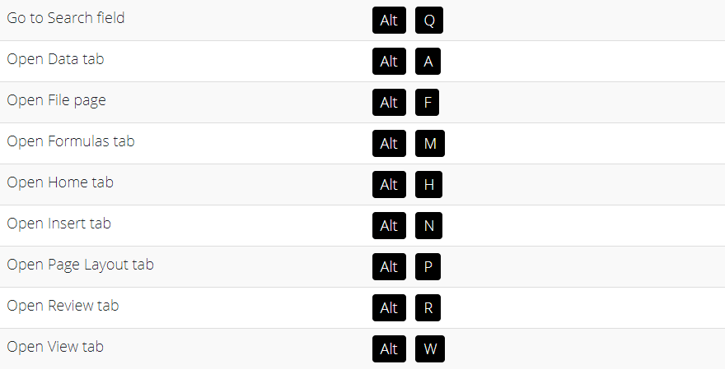

# Power Pivot Shortcuts

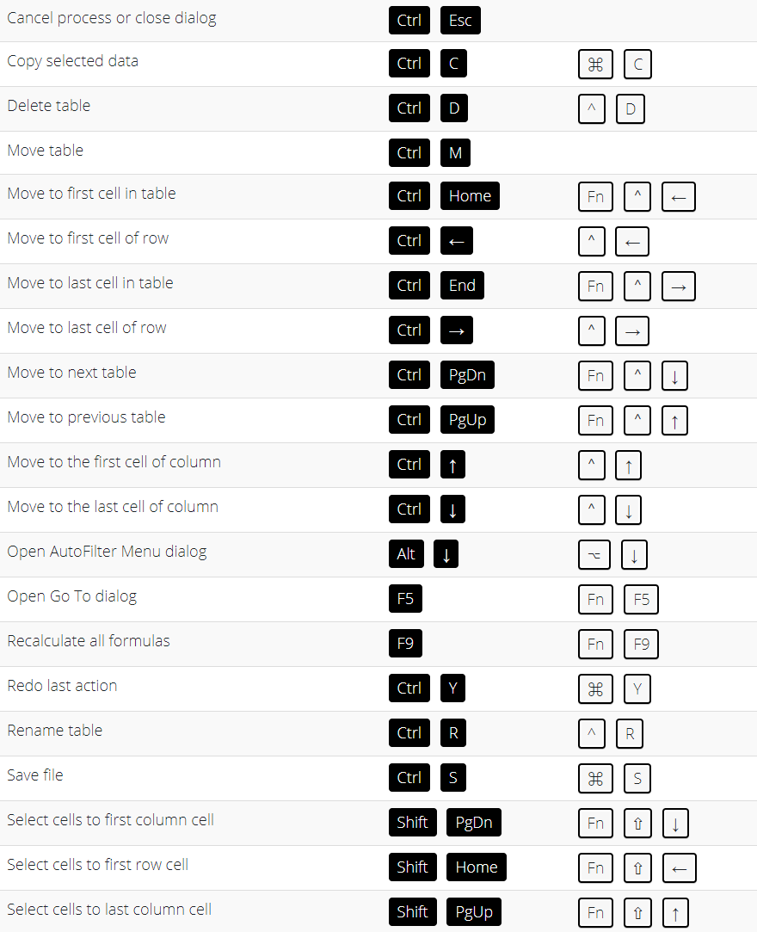

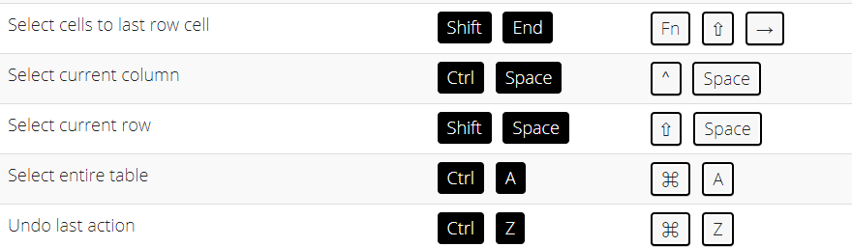

# Function Key Shortcuts

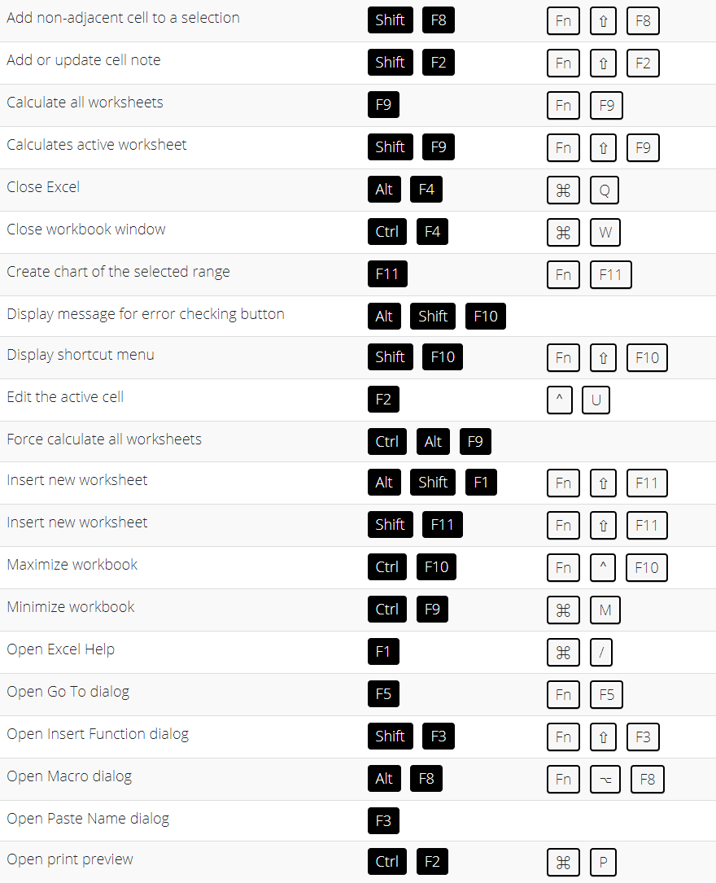

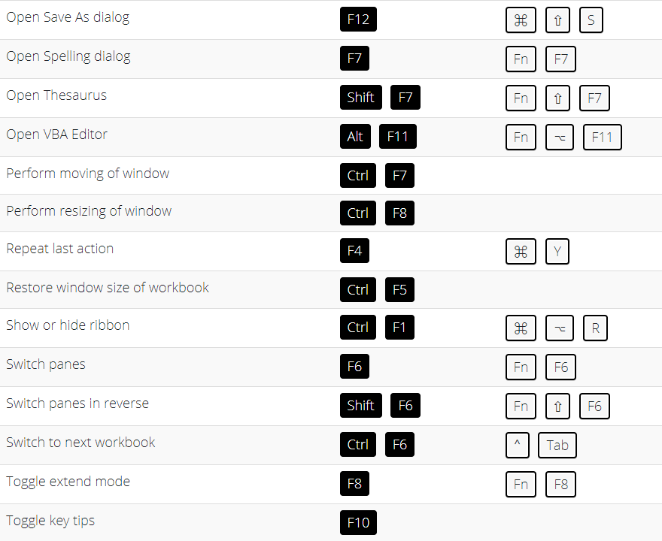

# Drag and Drop Shortcuts

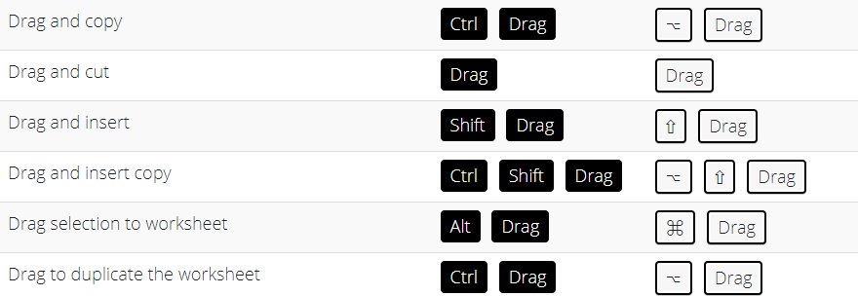

# Macros and VBA Shortcuts

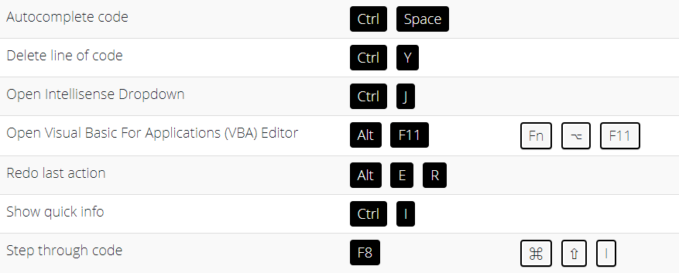

# Pivot Table Shortcuts

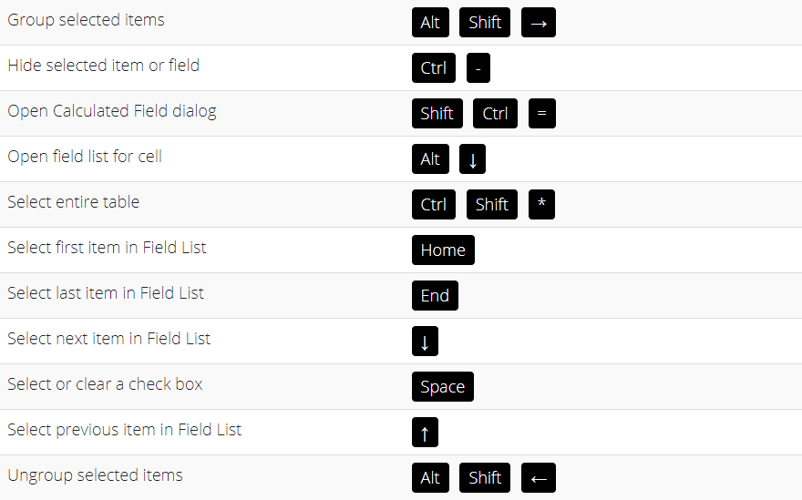

# Power BI Shortcuts

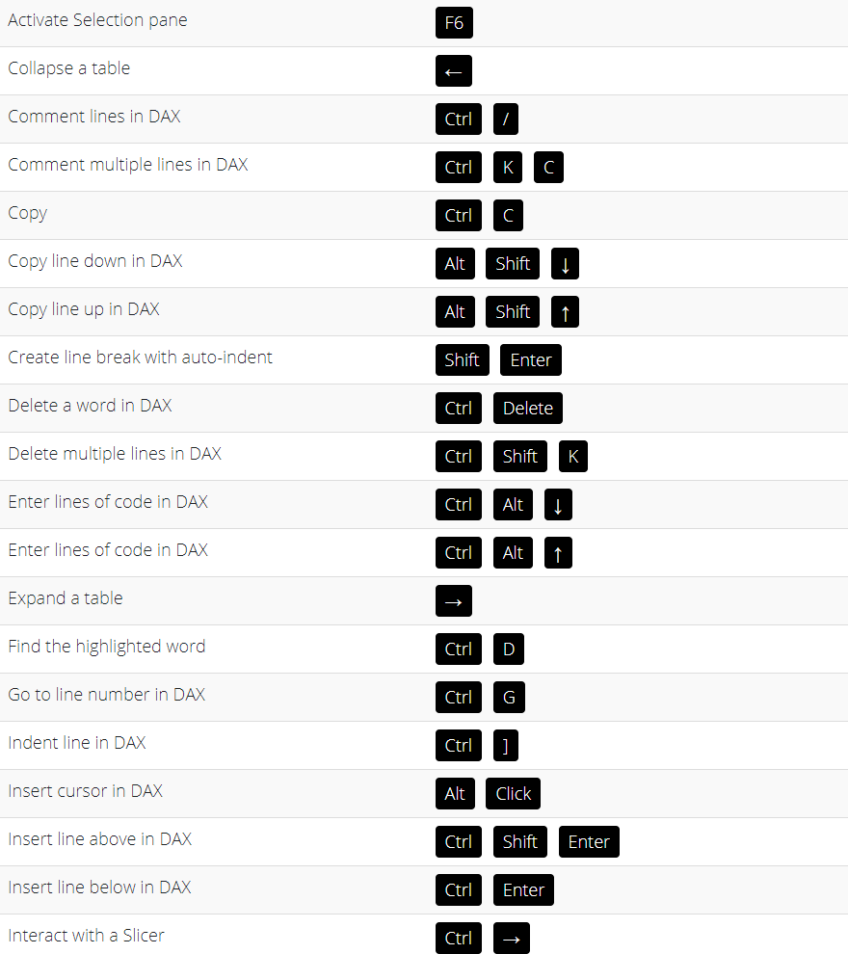

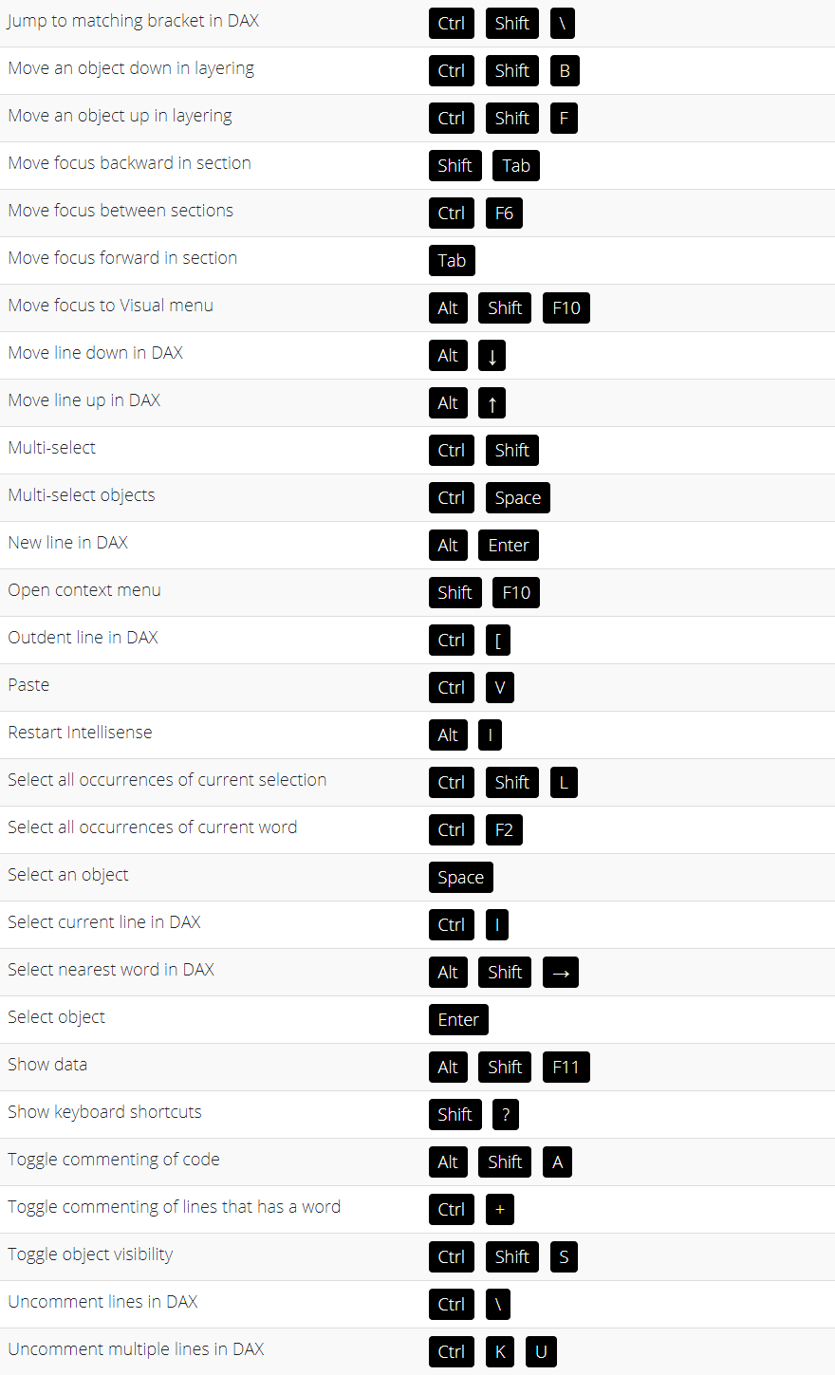

# Other Shortcuts

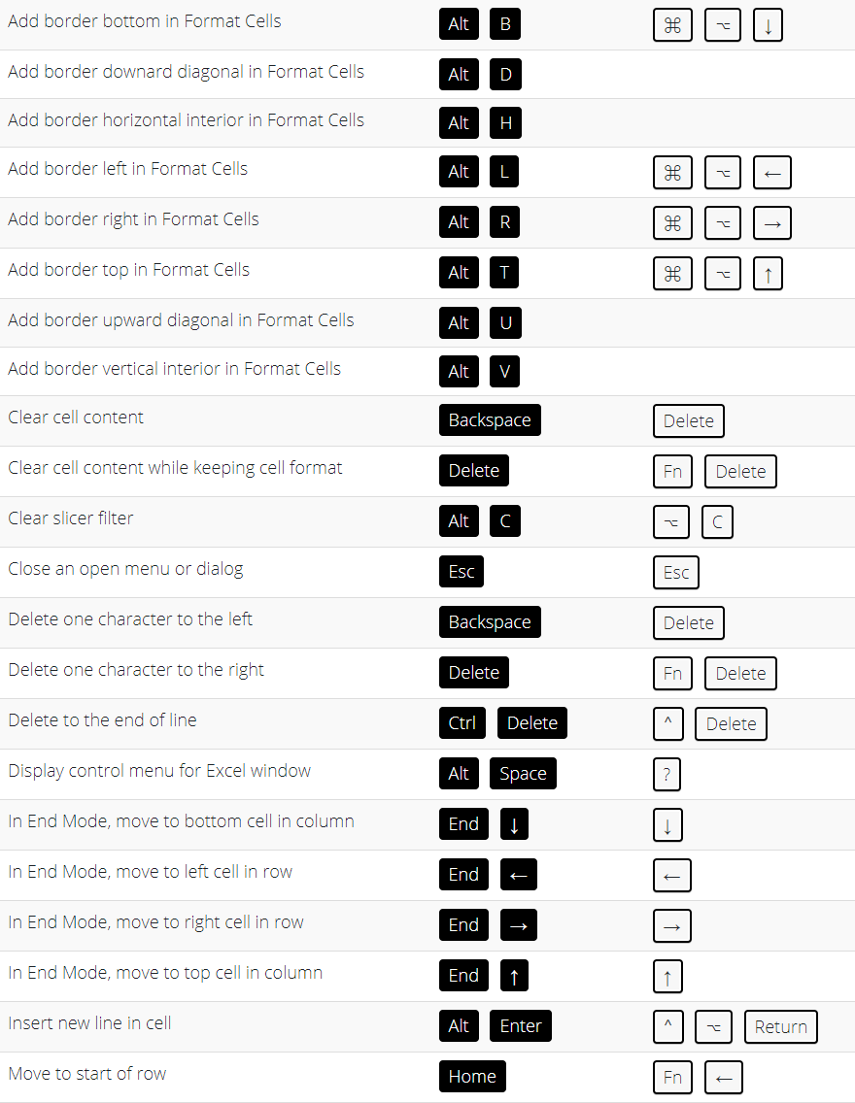

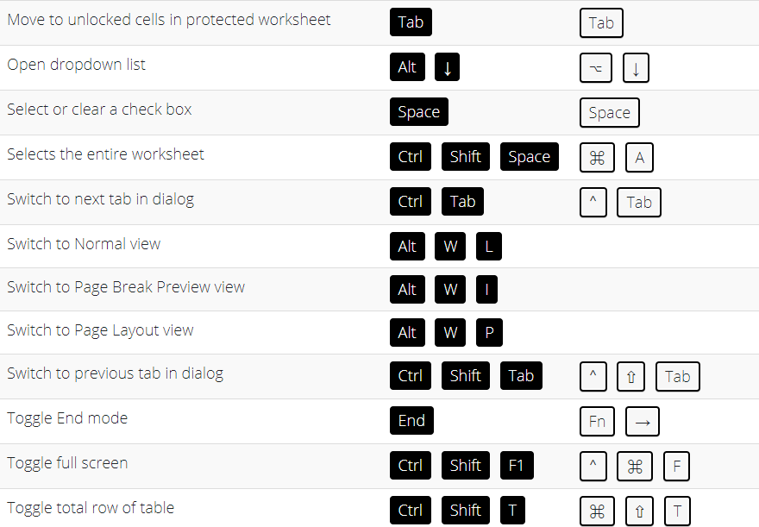



### 



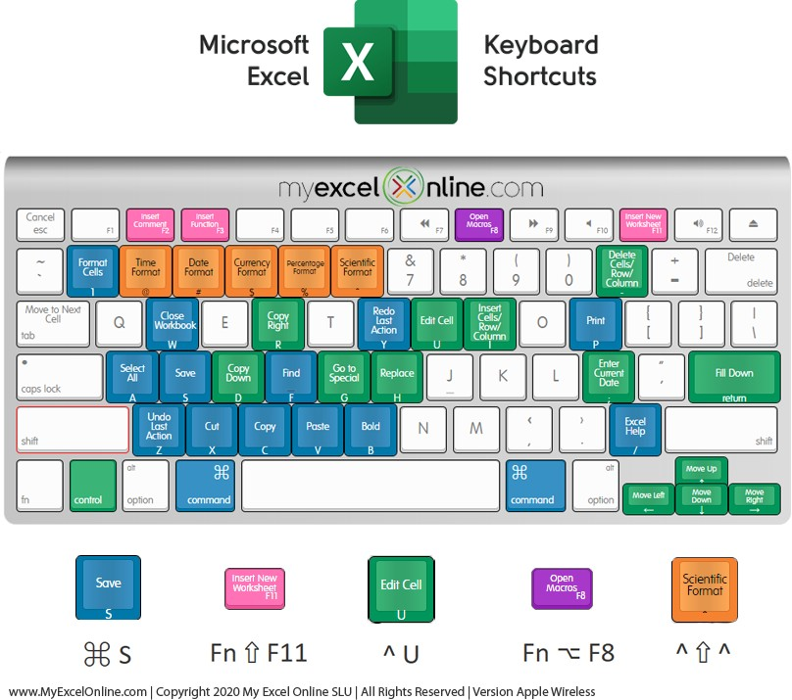



I’d like to thank you again for taking the time to check out the 333 Excel Shortcuts for Windows and Mac! I hope you’ve found some value in it and can use it as a guide to help you gain more Excel knowledge which will make you more productive, give you more confidence and ultimately make you stand out from the crowd!

If for whatever reason you got this e-book without ever subscribing to my email list (which is totally okay because I realize people love to share things like this), then please head on over to [www.MyExcelOnline.com/blog](http://www.myexcelonline.com/blog) and subscribe to my email list there.

And lastly, if you enjoyed this e-book, give me a shout out on Twitter or Facebook and share [www.MyExcelOnline.com/blog/333-excel-shortcuts-for-windows-and-mac/](http://www.myexcelonline.com/blog/333-excel-shortcuts-for-windows-and-mac/)

##### You can also go directly to our Excel services & products here:

[www.MyExcelOnline.com/webinars](http://www.myexcelonline.com/webinars) to get free online Excel training from me! [www.MyExcelOnline.com/academy/enroll-eg/](http://www.myexcelonline.com/academy/enroll-eg/) to enroll in our Flagship Excel

Academy Course and access 500+ video tutorials covering ALL Excel features! [ebooks.MyExcelOnline.com](https://ebooks.myexcelonline.com/) to get our bestselling Excel Books!

[www.MyExcelOnline.com/microsoft-excel-consulting-services](http://www.myexcelonline.com/microsoft-excel-consulting-services) to get fast Excel help from our Excel Consultants!

[www.MyExcelonline.com/blog](http://www.myexcelonline.com/blog) to get daily tutorials on Formulas, Pivot Tables, Charts, Analysis, Macros & Power BI!

[www.MyExcelOnline.com/podcast](http://www.myexcelonline.com/podcast) to get the Excel insights from the Excel experts each month!

Feel free to email me regarding anything Excel related, improvements and additions to this guide [at support@myexcelonline.com](mailto:support@myexcelonline.com)

To Your Success!

## [John Michaloudis](https://www.youtube.com/user/LearnExcelPivotTable/featured)

#### [Chief Inspirational Officer](https://www.youtube.com/user/LearnExcelPivotTable/featured)

#### [SUBSCRIBE TO OUR YOUTUBE CHANNEL](https://www.youtube.com/user/LearnExcelPivotTable/featured)





