**Below is a screenshot of python program screenshot written by the Instructor (Mr. Wisdom). Answer the questions that follow.**

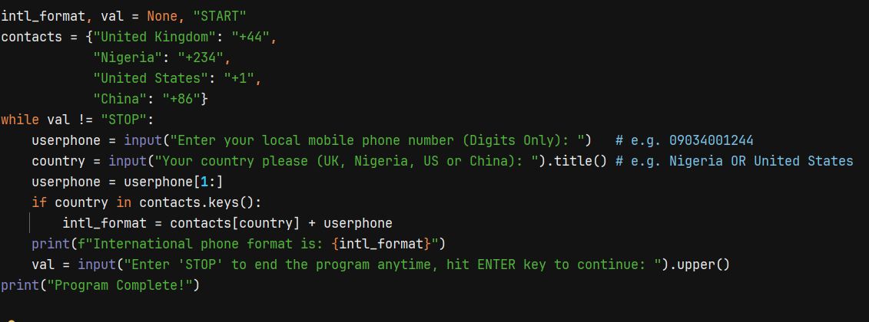

1. **Open/Power up your Kali Linux Virtual Machine and open up a new terminal.**
2. **Change/Navigate into the Desktop directory inside Kali.**
3. **In the Desktop directory, create a new subdirectory named *“GeneralTaskZero”.***
4. **Change/Navigate into this new directory you just created *(GeneralTaskZero).***
5. **Create a new file in this new directory, naming it *gen_task_zero.txt***
6. **Using any editor in Kali (nano, vim, mousepad), open this new file *(gen_task_zero.txt)* which you just created.**
7. **Write all the python code in the screenshot above inside your opened file and close it appropriately.**
8. **Once closed. You should now rename the file in order to run the python program. Using any commands you know in Linux, rename this file from *gen_task_zero.txt* to *gen_task_zero.py***
9. **Execute the python program/script repeatedly using different mobile contacts/numbers from the countries requested by the program.**
10. **Observe the results. What happens if the user enters an 11-digit Chinese mobile number** (1XXXXXXXXXX) **and is from the country of China? Is the first digit** (i.e. 1) **replaced with** +86 ? ***Yes OR* *No*** ?