Experiment No. 9
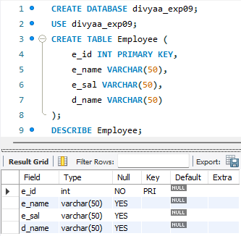
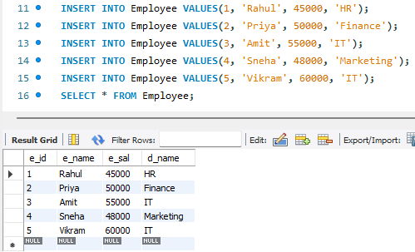

- Create an index on d_name.
CREATE INDEX idx_dname
ON Employee(d_name);

- Create an index on salary.
CREATE INDEX idx_salary
ON Employee(e_sal);

- Create a composite index on department name and salary.
CREATE INDEX idx_dept_salary
ON Employee(d_name, e_sal);
- Show all the index for Employee table.
SHOW INDEX FROM Employee;
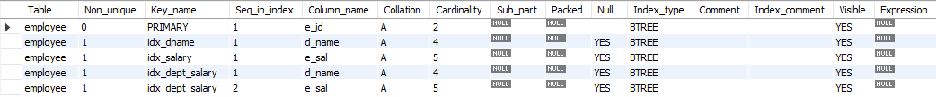

- Explain all the index by writing retrieval queries.
