Experiment 6A:- Views
Customer (cno, cname, cadd, cage):-
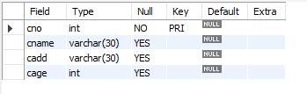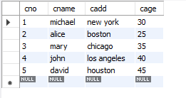
Loan (lno, lamt, ldate, cno (fk)):-
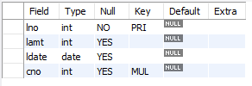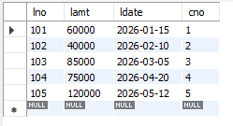
- Create a view customer details which contains customer number , customer name and loan amount of those customer who have a loan amount between 50000 and 100000 :- 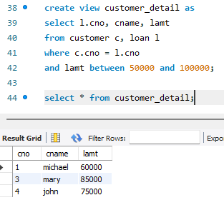
- Find customer name from view of those customers who have a loan amount less than 70000:- 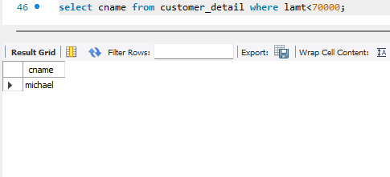
- Find customer name from view of those customers whose customer name start with letter m :- 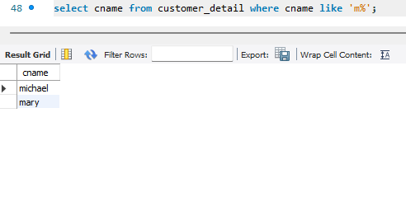
Create view customer_detail
As (select l.cno,cname,lamt
From customer c , loan l
Where c.cno = l.cno AND
Lamt between 50000 AND 100000);

Experiment 6B:- Triggers
Employee (eid, ename, dname, sal):-
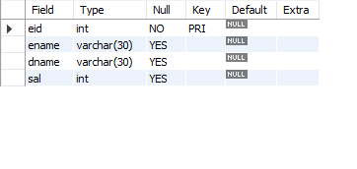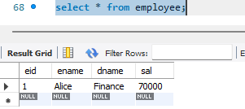
Employee_log(logid, empid, action, action_date):-
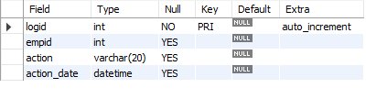
- Create a trigger named as before_insert_trigger which converts employee department name to uppercase before insertion:- 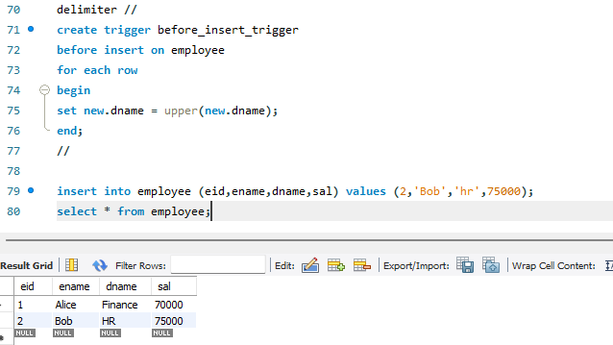
- Create a trigger named after_insert_trigger to record to newly inserted employee record into the table:- 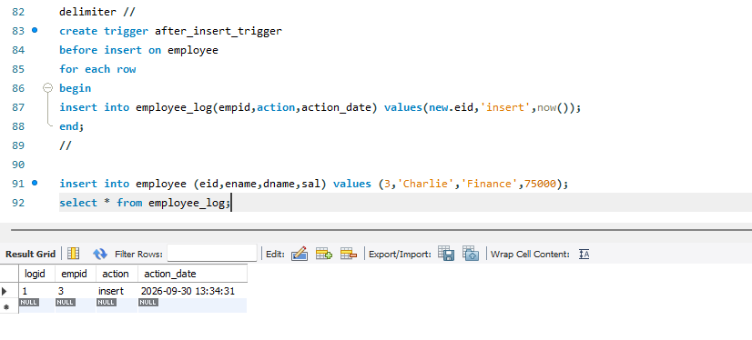
- Create a trigger named before_update_trigger which will not allow employee salary to be reduced:- 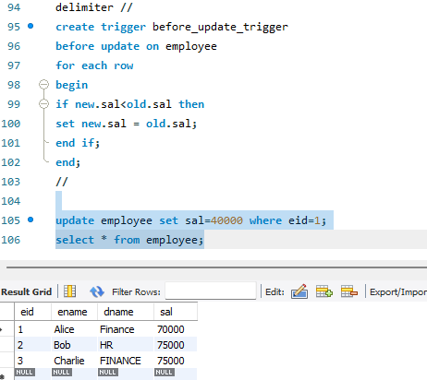
- Create a trigger named after_delete_trigger to record deleted employee log:- 