EXPERIMENT NO. 5
AIM: Implementation of Joins and Nested SQL Query
THEORY:

Joins:
Natural, Inner, equijoin, outer join
Nested Query:
Sub query or Inner query or Nested query is a query in a query. SQL sub query is usually added in the WHERE Clause of the SQL statement. Most of the time, a sub query is used when you know how to search for a value using a SELECT statement, but do not know the exact value in the database.
Subqueries are an alternate way of returning data from multiple tables.
Subqueries can be used with the following SQL statements along with the comparison operators like =, <, >, >=, <= etc. and Set membership operators like IN, ALL and ANY etc. ALL and Any applied with comparison operators.
Example: SELECT column-names
FROM table-name1
WHERE value IN (SELECT column-name
FROM table-name2
WHERE condition)
Question:
Employee (ename,street,city)
Works(ename,cname,sal)
Company(cname,city)
Manages(ename,manager_name)
-

- Find employees who work for more than one company
- Find all employees who work for companies in a different city than they live
- List all companies and employees working there (include companies with no employees).
- Find the names and cities of all employees who work for Infosys.
- Find the names, street, cities of all employees who work for Infosys and earn more than Rs.50000
- Find all employees who lives in the same cities the company cities.
- Find all employees who lives in the same cities as do their manager
- Find all employees in the database who earn more than every employee of TCS
- Find the company that has the smallest payroll
- Find minimum salary belongs to which employee.
- Find Employees earning the highest salary in their company.

CONCLUSION: Thus, we have implemented Joins nested SQL Queries

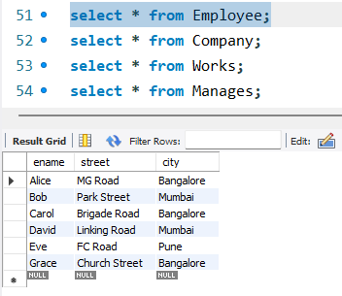
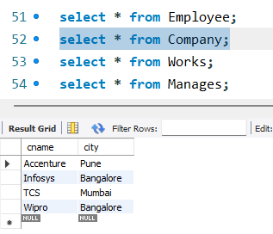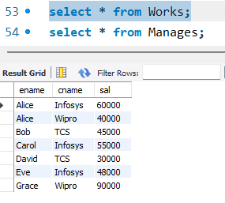
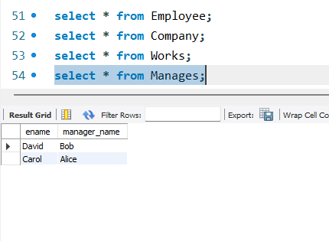
- Find employees who work for more than one company:- 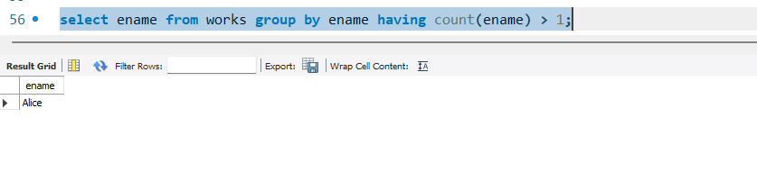
- Find all employees who work for companies in a different city than they live:- 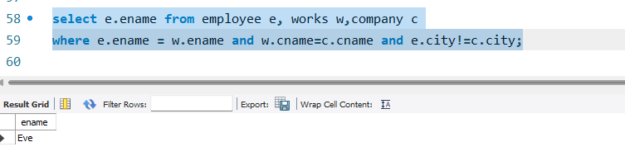
- List all companies and employees working there(include companies with no employees):- 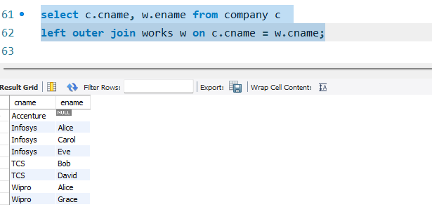
- Find the names and cities of all employees who work for Infosys:- 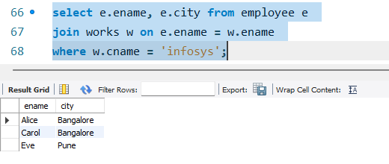
- Find the names, street, cities of all employees who work for Infosys and earn more than Rs.50000:- 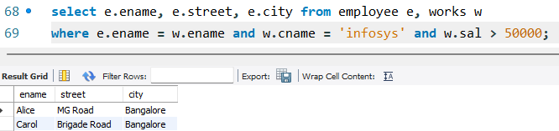
- Find all employees who lives in the same cities the company cities:- 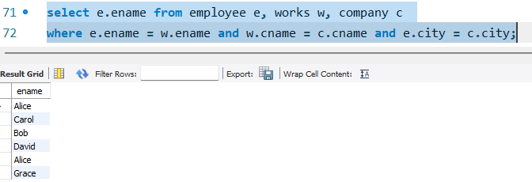
- Find all employees who lives in the same cities as do their manager:- 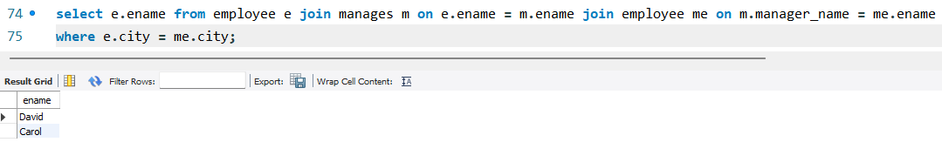
- Find all employees in the database who earn more than every employee of TCS:- 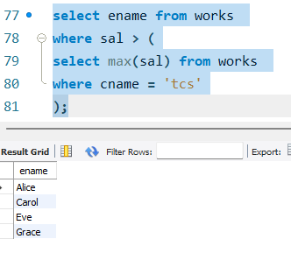
- Find the company that has the smallest payroll:- 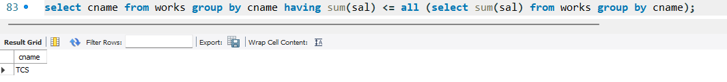
- Find minimum salary belongs to which employee:- 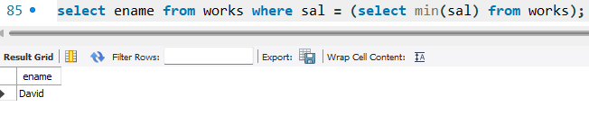
- Find Employees earning the highest salary in their company:- 