1. Create a table STUDENT with the attributes s_RollNo, s_name, s_add and s_age. Insert one value in the table:- 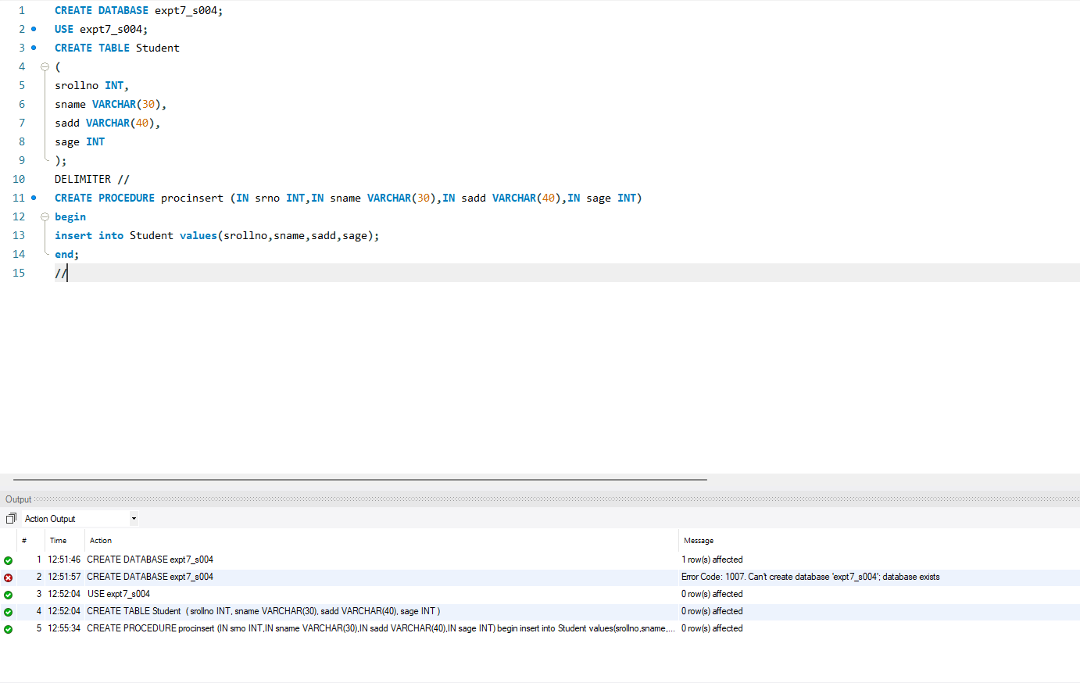
2. Create a procedure to insert a new value in Student table :- 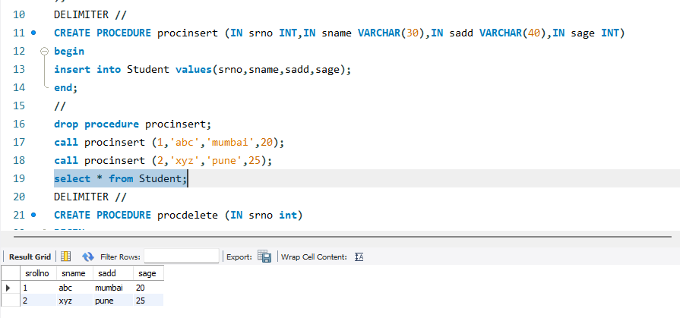
3. Create a procedure to delete a value from the Student table:- 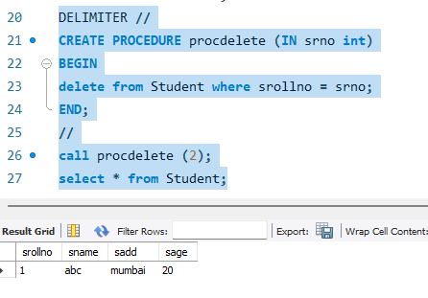
4. Create a procedure to retrieve the value from the student table:- 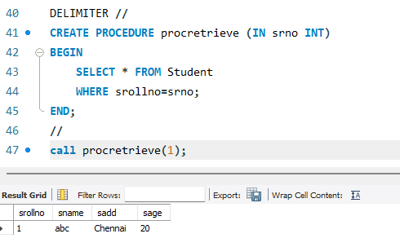
5. Create a procedure to update a value in student table:- 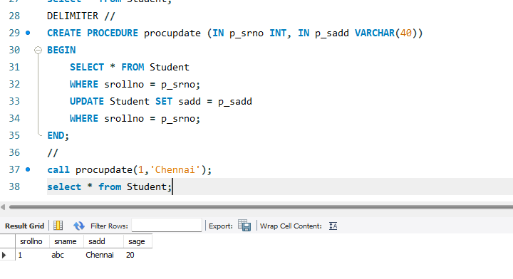
6. Create a function to find a factorial of a number:- 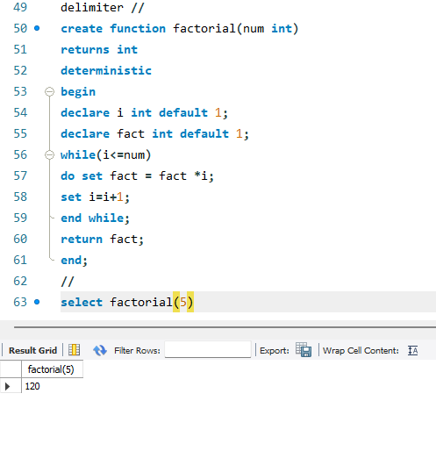
7. Create a function to multiply two numbers:- 