EMPLOYEE (eno, ename, jobtitle, jointdate, eadd, esal, dno)
DEPARTMENT (dno, dname)
- Display the name of employee whose department name is AIDS
- Display the name of employee whose jobtitle is manager
- Retrieve the distinct address from employee
- List all names and joint date of employee whose name starts with letter m
- List the names of employee who earn more than rupees 60000
- List name of all employees who joined between 2023 to 2025
- List all the names and joint dates of employee whose names has letter e as the 2nd letter
- Display the name of employee excluding job title manager
- Display employee in descending order of joint date
- Retrieve the name of employee who do not get salary
- Calculate the average salary of dno = 20
- Retrieve the total no of employee in the department
- Calculate average salary per department
- Retrieve maximum and minimum salary offered to employee
- Give all employee who joined before 2022 a 10% raise

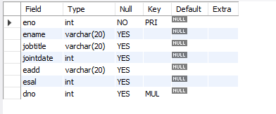
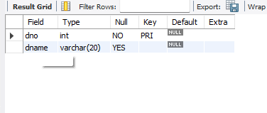

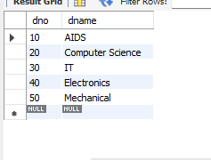
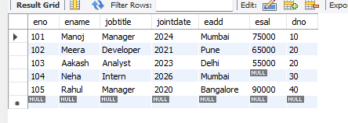
- Display the name of employee whose department name is AIDS:- 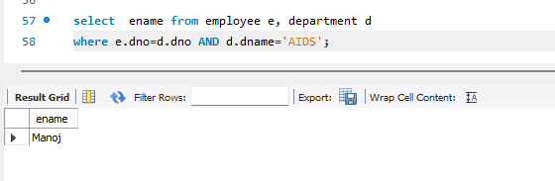
- Display the name of employee whose jobtitle is manager:- 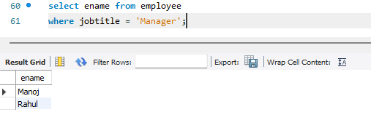

- Retrieve the distinct address from employee:- 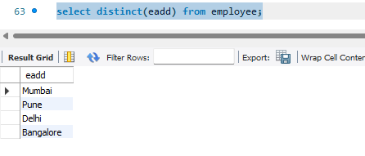
- List all names and joint date of employee whose name starts with letter m:- 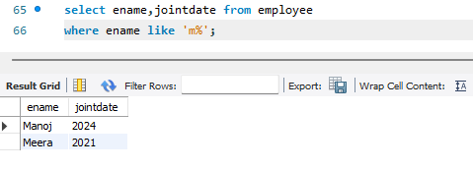
- List the names of employee who earn more than rupees 60000:- 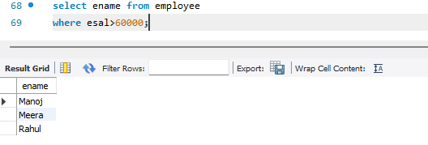
- List name of all employees who joined between 2023 to 2025:- 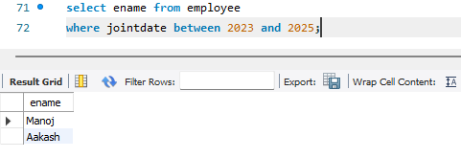
- List all the names and joint dates of employee whose names has letter e as the 2nd letter:- 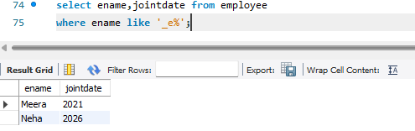
- Display the name of employee excluding job title manager:- 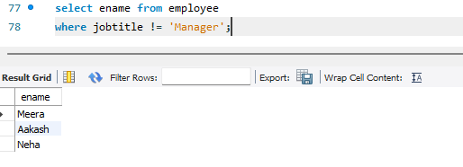
- Display employee in descending order of joint date:- 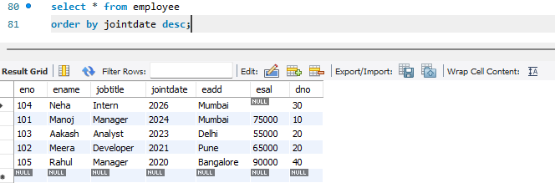
- Retrieve the name of employee who do not get salary:- 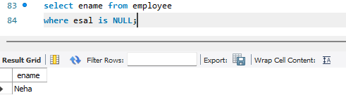
- Calculate the average salary of dno = 20:- 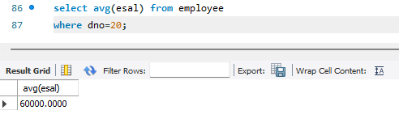
- Retrieve the total no of employee in the department:- 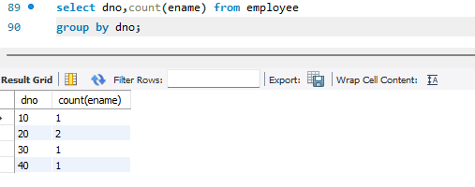
- Calculate average salary per department:- 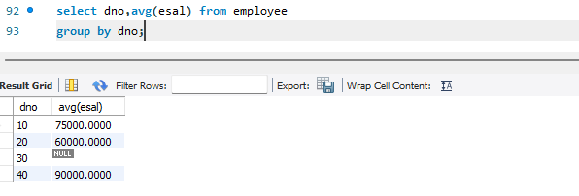
- Retrieve maximum and minimum salary offered to employee:- 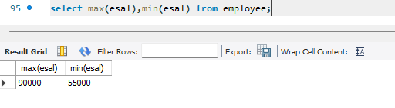
- Give all employee who joined before 2022 a 10% raise :- 