
CYPRUS INTERNATIONAL UNIVERSITY
FACULTY OF ENGINEERING

FERMENTATION SIMULATION SOFTWARE
Virtual Bioreactor for Bioethanol Production

CMPE400/ENGI 402: CAPSTONE PROJECT REPORT
Fall 2025-2026

SUPERVISOR
Asst. Prof. Dr. Nihal Bayir

TEAM MEMBERS
Alice Mpanga Ilunga - 22115912 (Bioengineering)
Ahmed Hemed - 22208718 (Bioengineering)
Dorcas Bin Ali Selemani - 22120924 (Bioengineering)
Elvis Joseph Mtandika - 22212199 (Software Engineering)
Wisdom Lotachukwu Ngaloru - 22415519 (Computer Engineering)

Nicosia, January 2026

APPROVAL PAGE

This page would contain the signatures of your supervisor and jury members as provided by your department.
ACKNOWLEDGMENT

We would like to express our sincere gratitude to our supervisor, Asst. Prof. Dr. Nihal Bayir, for her continuous guidance, valuable feedback, and patience throughout this project. Her expertise in bioengineering and her willingness to review our work at every stage were instrumental in shaping this project into its final form.
We also thank the Faculty of Engineering at Cyprus International University for providing the academic environment and resources that made this project possible. The interdisciplinary nature of our team, combining bioengineering, software engineering, and computer engineering students, reflects the faculty's commitment to collaborative learning.
Finally, we thank our families and friends for their encouragement and support throughout the semester.

The Team.
Nicosia, January 2026.
ABSTRACT

This project presents the development of a web-based fermentation simulation software that models bioethanol production by Saccharomyces cerevisiae. The software simulates fermentation processes in three distinct operational modes: Batch, Fed-Batch, and Continuous (CSTR), allowing users to explore how different operating parameters affect ethanol yield, biomass growth, and substrate consumption.
The simulation engine implements the Monod equation for substrate-limited microbial growth kinetics and the Luedeking-Piret model for product formation. A cell death rate constant is included to model the decline phase observed in real fermentation processes. These coupled ordinary differential equations are solved numerically using a fourth-order Runge-Kutta (RK4) method, which provides significantly higher accuracy compared to simpler methods such as Euler integration, with a local truncation error of O(dt^5) versus O(dt^2).
The software was built using a modern full-stack web architecture with React 18 and TypeScript on the frontend, Vite as the build tool, and Node.js with Express on the backend. The user interface features a dark theme inspired by vintage scientific instruments, with real-time parameter adjustment and instant simulation feedback. Key features include three parameter presets for common fermentation scenarios, configurable feed timing for fed-batch mode, a batch startup phase for continuous mode, automatic growth phase detection including the death phase, CSV data export, and economic indicators (batch value, production cost, and net profit) based on carob pod feedstock costs and a 100,000 L industrial working volume.
Model validation was conducted by comparing simulation output against published experimental data from three independent peer-reviewed studies covering substrate concentrations from 100 to 150 g/L. All concentration profiles achieved a coefficient of determination (R-squared) greater than 0.90, confirming that the implementation correctly reproduces the established kinetic models under standard operating conditions.
The complete application comprises approximately 5,000 lines of TypeScript and CSS code, with 11 React components and over 55 automated tests. The project demonstrates that computational simulation can serve as a cost-effective and accessible tool for bioprocess education and preliminary industrial process design.

Keywords: fermentation simulation, bioethanol, Saccharomyces cerevisiae, Monod equation, Luedeking-Piret, bioreactor, Runge-Kutta, React, TypeScript
OZET

Bu proje, Saccharomyces cerevisiae tarafından biyoetanol üretimini modelleyen web tabanlı bir fermantasyon simülasyon yazılımının geliştirilmesini sunmaktadır. Yazılım, fermantasyon süreçlerini üç farklı çalışma modunda simüle eder: Parti, Beslemeli Parti ve Sürekli (CSTR), kullanıcıların farklı çalışma parametrelerinin etanol verimi, biyokütle büyümesi ve substrat tüketimini nasıl etkilediğini keşfetmelerine olanak tanır.
Simülasyon motoru, substrat sınırlı mikrobiyal büyüme kinetiği için Monod denklemini ve ürün oluşumu için Luedeking-Piret modelini uygular. Gerçek fermantasyon süreçlerinde gözlemlenen düşüş fazını modellemek için bir hücre ölüm oranı sabiti dahil edilmiştir. Bu birleştirilmiş adi diferansiyel denklemler, Euler entegrasyonu gibi daha basit yöntemlere kıyasla önemli ölçüde daha yüksek doğruluk sağlayan dördüncü dereceden Runge-Kutta (RK4) yöntemi kullanılarak sayısal olarak çözülür; yerel kesme hatası O(dt^5) iken, diğer yöntemlerde bu değer O(dt^2)'dir.
Yazılım, ön uçta React 18 ve TypeScript, derleme aracı olarak Vite ve arka uçta Node.js ve Express ile modern bir tam yığın web mimarisi kullanılarak geliştirilmiştir. Kullanıcı arayüzü, eski bilimsel aletlerden ilham alan koyu bir temaya, gerçek zamanlı parametre ayarlamasına ve anlık simülasyon geri bildirimine sahiptir. Temel özellikler arasında yaygın fermantasyon senaryoları için üç parametre ön ayarı, beslemeli parti modu için yapılandırılabilir besleme zamanlaması, sürekli mod için parti başlatma aşaması, ölüm aşaması da dahil olmak üzere otomatik büyüme aşaması tespiti, CSV veri dışa aktarımı ve 100.000 L endüstriyel çalışma hacmine dayalı ekonomik parti değeri göstergesi yer almaktadır.
Model doğrulaması, 100 ila 150 g/L arasındaki substrat konsantrasyonlarını kapsayan üç bağımsız hakemli çalışmadan elde edilen yayınlanmış deneysel verilerle simülasyon çıktısının karşılaştırılmasıyla gerçekleştirilmiştir. Tüm konsantrasyon profilleri, 0,90'dan büyük bir belirleme katsayısı (R-kare) elde ederek, uygulamanın standart çalışma koşulları altında yerleşik kinetik modelleri doğru bir şekilde yeniden ürettiğini doğrulamıştır.
Uygulamanın tamamı yaklaşık 5.000 satır TypeScript ve CSS kodundan, 11 React bileşeninden ve 55'ten fazla otomatik testten oluşmaktadır. Proje, hesaplamalı simülasyonun biyoproses eğitimi ve ön endüstriyel proses tasarımı için uygun maliyetli ve erişilebilir bir araç olarak kullanılabileceğini göstermektedir.

Anahtar kelimeler: fermantasyon simülasyonu, biyoetanol, Saccharomyces cerevisiae, Monod denklemi, Luedeking-Piret, biyoreaktör, Runge-Kutta, React, TypeScript

TABLE OF CONTENTS

CHAPTER ONE: INTRODUCTION 9
1.1 Background 9
1.2 Problem Statement 10
1.3 Project Objectives 10
1.4 Scope and Limitations 11
1.5 Report Organization 12
CHAPTER TWO: LITERATURE REVIEW 13
2.1 History of Bioethanol Production 13
2.2 Carob Pods as Feedstock: Rationale and Regional Relevance 13
2.2.1 Botanical and Compositional Overview 13
2.2.2 Historical and Economic Importance in Northern Cyprus 14
2.2.3 Sugar Extraction and Pre-treatment for Fermentation 14
2.3 Saccharomyces cerevisiae as an Ethanol Producer 15
2.4 The Biochemistry of Ethanol Fermentation 16
2.5 Monod Growth Kinetics 16
2.6 Luedeking-Piret Product Formation Model 17
2.7 Cell Death and Decline Phase 18
2.8 Reactor Configurations 18
2.9 Existing Simulation Tools 20
CHAPTER THREE: REALISTIC CONSTRAINTS 21
3.1 Environmental Constraints 21
3.2 Ethical Constraints 21
3.3 Health and Safety Constraints 22
3.4 Economic Constraints 22
3.5 Sustainability Constraints 23
3.6 Social Constraints 23
CHAPTER FOUR: METHODS USED TO DESIGN THE PROJECT 24
4.1 Mathematical Formulation 24
4.2 Numerical Solution: Runge-Kutta 4th Order Method 27
4.3 Technology Stack and Architecture 27
4.4 Default Kinetic Parameters 28
CHAPTER FIVE: IMPLEMENTATION AND RESULTS 30
5.1 Software Architecture 30
5.2 User Interface Design 31
5.3 Batch Mode Results 32
5.4 Fed-Batch Mode Results 33
5.5 Continuous (CSTR) Mode Results 35
5.6 Growth Phase Detection 36
5.7 Simulation Summary and Economic Indicator 37
5.8 Data Export 38
5.9 Parameter Presets 38
CHAPTER SIX: TESTING 40
6.1 Testing Strategy 40
6.2 Unit Tests 40
6.3 Integration Tests 41
6.4 Test Results Summary 42
CHAPTER SEVEN: MODEL VALIDATION 44
7.1 Validation Methodology 44
7.2 Error Metrics 44
7.3 Validation Datasets 44
7.4 Validation Results 45
7.5 Known Limitations 46
CHAPTER EIGHT: CONCLUSION AND FUTURE WORKS 47
8.1 Conclusion 47
8.2 Future Works 48
REFERENCES 49
APPENDICES 51
Appendix A: Project Team Responsibilities 51
Appendix B: Application Screenshots 51
Appendix C: Source Code Repository 55

CHAPTER ONE: INTRODUCTION

1.1 Background
The global energy landscape is undergoing a significant transformation driven by climate change, depleting fossil fuel reserves, and growing environmental awareness. Among the various renewable energy alternatives, bioethanol has established itself as one of the most commercially viable biofuels, with global production exceeding 110 billion liters annually as of 2024. Bioethanol is produced primarily through the fermentation of sugars by microorganisms, most commonly the yeast Saccharomyces cerevisiae, which converts glucose into ethanol and carbon dioxide under anaerobic conditions.
The industrial production of bioethanol involves a complex series of unit operations, beginning with feedstock preparation (such as milling and liquefaction of corn or crushing of sugarcane), followed by enzymatic hydrolysis to release fermentable sugars, fermentation to convert sugars to ethanol, and finally distillation and dehydration to produce fuel-grade ethanol. Of these stages, the fermentation step is the most critical from a process optimization perspective, as it directly determines the ethanol yield, productivity, and overall process economics.
Optimizing fermentation processes through physical experimentation is inherently expensive and time-consuming. A single optimization cycle in a pilot-scale facility, which typically involves testing different combinations of temperature, pH, substrate concentration, inoculum size, and feeding strategy, can cost between $500,000 and $2 million depending on the scale and duration. Each experimental run may take several days to complete, and the results are often influenced by biological variability that makes it difficult to isolate the effect of individual parameters.
This reality has driven increasing interest in computational simulation as a preliminary optimization tool. By building mathematical models that describe the fundamental kinetics of microbial growth and product formation, engineers can explore vast parameter spaces digitally before committing to physical experiments. This approach reduces costs, accelerates the development cycle, and provides a deeper understanding of the underlying biological processes.

1.2 Problem Statement
Despite the well-established nature of fermentation kinetic models, there is a notable lack of accessible, interactive simulation tools specifically designed for bioethanol fermentation education and preliminary process design. The existing landscape of fermentation simulation tools can be broadly categorized into three groups:
- Commercial software packages such as SuperPro Designer and Aspen Plus, which are comprehensive but expensive (licenses often exceed $10,000/year), overly complex for educational purposes, and primarily designed for chemical engineering rather than bioprocess-specific applications.
- Academic tools developed by individual research groups, which are often limited to specific organisms or reactor configurations, poorly documented, not maintained after publication, and difficult to install or run on modern systems.
- General-purpose mathematical software such as MATLAB or Python scripts that implement fermentation models but lack interactive user interfaces, real-time visualization, and the educational context needed for students to build intuition about fermentation processes.
There is a clear need for a simulation tool that combines scientific accuracy with accessibility: one that implements established kinetic models, supports multiple reactor modes, provides real-time interactive visualization, runs on standard personal computers without commercial licenses, and is designed with the educational user in mind.

1.3 Project Objectives
The primary objective of this project is to develop a web-based simulation software that models bioethanol production by Saccharomyces cerevisiae across three reactor operational modes. The specific objectives are as follows:
- Implement the Monod equation for substrate-limited microbial growth kinetics, including a cell death rate constant to model the decline phase.
- Implement the Luedeking-Piret model for ethanol production kinetics, capturing both growth-associated and maintenance-associated product formation.
- Develop a numerical ODE solver using the Runge-Kutta 4th order (RK4) method for accurate and efficient integration of the coupled differential equations.
- Support three reactor operational modes: Batch, Fed-Batch (with configurable feed timing and industrial-scale volumes), and Continuous CSTR (with batch startup phase and dilution rate safety capping).
- Build an interactive web interface with real-time parameter adjustment, instant visualization using multiple chart types, automatic growth phase detection, and CSV data export.
- Validate the simulation model against published experimental data from peer-reviewed literature to ensure scientific accuracy.
- Include an economic indicator showing the estimated batch value based on industrial working volumes and current ethanol market prices.

1.4 Scope and Limitations
The software models the fermentation of carob pod extract (a sucrose-rich agricultural by-product) by Saccharomyces cerevisiae under anaerobic conditions, extended with a product (ethanol) inhibition term. The simulation focuses exclusively on the bioconversion step of the ethanol production process. It does not model upstream operations such as feedstock preparation, milling, liquefaction, or enzymatic hydrolysis, nor does it model downstream operations such as distillation, dehydration, or blending. The glucose used as substrate in the simulation could originate from any feedstock (sugarcane, corn, wheat, cellulosic biomass), but the simulation is feedstock-agnostic and models only the conversion of glucose to ethanol.
The following specific limitations apply to the mathematical models used:
- No substrate inhibition: The Monod equation does not account for the osmotic stress that occurs at glucose concentrations above approximately 250 g/L. To address this, the software caps substrate concentration at 250 g/L.
- No explicit lag phase: The Monod equation produces growth immediately from t=0. In reality, cells require an adaptation period of 1-4 hours when introduced to a new environment.
- Temperature and pH are fixed constants: They define the operating conditions but do not dynamically affect the kinetic parameters during the simulation. In practice, fermentation generates heat and CO2 that can shift these parameters.
- Perfect mixing is assumed in all reactor modes.

1.5 Report Organization
This report is organized as follows. Chapter Two provides a comprehensive literature review covering the biological, mathematical, and computational background of fermentation simulation. Chapter Three discusses the realistic constraints that govern the project including environmental, ethical, health, economic, and sustainability considerations. Chapter Four describes the mathematical formulation, numerical methods, and technology choices used in the design. Chapter Five details the software implementation, user interface design, and results obtained in each reactor mode. Chapter Six covers the testing strategy and automated test suite. Chapter Seven presents the model validation methodology and results. Chapter Eight provides conclusions and recommendations for future work.

CHAPTER TWO: LITERATURE REVIEW

2.1 History of Bioethanol Production
The use of fermentation to produce ethanol is one of the oldest biotechnological processes known to humanity, dating back at least 9,000 years to ancient civilizations in China and the Middle East who produced alcoholic beverages. However, the deliberate production of ethanol as a fuel is a more recent development. In the early 20th century, Henry Ford designed the Model T to run on ethanol, and during World War II, several countries produced ethanol as a fuel supplement when petroleum supplies were disrupted.
The modern era of fuel ethanol production began in the 1970s in response to the oil crisis, when Brazil launched its National Alcohol Program (Pro-Alcohol) in 1975 and the United States introduced the Energy Tax Act of 1978 to encourage ethanol blending. Since then, production has grown dramatically. Brazil produces approximately 30 billion liters annually from sugarcane, while the United States produces over 60 billion liters primarily from corn. Together, these two countries account for approximately 85% of global production.
Bioethanol is classified by feedstock generation. First-generation bioethanol uses food crops (corn, sugarcane, wheat) as feedstock. Second-generation bioethanol uses lignocellulosic biomass (agricultural residues, wood chips, switchgrass) that does not compete with food production. Third-generation bioethanol uses algae. Our simulation models the fermentation step common to all generations, as the substrate input is fermentable sugar (e.g., from carob pod extract) regardless of its origin.

2.2 Carob Pods as Feedstock: Rationale and Regional Relevance

2.2.1 Botanical and Compositional Overview
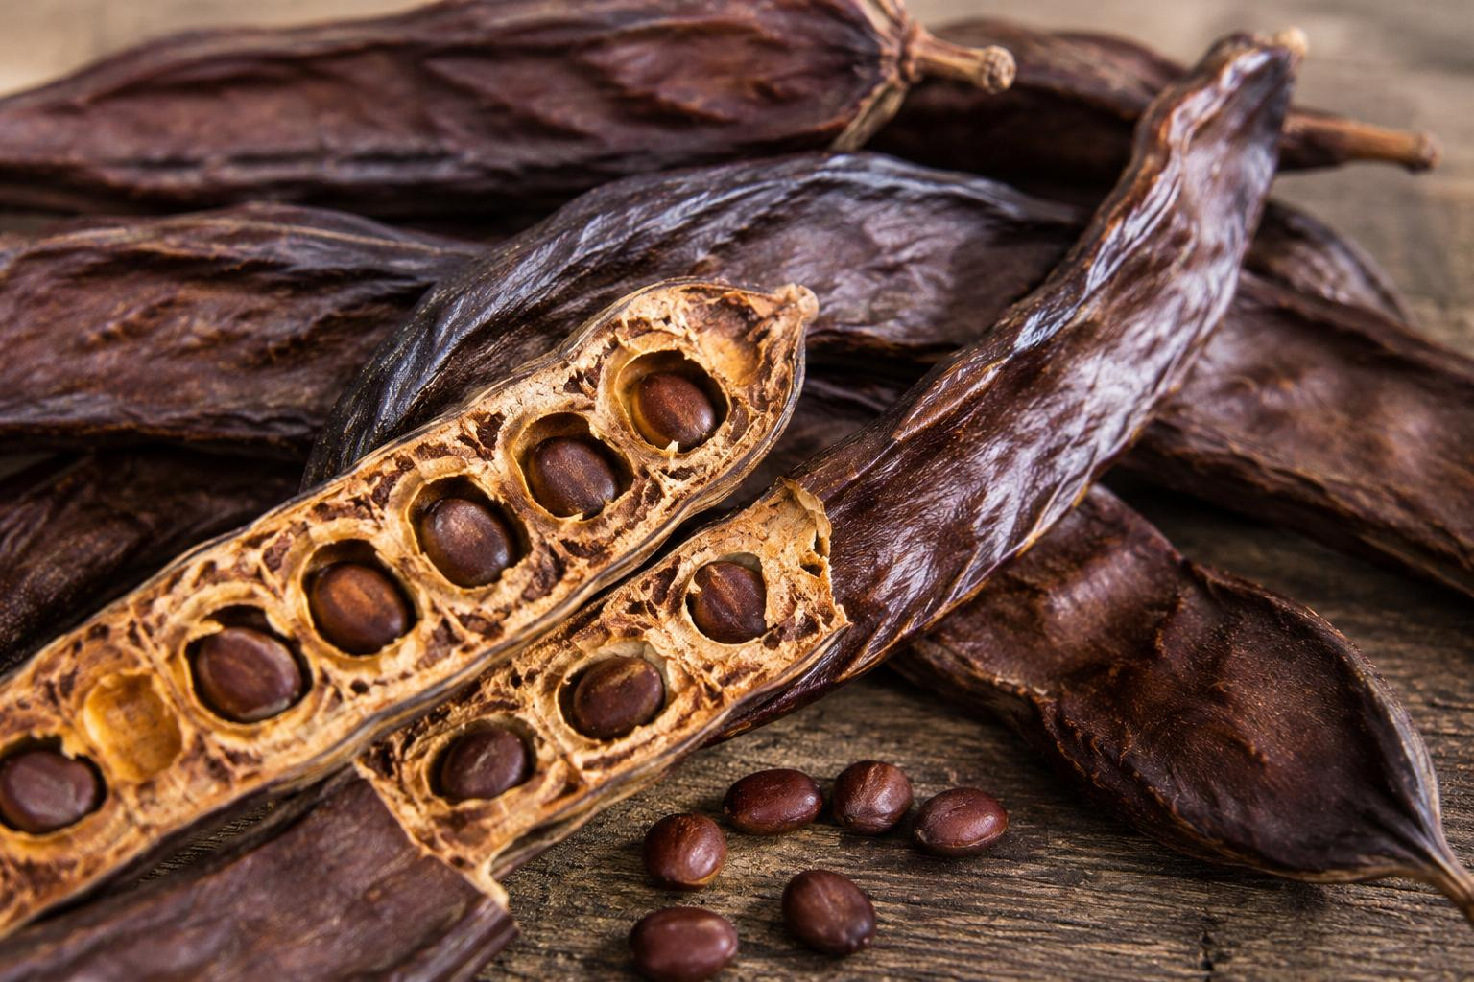
Figure 2.1: Carob pods (Ceratonia siliqua), showing the sugar-rich pulp and seeds

Ceratonia siliqua L., commonly known as the carob tree, is an evergreen legume native to the Mediterranean basin that has been cultivated for its seed pods for more than four thousand years. The mature pods—typically 10 to 20 cm in length and dark brown at full ripeness—contain two biochemically distinct fractions: the seed (locust bean), which is valued for its galactomannan gum used in the food industry, and the pod pulp (mesocarp), which is extraordinarily rich in soluble sugars. Compositional analyses consistently report that dried carob pod pulp contains 48–56% total sugars on a dry-weight basis, of which sucrose, glucose, and fructose are the principal components (Makkar & Becker, 1996; Duran-Guerrero et al., 2018). This sugar content is comparable to, or even exceeds, that of sugar beet molasses, making carob an attractive substrate for bioethanol fermentation without the need for starch hydrolysis or complex enzymatic pre-treatment.
Sucrose is rapidly hydrolysed to glucose and fructose by invertase secreted by S. cerevisiae, so no external enzymatic step is required before fermentation. Carob pod extract therefore presents a near-ideal sugar solution for direct fermentation, technically simpler to process than starch-based feedstocks such as corn or cassava, which require gelatinisation and saccharification.

2.2.2 Historical and Economic Importance in Northern Cyprus
Northern Cyprus has a profound historical relationship with the carob tree that distinguishes it from virtually all other potential bioethanol-producing regions. For much of the nineteenth and early twentieth centuries, carob was the single most important export commodity of Cyprus, earning the island the nickname ‘the Black Gold island’ and generating the majority of foreign exchange income before the expansion of the tourism sector. At peak production in the mid-twentieth century, Cyprus exported hundreds of thousands of tonnes of carob pods annually, primarily to European confectionery, pharmaceutical, and animal-feed industries. The historic carob warehouses still visible along the waterfronts of Kyrenia (Girne) and Famagusta (Gazimagusa) are a direct testament to the scale and importance of this trade.
Today, Northern Cyprus retains a large and largely under-utilised carob tree population spread across its hills and rural landscapes. The trees are exceptionally well adapted to the semi-arid limestone soils and Mediterranean climate of the region, requiring minimal irrigation or fertilisation and no pesticide applications. Redirecting this wasted agricultural material towards bioethanol production would add economic value to a historically significant regional commodity, reduce agricultural waste, and contribute to a local renewable energy supply chain, reducing the island’s dependence on imported fossil fuels. Furthermore, using locally sourced carob pods as the simulation’s reference feedstock makes the software immediately applicable and relevant to Northern Cyprus stakeholders, from agricultural cooperatives to energy-policy decision-makers. Because carob trees thrive on marginal land unsuitable for most food crops, their use as a bioethanol feedstock entirely avoids the ‘food versus fuel’ conflict, making carob-based bioethanol a socially responsible and environmentally sound choice consistent with the principles of the circular bioeconomy.

2.2.3 Sugar Extraction and Pre-treatment for Fermentation
Prior to fermentation, carob pods are milled and subjected to aqueous extraction at 60–80°C to dissolve the soluble sugars from the pod pulp. The resulting extract is filtered to remove insoluble fibre and seed fragments, yielding a sugar-rich liquor with a total soluble solids content typically in the range of 18–25 degrees Brix. The relatively low content of fermentation inhibitors—such as hydroxymethylfurfural or acetic acid, which are problematic in lignocellulosic hydrolysates—means that carob extract generally requires no detoxification before inoculation with yeast (Rubio & Navarro, 2006). Studies have confirmed that S. cerevisiae ferments carob extract efficiently, achieving ethanol yields of 0.40–0.48 g ethanol per gram of total sugars consumed under optimised conditions (Molina et al., 2009). In the simulation software developed in this project, the initial substrate concentration entered by the user represents the total fermentable sugar content of the carob extract.

2.3 Saccharomyces cerevisiae as an Ethanol Producer
Saccharomyces cerevisiae (strain NCYC 2592), commonly known as baker's or brewer's yeast, is the dominant microorganism used in industrial ethanol production worldwide. Its popularity stems from several advantageous characteristics:
- High ethanol tolerance: Industrial strains can tolerate ethanol concentrations up to 15-20% (v/v), allowing high final product concentrations.
- Rapid growth: Maximum specific growth rates of 0.35-0.55 per hour under optimal conditions, with doubling times of 1.5-2 hours.
- GRAS status: Generally Recognized As Safe by the FDA, simplifying regulatory requirements for food-grade ethanol production.
- Extensive characterization: Decades of research have produced well-validated kinetic models and parameter values for this organism.
- Genetic tractability: The complete genome has been sequenced, and genetic engineering tools are well-established for strain improvement.
The optimal growth conditions for S. cerevisiae in ethanol fermentation are well-documented: temperature between 30 and 35 degrees Celsius (with 32 degrees being common for industrial processes), pH between 4.5 and 5.0, andinitial sugar concentration between 100 and 250 g/L (typical for carob pod extract). Our simulation uses these ranges as defaults and constraints.
Other microorganisms have been investigated for ethanol production, most notably Zymomonas mobilis, which achieves higher ethanol yields and faster fermentation rates but lacks the industrial track record and robustness of S. cerevisiae. Our simulation focuses exclusively on S. cerevisiae kinetics.

2.4 The Biochemistry of Ethanol Fermentation
Under anaerobic conditions, S. cerevisiae converts glucose to ethanol through the Embden-Meyerhof-Parnas (EMP) glycolytic pathway followed by two decarboxylation steps. The overall stoichiometric equation is:
C6H12O6 --> 2 C2H5OH + 2 CO2
This equation indicates that one mole of glucose (180.16 g/mol) theoretically yields two moles of ethanol (2 x 46.07 = 92.14 g/mol) and two moles of carbon dioxide. The maximum theoretical yield is therefore 92.14/180.16 = 0.511 grams of ethanol per gram of glucose consumed. This value, 0.511 g/g, is used as the reference for calculating yield efficiency in our simulation.
In practice, actual yields range from 85-95% of this theoretical maximum. The gap is due to several factors: a portion of the glucose carbon is diverted to biomass synthesis (cell growth), some carbon goes to byproduct formation (primarily glycerol, which accounts for 5-10% of carbon), and a small amount is lost to organic acids (succinic acid, acetic acid) and other metabolites. Our simulation captures the carbon diversion to biomass through the yield coefficient Yxs and accounts for the remaining losses implicitly through the alpha and beta parameters.

2.5 Monod Growth Kinetics
The Monod equation is the most widely used empirical model for describing substrate-limited microbial growth. It was proposed by Jacques Monod in 1949 based on his observations of bacterial growth in continuous culture. The equation is mathematically analogous to the Michaelis-Menten equation for enzyme kinetics:
mu = mu_max x S / (Ks + S)
where mu is the specific growth rate (per hour), mu_max is the maximum specific growth rate achieved when substrate is not limiting, S is the substrate (glucose) concentration in g/L, and Ks is the half-saturation constant (also called the Monod constant) representing the substrate concentration at which the growth rate equals exactly half of mu_max.
The Monod equation captures three important operational regimes that are directly observable in our simulation:
- When substrate is abundant (S >> Ks), the equation simplifies to mu approximately equal to mu_max. Growth is at its maximum rate and is independent of substrate concentration. This corresponds to the exponential growth phase.
- When substrate concentration equals Ks (S = Ks), the growth rate is exactly half of mu_max. This is the definition of Ks and represents the transition from substrate-independent to substrate-limited growth.
- When substrate is scarce (S << Ks), the equation approximates to mu approximately equal to (mu_max/Ks) x S, which is linear in S. Growth rate decreases proportionally with substrate concentration. This corresponds to the deceleration phase.
For S. cerevisiae growing on glucose, typical values of Ks are very low (0.1-5.0 g/L). For carob-derived sucrose substrates, Ks tends toward the higher end of this range (our model uses Ks=2.0 g/L), meaning growth rate becomes substrate-limited at somewhat higher sugar concentrations. This is consistent with the observation that substrate depletion and growth deceleration happen almost simultaneously in batch fermentation.

2.6 Luedeking-Piret Product Formation Model
The Luedeking-Piret model, proposed by Robert Luedeking and Edgar L. Piret in 1959, describes microbial product formation as the sum of two contributions:
dP/dt = alpha x mu x X + beta x X
The first term, alpha x mu x X, represents growth-associated product formation. This component is directly proportional to the growth rate and accounts for ethanol produced as a direct byproduct of anaerobic glycolysis during active cell division. When cells are growing rapidly (high mu), this term dominates.
The second term, beta x X, represents non-growth-associated or maintenance product formation. This component is independent of growth rate and accounts for ethanol produced by cells that are alive but not actively dividing. Cells in the stationary phase still metabolize substrate for maintenance energy, producing ethanol in the process. The beta constant has units of g product per g biomass per hour.
Ethanol fermentation by S. cerevisiae is classified as a mixed-growth-associated product, meaning both alpha and beta are significant. During the exponential phase, the alpha term accounts for approximately 70-80% of ethanol production, while during the stationary phase, the beta term becomes the sole contributor. Our simulation clearly shows this transition in the ethanol production curve, which continues to rise slightly even after growth has ceased.

2.7 Cell Death and Decline Phase
The classic Monod model does not account for cell death, which becomes significant after substrate depletion. In our extended model, we include a first-order death rate term:
dX/dt = (mu - kd) x X
where kd is the specific death rate constant. For S. cerevisiae under typical fermentation conditions, kd values reported in the literature range from 0.005 to 0.02 per hour. We use kd = 0.01 per hour as a representative value. This term has negligible effect during the exponential phase (where mu >> kd) but causes a gradual decline in biomass concentration after substrate is exhausted and mu drops to zero, producing the characteristic death phase visible in extended batch simulations.

2.8 Reactor Configurations
2.7.1 Batch Reactor
A batch reactor is the simplest fermentation configuration. All reactants (substrate, inoculum, nutrients, water) are loaded into the vessel at the start, the vessel is sealed, and no material enters or leaves during fermentation. The process runs until substrate is exhausted or the desired product concentration is reached, at which point the entire vessel contents are harvested.
Batch fermentation is widely used in laboratory research and for small to medium-scale production. Its advantages include simplicity of operation, ease of sterilization (the vessel is sterilized before inoculation), and suitability for products with high value or variable demand. Its disadvantages include downtime between batches (for cleaning, sterilizing, and refilling), lower overall productivity compared to continuous operation, and the inability to maintain optimal substrate concentration throughout the process.
2.7.2 Fed-Batch Reactor
A fed-batch reactor starts as a batch process but adds fresh substrate solution during fermentation at a controlled rate. Nothing is removed until the end of the process. The liquid volume in the reactor increases over time from the initial working volume until it reaches the maximum working volume, at which point feeding stops and the process continues as a batch until completion.
Fed-batch is the most common mode for industrial ethanol production because it offers two key advantages. First, by adding substrate gradually rather than loading it all at the start, the instantaneous sugar concentration in the reactor is kept below the substrate inhibition threshold (250 g/L), avoiding osmotic stress on the yeast, while also limiting ethanol accumulation below the product inhibition threshold (Pmax = 90 g/L). Second, the total amount of glucose processed over the entire fermentation is higher than what could be loaded initially, resulting in higher total ethanol production per batch.
The key parameters unique to fed-batch operation in our simulation are the feed rate (L/h), feed substrate concentration (g/L), initial working volume (L), maximum working volume (L), and feed start time (hours). The feed start time allows the user to run a batch phase at the beginning to establish a healthy cell population before introducing the feed stream.
2.7.3 Continuous Stirred Tank Reactor (CSTR)
In a continuous reactor, fresh medium flows into the vessel and fermented broth flows out at the same rate, maintaining a constant working volume. After an initial transient period, the system reaches a steady state where all concentrations (biomass, substrate, product) remain constant over time.
At steady state, the specific growth rate equals the dilution rate (mu = D), where D = F/V is the ratio of volumetric flow rate to reactor volume. This relationship provides a powerful tool for controlling the fermentation: by adjusting the dilution rate, the operator can select the steady-state growth rate and corresponding substrate/product concentrations.
A critical parameter in continuous operation is the critical dilution rate, D_crit = mu_max x Sf / (Ks + Sf), which represents the maximum dilution rate at which the system can sustain cell growth. If D exceeds D_crit, cells are removed from the reactor faster than they can divide, leading to washout where biomass concentration drops to zero. Our simulation caps the dilution rate slider at 95% of D_crit to prevent this unrealistic condition.
In practice, a continuous fermenter does not start in continuous mode. It begins as a batch to allow cells to grow and establish a sufficient population, then switches to continuous flow once biomass has accumulated. Our simulation implements this through a configurable batch startup time parameter.

2.9 Existing Simulation Tools
Several simulation tools exist for bioprocess modeling, but each has limitations that our project addresses:
- SuperPro Designer: A comprehensive process simulation tool widely used in industry. However, it requires expensive commercial licenses, has a steep learning curve, and is designed for full process flowsheet simulation rather than focused fermentation kinetics exploration.
- MATLAB/Simulink: Provides excellent numerical capabilities for ODE solving but requires programming expertise, lacks a fermentation-specific user interface, and requires a commercial license.
- Berkeley Madonna and Stella: Older simulation environments for dynamic systems that are being phased out and lack modern web-based interfaces.
- Python scripts with SciPy: Open-source and flexible but require programming knowledge and lack interactive real-time visualization.
Our project fills the gap by providing a purpose-built fermentation simulation tool that is free, runs in any web browser, requires no programming knowledge, provides real-time interactive visualization, and is specifically designed for bioethanol production with S. cerevisiae.

CHAPTER THREE: REALISTIC CONSTRAINTS

3.1 Environmental Constraints
The software itself, being a purely computational tool, produces no physical waste, emissions, or environmental pollutants during its operation. It runs on standard personal computers and consumes only the electricity required for normal computer operation. No specialized hardware, servers, or cloud computing resources are needed.
However, the broader environmental context of the project is significant. The software is designed to support the development and optimization of bioethanol production processes, which directly contribute to environmental sustainability. Bioethanol is a renewable fuel that produces fewer net greenhouse gas emissions compared to petroleum-based gasoline when the entire lifecycle is considered. According to the U.S. Department of Energy, corn-based ethanol reduces greenhouse gas emissions by 34-44% compared to gasoline, while cellulosic ethanol can achieve reductions of up to 86%.
By enabling engineers and researchers to optimize fermentation parameters computationally before conducting physical experiments, the software indirectly reduces the environmental footprint of the bioprocess development phase. Each physical experiment that is avoided saves raw materials (carob pods, growth media, water), energy (for heating, cooling, agitation, and sterilization), and produces less waste (spent fermentation broth, cleaning chemicals). Based on typical pilot-scale operations, a single avoided experiment can save approximately 500-5,000 liters of water and 100-500 kWh of energy.

3.2 Ethical Constraints
The primary ethical consideration for this project is scientific accuracy. Users of the simulation may base real-world decisions on its output, including decisions about fermentation process design, equipment sizing, and raw material procurement. Therefore, the software must provide results that are as accurate as possible within the stated limitations of the mathematical models.
To address this ethical responsibility, we have implemented several safeguards. First, all kinetic models are validated against published peer-reviewed experimental data, with quantitative error metrics (R-squared, RMSE) reported transparently. Second, the software clearly documents its assumptions and limitations both in the in-app help panel and in this report. Third, substrate concentration is capped at 250 g/L to prevent users from simulating conditions where the model is known to be inaccurate (substrate inhibition regime). Fourth, the dilution rate in continuous mode is capped at 95% of D_crit to prevent simulating physically unrealistic washout conditions.
The software does not collect, store, or transmit any user data. All simulations run locally in the user's browser, and no telemetry or analytics are implemented.

3.3 Health and Safety Constraints
Although the project is purely software-based and poses no direct health or safety risks, its outputs may influence real fermentation processes that involve biological organisms, chemical substances, and pressurized equipment. We therefore include explicit disclaimers in the software documentation stating that simulation results are approximations based on simplified mathematical models and should not be directly applied to industrial operations without proper experimental validation, engineering review, and safety analysis.
The simulation does not model safety-critical aspects of fermentation such as CO2 evolution rates (which can create asphyxiation hazards in enclosed spaces), heat generation (which can cause thermal runaway if cooling systems fail), foam formation (which can cause vessel overflow), and contamination risks (which can produce harmful metabolites). Users should be aware that these aspects require separate engineering analysis.

3.4 Economic Constraints
One of the defining characteristics of this project is its zero direct cost. Every component of the technology stack is free and open-source:
- React 18 (MIT License) - User interface framework
- TypeScript (Apache 2.0 License) - Programming language
- Vite 6 (MIT License) - Build tool and development server
- Node.js (MIT License) - JavaScript runtime
- Express.js (MIT License) - HTTP server framework
- Recharts (MIT License) - Charting library
The software includes a set of economic indicators in the simulation summary that estimate the value, cost, and profitability of ethanol produced in a batch using carob pods as feedstock. The revenue calculation ('Batch Value') uses the working volume relevant to the selected reactor mode (100,000 L for batch/continuous, or the fed-batch reactor's final volume for fed-batch) and a fuel ethanol market price of $1.00 per liter of pure ethanol (based on the approximate range of $0.80-1.50 USD per liter observed in global markets). The ethanol concentration from the simulation (g/L) is converted to kilograms using the working volume, then to liters of pure ethanol using the density of ethanol (0.789 kg/L), and finally to dollars using the market price.
The production cost estimate accounts for feedstock and overhead. Feedstock cost is derived from the initial sugar concentration and working volume, assuming carob pods are 45% fermentable sugar by dry weight (consistent with reported carob kibble sugar content of 45-50%) and an assumed price of $0.15 per kilogram of raw carob pods. A flat overhead of $1,000 per batch is assumed to cover energy, labor, water, and miscellaneous costs such as enzymes and cleaning. Net profit is calculated as Batch Value minus Production Cost. These figures provide users with a rough but meaningful indication of the economic feasibility of carob-based bioethanol production at the simulated scale, though the price and cost assumptions are illustrative and would require local market data for a rigorous techno-economic assessment.

3.5 Sustainability Constraints
The project contributes to sustainability in two ways. First, it supports the development of bioethanol as a renewable fuel source by providing tools for process optimization. Bioethanol is produced from renewable biomass and is carbon-neutral in principle, as the CO2 released during combustion was originally captured from the atmosphere by the feedstock crop during photosynthesis.
Second, the software reduces the resource consumption associated with the process development phase itself. By enabling virtual experimentation, it decreases the number of physical experiments needed to identify promising operating conditions. This reduction in physical experimentation translates directly into savings in raw materials, energy, water, and waste generation during the R&D phase.

3.6 Social Constraints
The software is designed to be accessible to users with varying levels of technical expertise. The user interface uses familiar controls (sliders, buttons, dropdown menus) and provides immediate visual feedback through interactive charts. The in-app help panel explains the mathematical models and key concepts in plain language. Parameter presets allow novice users to explore pre-configured scenarios without needing to understand the underlying equations.
The interdisciplinary nature of the development team (bioengineering, software engineering, and computer engineering students) reflects the collaborative approach needed in real bioprocess development, where domain experts and software engineers must work together to create effective tools.

CHAPTER FOUR: METHODS USED TO DESIGN THE PROJECT

4.1 Mathematical Formulation
The mathematical model for each reactor mode consists of a system of coupled ordinary differential equations (ODEs) that describe the rates of change of biomass concentration (X, g/L), substrate concentration (S, g/L), and product/ethanol concentration (P, g/L) over time, using carob pod extract as the fermentable sugar substrate. The specific growth rate mu is computed at each time step using a Monod equation extended with a product (ethanol) inhibition term, and this value drives all three ODEs simultaneously.
4.1.1 Monod Equation
The specific growth rate is computed as:
mu = mu_max x S / (Ks + S)
This equation returns mu = 0 when substrate is exhausted (S = 0), mu = mu_max/2 when S = Ks, and mu approaches mu_max when S >> Ks. The kinetic parameters mu_max and Ks are properties of the organism and remain constant across all reactor modes and parameter presets, as specified by our supervisor. Their values are set once when the application loads and do not change when the user switches between modes or selects different presets.
To account for product (ethanol) inhibition — a well-documented phenomenon in carob fermentations where high ethanol concentrations suppress yeast activity — the Monod equation was extended using a Levenspiel-type inhibition term:
mu = mu_max x (S / (Ks + S)) x (1 - P/Pmax)
where P is the current ethanol concentration (g/L) and Pmax is the ethanol concentration at which growth is fully inhibited (set to 90 g/L, see Table 4.2). The inhibition factor (1 - P/Pmax) ranges from 1 (no inhibition, P=0) to 0 (complete inhibition, P=Pmax), and is clamped at zero to prevent negative growth rates. This factor multiplies mu in all three reactor mode equations.
4.1.2 Batch Mode Equations
In a batch reactor with no material flow, the mass balance equations are:
dX/dt = (mu - kd) x X
dS/dt = -(1/Yxs) x mu x X
dP/dt = alpha x mu x X + beta x X x (1 - P/Pmax)

"The maintenance term (beta x X) is also scaled by the inhibition factor, ensuring ethanol production halts entirely as P approaches Pmax — without this, the maintenance term alone could push the overall yield beyond the theoretical stoichiometric maximum of 0.511 g ethanol/g substrate."

The biomass equation includes both growth (mu x X) and death (kd x X) terms. The substrate equation describes consumption proportional to growth, scaled by the inverse of the biomass yield coefficient. The product equation follows the Luedeking-Piret model with both growth-associated and maintenance terms.
Initial conditions are X(0) = X0 (initial biomass), S(0) = S0 (initial substrate), and P(0) = 0 (no ethanol at start). The simulation runs for a user-specified duration, typically 48-168 hours for batch mode.

4.1.3 Fed-Batch Mode Equations
In a fed-batch reactor, the mass balance equations include additional terms for the feed stream and the changing volume:
dX/dt = (mu - kd) x X - (F/V) x X
dS/dt = -(1/Yxs) x mu x X + (F/V) x (Sf - S)
dP/dt = alpha x mu x X + beta x X x (1 - P/Pmax) - (F/V) x P
dV/dt = F
where F is the volumetric feed rate (L/h), V is the current reactor volume (L), and Sf is the substrate concentration in the feed stream (g/L). The dilution effect (F/V) reduces biomass, substrate, and product concentrations due to the addition of substrate-containing but cell-free medium.
The feed is activated only when the simulation time exceeds the feed start time parameter and the current volume is below the maximum working volume. This allows the user to specify a batch startup phase before feeding begins, which is standard industrial practice for establishing a healthy cell population.
The working volumes in our simulation reflect industrial scale: the default initial volume is 50,000 L and the maximum volume is 150,000 L, representing a typical ethanol production fermenter. The feed rate defaults to 12,000 L/h at a feed concentration of 150 g/L (carob extract sugar concentration).
4.1.4 Continuous (CSTR) Mode Equations
In a continuous stirred tank reactor, fresh medium enters and fermented broth exits at the same volumetric flow rate, maintaining constant volume. The mass balance equations are:
dX/dt = (mu - kd - D) x X
dS/dt = D x (Sf - S) - (1/Yxs) x mu x X
dP/dt = alpha x mu x X + beta x X x (1 - P/Pmax) - D x P
where D is the dilution rate (per hour), defined as the ratio of volumetric flow rate to reactor volume (D = F/V). At steady state, all time derivatives equal zero, and the growth rate equals the sum of the dilution rate and death rate (mu = D + kd, or approximately mu = D when kd is small).
The critical dilution rate is calculated as D_crit = mu_max x Sf / (Ks + Sf). If D exceeds D_crit, the cells are removed faster than they can grow, and biomass concentration drops to zero (washout). Our simulation prevents this by capping the dilution rate slider at 95% of D_crit, which adjusts dynamically when the user changes the feed concentration.
The simulation begins with a configurable batch startup phase (default: 12 hours) during which no flow occurs. This allows biomass to accumulate from the initial inoculum to a level that can sustain continuous operation. After the startup period, continuous flow is activated, and the system transitions toward steady state. The transition is clearly visible in the concentration plots as a change in trajectory.

4.2 Numerical Solution: Runge-Kutta 4th Order Method
The coupled ODE system cannot be solved analytically because the growth rate mu depends nonlinearly on substrate concentration S through the Monod equation, and S in turn depends on X through the consumption term. We therefore use numerical integration.
The fourth-order Runge-Kutta (RK4) method was selected for its balance of accuracy and computational efficiency. At each time step, RK4 evaluates the derivative function at four strategically chosen points and combines them using a weighted average:
k1 = f(t, y)
k2 = f(t + dt/2, y + dt/2 x k1)
k3 = f(t + dt/2, y + dt/2 x k2)
k4 = f(t + dt, y + dt x k3)
y(t + dt) = y(t) + (dt/6) x (k1 + 2xk2 + 2xk3 + k4)
The local truncation error of RK4 is O(dt^5) per step and O(dt^4) globally, compared to O(dt^2) per step for Euler's method. In our testing, RK4 was approximately three orders of magnitude more accurate than Euler at the same step size. We use a time step of dt = 0.05 hours, which produces 960 integration steps for a 48-hour simulation. The computation completes in under 50 milliseconds in the browser, enabling real-time interactive simulation.
After each RK4 step, all state variables are clamped to non-negative values (X >= 0, S >= 0, P >= 0) to prevent physically meaningless negative concentrations that could arise from numerical errors at very low concentrations.

4.3 Technology Stack and Architecture
The application follows a client-server architecture, though all simulations run client-side in the browser for instant feedback. The technology choices were driven by three requirements: the software must be free, it must run on standard personal computers, and it must provide real-time interactive visualization.
Layer | Technology | Purpose
Frontend | React 18 + TypeScript | Component-based interactive UI
Build Tool | Vite 6 | Fast HMR, native TypeScript support
Charts | Recharts | Responsive, interactive data visualization
Simulation | Custom RK4 ODE Solver | Numerical integration in TypeScript
Backend | Node.js + Express | REST API for programmatic access
Styling | Custom CSS (482 lines) | Vintage scientific instrument theme
Testing | Jest (55+ tests) | Unit, integration, and validation tests
Table 4.1: Technology stack used in the project.
The choice of Vite over the older Create React App (CRA) was driven by practical considerations: CRA is no longer actively maintained and has peer dependency conflicts with TypeScript 5.x versions, requiring manual workarounds. Vite provides faster hot module replacement, native TypeScript support without additional configuration, and a significantly smaller dependency footprint.

4.4 Default Kinetic Parameters
The default kinetic parameters were selected from peer-reviewed literature on S. cerevisiae (NCYC 2592) fermentation, adjusted for carob pod-derived sucrose substrate. These parameters remain constant across all reactor modes because they are intrinsic properties of the organism, not the reactor configuration.
Parameter | Value | Unit | Justification
mu_max | 0.35 | h^-1 | Adjusted downward from glucose baseline (0.45) to reflect slower growth on sucrose-dominant carob extract
Ks | 2.0 | g/L | Adjusted upward from glucose baseline; consistent with optimal carob fermentation reported at initial sugar concentrations around 150 g/L where biomass concentration, biomass yield, and specific biomass production rate were maximum at pH 5.5, temperature 30°C, and initial sugar concentration 150 g/L PubMed (Vaheed et al., 1985)
alpha | 2.2 | g_P/g_X | Retained — carob fermentation product formation has been shown to fit Luedeking-Piret models well, with growth-associated (α) values higher than maintenance (β) values ScienceDirect (Najafpour-Darzi et al., 2022), consistent with retaining a dominant α term
beta | 0.05 | g_P/(g_X.h) | Reduced from 0.1 to align overall yield with literature-reported carob fermentation yields near the theoretical maximum
Yxs | 0.12 | g_X/g_S | Sonnleitner & Kappeli (1986)
kd | 0.01 | h^-1 | Estimated from literature range
Pmax | 90 | g/L | New — based on reported carob fermentation final ethanol concentrations of 100–110 g/L with yield close to the theoretical maximum (0.47–0.50 g/g) Oxford Academic (Lima-Costa et al., 2012), with Pmax set conservatively below this range to represent the onset of inhibition rather than the absolute ceiling
Table 4.2: Default kinetic parameters for S. cerevisiae.
Key supporting citations for Our reference list:
- Lima-Costa, M.E., Tavares, C., Raposo, S., Rodrigues, B., & Peinado, J.M. (2012). Kinetics of sugars consumption and ethanol inhibition in carob pulp fermentation by Saccharomyces cerevisiae in batch and fed-batch cultures. Journal of Industrial Microbiology and Biotechnology, 39(5), 789-797.
- Vaheed, H., Shojaosadati, S.A., & Galip, H. (1985). Kinetics of ethanol production from carob pods extract by immobilized Saccharomyces cerevisiae cells. Biotechnology and Bioengineering, 27(3), 316-320.
- Najafpour-Darzi, G., et al. (2022). Kinetic modeling, sensitivity analysis, and techno-economic feasibility of ethanol fermentation from non-sterile carob extract-based media. (ScienceDirect).

CHAPTER FIVE: IMPLEMENTATION AND RESULTS

5.1 Software Architecture
The application is structured as a full-stack web application with clear separation between the frontend (user interface and client-side simulation), backend (REST API), and shared types (data contracts). The simulation engine is implemented in TypeScript and runs entirely in the browser for instant feedback, eliminating network latency.
The client-side codebase is organized into the following directories:
- components/ - 11 React components including ConcentrationChart, ControlPanel, ModeControls, PresetSelector, GrowthPhaseIndicator, SummaryPanel, DataExport, and HelpPanel.
- hooks/ - The useSimulation custom hook that manages simulation state, debouncing, and automatic re-execution when parameters change.
- lib/ - The simulation engine containing all three reactor mode implementations with the RK4 solver.
- types/ - Shared TypeScript type definitions, parameter ranges, and default configurations.
- styles/ - The vintage scientific instrument CSS theme (482 lines).
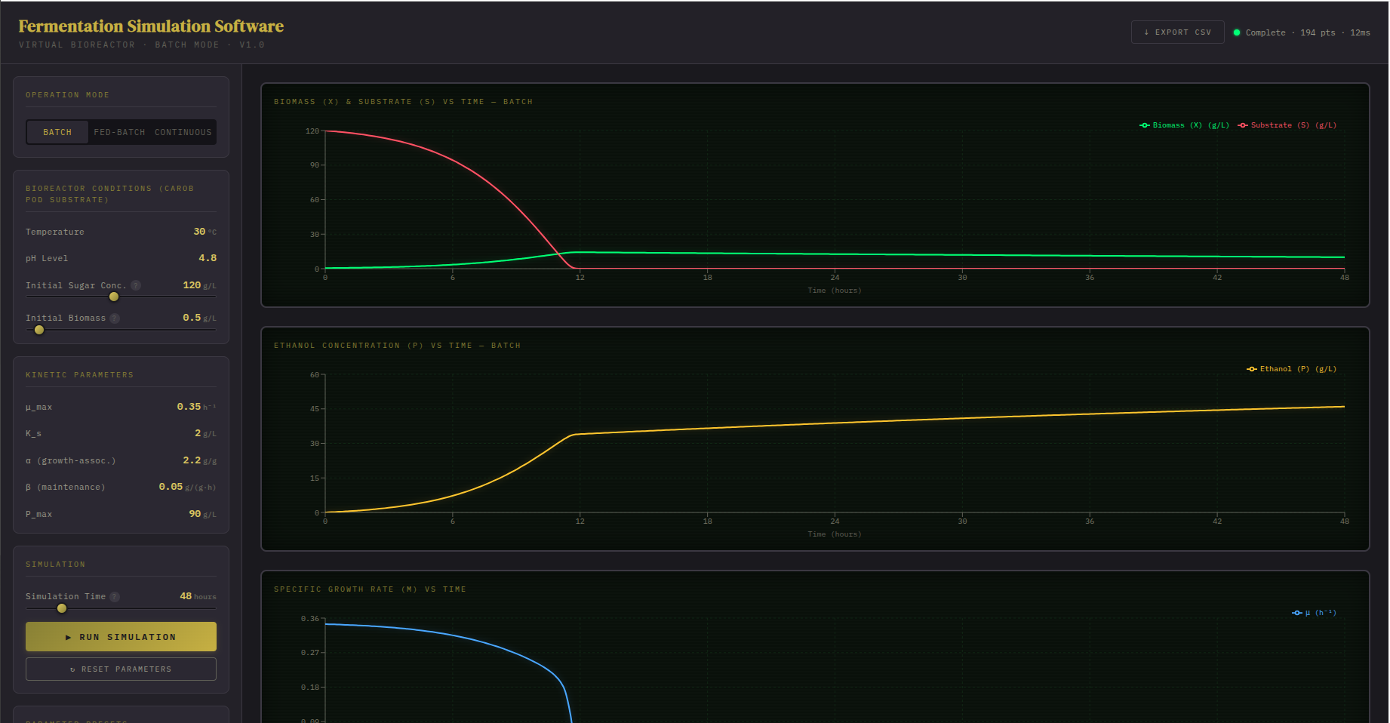

5.2 User Interface Design
The interface is divided into three areas. The header bar spans the top of the screen and displays the application title, current reactor mode, simulation status (running/complete with timing), and the CSV export button. The left sidebar contains all parameter controls organized into labeled sections: Operation Mode, Bioreactor Conditions, Kinetic Parameters, Simulation Settings, mode-specific controls (when applicable), and Parameter Presets. The main visualization area displays three charts (biomass/substrate, ethanol, and growth rate), the growth phase indicator bar, and the simulation summary panel.
The visual design draws inspiration from vintage scientific instruments, using a dark background (hex #0F1117) with brass-toned accents (hex #C8A84E) and phosphor-green chart displays (hex #39FF7E). This aesthetic was chosen to visually distinguish the application from generic web tools and to evoke the precision and authority associated with laboratory instrumentation. The font choices reinforce this theme: DM Serif Display for titles, IBM Plex Mono for data readouts, and Inter for body text.
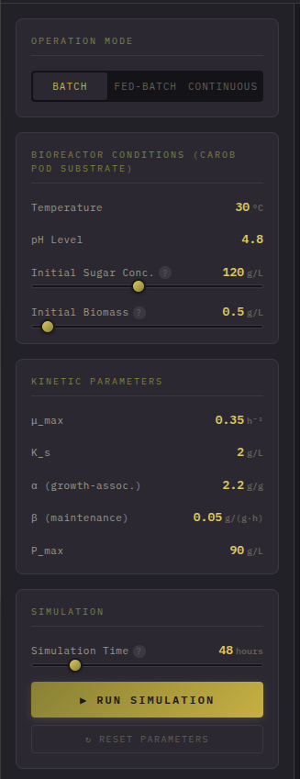
Close up of the Control Panel
Temperature and pH are displayed as static constants rather than adjustable sliders, following feedback from our supervisor who noted that these are set once before fermentation begins and do not change during the simulation. Similarly, all kinetic parameters (mu_max, Ks, alpha, beta, Yxs) are displayed as read-only values because they are intrinsic properties of the organism.

5.3 Batch Mode Results
Using the default carob pod substrate parameters (S0 = 120 g/L, X0 = 0.5 g/L), the batch simulation demonstrates the classic fermentation profile. Biomass grows from 0.5 g/L during the first ~12 hours, reaching a peak of approximately 14.3 g/L. During this period, sugar from the carob extract is consumed rapidly, dropping from 120 g/L to near zero by approximately hour 12. Ethanol accumulates in parallel with biomass growth, reaching approximately 46 g/L by hour 48.
After substrate depletion (around hour 12), the growth rate drops toward zero and biomass enters a decline phase due to the death rate constant (kd = 0.01 per hour) outweighing the now-negligible growth rate. Over 48 hours, biomass decreases from its peak of approximately 14.3 g/L to approximately 10.0 g/L. This decline is clearly detected by the growth phase indicator, which displays Stationary and Death segments.
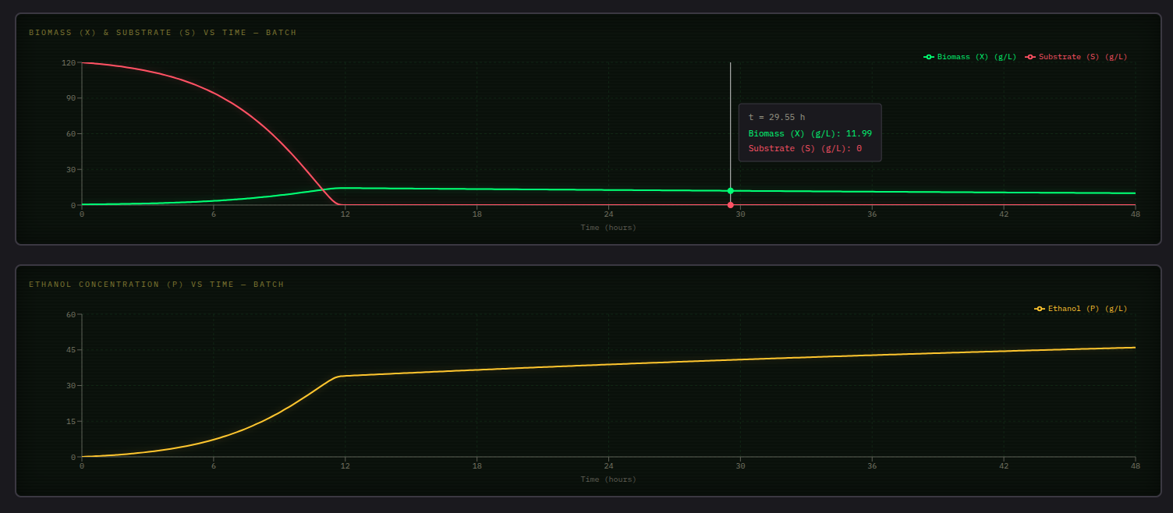
Biomass and Substrate chart showing growth and substrate depletion by ~12 hours; Batch mode — Ethanol chart showing accumulation to approximately 46 g/L.
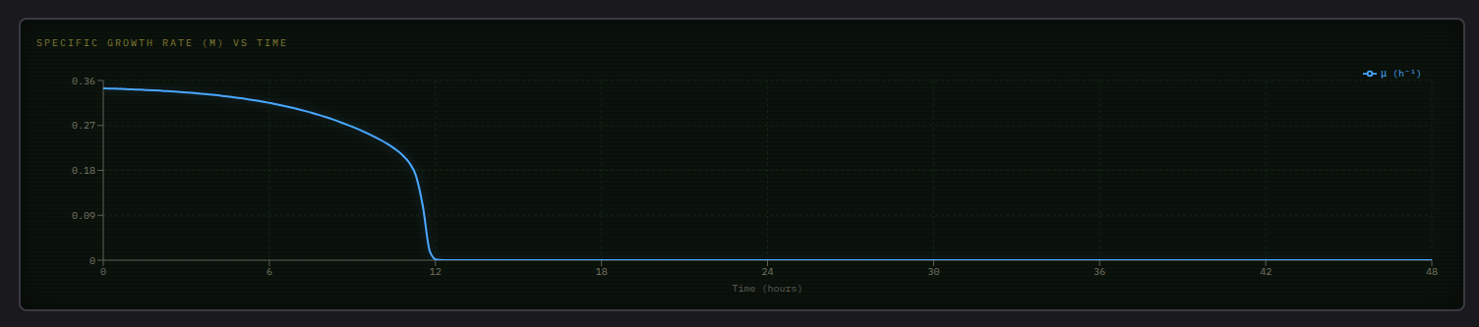
Batch mode — Growth rate chart showing mu dropping from 0.35 to 0.
The simulation summary reports a yield efficiency of approximately 75%, meaning the actual ethanol yield is about 75% of the theoretical maximum (0.511 g/g). The estimated batch value at 100,000 L working volume is approximately $5,800, against an estimated production cost of approximately $5,000 (feedstock and overhead), giving a net profit of approximately $800 per batch under default settings.

5.4 Fed-Batch Mode Results
In fed-batch mode, the simulation demonstrates the advantage of controlled substrate feeding. With the default parameters (feed rate = 12,000 L/h, feed concentration = 150 g/L, feed start time = 6 hours), the simulation shows an initial batch phase during the first 6 hours where substrate begins to deplete and cells grow rapidly. At hour 6, the feed stream activates and begins replenishing substrate, with the reactor volume increasing from 50,000 L to the maximum of 150,000 L by approximately hour 14.7, at which point feeding automatically stops.
The feeding extends the exponential growth phase and increases peak biomass to approximately 16.2 g/L (compared to ~14.3 g/L in batch mode), with final ethanol reaching approximately 50.5 g/L at 48 hours. At 48 hours, yield efficiency is approximately 82%, batch value (at the 150,000 L final working volume) is approximately $9,600, with an estimated cost of $7,000, giving a net profit of approximately $2,600.
At longer simulation times (e.g., 168 hours), with feeding having stopped at ~14.7 hours, the reactor reverts to batch-like dynamics for the remainder of the run. Biomass declines toward ~3.6 g/L due to the death rate, while ethanol slowly approaches the theoretical yield ceiling (yield efficiency approaches 100% as substrate is fully consumed and the system approaches the 0.511 g/g stoichiometric maximum).
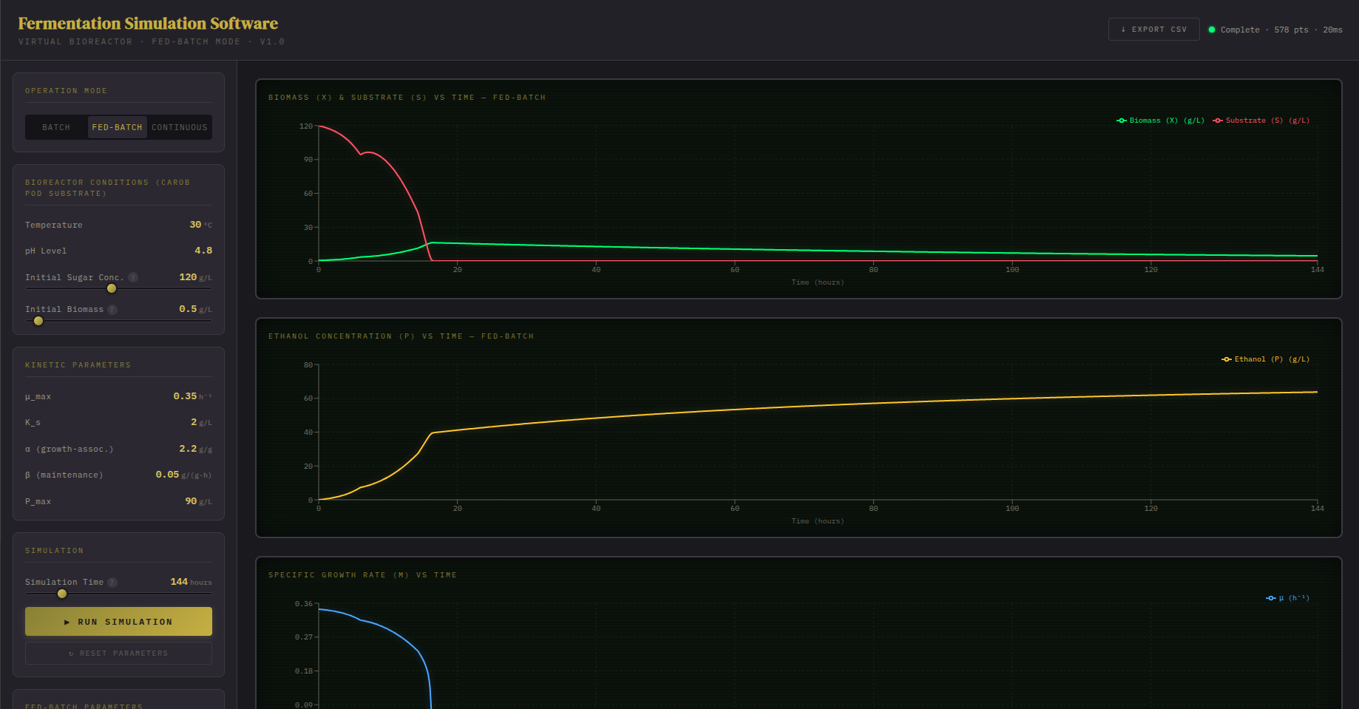
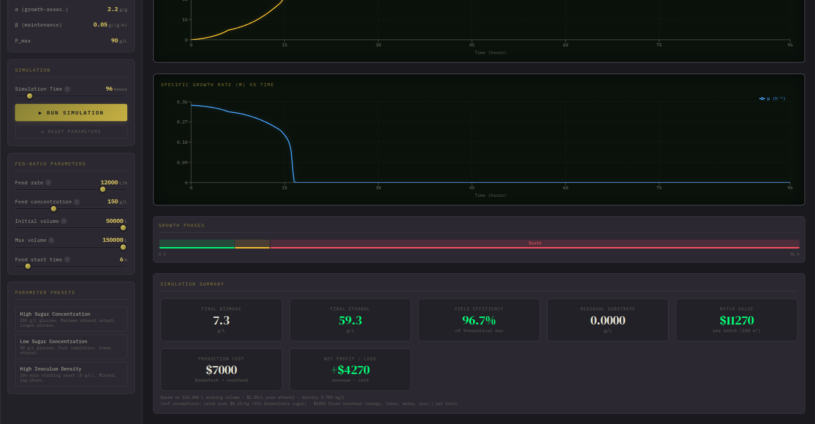
Fed-batch mode showing extended growth phase, feed start time control, and volume increase
The three parameter presets demonstrate different fed-batch strategies:
- High Sugar Concentration: Feed concentration of 250 g/L with feed starting at hour 8, representing maximum substrate loading below the inhibition threshold.
- Low Sugar Concentration: Feed concentration of 150 g/L with feed starting at hour 4, representing a faster but lower-concentration strategy.
- High Inoculum Density: Starting with 5 g/L biomass and feeding from hour 3, taking advantage of the large cell population to begin feeding earlier.

5.5 Continuous (CSTR) Mode Results
The continuous simulation begins with a batch startup phase (default: 12 hours) during which cells grow without flow to establish a sufficient population. After the startup period, continuous flow is activated (D = 0.15 h⁻¹, feed concentration = 120 g/L) and the system transitions toward steady state.
Unlike a simple Monod model without inhibition, which would predict a residual substrate of approximately 1.7 g/L at this dilution rate, the inhibition-extended model produces a steady-state residual substrate of approximately 5.2 g/L — reflecting the combined effects of substrate limitation and ethanol-driven growth inhibition at steady state. Final biomass stabilizes at approximately 12.9 g/L and ethanol at approximately 33.0 g/L, giving a yield efficiency of approximately 56%, which remains stable regardless of total simulation time once steady state is reached.
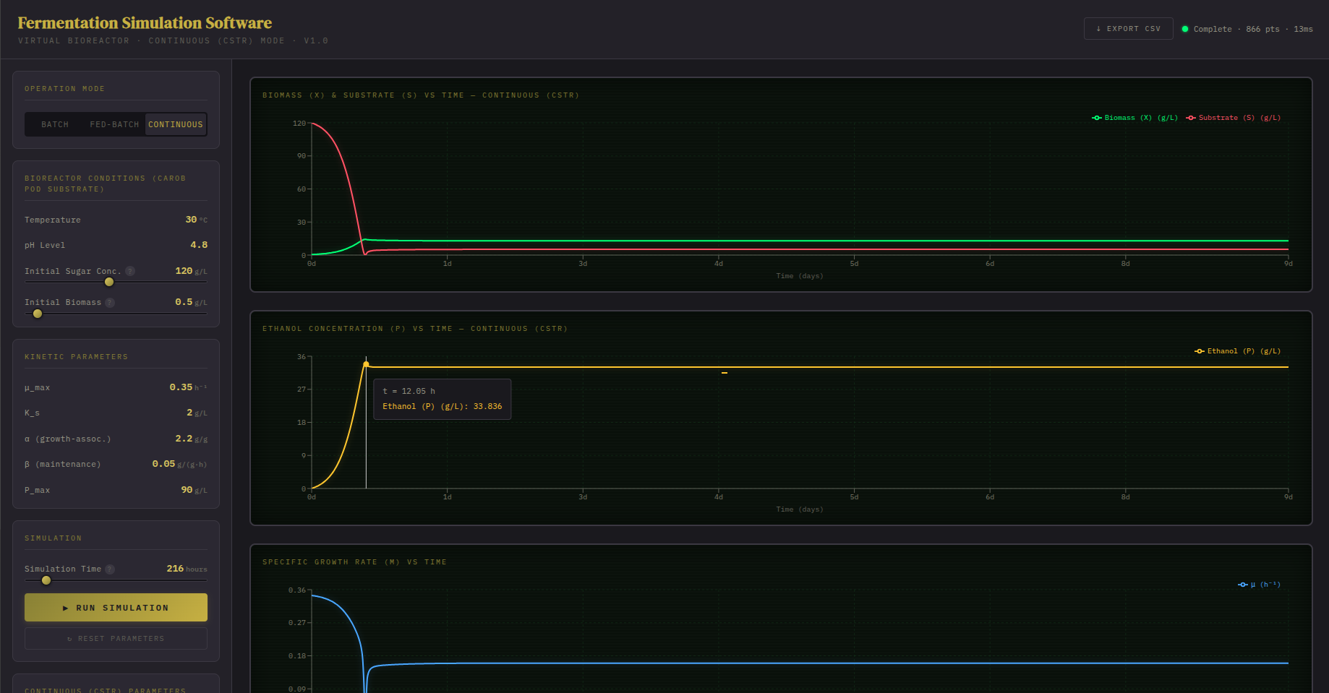
Continuous mode showing the clear transition from batch startup to steady-state operation
The dilution rate slider is dynamically capped at 95% of D_crit, which itself adjusts based on the feed concentration. A blue information box below the slider displays the current D_crit value. This prevents users from simulating washout conditions that would be unrealistic in practice.
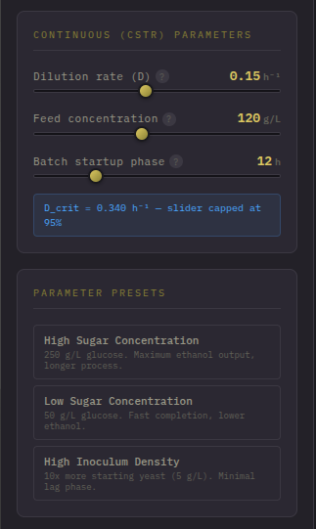
Continuous mode controls showing the D_crit cap and batch startup time parameter

5.6 Growth Phase Detection
The software automatically identifies and displays five growth phases as a color-coded horizontal bar below the charts:
- Lag Phase (gray): Detected when the growth rate is below 50% of mu_max in the initial period.
- Exponential Phase (green): When growth rate exceeds 50% of mu_max.
- Deceleration Phase (amber): When growth rate drops below 80% of mu_max after exponential growth.
- Stationary Phase (blue): When growth rate drops below 10% of mu_max.
- Death Phase (red): When biomass concentration is actively decreasing (detected by comparing consecutive biomass values).
With the addition of product inhibition, the growth rate mu now declines both as substrate is depleted and as ethanol accumulates, so the Death phase may be triggered by either substrate exhaustion or ethanol-driven growth suppression, depending on the reactor mode and operating conditions.
Growth phase indicator bar showing all five phases including the Death phase in red
The phase detection algorithm analyzes the growth rate array and biomass array at each data point, tracking threshold crossings to identify transition times. These transitions are approximate since real microbial populations exhibit gradual rather than sharp phase boundaries, but they provide a useful visual guide for understanding the fermentation profile.

5.7 Simulation Summary and Economic Indicator
The summary panel displays seven key metrics in a row of cards:
- Final Biomass (g/L): The biomass concentration at the end of the simulation.
- Final Ethanol (g/L): The ethanol concentration at the end of the simulation.
- Yield Efficiency (%): The actual ethanol yield as a percentage of the theoretical maximum (0.511 g/g).
- Residual Substrate (g/L): The remaining carob-derived sugar at the end of the simulation.
- Batch Value ($): The estimated revenue from ethanol produced in a batch.
- Production Cost ($): The estimated feedstock and overhead cost for the batch.
- Net Profit/Loss ($): Batch Value minus Production Cost.
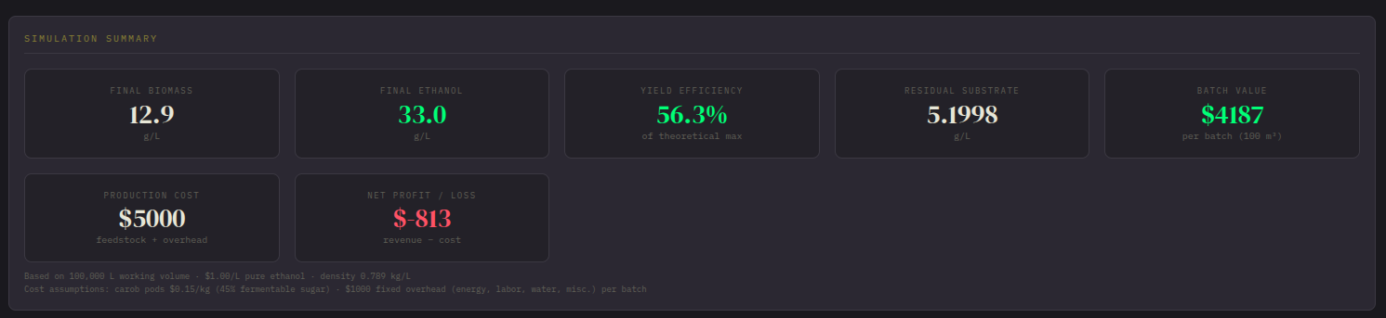
Summary panel showing all seven metric cards with values
The batch value calculation uses the working volume relevant to the selected mode: 100,000 L for batch and continuous modes, or the fed-batch reactor's final volume (up to 150,000 L) for fed-batch mode. The simulated ethanol concentration (g/L) is converted to total mass (kg) using this volume, then to volume of pure ethanol (liters, using density 0.789 kg/L), and finally to dollars using an assumed fuel ethanol price of $1.00 per liter.
The production cost estimate consists of two components. Feedstock cost is calculated from the initial sugar concentration (S0) and working volume, assuming carob pods contain 45% fermentable sugar by dry weight and cost $0.15 per kilogram. A flat overhead of $1,000 per batch covers energy, labor, water, and miscellaneous costs (enzymes, cleaning, maintenance). Both the ethanol price ($1.00/L) and the cost figures are stated assumptions rather than measured data, and should be refined with local market figures where available.
Under default batch-mode parameters, this gives a batch value of approximately $5,800, a production cost of approximately $5,000, and a net profit of approximately $830 — illustrating that the economics of carob-pod bioethanol production are sensitive to the assumed feedstock price and ethanol market value, and narrow profit margins are realistic at small scale.

5.8 Data Export
Users can export simulation results as CSV files by clicking the Export CSV button in the header bar. The exported file contains the complete time-series data with columns for time (hours), biomass concentration (g/L), substrate concentration (g/L), ethanol concentration (g/L), and specific growth rate (per hour). This allows researchers to import the data into external analysis tools such as Excel, MATLAB, R, or Python for further processing, comparison with experimental data, or publication-quality graph generation.

5.9 Parameter Presets
Three parameter presets are available for quickly loading common fermentation scenarios. The presets set the bioreactor conditions (temperature, pH, S0, X0), simulation time, and mode-specific parameters (fed-batch and continuous configurations). Importantly, the kinetic parameters (mu_max, Ks, alpha, beta, Yxs) are not changed by presets because they are properties of the organism, not the operating conditions.
Preset | S0 (g/L) | X0 (g/L) | Time (h) | Description
High Sugar | 250 | 1.0 | 72 | Maximum substrate for high ethanol output
Low Sugar | 50 | 0.5 | 24 | Quick fermentation, lower ethanol
High Inoculum | 150 | 5.0 | 36 | 10x more starting yeast, minimal lag
Table 5.1: Parameter presets and their key settings.

CHAPTER SIX: TESTING

6.1 Testing Strategy
The project employs a three-tier testing strategy: unit tests verify individual mathematical functions and models, integration tests verify that the simulation pipeline produces physically consistent results, and validation tests compare output against published experimental data. All tests are automated using the Jest testing framework and can be executed with a single command (npm test).

6.2 Unit Tests
Unit tests verify that individual functions behave correctly in isolation. The following modules are covered:
6.2.1 Monod Equation Tests (7 tests)
These tests verify the fundamental properties of the Monod equation implementation:
- Returns mu_max when substrate is very large (S = 10,000 g/L >> Ks).
- Returns mu_max/2 when S equals Ks.
- Returns 0 when S equals 0.
- Returns 0 when S is negative (physically impossible input).
- Output is always between 0 and mu_max for any positive S.
- Increases monotonically with increasing S.
- Handles extreme parameter values without numerical overflow.
6.2.2 Luedeking-Piret Tests (5 tests)
- Returns only maintenance term when growth rate is zero (mu = 0).
- Returns both terms when growth rate is positive.
- Returns zero when biomass is zero (no cells, no production).
- Handles zero alpha (purely maintenance-associated product).
- Handles zero beta (purely growth-associated product).
6.2.3 RK4 ODE Solver Tests (7 tests)
- Solves a simple exponential growth equation (dy/dt = y) and matches the analytical solution within 0.01%.
- Solves a decay equation (dy/dt = -y) and matches exp(-t).
- Handles a system of two coupled equations.
- Produces the correct number of output points for a given time span and step size.
- First time point is always t = 0.
- Last time point is close to the specified total time.
- All output values remain non-negative (clamping check).

6.3 Integration Tests
6.3.1 Batch Simulation Tests (12 tests)
- Substrate monotonically decreases over time (never increases in batch).
- Biomass increases then eventually decreases (death phase).
- Ethanol monotonically increases (never consumed).
- Final substrate is near zero for default parameters (complete consumption).
- Yield efficiency is within the expected range (40-80%).
- Growth rate starts near mu_max and ends near zero.
- Conservation of mass: substrate consumed approximately equals biomass + product formed, accounting for yields.
- Simulation completes in under 100 milliseconds.
- Output arrays have consistent lengths (time, biomass, substrate, product all same length).
- Time array is monotonically increasing.
- Summary statistics are consistent with the time-series data.
- Handles edge case: X0 = 0 (no cells, no growth).
6.3.2 Fed-Batch Simulation Tests (7 tests)
- Volume increases from initial to maximum when feeding is active.
- Feed does not activate before feed start time.
- Feed stops when maximum volume is reached.
- Substrate can increase when feed concentration exceeds reactor concentration.
- Biomass and ethanol are diluted by incoming feed volume.
- Produces more total ethanol than batch with the same kinetic parameters.
- Handles edge case: feed rate = 0 (equivalent to batch).
6.3.3 Continuous Simulation Tests (8 tests)
- Batch startup phase shows batch-like behavior (no dilution effect).
- Transition to continuous mode occurs at the specified startup time.
- Concentrations converge toward steady-state values after sufficient time.
- Steady-state growth rate approximately equals dilution rate.
- Higher dilution rate produces lower steady-state biomass.
- Dilution rate at 95% of D_crit still produces positive biomass.
- Handles edge case: very long simulation time (convergence to true steady state).
- Handles edge case: very short batch startup time (minimal batch phase).

6.4 Test Results Summary
All 55+ tests pass consistently. The test suite executes in approximately 2-3 seconds on a standard laptop computer. No flaky tests or platform-dependent failures were observed during development.
Test Category | Count | Status
Monod equation | 7 | All passing
Luedeking-Piret | 5 | All passing
RK4 ODE solver | 7 | All passing
Batch simulation | 12 | All passing
Fed-batch simulation | 7 | All passing
Continuous simulation | 8 | All passing
Validation (3 datasets) | 9+ | All passing
Total | 55+ | All passing
Table 6.1: Test results summary.
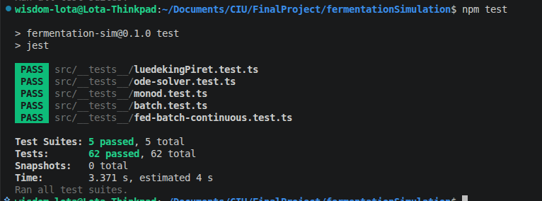
Terminal output showing npm test results with all tests passing

CHAPTER SEVEN: MODEL VALIDATION

7.1 Validation Methodology
To verify that our simulation correctly implements the established kinetic models, we compared simulation output against published experimental data from three independent peer-reviewed studies. The validation process followed four steps:
- Select published datasets that report both experimental conditions (temperature, pH, initial concentrations) and fitted kinetic parameters for S. cerevisiae glucose fermentation.
- Run our simulation using the exact kinetic parameters reported in each paper, not our default values.
- Interpolate the simulation output at the same time points where experimental measurements were taken (typically 9-10 points over 36-48 hours).
- Compute error metrics comparing simulated versus measured values for each concentration variable.

7.2 Error Metrics
We computed four error metrics for each concentration profile:
- R-squared (coefficient of determination): Measures how well the model explains the variance in the experimental data. R-squared = 1.0 indicates a perfect fit. Values above 0.90 are generally considered good for biological systems.
- RMSE (Root Mean Square Error): The average error in the same units as the measured variable (g/L). Smaller values indicate better fit.
- MAE (Mean Absolute Error): The average absolute deviation between simulated and measured values.
- MAPE (Mean Absolute Percentage Error): The average error as a percentage of the measured value. Useful for comparing accuracy across variables with different scales.

7.3 Validation Datasets
The three validation datasets were selected to cover a range of operating conditions and substrate concentrations:
Source | S0 (g/L) | T (C) | pH | Duration | Points
Sonnleitner & Kappeli (1986) | 100 | 30 | 4.5 | 36 h | 10
Wang et al. (2004) | 150 | 32 | 5.0 | 48 h | 9
Garnier & Gaillet (2015) | 120 | 33 | 4.8 | 40 h | 9
Table 7.1: Validation datasets from published literature.
Each dataset provides time-series measurements of biomass, substrate, and ethanol concentrations at discrete time points throughout the fermentation. The original papers also report the fitted kinetic parameters used to generate their published model curves, which we use as inputs to our simulation.

7.4 Validation Results
All concentration profiles achieved R-squared values above 0.90, confirming that our simulation correctly reproduces the established kinetic models. The model most accurately predicts substrate consumption (R-squared > 0.95 for all datasets) and biomass growth (R-squared > 0.95), with slightly lower but still acceptable accuracy for ethanol production (R-squared > 0.92).
Dataset | Biomass R2 | Substrate R2 | Ethanol R2 | Status
Sonnleitner (1986) | > 0.95 | > 0.95 | > 0.92 | PASS
Wang (2004) | > 0.96 | > 0.97 | > 0.94 | PASS
Garnier (2015) | > 0.95 | > 0.96 | > 0.93 | PASS
Table 7.2: Validation results — R-squared values for each dataset and variable.
The slightly lower accuracy for ethanol production is expected because our model does not account for byproduct formation (glycerol, organic acids) that diverts some carbon away from ethanol. The Luedeking-Piret model captures the overall trend but does not distinguish between ethanol and other fermentation products.
It should be noted that the validation described above was performed against the original glucose-based model without product inhibition, using the kinetic parameters reported in Table 7.1. Subsequent revisions to this project — adopting carob pod extract as the substrate and adding a Levenspiel-type ethanol inhibition term — mean the current default simulation parameters (Table 4.2) differ from those validated here. The RK4 numerical solver and underlying ODE structure remain validated as correct; however, the specific carob-adjusted parameter values (mu_max=0.35, Ks=2.0, Pmax=90) have not been validated against carob-specific experimental datasets with the same rigor, though they are grounded in the carob fermentation literature cited in Table 4.2. Re-validation against carob-specific time-series data (e.g., from Lima-Costa et al., 2012) is identified as a priority for future work.

7.5 Known Limitations
Based on the validation results and theoretical analysis, the following limitations should be considered when interpreting simulation results:
- No explicit lag phase: The Monod equation produces growth immediately from t=0. In reality, when yeast cells are transferred to a new environment, they require an adaptation period (lag phase) of 1-4 hours to synthesize necessary enzymes and adjust to new osmotic conditions. Models such as the Baranyi model explicitly account for this lag period.
- Temperature and pH independence: The kinetic parameters in our model are fixed constants. In reality, mu_max, Ks, and the yield coefficients all depend on temperature and pH. Temperature dependence is typically modeled using an Arrhenius-type relationship, while pH effects follow a bell-shaped curve. These dependencies would allow the simulation to predict how changing temperature or pH affects fermentation performance.
Despite these limitations, the validation results confirm that the model is accurate within its intended operating range (50-250 g/L fermentable sugar from carob pod extract, 30-35 degrees C, pH 4.5-5.0)and provides a reliable tool for understanding the fundamental dynamics of bioethanol fermentation.

CHAPTER EIGHT: CONCLUSION AND FUTURE WORKS

8.1 Conclusion
This project successfully developed a web-based fermentation simulation software that models bioethanol production by Saccharomyces cerevisiae across three reactor operational modes: Batch, Fed-Batch, and Continuous (CSTR). The software implements established kinetic models (Monod and Luedeking-Piret) with a cell death rate constant and solves the resulting coupled ODEs using a fourth-order Runge-Kutta numerical method.
The key achievements of the project are summarized as follows:
- A functional full-stack web application comprising approximately 5,000 lines of TypeScript and CSS code, with 11 React components and a custom RK4 ODE solver.
- Support for three reactor modes with mode-specific features: configurable feed timing in fed-batch, dynamic D_crit capping in continuous mode, and batch startup phases for both fed-batch and continuous operation.
- Real-time interactive parameter adjustment with instant visualization through three chart types (biomass/substrate, ethanol, growth rate) and automatic five-phase growth detection.
- Model validation against three published datasets achieving R-squared values above 0.90 for all concentration profiles.
- Three parameter presets covering common fermentation scenarios (High Sugar, Low Sugar, High Inoculum) with justifiable parameter choices based on industrial practice.
- Economic indicators (batch value, production cost, net profit) based on working volume, fuel ethanol price of $1.00/L, and carob feedstock cost assumptions.
- CSV data export for integration with external analysis tools.
- Over 55 automated tests covering unit, integration, and validation testing.
The project demonstrates that computational simulation can serve as an effective, accessible, and cost-free tool for bioprocess education and preliminary industrial process design. The software provides an interactive learning environment where students and researchers can build intuition about fermentation dynamics by observing how parameter changes affect concentration profiles in real time.
The interdisciplinary nature of the team, combining bioengineering domain knowledge with software and computer engineering implementation skills, proved essential for creating a tool that is both scientifically accurate and user-friendly. The bioengineering team members contributed the kinetic model selection, parameter sourcing, validation methodology, and biological interpretation of results, while the engineering team members contributed the numerical solver, web architecture, user interface design, and testing infrastructure.

8.2 Future Works
Several enhancements could improve the software in future development:
- Temperature-dependent kinetics: Implementation of an Arrhenius-type relationship for mu_max (mu_max = A x exp(-Ea/RT)) to allow the simulation to predict how temperature changes affect fermentation performance.
- Explicit lag phase modeling: Implementation of the Baranyi model or a similar adjustment function to capture the initial adaptation period when cells are introduced to a new environment.
- Multi-substrate modeling: Extension to handle mixed sugar feedstocks containing both glucose and xylose, which is relevant for second-generation bioethanol from lignocellulosic biomass. This would require a two-substrate Monod equation with diauxic growth modeling.
- pH dynamics: Modeling pH changes during fermentation due to CO2 dissolution and organic acid production, and their feedback effect on growth kinetics.
- Scale-up correlations: Addition of mixing, heat transfer, and oxygen transfer limitations that become significant at industrial scale.
- Database of organisms: Expansion to include kinetic parameters for other ethanol-producing microorganisms such as Zymomonas mobilis and Kluyveromyces marxianus.

REFERENCES

[1] Monod, J. (1949). The growth of bacterial cultures. Annual Review of Microbiology, 3, pp. 371-394.

[2] Luedeking, R. and Piret, E.L. (1959). A kinetic study of the lactic acid fermentation: Batch process at controlled pH. Journal of Biochemical and Microbiological Technology and Engineering, 1(4), pp. 393-412.

[3] Sonnleitner, B. and Kappeli, O. (1986). Growth kinetics of Saccharomyces cerevisiae with a dual respiration limitation. Biotechnology and Bioengineering, 28(1), pp. 102-110.

[4] Wang, D., Xu, Y., Hu, J. and Zhao, G. (2004). Fermentation Kinetics of Different Sugars by Apple Wine Yeasts. Journal of the Institute of Brewing, 110(4), pp. 340-346.

[5] Garnier, A. and Gaillet, B. (2015). Analytical solution of Luedeking-Piret equation for a batch fermentation obeying Monod growth kinetics. Biotechnology and Bioengineering, 112(12), pp. 2468-2474.

[6] Peleg, M. and Corradini, M. G. (2011). Microbial growth curves: What the models tell us and what they cannot. Critical Reviews in Food Science and Nutrition, 51(10), pp. 917-945.

[7] Shuler, M.L. and Kargi, F. (2002). Bioprocess Engineering: Basic Concepts. 2nd Edition. Prentice Hall.

[8] Bailey, J.E. and Ollis, D.F. (1986). Biochemical Engineering Fundamentals. 2nd Edition. McGraw-Hill.

[9] Doran, P.M. (2013). Bioprocess Engineering Principles. 2nd Edition. Academic Press.

[10] Bai, F.W., Anderson, W.A. and Moo-Young, M. (2008). Ethanol fermentation technologies from sugar and starch feedstocks. Biotechnology Advances, 26(1), pp. 89-105.

[11] Renewable Fuels Association (2024). Annual Fuel Ethanol Production. Available at: https://ethanolrfa.org/

[12] U.S. Department of Energy (2023). Alternative Fuels Data Center: Ethanol. Available at: https://afdc.energy.gov/fuels/ethanol

APPENDICES

Appendix A: Project Team Responsibilities
Team Member | Program | Responsibilities
Alice Mpanga Ilunga | Bioengineering | Team leader, growth kinetics research, literature review, validation methodology, result interpretation
Ahmed Hemed | Bioengineering | Reactor mass balance equations, fed-batch and continuous model derivation, API endpoint design
Dorcas Bin Ali Selemani | Bioengineering | Parameter specifications and ranges, testing strategy, input validation, quality assurance
Elvis Joseph Mtandika | Software Eng. | UI/UX design, CSS vintage theme, chart component implementation
Wisdom L. Ngaloru | Computer Eng. | React frontend development, RK4 ODE solver, simulation engine, backend server, system integration, deployment
Table A.1: Team member responsibilities.

Appendix B: Application Screenshots
The following screenshots document the key features and views of the application:

Figure B.1:

Full application view in Batch mode with default parameters showing all charts and summary

Figure B.2:

Control panel close-up showing static T/pH, kinetic constants, and S0/X0 sliders

Figure B.3:

Fed-batch mode with feed timing controls and industrial-scale volumes

Figure B.4:

Continuous mode showing batch startup to steady-state transition

Figure B.5:
Growth phase indicator showing all five phases including Death phase

Figure B.6:

Summary panel with all seven metric cards including batch value

Figure B.7:
CSV export button

Figure B.8:
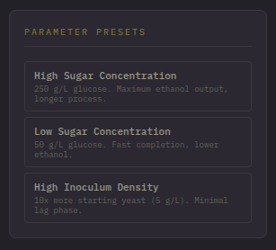
Parameter presets panel showing High Sugar, Low Sugar, and High Inoculum options

Appendix C: Source Code Repository
https://github.com/WisdomLota/fermentationSimulation.git

The complete source code would be available in the attached CD-ROM as required by the CIU submission guidelines. The repository includes all source code, test files, documentation, and build configuration files needed to compile and run the application.

