CprE 3810, Computer Organization and

Assembly Level Programming

Lab 1 Report

Student Name ____Zephaniah Gustafson_________________

Submit a typeset pdf version of this on Canvas by the due date. Refer to the highlighted language in the lab document for the context of the following questions.

[Part 3.1.c] Think of three more cases and record them in your lab report.
For the first case I tried to make oY be my birth day. So iW=0x0A or 10 in decimal, iX=0x01, and iY=0x09. This results in oY=19 and oX=1. For the second case, I will give the max positive value for all values. This means that iW=0x7F or 127 in decimal, iX=0x7F, and iY=0x7F. This reasults in 127*127+127=16256 in decimal or 0x3F80 in hexadecimal. For the third case, I tried to get the highest value that oY could be, so iW=0x80 or -128 in decimal, iX=0x80, and iY=0x7F or 127 in decimal. So oY should be 16511 or 0x407F and oX should be -128 or 0x80.

[Part 3.1.e] For labels 1, 7, 22, and 28, specify where (VHDL file and line number) these values are located – some will be found in more than one place. Also attempt to explain the functionality of each label as it occurs in the code
For label 1, this is just the TPU_MV_Element.vhd file. For label 7, this is just the Adder.vhd file. For label 22, this is located in s_W on line 96 in the TPU_MV_Element.vhd file, which is given functionality in the RegLd.vhd file, where oQ is the output that will be linked to s_W. For label 28, this is the s_X1 input to the g_Delay3 component on line 129 in the TPU_MV_Element.vhd file, which is given functionality in Reg.vhd under the name iD, which is implemented through out that file.

[Part 3.1.f] Implement your test cases from part c into this testbench. Remember to include these in
your waveform screenshot.
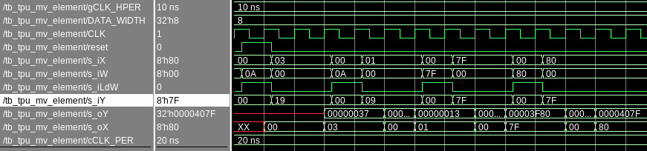
[Part 3.1.g.v] In your lab report, include a screenshot of the waveform. Describe, in plain English, any differences between what you expected and what the simulation showed.
Everything behaved as expected other than I did not anticipate the fact that oY and oX would be undefined red lines before they had any input, but I guess I should have expected that.

[Part 3.1.h] In your lab report, include a screenshot of the waveform. Describe, in plain English, how your waveform matches the expected result (e.g., reference the specific cycles and times). In your submission zip file, provide the completed TPU_MV_Element.vhd file in a folder called ‘MAC’.
We see that for the first test case, s_iW is set to 0x0A, which is expected. Then s_oY is set to 0x37, which is expected. Then, in the next test case, s_oYis set to my birthday of 0x13 or 19 in decimal. After that s_oY is 0x3F80, which matches with the expected value for having the max positive amount in each of the input values (0x7F). Then the final test case has s_oY = 0x407F, which matches what we predicted for having s_iW = 0x80, s_iX = 0x80, and s_iY = 0x7F, which should make s_oY be the largest positive value it can be of -128*-128+127=16511 or 0x407F in hexidecimal. For s_oX, it matches what s_iX was in each test case as expected.

[Part 3.3.a] Draw the truth table, Boolean equation, and Boolean circuit equivalent (using only two-input gates) that implements a 2:1 mux. Include this in your lab report.
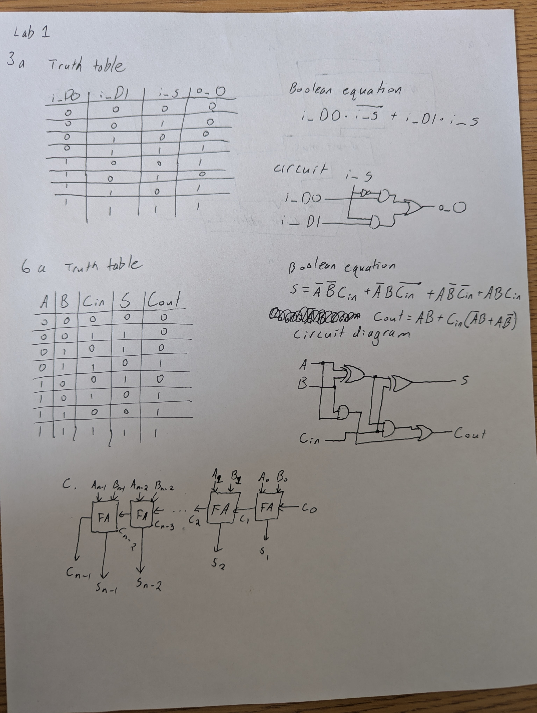

[Part 3.3.d] In your lab report, include a screenshot of the waveform. Make sure to label the screenshot with which module it is testing.
Mux2t1 structural:
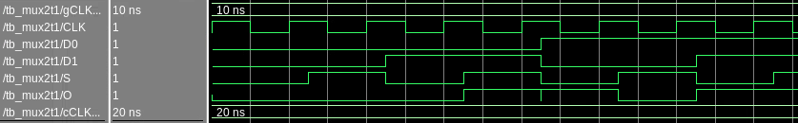

[Part 3.3.e] Again, in your lab report, include a labeled screenshot of the waveform showing the dataflow mux implementation working.
Mux2t1 dataflow:
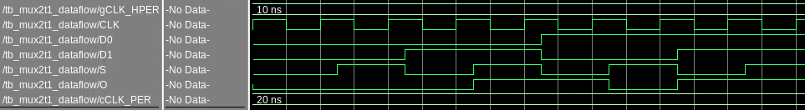
[Part 3.4] Include a waveform screenshot and corresponding description demonstrating it is working correctly.
N-bit 2t1 mux:
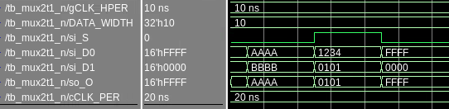
Fairly simple testing. Just different values put into si_D0 and si_D1 with si_S swapping between them.

[Part 3.5.b] Include a waveform screenshot and description in your lab report.
N-bit one’s complementor or inverter.
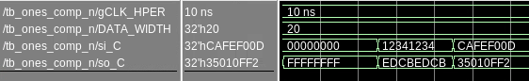
Another simple test case, starting with all zeroes to all ones. Then some fairly simple patterns with their inversions.

[Part 3.6.a] A full adder takes three single-bit inputs and produces two single-bit outputs – a sum and carry for the addition of the three input bits. Draw the truth table, Boolean equation, and Boolean circuit equivalent (using only two-input gates) that implements a 1-bit full adder. Include this in your report.

[Part 3.6.c] Then draw a schematic of the intended design, including inputs and outputs and at least the 0, 1, N-2, and N-1 stages. Include this in your report.

[Part 3.6.d] Include an annotated waveform screenshot in your write-up.
N-bit carry adder:
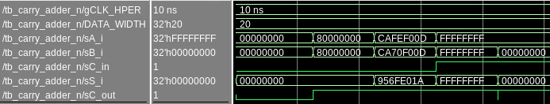
For the first test case, both sA_i and sB_i are just zero, so we get the expected value of 0. Then we try to intentionally test just the carry bit for sC_out, which gives what is expected. Then in the next test case sA_i=0xCAFEF00D and 0xCA70F00D (Cat food). This produces 0x956FE01A and sC_out is 1, which is expected. Then the next two cases test when we set sC_in to 1. So the first one is 0xFFFFFFFF in both inputs with the extra bit, which gives 0xFFFFFFFF in sS_i and 1 in sC_out, which is expected. Then in the final we have just one 0xFFFFFFFF in sA_i and straight zeroes in sB_i and sC_in is 1. So we expect there to be a carry all the way, which is what we see with sS_i = 0 and sC_out = 1.

[Part 3.7.a] Draw a schematic (don’t use a schematic capture tool) showing how an N-bit
adder/subtractor with control can be implemented using only the three main components designed in earlier parts of this lab (i.e., the N-bit inverter, N-bit 2:1 mux, and N-bit adder). How is the ‘nAdd_Sub’ bit used? Include this in your report.

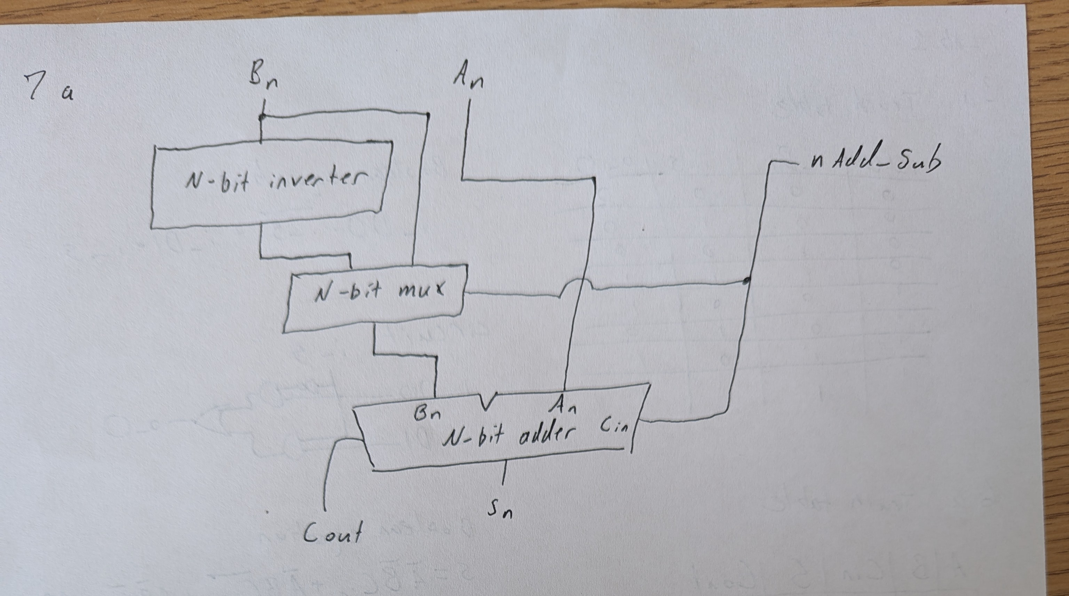

[Part 3.7.c] Provide multiple waveform screenshots in your write-up to confirm that this component is working correctly. What test-cases did you include and why?

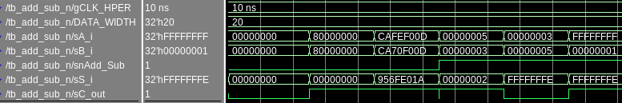
The first three test cases are the same as the normal carry adder. Then the last three show the subtracting capability and they are all spot on.

