Lab 4 report
1.
a.
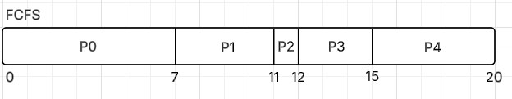
7 + (11 – 2) + (12 – 4) + (15 – 5) + (20 – 7) = 47
47/ 5 = 9.4

b.
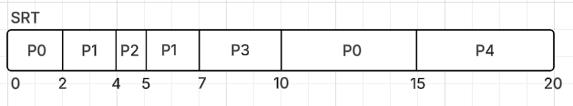
1 + (7-2) + (10 – 5) + (15 – 0) + (20 – 7) = 39
39/5 = 7.8

When t=4 we swap from P1 to P2 because it has a shorter remaining process time than P1.
c.
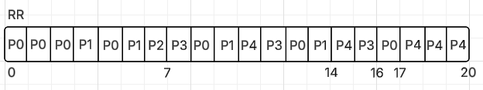
(7 – 4) + (14 – 2) + (16 – 5) + (17 – 0) + (20 – 7)= 56
56/5 = 11.2
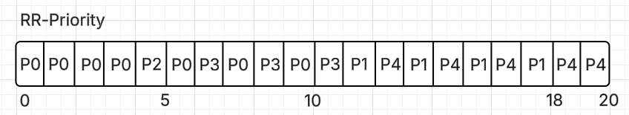
1+(10-0) + (11-5)+(18-2)+(20-7)=46
46/5=9.2

NOTE: In tie breaks where a process runs and another process enters the queue, I put the process that ran in first and then the arriving process.

d.
 | FCFS | SRT | RR | RR-Priority
Avg. Turnaround T | 9.4 | 7.8 | 11.2 | 9.2

The best algorithm is SRT, with a significantly less average turnaround time than the others. This is the result we would expect since in lecture we said that SRT is mathematically the most optimal for this metric.

2.

