Meet in the middle – Divide problem in two, solve them individually, merge them

(Look at the constraint and possible answers and who knows pigeonhole might be there)

LIS,LCS -- > generally look and see DP[i] = depends on what we can extend .

String dp = > state possibility – dp[i][j] = (1...i)(1...j) .. ((like in lcs)).

Sorting plus dp => first sort and see some relation gained from them

Game based dp :
player 1, 2 - in one move one can take out k0,k1,k2

---------------------------
2 pointer – two techniques, push heads, compress range , Note that there is a techinique where we need to find prefix sum and prefix sum is not monotonic, think about multiset and lower bound, upper bound.

--------------------------

Stack can be used to find nearest smallest, or nearest largest .****

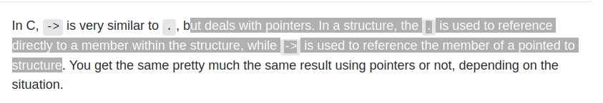

1->2->3->4->5->NULL == In this case, while(cur) means that it will execute all statements in while for all nodes.. meaning 1,2,3,4,5 will get processed..
if while(cur->next!=NULL) then it will process statements for 1,2,3,4 only...
while(cur->next){
cur=cur->next;
}
this is equivalent to while(i<5)i++; final i = 5, and if while(i<=5) final i = 6;
the final cur will be 5... and if i take cur!=NULL then final cur will be null.

bool detectLoop(Node *head) {
// fp!null fp.n!null.. fp+=2, sp++ if(equal)return 1;

auto fp = head, sp = head;
while (fp != NULL && fp->next != NULL) {
fp = fp->next->next;
sp = sp->next;
if (sp == fp)return 1;
}
return 0;
}

For removal of loop, it is easy.. once we find the loop, we bring sp to head and run a second loop with same speed (sp++,fp++) until sp->next==fp->next .. (jab tak fp->next aur sp->next equal na aaye).
Second ke bahar fp ke next ko null kar dena

