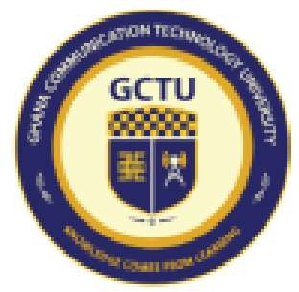
Ghana Communication Technology University (GCTU)
Knowledge Comes From Learning ...

Registered Courses

Name:

Student ID:

Programme: Level: Semester: Session:

Mr. Prince Okonoi Tetteyfio

1703274713
BSc. Computer Engineering 300
First Semester

Morning

Course Code | Course Title | Group | Credit  Hours | Requires Exams | Registration Type | Date Registered
ENCE 315 | SOFTWARE ENGINEERING | 1 | 3 | Yes | Regular | Nov 17, 2025
ENCE 313 | COMPILERS CONSTRUCTION DESIGN | 1 | 2 | Yes | Regular | Nov 17, 2025
MATH 311 | ENGINEERING MATHEMATICS V (PROBABILITY, STATISTICS & STOCHASTIC PROCESSES) | 1 | 3 | Yes | Regular | Nov 17, 2025
ENEE 361 | FIELD TRIPS & REPORTS WRITING FOR ENGINEERING | 1 |  | Yes | Regular | Nov 17, 2025
ENEE 341 | CONTROL THEORY | 1 | 3 | Yes | Regular | Nov 17, 2025
ENCE 317 | EMBEDDED SYSTEMS & DRONE TECHNOLOGY | 1 | 3 | Yes | Regular | Nov 17, 2025
ENTE 351 | ELECTROMAGNETIC WAVE THEORY | 1 | 3 | Yes | Regular | Nov 17, 2025
SSSC 361 | ENGINEERING ECONOMICS, MGT. & ACCOUNTING | 1 | 2 | Yes | Regular | Nov 17, 2025

Total Credits Registered: 20

FOR STUDENT USE

Student Signature: .............................

Date: .............................
FOR OFFICIAL USE ONLY

Official Stamp

Received by: .............................

Date: .............................

C 2025 Ghana Communication Technology University (GCTU). All Rights Reserved

