Installing Ubuntu on Virtualbox and Creating user - “kalyani”

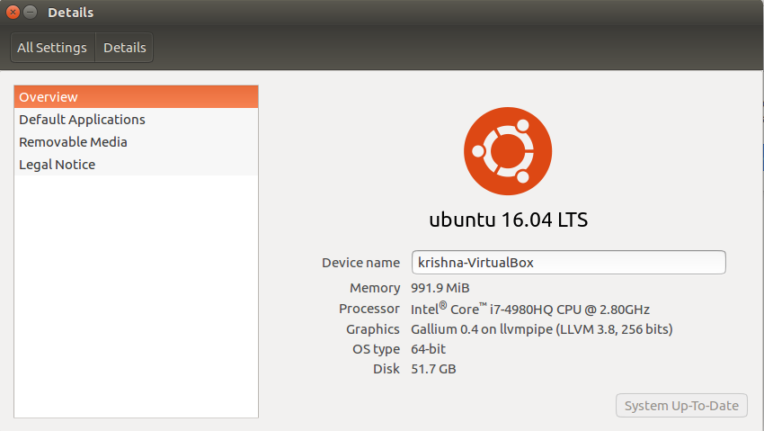
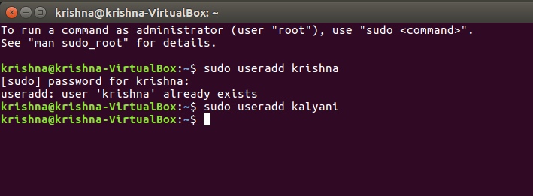

Go to home directory and creating 2 sub directories with username +1 & 2

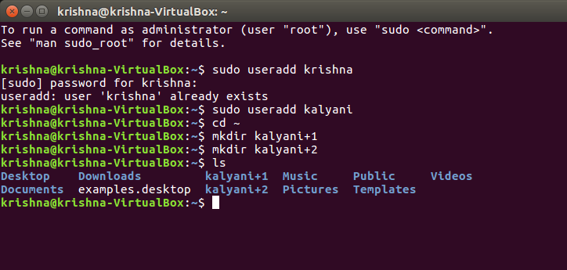
Creating a file with my name to give specific permissions to access the file.

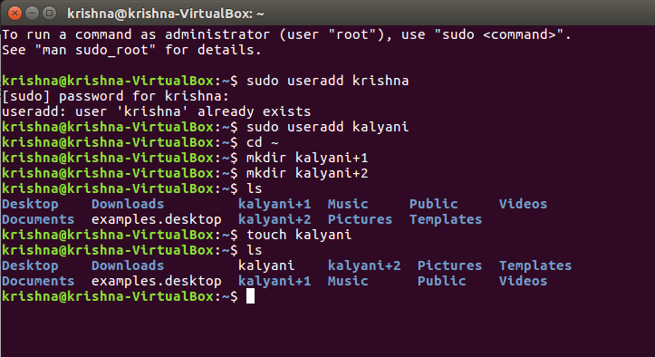

Changing the permissions of the file to read and write but not execute below.

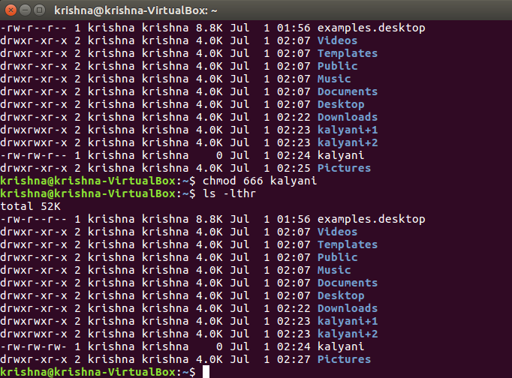

Changing the permissions of the file to read and execute but not write below.
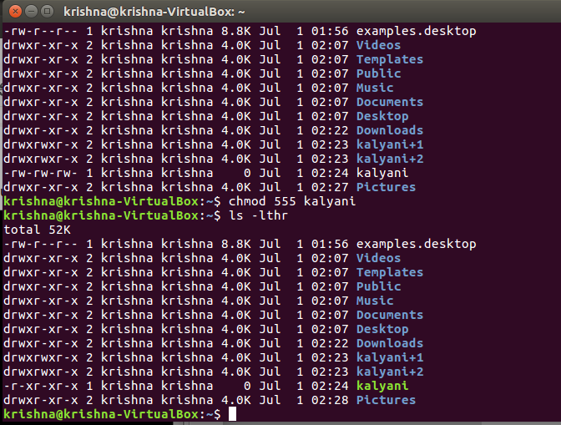

Write two lines in the file and displaying it the screen here.

