Chinese Website Front End
- Header menu is not given [Required]

- Best of china page
Title and image is required [ Required]
Footer is required or not [Required]

- Register now and login now page is requird or not [Required]
Footer is required in register and login page [Required]

- section 1 image and text [ok]

- Website Logo is required [Required]

- Section 2
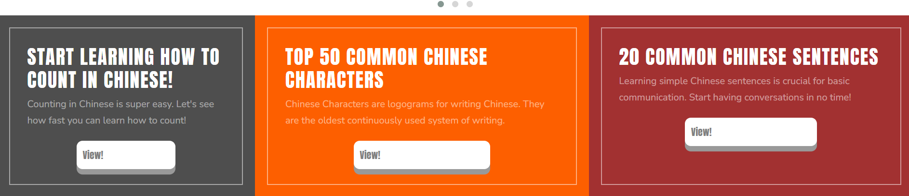

Heading or in formation diya hai [ok
View click krne ke bad 404 ka error aaraha hai kya krna hai [Required]
View click krne ke bad ye page open hota hai https://chinese4schools.org/count_chinese.php

- section 3

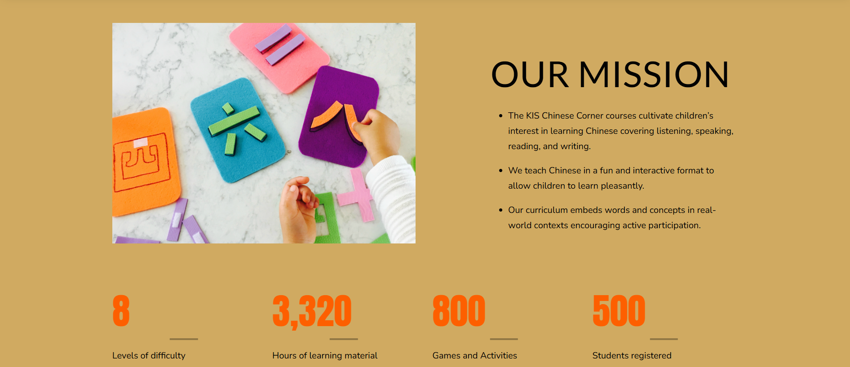

Text diya hai [ok]
Image is [Required]
Background image is required [Required]

- Section 4
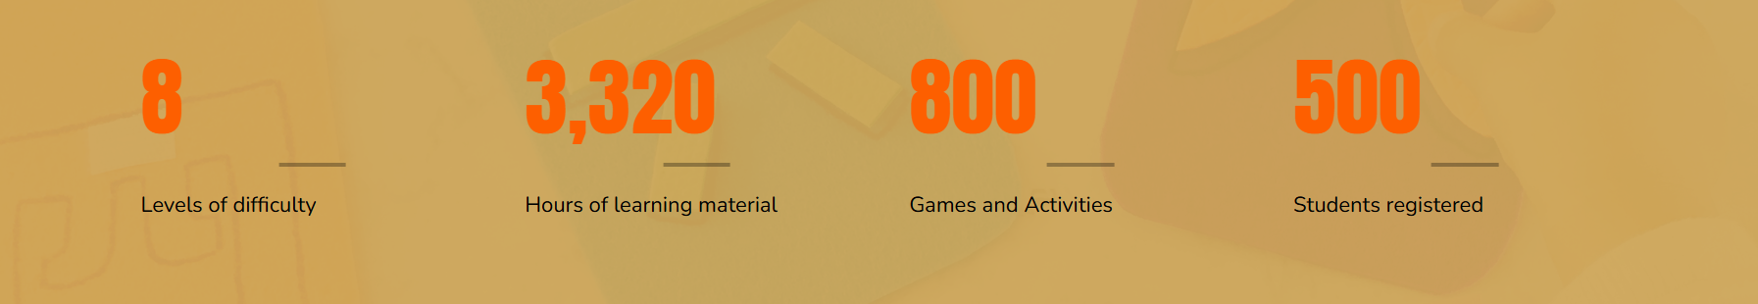
Text or number is ok [ok]

- Section 5
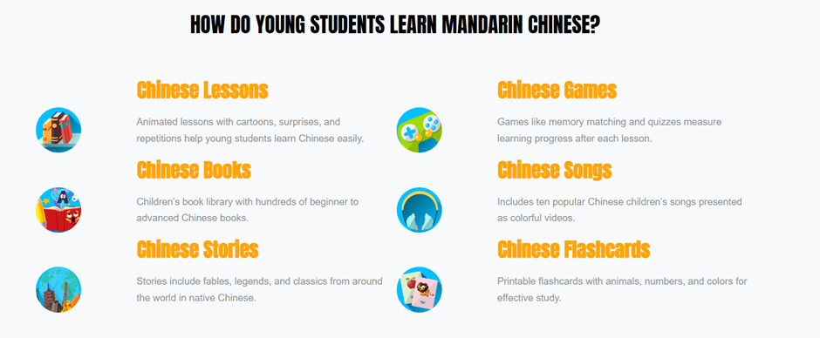

Heading is required in Section 5 [Required]
text is given 4 sections [ok]
Icon is required [required]


- Section 6

Background image is required [Required]
Want to know botton is required or not “learn Chinese now” [Required]
- Section 7
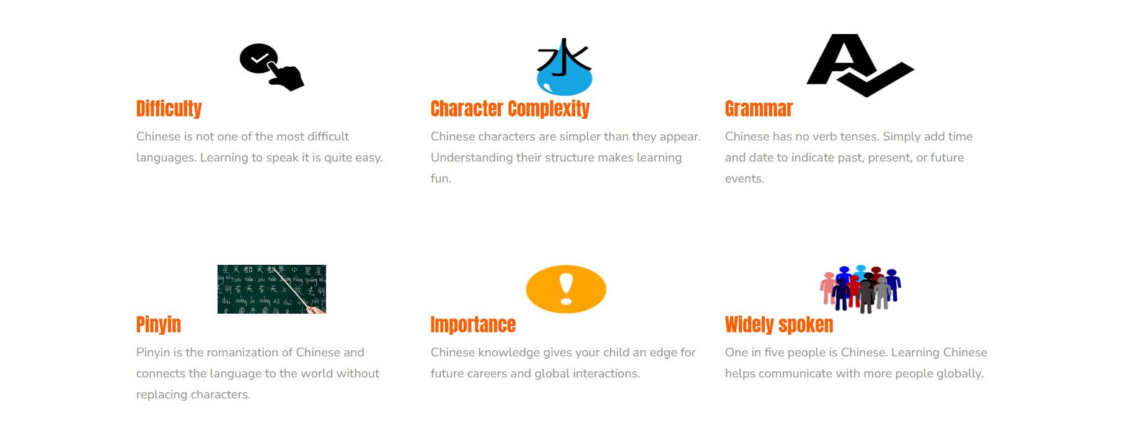
Text is given[ok]
Icon is required [Required]

- Section 8
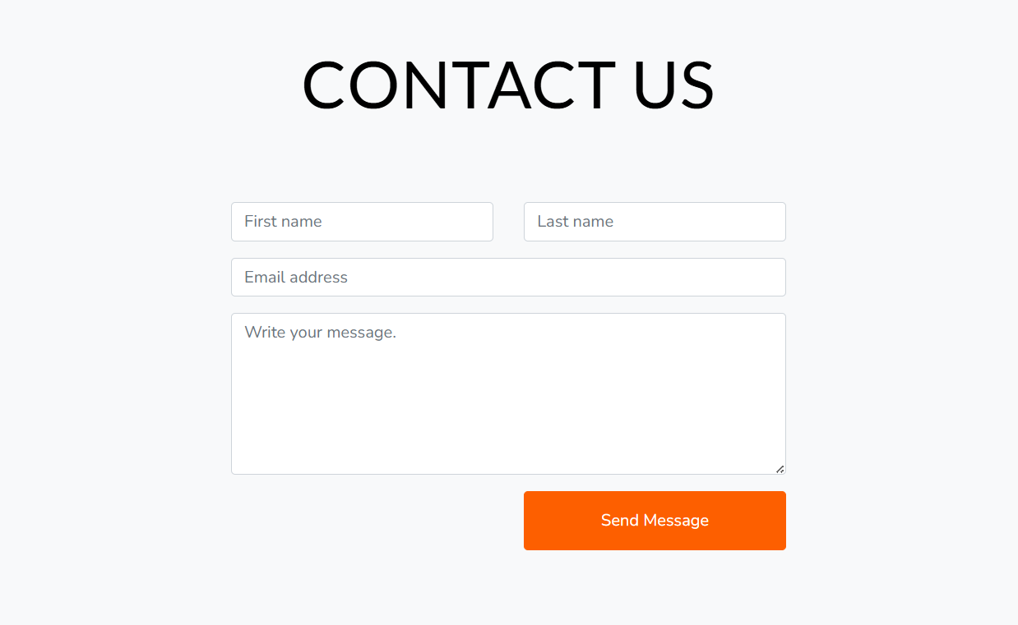
Contact us form same as Chinese for school website [ok]
- Section 9
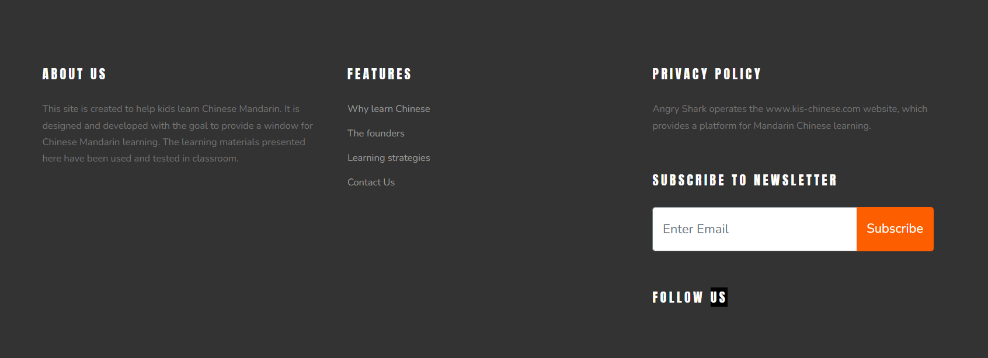

founders , About us , subscribe to newsletter , follow us not needed [ok]

In features Why learn Chinese , Learning strategies, contact us is this required ? [required]

“privacy policy” , “terms of use” is given [ok]

