WISHLIST APPLICATION



WEB APPLICATION USER GUIDE

Table of Contents
Table of Contents 2
Introduction 3
WishList App LogIn Page 4
Create an account Page 5
Home Page 6
WishList Page 7
Add item (Your WishList) 8
Restore Item (Your WishList) 9
Fulfilled Items (Your WishList) 9
Export (Your WishList) 10
Categories (Category list) 11
Balance History (Your Balance) 12
Balance settings (Your Balance) 13
Export (Your Balance) 13
Profile settings 14
Administrator settings 15
Users (Admin panel) 16
Category list (Admin panel) 17

Introduction

Nowadays online shopping is becoming more and more popular, this helps you to easily buy a wide variety of clothes, books, accessories and other gadgets, including gifts, for you or your family members directly from your home.
With our WishList App you can create personalized collections of products that you want to buy and you can save them in your user account for future reference, without an immediate intent to purchase them.
You will find easy to locate your item’s website, categorize and prioritize your products on WishList, manage your account’s balance and much more at https://ozo.lv.

WishList App LogIn Page

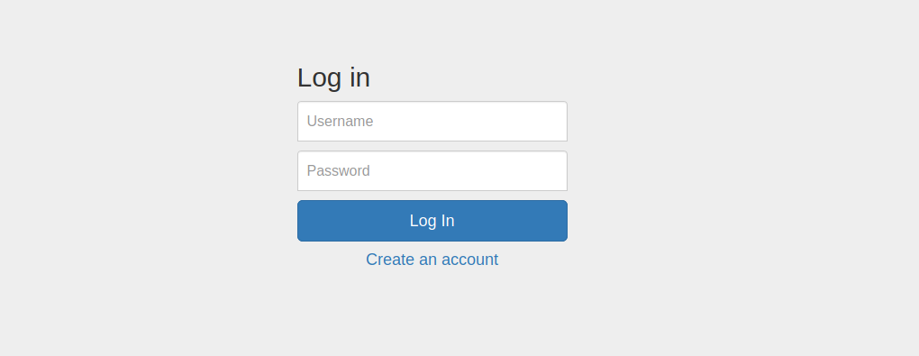
Log in
Users who have previously registered for the WishList App must login by:
Entering their Username.
Entering their Password.
Selecting Log In to advance to the next screen and begin using the application.

Create an account
Users who have not previously registered for the WishList App must select “Create an account” to use the site.

Create an account Page

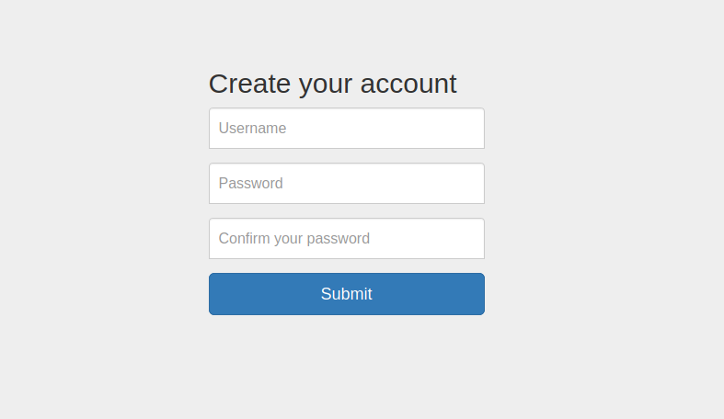
Username
Enter the user’s username, it must be at least 6 characters long.

Password
Passwords must be at least eight characters long and contain at least one letter character and one numeric character.

Confirm your password
As a security check, users will be asked to retype their password.

Submit
Press Submit to submit the registration information and continue to the next screen.

Home Page

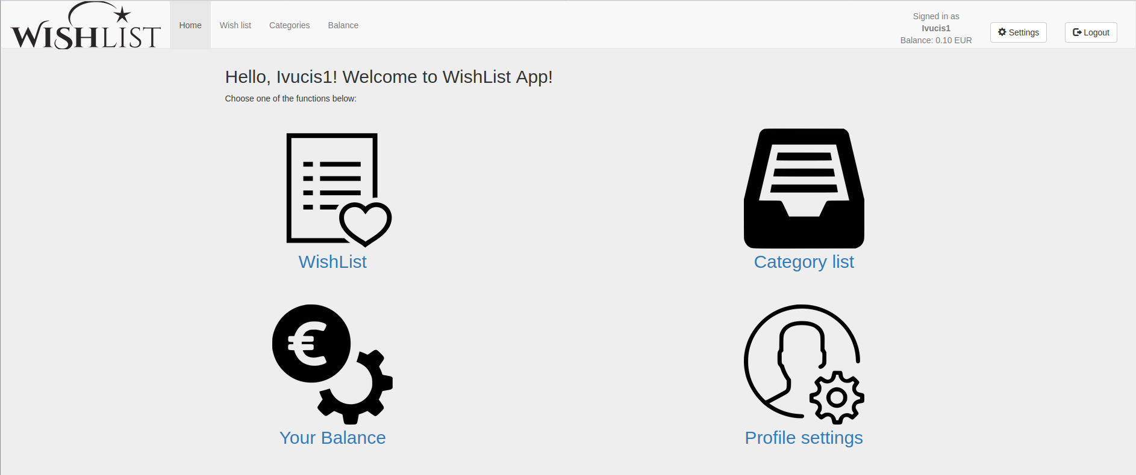
After logging into the WishList App, the user will advance to the Welcome Page. Select the icons on this page to do the following:

WishList
Here you can see, edit and delete items from your WishList.

Category List
Here you can see your items categorized from your WishList.

Your balance
Here you can edit balance of savings to your account.

Profile settings
Here you can see WishList statistics of your profile and edit password information.

Logout
Press Logout button to exit your current session.

WishList Page


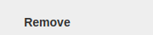
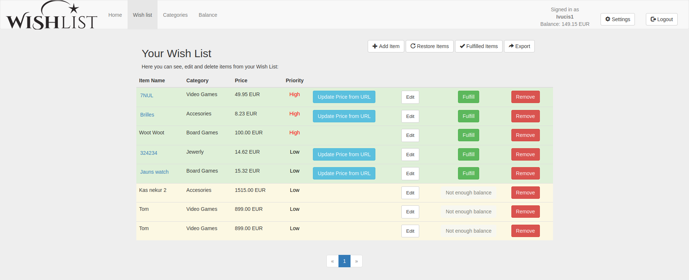
Here you can see, edit and delete items from your WishList. The list will store up to 15 items per page.

Item Name
Your assigned identification to your item.

Category
Division by category.

Price
Price of the product. If your item is linked to URL of original product, you can press button ‘Update price from URL’ in order to refresh information.

Priority
Sort items by putting level of priority to them. Items will be automatically displayed in order from High to Low

Edit
Press Edit button to update details about your WishList item.

Fulfill
By pressing Fulfill button, you will buy the product from your WishList. The balance of your account will be updated and item moved to Fulfilled Items list.

Remove
By pressing Remove button, you will remove product from your WishList and item will be moved to Restore Item list.

Add item (Your WishList)
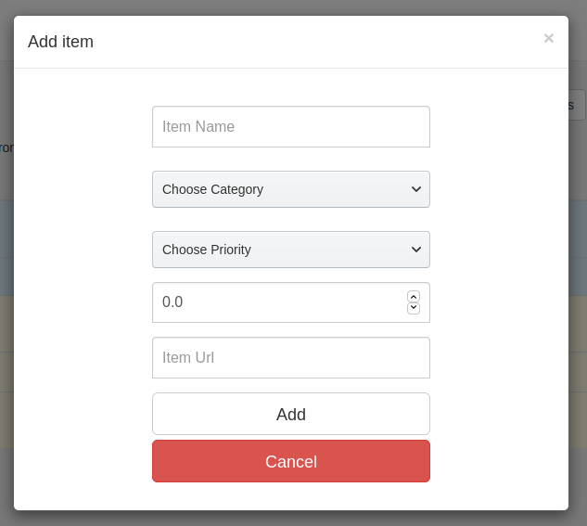

Add item options. The functionality and changes is the same as for Edit button.

Item Name
Your assigned identification to your item.

Choose Category
Division by category.

Choose Priority
Sort items by putting level of priority to them.

Price
Enter price of your product.

Item Url
Add original URL of your product for future reference.

Add
Press Add button to create new item on your WishList.

Cancel
Press Cancel button to disregard any changes made to this screen.

Restore Item (Your WishList)

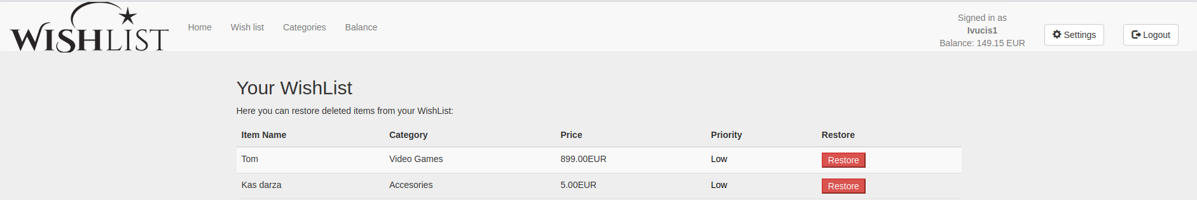
Here you can restore deleted items from your WishList.

Restore
Press Restore button to add item back to your WishList. Restored items will disappear from this item queue.

Fulfilled Items (Your WishList)

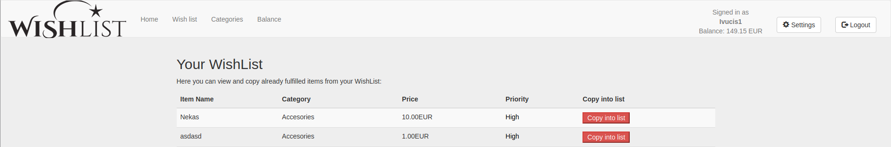
Here you can view and copy already fulfilled items from your WishList. All successfully completed items will be stored in this queue.

Copy into list
Press Copy into list button to create a re-newed entry of this item in your active WishList once again.

Export (Your WishList)

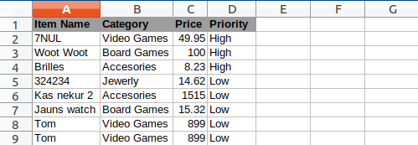

Press Export button in order to generate Excel sheet for all of your current items in your WishList for general overview and possibilities to add your own extra comments and calculations.

Categories (Category list)

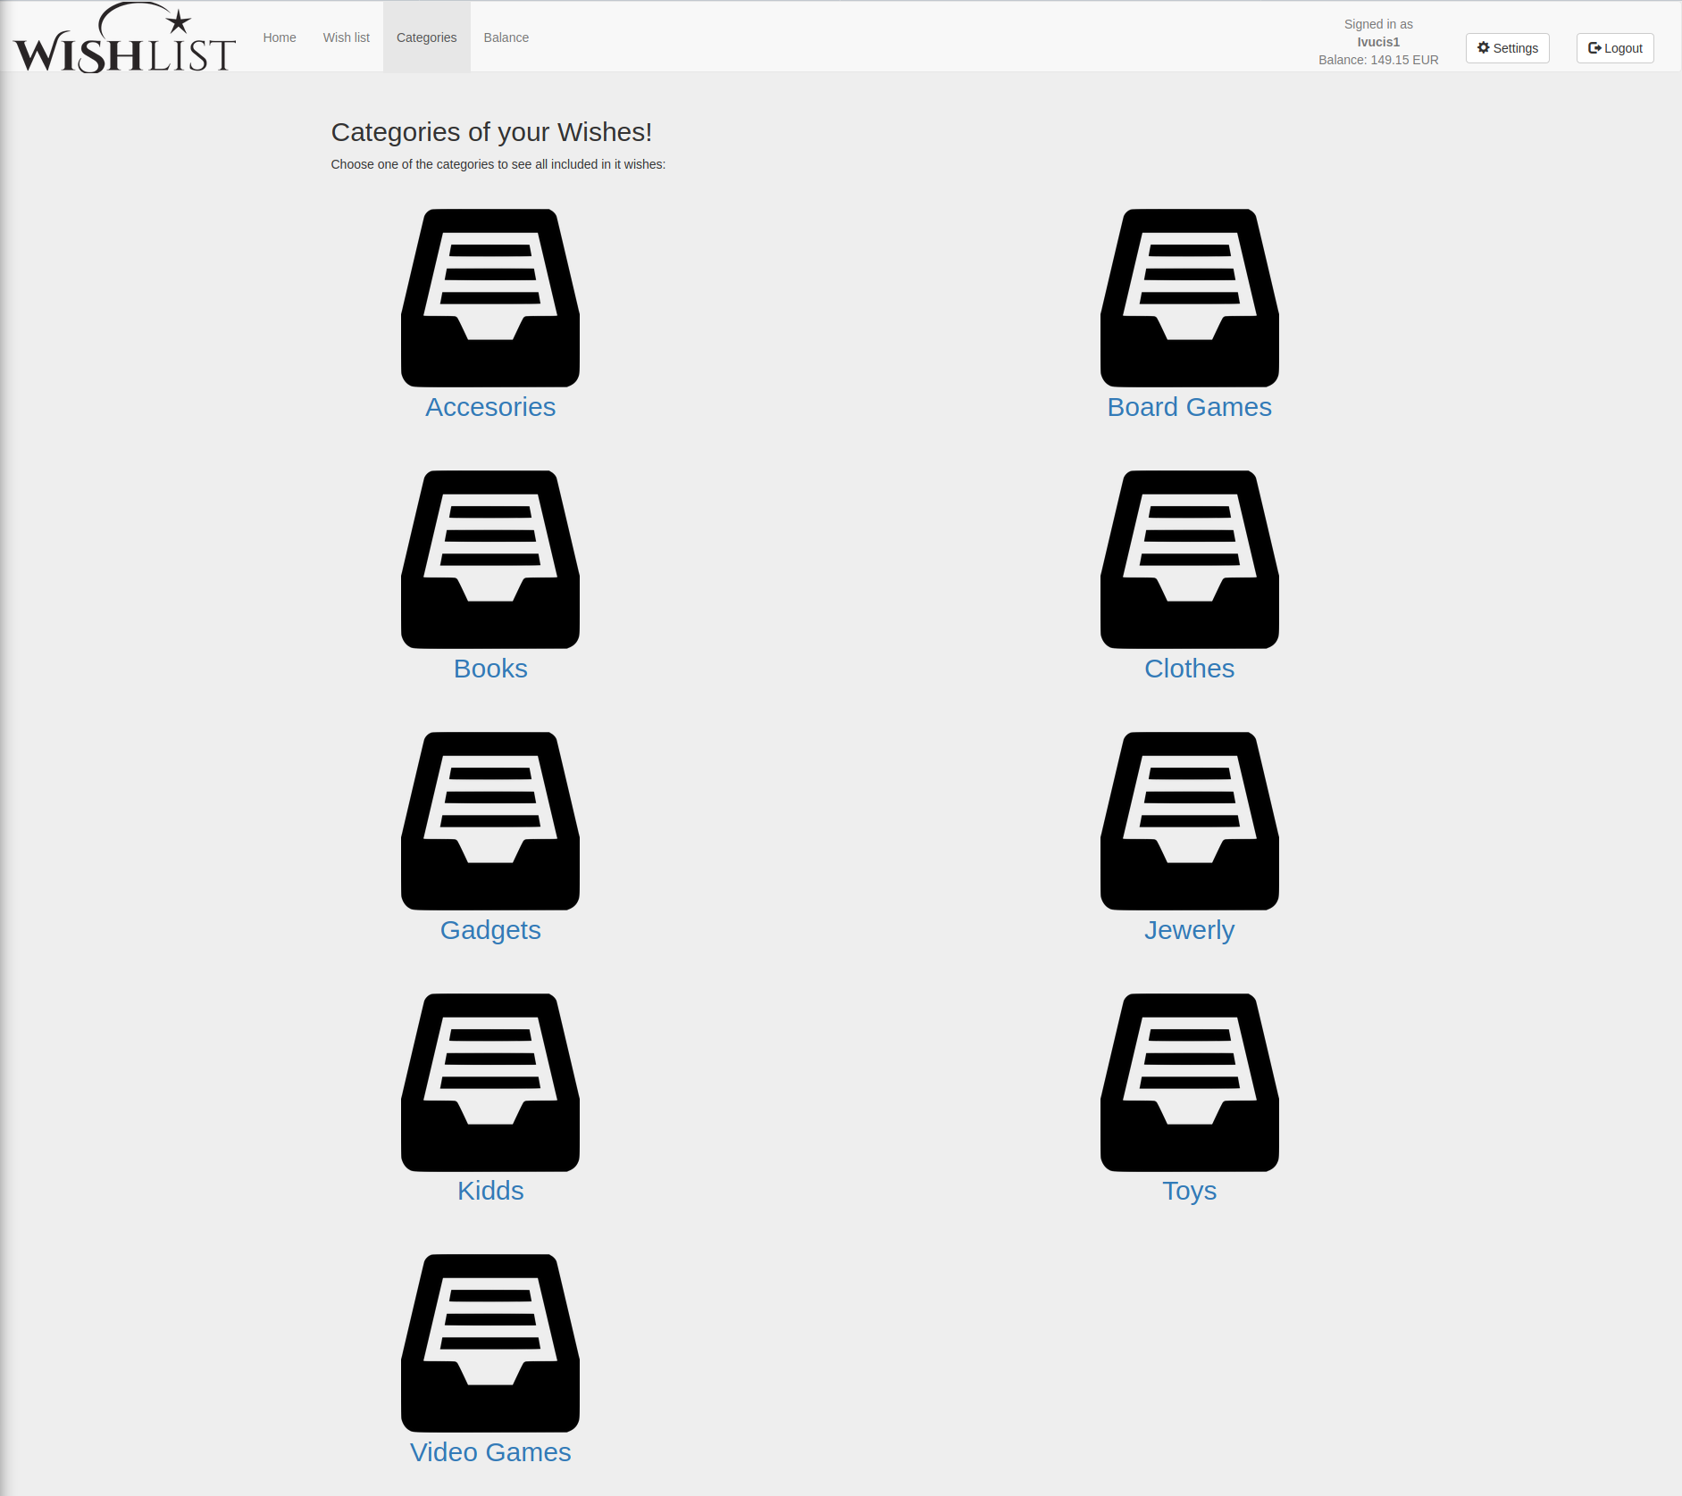

Choose one of the categories to see all included in WishList: Accessories, Board Games, Books, Clothes, Gadgets, Jewelry, Kidds, Toys and Video Games. This provides fast and easy access to your items mentioned only in this category.

Balance History (Your Balance)

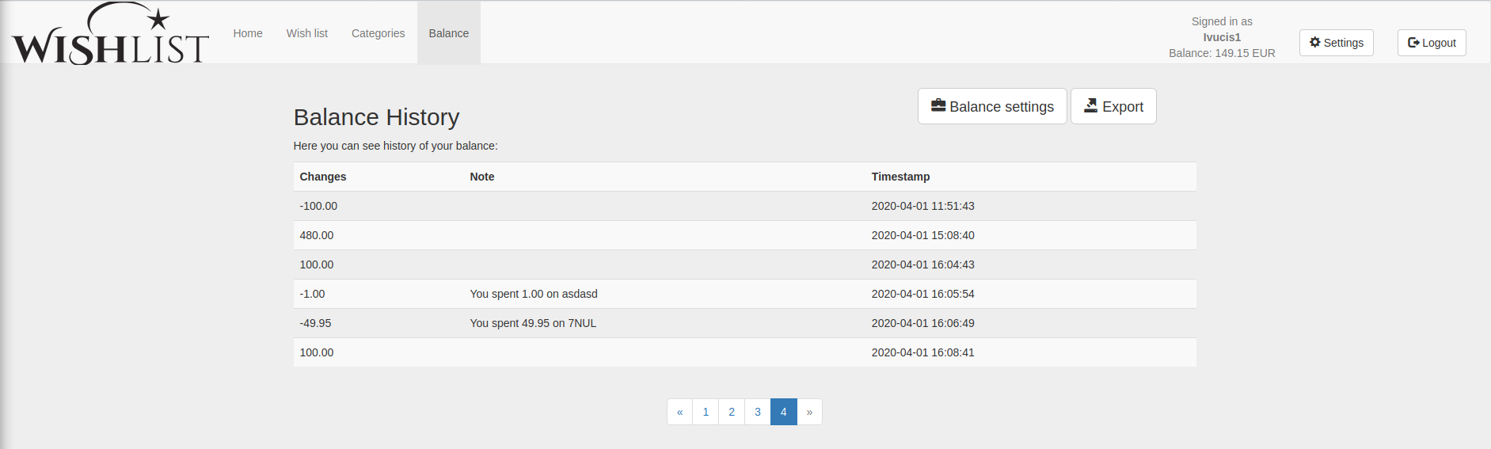

Here you have an overview of all your past item purchases and account balance updates.

Changes
Changes of account balance affected by purchase

Note
Your personal notes about each particular entry (optional).

Timestamp
Timestamp recording changes on your account.

Balance settings (Your Balance)
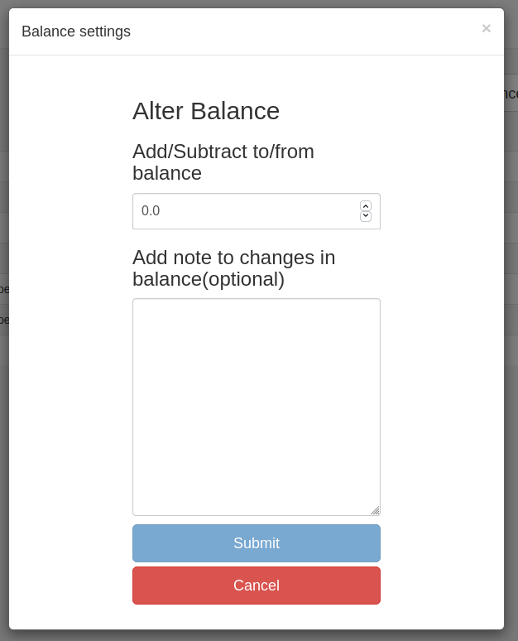

Press Balance settings button to enter ‘Alter Balance’ page, where you can update funding on your account and add comments of each particular entry. All changes will be recorded in Balance Hostory.

Export (Your Balance)
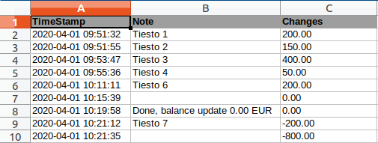

Press Export button in order to generate Excel sheet summary for all of your past transaction on your WishList App account.

Profile settings

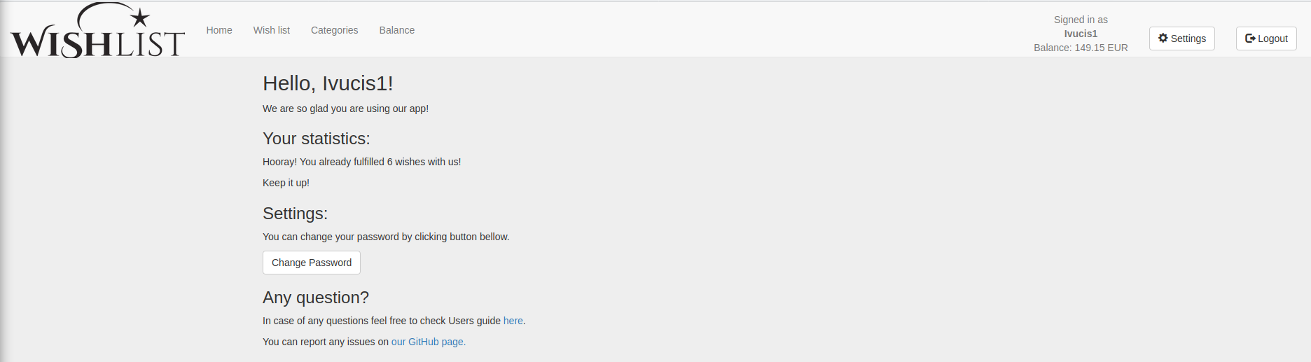

Here you can see your Profile Settings.

Your statistics
Amount of fulfilled items so far.

Settings
Under Settings you can change password for your profile.

Any question?
For further information users can attend to this user-guide or report any issues on our GitHub page.

Administrator settings

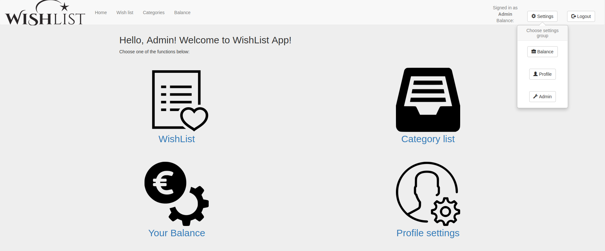
Under Settings button is displayed Admin button, that grants extra access to features in WishList App in order to modify site global details, like Users and Categories list.
This option is not accessible for normal users of the site.

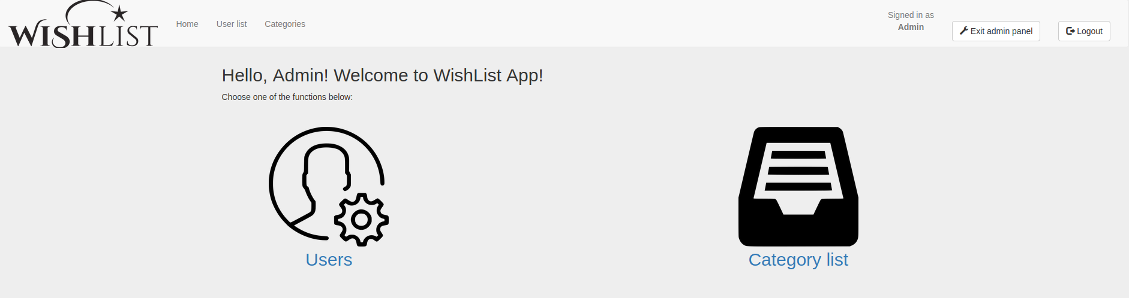
Users
Here are displayed all current users of the WishList App site.

Category list
Here you can update list categories displayed on WishList site.

Exit admin panel
Press Exit admin panel to go back to WishList Welcome page.

Users (Admin panel)

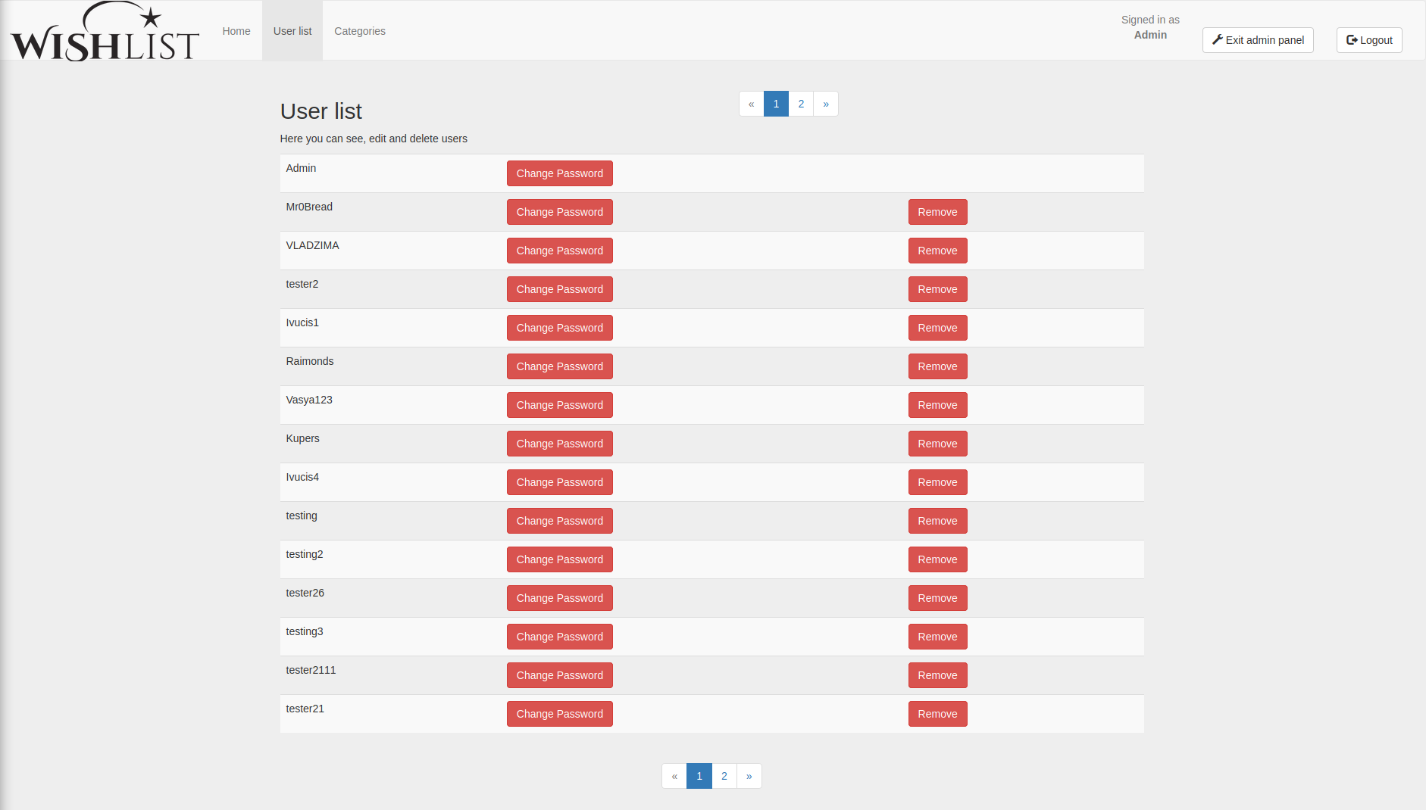
Here are displayed all current users of the WishList App site.

Set Password
Press Set Password button to edit new password for the client’s account.

Remove
Press Remove button to delete user from.

Category list (Admin panel)

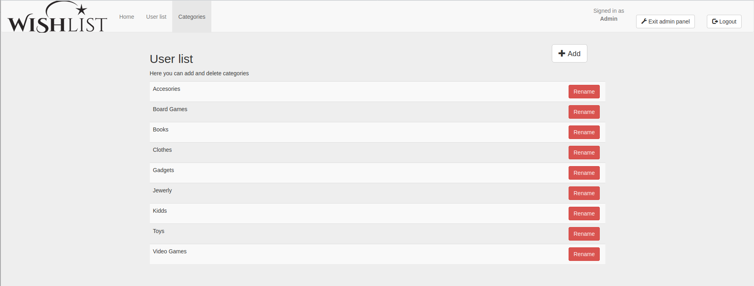
Here you can update list categories displayed on WishList site.

Rename
Press Rename button to change category name.

Add
Press Add button to enter new category to the existing list.

Thank You!

